Chapter 10

A few syndromes

I am sorry about this first bit, I don’t mean to insult your intelligence, but just in case there is something you have forgotten.

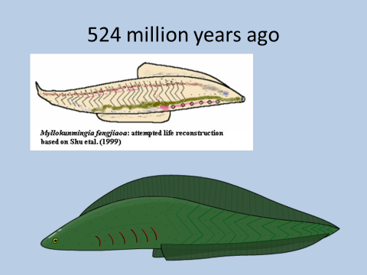

Let me introduce you to one of my relatives and indeed one of yours too.

This is Myllokunmingia. Only one fossil has been found but it may have been the first type of animal with a simple backbone. As you can see it is already quite well developed. There is an obvious head-end with a mouth and a digestive tract. The edges of the body are spread out to give structures which we could call fins and there are 6 gill flaps. So there are areas of specialisation a respiratory area, a digestive area a locomotion area.

The first multicellular creatures were not like this.

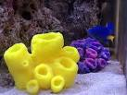

This is a sponge. If you take a living sponge from the sea and put it in a blender to break it up into its constituent cells and then pour it into a still aquarium the cells will reunite and the sponge will form again.

This is because every cell can:

Catch particles of food and engulf them.

Excrete waste.

React to external stimuli.

Respire by transfer of dissolved gases.

This transfer of gases is more efficient if the surface area is increased. Some creatures developed feathery gills.

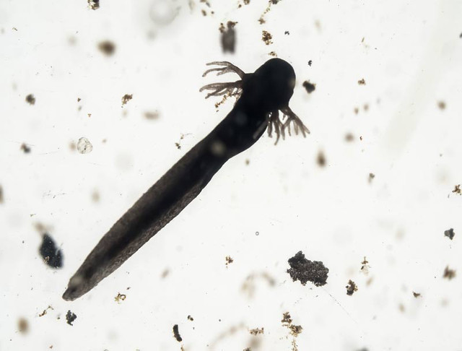

But to have such a delicate structure leads it open to damage.

So the Myllokunmingia has developed flaps over the gills and instead of gills that stick out into the water. The water is taken in through the mouth and passes over the gills.

It seems like the Coelacanth had been swimming around in the Indian ocean for 360 million years when it was discovered in 1936 (It must have been awfully tired)

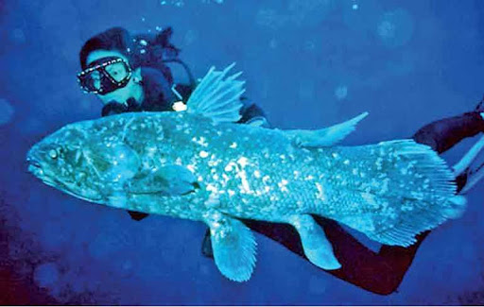

In this living fossil you will see evolutionary change has given an improvement in the structure of fins and this may have been the earliest fish to have not just a backbone (now of bone rather than cartilage) but bones in the fins and a protective plate of bone around the brain.

However we did not evolve from the majestic giants of the sea.

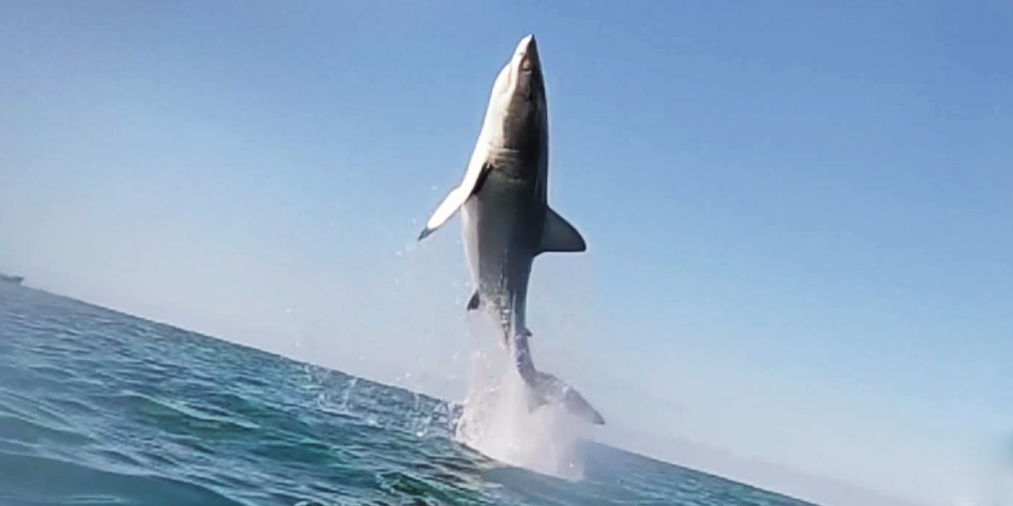

But from creatures of the mud and dried up puddles

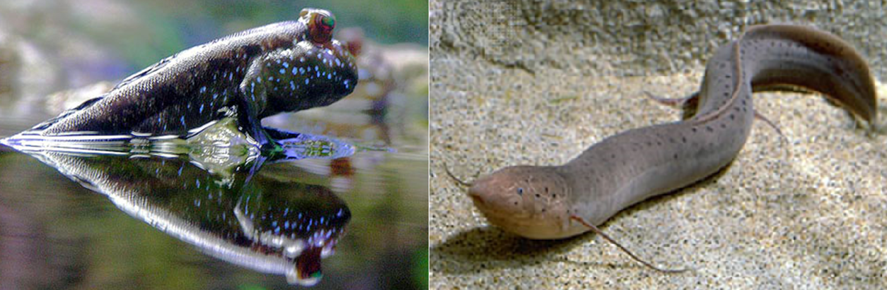

Because the water they lived in was poor in oxygen they evolved to gasp air. Some used their fins to help them crawl from one puddle to another.

Note what is happening. Evolution modifies existing structures.

[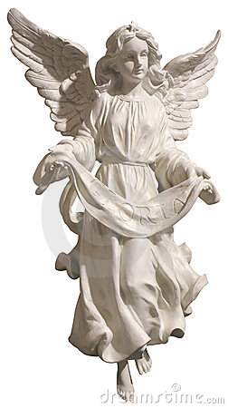](http://www.dreamstime.com/register?jump_to=http://www.dreamstime.com/royalty-free-stock-image-gloria-angel-image2646136)

This depiction of an Angel has arms as well as wings. But evolution is not like that. A bird has wings made from modified arms. And limbs are made of modified fins we don’t keep the fins.

How do we know this?

1. Inter uterine development. Yes in the womb you were like a little fish and then developed limb buds and you had the classic gill flaps that go all the way back to Myllokunmingia.
2. The fossil records.
3. It is in our genes. We have deleted genes in our chromosomes which path our evolution.

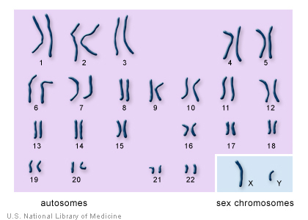

Here are my chromosomes. I have 46 that is 23 pairs. 22 pairs are matching and they are called Autosomes. The other pair (strictly speaking called allosomes) are the sex chromosomes which look quite different (allo means different in Greek).

The chromosomes from a female cell show the 22 autosomes and the sex chromosomes which look like a matching pair.

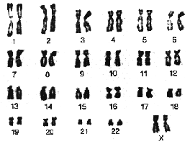

In fact, this is a better picture because you can see each chromosomes is two strands Joined at the centromere. 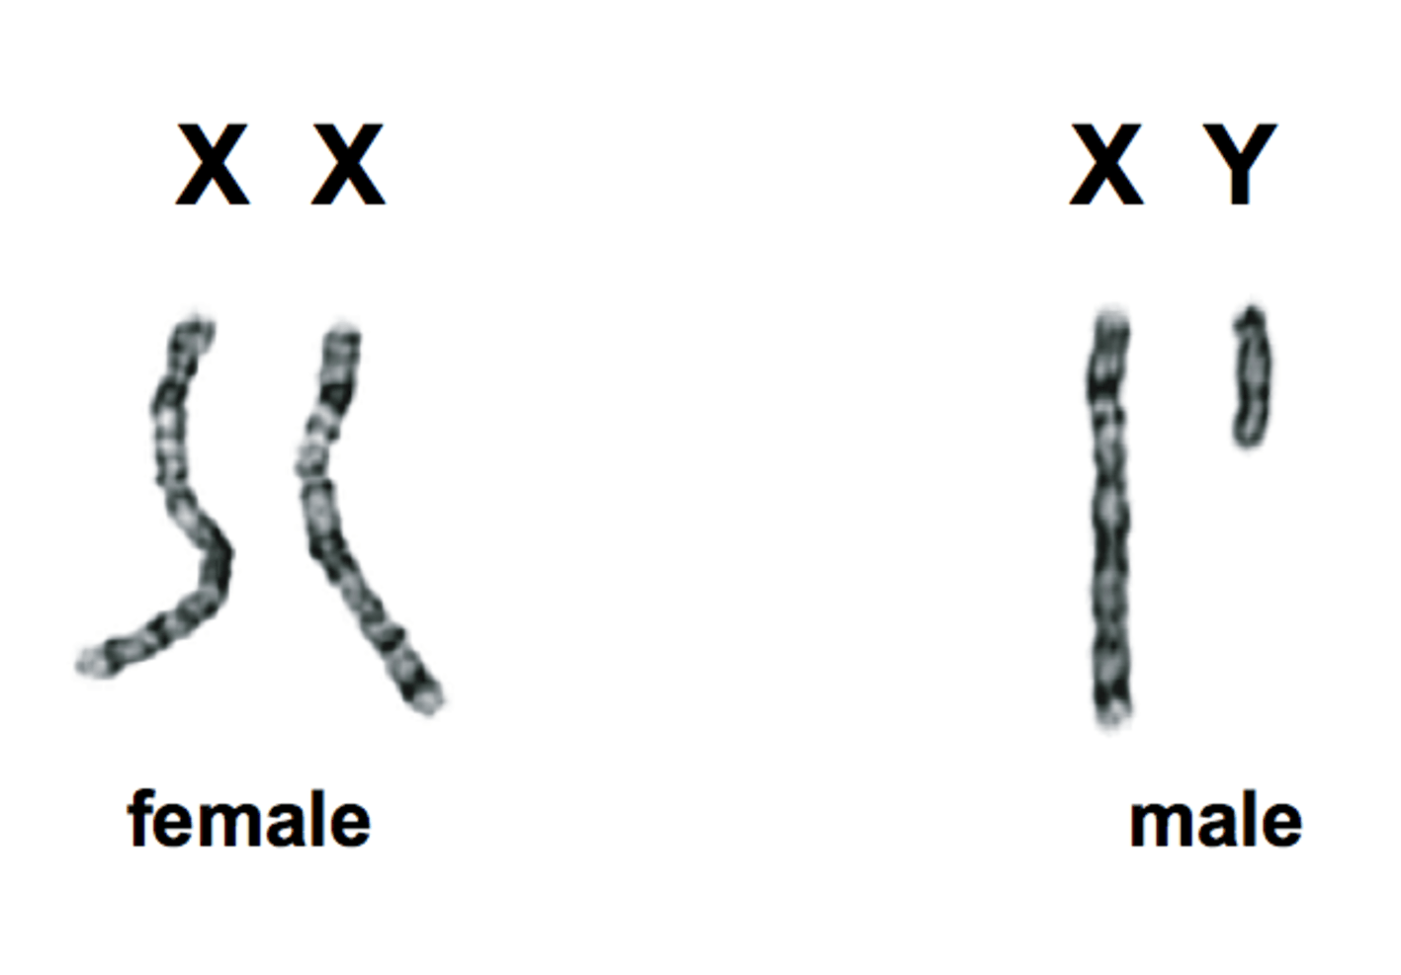

Fig sex chromosomes now you can see why all women think men are a bit deficient

Eggs and sperm have only one half of each pair. But before the pairs split up they often swap bits from one two another a process called “recombination”

Even without this recombination the number of different combinations is breath-taking.

If you and your partner wish to have every genetic combination you would need to have 5,299,204 children.

**The driving force for evolution:**

* The variability of genetic reproduction produces a spread of individuals. Because some are more able to survive harsh conditions the gene pool will change in time.
* Mutations (changes in genes) caused by radiation, viruses and some chemicals.

A Gene is just a recipe for making a protein. On the paired chromosomes (autosomes) there are two recipes (alleles) working together as allies making the protein. If the gene is on the sex chromosome all females will have two copies but if it is in the part of the Y chromosome that is missing then the male will only have one.

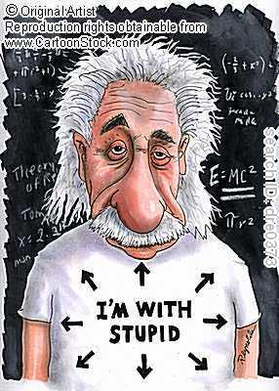

So, if we are the cleverest on the planet do we have the most chromosomes and the most genes?

* Humans have 46 chromosomes (23 pairs) and about 20,000 genes
* This is nothing to shout about. The marbled lungfish has 6 times as many genes
* And your goldfish has 94 chromosomes
* A hermit crab has 254

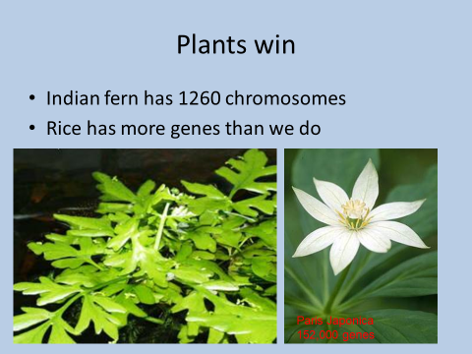

Imagine back in our evolutionary history genes developed to make blood and bone etc. these same genes will be shared with many other animals

So you can expect we share a lot of genes with say a dog or a mouse. (We share 92% of our genes with a mouse. No wonder I like cheese)

I share 98% of my genes with a chimpanzee.

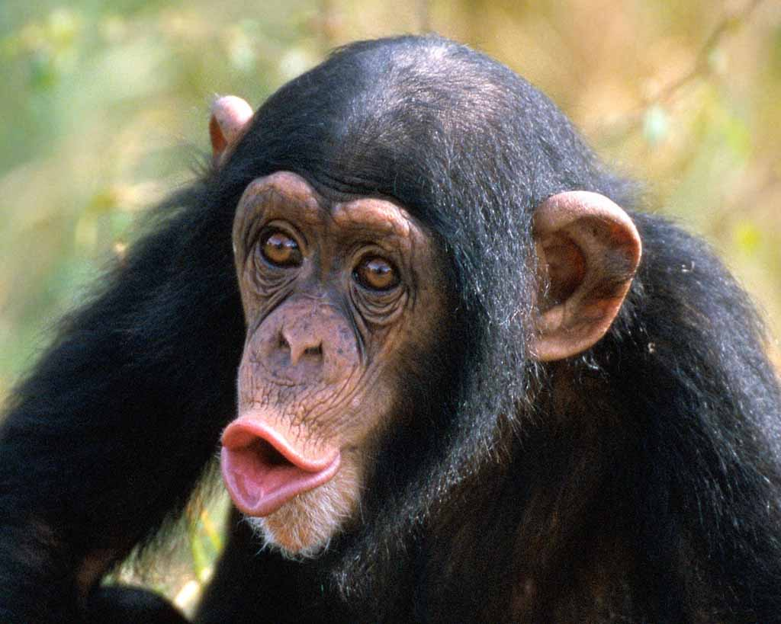

Can you tell?

A word of warning you may hear that we share 99% of our genes with a banana. This is a misunderstanding (It is more like18%). Genes are written in a four protein code Adenine, Thymine, Guanine and Cytosine. Consider them like a four letter alphabet. It is true that the book that is the genetic code of a banana is written with the same four letters as that of a human and in proportions that may be 99% the same, but the books are quite different.

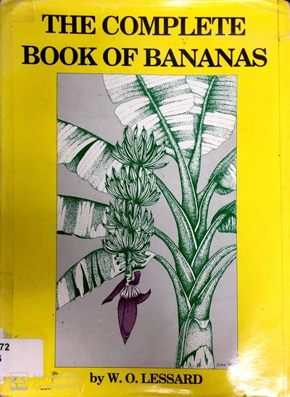

We said that a gene is a recipe for a protein and if the gene is on one of the paired chromosomes (autosomes) we will have two recipes. Imagine this protein is Fibroblast growth factor. If both genes are defective you will have no fibroblast growth factor and I am afraid this is not compatible with life. But if one gene works you may survive but with Apert’s syndrome. If you have children you stand a 50% chance of passing the defective gene on to each child. If they get the faulty gene they get the disease. This is called **an autosomal dominant disease.** There is usually a strong family history.

The **CFTR gene** provides instructions for making a protein called the cystic fibrosis transmembrane conductance regulator. This protein functions as a channel across the membrane of cells that produce mucus, sweat, saliva, tears, and digestive enzymes. If you have one good copy of this gene you can manage perfectly well and it is only if you have two faulty copies that you will get the symptoms of cystic fibrosis.

The people with one faulty copy and no symptoms of the disease are **carriers.** If two carriers have children 25% will be normal 50% will be carriers and 25% will have the disease.

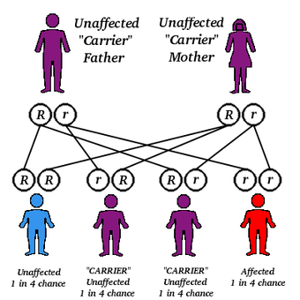

The effect of this is that a disease may pop up unexpectedly and this is called a recessive gene. Recessive Jean

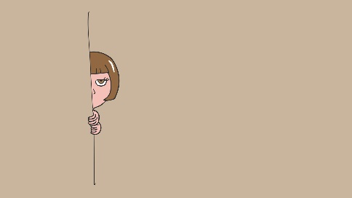

Hypohidrotic ectodermal dysplasia has several different inheritance patterns. Most cases are caused by a fault in the EDA gene. This is on the X chromosome. Females have two but males have only one. So that a carrier mother may pass the gene to a daughter who will be a carrier but with no disease because the other x chromosome can produce the protein. (Sometimes she may exhibit less severe symptoms). But if she passes it to her son he will have the disease because he doesn’t have another X chromosome. Fathers can also pass on the disease but only if they have symptoms (you cannot have a male carrier)

This is X linked transmission. The most famous example being Queen Victoria who was a carrier for haemophilia.

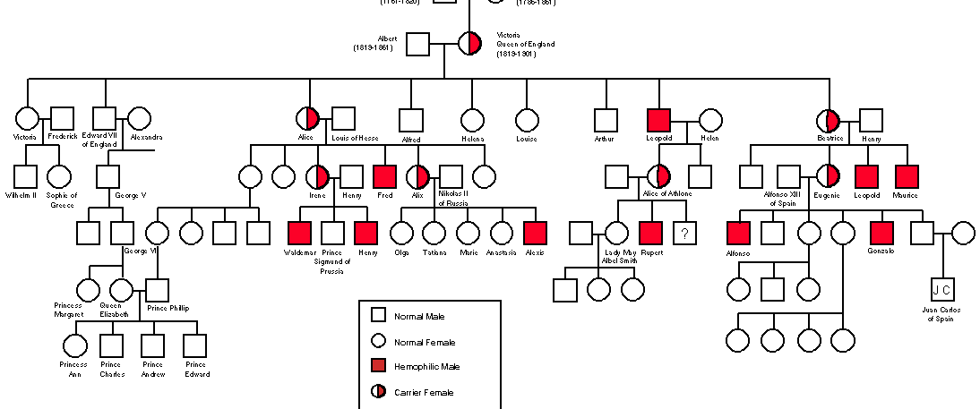

Fig Queen Victoria Empress of India and breeding experiment.

So:

* Evolution has been made possible by the law of the survival of the fittest discovered by Charles Darwin and the huge variability which occurs in sexual reproduction plus the possibility of mutation as the result of radiation,viruses and some chemicals.
* The genetic code is the blueprint that allows our bodies to be built
* Changes occur by modifying existing organs for example fins to forelegs and then to wings. In time bits of the body can change their use.

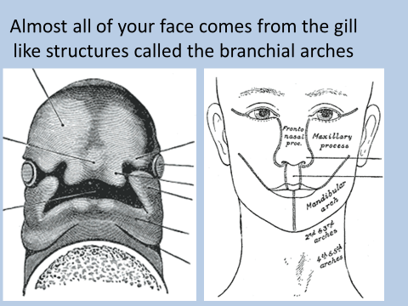

Branchial is Latin for a Gill

Pharygeal is Greek for throat

Gill is old Norse

**I doesn’t matter if you call them pharyngeal arches,branchial arches or gill arches they are all the same,**

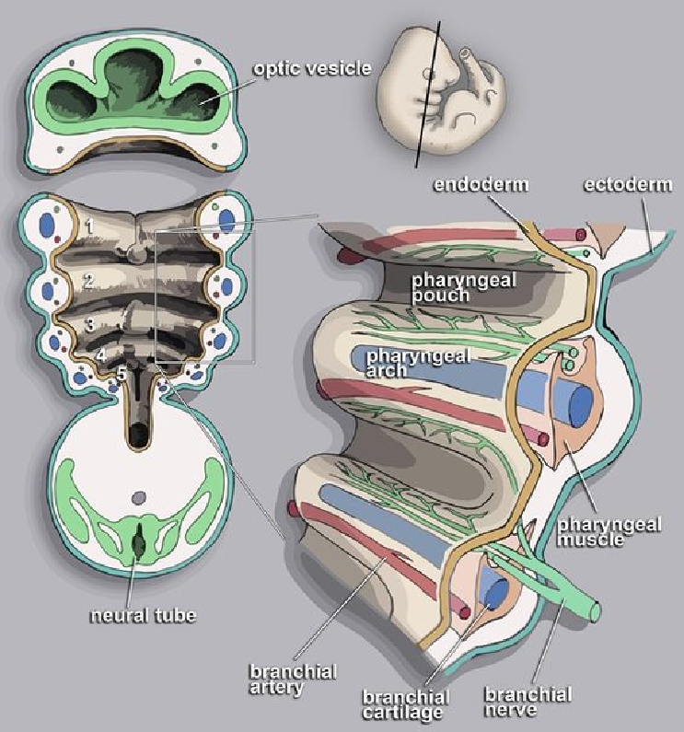

Each arch has:

* A central rod of cartalage
* An artery supplying blood (and a vein to drain it away)
* A nerve
* A block of muscle supplied by that nerve

Between each arch is a pouch. These structures can be seen in the developing human fetus but development transforms them.

The first arch becomes:

* The pouch of the first arch forms>Auditory tube, part of the middle ear, mastoid antrum and the inner layer of the tympanic membrane
* The central rod of cartilage (Meckel's cartilage) forms> Spheno-mandibular ligament the incus and malleus bones of the ear
* The nerve forms> the Trigeminal nerve
* The blood vessel forms> the Maxillary artery and external carotid
* The muscle forms> the muscles of mastication, anterior belly of diagastric, mylohyoid, tensor tympani and tensor veli palatine.

The second arch becomes:

* The pouch of the second arch forms part of middle ear and palatine tonsil
* The central rod of cartilage (Reichert's cartilage) forms: Stapes, styloid, stylohyoid ligament and the upper part of the hyoid bone
* The nerve forms the Facial nerve
* The blood vessel forms the Stapedial and hyoid arteries
* The muscle forms the muscles of facial expression, buccinators ,platysma, stapedius, stylohyoid and posterior belly of the digastric

The 3rd 4th & 6th arches form:

* muscles of the neck, cartilages of the larynx, Thyroid cartilage and epiglottis and muscles of the larynx

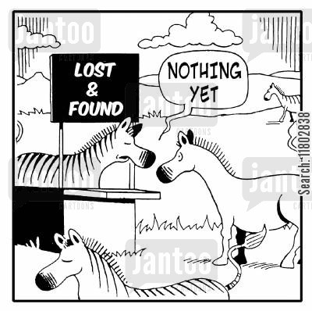

The fifth arch just got lost

**Branchial arch syndromes**

**What is a syndrome?**

A syndrome is a pattern of pathologically connected abnormalities

In 1906 Eugene Apert described a family of 9 who all had the same hand and facial abnormality.

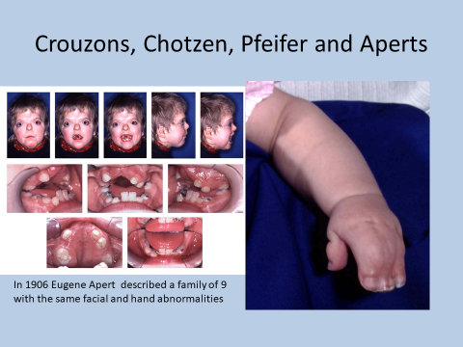

Similar conditions came to light which had some of the same features. For example Crouzon’s disease is very like Apert’s but the hands are normal.

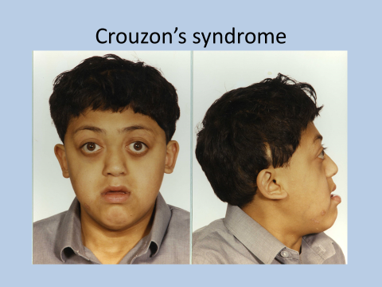

Early fusion of the sutures in the skull cause a rise in intracranial pressure and prevent the normal growth of the maxilla. There are no sutures in the mandible which grows normally

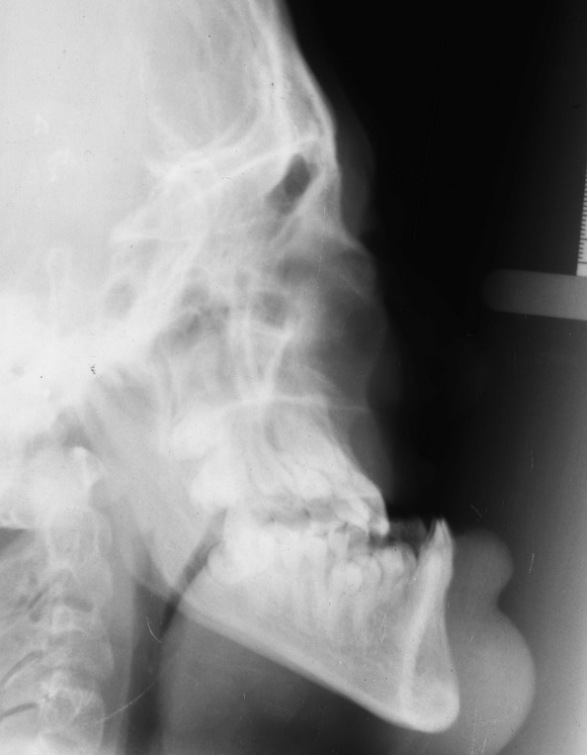

The patient will become a gross class III.

These syndromes although they are described seperately are clearly related.

* They are all associated with a disorder of a gene on chromosome 10 **Fibroblast growth factor receptor 2**
* Low-s
* et ears occurs in all branchial arch syndromes because the ears on a foetus are much lower than those on an adult. During normal development, the ears "travel" up the head; however, in Crouzon patients, this pattern of development is disrupted. Ear canal malformations are extremely common, generally resulting in some hearing loss.

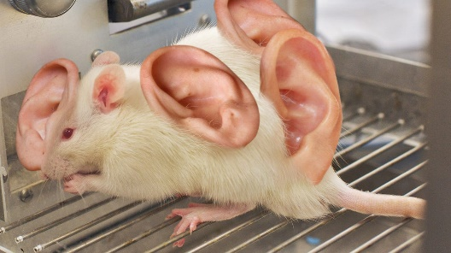

* The most notable characteristic is the early fusion of sutures in the skull causes raised intra-cranial pressure
* A similar process causes early fusion of sutures in the maxilla and palate.
* Careful handling is required to prevent mental impairment (due to the raised inter-cranial pressure) or respiratory problems because restricted maxillary growth impairs the airway

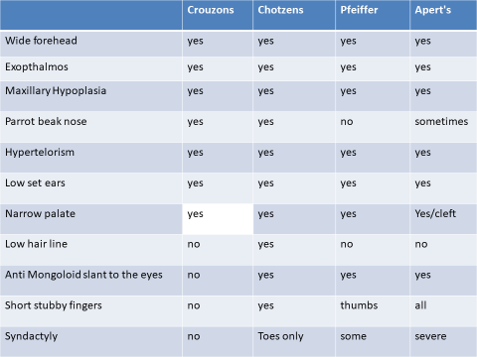

**First and second arch syndrome (also called cranio-facial Microsomia)**

* Treacher Collins syndrome/Mandibulo-Facial Dysostosis Known to be genetic autosomal dominant, causing a lack of “treacle” protein which in turn causes a lack of neural crest cells migrating into the branchial arches
* Goldenhar’s Syndrome unilateral may be related to loss of blood supply in utero but? May be genetic.
* Hemi-Facial Microsomia. Is this just mild Goldenhar’s syndrome?
* Romberg’s syndrome. Progressive.

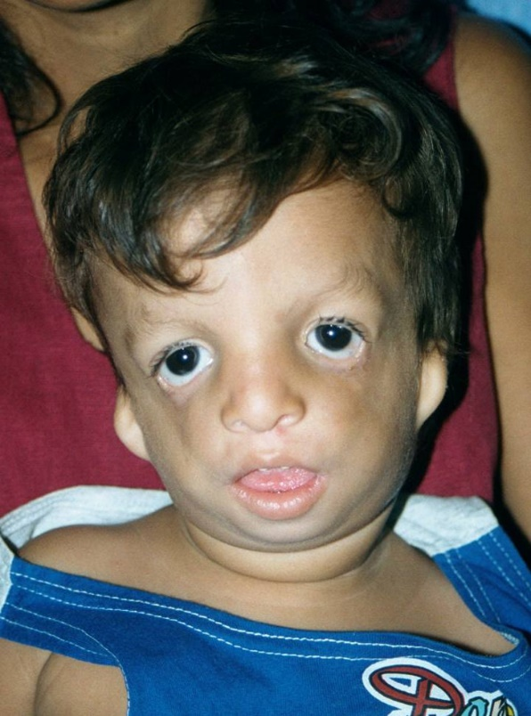

Fig Treacher Collins syndrome (mandibulo-facial dysostosis)

The Zygomatic arches are reduced or missing and the mandible is small. The tongue which is short of space because of the small mandible bulges out of the mouth.The eyes show an anti-mongoloid slant there may be no eyelashes or tear ducts.

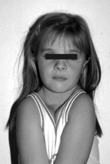

Cleidocranial Dysplasia (dysostosis)

* Runx2 gene on chromosome 6
* Partly or completely missing collarbones. If the collarbones are completely missing or reduced to small vestiges, this allows hypermobility of the shoulders including ability to touch the shoulders together in front of the chest.
* A soft spot or larger soft area in the top of the head where the fontanelle failed to close. Wormian bone
* Bones and joints are underdeveloped. People are shorter and their frames are smaller than their siblings who do not have the condition.
* The permanent teeth include **supernumerary teeth**. Unless these supernumeraries are removed before adolescence, they will crowd the adult teeth in what already may be an underdeveloped jaw. In that case, the supernumeraries will probably need to be removed to provide space for the adult teeth.
* **Permanent teeth not erupting**
* Bossing (bulging) of the forehead.
* Hypertelorism

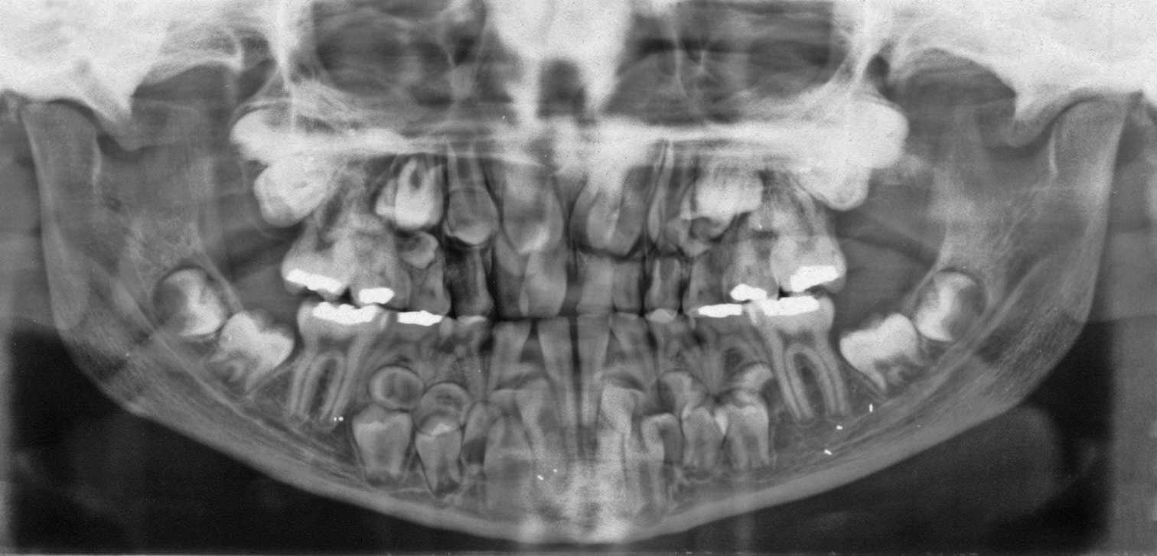

**A warning**

Seems tempting doesn’t it give a GA and remove all the supernumeraries and all the deciduous teeth BUT this doesn’t leave you with enough teeth to pull from and the treatment will be a failure DO IT IN TWO STAGES.

**Downs Syndrome**

Trisomy 21 these patients have an extra 21 chromosome

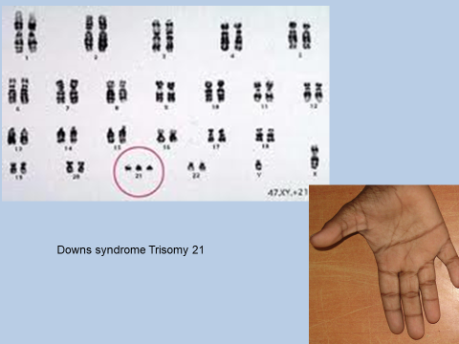

Many of the common physical features of Down syndrome may also appear in people with a standard set of chromosomes, including microgenia (an abnormally small chin),] an unusually round face, macroglossia (protruding or oversized tongue), an almond shape to the eyes caused by an epicanthic fold of the eyelid, upslanting palpebral fissures (the separation between the upper and lower eyelids), shorter limbs, a single transverse palmar crease (a single instead of a double crease across one or both palms), poor muscle tone, and a larger than normal space between the big and second toes. Health concerns for individuals with Down syndrome include a higher risk for congenital heart defects, gastro-oesophageal reflux disease, recurrent ear infections, obstructive sleep apnoea, and thyroid dysfunctions.

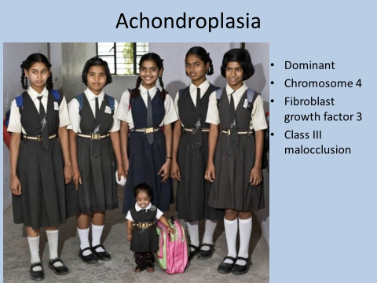

I am not sure this is a picture of an achondoplastic dwarf but this picture of a schoolgirl with the same uniform and with the same bag as her class-mates is so charming I have included it.

**Gorlin-Goltz syndrome**

* May be diagnosed by a dentist. As the initial presentation may be a Dentigerous cyst
* PTCH gene on chromosome (Dominant)
* Initial presentation are Odontogenic Keratocysts
* Later Basal cell carcinomas develop

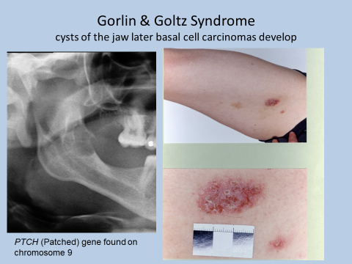

**Marfan’s Syndrome**

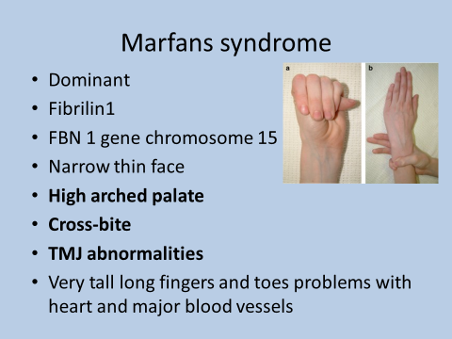

It is quite important to spot this disease as it is associated with weakness in the arterial wall.

**Gardeners Syndrome**

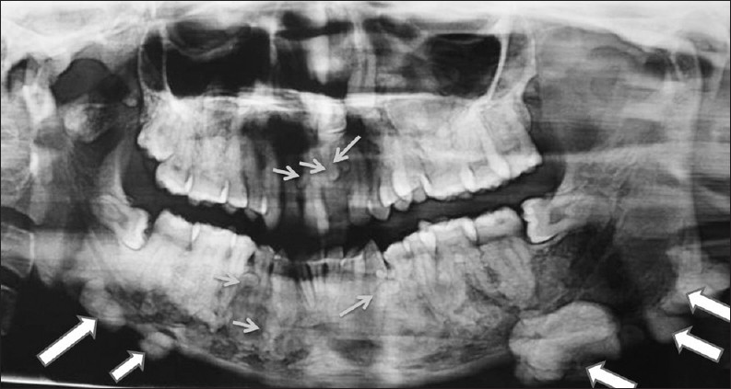

Is important because it is a syndrome that may be spotted by an orthodontist.

At first radiolucent areas form. Then develop a cotton wool appearance before turning into osteomas/cementomas. Associated teeth fail to erupt and will not move under orthodontic force. Because of the association with malignancies of the colon correct diagnosis is important.

* Autosomal dominant
* APC gene chromosome 5
* Cotton wool appearance in jaws
* It develops into hard osteomas
* Polyps develop in the colon and turn malignant

**Hypohidrotic Ectodermal Dyspalsia a collection of over 150 syndromes.** This one is an abnormality of the EDA gene on the X chromosome

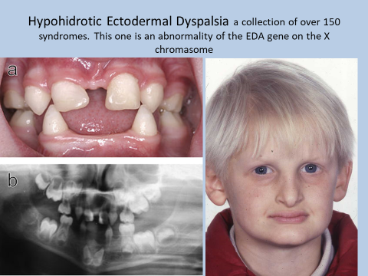

|  |  |
| --- | --- |
| 1. Why is it important to diagnose Gardner’s syndrome? | It is related to colon polyps and bowel cancer |
| 2. Oral features of Marfans syndrome | High arched palate |
| 3. Supernumeraries, failure of teeth to erupt & wormian bone are a feature of what condition | Cleidocranial Dysplasia |
| 4. What are the features of Treacher Collins syndrome | Zygomatic arch deficient. Mandible small ? no eyelashes ? Tear duct deficiency ? ear deformity |
| 5. Fundamental cause of 1st arch syndrome | Early fusion of sutures |