**Chapter 12**

**A Tedious History of Orthodontics, including a short history of glue.**

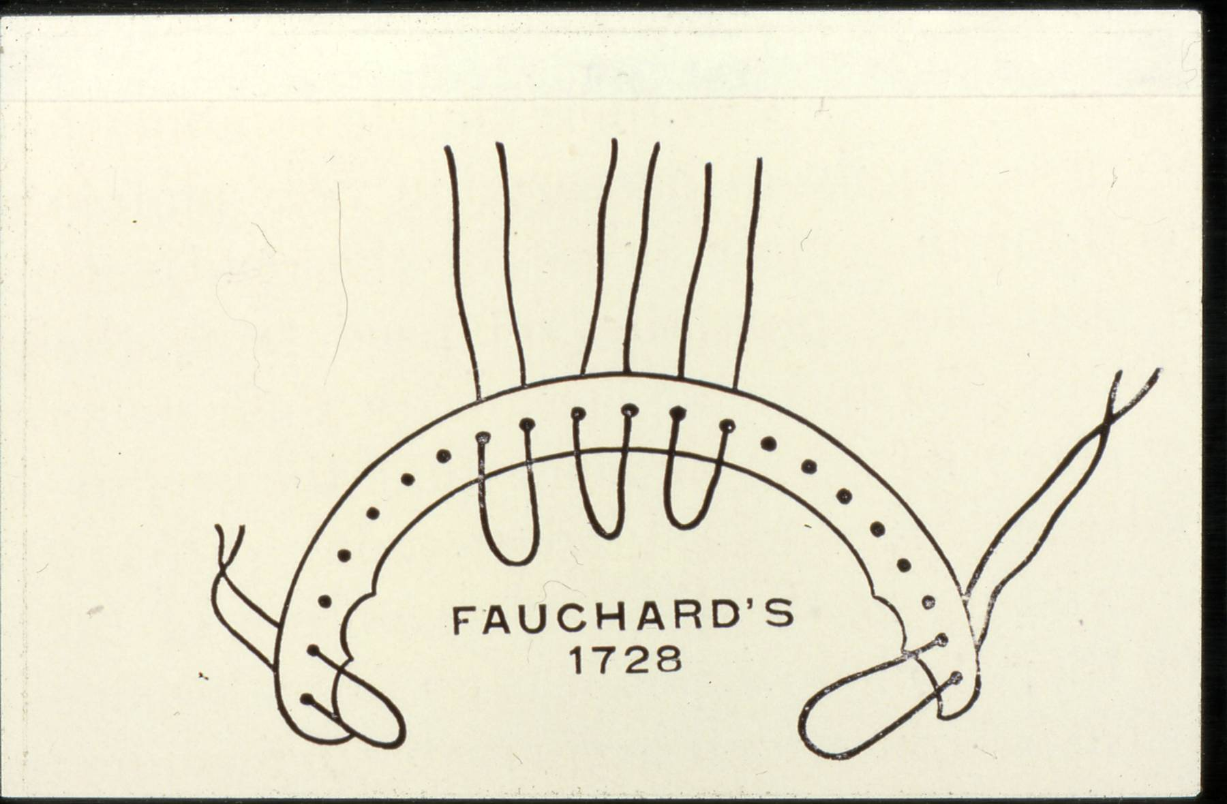

In 1728 Pierre Fauchard described an appliance which was a strip of whalebone or walrus ivory laced, or braced, to the teeth. In effect this was treatment by expansion, Fauchard’s contribution to science is greater because he believed in publishing his inventions whereas most doctors kept them secret to preserve their income. An up market version with a strip of gold working on the lingual side of the teeth was described and used by Etienne Bourdet (1722-1789) he was the dentist to the king of France. This was not a good idea.

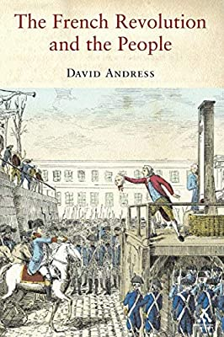

Fig Gold lingual braces a warning from history 1789

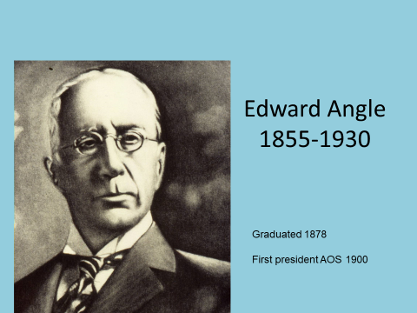

Edward Angle is a hugely important figure in modern orthodontics, He took the idea of Fauchard plus:

* William Lintott 1841 first described screws being used in the mouth for expansion
* A French dentist Strange described a band and screw clamp fitted around teeth also in1841
* Norman Kingsley was the first to describe the use of headgear
* William Magill described cements that could fix bands in1871

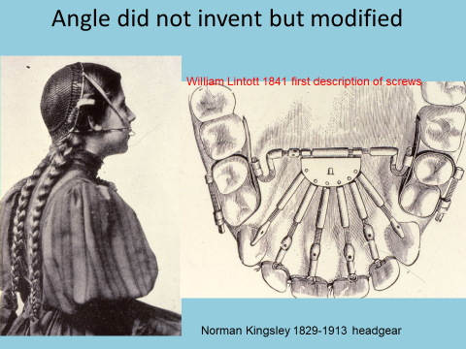

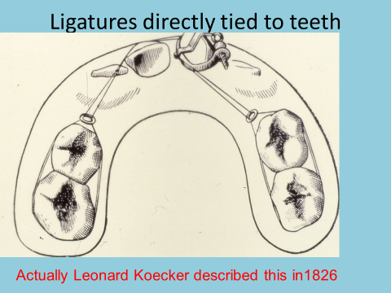

Now we are all set for Angle’s first appliance the E-Arch

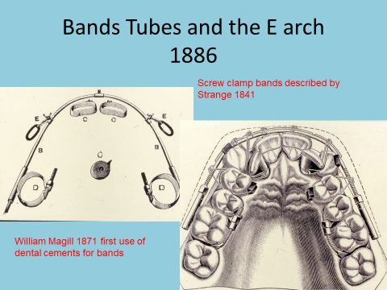

The E-Arch was a thick gold archwire with a screw-thread tapped on the ends. A soldered hook each side allows the use of class II elastics. The bands are gold and the molars tighten around the teeth with a screw thread.

Treatment is by expansion. Turn the screw in front of the molar tube and very slowly the incisors will move forward. As space opens ligatures can be placed pulling the teeth into line.

The pin and tube appliance.

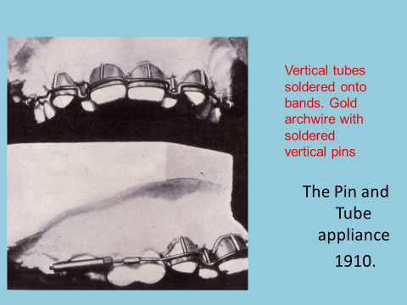

Probably it never worked. Now the E-Arch has vertical pins which fitted into vertical tubes on the anterior teeth at each visit you had to remove the pins and re-solder them a tiny distance away. It must have been very difficult but it led to the first real fixed appliance system,

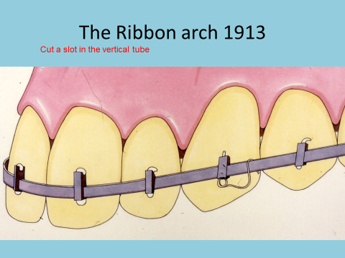

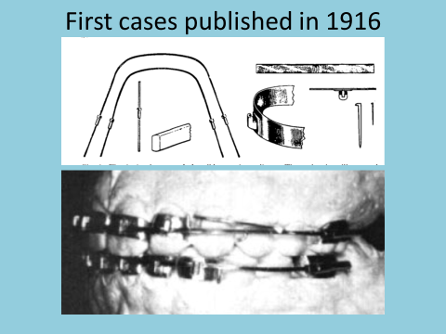

In effect Angle took the vertical tubes and cut a slot making a **Bracket.** The **archwire is no longer round but rectangular in cross section.** First and third order movements are achieved with bends in the archwire but tip is achieved by using uprighting springs. The archwire is held in place with small pins. Everything is made of gold. The use of ribbon arch gradually declined but it was the increased cost of gold which finished it off.

In 1924-25 P.R. Begg was one of Angles students. He may have been the first person to use the new edgewise bracket but when he returned to Australia he used Ribbon arch. Later after an association with an Australian metallurgist A. J. Wilcock he changed the brackets to stainless steel and instead of the ribbon arch he used high tensile special plus stainless steel wire. This is the Begg technique,

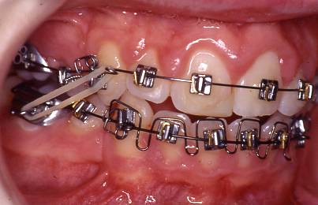

Fig using round wire means that auxiliaries are needed to torque teeth.

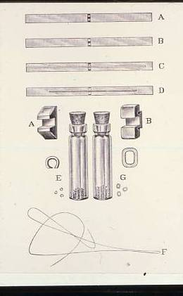

This is a classic picture of the introduction of the edgewise appliance. Introduced in 1927 when Angle was 73. He described it as “**The Latest and Best Orthodontic Appliance**” (Good thing Kevin O’Brian wasn’t around at the time).The archwire was turned through 90° and went into the slot “Edgewise” on. The slot was 0.022 x 0.025 inches. You will recognise bracket B and may be wondering about bracket A. For this the ligature wire went right around the teeth in a similar way to the E-Arch.

Angle thought the edgewise appliance was the best because it did not need any auxiliary springs. It could move teeth in all three planes of space. He described:

* 1st Order - In Out
* 2nd Order - Tip
* 3rd Order – Torque

Very soon the narrowness of the bracket became a problem. Two solutions were tried you could put two brackets on each tooth. This is called a Siamese bracket

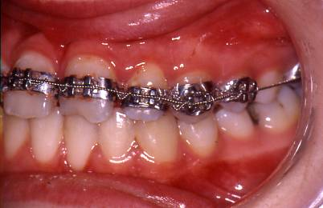

Or you could use a bracket with wings.

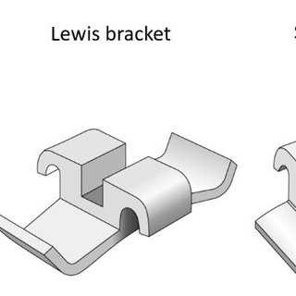

Brackets with wings

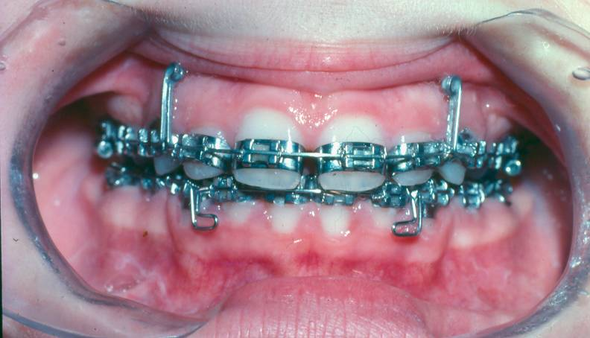

This a picture of one of my cases in 1975. Things had not changed much. After 1948 stainless steel replaced the gold. But we still used quite soft wires which was good because there was a lot of quite complex wire bending.

A Little footnote on stainless steel

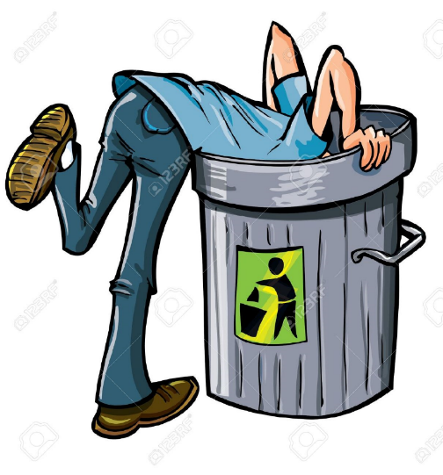

On the 13 August 1913 Harry Brearley was clearing away metal samples and putting them in a dustbin when he noticed those containing a certain amount of chromium had not rusted. He called his invention rustless steel but we call it stainless steel. In 1924 William Hatfield developed 18:8 stainless steel 18% Chromium and 8% Nickel which is the alloy used in most brackets. In 1948 Unitek introduced the first steel orthodontic brackets

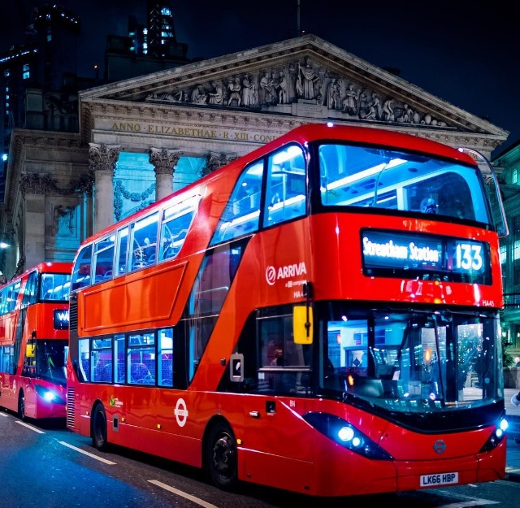

**Then 3 come along at once**

Three inventions came along at once which revolutionised Orthodontics.

They were:

1. Michael Buonocore showed that you could etch enamel and this gave a surface to which you could bond plastic resin. He invented adhesive dentistry. In orthodontics that ment we said goodbye to bands (except sometimes on molars) in 1978. And bonded brackets directly to the teeth.

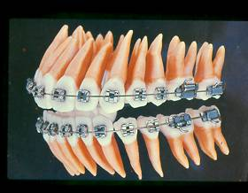

2. Larry Andrews introduced the **straight-wire bracket**. Most people today think he thought up the idea. In fact Reed Holdaway had already described pre-tipped brackets in 1952 and Ivan Lee pre-torqued brackets 1957. Joseph Jarabak was the first to describe pre-torqued pre-angulated brackets in 1968. Andrew’s added science and entrepreneurship.

3. Nitanol the first “Shape Memory” wire came on the scene. The term **Nitinol** is derived from its composition and its place of discovery: (**Ni**ckel **Ti**tanium **N**aval **O**rdnance **L**aboratory). William Buehler along with Frederick Wang, discovered its properties during research at the Naval Ordnance Laboratory in 1962. It was very difficult to manufacture so it didn’t arrive in orthodontics until 1980

So all at once in 1980 you had a new type of bracket that ment you could use a flat (No first ,second or third order bends) archwires. This bracket needed to be fixed to a precise position on the tooth and all of a sudden this became possible with bondable brackets. And now we had super-flexible NiTi wires ready shaped that could rush as up to 0.019 x 0.025 wire in 3 or 4 visits instead of 5 or 6.

In plain edgewise you had to put in different amounts of torque in each section of the wire I used to use 12° for upper centrals. 7° for upper laterals and Zero for the canines in the upper buccal segments we twisted in some reverse torque so that increased as you went back. This was called progressive root torque. **Because of all these bend you could not use sliding mechanics.** With the new straight-wire it became possible.

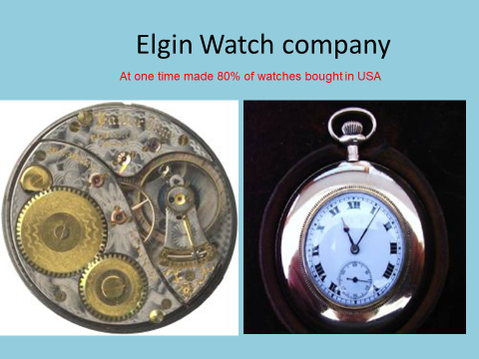

The American army expressed dissatisfaction with the watches provided by the Elgin watch company in World War II. The mainsprings tended to break. The Elgin Company set out to find a superior material and hit upon a Cobalt (40%) Chromium (20%) Nickel (15%) wire that existed in three forms: BLUE which was dead soft YELLOW which was similar to stainless steel in hardness and RED which was very springy indeed but you could not bend it without breaking it. The idea was that you bent a spring in the BLUE or YELLOW form and then heat treated the wire to turn it to the red form. Orthodontists tried this but putting wires in the oven was not practical.

One orthodontist Robert M Ricketts used this wire to develop a whole new technique which he called Bioprogressive. A key feature was the utility arch.

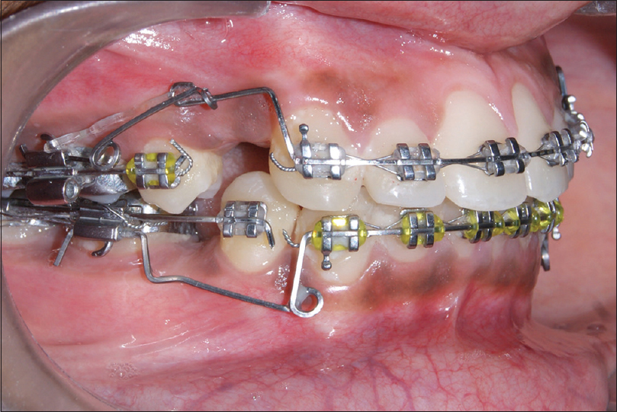

This allowed you to intrude the incisors to control the overbite at the same time you were retracting the canines. The slot was only 0.018 across but 0.030 deep so you can fit two wires in at once. Ricketts thought that if you bent the archwires from the soft BLUE Elgyloy wire you would avoid root damage because you could not generate enough force at the apex to do any damage. I am not convinced this is true and the wire was so soft that breakages prevented any progress,

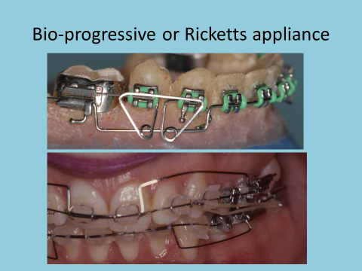

I did find the technique worked well if you used slightly more robust wires

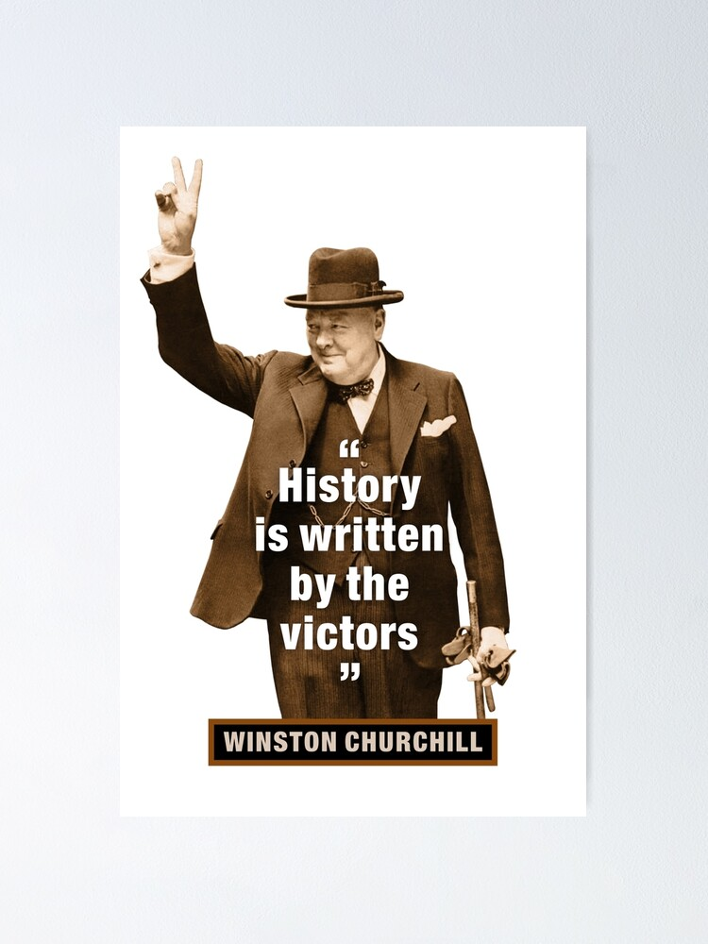

It looks like an orderly process Angle invented edgewise and Andrews developed it into straight wire. But it did not seem like that at the time. Begg, Tip-Edge and Ricketts were important techniques and could easily have finished up the victor (and still might). Looking back I believe that had Ricketts arrived a little earlier and not put so much emphasis on the use of hopelessly soft wires. Andrews might have developed a straight –wire bioprogressive appliance.

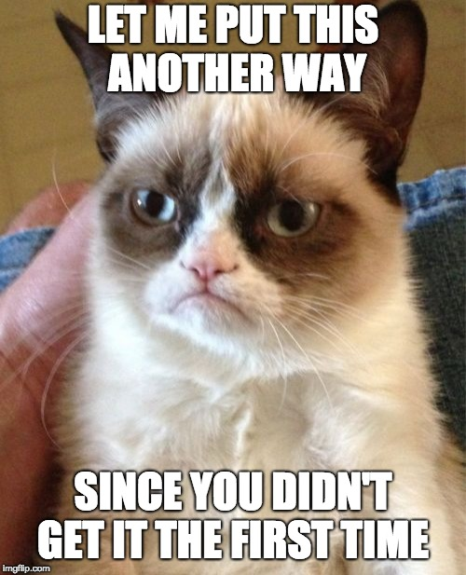

We teach the men were important (sorry they were all men. but ladies but you could change that) but is it possible that the wires were more important:

* The E-Arch needed the soft gold archwire.
* The Begg appliance needed resilient special plus steel archwires
* Ricketts needed Elgyloy
* Straight wire is so good because on NiTi wire
* TIP-Edge needs the NiTi in the deep slot.

**A Short History of glue**

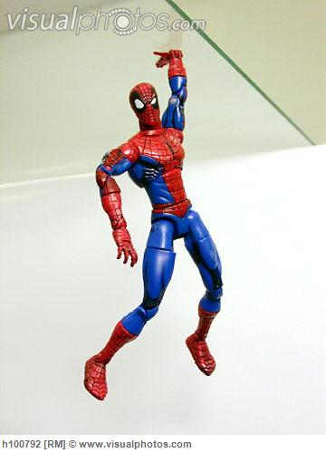

Nobody invented glue it was there all the time.

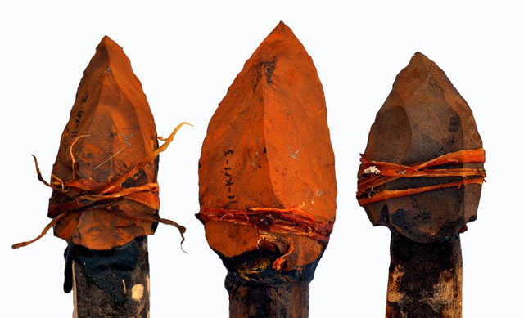

200,000 years ago people were gluing stone spear tips using resin from trees.

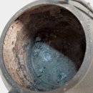

6,000 years ago they discovered they could render down animal product to make glue. About one third of the protein in animal (and our) bodies is collagen Kolla is from the Greek meaning “glue former” and refers to the practice of boiling down skin and bones to form glue. Animal glues are thermoplastic, softening again upon reheating, and so they are still used in making musical instruments such as violins and guitars. Keep going and you will eventually get to gelatin.

**Mortar**

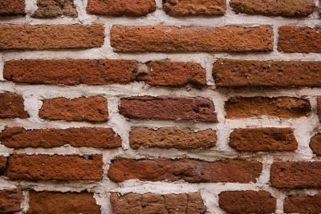

It was discovered that limestone, when burnt and then combined with water

produced a material that would harden with age. The earliest documented use of

lime as a construction material was approximately 4000 B.C. when it was used in

Egypt for plastering the pyramids. In the early 19th century a Leeds bricklayer

Joseph Aspdin was trying to make a cheap substitute for the posh Portland

Stone which was being used at that time. He heated limestone and clay in his wife’s

kitchen stove and made **Portland cement.** It stronger than mortar and it sets much

more quickly even under water.

**Lime plaster**

Plaster comes from the Greek to daub on.

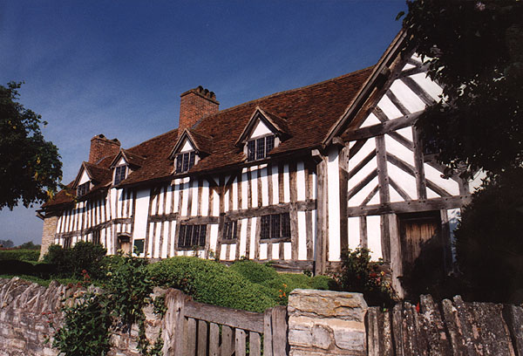

It is quite the thing to daub on the walls of your country cottage. Compared with its predecessor (animal dung) it was clean, disinfectant, fire retardant and decorative. But it was slow to set.

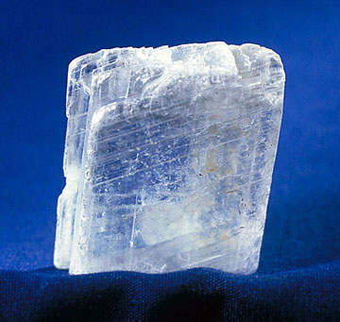

**Gypsum**

**Gypsum** is a very soft sulphate mineral composed of calcium sulphate di-hydrate,

with the chemical formula CaSO4·2H2O.

Because gypsum from the quarries of the Montmartre district of Paris have long provided the dried gypsum used for various purposes, this dehydrated gypsum became known as **plaster of Paris**. Upon addition of water, after a few minutes plaster of Paris becomes regular gypsum (di-hydrate) again, causing the material to harden or "set” and giving out heat. It is a reversible reaction. If you want you could grind up all the study models in Birmingham Dental hospital into a fine powder and dry it to make new dental plaster.

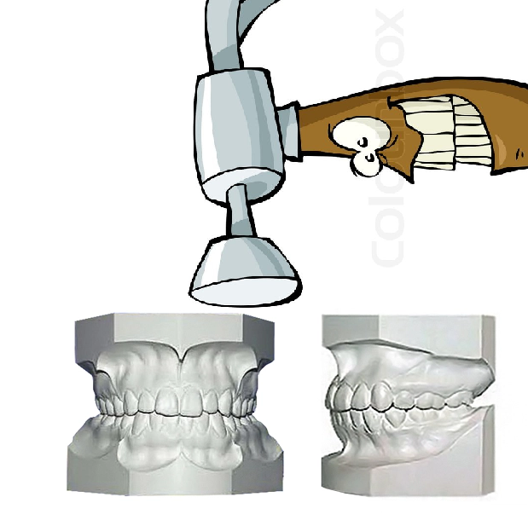

**Dental Cements**

In 1871 William Magill discovered if you took a metal Oxide and mixed it with a weak acid it would set. Some metal Oxides (copper and Iron) are a horrid brown colour. Refinement by Pierce and Fleck in1902 lead to a workable dental cement, made of Zinc Oxide and Phosphoric acid. But acids with a Carboxyl group were better.

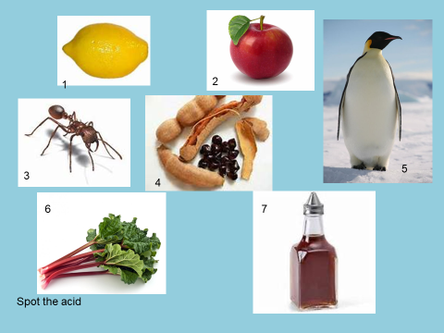

1. Citric has 3 carboxyl groups (COOH)
2. Malic has two
3. Formic
4. Tartaric in tamarinds and grapes has two carboxyl groups
5. Acrylic is rare in nature but it is found in the guts of penguins (don’t worry they get it from petrol) has one carboxyl and one vinyl group
6. Oxalic has two
7. Acetic

These acids with carboxyl groups like linking together.

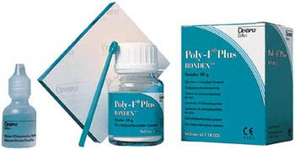First on the scene was poly-acrylic acid like Poly F

Now imagine adding metal oxides to molten glass and shaping it into millions of tiny balls. Then add these acids that like linking together, (Nowadays the acid is in dried powder form and mixed with water) and you have **Glass ionomer cement**

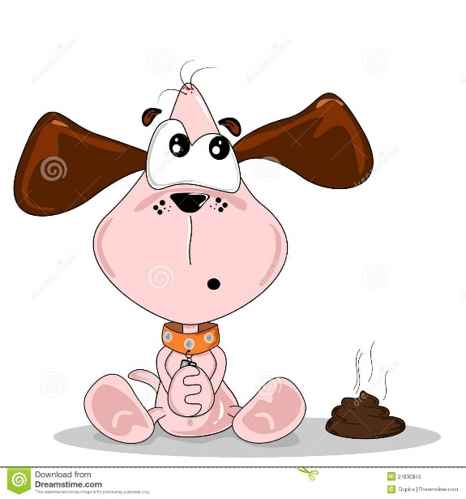

We are now going to have a dog poo moment (you might like to step over it)

Our latest hero is a German chemist Otto Rhom 1879-1939

Before Rhom this is how you made leather.

The tanner needed to remove the hair from the skin. This was done by either soaking the skin in urine, painting it with an alkaline lime mixture, or simply allowing the skin to putrefy for several months and then dipping it in a salt solution. After the hairs were loosened, the tanners scraped them off with a knife.

Once the hair was removed, the tanners would "bate" (soften) the material by pounding dung into the skin, or soaking the skin in a solution of animal brains. Bating was a fermentative process which relied on enzymes produced by bacteria found in the dung. Among the kinds of dung commonly used were those of dogs or pigeons. Sometimes, the dung was mixed with water in a large vat, and the prepared skins were kneaded in the dung water until they became supple from bacterial enzyme action, but not too soft. The ancient tanner might use his bare feet to knead the skins in the dung water, and the kneading could last two or three hours.

This combination of urine, animal faeces, and decaying flesh made ancient tanneries malodorous. You might like to know that gunpowder was made using urine (Saltpetre KNO3 was made from urea CH4N20 and wood ash that contains Potassium hydroxide KOH) and wool cloth was also soaked in urine. Urea makes another appearance under a different name Urea peroxide is used to whiten teeth but the name on the label is Carbamine.

Rhom produced an enzyme which tanned leather without all the poo BUT he achieved his greatest invention in 1933 when he invented Plexiglas which is poly-methyl-methacrylate or Acrylic to you and me.

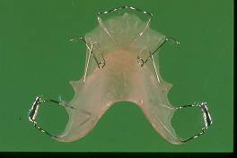

As well as making URAs acrylic was used to fill teeth but the product “Sevriton” suffered from shrinkage.

In 1955, Buonocore published "A simple method of increasing the adhesion of acrylic filling materials to enamel surfaces." He described the advantageous effect of a filling material having the capability of forming a bond to tooth structure so strong that it would eliminate the need for retention and resistance form in cavity preparation

His experiments resulted in using **an 85% concentration of phosphoric acid for 30 seconds**, which rendered a decalcified enamel surface. The dental profession were resistant to putting acid in cavities for fear it would damage the pulp.

In 1978 Bis GMA resins were developed. The active ingredients were a combination of **Bis**phenol A and **G**lycidyl **M**eth-**A**crylate. With these the enamel surface is etched with phosphoric acid (for much less time and weaker than Buonocore advised). Then the tooth is rinsed in water, dried and an unfilled resin applied.

2002 saw the elimination of a phosphoric acid etch with the development of the self-etching adhesives. The etch is included in the resin. Many people have discovered that for a very reliable bond use etch wash and dry then use SEP.

Back to Nature.

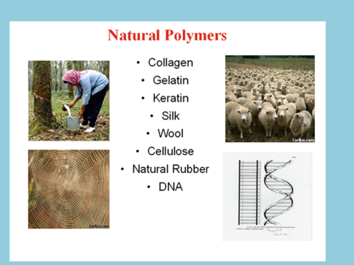

Polymers occur in Nature

Rubber/ Latex

The first use of rubber was by the Olmecs, who centuries later passed on the knowledge of natural latex from the *Hevea* tree in 1600 BC to the ancient Mayans. They boiled the harvested latex to make a ball for a Mesoamerican ballgame

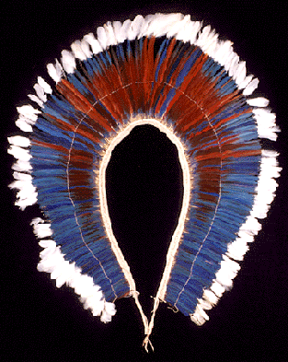

Some tribes had found rubber handy as an adhesive when attaching feathers to their person

All articles made from rubber soon started to disintegrate.

Goodyear became obsessed with solving the problem. During his lifetime, Goodyear was judged to be a crackpot. Leaving his hardware business, he began working on the problem in his wife’s kitchen, spending hours mixing up bizarre brews of rubber.

In 1839 Goodyear accidentally dropped some rubber mixed with sulphur on top of a hot stove. Instead of turning into a gooey mess, the rubber “cured.” It was still flexible the next day.

The process, involving a mixture of raw rubber, sulphur, and heat was dubbed vulcanization, after Vulcan, the Roman god of fire. Vulcanized, rubber didn’t disintegrate. The discovery paved the way for hundreds of practical applications of rubber. In June 1844, Goodyear patented for his process. Vulcanised rubber was used for dentures and removable appliances up until 1951 when it was replaced by Acrylic.

Remember when you read about Andresen appliances or Nance buttons that they were originally made of vulcanised rubber. Latex allergy is a problem but despite this most intraoral elastics are made of latex.

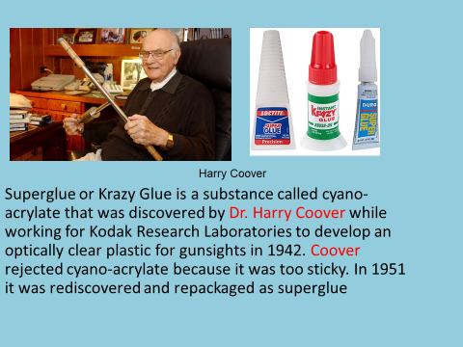

The sort History of glue comes to a sticky end.

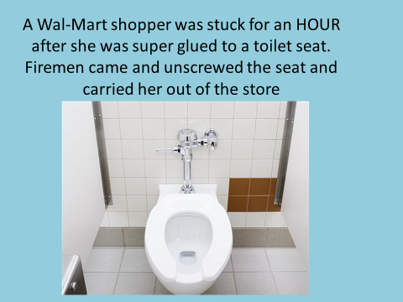

Perhaps you should also know:-

* Emerson Angell 1860 first suggested the use of RME
* Herbert Pullen reintroduced it in 1902
* Holly Broadbent 1931 Cephalostat
* Joseph Johnson 1938 Twin wire arch
* H D Kesling 1945 the positioner
* W.B Downs 1948 first cephalometric analysis
* C C Steiner analysis 1953 SNA, SNB

|  |  |
| --- | --- |
| 1. Edward Angles appliances were made of what metal? | Mainly gold but he also used German silver |
| 2. Did P R Begg use the Edgewise appliance | He may have been one of the first to use it but when he went back to Australia he used Ribbon arch and then later altered it into the Begg Technique |
| 3. What 3 inventions meant that the Straight-wire bracket became a big success? | 1. the ability to bond brackets directly onto teeth  2. Shape memory wires were developed  3. Andrews measure the prescription on120 ideal occlusions |
| 4. What wire was used in the Bioprogressive technique (Ricketts) | Elgyloy it is a chrome cobalt alloy |
| 5. What type of acids are used in dental cements | Those with a Carboxyl group |