**Chapter 14 The only way is ETHICS**



Save yourself, this Chapter is a worthy but tedious read, why not try the test at the end first maybe you know it already (is that unethical?).

Definition

Ethics concerns your personal values and respect for the values of others. It is about understanding how your feelings relate to societies norms. **It is a code of behaviour considered to be correct by your profession**. In most cases, ethics and morals means the same. But in theory, morals means standards of behaviour actually held or followed, while ethics refers to the science or study of morals (moral philosophy). You will have heard about the Hippocratic Oath (but probably forgotten the bit that says you should give your teachers money if they need it). It says “I will benefit the sick according to my ability and judgment; **I will keep them from harm and injustice.”**

Moral Judgement

A judgement which expresses whether people’s actions are right or wrong and what motives are considered to be good or bad. This introduces the idea of moral values.

Factors influencing you value system

Ethnic background, education, environment, political beliefs, religion, parent’s views, life experience role models etc.

The first step in making ethical decisions is to identify you own values through self-reflection. Then understand which of these have a moral content. Then understand that other people have different values. Now ask is there a conflict between your values and those of your colleagues and patients? The final step is to recognise that when values conflict you will need a process of balancing. Remember you can always seek guidance from others.

Implicit in moral issues is the idea of harm and benefit; but these values have been set over a long period and include issues of personal rights and dignity etc.

Here are some principles

**Autonomy**- You’re a big boy now (or a slender but sophisticated female) and you can make your own mind up.)

**Beneficence** You have a duty to do good and avoid or minimise harm to the patients.

**Justice** equal treatment in equal cases.

**Veracity** tell the truth disclose relevant facts.

**Fidelity** a trusting relationshipmaintaining confidentiality.

There is a requirement for you to show **Moral virtue** for which you need **Discernment, compassion, trustworthiness, Integrity and conscientiousness.**

There are many ethical theories including **Utilitarianism** Do the greatest good for the largest number of people and **Deontology** which considers your intention to do good as an important part. Deontology implies a clear set of good and bad rules. When moral values are held by the majority of people in a country and are given government backing to enforce them they become **Laws**. The function of laws is:

* to maintain public order
* to remedy grievances
* Organise the authority structure.

Law can be private or public.

**Public law** includes criminal and constitutional law. (This includes law relating to the provision of the health services)

**Private law** regulates the legal relationship between individuals or groups outside the state it also regulates health care in particular professional practice in areas such as consent and negligence.

**Criminal law** regulatesbehaviour that the state considers harmful, as opposed to civil law, where a person or group try to enforce their legal rights.

**Civil law** includes Tort and Contract law

**Tort law.** The term is derived from the French for wrong and implies a breach of duty that causes harm to you, or your property, or your reputation.

**Contract law** includes employment disputes and private agreements.

Legislation can be primary (consisting of acts of Parliament) or secondary (consisting of statutory instruments, usually in the form of Rules and Regulations).To this has to be added the effect of EU law which has some impact on:

* Recognition of professional qualifications.
* Equal pay and equal opportunity
* Regulation of Pharmaceuticals
* The **Human Rights Act** (right to life, right not to be subjected to torture or inhuman treatment [this is article 3, please note article 3 expressly excludes my tutorials] , the right to liberty, the right to respect for private and family life and the right to marry and found a family)

Of course we have had the law for a long time. In olden days the king or queen and the judges would go around the country hearing grievances and passing judgement. This is the basis of **common law.** This progressed through a system of binding precedent so the courts are legally bound to follow earlier decisions on similar cases. And lower courts must follow directives from higher courts. In itself this would bring about gradual change but other factors can change the law:

* Government policy
* Changes in society’s values
* Technological progress
* Membership of the EU

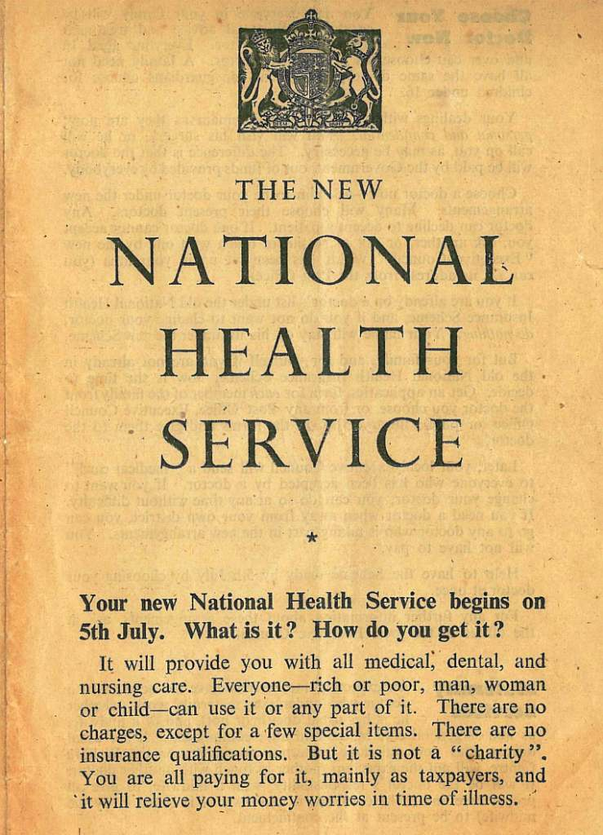

The NHS was formed on the 5 July 1948 with three principles:

* Providing a service to all
* Free at the point of use
* Fair, everyone’s need is assessed on equal basis

Doctors were guaranteed clinical freedom and independence from the state (this means that consultants can also see private patients.)

In 1948 it was believed that provision of free treatment would improve the health of the nation and so demand would drop. But this did not happen. New treatments were developed and new drugs introduced. In dentistry we moved from extractions and dentures; to crowns, bridges and now implants and orthodontics has moved from removable appliances to the straight-wire appliance. This gave rise to increase costs and underfunding. Demand for treatment was controlled using waiting lists. Management was divided into Regions e.g. West Midlands region. The regions were subdivided into areas e.g. Staffordshire area health authorities and the area was subdivided into districts. Area Heath Authorities were scrapped in the 1996.

The labour government came to power in May 1997 they had inherited a favourable financial position. In the same year they published a white paper (this sets out future policy) the new NHS. This introduced a so called **third way**:

* More power and information for patients
* More hospitals and beds
* More doctors and nurses
* Shorter waiting times
* Cleaner wards and better food
* Improved care for older people
* Tougher standards for NHS organisations

It divided the NHS into primary and secondary care (15 years later and the general public have not woken up to this trick yet, ask them if the treatment of a heart attack is primary or Secondary and they will say primary ask them if their community dental clinic is primary or secondary they will say secondary) it introduced Primary Care Trusts (PCTs) they were supposed to decide the needs of the local population, improve the health of the community and interact with the local authorities to see that the needs of the community were met. The previous system of regional health Authorities was scrapped and Strategic health authorities were introduced.

Although some may doubt if the Labour government spent its money wisely, it did introduce a real concept of measuring quality that was not there before (for example maximum waiting times). It imposed a legal duty on the NHS to promote quality. It introduced the concept of **clinical governance** a framework through which NHS organisations are accountable for continuously improving the quality of their services and safeguarding high standards of care by creating an environment in which excellence in clinical care will flourish.

Clinical governance has become shorthand for the processes needed to achieve **best practice** it includes:

* Measuring outcome
* Clinical audit
* Evidence bases practice
* Guidelines
* Clinical risk management
* Clinical effectiveness
* Professional self-regulation
* The chief executive of the trust was made in overall responsibility.

In short the idea was to produce a system providing **Clinical Excellence**. A **National Institute for Clinical Excellence (NICE)** was set up to:

* Look at clinical effectiveness of new drugs and treatments
* Rule on availability of treatments under the NHS ending the previous system where treatments were available in some areas not others (postcode lottery)
* Devise clinical guidelines

In 2003 a new body was set up the **Commission for Healthcare Audit and Inspection (CHAI)** this monitors the performance of the NHS.

The Labour government lost power and in May 2010 and a coalition conservative/ liberal government was elected. This was a period of extreme financial hardship. They introduced a white paper which:

* Put patients at the centre of the NHS
* Changed the emphasis of measurement to clinical outcomes
* Empowers health professionals, in particular GPs.

The white paper set out the following timetable. In April 2012 it:

* established the independent NHS Commissioning Board
* established new local authority health and well-being boards
* Developed [**Monitor**](http://en.wikipedia.org/wiki/Monitor_(NHS))as an economic regulator.

**The role of Monitor**

* To set prices for NHS-funded care in partnership with [NHS England](http://en.wikipedia.org/wiki/NHS_England)
* enable [integrated care](http://en.wikipedia.org/wiki/Integrated_care)
* safeguard patient choice and prevent anti-competitive behaviour which is against the interests of patients; and
* support commissioners to protect essential health care services for patients if a provider gets into financial difficulties

Monitor's main tool for carrying out these functions is the NHS provider license. They abolished CHAI and its duties were taken over by the **care quality commission (CQC)**

The NHS reformed again on April fool’s day 2013

These changes have an effect on who makes decisions about NHS services, how these services are commissioned, and the way money is spent.

Some organisations such as primary care trusts (PCTs) and strategic health authorities (SHAs) were abolished, and other new organisations such as clinical commissioning groups (CCGs) will take their place.

NHS services will be opened up to competition from providers that meet NHS standards on price, quality and safety, with a new regulator ([Monitor](http://www.monitor-nhsft.gov.uk/)) and an expectation that the vast majority of hospitals will become foundation trusts by 2014.

**The key messages of *Liberating the NHS***

The intention is to change NHS culture to provide a quality service improvement framework that:

􀂃 is patient centred,

􀂃 achieves high quality outcomes,

􀂃 refuses to tolerate unsafe or substandard care,

􀂃 eliminates discrimination and inequalities,

􀂃 puts clinicians in the driving seat to innovate,

􀂃 is transparent and accountable,

􀂃 gives citizens a greater say,

􀂃 is less fragmented,

􀂃 is more efficient, dynamic with reduced bureaucracy and,

􀂃 is sustainable and free from day to day political interference

Plus ça change, plus c'est la même chose

**Rationing**

Comes from the Latin for reason. The implication is that where there is a shortage it should be fairly distributed. This seems ethical, but in the UK the term became associated with wartime shortages, so now we use terms like **prioritisation**. Since demand for provisions of the health service are almost limitless there will always be a need for prioritisation. This can involve:

* withdrawal of the service e.g. some cosmetic operations
* Denial/restriction where access is restricted to some patients with a certain lifestyle e.g. smoking or drinking
* Improved efficiency. Certain drugs are not available where cheaper ones work just as well
* Deterrence by patient charges e.g. dental patients
* Dilution, the service is spread more thinly
* Deflection. Try to discourage patients seeing their GPs with trivial illness.

**Distributive justice**

Making sure that individuals receive the care and treatment that is appropriate and proper i.e. that society shares out its resources in a moral way.

You will be aware of orthodontist’s way of doing this. I.e. Use of IOTN to redirect the services to the most needy but there are some ethical dilemmas here:

* A 19 year old is denied NHS treatment her malocclusion is not judged complex enough to justify hospital treatment but the specialists have only contracts for treatment on under 19s. She has been asking for treatment for years and the GDP has not sent any referral letters.
* A 17 year old patient is accepted for treatment starting immediately because he will need an osteotomy while the patient seen before him will have to wait.
* You are a specialist practitioner with an NHS contract of 300 cases per year. Such is the demand for your service that you have a 3 year waiting list. You see a new patient aged 13 who needs a functional appliance but in 3 years he will be too old for treatment.

One of the problems is that Need is difficult to define. I think we do not mean the market concept of need, that is, people want out service so there is an unmet need. But we mean the professionally led concept of need. However some people feel the NHS should target people’s basic health care needs only. That is treating life threatening conditions only. But even here there is a problem. We need to consider outcome, it would be pointless paying vast sums for treatment of life threatening conditions if the treatment had no effect on the outcome; while it seems more sensible to fund treatment which brings about a modest improvement in the quality of life, if his is sustained for 50 years.

The politicians love to tell us that if more money is spent on prevention it will save money in secondary care. This is not true, it just means that the patient will live longer so they will be older when the inevitable happens. Evidence based medicine is a way of attempting to allocate resources fairly. It can be used to develop **quality-adjusted life years (QUALYs**) I am sure you are familiar with the idea a year of healthy life counts as 1 and counts as less in the un-healthy. Couple this with the cost of treatment and you have an accountant’s view of the value of medicine.

Do you have a right to healthcare?

Well article 2 of the human rights act “a right to health” includes a right to health care. But this act really requires governments to take reasonable steps to protect life; it is doubtful whether patients who have been denied a specific treatment could use it to support their demands for treatment, because obligations under article 2 must be interpreted in a way that does not impose an impossible burden on the health authorities. However the law expects them to act reasonably in allocating such resources.

The combined effects of the human rights act 1998 and the National Health Service Act 1977 is that a comprehensive legal duty is imposed on the government to provide health services “to the extent that the secretary of state considers necessary to meet all reasonable requirements”

See the neat get out clause? If you feel aggrieved you have two legal options:

1. Judicial review
2. Breach of statutory duty/negligence. These are basically claims for compensation; they allege that a decision about the provision of service has been made negligently.

Cases brought along these lines seem seldom to have been successful.

**Regulating the professionals**

**Self-regulation**

Although doctors have moved on from this, dentists are still under this system. You are required by the GDC to keep up to date, including a minimum amount of CPD which must include some specific areas.

**Revalidation**

Thanks to some helpful intervention by Dr Harold Shipman it was considered that self-regulation was insufficient and in 2012 Doctors have move to revalidation. Starting in 2012 Doctors have to undergo this process; every 5 years they must show they are up to date and fit to practice. (Interestingly everyone agrees that Harold Shipman would have sailed through revalidation)

**Accountability**

Professionals must acknowledge their competence and only undertake those activities for which they are competent. So under no circumstances should I be allowed to give you a tutorial on ethics.

**Professional culture**

Interestingly this goes right back to when I qualified. Clinical Governance had not been invented and the emphasis was on what was the professional thing to do.

**Codes of professional conduct**

Are one of the key characteristics of a profession? They guide professionals in the direction of their duties to their patients, colleagues and the wider society. Codes of conduct are the principal way that bodies such as the GDC carry out their statutory duty to provide advice on standards of professional conduct:

* To set maintain and improve ethical standards
* To regulate professional conduct
* To provide information
* To encourage a common identity

**The General Dental Council**

Regulates your profession by setting standards, quality assuring education, and registering you and your colleagues. They take action against those who work outside the law.

Once the council was all dentists (50 of them) but then the number reduced to 24 of which 12 are qualified dentist and the chair was Prof Kevin O’Brien a dentist and an orthodontist. But in 2013 the number was reduced still further to 12 six of whom are dentists and a chair Bill Moyes who is not a dentist. He was director of British Rail in 2000-2003 and chairman of Monitor 2004-2010. He holds lots of other posts as well and has a PhD in theoretical chemistry. (so he should be good at cooking the books)

Which brings us to who funds the GDC?

You do,

It is funded by your and my retention fees. I don’t know how you feel about this but I feel they should move out of their multi-million pound offices in Wimpole Street and buy offices in Wigan or Bloxwich (their accounts are published on line they have reserved of 17 million)

**Registration**

An important role of the GDC is to prepare and maintain a register of qualified members. This means that you cannot get on the register or specialist register without the correct qualifications. **It is a criminal** **offence to falsely represent yourself to be registered** when you are not or to claim to be qualified when you are not. In addition any treatment that you carry out might be deemed assault.

**Disciplinary actions**

Having got a register and made it an essential requirement to be registered before you practice dentistry this makes removal or suspension from the register the principal weapon in regulating misconduct from dentists.

They say they are likely to do this for:

• Very poor treatment.  
• Not having professional indemnity insurance.  
• Cross-infection issues (for example, using dirty equipment).  
• Being under the influence of drink or drugs.  
• Fraud or theft.

* **Not handing essays in to Mr Turner on time**

The GDC say

Hearings are held once a complaint about a dental professional has been investigated and the [Investigating Committee](http://www.gdc-uk.org/Aboutus/Thecouncil/Pages/Investigating-committee.aspx) has decided there is a case. The case is then referred to one of the practice committees depending on the type of case, and a hearing is held. Practice committee hearings form the third and last stage of our [complaints procedure](http://www.gdc-uk.org/Membersofpublic/Raisingaconcern/Pages/How%20we%20investigate.aspx).

* **The** [**Professional Conduct Committee**](http://www.gdc-uk.org/Aboutus/Thecouncil/Pages/Professional-conduct-committee.aspx) (PCC) is charged with determining whether or not a dental professional's fitness to practice is impaired on the basis of the facts found proved. Where a registrant's fitness to practice is found to be impaired the PCC decides whether to impose a sanction.
* The [Professional Performance Committee](http://www.gdc-uk.org/Aboutus/Thecouncil/Pages/Professional-performance-committee.aspx) (PPC) deals with cases where it appears that a dental professional's performance is consistently falling below an acceptable standard.
* The [Health Committee](http://www.gdc-uk.org/Aboutus/Thecouncil/Pages/Health-committee.aspx) (HC) deals with cases where the dental professional's fitness to practice is impaired by reason of ill health.

## The [Interim Orders Committee](http://www.gdc-uk.org/Aboutus/Thecouncil/Pages/Interim-orders-committee.aspx) (IOC) can, as an interim measure, suspend or place conditions upon a dental professional before a full inquiry by the PCC.  The suspension may be renewed or revoked later.  At this stage it is important to note that the allegations have not been tested or proved - this is the List of sanctions:

* **Reprimand:** This is a statement of the committee's disapproval, but the registrant is still fit to practice with no restrictions and so no other action needs to be taken.
* **Conditions:** This is where restrictions are placed on the registrant’s work for a set amount of time. The conditions may include that the registrant must take further training and give us evidence to prove that they are taking steps to improve. The conditions usually have to be reviewed within a certain time.  Although conditions may be tailored to fit specific circumstances, they generally follow the format set out in the practice Committee and Interim Order Committees Conditions. .
* **Suspension:** The committee can suspend the dental professional’s registration. This means that the registrant cannot work as a dental professional for that set period of time.
* **Erasure:** This is the most serious sanction as it removes a registrant’s name from the register. This means that they can no longer work in dentistry in the UK.

Needless to say this is as well as any criminal charges against you in the courts.



We seem to have reached a rather low ebb so let’s talk about **Beneficence.**

This means that the principle of healthcare is that it should benefit the patients so you have a moral and legal duty to do good. This is why I tell you to get that canine down before you extract the premolar you are legally obliged to do so. This is called a duty of care. Your duty of care may extend beyond your own practice so that **if some other person commits a malpractice and you are aware of it you have a duty to report it.**

One step beyond this is the concept of **Non-maleficence which means you have a duty not to harm or allow harm to your patients.**  Actually this can be quite helpful in orthodontics that patient who is not cleaning their teeth may have signs of decalcification or is simply not making any progress perhaps they are not wearing their elastics or headgear. You have explained what they must do, you have recorded it on the notes and they have not improved. You have a duty to remove the appliance if it is likely to cause them harm. The decision is not always easy. Have teeth been extracted in which case will an early deband leave spaces? Will the debond stop other treatment such as an osteotomy or implants?

In General Medicine similar problems occur for example radiotherapy causes harm but it may cure cancer these decisions are a balancing act.

**Responsibility**

**Moral responsibility**-making judgments of what is right and wrong

**Professional responsibility**-derived from the advanced knowledge that professionals possess

**Causal responsibility**-you have caused something to happen either by your action or your failure to act (omission)

**Role responsibility**- here the question is “was it your job”

**Accountability-** being required to answer for you actions or lack of action. You should be able to account for you actions on the grounds of best practice and knowledge informed by good clinical judgment.

**Negligence**

Only 5% of negligence claims come to trial most are settled out of court. It is said to have four functions:

1. Compensation (this is the main function)
2. Deterrence (to stop a practitioner doing it again)
3. Retribution ( a form of revenge for the wrong suffered)
4. Investigation (to prompt an explanation and an apology)

If you want to win a case of negligence you must prove three things:

1. There was a duty of care i.e. the defendant was responsible for your care.
2. The defendant breached that duty by failing to reach the standard of practice required by law
3. That you suffered damage directly as a result of that failure.

As we discussed earlier much of English law is case law and a famous case Bolam v Friern Barnet Hospital Management Committee in1957 defines what is meant by a “reasonable standard of care” This is known as the **Bolam test** . The judge decided that the treatment is acceptable if this is accepted practice by your peers. An interesting feature is that this means the action is dependent on your level of training. Standards are judged by the current knowledge at the time of the incident and you must be reasonably up to date especially with changes in procedures in your specialty or procedures that have been widely accepted as best practice.

The lawyers consider that Bolam was too much in favor of the doctors you only had to get a couple of colleagues to agree with you and you were acquitted. This changed in 1997 with **Bolitho v Hackney Health** authority this allows the courts to critically scrutinize accepted practice.

**Consent**

Do you remember at the beginning I described “autonomy” as you’re a big boy now you can make up your own mind”? Well, it really comes from the Greek and means self-rule. It implies that the clinician should involve such patients in decisions about their care. It involves:

* The ability to evaluate.
* These evaluations must be rational.
* You need the capacity to make the decisions and you must understand the facts.
* Freedom to act.

Over the years there has been a change in the relationship between health care professionals and patients. Once the doctor told the patient what was best for them. Now it is on a much more equal footing, a contractual relationship with each side having rights and duties. You are under an obligation to show respect for a patient’s autonomy. This is done by

* Truthfulness.
* Communication. You have a moral obligation to disclose the facts that you as a professional believe to be material, the facts that patients usually consider material, your professional recommendations and the purpose of seeking consent.
* Allow them to make free decisions.

Clearly a matter of great importance is what risks do you have to disclose.

I was once in the operating theatre at St George’s hospital when a bit of the operating light fell from the ceiling onto the patient, but it would be silly to include this in consent for all patients having a general anesthetic. A first step would be to outline the reasonable risks plus any risks specifically asked by the patient. Patients must be given enough information to make a balanced judgment and the patient’s questions must be answered truthfully.

HOW DO YOU DECIDE IF A PATIENT IS COMPETENT TO MAKE A DECISION?

The official test is that they can **Understand** and **Retain** relevant information, especially as to the likely consequences of having or not having the treatment in question and weigh up this information in reaching a decision.

I find a useful test is to ask a patient their age and the date of their birthday. If they cannot answer they probably will not understand what is involved in orthodontics.

The law assumes adults to be competent unless proved otherwise. Incapacity can be caused by psychiatric illness, brain injury, learning disability and dementia. It may be temporarily affected by shock or confusion (but do not automatically assume this). **The graver the consequences the greater the level of competence required**. If the levels of capacity fluctuate the patient’s views should be fully recorded. Capacity should not be confused with unreasonable or irrational behavior but they may be a symptom or evidence of incompetence.

Patients have a right to refuse consent. In orthodontics that is easy. In medicine it can be more difficult

Exceptions to the principle of consent:

* **Unconscious adults.** Here you should use **the principle of necessity** i.e. you make an on the spot decision to do what you consider to be the best treatment. **Note that English law does not recognize a mechanism whereby a relative can give consent to medical treatment being given to an adult.**
* **Incompetent adults.** Here you must use the **best interest test** here it is important that you use treatment that would be agreed by your peers and follow any acknowledged guidelines.
* **Children under 16 who are not Gillick-competent.** In the famous case Gillick v West Norfolk and Wisbech AHA. it was decided that a child could be competent to give consent in the following situations:
* **They understand the nature of their condition, the proposed treatment and the consequences of agreeing to or refusing treatment.**
* Do they understand the moral, social and family issues?
* How much experience of life do they have?
* How complex and life threatening is the proposed treatment?

Good news for orthodontics, most of our patients know much more about orthodontics than their parents and so are definitely Gillick-competent. An interesting point is that the reverse does not seem to be true. If a Gillick-competent child refuses treatment their refusal can be overruled by a parent or the court. This seems also to apply to and including 17 year olds

**Under 16s who are not Gillick-competent** (in orthodontics this would typically be removal of a supernumerary in a 7 year old or perhaps the removal of some teeth. Here permission has to come from someone else. This person is known as a **proxy**. These would be:

* Both (either) parents if they are married.
* The mother if she is not married to the father.
* **The father if the birth is jointly registered with the mother or he has been granted a parental responsibility order**.
* Adoptive parents.
* A step parent by agreement or court order.
* Special and ordinary guardians.
* Other persons granted parental responsibility by a court order often either grandparents or care orders granted by the local authority.

Before we go on to child protection it is worth considering how the consent process works in a town to the north of Birmingham. The consultant is a very old gentleman who relies heavily in his excellent nurses; the process is as follows:

1. The consultant explains the treatment options at the new patient clinic. This includes how long each option would take and any extractions needed also headgear, class II elastics and surgical exposures of teeth are mentioned if relevant.
2. The patients are given a comprehensive consent document and have a right to a copy of the treatment plan sent to the referring dentist.
3. The next appointment is for impressions this is done by the nurses. They ask if the patient and parents have read the consent document. If they have, they ask do they have any questions. If they don’t then the consent form is signed and this is recorded in the notes. They are given further printed information about what to expect when separators, bands and brackets are placed.
4. The next appointment is with the orthodontist who will be doing the treatment. He or she will place separators but also fill in a section in the notes confirming the treatment plan at the same time confirming it with the patient and parent. And confirming the consent.
5. Only at this stage are extraction letters written to the dentist.
6. The next week the bands are placed. The patient sits in the chair and the procedure is done while they are awake. (This in itself is indicative of consent)
7. The patient or parent has to contact the dentist to make the appointment for extractions. (Again this is indicative of consent)
8. Finally the brackets and wires are placed (again the willingness of the patient to sit in the chair and have this done Is indicative of consent)

The leaflet given out is the following but without the references (which I have added for your interest) you can download it from burtonortho.co.uk and follow documents. Patients requiring EOT or functional appliances are given different leaflets as well.

**Helping you to make informed consent for fixed appliance treatment**

**Why do people need braces?**

Braces can help to correct a number of teeth or jaw problems:

**Crowding** – this is the most common use of braces. Teeth may be poorly aligned because the teeth are too large for the mouth. Poor biting and unsightly appearance can result from crowding. Braces can straighten teeth and make them look nicer. Crowding may contribute to tooth decay and gum disease because the teeth are harder to clean but patient motivation and good tooth hygiene are more important factors.1 (Geiger et al 1974). Oliveira & Shieham 2004 found adolescents who had completed a course of orthodontic treatment had better oral health related quality of life than those who had never had treatment. Shaw found that children were teased more about their teeth than anything else.

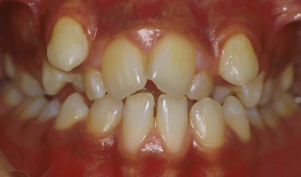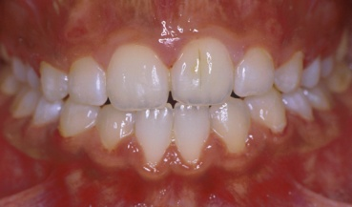

Figure 1 Crowding before and after treatment

**Deep overbite** – Increased vertical overlap of the top and bottom teeth can cause damage to the roof of the mouth or gums and tooth wear.

**Increased overjet** – Where the top front teeth are more prominent. This can increase the risk of trauma.2 The risk of trauma/injury to upper incisors has been shown to increase to 45% for children with significantly protruding upper front teeth (Todd & Dodd, 1985)

**Spacing** – if teeth are small or missing unsightly spaces can occur between the teeth.3 Johal 2006 found that spacing or increased prominence of front teeth effected quality of life scores.

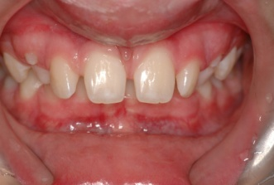 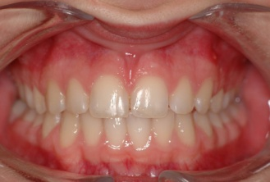

Figure 2 increased overjet and spacing before and after treatment

**Open bite** – this is when the front teeth do not meet when biting together. This means that the chewing forces are placed on only the back teeth which can wear down quicker and it can make biting and eating more difficult.

**Reverse overjet** – this occurs when the lower teeth bite in front of the upper teeth, usually because the lower jaw is longer than the upper jaw. This problem can lead to wear of the tips of the upper teeth.

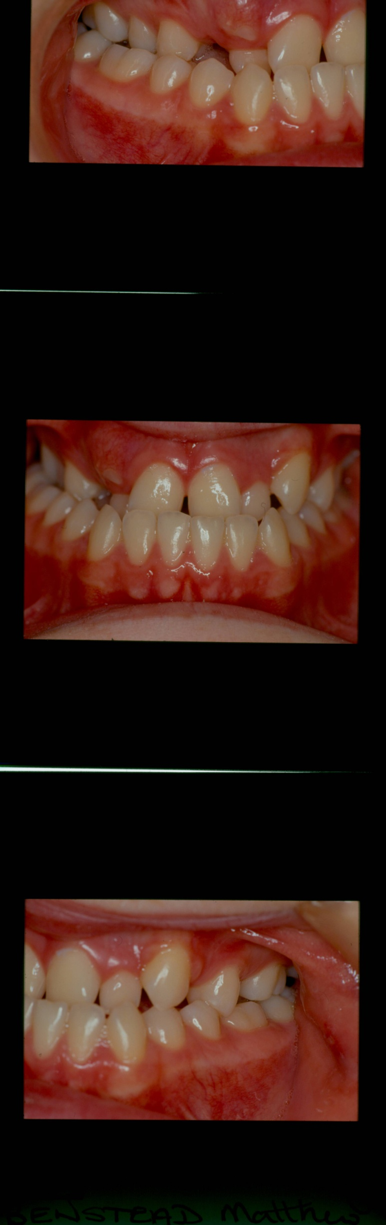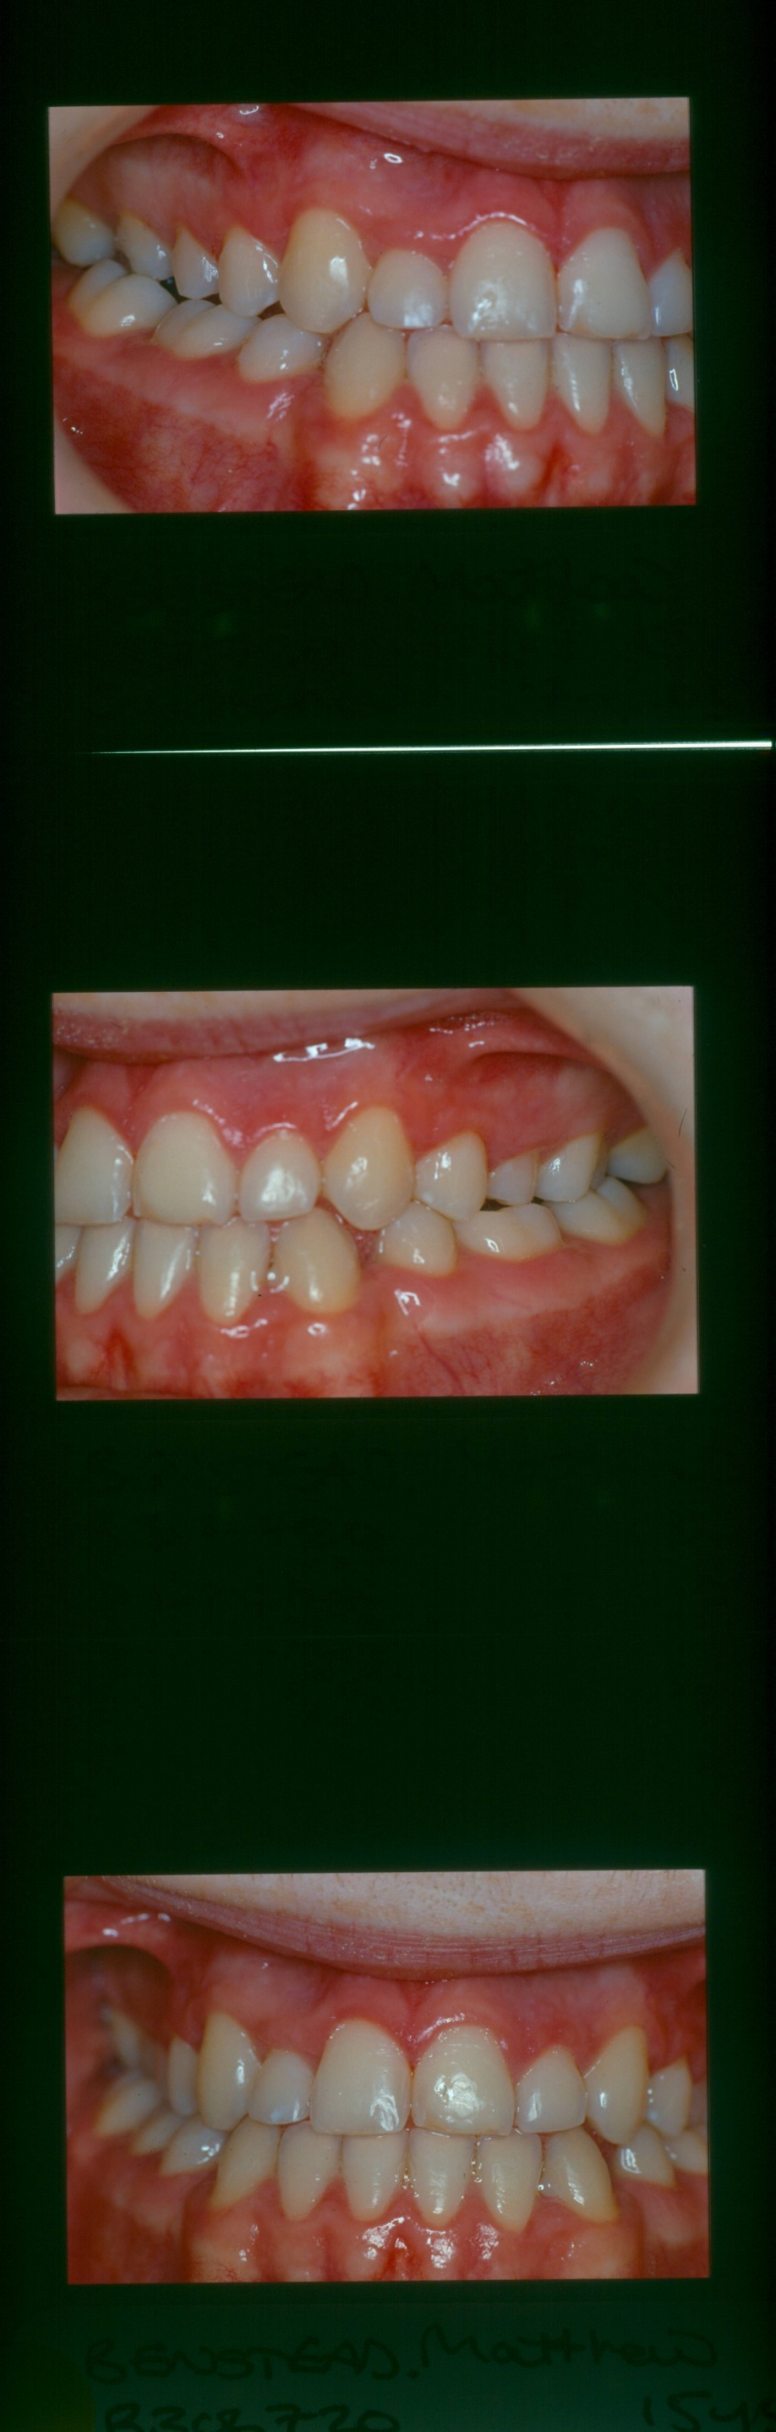

Figure 3 Reverse overjet before and after treatment

**Treatment of impacted teeth –** Someteethmay become impacted (buried), especially the upper canine tooth.Buried teeth can cause damage to the roots of the other teeth or undergo cyst development. Extra teeth may prevent a normal tooth from erupting.

**Jaw joint problems** – studies have not found that brace treatment can help with jaw joint problems 4 Sadowsky, 1992 AJODO)

**What are the risks of my fixed brace treatment?**

**Like any treatment, orthodontic treatment does have some associated risks; however it is important to know that it is highly unlikely that your brace will cause a serious injury.**

The risks include:

Tooth problems:

* Enamel damage- there are 2 ways in which your brace might cause damage to the enamel (outer surface of your teeth). The first is called *decalcification* and occurs if you do not brush your teeth and brace properly; this allows plaque to build up around your teeth. The bacteria in the plaque then start to break down the enamel 5 Kidd, E. and B. Smith and this causes white spots to appear on the teeth. The white spots can progress to brown spots, and if left can develop into tooth decay. At least 1 small white spot is seen in about 50% patients compared with 25% of non-orthodontic patients 6 Gorelick, L. and E. al

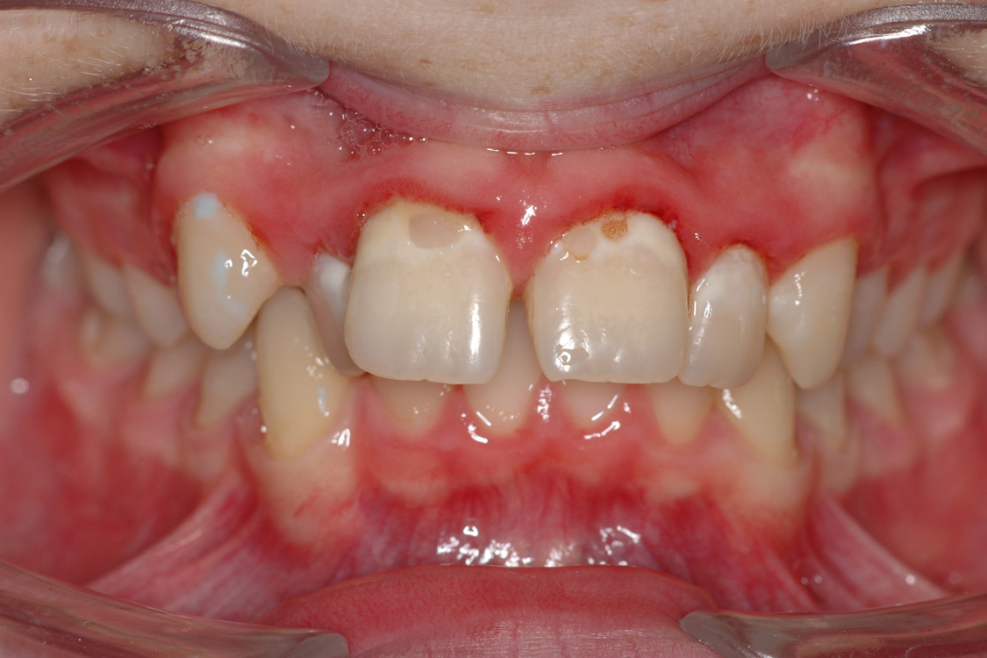

Figure 4 decalcification and gingivitis as a result of poor tooth brushing and a high sugar diet

It is important to maintain a low sugar diet throughout treatment and avoid fizzy drinks to help minimise the chances of this happening. 5 Kidd, E. and B. Smith 7. Bloom, R.H. and L.R. Brown Should it happen your brace will be removed, most small spots will get better spontaneously, but if some remain there are some treatments available if necessary to improve the appearance 8 Geiger, A. and e. Al 9. Welbury, R. and N. Carter,

* The second way in which the enamel can be damaged is when *the braces are* removed- sometimes a bit of enamel may chip off when the braces and/or their glue are taken off; this tends to happen where the enamel is already softened (see above), or where there are fillings. Small chips can be polished away and any damaged fillings can be repaired.10 Cambell, P

5. Kidd, E. and B. Smith, *Pickard's manual of operative dentistry*. 6th ed. 1991, Oxford: Oxford Medical Publications.

6. Gorelick, L. and E. al, *Incidence of white spot formation after bonding and banding.* American Journal of Orthodontics, 1982. **81**: p. 93-98.

7. Bloom, R.H. and L.R. Brown, *A study of the effects of orthodontic appliances on the oral microbial flora.* Oral Surgery, Oral Medicine, Oral Pathology, 1964. **17**(5): p. 658-667.

8. Geiger, A. and e. al, *Reducing white spot lesions in orthodontic populations with flouride rinsing.* American Journal of Orthodontics and Dentofacial Orthopedics, 1992. **101**: p. 402-407.

9. Welbury, R. and N. Carter, *The hydrochloric acid-pumice microabrasion technique in the treatment of post-orthodontic decalcification.* British Journal of Orthodontics, 1993. **20**: p. 181-186.

10. Cambell, P., *Enamel surfaces after orthodontic bracket debonding.* Angle Orthodontist, 1995. **65**: p. 103-110.

Root resorption- When a tooth is moved a small amount of the root may be lost. It seems to happen for almost all patients 11& 12 Brezniak, N. and A. Wasserstein and does not seem to shorten the life of the teeth. Usually the roots of the teeth are shortened by less than 2mm 13 Kennedy, D. and e. al, but some people are at greater risk.

These include

* + Blunt, pipette shaped 14 Levander, E. and O. Malmgren, or short thin roots 15 Linge, B. and L. Linge
  + Roots that are already partially resorbed due to previous trauma, 16 Malmgren, O. and e. al
  + Teeth with poor root fillings 17 Wickwire, N. and e. al
  + Long treatment times 15 Linge, B. and L. Linge
  + Teeth moved long distances 18 Kaley and Philips
  + Habits such as nail biting, thumb sucking or grinding 15 Linge, B. and L. Linge
  + Certain medical conditions e.g. hyperthyroidism 14 Levander, E. and O. Malmgren

Your orthodontist will advise you if you have any of these and will take x-rays every 6 months or so if necessary to monitor your teeth. Should any of your teeth become wobbly the brace will be taken off those teeth; they will remain wobbly but will last as long as your other teeth provided you maintain the health of your gums. Should you get gum disease these teeth will be at an increased risk of being lost.

11. Brezniak, N. and A. Wasserstein, *Root resorption after orthodontic treatment Part I: Literature Review.* American Journal of Orthodontics and Dentofacial Orthopedics, 1993a. **103**: p. 62-66.

12. Brezniak, N. and A. Wasserstein, *Root resorption after orthodontic treatment Part II: Literature review.* American Journal of Orthodontics and Dentofacial Orthopedics, 1993b. **103**: p. 138-146.

13. Kennedy, D. and e. al, *The effect of extractions and orthodontic treatment on dentoalveolar support.* American Journal of Orthodontics, 1983. **84**: p. 183-190.

14. Levander, E. and O. Malmgren, *Evaluation of risk of root resorption during orthodontic treatment: a study of upper incisors.* European Journal of Orthodontics, 1988. **10**: p. 30-38.

15. Linge, B. and L. Linge, *Apical root resorption in upper anterior teeth.* European Journal of Orthodontics, 1983. **5**: p. 173-183.

16. Malmgren, O. and e. al, *Root resorption after orthodontic treatment of traumatised teeth.* American Journal of Orthodontics, 1982. **82**: p. 487-491.

17 Wickwire, N. and e. al, *The effects of tooth movement upon endodontically treated teeth.* Angle Orthodontist, 1974. **44**: p. 235-242.

18 Kaley, J. and C. Phillips, *Factors related to root resorption in edgewise practice.* Angle Orthodontist, 1991. **61**: p. 125-131.

* Tooth death- this is very rare 19 Anstentig, H. and J. Kronman and is most likely to occur to teeth that have had previous trauma 20 Atack, N.,. If you notice any of your teeth become darker, or you develop a lump on your gum you must tell your orthodontist immediately. This tooth will be investigated and taken off the brace until it has been treated successfully. **You must see your own dentist regularly for check-ups throughout your treatment. Your orthodontist is not responsible for the routine care of your teeth.**

19. Anstentig, H. and J. Kronman, *A histological study of pulpal reaction to orthodontic tooth movement in dogs.* Angle Orthodontist, 1972. **42**: p. 50-55.

20 Atack, N., *The orthodontic implications of traumatised upper anterior teeth* Dental Update, 1999. **26**: p. 432-437.

* Discomfort- it is normal to experience a mild ache and tenderness of your teeth after the brace has been put on; about 90% of patients do 19 Anstentig, H. and J. Kronman. This is easily treated with painkillers such as paracetamol and will wear off after 2-3 days. It can reoccur after subsequent visits when the brace is adjusted.

Gum problems

* Gingivitis- this is swelling and reddening of the gums, which most patients will experience to a mild degree 21 Boyd, R. and S. Baumrind, this settles after treatment. 22 Poison, A. and e. al If you do not brush your teeth properly your gums may become very swollen, sore and bleed spontaneously.

21. Boyd, R. and S. Baumrind, *Periodontal considerations in the use of bonds or bands on molars in adolescents and adults.* Angle Orthodontist, 1992. **62**: p. 117-126.

22. Poison, A. and e. al, *Longterm periodontal status after orthodontic treatment.* American Journal of Orthodontics and Dentofacial Orthopedics, 1988. **93**: p. 51-58.

* Periodontitis- whilst very few people get this 13 Kennedy, D. and e. al, if you continue to fail to brush your gum disease may progress to periodontal disease where the gum begins to shrink away from the tooth, this can give the teeth a long appearance and may make them loose. It also makes them more likely to drift out of position:

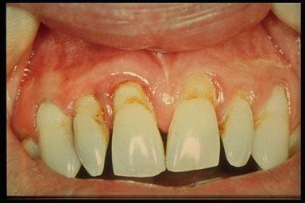

Figure 5 Periodontitis

Lip/cheek problems:

* Discomfort- Almost all patients experience some rubbing from their brace McGuinness, N., 23 , which can lead to small ulcers. Your orthodontist will give you wax to put on the brace to stop this from happening. **Do not use Bonjela** as the brace will trap it against the lips and make it worse. Rarely some people feel a mild burning sensation when the brace is being put on; this is due to treatment we use on the tooth and will not cause any long term damage 23 McGuiness, N

23 McGuinness, N., *Prevention in orthodontics- a review.* Dental Update, 1992. **19**: p. 168-175.

* Allergies- It is very important that you tell your orthodontist about any allergies you may have, especially *nickel or latex*. Most people who are allergic to nickel do not have a problem with their brace 24 Bass,J and e al, as a much higher concentration is needed (5-12x) to cause a mouth problem than on the skin 25 Dunlap, C. and e. al. If your orthodontist has any concerns they will send you to a doctor for allergy testing prior to starting treatment.

24. Bass,J and e al, *Nickel hypersensitivity in the orthodontic patient.* American Journal of Orthodontics and Dentofacial Orthopedics, 1993. **103**: p. 280-285.

25. Dunlap, C. and e. al, *Allergic reaction to orthodontic wire: report of a case.* Journal of the American Dental Association, 1989. **118**: p. 449-456.

Treatment goals not being met:

Occasionally treatment may not be successful, resulting in some/all of the expected outcomes not being met. The usual reasons for this are:

* Failure to clean teeth/brace
* Repeated breakages of the brace
* Not wearing headgear/elastics/additional braces
* Changing your mind about treatment
* Repeatedly not turning up for appointments

Medical problems

You must tell your orthodontist about any medical conditions that you have, along with the details of any medication that you take. This is especially important if you have/have had a heart problem, as your orthodontist may need to contact your cardiologist to assess your treatment needs and risks. You must also tell your orthodontist about any bleeding problems, especially if you are to have teeth removed as part of treatment.

Brace breakages

Fixed appliances are stuck to the teeth with a type of glue, and can become dislodged from time to time, especially if you eat something hard or sticky- **you must not eat chewing gum** with a brace on. If your brace breaks you must contact your orthodontist, as if broken it will not be working. Sometimes you can swallow small pieces of the brace; if this happens it is not usually a problem as they are passed uneventfully. If you do experience any symptoms contact your orthodontist or GP straight away. It is very unlikely that you will inhale part of your brace, but should you do so you will require urgent medical attention.

ADVICE TO PATIENTS

1. What can I do if the appliance is painful?

After each adjustment visit the teeth may be tender for approximately 3 – 5 days. During this time painkillers may be helpful. Whatever you normally take for headache type pain will be sufficient.

If the brace is cutting the cheek or lips wax, supplied by your orthodontist, can to used to cover over the part of the brace causing discomfort.

If the pain persists consult your orthodontist

2. Can I remove the appliance?

Fixed appliances can only be removed by the orthodontist.

3. Can I eat normally?

During orthodontic treatment some minor adjustment to your diet should be made. These include:

- reducing sugar consumption, including sweets and fizzy drinks,

- avoid sticky foods such as toffee and chewing gum

- hard food such as raw fruit and vegetables – should be cut up and placed in the back of the mouth before chewing to help prevent breaking the brace.

4. How do you brush your teeth with the fixed appliances in place?

Teeth should be brushed after every meal and snack. Your brace will act as a plaque trap, therefore it is essential that regular cleaning is carried out – this will help to prevent early decay from happening. Pull your lip away from the teeth and clean thoroughly around the brackets and archwires

Last thing at night a fluoride mouthwash should be used.

5. Will I have to wear another appliance once my treatment is finished?

Almost all patients will have to wear an additional appliance once all of their active orthodontic treatment is finished. This appliance is called a retainer and comes in a variety of forms. Your orthodontist will prescribe the retainer most suitable for you. The retainer is an essential part of orthodontic treatment and aims to hold the teeth in their new position to allow the surrounding tissues to adjust. If retainers are not worn your teeth will move out of their new alignment. If you do not intend wearing the retainer after your teeth have been moved do not start orthodontic treatment.

6. How often and how many times will I need to attend?

Once the brace has been fitted regular appointments at 6 – 8 week intervals will be required to make the necessary adjustments to the appliance and to monitor progress. If you are unable to commit to regular appointments it may be best not to embark on orthodontic treatment.

7. Do I need to attend my regular dentist?

Teeth are more at risk during orthodontic treatment; therefore it is essential that you continue attending your regular dentist for check-ups and routine treatment.

8. What do I do if I play contact sports?

Removable appliances should be removed during contact sports and an appropriate gum shield should be worn.

For patients wearing fixed braces it is not possible to remove the brace, however, it is important to protect the brace and mouth during sport. It is therefore necessary to wear a gum shield during contact sport. There are specially designed gum shields available that allow for continued movement of teeth during treatment and offer protection during sport. Ask your orthodontist what type of gum shield is best for you.

9. What if I play a musical instrument?

In the early stages of treatment wearing a brace will affect your ability to play a wind instrument. With practice you can achieve your original standard of play. You may find that the contact between the lips and cheeks and the instrument mouthpiece may be uncomfortable and the use of wax may be needed to overcome this. Before starting orthodontic treatment you should discuss your concerns with your orthodontist and music teacher.

10. Is my brace likely to break? If it does what do I do?

Fixed braces are prone to breakages, especially at the start of treatment or if inappropriate foods are eaten. With due care of your brace breakages will be minimised. If a breakage occurs contact your orthodontist as soon as possible to have it repaired.

A broken brace will not be moving the teeth in the desired way and will delay or hinder overall treatment times. If you repeatedly break your brace treatment may be stopped.

11. Will I need to wear elastics?

Elastics are frequently needed when wearing a brace. The elastics assist the brace to achieve the planned tooth movements. Your orthodontist will advise you when and how to wear the elastics.

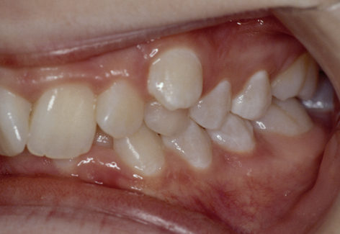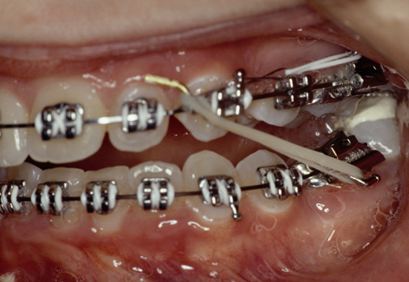

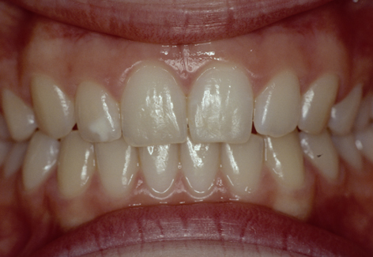

Figure 6 Typical elastics used with fixed appliances

Sometimes your brace will need additional help to achieve the desired tooth movements. Additions such as mini-screws or headgear will usually be discussed prior to starting a course of treatment.

13. Will I need to have extractions?

Extractions are frequently needed as part of orthodontic treatment. The orthodontist will advise on appropriate teeth to be extracted based on the aims of the treatment and thorough patient examination

**Please complete this form. Keep the leaflet but return this page**

It is important the orthodontist treating you is fully aware of any medical problems you have had either in the past, or currently, as this may in some cases affect your treatment. It is also important to let your orthodontist know if your medical history changes during your brace treatment.

Are you:

|  |  |  |  |
| --- | --- | --- | --- |
| 1 | Receiving medical of hospital treatment at present? | yes | no |
| 2 | Taking any tablets, medicines or any other substance, e.g. inhalers? | yes | no |
| 3 | Allergic to any tablets, medicines or other substance, e.g. Penicillin/Latex? | yes | no |
| 4 | Pregnant? | yes | no |

Have you:

|  |  |  |  |
| --- | --- | --- | --- |
| 1 | Ever had a heart murmur, rheumatic fever or another problem with your heart? | yes | no |
| 2 | Had raised blood pressure, angina, heart attack or thrombosis? | yes | no |
| 3 | Ever had hepatitis, jaundice or been diagnosed with HIV? | yes | no |
| 4 | Ever had any chest problems, e.g. asthma/bronchitis or tuberculosis? | yes | no |
| 5 | Ever had an operation of illness treated in hospital? | yes | no |
| 6 | Been diagnosed with epilepsy? | yes | no |
| 7 | Been diagnosed with diabetes? | yes | no |
| 8 | Have you had brain surgery or growth hormone treatment before the mid 1980’s or do you have a close relative with CJD? | yes | no |
| 9 | Ever had prolonged bleeding following a tooth extraction of other surgery? | yes | no |
| 10 | Ever had a problem with local or general anaesthetic? | yes | no |
| 11 | Are there any problems that may be relevant? | yes | no |

**You may be asked to sign an official consent form but it would be helpful if you could sign below to show you have read this leaflet and wish to have fixed appliance orthodontic treatment. Please ask if there are any issues that need clarification**.

Signature Patient…………………………………………Date……………...

Parent………………………………………….Date……………...

Clinician……………………………………….Date……………...

**Child protection**

**The welfare principle**

This emphasises that children come first and that their interests must be paramount

**Prevention rather than intervention**

Under most circumstances there is a belief that children are best cared for in their families. The state should only interfere in family life when necessary.

**The child voice**

The 1989 Children act aimed to improve the legal status of children. They are given greater rights to be consulted and to have their views taken into account.

Part III suggests that almost all the services are targeted on children considered especially vulnerable:

* Disabled
* Unlikely to achieve or maintain reasonable standards of health
* Health or development is likely to be significantly impaired unless services are provided.

After Victoria Climbié a new act was passed in 2004

**A Children’s Commissioner (Sections 1-9)**

The Children’s Commissioner for England will be responsible for promoting awareness of the views and interests of children.

**A new duty on agencies to co-operate to improve the well-being of children and young people (Section 10)**

This duty, which provides the basis for the children’s trust approach, provides for integrated planning and commissioning through local partnerships.

**A duty to safeguard and promote the welfare of children (Section 11)**

This duty requires all agencies with responsibilities towards children to discharge their functions with regard to the need to safeguard and promote the welfare of children.

**A power to set up a new database with information about children (Section 12)**

**Local Safeguarding Children Boards (Sections 13-16)**

Children’s services authorities must establish Local Safeguarding Children Boards (LSCB) to replace area child protection committees

**Children and young people’s plans (Section 17)**

Children’s services authorities must produce a plan setting out the authority’s strategy for discharging their functions in relation to children and those young people.

**Director of Children’s Services and Lead Member (Sections 18 and 19)**

Children’s services authorities must appoint a director of children’s services to be

accountable for all local authority children’s education and social services and any services for children provided on behalf of the NHS under section 31 of the Health Act 1999

**A framework for inspection and joint area reviews (Sections 20-24)**

.

**New powers of intervention in failing authorities (Section 50)**

.

**A duty to promote the educational achievement of looked after children (Section 52)**

**Ascertaining children’s wishes (Section 53)**

You role is:

* Identify and assess children in need
* Advise other agencies involved in child protection. (You will have been on Child protection mandatory training and there will be a named person in your trust who you should contact. If you don’t know who it is in a general hospital you should ask a consultant paediatrician. In the dental hospital ask a consultant in paediatric dentistry.

It is relatively unlikely that a parent who is assaulting their own child would take them for orthodontic treatment but that does not mean you should not look out for signs and record them on the notes.

**Confidentiality**

This follows the principle of fidelity a trusting relationship. In 1999 a network of so-called **Caldicott Guardians** were established throughout the NHS recognising its responsibility to **safeguard confidentiality**. It published a code in 2003. The key requirements were:

* Protect patient information.
* Make patients aware that information they have given may be recorded.
* Provide choice.
* Improve practice.

In fact there have been very few cases brought to law concerning confidentiality. This may be because professional codes are more precise than the law. There are exceptions to confidentiality they are:

1. If the patient gives their consent
2. A need to know basis necessary in the modern multi-disciplinary medicine.
3. Public interest e.g. disclosing serious crime, national security risk of child abuse or where the disclosure is required by law.

Five rules to observe:

1. Don’t gossip about patients
2. Take care when discussing patients in a public case
3. Don’t leave notes open
4. Only give minimal details over the phone
5. Be very careful when peaking to the press

# Clinical Research

There are two types of research and it is important to distinguish between them in terms of research ethics. However the boundaries between the two types can blur.

* Therapeutic research
  + Uses new methods or procedures likely to improve the patient’s condition
  + Combines research with patient care
* Non-therapeutic research
  + Aims to gain scientific knowledge
  + Unlikely to benefit the patients personally

The type of research affects the ethical guidelines used, the risk-benefit balance and the amount of information that should be disclosed.

## Purpose of research

There are two main purposes of research:

* Benefit society by understanding the causes of disease or dysfunction
* To find effective methods of prevention and treatment

## Ensuring research is ethical

##### Respect for autonomy

Participants should be treated with respect and must have the right to make their own reasoned decisions in order to give informed consent.

* Participation should be voluntary and free from coercion
  + Patients should not think their treatment will be compromised if they don’t participate
  + Rewards should not be excessive
* Participants should be fully informed
  + Rational choices cannot be made without sufficient information
  + Participants should be aware of the purpose of the study, what happens to them, the procedure being tested, alternatives, side effects, risks, benefits, what happens if something goes wrong, results and confidentiality
* Privacy and confidentiality
  + Participants should decide when, where and what information is shared
  + Participants’ confidentiality and anonymity must be protected
* Justice
  + Selection should be on the basis of research rather than recruiting the disadvantaged
  + Distribution of risks and benefit must be fair for all
  + Participants should be supported during and after the trial

##### Beneficence and non-maleficence

* Participants health and well-being must be safeguarded
* Harm must be minimised and this includes physical, mental, emotional, spiritual, embarrassment and financial harm
* Therapeutic research may have benefits for the patient but non-therapeutic research may benefit society as a whole
* Risks and benefits should be weighed up but minimal risk should always be adopted

##### Scientific validity

* To be valid research must be well-designed, based on good scientific methods and carried out by suitably trained researchers

## Regulation of research

Research is regulated by:

* Ethical codes and professional guidelines such as the Nuremberg Code (1949) and Declaration of Helsinki (1964)
  + Research should be scientifically sound
  + Benefits must outweigh risks
  + Participants must not be coerced
  + Participants must be fully informed
  + Payments may offset reasonable costs
* National Health Service research governance for health and social care (2001)
  + Applies to all research carried out by NHS staff or by researchers performing research in NHS settings
* Research ethics committees (introduced in 1968)
  + Provide independent review on the ethical acceptability of research
  + Act primarily in the interest of participants
  + Research is assessed on scientific design, conduct of the study, recruitment, protection of participants, informed consent and community considerations

## Legal regulation of research

There is no legislation regarding research on humans:

* Researchers have a duty of care to participants
* The common law of consent applies to research
  + Physical contact with participants is unlawful unless informed consent is taken
  + Participants should be competent to give consent

## Conclusion

There are four commonly cited ethical pillars:

* Autonomy
* Justice
* Beneficence
* Non-maleficence

These ethical pillars apply to all aspects of medicine including clinical research. Ethical codes, research ethics committees and NHS research governance regulate clinical research to ensure that these pillars are followed in the interest of participant protection

|  |  |
| --- | --- |
| 1. At Its foundation what were the 3 principles of the NHS | 1. Service provided to all  2. free at the point of contact  3 Fair. Everyone’s needs assessed on an equal basis |
| 2.What was NICE set up to do | 1. Look at clinical effectiveness  2. rule on treatment availability  3 Devise clinical guidelines |
| 3 In clinical governance what is considered best practice | 1. Measure outcome  2. Clinical audit  3. Evidence based practice  4, Guidelines  5. Clinical Risk Management  6. Clinical effectiveness  7. Professional self-regulation  8 Chief Executive overall responsibility |
| 4 what four factors are involved in consent | 1. Ability to evaluate  2. the evaluations must be rational  3. needs the capacity to make decisions  4. freedom to act |
| 5.How do you overcome the problems of acting with consent in an unconscious adult | I tis called the principle of necessity you must act in the way you consider is the best treatment |
| 6 What is meant by Gillick competence | A child under 16 can give consent to treatment if they understand the nature of their condition and the proposed treatment. |
| 7 Who can give consent for a child under 16 who is not Gillick competent | A proxy. This can be: Mum, Mum or Dad if they are married, Dad if his name is on the child’s birth certificate or if he has been legally granted parental responsibility.  Adopted parents step parents if given authority by the courts. Special or ordinary guardians and persons given authority by the local authorities |
| 8, What should you do if you think your patient has been subjected to mal treatment by the parents | There will be a named person in your trust who you must contact |
| 9. What was the Bolam test and what was wrong with it | It said you should carry out your clinical practice in the same way as your colleagues but the House of Lords ruled that just because you could find a colleague to appear in court and support you it doesn’t mean the treatment was right |
| 10 What changed things in the Sidaway case | It was ruled that there was a need to disclose all potentially serious consequences |
| 11. Which type of bracket is most likely to cause enamel fracture during debond. | With Ceramic brackets there is a 20% chance of tiny enamel fracture lines as opposed to 5% with normal brackets |
| 12. what is the typical amount of apical resorption you would expect from a whole course of orthodontic treatment | 1-2mm |
| 13. Which abnormalities of teeth mean they are more prone to root resorption | Blunt roots, short roots, pipette shaped roots. Teeth with a previous history of trauma, non-vital teeth. Teeth. Teeth that have been intruded. subjected to lengthy orthodontic treatment |
| 14 According to Brallstrom what is the failure rate in orthodontics | 4-23% |
| 15. What are the ten points of the Nuremburg code. | 1. The voluntary consent of human subjects must be obtained 2. The experiment should only be carried out if it will yield fruitful results for society unobtainable by other means 3. The experiment should be based on animal experimentation and knowledge of the natural history of the disease so that the anticipated results will justify the experiment 4. The experiment should avoid all unnecessary physical/mental suffering of subjects 5. No experiment should be conducted if there is reason to believe that death or a disabling injury may occur 6. The degree of risk to be taken should not exceed the humanitarian importance of the issue to be solved by the experiment 7. The subjects should be protected as much as possible against injury death or disability. 8. The experiment should be carried out by scientifically qualified persons. 9. The subject should be at liberty to terminate the experiment at whatever point they see fit. 10. The scientist in charge must also terminate the experiment if they have any reason to believe that the experiment if continued will result in injury disability or death to the subject. |
| 16. what are the five factors that are the concern of the ethics committee of research | 1.scientific design and conduct of the study  2. Recruitment of participants  3. Care and protection of participants- safety of intervention  4. Informed consent  5 Community considerations-impact of research on the local community and steps taken to consult these. |
| 17 What is Autonomy | The right to make up your own mind |
| 18 What is meant by Beneficence | The duty to do good and not harm |
| 19 what is the role of MONITOR | Set prices for the NHS, Safeguard patients choice and enable integrated care |
| 20. What does the Helsinki declaration say | Research should be scientifically sound, participants must not be coerced and benefits must outweigh risks |
| 21 How can the GDC take action on poorly performing dentists | Reprimand, set conditions for future work or Remove their names from the register either for a limited period or permanently |