Chapter 18 Wire bending
A version of a two day course given over many years at Burton
With valuable input by Rachael Little and Emil Habib

Preliminary exercises
On round wire
1. Set up wire by 1mm.
Hold the wire in the light wire plier and bend one side and the other side up. Remember to place your finger or thumb as close as you can to the pliers.
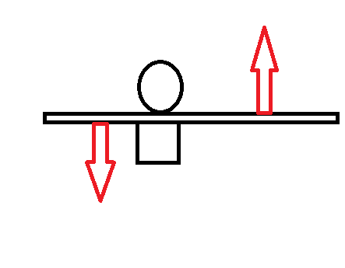
You should produce this:
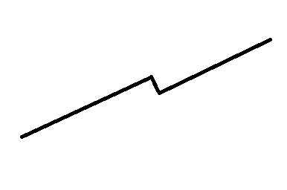
Now practice with the wire near the tip of the pliers. This will produce a small offset. Or further down the pliers to produce a bigger offset.
Now you need to mark the wire for the second bend hold the wire with the pliers exactly on that spot. The second bend is a mirror image of the first.
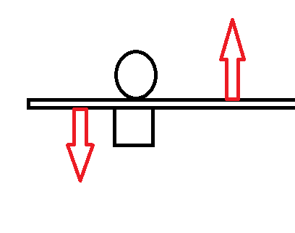
And now the wire should look like this:
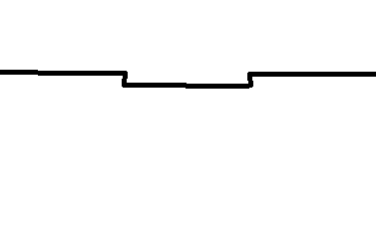

Practice a few times and then show your trainer a bend with a 1mm set down (or up).
Now imagine a situation where the upper right central is 1mm too short.
You need a set down bend to restore it to the correct length. IF YOUR BEND IS CORRECT, IF YOU TURN THE WIRE UPSIDE DOWN IT WILL LIE ALLONG THE INCISAL EDGES. If it does this you can be sure you will get the tooth down to the correct position.
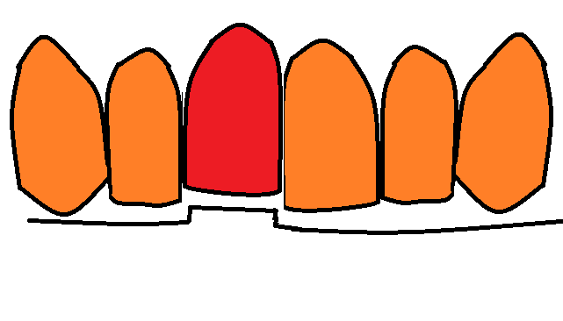
Of course the wire goes in this way up
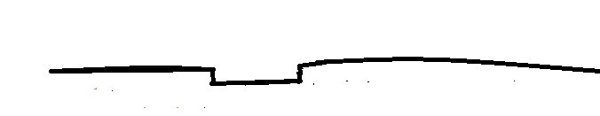
2. Tip and tent peg bends
When you tried to do exercise 1 you may have produced this:
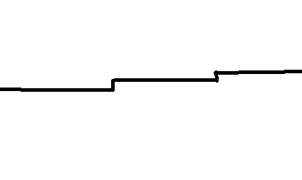
In other words you bent the same bend on both sides of the tooth. From this it is a tiny adjustment to produce this:
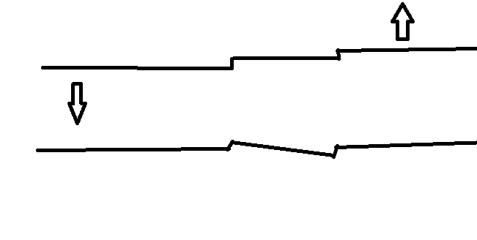
This produces tip on the tooth. Back in the days of plain edgewise we used to finish with a wire that looked like this in the anterior labial segment.
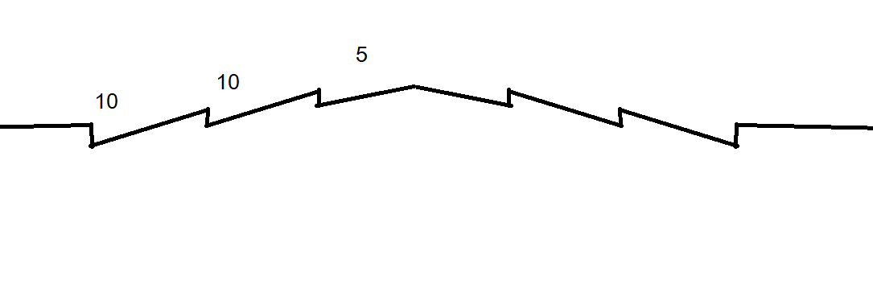
Known as artistic finishing bends. This produced 5° of mesial tip on the centrals and 10° on the laterals and canines. Of course Andrews came along and produced the straight wire bracket which had his tip built-in with values from his 120 normal occlusions. This was 5° for the centrals 9° for the laterals and 11° for the canines. MBT reduces this tip a little to 4° for the centrals and 8° for both laterals and canines,
ANDREWS MAKES THE POINT THAT ANTHOUGH PEOPLE ARE VERY GOOD AT JUDGING PARALLEL AND RIGHT ANGLES THEY ARE VERY POOR AT JUDGING OTHER ANGLES SAY 8°.
Have a try place a bend that you think is 8° and measure it with a protractor.
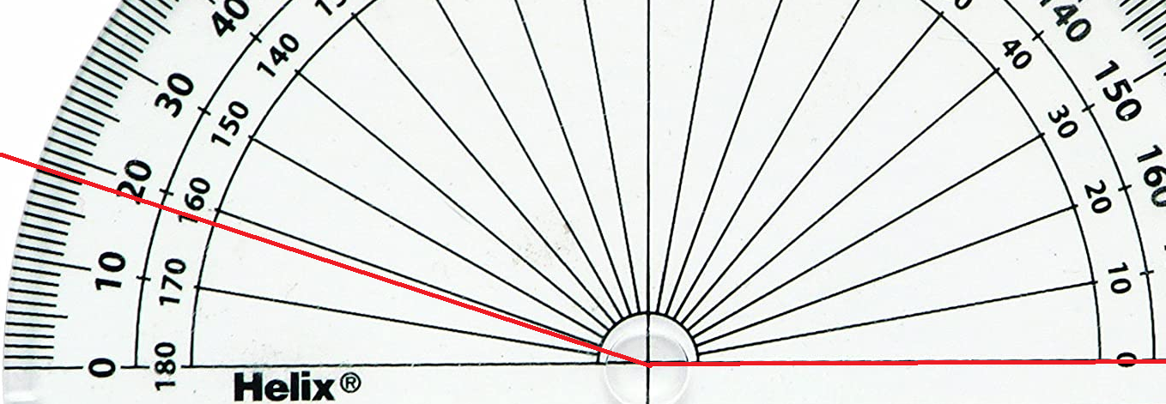
It is quite hard to do, so some important information:
If you have placed a bracket on wrongly it is best to re-bond it (Ideally when you get to 0.016 x 0.022 NiTi wire) rather than to put adjustment bends in the wire.
In part this is because if you bend a series of wires each with let us say a 10° mesial tip on the upper left lateral the wires will all be slightly different and the lateral will be subjected to repeated high forces which might cause root resorption. Best to save this kind of bend to the final archwire.
Tent pegging
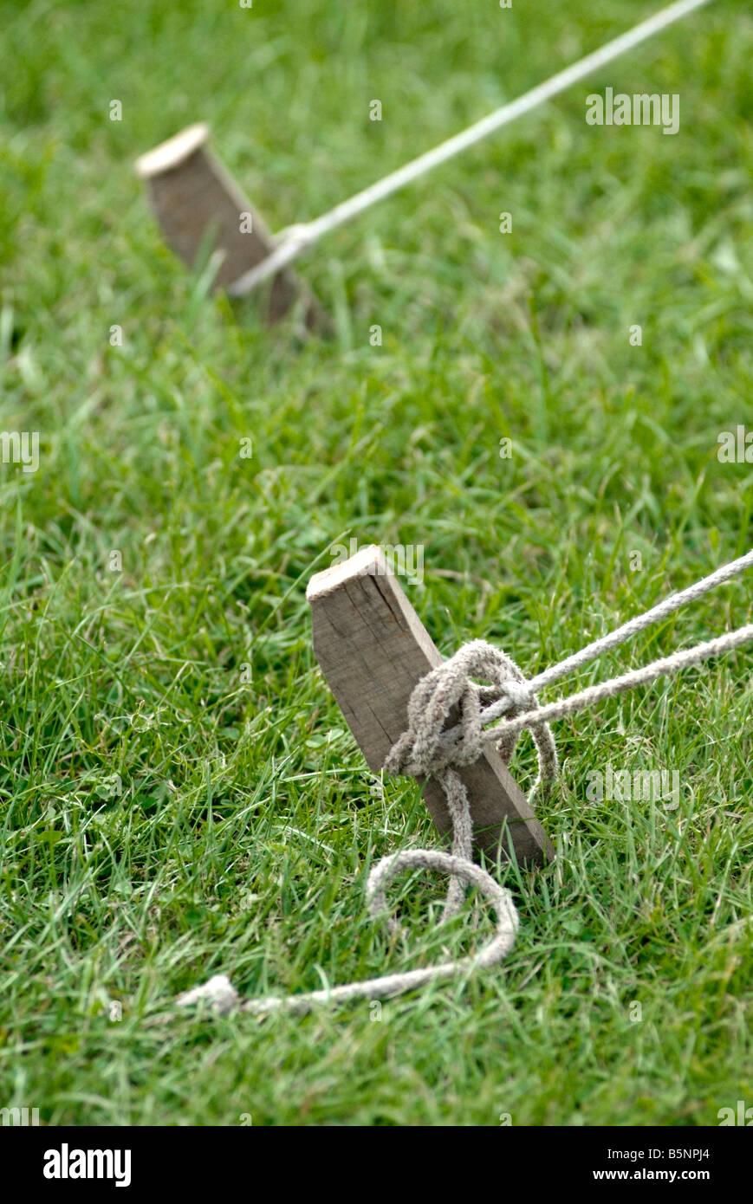
This picture is for orthodontists who have never been camping, to resist the pull of the rope the tent peg is hammered in at an angle.
Now let us look at a common orthodontic problem closing lower 5 spaces.
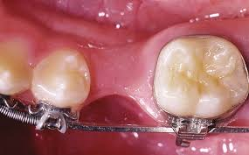
If you close lower 5 space the lower labial segment will drop back. To reduce this effect put mesial tip into 3 and 4. This is called tent pegging

3. Bending a curve in a wire with one end fixed in a vice.
Wire to be used. Any round wire
A. Fit the wire into the vice and place the bend by pulling it around thumb and finger.
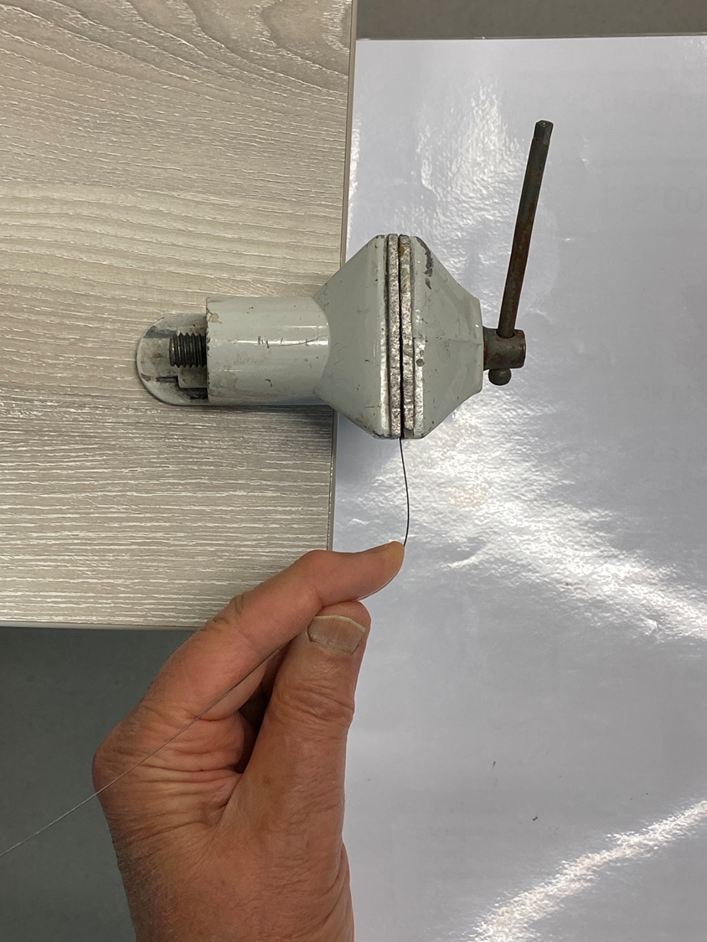
B. This produces a bend but when you take it out of the vice you will see that it is asymmetrical
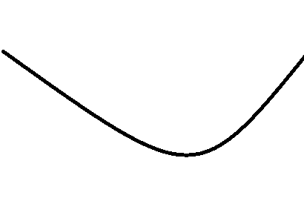
C. Place wire other way into the vice and repeat bend try to bend it a little tighter than the desired archform. You will find if you bend it into an archform that is a little too tight you can just pull it open a bit but if it is too wide it is hard to bend it into a tighter archform.
D. Symmetrical archform.
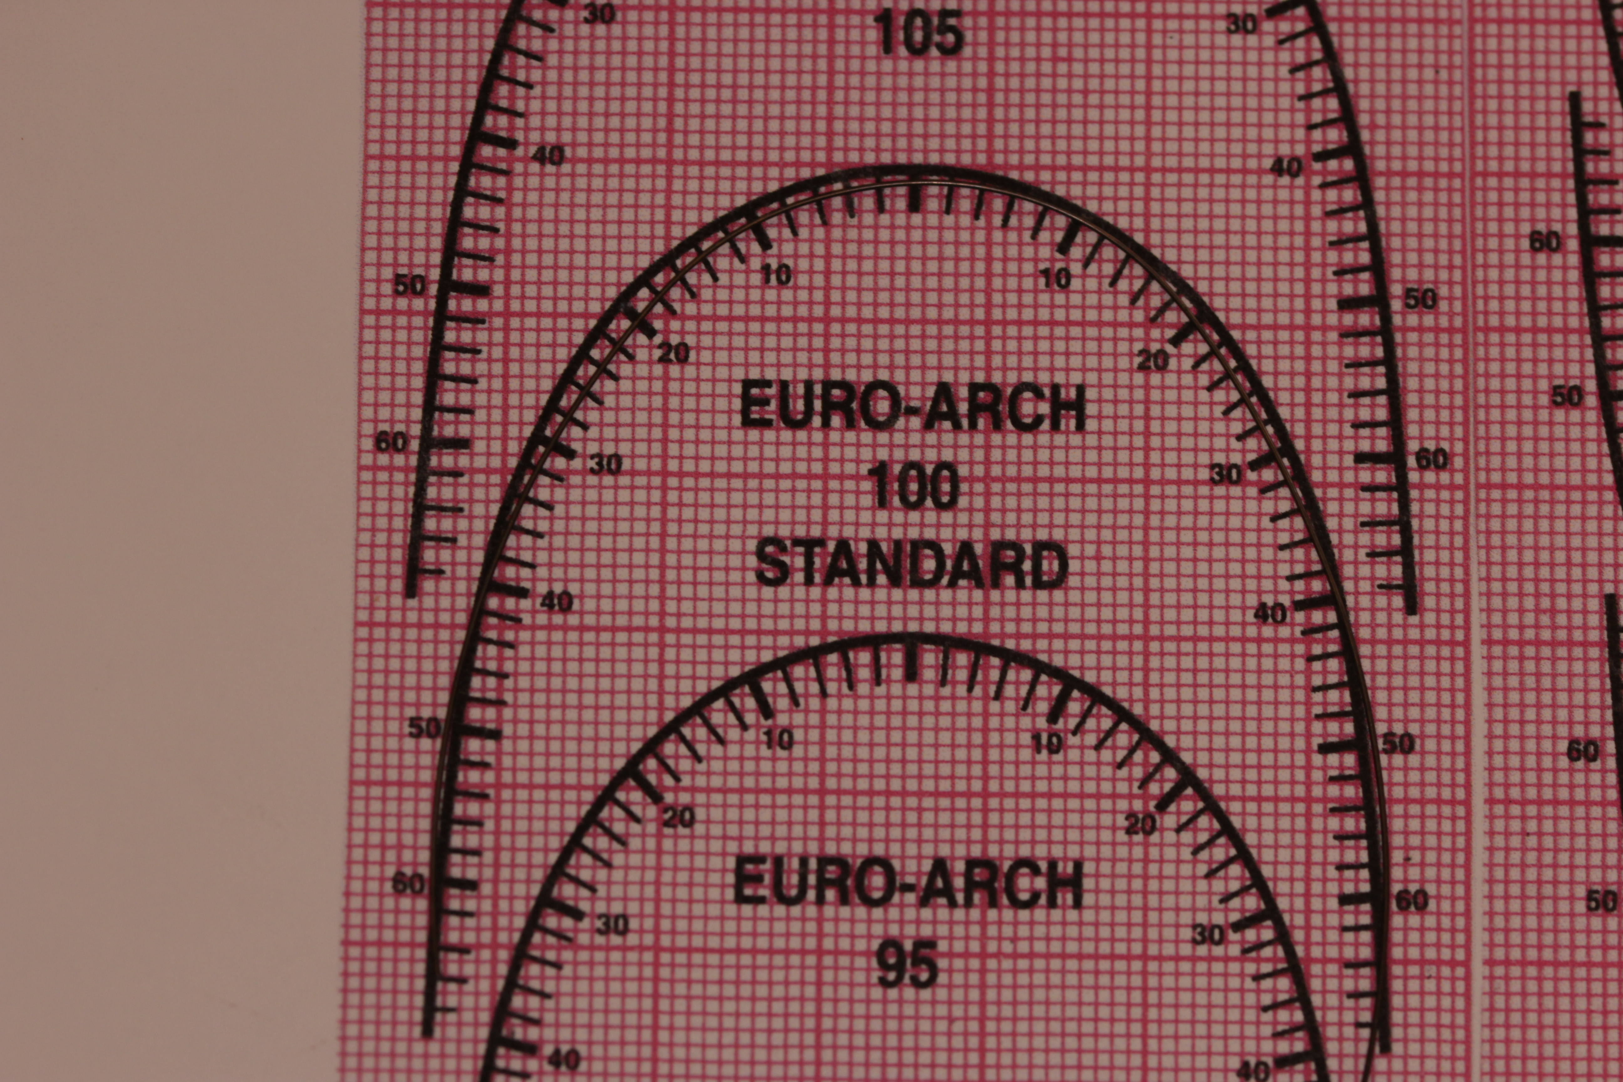

Hold on a minute. We don’t use a vice to bend an archform SO THIS IS THE REAL EXERCISE.
4. Bending an archform.
Again using any round wire for example 016 special wire and matching to an archform. The idea to show the pliers are used as the vice and the curve is bent with the fingers and thumb.
A. Wire held in pliers.
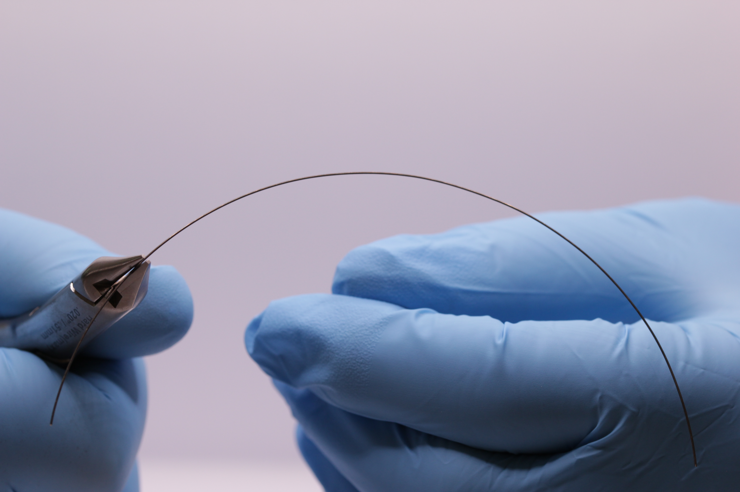
B. Finger and thumb bending wire.
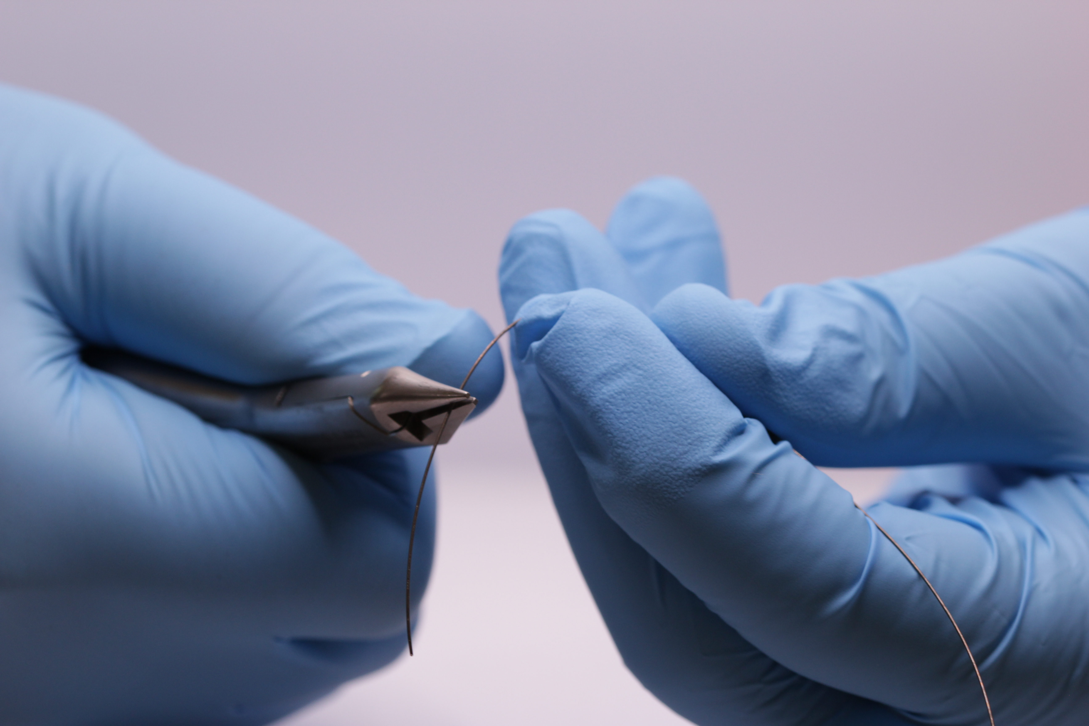
C. The arch bent is often asymmetrical.
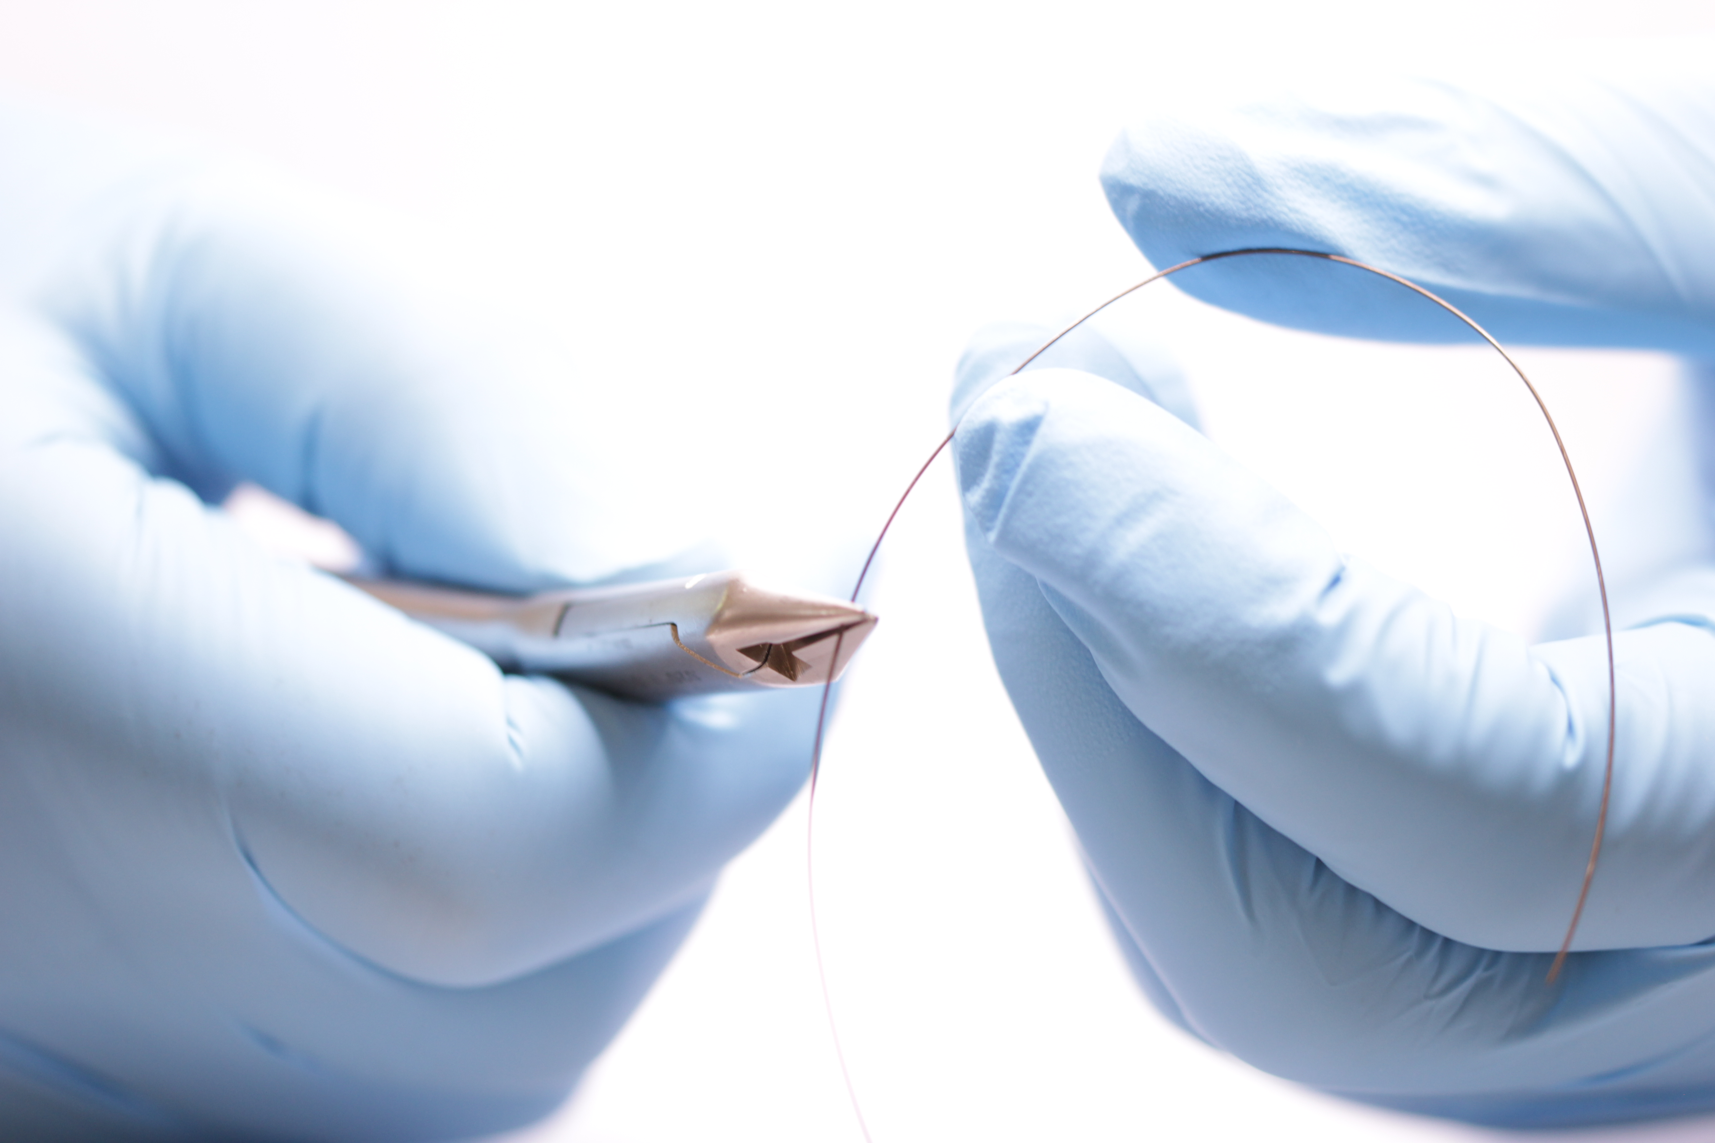
D. So to correct this place the other way up and repeat the bend try to bend it a little tighter than the desired archform.
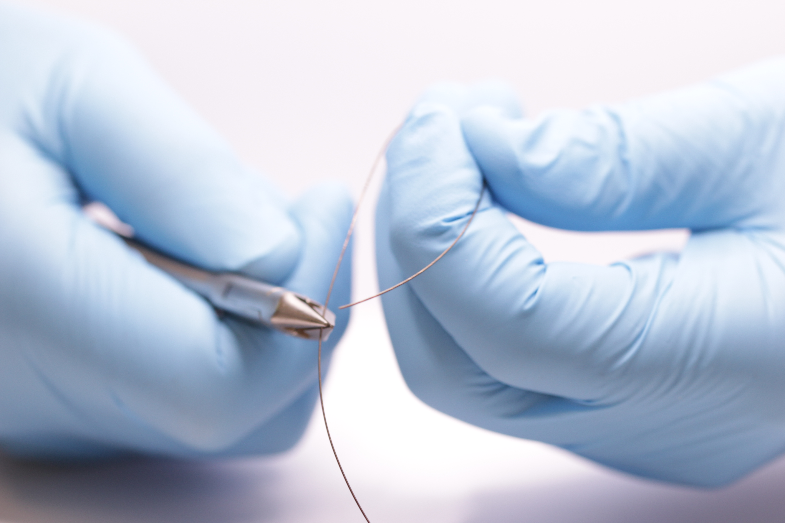
E. Make a symmetrical archform matched to 100% upper archform on chart.
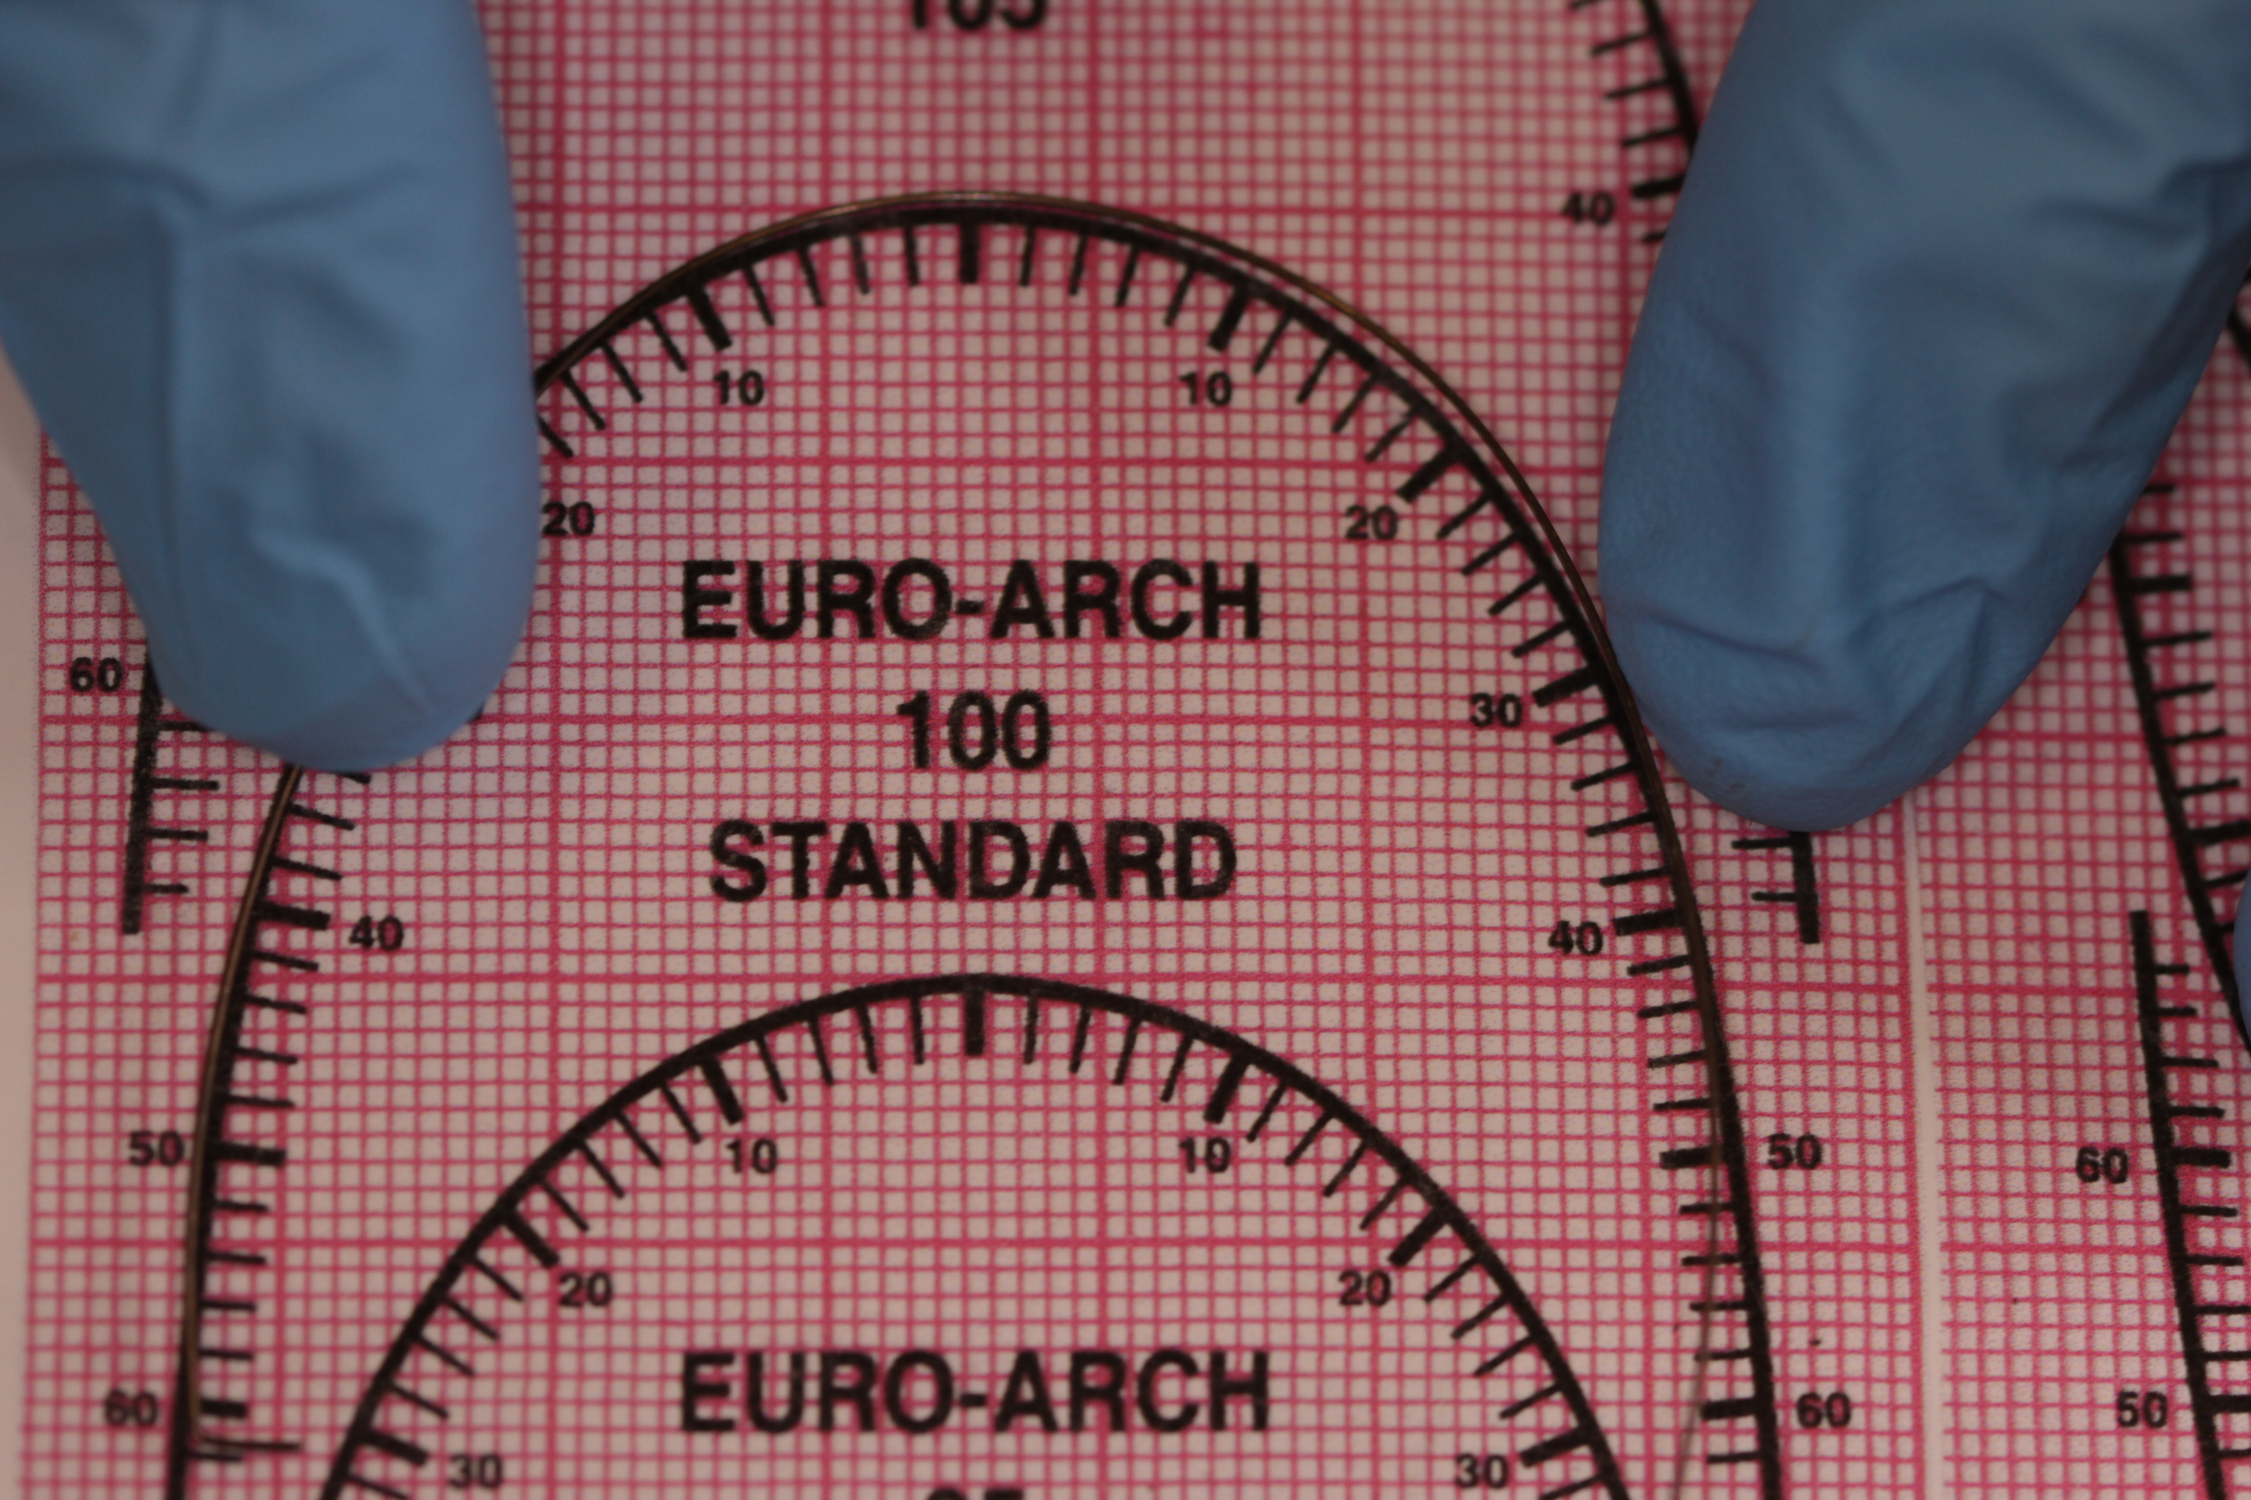
5. Bending an archform with circle hooks in front of the canines.
Again any round wire like 016 special.
A. Bend an archform.
B. Mark the spot where you want the circle.
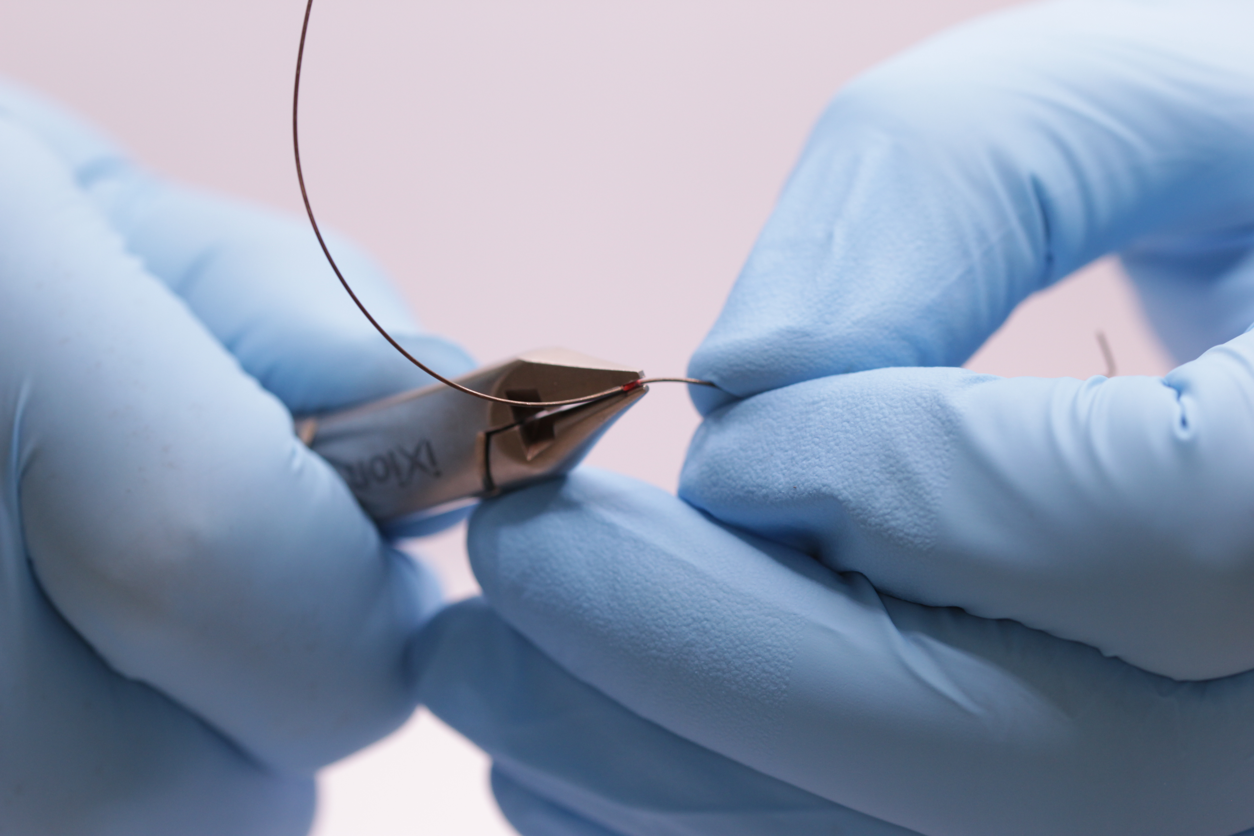
C. Hold the wire with light wire pliers with the round beak on the outer side of the archform. Hold the wire tight to the pliers and wind the circle hook going down the pliers to the wider part.
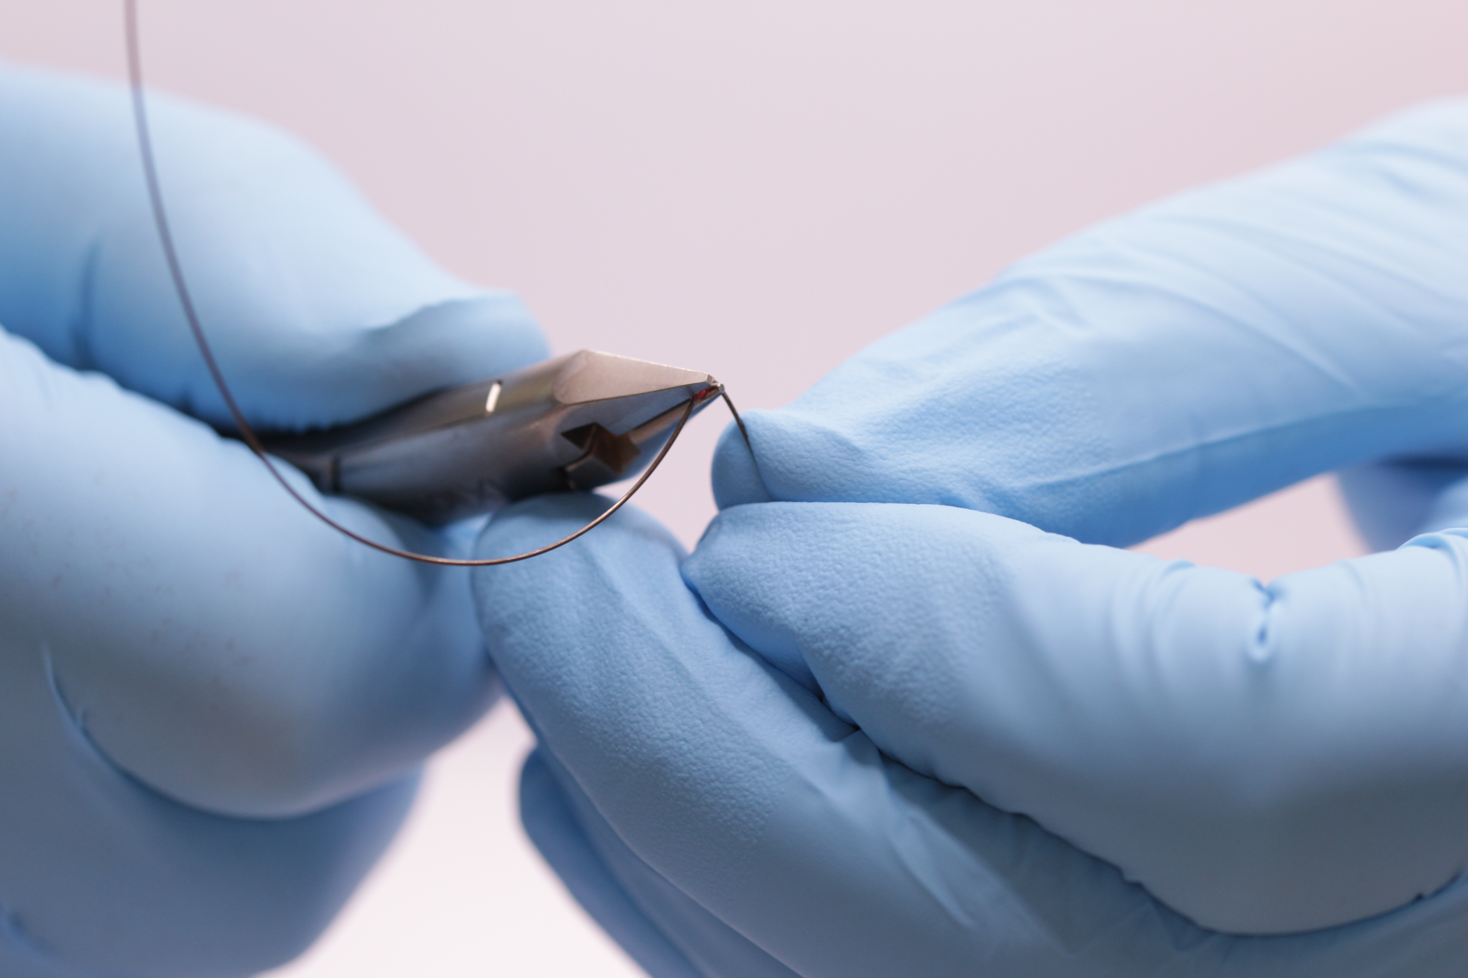
D. Restore the archform.
E. Mark the other side and bend the other circle hook and restore the archform.
F. Try again with vertical circle hooks.

Preliminary exercises
On rectangular wire
You need special pliers often referred to as Tweed pliers and Tweed loop forming pliers. The beaks of these pliers are made so that if the pliers are opened to hold a 0.022 wire the sides are parallel. In theory this means that when you bend the wire you don’t put in any torque. (However if you are bending 0.019 wire you might put in a little.) If you use light wire pliers with one square beak and one cone shaped beak you WILL put in torque.
1. Set up wire by 1mm

Same idea as before but here if you want a smaller bend you bend it less:
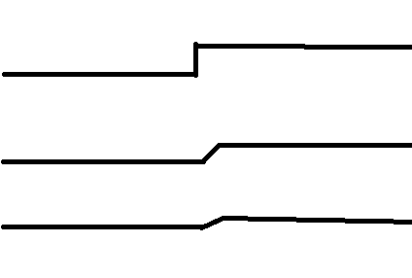
As before the second bend is a mirror image of the first. Show your trainer a 1 mm set up or set down bend.
2. Tent peg bends
Start putting tip into rectangular wire risks high forces on the teeth and putting tip and torque into rectangular wire and getting it right for every tooth ups the skill level. My advice tip problems in the incisor region are best dealt with by repositioning the bracket or getting the torque right first and then finishing with a round wire with the tip bends.
However tent peg bends on lower 4s and 3s are useful
Bend one and show it to your trainer.
3. Bending a sliding jig
A sliding jig allows you to use class II elastics to distalise the molars. It is a useful exercise, as it introduces the Loop forming pliers. (Although strictly speaking we do not need to worry about putting in torque as it doesn’t go into the brackets so you could get away with other pliers.)

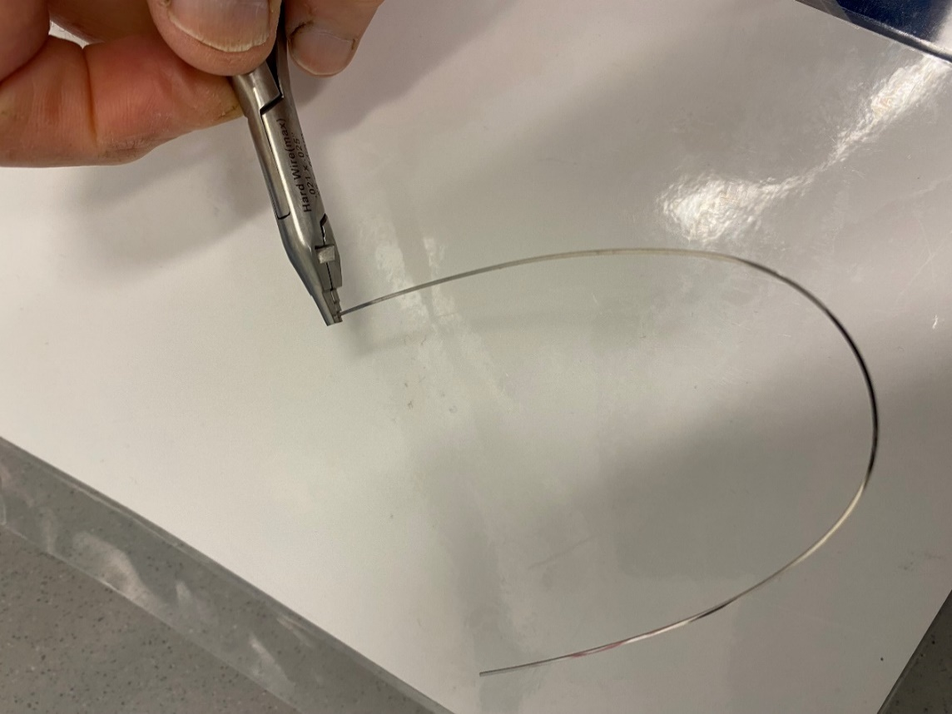
A. Bend a circle with the loop forming pliers
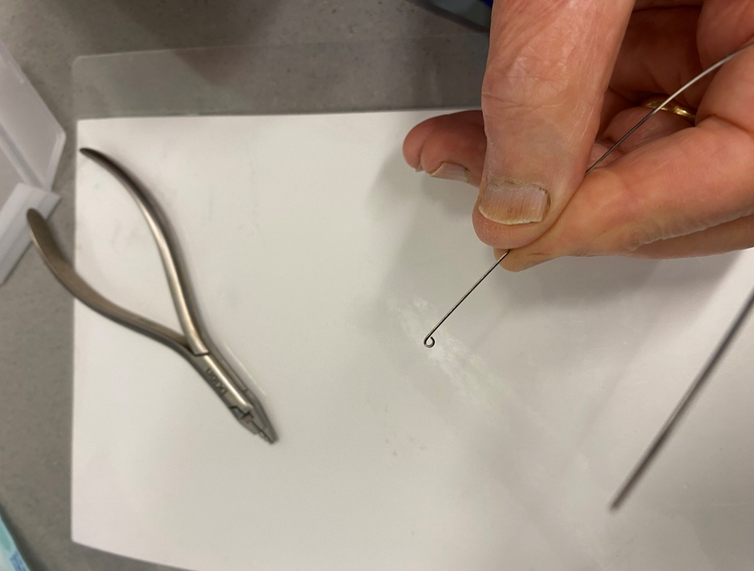
B. Circle complete
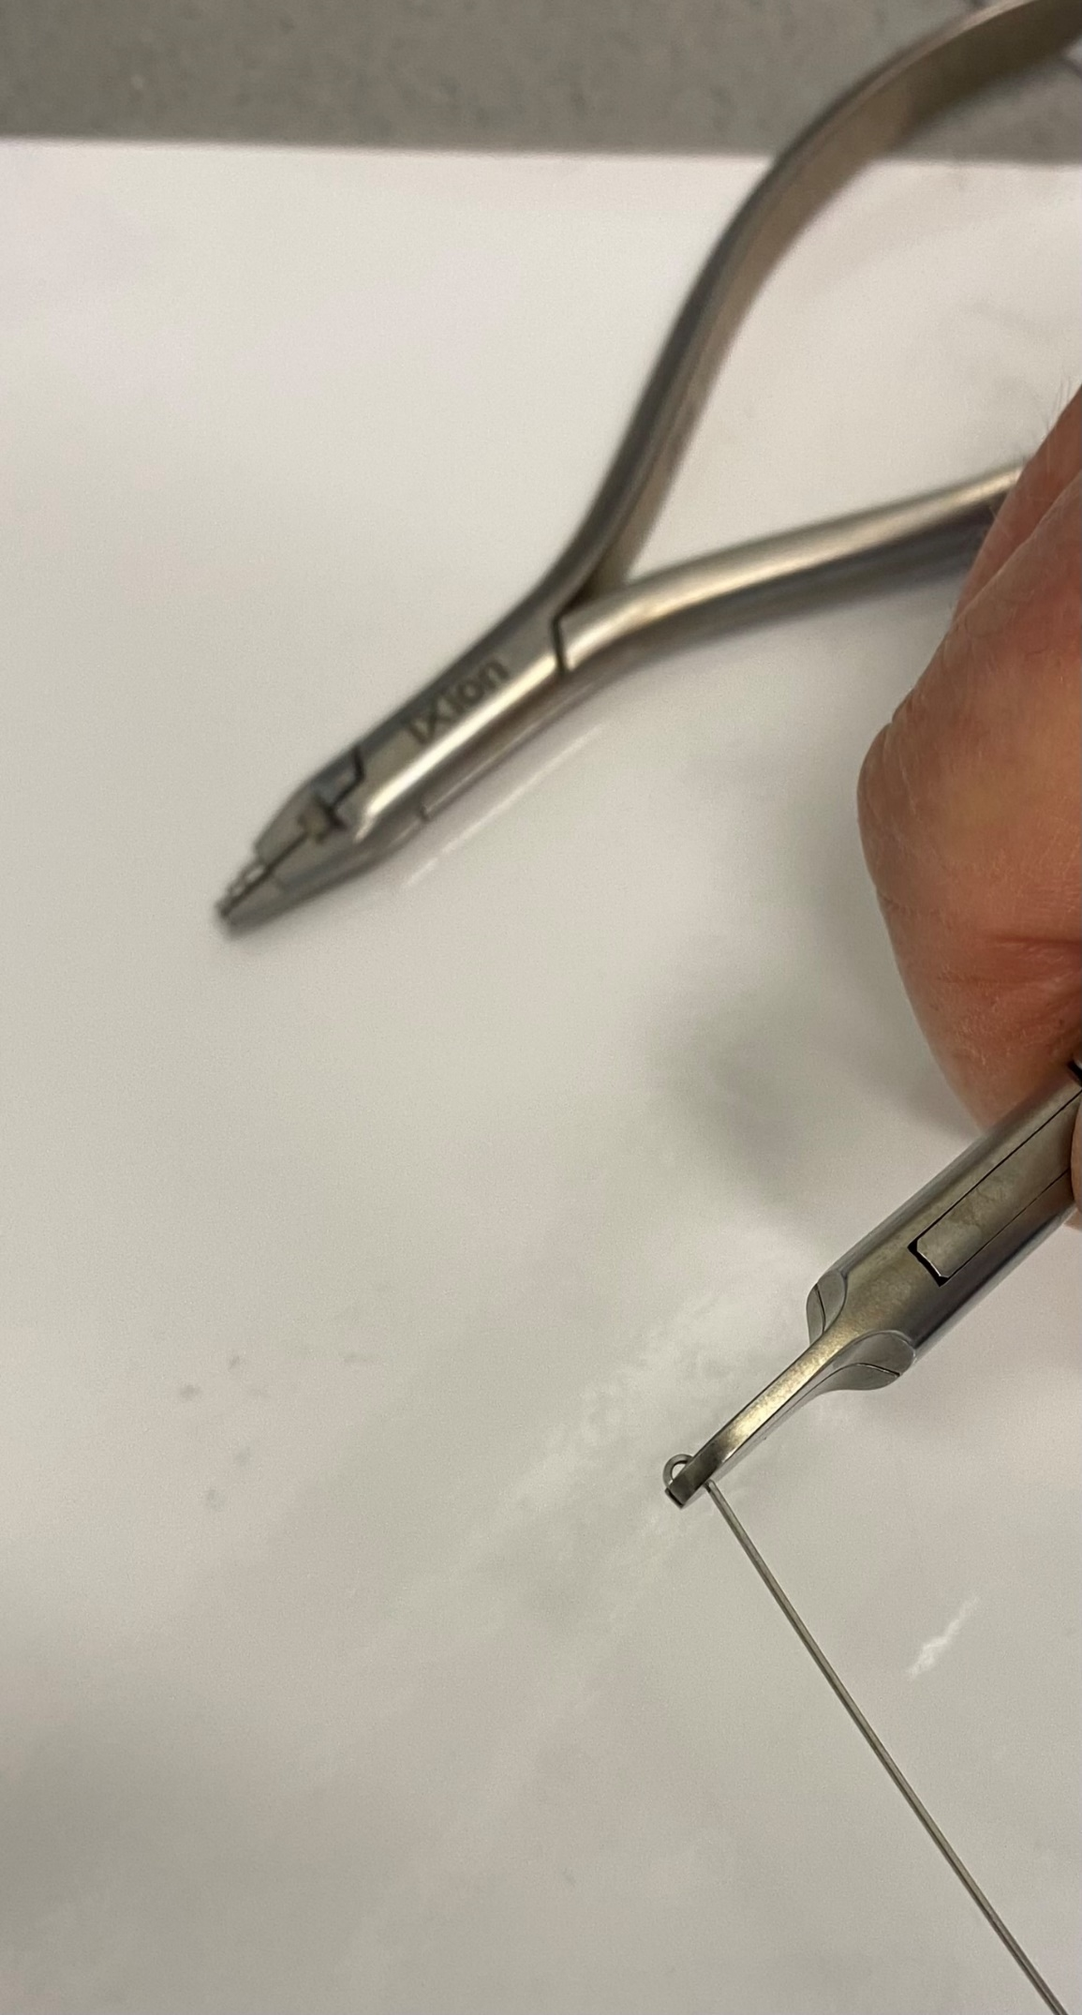
C. Grab hold of the wire using Tweed pliers and bend to 90°
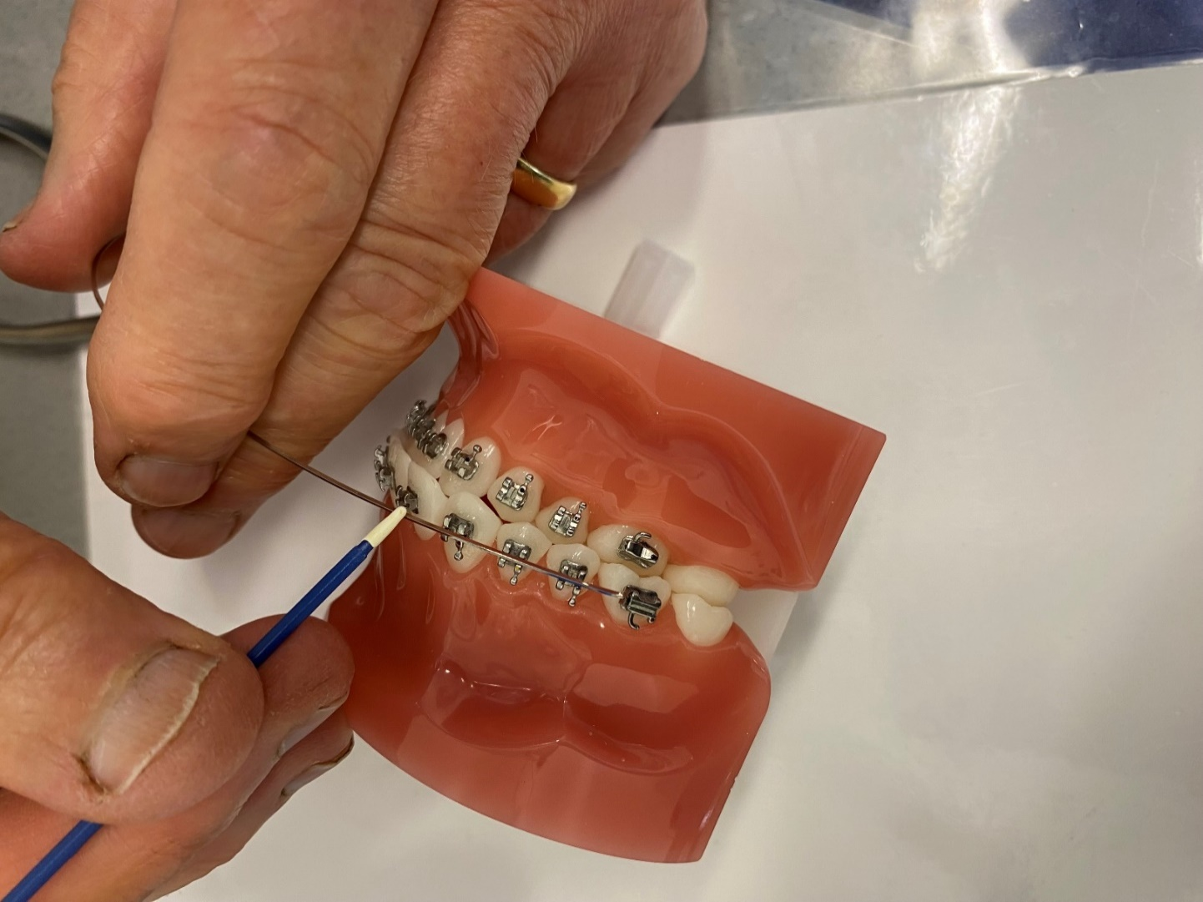
D. Hold this circle against the front of the molar tube and mark distal to the lateral incisor
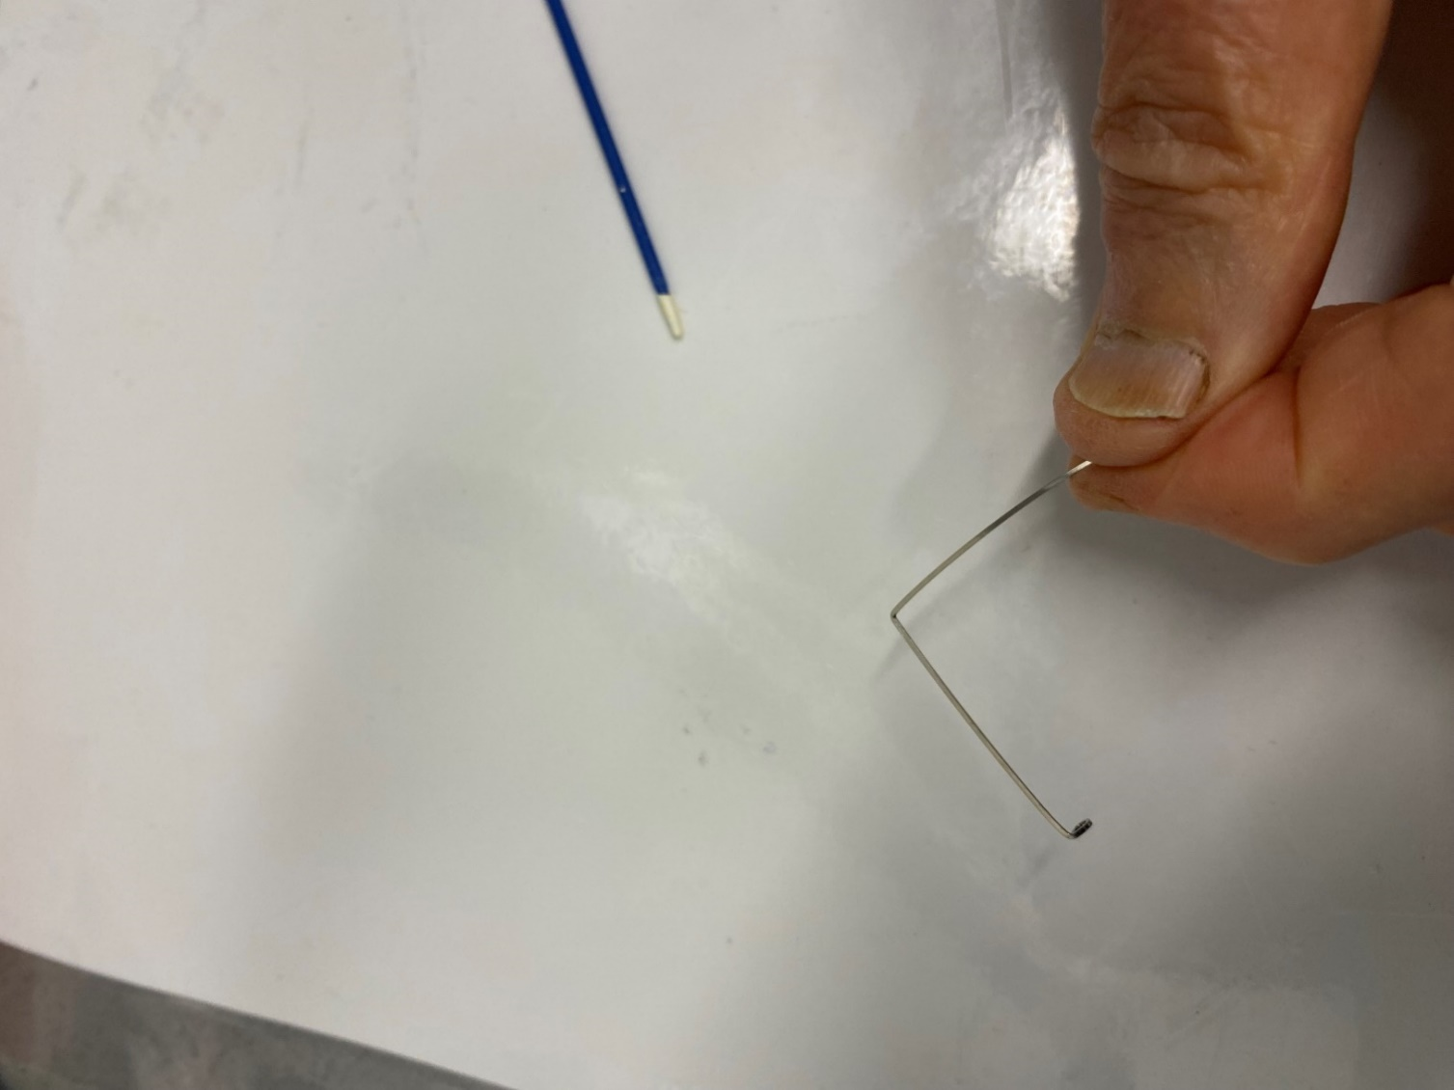
E. Place a bend at the marked point bending it to 90°
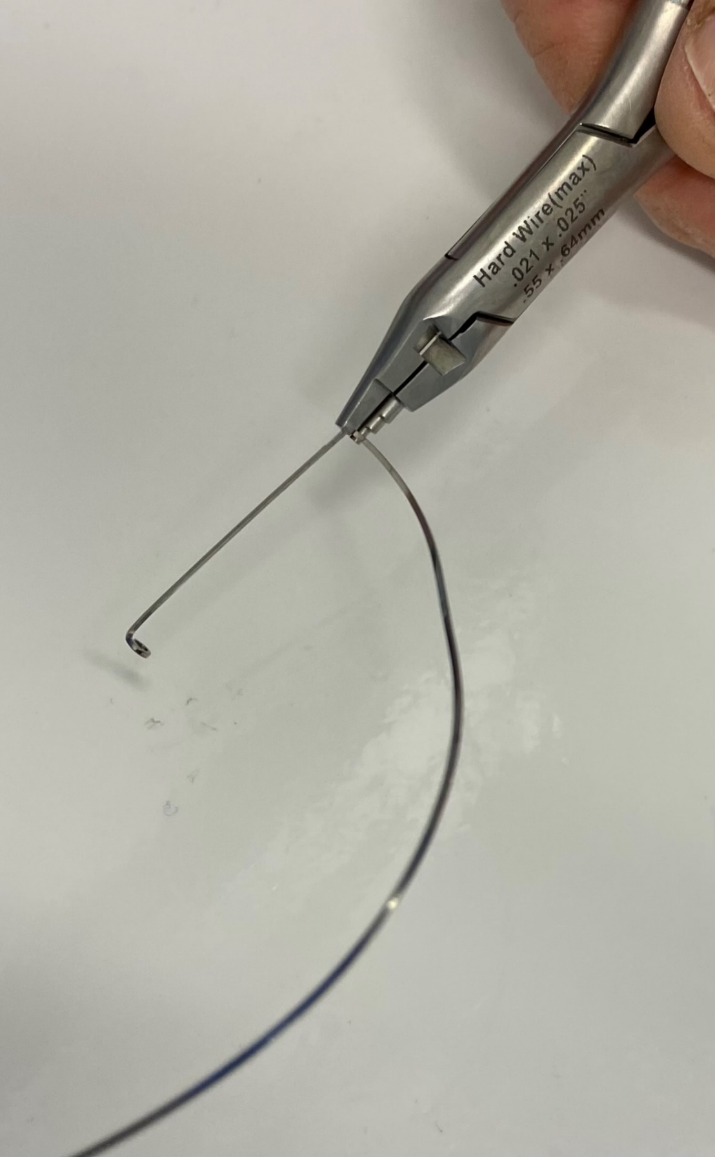
F. Bend the second circle
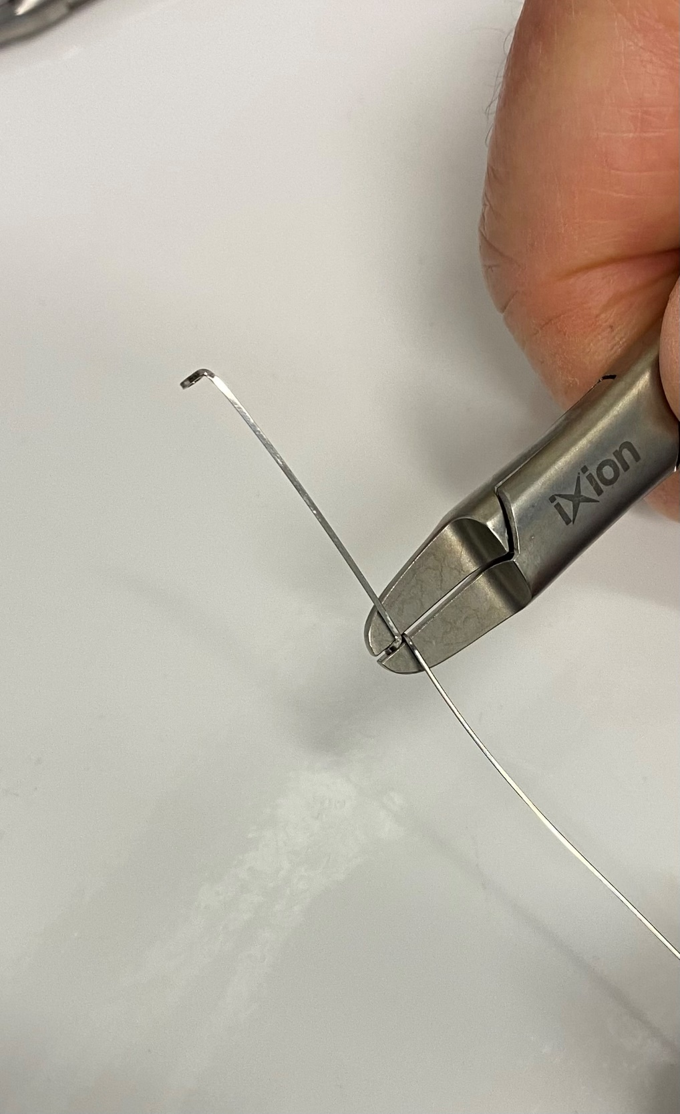
G. Bend the end be parallel to the shaft of the jig
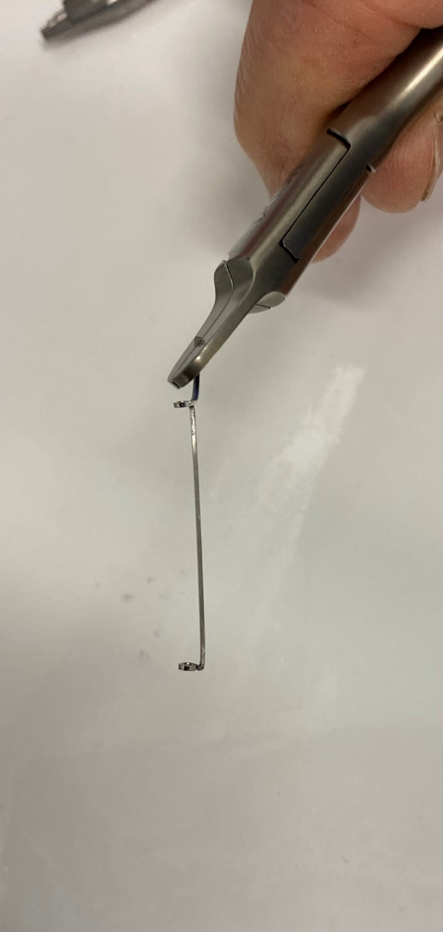
H. Place a slight curve in the shaft and the end which will form the hook
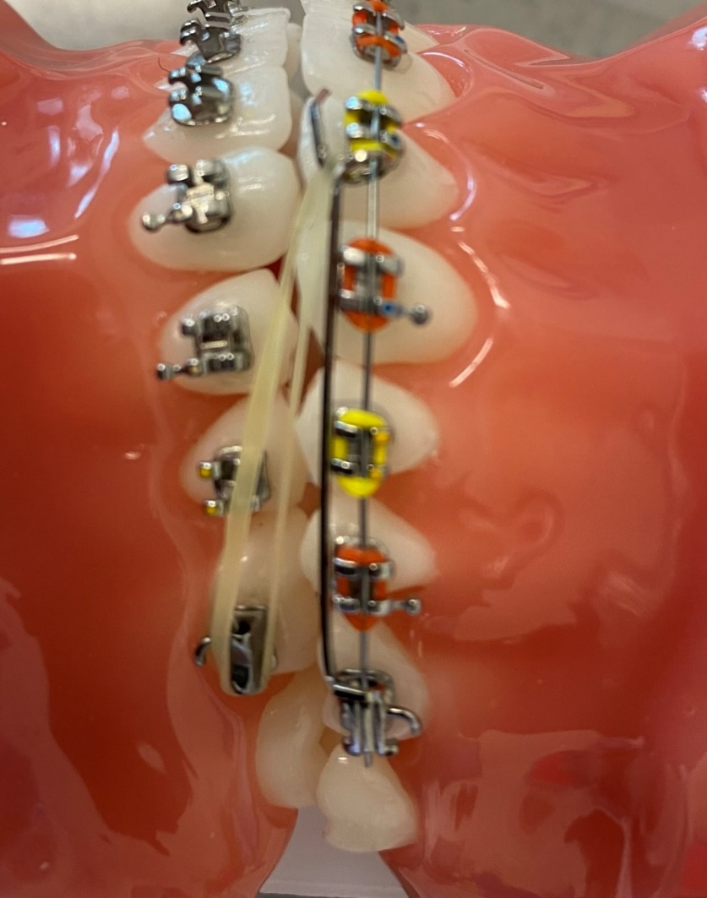
I. This is the sliding jig in place. Note you thread it on the archwire. Class II elastics from the lower molar provides a force which pulls the jig back and this presses on and distalises the molar.
The following exercises are listed in order of usefulness. I have described them as simple or advanced.
- Class simple.
Parkhouse arch. Very similar to the archform with circle hooks but with the circle hooks in front of the lower 4s and a piece of push-coil in-between the circle hooks. Bent in 014 special or similar wire. Note the elastic module goes from the canines to the circle hooks, this powers open space in the labial segment but the amount of space is controlled because when the circle hook hits the canine it stops.
A. Bend an archform.
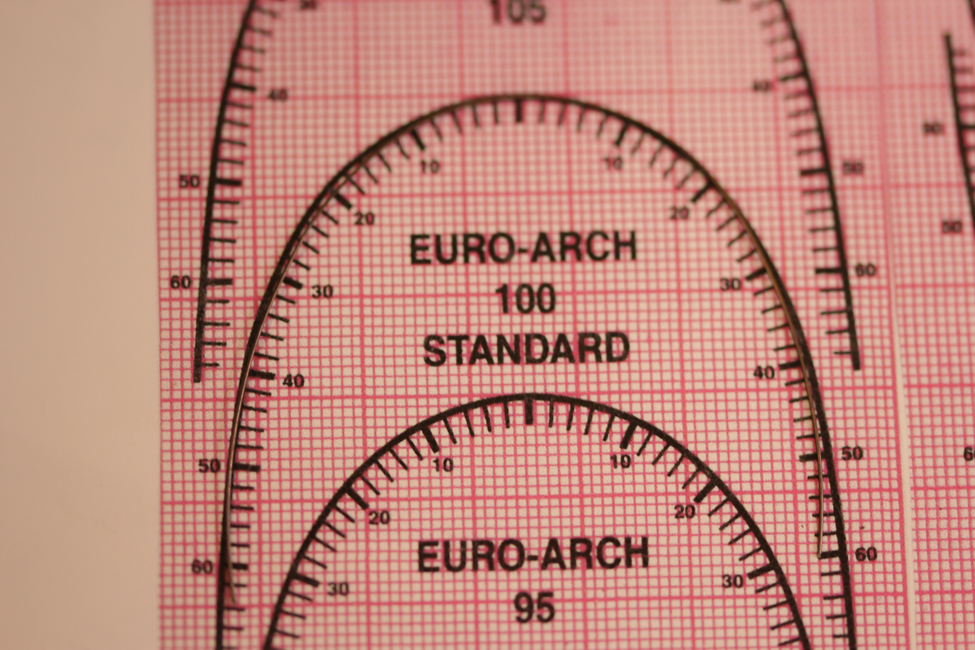
B. Mark and bend the first circle hook just mesial to LL4
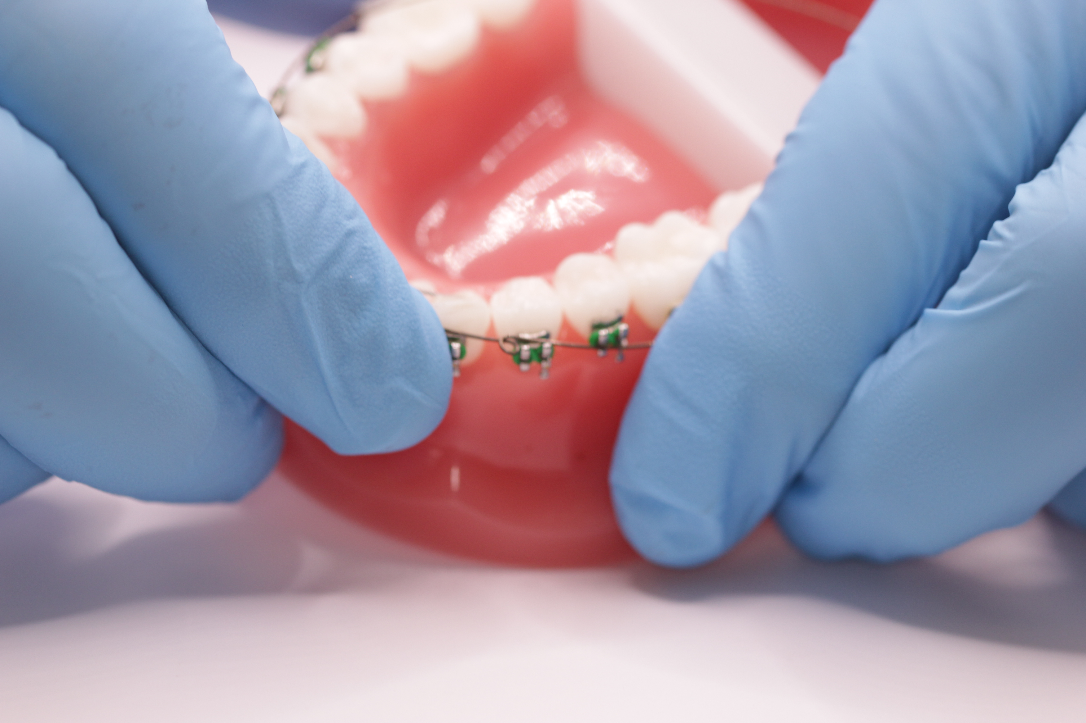
C. Thread on the push-coil.
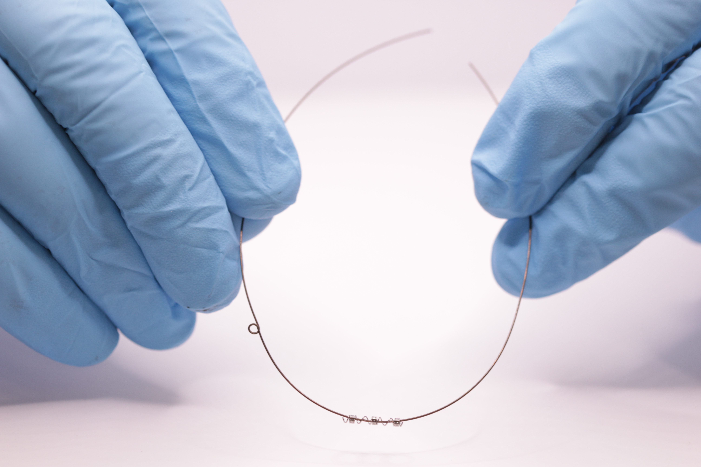
D. Mark and bend the second circle hook
E. Below a Parkhouse arch on insertion.
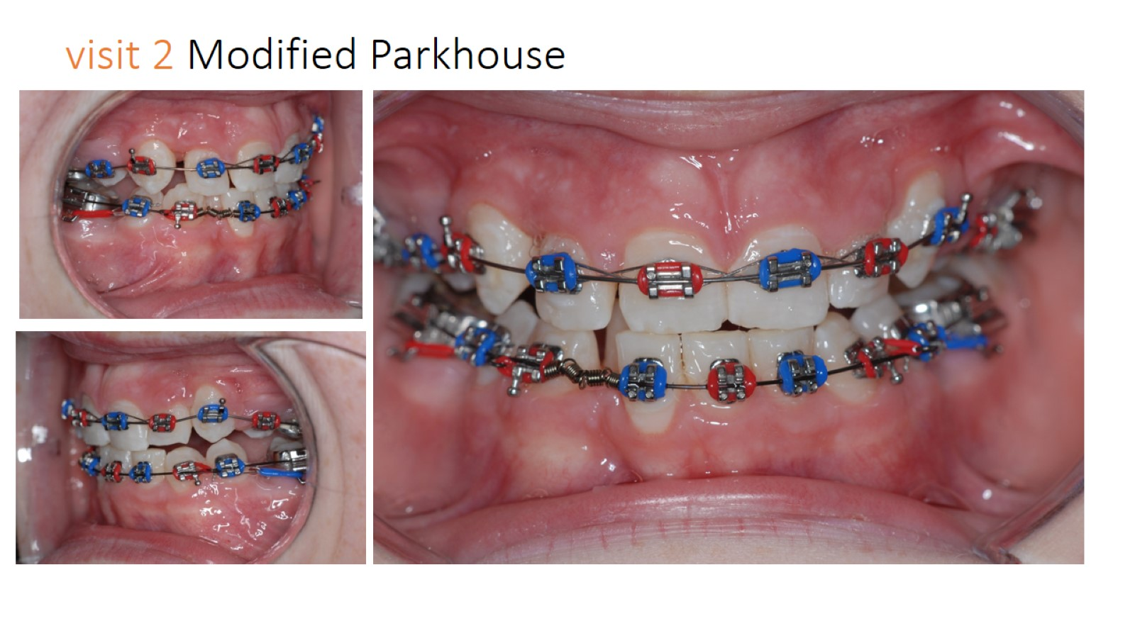
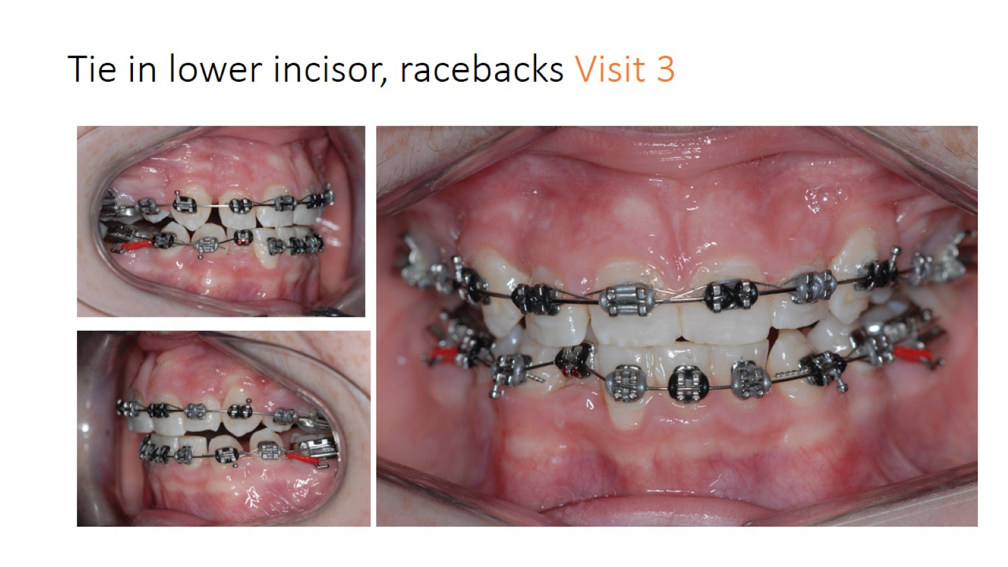

F. Above the next visit. With practice you will find that you can open the exact amount of space in one visit

Ideally you need a typodont for this exercise
- Advanced
Single tooth torquing auxiliary. 0.014 Special plus or similar. It is the concept rather than the wire bending that gets this in the advanced section it is the easiest of wire bending exercises. It uses the curve of the archform to give the torque in either direction on any tooth.
A. wipe the curve into the wire.
B. bend a 90° bend towards the centre of the curve
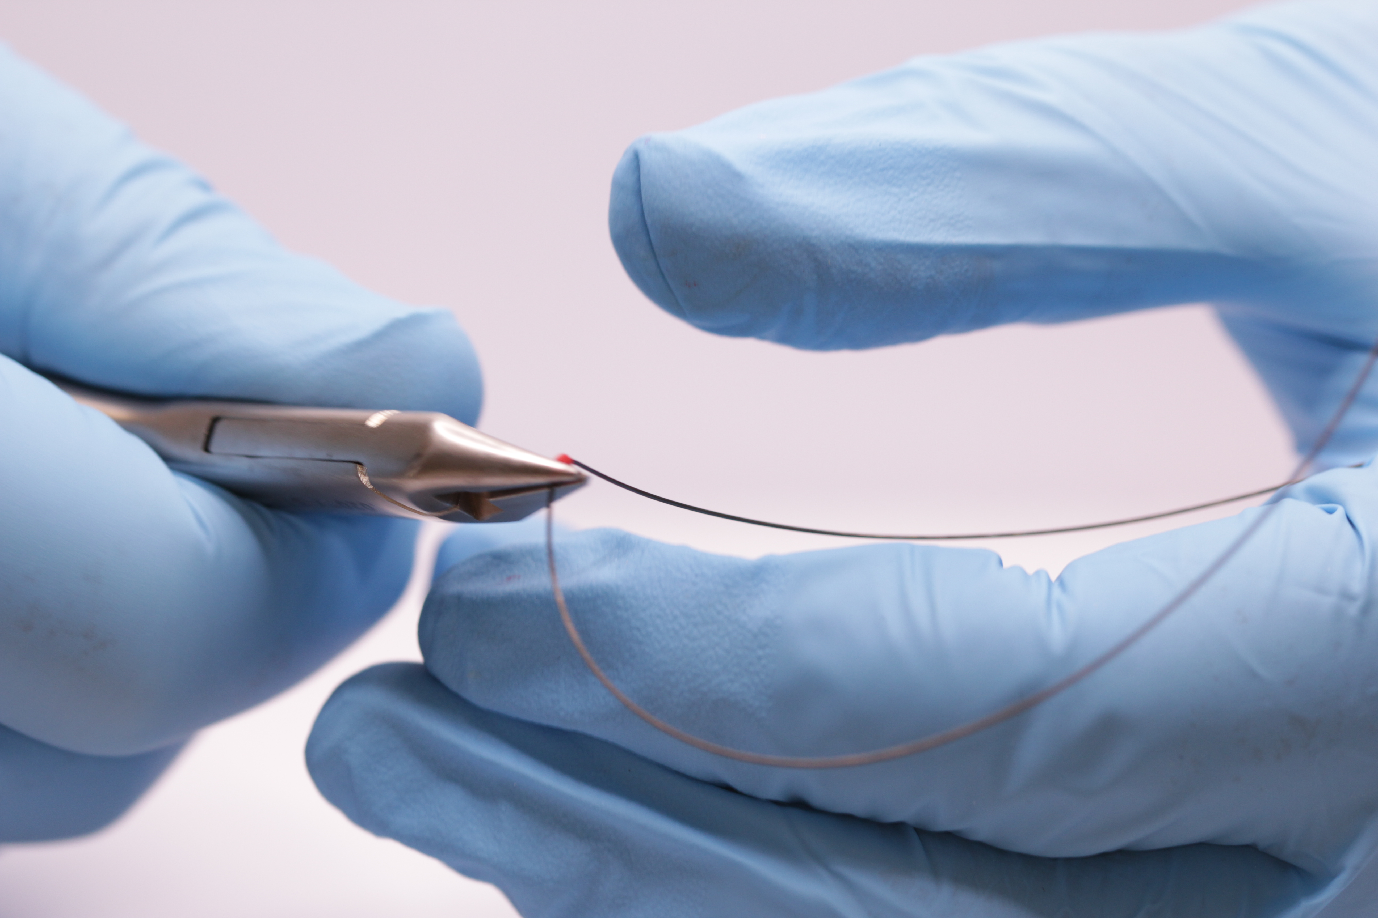
C After 3mm bend another 90° bend so that the wire turns back on itself
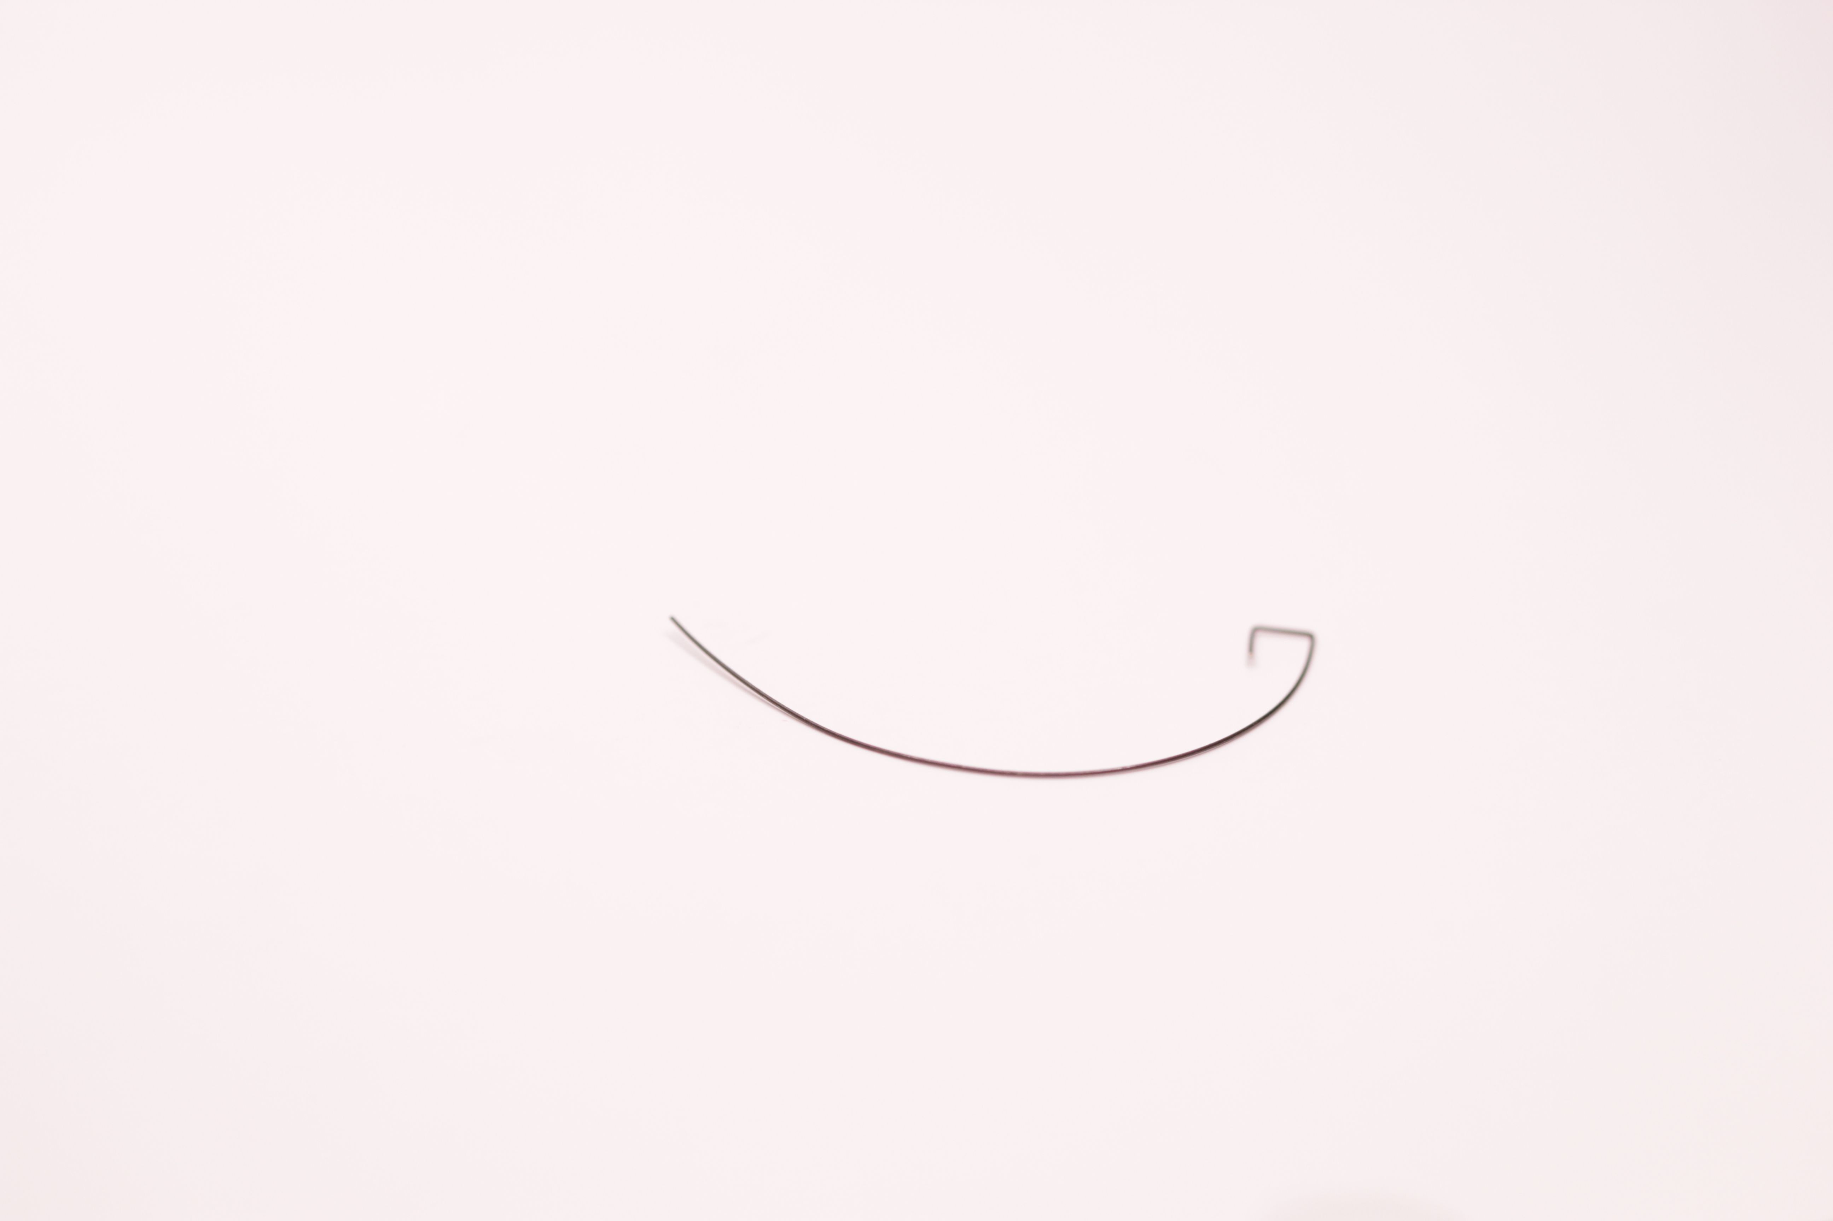
D. Note how this can be placed to produce either buccal or palatal root torque on any tooth.
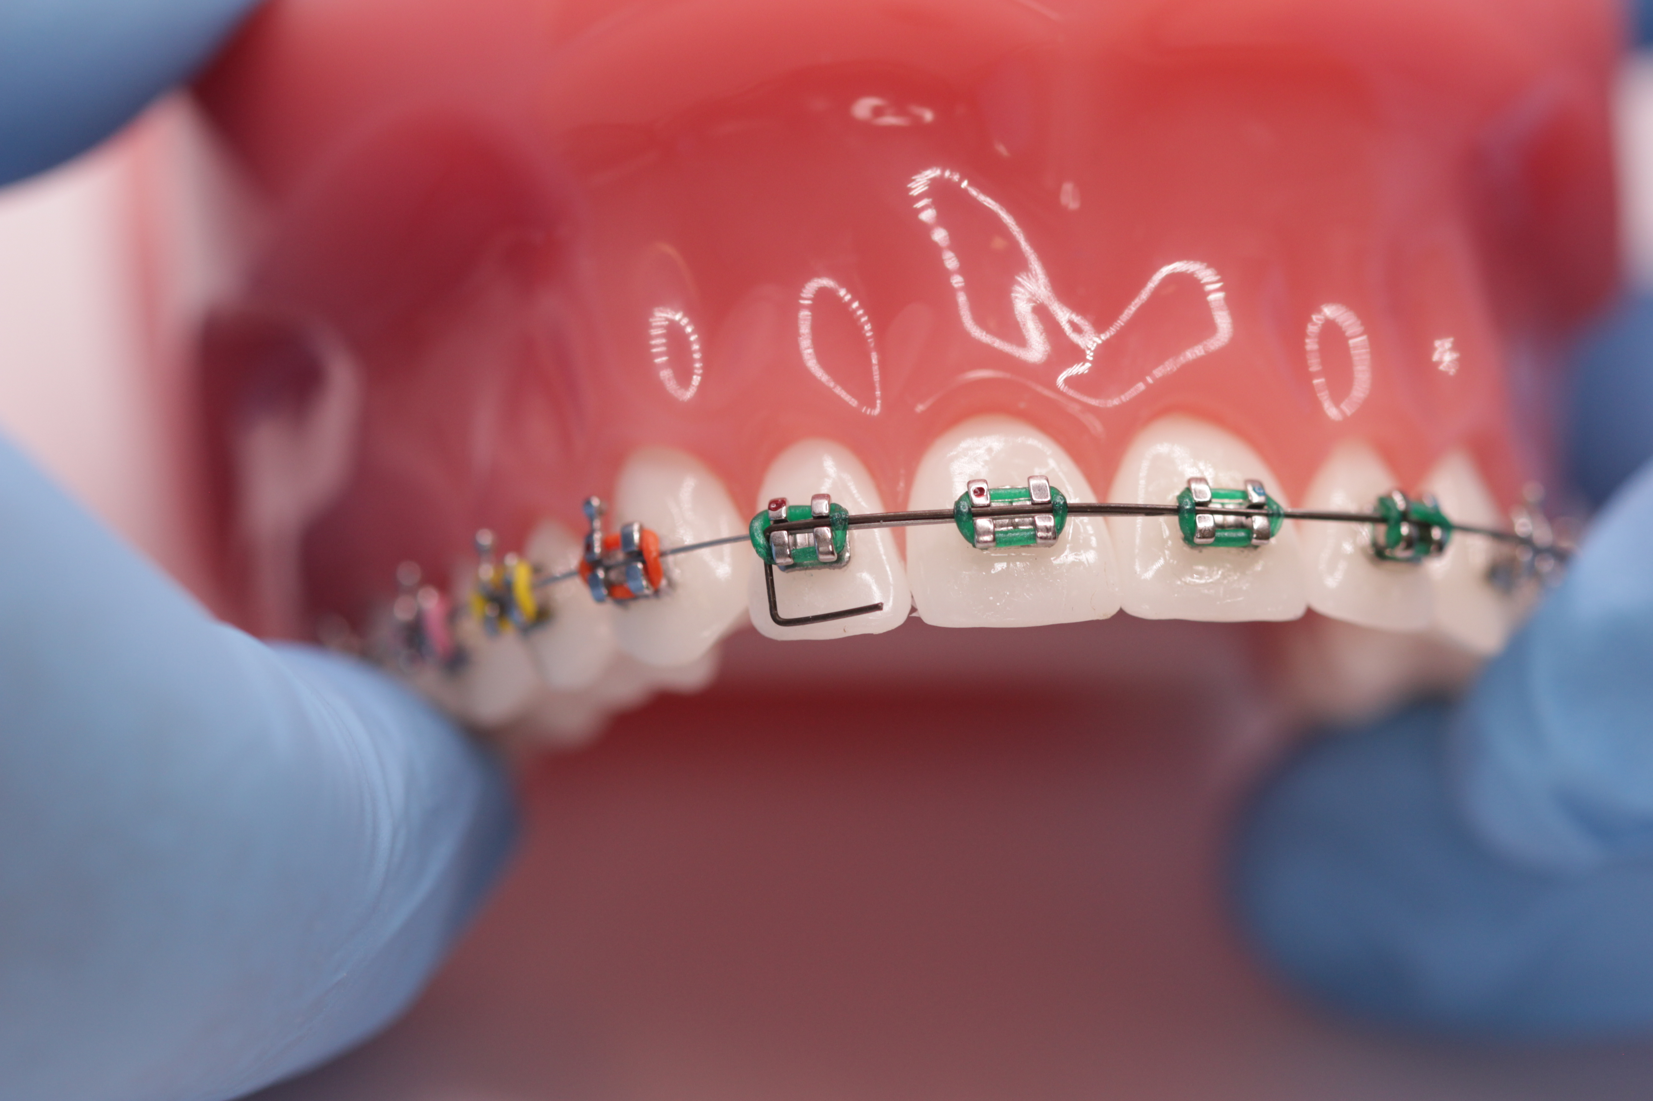
With the end incisal like this it will produce buccal root torque. The same wire with the end to the gingival would produce palatal root torque

3. Class Advanced
Ballista 016 special. (The Magic Ballista) This version of a ballista spring pulls down a palatal canine at the same time opening the space for the tooth. You do not have to bend this at the chairside there are only two versions a left and a right. Why not bend one of each and keep them in a drawer until needed.
A. Bend an archform and mark the position for the ballista.
B. Bend up at 90° and 8mm up wind a circle hook
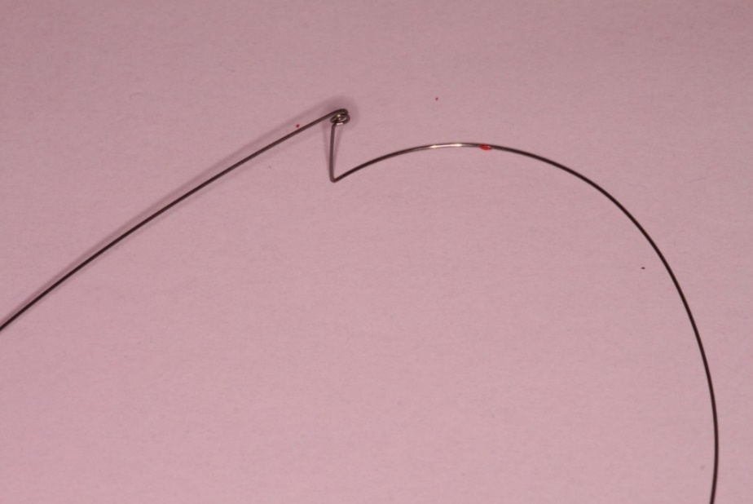
C. Bend the wire down back to the archform
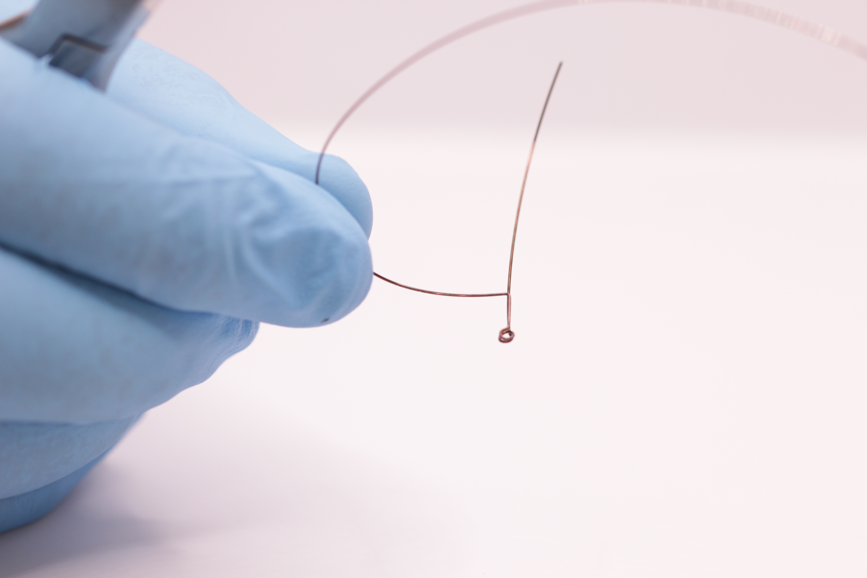
D Place a 90° bend to get the wire back to the archform.
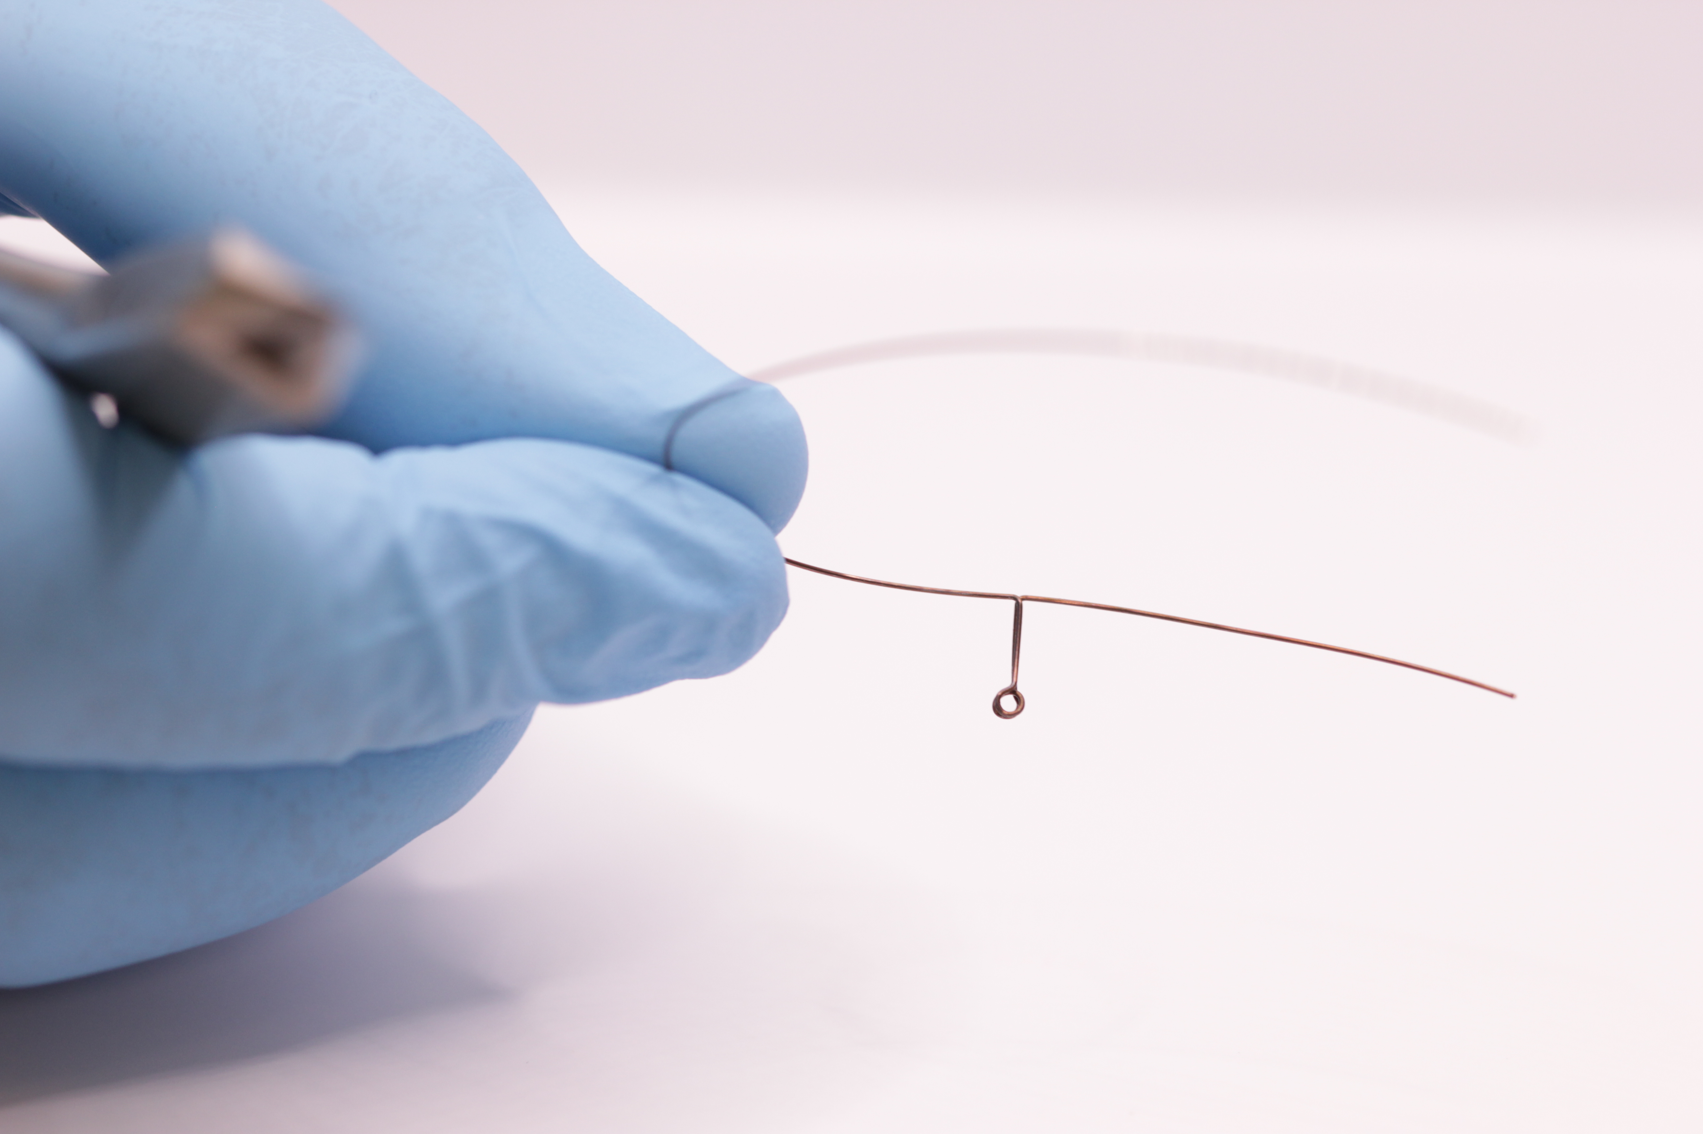
E. Place a module over the Ballista and cover with flowable composite
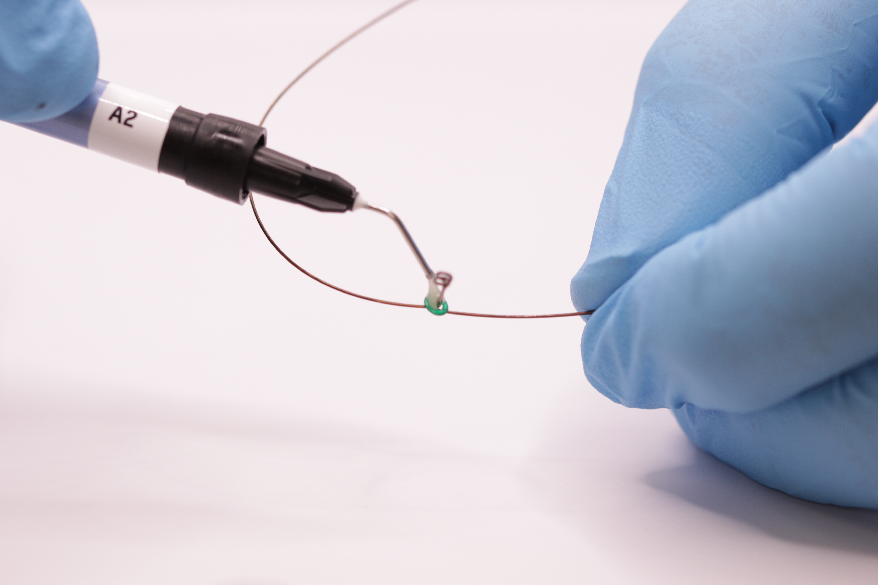
F. Slide on the NiTi push-coil and fix in place with more composite
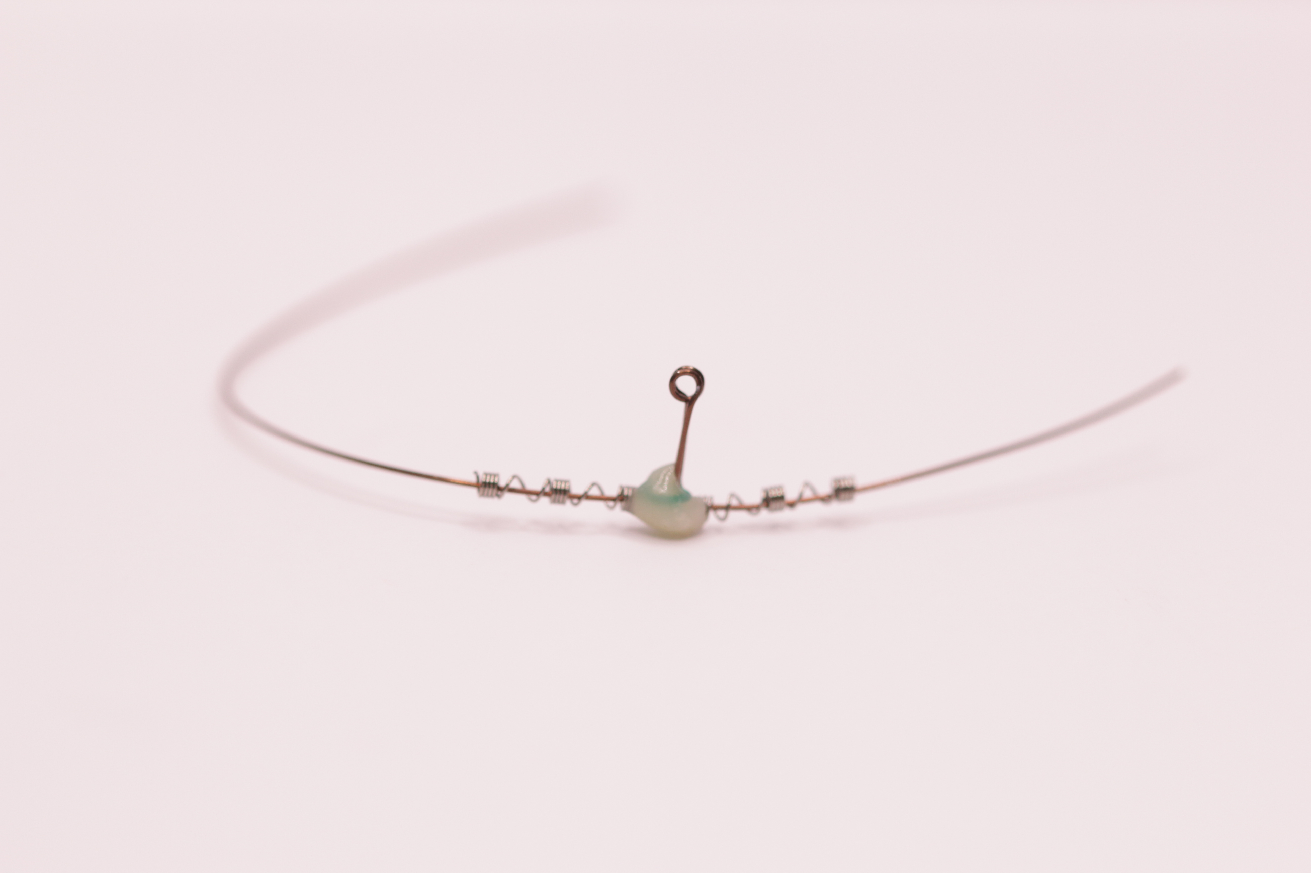
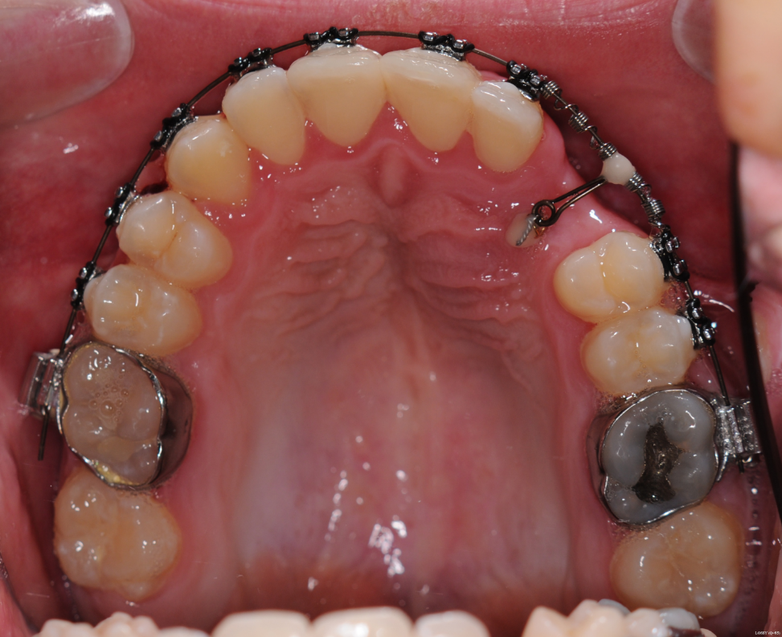

4. Class Simple.
Round wire arch with closing loops. (The test piece is in 0.016 special plus but any resilient wire will do) This achieves space closure in a friction-free way. The wire is activated by pulling the end through the molar tube and turning it up
A. Bend an archform.
B. Mark a spot between 2 and 3 and bend up at 90°.
C. Measure 7mm up and bend a curve mesially so the wire crosses the archform 3mm in front of the up bend.
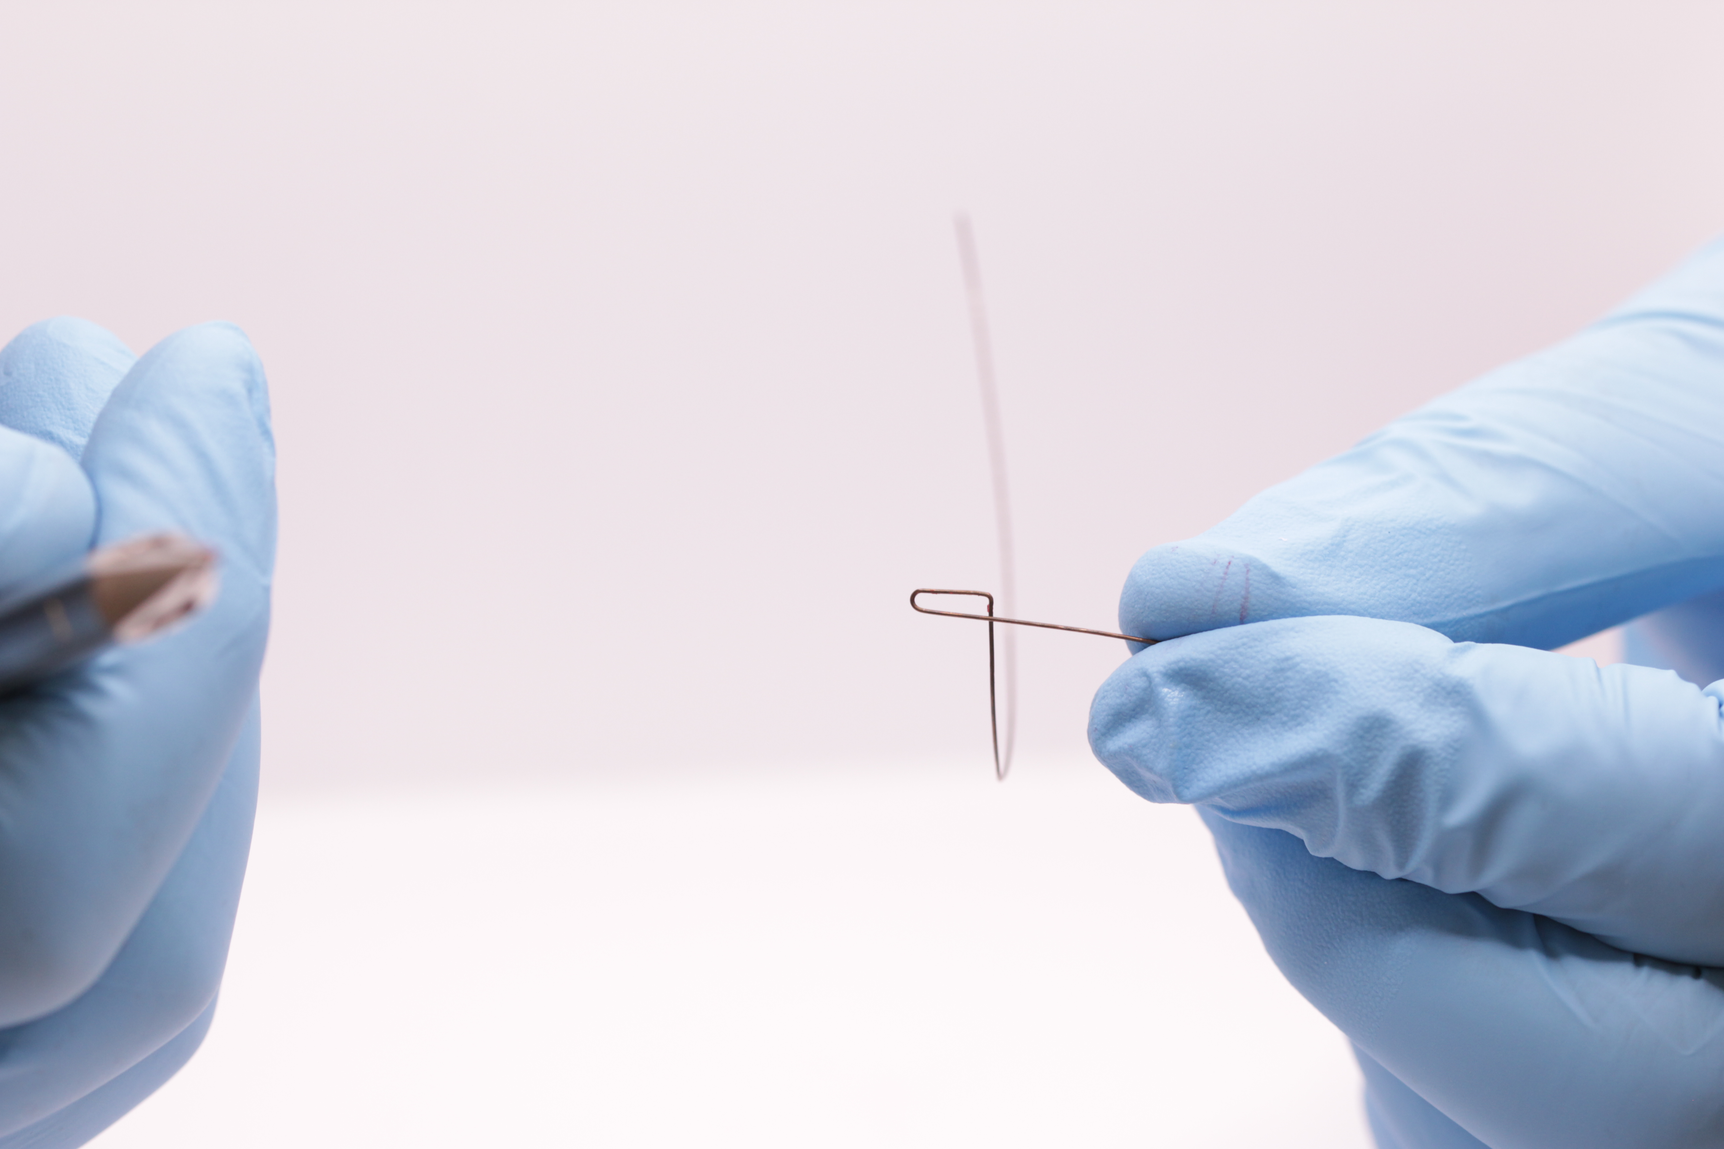
D. Now bending around the square side of the pliers complete the closing loop so that it restores the archform. (Note it will produce a tiny canine offset.)
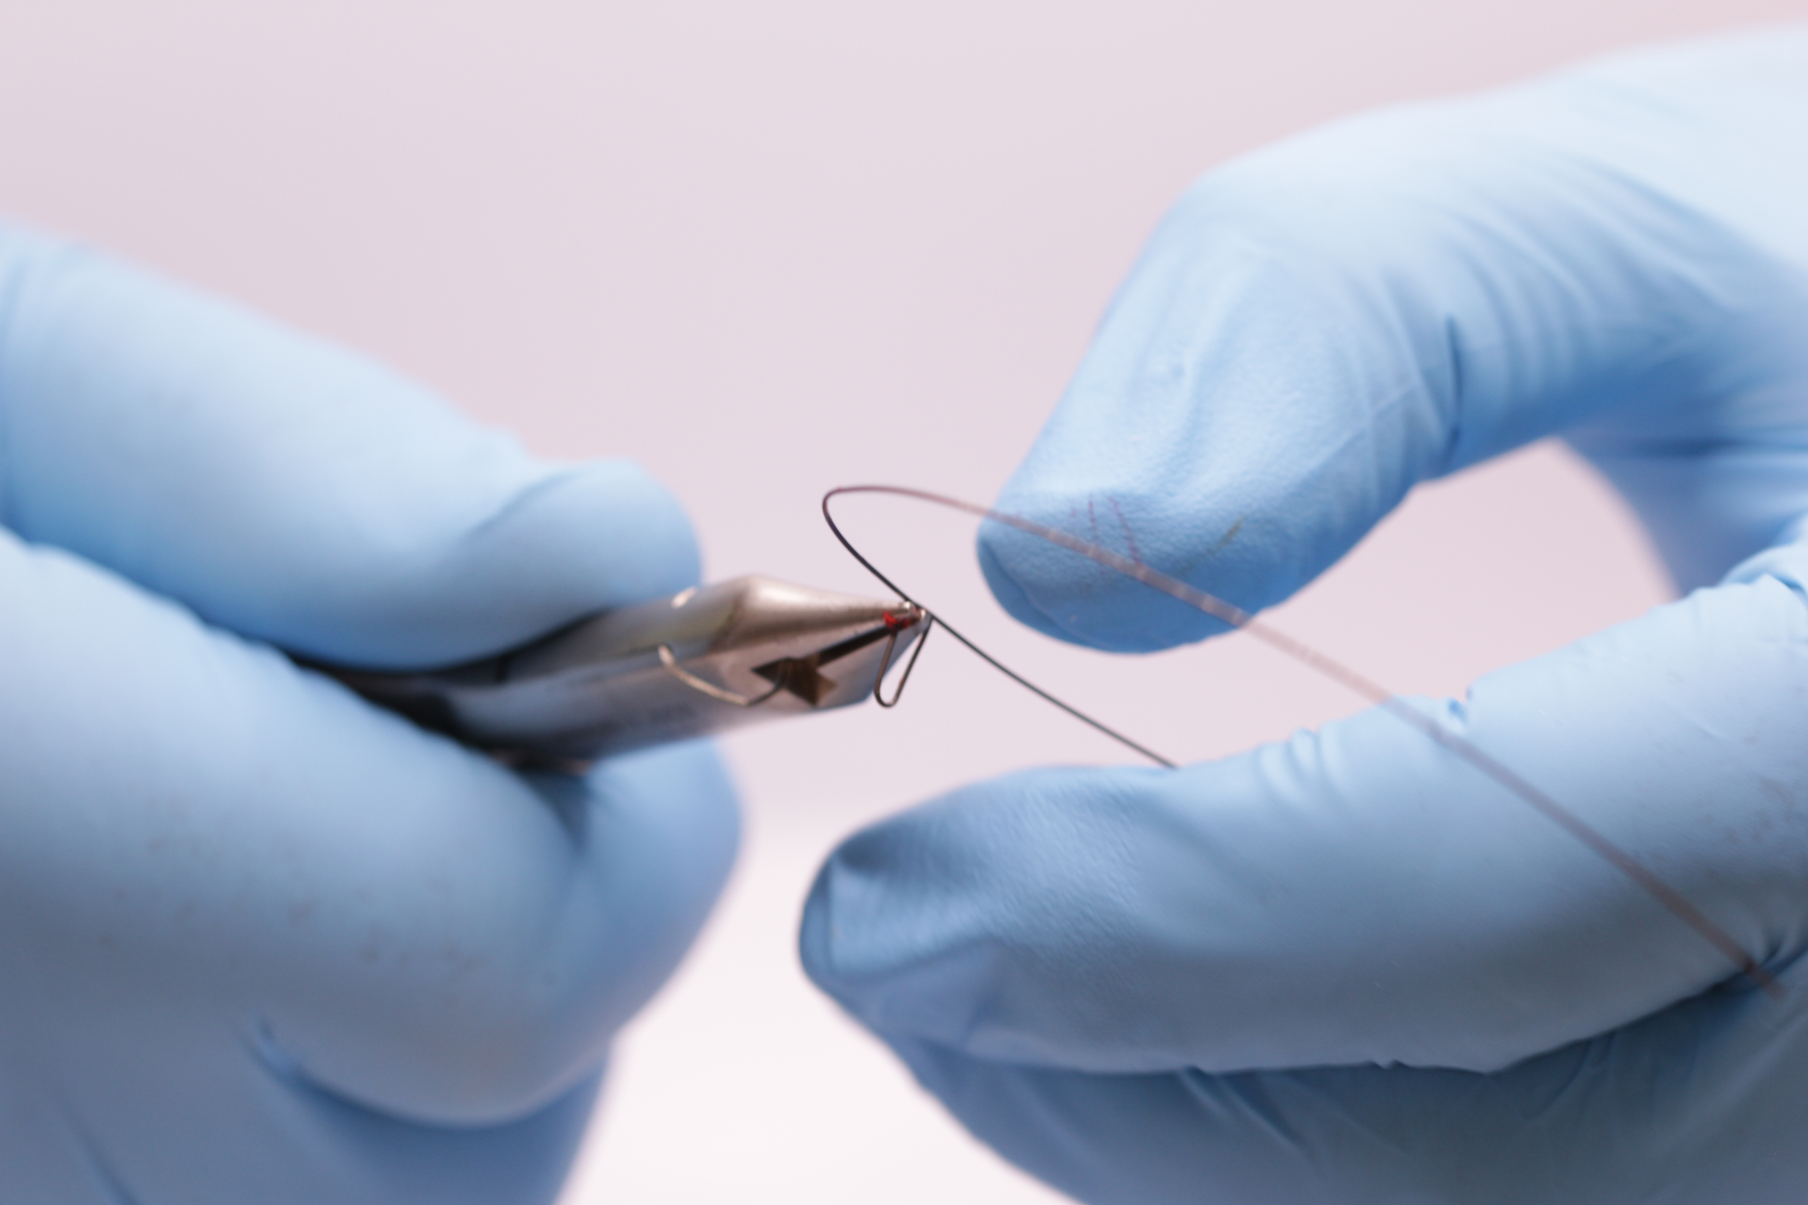
E. make sure the wire is flat before doing the closing loop on the other side.
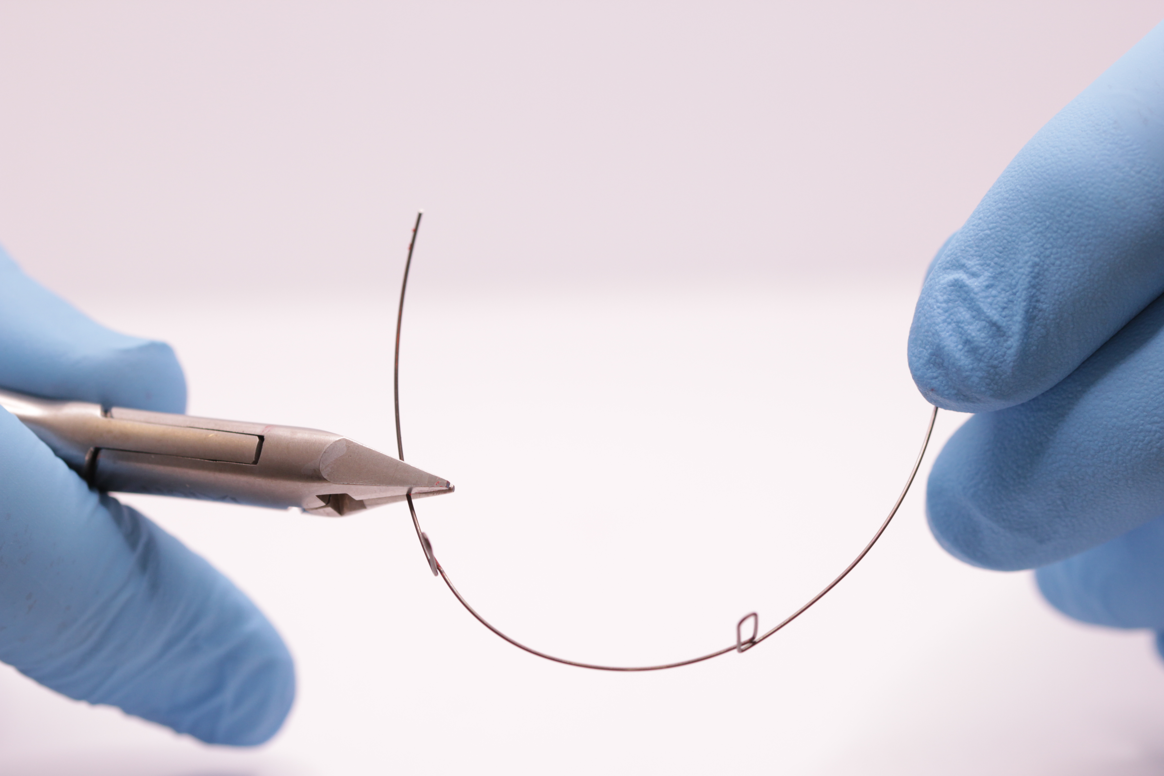
5. Class Simple
Putting torque into a posted arch where there is excessive incisal show.
A. Hold the wire as close to one post as possible and lift the distal end up by 7° (up means the same direction as the posts)
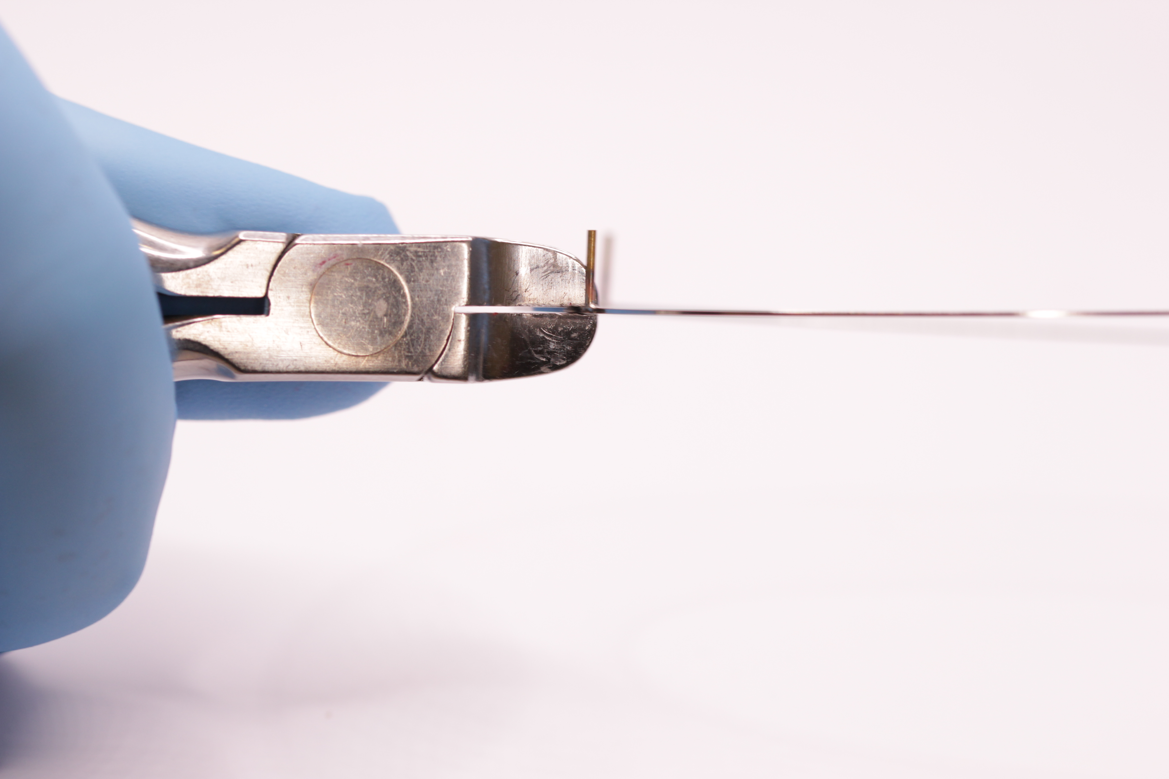
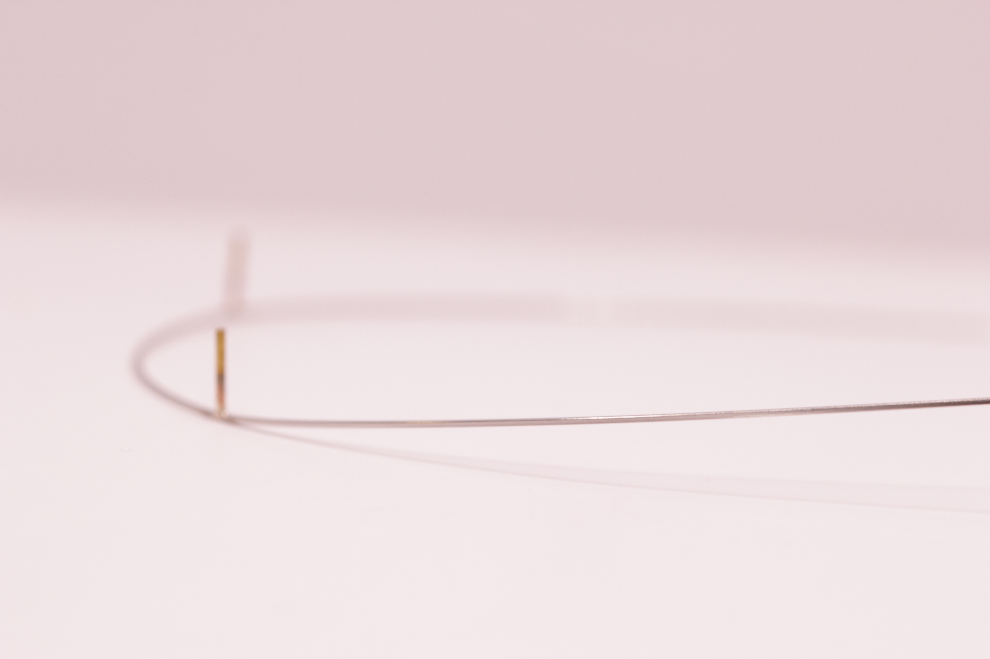

B. Hold the wire as close as possible to the other post and look across the archwire lifting the other distal end until it matches the first side
C. Place the wire on a flat surface and you will see that you have added 7° of torque but the wire is not quite flat it lifts up by 2mm at the front. In cases where there is excessive incisal show (i.e. more than 5mm) this is a good thing.
