Chapter 19 Removable Appliances
I used to think I was quite good with removable appliances but later discovered that my two wonderful technicians Patricia Watkins and Victoria Bond were a major factor in my success.
Removable appliances, including aligners, but not functional appliances.
I have already mentioned the flowering of removable appliances that occurred in the 1960s and 70s when the NHS would pay for orthodontics, but there were almost no dentists trained to use fixed appliances. The arrival on the scene of acrylic resin and a major contribution by C. P Adams (Philip) made removable appliances a possible method of straightening teeth. Adams’ contribution was:
- While he was a lecturer in Liverpool, he developed the modified arrowhead clasp, later called the Liverpool clasp and now rightly called the Adams crib.
- He published a book with details of a number of removable appliances. It contained wire bending exercises and details of the construction of each appliance. This book became essential reading for orthodontists and technicians.
- He development of the Universal pliers (In this part of the universe, we call them Adams Pliers)
Although the era of removable appliances is over, we still use Upper Removable Appliances (URAs) as retainers and often to start treatment. They can also be useful in interceptive treatments, like pushing incisors over the bite.
The Adams crib
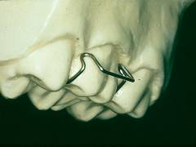
The perfect Adams crib. Note the bend halfway down the labial surface and that the bridge stands away from the labial surface.
How to adjust an Adams crib.
A. If the appliance fits but is too lose.
Place your finger on the bridge and press, if it moves or you can see a gap between the arrowheads and the tooth you need to tighten the crib. You can do this by bending the wire in one of four places:
1. If the appliance needs tightening and the arrowhead lies below the gingival margin put the Adams pliers right over the arrowhead and bend it toward the tooth. This will tighten the crib and move the contact point of the arrowhead up the tooth. (Towards the occlusal surface.)
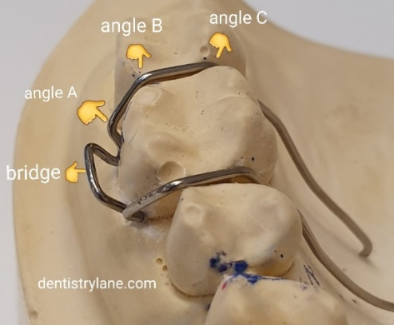
2. If the crib needs tightening and the arrowhead is just below the gingival margin for a child or just above it for an adult. You need to increase angle A this will tighten the crib and keep the arrowhead at the same point on the tooth.
3. If you need to tighten the crib but the arrowhead is above the gingival margin you need to increase angle B this will tighten the crib and move the arrowhead more gingivaly.
4. If the crib needs tightening and the arrowhead is supra-gingival and the wire lies away from the contact point. Increase angle C. (this tends to occur when appliances have been worn for some time. It should not occur in a new appliance)
B. If an appliance is too tight or springs off the teeth.
Reduce angle C on all the cribs and hold the appliance in place. If it fits up, tighten each crib in turn. If it doesn’t fit it is worth looking at the working model, if a tooth is broken on the model there is probably an undercut preventing the appliance from fitting. Check also that no teeth have erupted since the impression was taken.

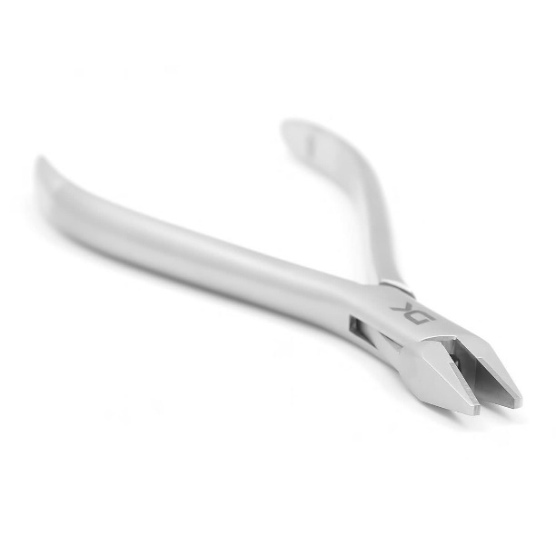
Adams pliers.

The abilities of removable appliances are strictly limited to tipping although modifications that produced apical torque of the upper incisors were described by Neville Bass in 1976 (the
Bass spring looked like a Southend clasp but was bent in 0.5mm wire) and also by me in
1982 (BJO). My version used an elastic which ran in a in bracket stuck on upper 1/1 right up close to the gingival margin. It may be of interest still, as it allows you to space close in the upper jaw giving forward movement of the premolars balanced by increased torque.
In retrospect it seems to me that both these ideas were ahead of their time.
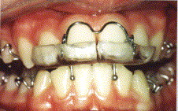
The Bass appliance had incisal capping and a 0.5 mm torqueing spring. The idea was that a high pull headgear was worn with the “J” hooks fitting into the coils of the spring. There was an empty chamber behind the incisors to allow the centrals to be torqued back and there was a full height anterior bite platform. At the time I thought:
- It worked and I had a few good cases
- The torqueing spring broke quite easily
- You could get decalcification of the incisal edge
On balance it didn’t seem that great and we moved on. Later we learnt:
- Mills showed fitting a bite-plane in Class II div ii malocclusions allowed a favourable natural forward drift of the lower incisors.
- Selwyn Barnett advocated intrusion of the upper incisors in a Class II div ii
- Marx showed high pull headgear was capable of producing apical torque.
Perhaps we should rethink this appliance
The significance of the elastic torqueing auxiliary is that you can use it to produce apical torque of the upper incisors in an aligner case. You need an aligner with a chamber behind 1/1 to allow the torque. Place a slotted plastic bracket at the gingival margin on 1/1 and trim back the aligner from this area. Then cut two pairs of double vertical slots in the first premolar region one on each side so that a horizontal elastic can be placed to apply pressure onto the slotted brackets.

Rotations were a problem with removable appliances, as a rule the upper central incisors could be de-rotated but narrower teeth were a problem. The combination of a removable appliance and a localised fixed appliance was often used.
Here are some removable appliances that are still useful in some cases:
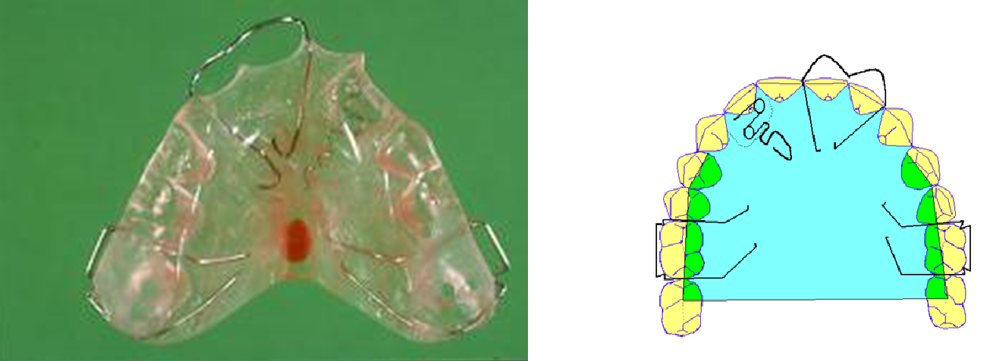
Pushing a lateral over the bite. Appliance upper left 2 diagram upper right
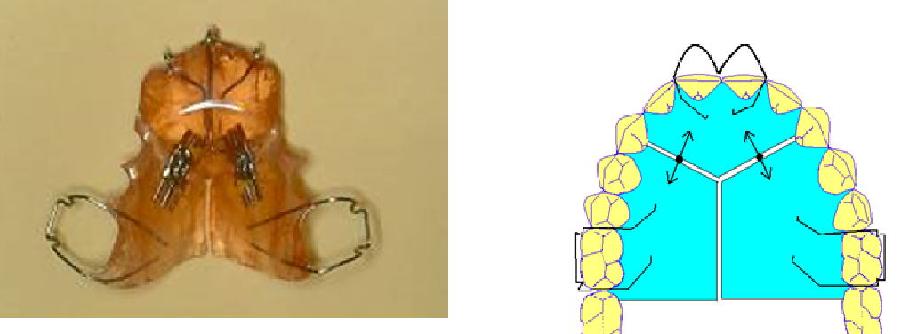
Two screw plate pushes all the incisors over the bite, expands the arch and opens space in the canine region.

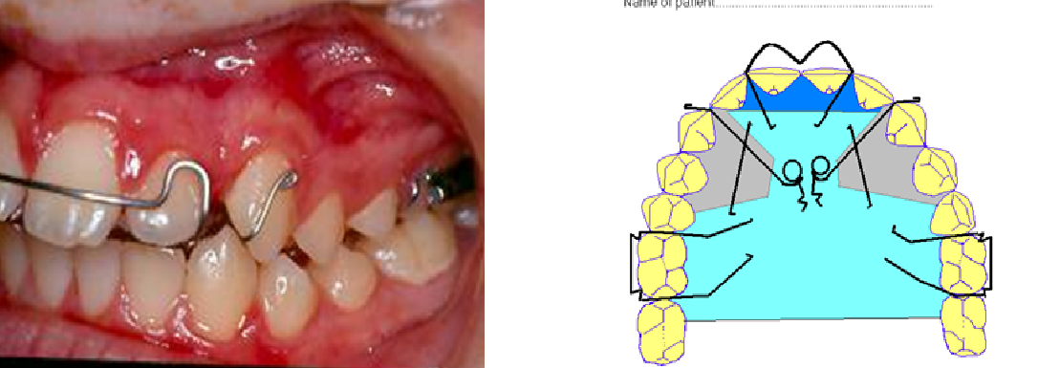
Palatal canine retractor. Use with fitted labial bow or Southend clasp for anterior retention.
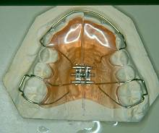
Mid line screw and labial bow sometimes called the ELSA or ESLA appliance. Trim the acrylic behind the UR1 and 10 turns of the screw and the labial segment will align. Then place a PBR.

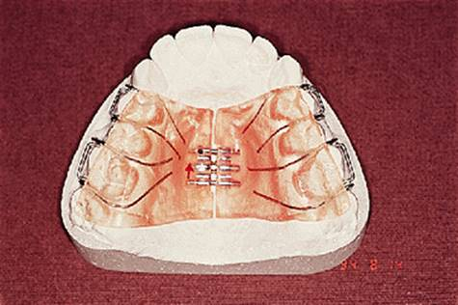
Appliance to correct crossbite where there is a unilateral crossbite and displacement on closing. Note the thin posterior bite platform.

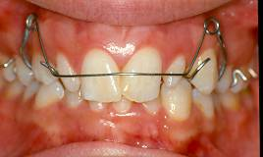
The Roberts retractor is a modified labial bow that allowed large movements without heavy forces. The wire is 0.5mm supported in tube.
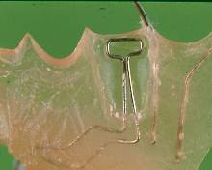
The T spring is used to move a premolar tooth buccally. To activate just pull the top of the T away from the plate.
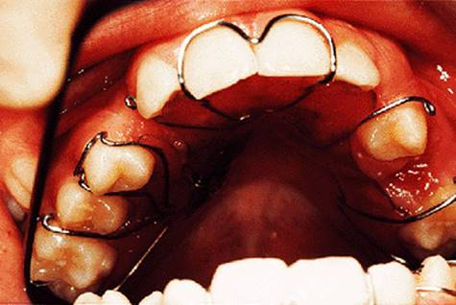
The Southend Clasp was invented by David Di Biase who was an orthodontist in Southend. He played an important part in the training of us registrars in the London area and I remember going to Southend to see his cleft palate treatments.
Closing a diastema.
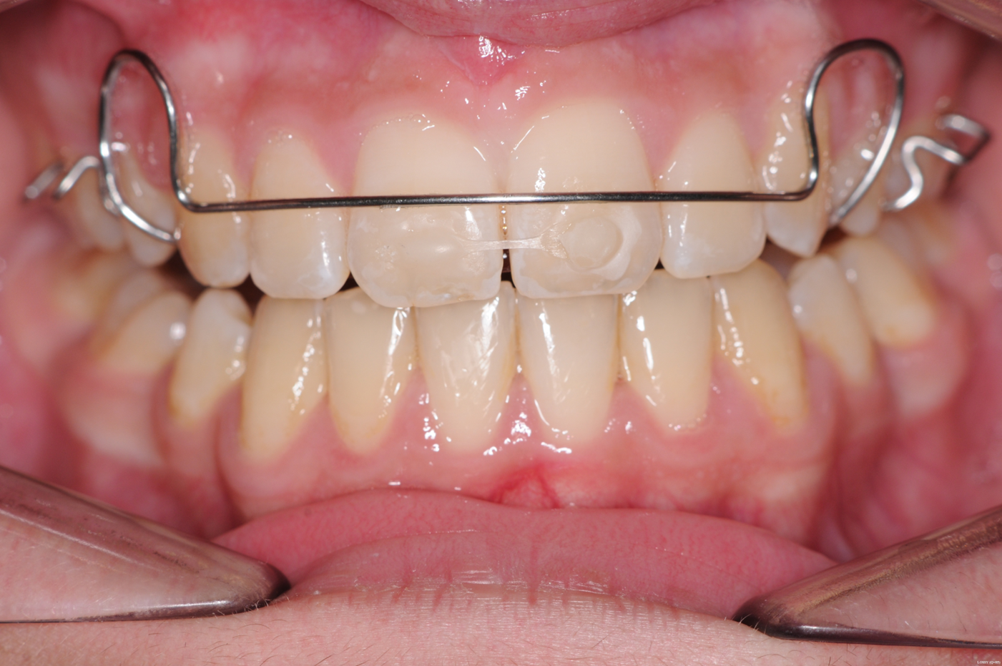
Is so simple using this idea from Helen Taylor. Bond elastic chain under tension from 1 to 1 and a Hawley retainer to prevent rotation of the teeth. One week later the diastema will have closed. Place a PBR and go on to night only wear of the Hawley.

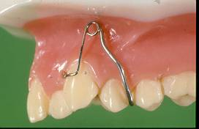
This is a buccal canine spring fitted before the extraction of the 4. However, they did tend to dig into the gingivae. Nowadays I would use a simple URA with cribs on 6s and a C clasp around the 5 and use elastic chain from 3 to 5.
URAs and the vertical dimension
You want to intrude the labial segment to correct a gummy smile. Use this simple appliance. Cribs 64/46 and hooks as shown or soldered to the premolar cribs. Stick any old brackets on the centrals right near the tips. (A chance to use up old brackets) and intrude with a light elastic until the tip lies about 2mm below the resting lip line. Warn the patient that they will only be temporarily shorter than the laterals.
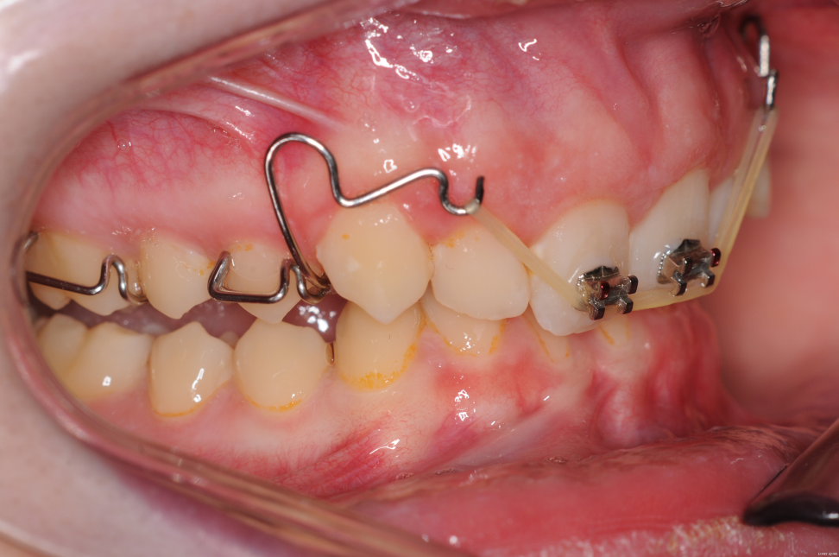
When they are up, you need to hold them with a stabilizing arch
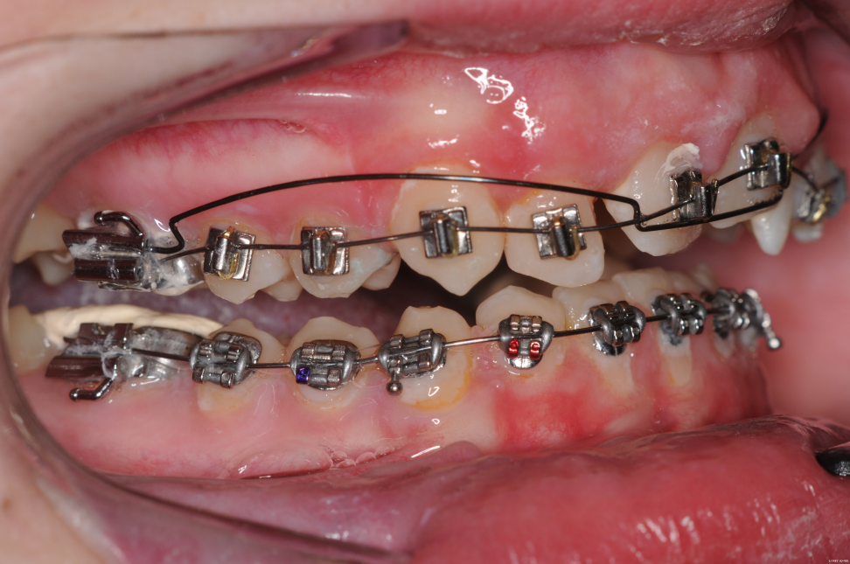
The same appliance will extrude the teeth and expand the arch. Just perfect for a thumb sucking AOB. In this case stick brackets on all 4 incisors quite gingivaly. It is best to use a flexible archwire as I suspect that if you do not there may be an increased risk of the incisor being knocked out if there was considerable trauma. This has never happened to me but if you take a radiograph you will see that the tooth is being gently extruded from its socket.
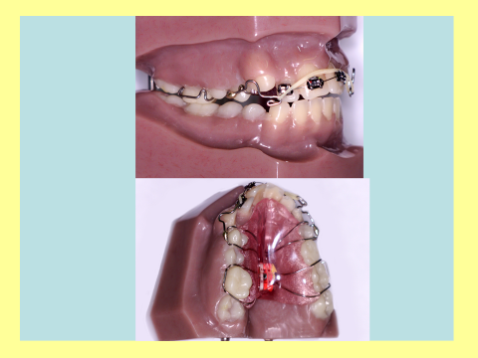

This appliance is very useful at controlling AOB.

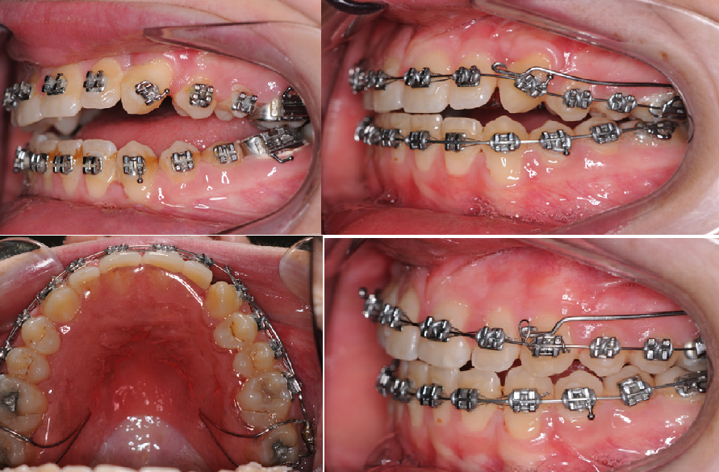
So simple, a URA with a long arm pressing on the canine bracket closes a significant open bite. In this case the removable appliance was worn evening and night only.
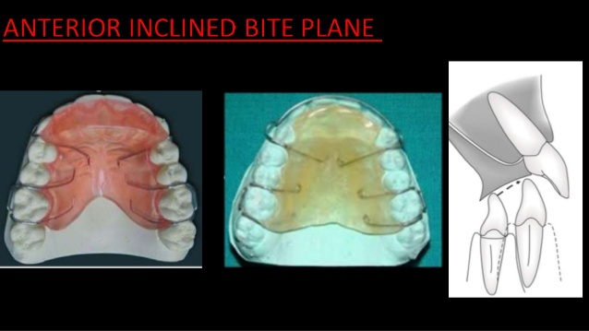
You can open the bite using a removable appliance with an anterior bite plane. It must be worn full time even for meals. Just removed for cleaning.
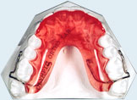
A clip over bite plane can be used if the fixed appliance has already been placed so you cannot use Adams cribs on the 6s. The best option is the Plint clip named after Jock (really Dennis Arthur) Plint a remarkable consultant orthodontics who was awarded the British Empire Medal for bravery, not for teaching me (although he probably deserved it) but for swimming out and rescuing a drowning man from shark infested waters.
Your technician would rather make a re-curved clip but this makes an appliance which is very difficult to get in and out.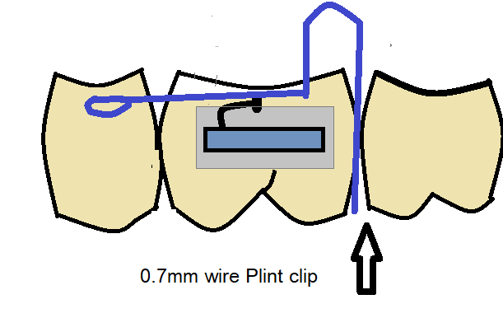
The significance of a bite plane is that it will open the bite even if there are a reduced number of posterior teeth.
A modern removable appliance
Inman tries to persuade us that the Inman aligner is modern because it has NiTi push coil in it. The incisors are squeezed between a lingual part which is being pushed forwards and a labial part that is being pulled back. It seems to me it does nothing that the ESLA appliance with Z springs behind the incisors could do but if you like it fine.
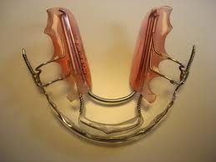

F7 Part Two Aligners
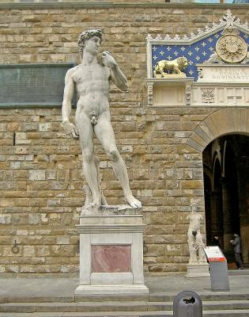
Fig. David had a very small part, in the history of aligners.
The first pressure formed retainer material was Trutain. The company say it started in1975 but it didn’t reach Burton on Trent until 1990. It didn’t take long to realise that if the patient stopped wearing the retainer for 2 weeks and a little tooth movement occurred, they could regain the original tooth position by forcing the retainer down and wearing it full time for a while. If the movement was too great the retainer would not fit, but you could make it fit by cutting along the incisal edge of the retainer with a scalpel in the area of obvious tooth movement. The split opened a little giving flexibility within two weeks the teeth had realigned.
The next step was to use the same method as a treatment of mild irregularities:
- Take an alginate impression
- Carefully cut off the mal-positioned teeth and reattach them to the model in the perfect (or slightly overcorrected) position using a high fusion point wax. (Ausblockwachs transp C ref-725-080 from EM NATTLtd 45-47 Frien Barnet Road London N11 3EG) This clear transparent wax melts at 86°C
- Then pull down two identical retainers using Essix Ace 0.030” material.
- Then using a sharp scalpel cut along the incisal edge of one retainer just one tooth past the irregular ones.
- The patient needs to wear the split retainer full time for 2 weeks. Then the split one full time for two weeks. This will correct the malocclusion. Then reduce the wear by one hour each day until you get to night only.
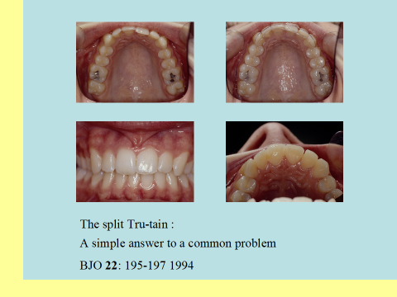
This treatment was so easy, so successful and so popular with the patients that I published it in 1994 and I believe it was the first published account of aligners. It still works very well and I still use it. But I am just a little wiser than I was in 1994 and now realise I was blessed with brilliant technical support in Burton and would like to thank Patricia Watkins and Victoria Bond for their excellent work.
The split Essix works fine but doesn’t cope with crowding. You can strip the teeth or pre-treat with a URA:
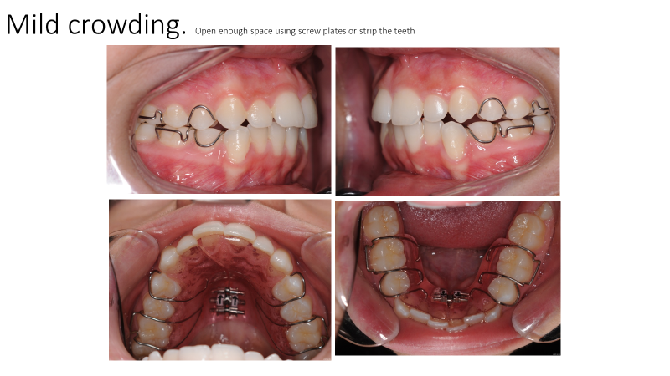
. 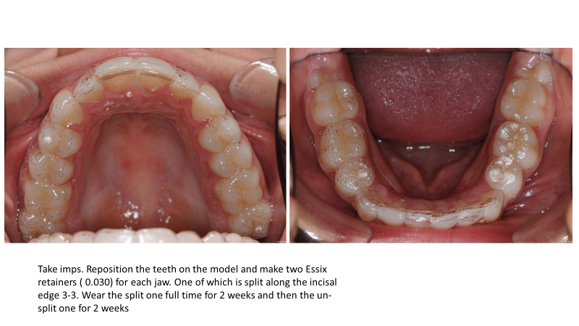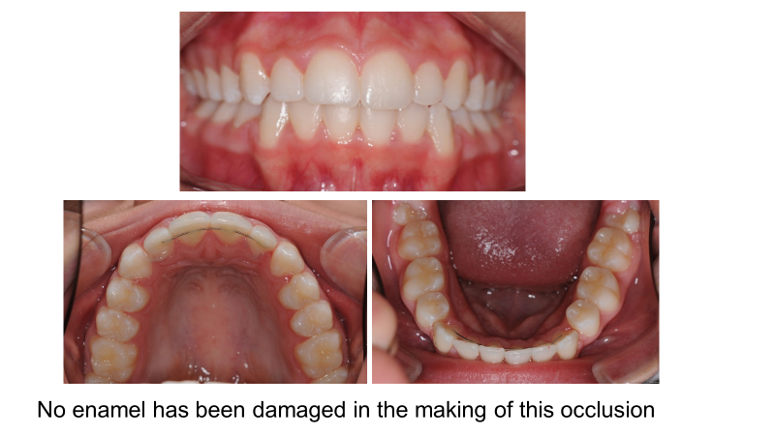
Just to align the teeth with a split Essix is very cheap (about £100 per arch) and for the patient who has not worn retainers properly it allows you to change an unhappy customer to your biggest fan. I have done some quite severe malocclusions using this method but you need to do it a section at a time. You can extend the idea by fitting bands on upper 6/6 and a Nance button. Then extract upper 4/4 and bond elastic chain directly from upper 6 to 3. This retracts the canines and you can use split Essix treatment to align the teeth
About 10 years later there was a new kid on the block.

INVISALIGN.
The arrival of Invisalign marked the arrival of something new in orthodontics, marketing.

Patients come to your clinic not asking for aligners but for Invisalign. Registrars are not interested in other systems they want to be registered users of INVISALIGN.
I do not for one-minute think Invisalign copied my ideas of 1994, indeed I would be amazed if they read the paper. At that time other firms were introducing similar systems. Let’s look at the good and the bad.
Good
- This is a sophisticated system where computer controlled incremental movements are made between each aligner. Each aligner is worn full time for two weeks.
- By using sequential movements, it is possible to get more controlled alignment
- By bonding small clear blocks onto the teeth (Smart Force attachments) the aligner can achieve mesial and distal movements of teeth
- Invisalign can provide help with the planning and using the clin-check you can modify the treatment plan.
- The aligners are capable of a small amount of intrusion of teeth. By intruding upper 6 and lower 7 on each side it seems you can close an AOB. (you can also do this with fixed appliances)
- By bonding buttons or cutting double slits in the aligners you can use class II or class III elastics
- By bonding attachments on a tooth near the gum margin buccally and palatally you can place an elastic over the aligner and extrude it
- It is the patients dream to have invisible orthodontic treatment (but this is true of other aligners and lingual orthodontics)
- Invisalign have done an impressive amount of development of their techniques.
- I have seen a few very good cases
Bad
- It is very expensive
- The failure rate is quite high. (It is true this is largely the patient’s fault but not many of them see it that way. A. typical story is that the patient became ill and left the aligners out and now are faced with another bill. We can all see that is not the dentist’s fault but you can bet this is not the story that the patient is telling everyone.
- You have to pay a lot of money to Invisalign to use their appliance. Can you imagine Tesco saying you could not push a trolley around their store unless you paid £1000 to go on a course?
- It is good at alignment of non-crowded incisor teeth. But some movements are less good. Examples include all second order movements and rotation of canines. See above for my ideas of apical torque with aligners.
- You cannot bring down un-erupted teeth
- Many Invisalign users seem to ignore the basic rules of a normal overjet and overbite and nicely slotted buccal segments.
- I have seen relatively few Invisalign cases at meetings. I hear claims that they can produce torque and close AOBs but I don’t see the cases. I have seen many more fixed cases.

