Chapter 4
Class II division I malocclusions
Definitions
British standard: The lower incisors occlude, or would occlude, palatal to the mid one-third of the palatal surface of the upper incisors and the upper incisors are not retroclined.
And Angles classification:
The molar relationship is class II and the overjet is increased.
Causes
- Dental base relationships
- Soft tissues
- Habits
- Mouth breathing malocclusions
- Pathology
- As a result of treatment
- Musical instruments; Saxophone ,clarinet (disputed by some)
- Iatrogenic

Features
It is quite interesting to note the diversity of class II division I malocclusions. Note the aetiology of a class II division ii malocclusions. You need a mild to moderate skeletal II base and an average or reduced FM angle. The lips must be competent or mildly incompetent but habitually held together. The effect is to retrocline the upper incisors as they erupt and because the dental bases are class II at that time the lower incisors are further back allowing the upper incisors to over-erupt and the smile tends to be rather gummy. So all the features of a class II division ii have a simple, logical, explanation and all patients with this type of malocclusion have a very similar facial form. [As growth continues the severity of the mild skeletal II relationship diminishes and they may become skeletal I or even mild III. As this happens the chin becomes more prominent.]
You could say the same for class III malocclusion, here the aetiology is almost always skeletal. The forward position of the mandible pushes the lower teeth towards the lips and this causes them to be retroclined. At the same time the upper incisors lie back closer to the tongue which causes them to be proclined. These changes tend to mask the underlying skeletal problem and are referred to as “soft tissue compensation.” (In fact, class III is a bit more complex because it is in 4 sub-groups: High angle, low angle, small maxilla and large mandible)

Class II division I malocclusions are much more varied: -
- In some cases, the aetiology is purely skeletal class II with an element of soft tissue compensation masking the severity of the underlying skeletal defect. In these cases, you would expect a normal inclination of the upper incisors and proclination of the lower incisors. The overbite would be increased and complete. The increase in overjet is quite small by comparison to the skeletal pattern.
- Lip trap malocclusions occur where the lower lip works behind the upper incisors, the FM angle is usually low (Hence the lips are firmly together albeit with the upper incisors trapped in between). Here the upper incisors are out of control of the lower lip and are significantly proclined. The lower incisors are squeezed back by the active lower lip and are markedly retroclined. See how this gives the opposite effect, the overjet is greater than the skeletal discrepancy. The overbite is usually very increased and complete.
- [You might like to stop here and consider the ease of treatment of these two different versions of class II division I malocclusion.] The lip trap occlusion is often a piece of cake to treat. A Modified Clark twin block will work well and because the uppers are proclined they will tip back but still be at a normal inclination the lower incisors will come forward, but again this is helpful and because the skeletal discrepancy is mild the end result will look good. Where the aetiology is purely skeletal the twin block will struggle. Progress will be slow and the upper incisors will be retroclined and the lowers too proclined after the overjet is reduced. There are some points to learn here (A) Don’t expect all your twin block cases to progress at the same speed and (B) there is a problem in clinical trials of functional appliance cases because lip trap type malocclusions are so easy to treat]
- The tongue to lower lip swallow is associated with an incomplete overbite the upper incisors are proclined by the activity of the tongue but the lower incisors are not retroclined as you see in a lip trap malocclusion.
- Sucking habits procline the upper incisors and retrocline the lowers. Again, the overbite is incomplete but here often there is an anterior open bite and often it is off-centre and not extending back past the canines. Note how the overjet can be very large even if the skeletal pattern is class I. In fact, it is possible to have a class II division I malocclusion on a skeletal III base. The lower tongue position and the negative pressure during thumb sucking can give rise to a crossbite.
- Crossbite is also a feature of the mouth breathing malocclusion. The maxilla is narrow and crowded. The FM angle is high and the upper incisors are out of lip control. Often it is the crowding caused by the narrow upper jaw that contributes to the increased overjet.

RARE CAUSES OF CLASS II division i

- Tongue thrust malocclusions show proclination of both upper and lower incisors together with a marked anterior open bite. Here I am talking about an Endogenous tongue thrust the word endogenous means originating within an organism or having no apparent cause. This separates it from the behavior of the tongue where it seals the mouth to overcome swallowing problems where there is a lack of teeth or an open bite caused by some other known cause. That would be an Adaptive tongue thrust. An endogenous tongue thrust is associated with a lisp [Interdental sigmatism] and excessive activity of the circumoral musculature during swallowing.
- Strap-like activity of the lower lip during expressive behavior people stopped talking about this 30 years ago. Together with tongue thrust there are people who don’t believe it exists. The idea is that the muscles of the lower lip contract excessively pulling back the lower labial segment. Ballard believed that treatment made these cases worse.
Sorry but we need to digress here; Proffit (who registrars believe) tells us that swallowing cannot have any effect on the occlusion because a force needs to be acting a long time to move the teeth. And he would say the same of strap like activity of the lower lip during expressive behavior. It is worth remembering that is just Proffit’s opinion not the result of research, after all it is possible that after swallowing or smiling the lips remain in that position for quite a while.
- Pathology. Bilateral Condylar fracture. Rheumatoid arthritis of the condyles. Idiopathic condylar resorption. Un- repaired cleft lip. Sickle cell disease and thalassemia (because of the overgrowth of blood forming areas in the bone of the maxilla) Treacher Collins or Mandibulo-facial dysostosis. Other First arch syndromes e.g. Goldenhar’s disease. Pierre Robins sequence. Parry Romberg syndrome.
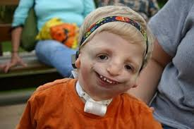
Treacher Collins

- Iatrogenic. Orthodontic alignment (with fixed appliances or aligners) by enthusiasts without a formal orthodontic training often ignores the sad truth that if you have class II molars and align without extraction you will produce a 9mm overjet.
----------------------------------------------------------------------------------------------------------

Treatment Objectives
Camouflage treatment
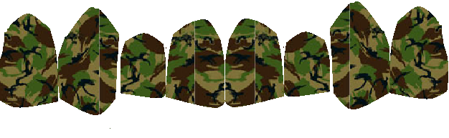
I blame Proffit for this term. I feel it causes a misunderstanding. First of all, let us just clarify the idea. It goes like this.
If the maxilla is a normal size but the mandible is too small you can disguise the problem by pulling back the upper labial segment to give a normal overjet and this will look OK because the eye sees the lower jaw is normal relative to the upper.
All the above is true, so what’s wrong with the term camouflage?
I suppose it is the idea that camouflage is somehow inferior treatment. Indeed, we have now bread a generation of orthodontists who will persuade their patients to have surgery on the belief that camouflage treatment is wrong. So here is a game to while away those tedious hours on the new patient clinic. Write down the SNA SNB measurements BEFORE you send the patients to X-ray then measure them and see how close you are. I suspect you will conclude as I do that there is quite a wide margin for error. In fact, more than anything else it is the naso-labial angle that is important. If it is greater than 95 degrees you should be careful about retracting the upper incisors.
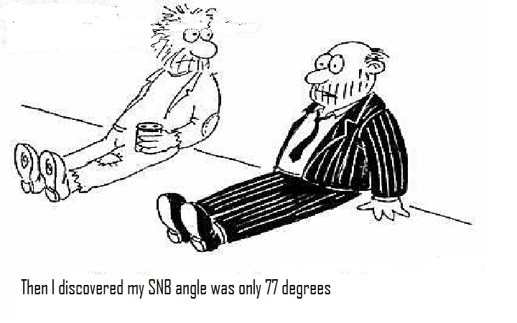

On the other hand, Ray Edler discovered facial attractiveness increased as the cephalometric measurements approached the average. My feelings are that if SNB is less than 75 and the Naso-labial angle is not acute you should consider surgery. I have colleagues who are evangelical that skeletal class II patients should not have camouflage treatment and it is better to have no treatment. But it is much more difficult. If you look at the results of orthognathic surgery not all the patient look like beauty Queens (or Kings) and many camouflage cases can look great. To decide if you can get away with camouflage look at the upper lip line. If the naso-labial angle is less than 90° then camouflage may be a good idea.
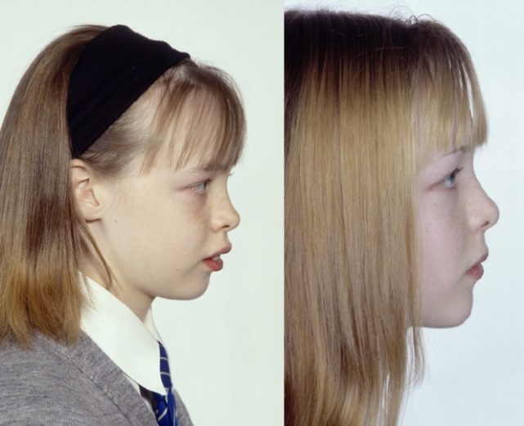
Fig Camouflage treatment. Does it look that bad?

Objectives continued
Let’s be honest sticking out teeth don’t look too great, but that is not quite the same as overjet. Sometimes when the overjet is increased but the upper incisors are at a normal inclination patients can be happy with the appearance of the teeth. While others with only a slightly increased overjet but very proclined upper teeth can be concerned. This is quite different from our teaching to budding orthodontists, they (you) are trained that the reduction of overjet to 2mm is the most important treatment objective. That is why it has a weighting of x 6 in PAR scoring. In part this is because we know that partial reduction of the overjet just will not do because: -
- It allows the lower lip to come behind the upper incisors allowing a relapse of overjet.
- The muscles of facial expression cannot work normally when the overjet is increased so the result is always un-satisfactory with excessive use of the mentalis muscle.
As well as this the occlusion functions and looks better when the overjet is normal. After all teeth are supposed to bite together that is what they are for.

Growth modification
In orthodontics you may be able to produce orthopaedic change by: -
- Headgear.
- Functional appliances
- RME
- Facemask/ Bone anchored maxillary protrusion (see class III cases)
Headgear inhibits the downwards and forwards growth of the maxilla. You need a high force worn aver a long period. The direction of pull needs to be upwards and backwards and the force needs to be distributed over a wide area rather than delivered just to one tooth. As you know in class II division I malocclusion the problem is more likely to be a retro-gnathic mandible than an overgrowth of the maxilla. So, is this type of treatment justified?
Functional appliances may promote additional mandibular growth but the amount always seems to disappoint and again some of this change may be in the form of a restriction of the forward growth of the maxilla.
One possible way of increasing the growth effect is to use both at once.
(Add EOT to Twin Block or use a Teucher or Van Beek appliance.)

Treatment
- Removable appliances
Simple removable appliances have rather gone out of fashion, but once they were the mainstay of British orthodontics. Now my patients say that they don’t want plate braces, they want proper fixed appliances. Now that we are into Invisalign etc. perhaps we could add removable appliances to retract canines and then an elastic to retract incisors followed by Invisalign (or a split trutain) to align the teeth. In fact, many of the 21 century aligner ideas are removable appliance concepts taking away the Adams cribs and replacing them with a plastic former going into the undercuts. Aligners are being modified to include springs and screws.
Why did it happen?
NHS arrived + no trained fixed appliance orthodontists + Invention of Acrylic + CP Adams describes the Adams crib
What appliances were used? A huge flowering of designs of springs, screws and elastics which could achieve quite good results. It is often said that it is not possible to produce rotations or torque but this is not strictly true Bass, Clark and even yours truly, showed designs that could produce torque. De-rotation of wide teeth like central incisors was quite easy but for smaller teeth or round teeth it was impossible. (But you could add little spurs to the teeth to rotate them.)
THE PROBLEM IS, THAT YOU GET WHAT YOU PAY FOR. So, if you pay for poor work and broken appliances that is what you get. Under the new contract things have changed now you get paid for “start treatments” so you will find people will start a case and then
-

Nothing.

Today some orthodontists use URAs to open the bite. Good news. It works very well even in adults. Bad news. In a state funded system it is so hard to get people to wear the appliances. Often even quite good patients leave the appliances out when they eat, Peter Huntley says that adults will wear URAs if you charge them enough but my advice is; yes, you should try them and all other methods of bite opening, and reach you own opinion. Just a warning if you use URAs you will find you get disillusioned.

Removable appliances and habits.
If you want to try to stop a thumb sucking habit in a young child. I would advise the use of a fixed in appliance which is basically a Nance button with a goal post or a hay rake on it. If you are prepared to wait until the child is older and wants help to try to stop a habit you can use a URA. In theory any URA will do but why not try and use one which corrects the malocclusion? So add a mid-line expansion screw and how about an extrusion elastic.
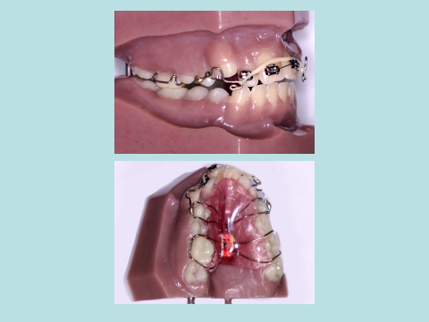

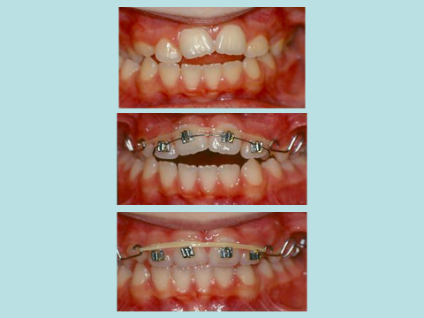
So other ways to stop habits are Oral Screens and spurs or brackets stuck on the palatal surfaces of the upper incisors.
Some removable appliance ideas remain as part of fixed appliance therapy. For example, the inclined bite plane can be used as a way to procline the lower incisors. It can be added to a fixed appliance and some people recommend it after functional appliance treatment. [I do not think that there is any real evidence to support the use of an inclined bite plane after functional appliances; it seems to me that they would only work in cases where the functional had not fully reduced the overjet and the patient was posturing. After all, if the patient had an edge-to-edge bite they would not bite on the inclined bite plane].
I suppose you could also consider a Nance button as a part of removable appliance that has been added onto a fixed appliance



Fig At its height removable appliance therapy became quite an art form and produced some remarkable results. But also, a lot of rather poor results. A few very skillful people were doing good work but those same people could do even better when fixed appliances became available.
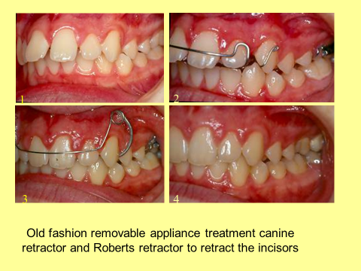

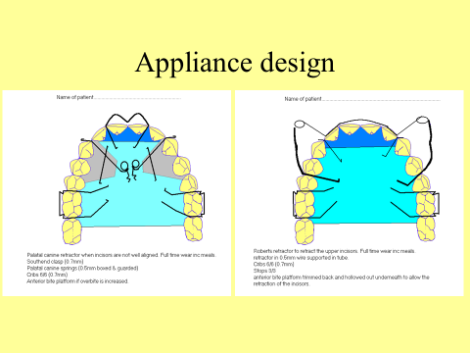
If you go back to features, you will see that the way the lips are held together is important aetiological factor in Class II division ii so supposing you altered the way a patient held the lips together by making them posture forwards to an edge-to-edge bite. What would happen? Well, the overjet would reduce even if the appliance had no labial bow. And this is what happens in functional appliance treatment. (Worth stopping to think about this because it is only one theory for the mode of action of functional appliances and I don’t want to mislead you. Others include a kind of inter-maxillary traction, pulling the condyle out from the fossa and allowing the eruption of the lower teeth while preventing the eruption of the upper teeth) to orthodontic registrars the modified Clark Twin Block has become synonymous with functional appliances.

- Headgear
Invented by Norman W Kingsley headgear was illustrated and described in Edward Angle’s book malocclusion of teeth published in 1908. It has not changed much since then.

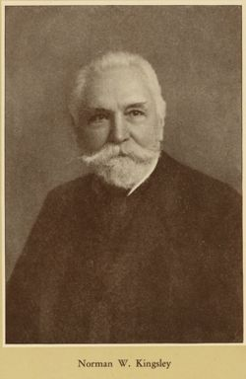
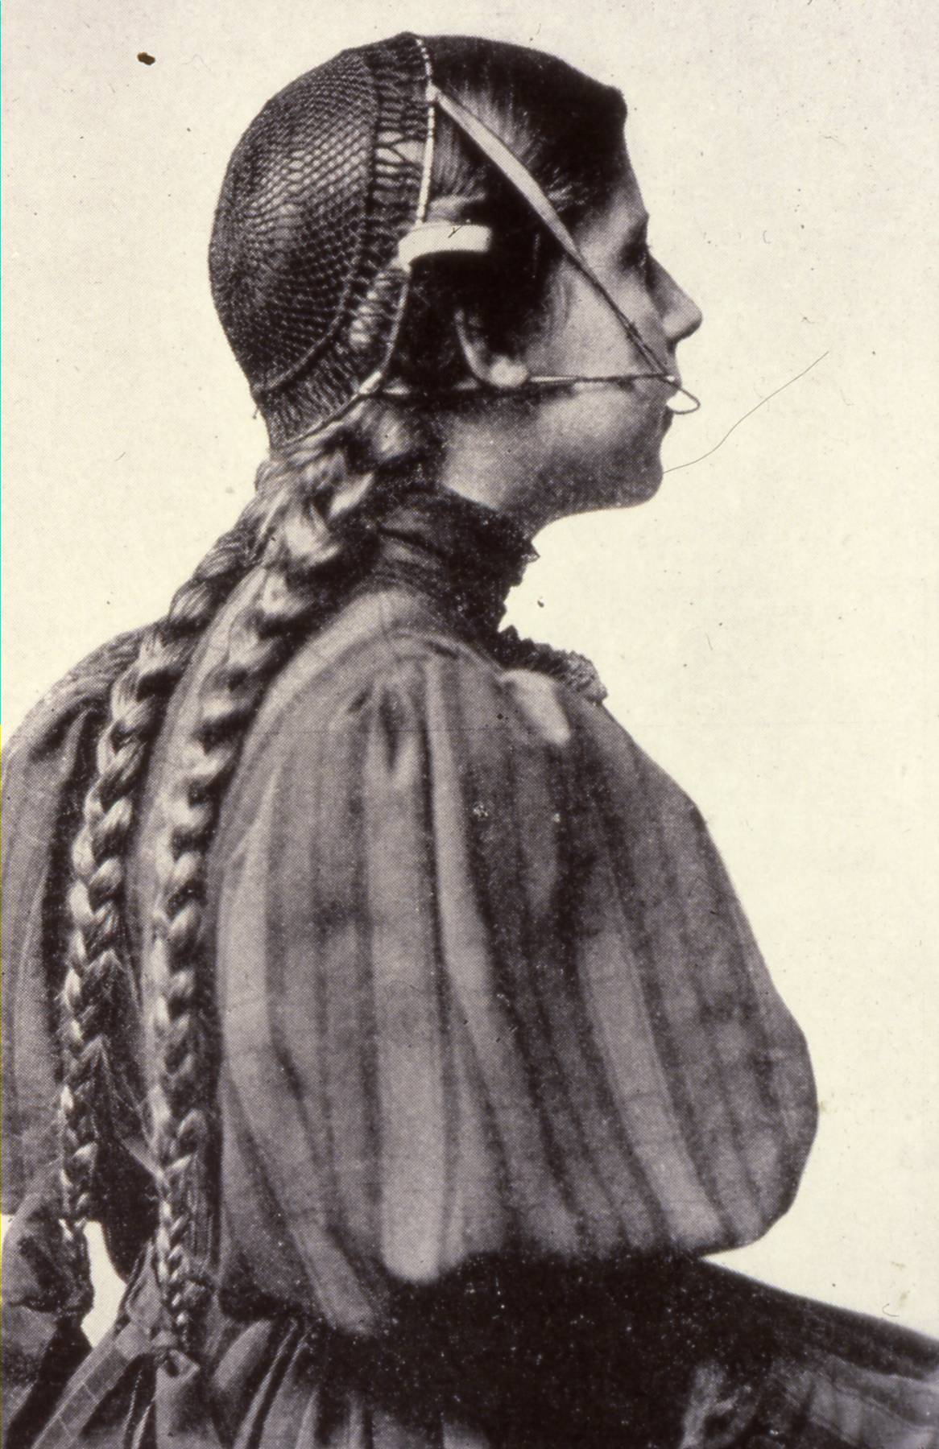
Fig early headgear sorry I could have cropped it but I wanted to leave the fashion in.
Unfortunately two cases where eye injuries occurred were widely reported. As a result, it was decided that we must use safety headgear that: -
- The face bow cannot be removed by accident.
- There must be a snap away mechanism in the elastic traction so it cannot be used as a catapult.
Regrettably this has not led to the manufacture of a slick easy to use headgear that is a joy to wear and a piece of cake to put on and take off. The result has rather been to make headgear more difficult to wear and less attractive in appearance. As a result, nobody is prepared to wear headgear and the eyes of the nation have been spared.
But if only you could persuade a patient to wear headgear you would find out that you can forget about all your worries about anchorage and overjet reduction. Unfortunately, many patients either fail to wear their EOT from the start or drop off after a short time so most of us have reserved headgear for a few really keen patients. Here are a few points about EOT
- Neck strap to molars gives the most rapid distal movement of the molars but they tip and extrude.
- High pull to the molars stops extrusion and limits tipping but tooth movement is very slow
- To improve the rate of distal movement of the molars add a URA two features help one is a bite platform to free cuspal interference and allow molar eruption the other is a spring to push on the mesial surface of the molar to prevent the relapse which will occur during the period the EOT is not being worn. This appliance is called a “nudger.”
- If you just want to move one side back you can use a different appliance with a screw when the screw is turned one molar will tend to move back and the other will.
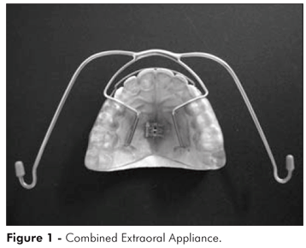
Fig. The En-masse appliance had the headgear built in
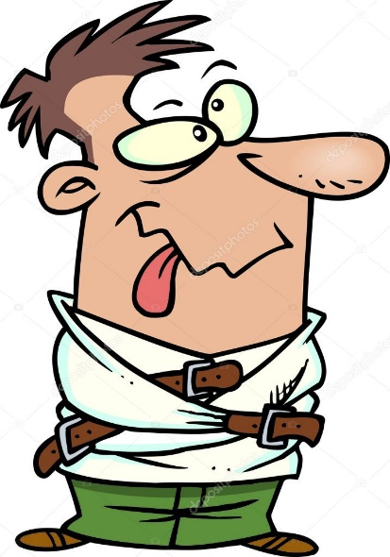
I AM GOING TO HAVE A BIT OF A RANT HERE.
Don’t you think it’s a bit shameful that headgear has not improved for 100 years? The Nitom safety facebow is fine.
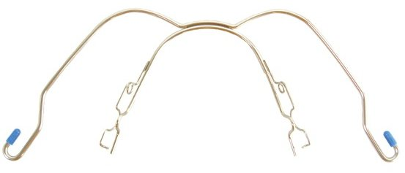
But fiddley to use and many patients don’t hook the end over for fear of finding they cannot remove it. Hard-pressed NHS orthodontists don’t want to spend 20 minutes teaching a child how to put the headgear on.
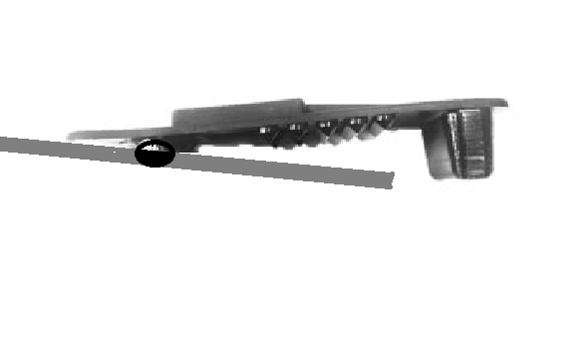
A crocodile clip attached to the end would be so much simpler or half a tiny clothes peg.
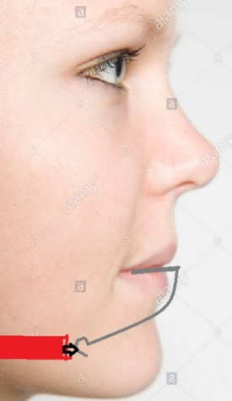
And if the facebow end was low then a simple neck strap would distalise without extruding the molars. Yes, it would tip the molar, but they would be easy to upright with fixed appliances. If worn with a nudger or push-coil between 5 and 6 to stop relapse I think 8-10 hours a day would be enough to change class two molars to class I.
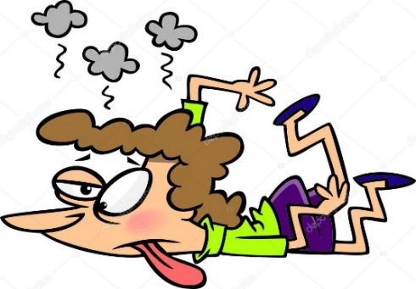
Rant over!

- Headgear /functional Van Beek, Teuscher

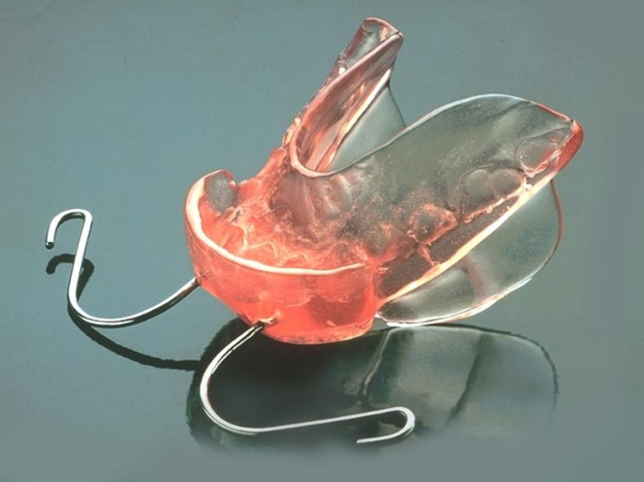
Fig. A Van Beek appliance, fresh out of the van
I am not sure that there is a difference between these two appliances. Certainly, on the ideas front they are the same. The acrylic is molded around all the upper teeth. A headgear is permanently fitted within the acrylic and the EOT is always worn with the appliance with a high direction of pull to hold the appliance in place. Needless to say, the lower teeth are set forward to a postured bite.
Now the basic idea seems a bit strange. You WANT the appliance to work slowly. The idea is to alter growth over a long period so little Hans will be going to bed for 3 years in the Teuscher appliance. And if he does the headgear should inhibit the downwards and forwards growth of the maxilla and the functional appliance should cause a little forward growth of the mandible. I had thought that the difference between these two appliances was that one had torquing spurs. These are loops of wire that lie labial to the upper incisors and press on the labial surface right up by the gingival margin. Do you get the idea? They are designed to prevent the upper incisors tipping back. If you like, they are designed to delay overjet reduction. I had thought that the Teuscher had the torquing spurs and the Van Beek did not, but I gather you can put them on either.
- Fixed functional. Mara, Herbst, fixed twin blocks. I used a fixed Dynamax but don’t use it anymore
Straight wire. It is difficult to know if I should write about straight-wire here when I have written separate notes about the straight-wire appliance. However, it gives me a chance to look at it in a different way. The Straight wire appliance is fantastically good at aligning the teeth but quite poor at overjet and overbite reduction.
Ways of reducing the overjet with SWA:
- Pre-treat with a functional. Start with an increased overjet and class II molars then fit a functional first correct the buccal segments and reduce the overjet. This explains the popularity of the Twin Block appliance in the UK. It solves the weakness of the Straight-wire appliance. Or rather it seems to. But does it just procline the lower incisors so that the overjet reduction is easier.
- Add a fixed functional appliance to the straight-wire this is très tres continentale. A clip on Herbst appliance will push the lower arch forward and the upper back. Emile Herbst was the first but there are lots of these things. The Carriere appliance is interesting.

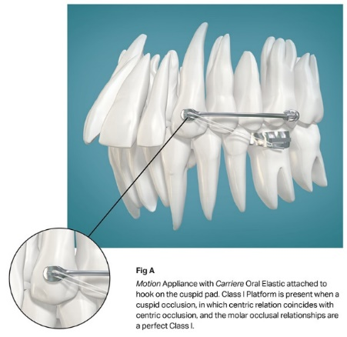
Didn’t he write Tinker, Tailor, Soldier, Spy?


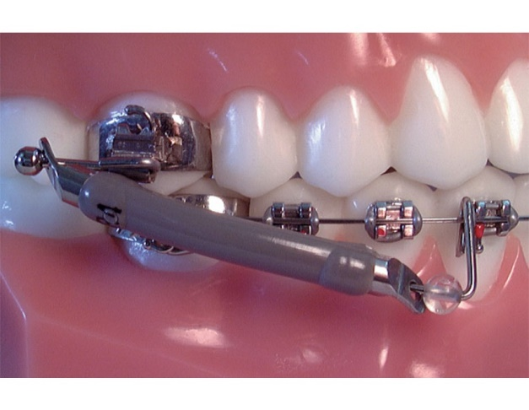
Jasper jumper II.
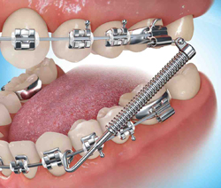
A Forsus spring, we could use them but you would have to forsus. (Sorry,) This is the old type, newer versions push into the molar tubes but you MUST have Unitek tubes
- Headgear. As well as using headgear first to correct the buccal segments or to drive back the whole arch En-Masse you can just add headgear as you go along.
- Non-compliance appliances

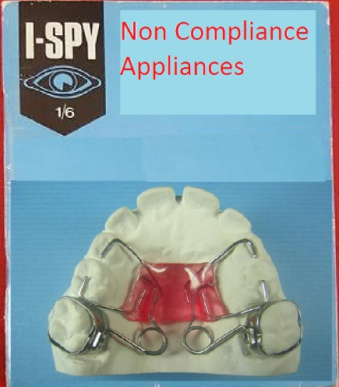
Yes, folks for only one shilling and six pence you can buy this exciting book and tick off the following:
Pendulum appliance (Hilgers)
Piston appliance
Distal Jet
Frog appliance
Veltri appliance
Gianelly appliance
Jones Jig
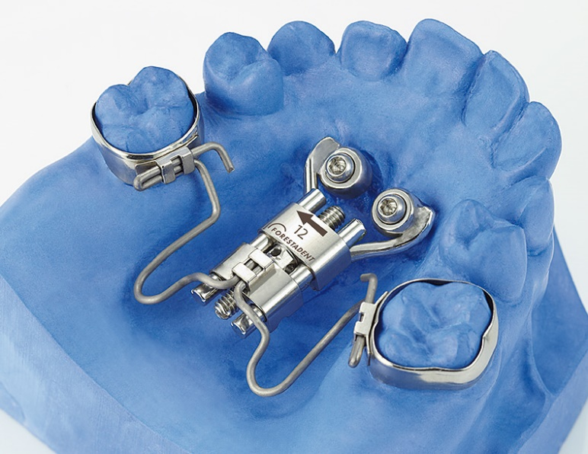
Frog appliance

- 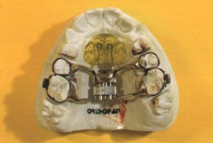

Veltri appliance
- TADs, bone anchors and Zygomatic wires
Of course, the Frog appliance combines non-compliance with TADs. The orthodontic literature is full of case reports of cases where TADs have been used. But without exception the same result could have been achieved without the TADs

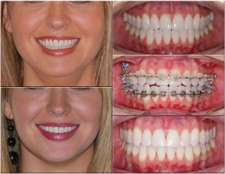
Some nice orthodontics going on here, but do you think the TAD played any part, except in the bill?

- Nance buttons and Trans Palatal arches (Already covered)
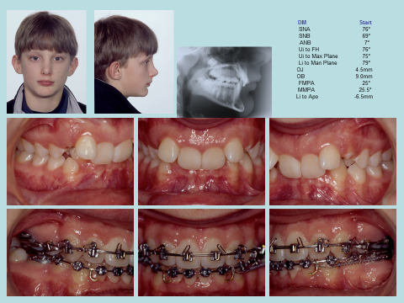
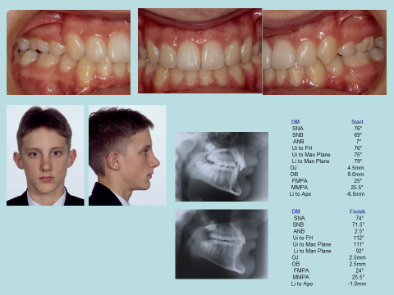
Scoff all you like, but Begg can do it. Note this case has class II molars and an upper and lower premolar has been removed each side, the upper incisors have been torqued from 76° to 112° while the lower incisors are maintained at 92°.

Nowadays Tip Edge Plus offers the same possibilities. It is simpler to use than extraction Begg. Less wire bending but stage III is very slow.
Actually, there were many attempts to combine the power and quick movements of Begg with the better finishing of Edgewise. The Unitek stage 4 appliance, Modular Begg and Beddiot.

TP were getting worried

- 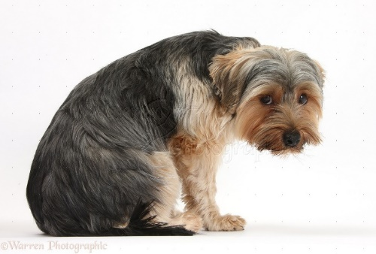
Sales of Begg brackets were dropping.
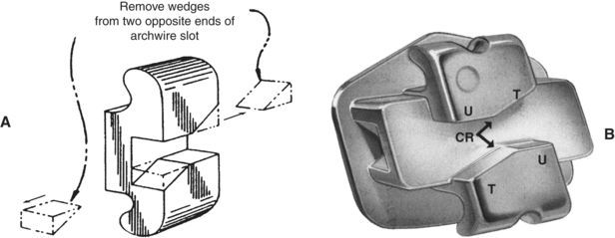
The first Tip Edge brackets were just Edgewise brackets with the corners cut off and a vertical tube. The bracket allowed tipping in stage 1 and 2 but in stage 3 uprighting springs and torquing auxiliaries were used. In the finishing stages special modules were used that filled in the triangles. Everyone called them Ghostbuster modules. Begg users were quite happy with this at first but then there were problems:
- The circle hooks were now more prominent and rubbed the cheeks so they had to be bent vertically.
- The uprighting springs now lie against the enamel and this could cause decalcification. The first solution was a side-winder spring.

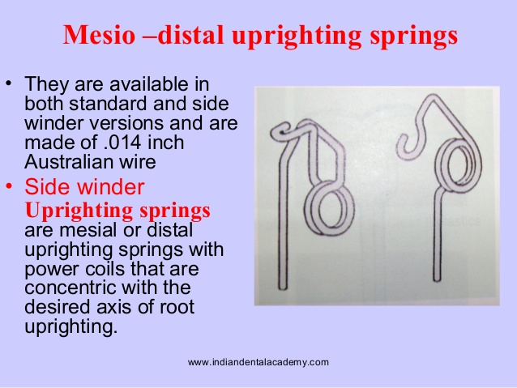
Sidewinder spring

But this had to be removed every time you changed the modules so it was replaced by an invisible sidewinder which pushes on the archwire and so doesn’t have a bulky hook.
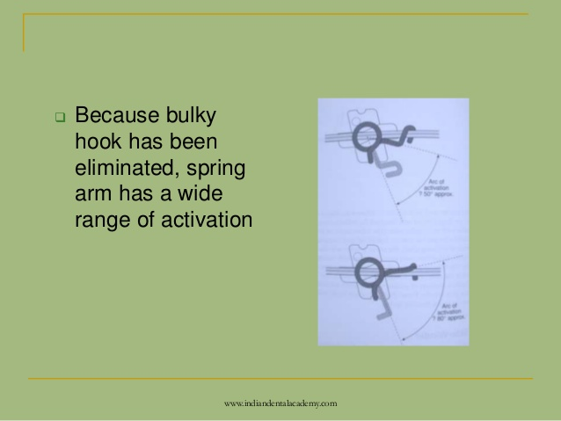
Because it pushes the movement would be in the opposite direction except for the fact that they were placed in from the opposite direction (i.e. occlusaly rather than gingivaly.)
All this was becoming complicated. And then along came Tip-Edge Plus.

This has a deep horizontal slot and you put a NiTi wire in the deep slot rather than use uprighting springs. It is easy to use. If you feel tempted to have a go. A few hints:
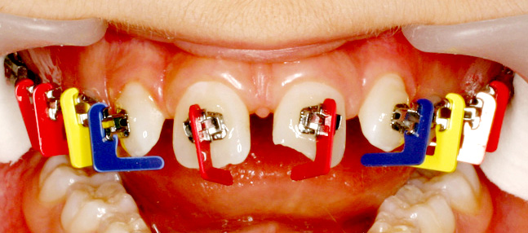
The brackets are available on jigs. Give them a go. A bit strange the first time but when you get the hang of it very rewarding
The standard jigs are a bit incisal but Ok.
I would always suggest buying non-extraction kits. Then you have a few spare premolar brackets. The brackets only allow tip in one direction so if it is a 4 extraction case swap the brackets on the 5s left to right. The premolar brackets have little arrows on them the arrows point towards the extraction spaces extraction case swap the brackets on the 5s left to right. The premolar brackets have little arrows on them the arrows point towards the extraction space
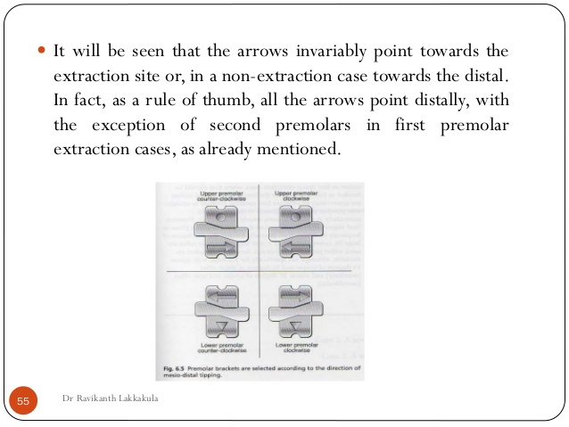

I would always suggest buying non-extraction kits. Then you have a few spare premolar brackets. The brackets only allow tip in one direction so if it is a 4 extraction case swap the brackets on the 5s left to right. The premolar brackets have little arrows on them the arrows point towards the extraction spaces.
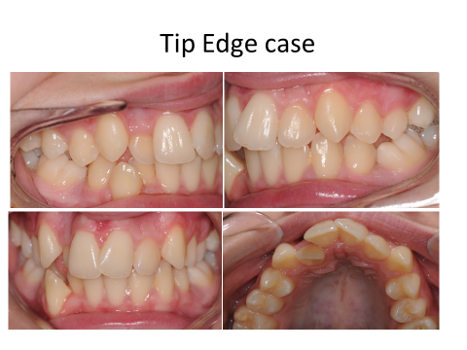
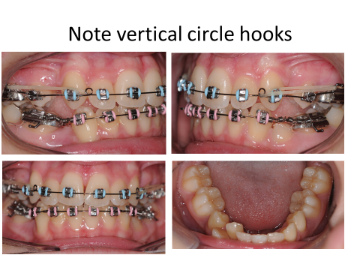
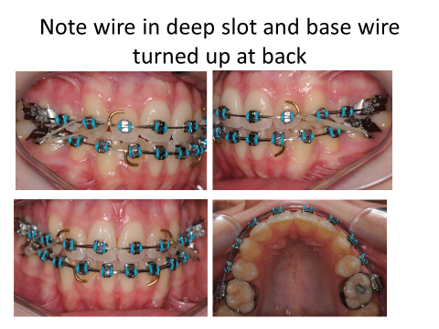
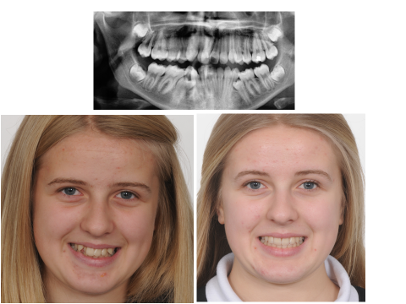
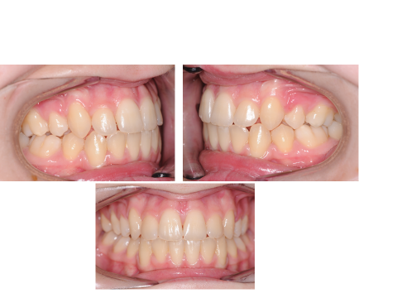
Upper Begg brackets with lower straight wire
I think this is so good I could not have run the department in Burton without it but it is only fair to say that the rest of the world think I am mad. Let me show you just one case:
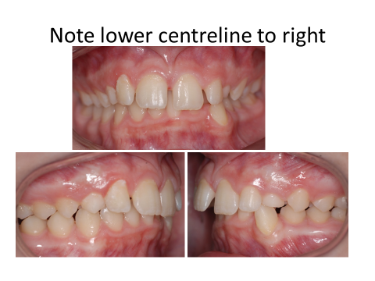
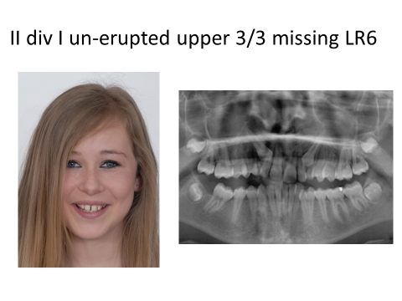
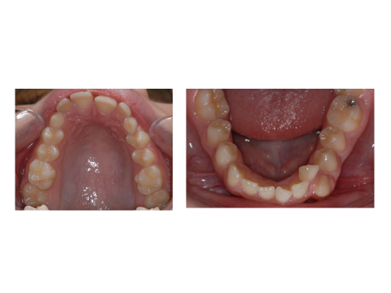
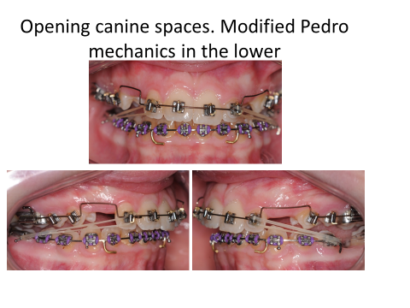
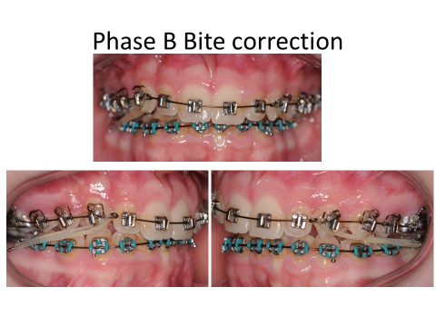
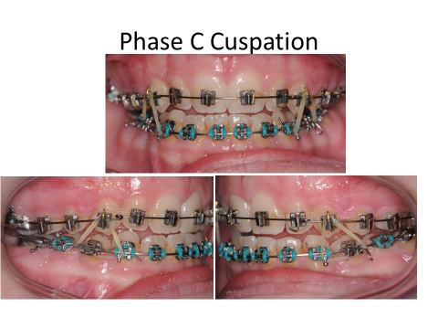
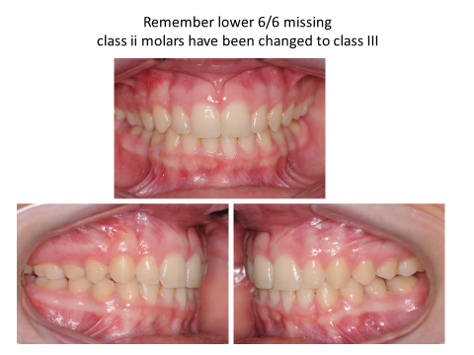
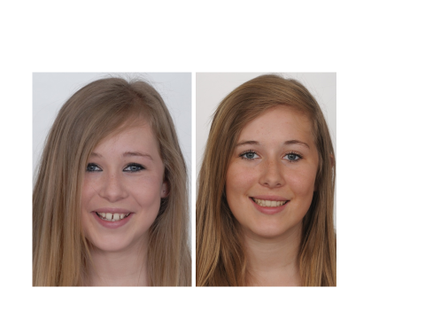
Rickets, Classic Tweed Edgewise and level anchorage system
You should know what these are.
- Fixed appliances camouflage
If the maxilla looks too big then great orthodontic retraction of the upper incisors is accompanied with surface remodeling which will give the right appearance [so it is never necessary to move the maxilla back in a surgical procedure]. If you treat a class II division I malocclusion by retraction of the upper labial segment and the profile looks less than perfect, the patient could consider a chin enhancement genioplasty which is a much less serious operation.
- Surgery has its own chapter
Retention
How do you retain a functional appliance? I believe the majority view is that you should continue for a while with the functional appliance worn for a limited period each day perhaps night only for 3-6 months. The idea is to maintain the overjet while continuing to encourage the lips to be held together while allowing the buccal segments to settle. A rather more old-fashioned approach was to replace the functional appliance with a Hawley retainer with an inclined bite plane.
I should explain here that the Hawley retainer with an inclined bite plane was part of old-fashioned removable appliance treatment which aimed to reduce overjets by proclining the lower incisors. In this context the appliances is said to be of use because it encourages the mandible to be postured forwards. Much more recently Bob Lee has suggested that the functional appliances should be worn for a long-time night only [15 months]. While I am told J Sandler has suggested that a fixed inclined bite plane should be worn during the fixed appliance treatment. It might be interesting to discover the mechanism of the beneficial effects of this extra treatment: -
Consider a patient who has worn a functional appliance and the treatment has successfully reduced his/her overjet to 0. Now the functional appliance is just holding he jaw in its normal RCP. Explain how prolonged use of a functional or the provision of a bite plane, on which the patient cannot bite, could possibly be of benefit.
Now consider a case where functional appliance treatment had resulted in a posture rather than a full reduction of overjet. Now I can see that an inclined bite plane of prolonged use of a functional might be of help. But I have a better idea let’s see what the occlusion is really like and then treat it with conventional orthodontics Yes, even if we have to extract upper 4/4.
Generally, I consider Essix A or Essix Ace pressure formed retainers to be the best retainers because they are best tolerated by patients and if you want you can put a drop of whitening gel inside them and use it to whiten the teeth. There is an argument for saying use a Hawley appliance in the upper to allow the teeth to settle. The problem is that the patient can pull the labial bow away from the upper incisors and this may allow the upper labial segment to relapse.
Positioners and pre-finishers work best on low angle cases where the biting force is high. Although they have the power to change a so-so case into a potential prize winner the results are unpredictable.

P.R. Begg believed you should overwork your cases so he reduced the overjet and overbite to zero. He also over rotated and rotated teeth. Then he fitted a loose-fitting retainer now called a Begg retainer. It is just a baseplate with a single wire from behind both last standing molars forming an ideal shaped labial bow. You may see a version with c clasps on the upper 6s to improve retention but this is a latter addition.

Stability
There was a classic paper by Bob Nashed and Ian Reynolds on the stability of overjet reduction in big overjet cases. Suggesting a frighteningly high relapse rate if you attempt to treat a big overjet. But look a little deeper into the text and you will see that many of these big overjet cases showed an overjet reduction BUT still had a 6mm+ overjet at the end.
So here is the first message in stability YOU MUST get the upper incisors back into lip control.
If you can then the chances of Overjet relapse is less than the chances of increase in overbite [Edwards]
Anterior open bite cases are of special concern. Thumb sucking is a common problem and may continue at a lower level even after the patient has reported that it has ceased. At this lower level it will not stop overjet reduction but can trigger a relapse. The Endogenous tongue thrust is a very rare condition and indeed may not exist at all. I believe I have seen one case. The features are a lisp and marked muscular activity around the lips in swallowing. One of the diagnostic features is that if the overjet is fully reduced and then retained for a year it will still relapse.
A tongue to lower lip swallow is associated with an incomplete overbite it seems logical to suppose that there is an increased risk of relapse.
In my opinion the difference between retruded contact position and centric occlusion plays a part in some cases of relapse of class II division I. malocclusion. I think this is especially true in functional appliance treatment. Functional appliances make the patient posture forwards and they get so good at it that it can be hard to get them to bite back into RCP. So supposing you treat a patient and feel that you have achieved a reduction of overjet down to 3mm but in fact his is a postured position by 2 mm. This means that the overjet will increase first to 5mm but this may allow the upper incisors to escape lip control. This could explain why RCTs of functional appliance treatment seem to show small but significant growth effects in the early stages but this change seems to melt away in time. [The accepted explanation is that they somehow trigger earlier growth rather than extra growth]
Growth
Because growth tends to reduce the overjet there is a potential problem that treated cases may go class III. I have seen this happen but it is quite rare. Growth can also cause a reduction in overbite or he worsening of an anterior open bite but it is more common for the overbite to increase if no retainers are being worn.

Is something missing?
Remember orthognathic surgery and Functional appliances are so important that they get chapters of their own.
Usual test:

1. What is the usual inclination of the upper and lower incisors in a Lip Trap malocclusion? | The upper incisors are usually very proclined and the lower incisors retroclined. The underlying skeletal pattern may be less severe than it appears.
2. What is meant by camouflage treatment of a class II division I malocclusion? | Although the maxilla is normal and it is the mandible that is too far back the treatment involves moving the upper labial segment backwards
3. What are the effects of thumb sucking on the teeth? | Anterior open bite, upper incisors proclined, lower incisors retroclined and upper arch narrowed
4. Why do you need safety headgear | Following two cases of severe eye injury we are advised by the BOS we should always use safety headgear
5. What is the weakness of the Nitom facebow? | It is quite difficult to fit and undo as a consequence some patients wear it but do not do up the safety clip
6. List some fixed functional appliances. | Herbst, Jasper jumper, Forcus spring, Carriere appliance and fixed Dynamax
7. Why have Begg and Tip edge advantages in threating a class II div I malocclusions? | Straight-wire attempts to bodily retract the upper labial segment. This is much more anchorage demanding than tipping the teeth back and uprighting them.
8, What factors influence your decision to choose camouflage or surgery? | Severity of the skeletal pattern. Naso Labial angle. Patient’s wishes, health and age..

