**Chapter 6 Class III malocclusions**

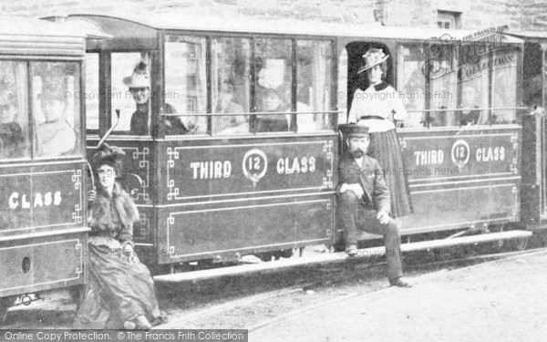

Fig A Third-Class Tutorial

**Definition**

In a class III malocclusion the tips of the lower incisors occlude, or would occlude, [incomplete overbite] anterior to the middle on third of the palatal surface of the upper incisors. Thus, this group includes patients where the overjet is reduced, edge-to-edge and reversed.

An Angle’s class III malocclusion.

It is worth remembering that the incisor classification that we use is a very “British” thing. Angle classified malocclusions according to the molar relationship so that an Angle’s class III malocclusion can be defined as: A malocclusion where the triangular ridges of the mesio-buccal cusps of the upper first permanent molars occlude distal to the buccal grooves of the lower first molars.

**Aetiology**

The cause of class III malocclusions is nearly always skeletal. But it would be wrong to consider that it is always due to an increased development of the mandible with a normal maxilla. In some cases, the maxilla is too small and the mandible is normal. There is also the possibility that both the mandible and the maxilla are of normal size and the error is in the positioning of TM joint. In fact, all three situations are probably quite rare and in most cases there are quite small variations in all three which add together to make a class III malocclusion.

A large number of pathological conditions can give rise to a class III malocclusion: -

Bony disorders such as Achondroplasia.

Endocrine disorders such as Acromegaly and infantile Hypo-Thyroidism.

Disorders of the tongue such as Amyloidosis.

Cleft lip and palate are associated with a class III malocclusion. [Although it is scar tissue following the surgery that produces the class III skeletal pattern]

Genetic conditions such as Downs syndrome.

Although it is not a common condition Acromegaly deserves a special mention. It results from a tumour of the Pituitary gland occurring after the fusion of the epiphyseal plates of the long bones. The mandible and the bones of the hands and feet are affected by the raised levels of growth hormone. If undiagnosed the patient may seek orthognathic surgery. Their condition makes them an “at risk” patient if surgery is carried out before the tumour is removed.

You will also come across Acromegaly in my notes on growth. Lots of people think that the mandibular condyle is not a growth centre but it is in Acromegaly.

You need to add iatrogenic

Incidence

According to Foster and Day 1974 class III malocclusions make up about 3% of the population of the UK {based on Shropshire school children} You need to be a little careful because in some populations, especially Chinese, the incidence is much higher.

Foster & Day

Class I = 44%

Class II div I = 27%

Class II div 2 = 18%

Class II indefinite = 7%

Class III = 3%

They had an additional group, postural class III of 0.3%

**Features**

1. Class III skeletal pattern. As already noted almost all class III malocclusions have a class III skeletal pattern. An exception may be the rare postural class III malocclusion which is due to early loss of the primary molars in the primary dentition. If all the deciduous molars are lost the child may posture forwards to achieve a good biting contact on the deciduous canines. Of course, a forward displacement on closing is a common finding in class III malocclusions but notice that where all posterior teeth are lost in a child there is no underlying skeletal class III base. This postural class III was rare even in the high caries 60’s and 70’s now it must be very rare indeed.
2. Soft tissue compensation. Consider a typical case, the upper jaw is underdeveloped so that the upper incisors are closer to the tongue which proclines them. The lower incisors are closer to the lower lip which tends to retrocline them. Note that this tends to mask the apparent severity of the class III malocclusion, in a mild case the overjet may be normal. In a moderate case the overjet may be edge to edge while a reverse overjet with no posture indicates a severe class dental base relationship. For this reason it is widely held that patients who cannot achieve an edge to edge bite are beyond the scope of ordinary treatment.
3. Forward Displacement on closure. Where the overbite is positive the development of a mild class III skeletal pattern brings the incisors into an edge-to-edge relationship. If the incisors contact with no posterior tooth contact there is a danger that the incisor teeth will be overloaded. A forward displacement of the mandible on closing is a reflex protective response. It brings the mandible forwards making the malocclusion look more severe. If the initial contact is eliminated by pushing the incisors over the bite the displacement will also go. As we will discuss later although the B point is moved forward the condyle may still be in the fossa. This is because the jaw closes in a hinge type of movement. [If class II patients are posturing forwards on the lateral skull cephalogram orthodontists will take another film, so it is a mystery to me while the same orthodontists will decide on surgery in a borderline class III case based on a postured film.]
4. Upper arch crowding. If there are no missing teeth the small maxilla is often associated with crowding. The lateral incisors are often palatally placed (which reflects their developmental position) and the canines can be very buccal. It is often the buccal canines that cause the patient to seek treatment. Patients may ask for the buccal canines to be extracted, but in some cases, this will cause a dropping backwards of the incisors and a worsening of the malocclusion. In any case as the incisors are moved forwards the space available for the canines will increase.
5. Missing and small teeth. Peg shaped and missing lateral incisors have an association with class III malocclusions. It may be that the central incisors drop back due to a lack of support.
6. Crossbite. The lower arch is often wide and ample with little or no crowding. The upper arch is often small and narrow with crowding. This can lead to a crossbite. If the difference is small the molars will meet cusp to cusp. This initial contact will lead to a displacement to one side. The result is a unilateral crossbite with the lower centreline moved to that side. In some cases, the patients face may look asymmetrical with the teeth in occlusion, but this appearance disappears when the jaws are wide open. It may also disappear if an appliance with a posterior bite plane is fitted. Note that a mid-line expansion device is needed to correct the problem. Where the problem is more severe there may be a bilateral crossbite. Usually there is no associated displacement on closing and as a result there is no absolute need to correct the problem. This perhaps fortunate as the treatment is associated with quite a high relapse rate.
7. Molar Relationship Often it is class I or only very slightly class III. If the molar relationship is a whole unit class III it often indicates a severe class III malocclusion.

Diagnosis

If you have a lateral skull radiograph taken with the mandible in the most retruded position you should be able to spot those cases which are unsuitable for orthodontic treatment [without surgery]. Kerr suggests that an ANB angle of -4° represents the border between Orthodontic and Orthognathic cases. But you have to take into account the possibility of unfavourable growth. A family history of a severe class III malocclusion is a poor sign. If you don’t have a lateral skull radiograph then the old rule that a patient who cannot achieve an edge-to-edge bite is beyond the scope of simple orthodontics is a good guide if perhaps a little over cautious. Remember that growing individuals may become more class III.

Dental assessment.

Start with the lower arch. Significant crowding should be treated with extraction. A bold approach perhaps extracting the lower first premolars where the crowding is quite mild may allow for a little dropping back of the lower incisors which would assist treatment. If the molars are class I then same number of teeth must be extracted in the upper arch as the lower. If this means the extraction of premolars then consider the extraction of upper 5/5. As the upper first premolars and canines are retracted anchorage loss drives the incisors and molars forwards correcting the malocclusion. Just occasionally the extraction of a lower incisor is indicated. I would sum up the indications as follows: -

* A non-growing patient.
* Not suitable for surgery or has decided that surgery is out of the question
* The upper arch is satisfactory
* The buccal segments are well slotted in
* The lower incisors are not too retroclined.

**Treatment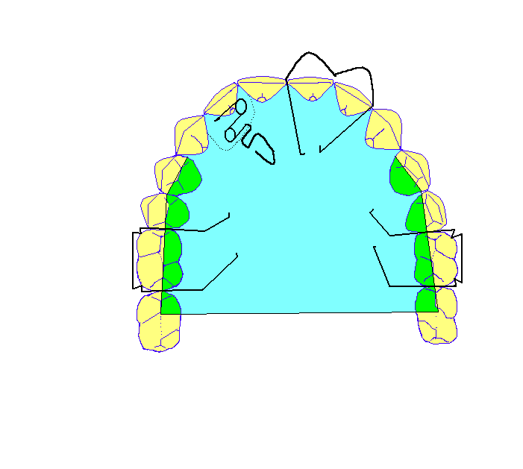 1.**  Pushing a lateral incisor over the bite.

Use a URA with a posterior bite platform to free the bite. A “Z” spring is best. Although some people advocate the use of very light wires but I think 0.5mm steel works best. Anterior retention is essential and a Southend clasp works well. Remember you don’t have to put it on both centrals so that if it is just one lateral offset it to the other side and the wires will not get in the way of the lateral. If both laterals are behind the bite then it must go on the centrals but make sure that your technician does not but wire or acrylic in such a way that it will obstruct the movement of the lateral.

2. Pushing all the incisors over the bite.

Hurrah for the two-screw plate. It can be used to push the incisors over the bite, open up space for impacted canines and expand the arch. Elsewhere it can convert a class II div ii into a class II div I prior to functionals or be combined EOT to distalise the buccal segments. It is also eco-friendly and suitable for vegetarians.

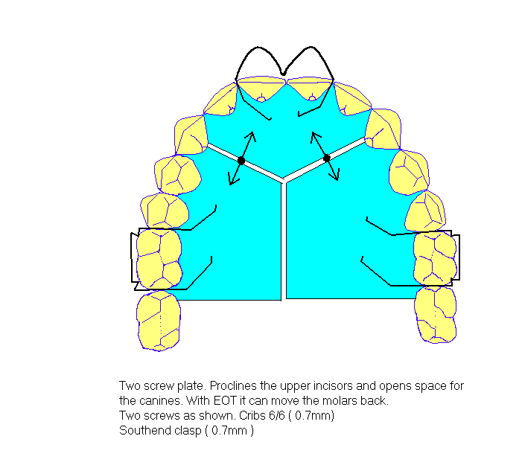

And it works even better if you use the posh new screws with built in NiTi push coils {Forestadent}. The two screw plate is less bulky than the conventional single screw plate so it is easier to wear and you can reduce the bulk further if you use cement on the lower 6/6 rather than a posterior bite plane. They do have their problems though: Full time wear is essential and the screw must be turned one turn per week per side [not on the same day] keep a record of how many turns there should be and turn the screw back each visit to check. The screws with the NiTi springs work differently give each screw a couple of turns to get it started and then the weekly turning maintains the force. They are great, but a bit bulky for very small arches. What happens when you get to the end of the screw? If you don’t know find out before you fit a screw plate.

3. Fixed appliances.

The problem is that all class III malocclusions occur in patients with a class III skeletal pattern. If you look at a typical case the upper incisors will be proclined and the upper canines and premolars mesially tipped. The lower incisors will be retroclined and the lower canines will be tipped distally. If you bond the patient up with “straight wire” brackets the upper arch will be moved back and the lower forwards as the teeth upright to the inclinations prescribed in the straight wire prescription. The truth is that Straight wire is a no compromise treatment it works on skeletal I cases and it will work on mild skeletal II cases because there is some bone behind the upper incisors so that it is possible to bodily retract the upper incisors a bit. It does not work in class III cases because you neither bodily retract the lower incisors nor move the upper incisors bodily forwards. [There is no bone behind the lower incisors or in front of the upper incisors]

**But you can modify the prescription by: -**

* **Mild class III case MBT prescription.** Swap the right and left lower canine brackets over. This allows the canines to be 3˚ retroclined. The MBT prescription has -6˚ of torque on the lower incisors which is helpful.
* **Mild case Roth prescription.** If you swap over the brackets on the lower canines the lower canines will tip back at 7˚ and I think this looks a bit excessive. For a mild case I prefer to use premolar brackets with 0˚ of tip. You can overcome the problems of the wrong torque by never using a thicker wire than 0.016 x 0.022” this allows the lower incisors to tip back despite the 0˚ of torque in the brackets. The upper arch is helped by the high tip on the upper canines.
* **More severe case that has declined surgery.** Use MBT canine brackets on upper 54/45 and Roth canine brackets on upper 3/3. If you have them, put super-torque brackets on upper 1/1. In the lower arch but swapped around canine brackets on 543/345 to tip every tooth distal by 3˚. **A word of warning.**  If you treat a borderline surgical case with orthodontics only, **don’t** go for a deep bite if growth is unfavourable it may become traumatic.

**You can modify the treatment planning by:** -

* Extract further back in the upper arch than you would in a class I case.
* Differ extractions in the upper arch until the upper incisors have come over the bite.
* Be rather bold with the extractions in the lower arch

**You can modify your treatment by: -**

* Start alignment in the upper jaw first. Lower incisor alignment tends to bring the lower incisors forward
* Place cement over the lower 6/6 this frees the occlusion and will rotate the mandible down and back making it less class III
* Close the lower space as soon as possible. [Note. If you have been doing an upper 5/5 lower4/4 class III case and think you still have a lot of space in the lower you have been working through the wrong arch sequences. In the upper you go 0.014 NiTi, 0.016 x 0.022 NiTi , 0.019 x 0.025 NiTi and then 0.019 x 0.025 steel **But in the lower** you should go 0.014 NiTi then 0.014 steel with circle hooks and Intra elastics. Then each visit you go up an arch, 0.016 steel with circle hooks and intra then 0.018 and finally 0.016 x 0.022 posted steel which is your working arch in the lower. By this time all the space in the lower jaw will be closed and in most cases the class III incisor relationship will be corrected. Only then should you consider class III elastics
* Only close upper spaces when a normal incisor relationship has been established.



* Be afraid of class III elastics. Remember upper molars love to come forward and lower incisors quite like to drop back; upper incisors also quite like to erupt. All these may be helpful in a class III case but it is easy to overdo them. You might think that a class III patient would call you for advice before the overjet reached 10 mm but don’t bet on it. I suggest you always close the lower arch space first. Short class III elastics are harmless and useful in slotting in the buccal segments they do not cause anterior open bites in fact they close them up.



There is a limit to the value of camouflage if you try orthodontic treatment on too severe a case you will find that the lower incisors are too retroclined and the upper incisors too proclined. Even worse, the occlusion may be unstable and tend to relapse. If there is a positive overbite this will cause a traumatic occlusion. If you are forced to try to produce an orthodontic result in a surgical case; correct the malocclusion as much as possible [procline the upper incisors to a maximum of 125˚, retrocline the lower incisors to no more retroclined than 75˚ (MM angle of 27˚)] but deliberately avoid a deep overbite.

4. Rapid maxillary Expansion

This may produce a little widening of the actual dental base (i.e., it is an orthopaedic appliance.) but that doesn’t mean it doesn’t relapse. It is also rather uncomfortable and tends to reduce the overbite. As the teeth are moved to cusp to cusp there is an opening rotation of the mandible which moves the B point back and means that the patient will become less class III. But it is not suitable for open bite cases as the opening rotation makes the AOB alarmingly worse. Some people claim that it improves the airway (Haas) but this now seems to be untrue. Nevertheless, if you meet any masochists with deep bites and bilateral crossbites who are happy to wear long term retention this may be just what you are looking for. Silver splints are still very good but remember to have buccal tubes so that you can get on with the alignment of the anterior teeth during the holding period. The typical expander with bands on upper 64/46 and a Hyrax screw works well and can be easily assimilated into a full fixed appliance. I now have the wire adapted to the occlusal surface of the 4 and bond it directly to the tooth. This makes it easier to fit the RME and we are almost out of premolar bands. Recent evidence suggests that splint type appliances work a little better but I wonder if it is a good idea to cover over the palatal soft tissue for a long period. See papers by Haas. My concern is over the stability of these cases I always use a palatal bonded retainer so that when the crossbite relapses at least the incisors remain well aligned. Since there is a tutorial on expansion and it appears later in “areas of debate” I think this is enough on RME.

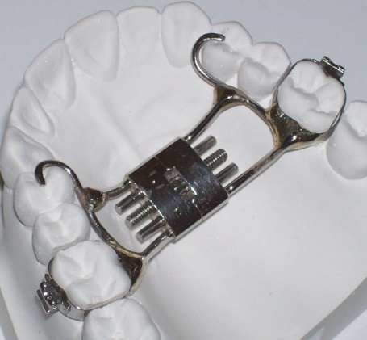

5. Surgery

Orthodontically all we need to do is to align the arches and decompensate i.e., get rid of the soft tissue compensation. Then after the surgery try to guide the teeth into a good functional occlusion. Some cases look very good and are stable but not all. In particular very high angle cases with high Gonial angles fare less well than low angle cases. There is a whole tutorial on Orthognathic treatment.

Basically, there are two widely used procedures. Maxilla forwards at the Le Fort I level. And the Mandibular Sagittal split osteotomy to move back the mandible. In my opinion maxillary distraction to advance the maxilla [particularly favoured in cleft cases] and maxillary movements at the Le Fort II and III levels should be done in Craniofacial Centres. The vertical sub sigmoid osteotomy has a place for patients who have had a Sagittal split but need still further Mandibular movement. The inverted “L shaped osteotomy” of the Mandibular Ramus is used in older patients with no bone marrow spaces in the mandible where it is felt that the mandible will not split and to lengthen the ramus.

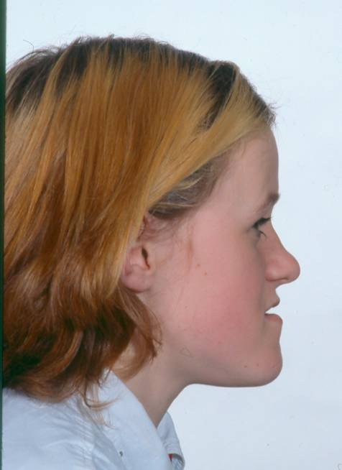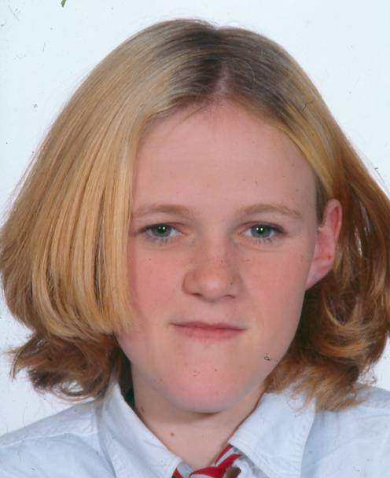

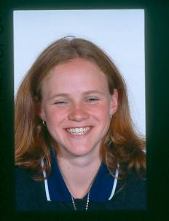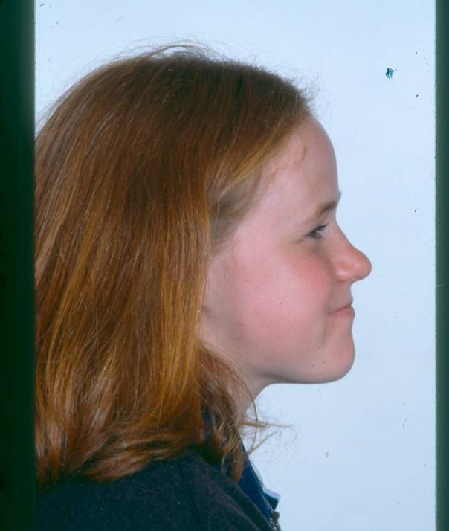

**Maxilla forward at Le Fort I level**

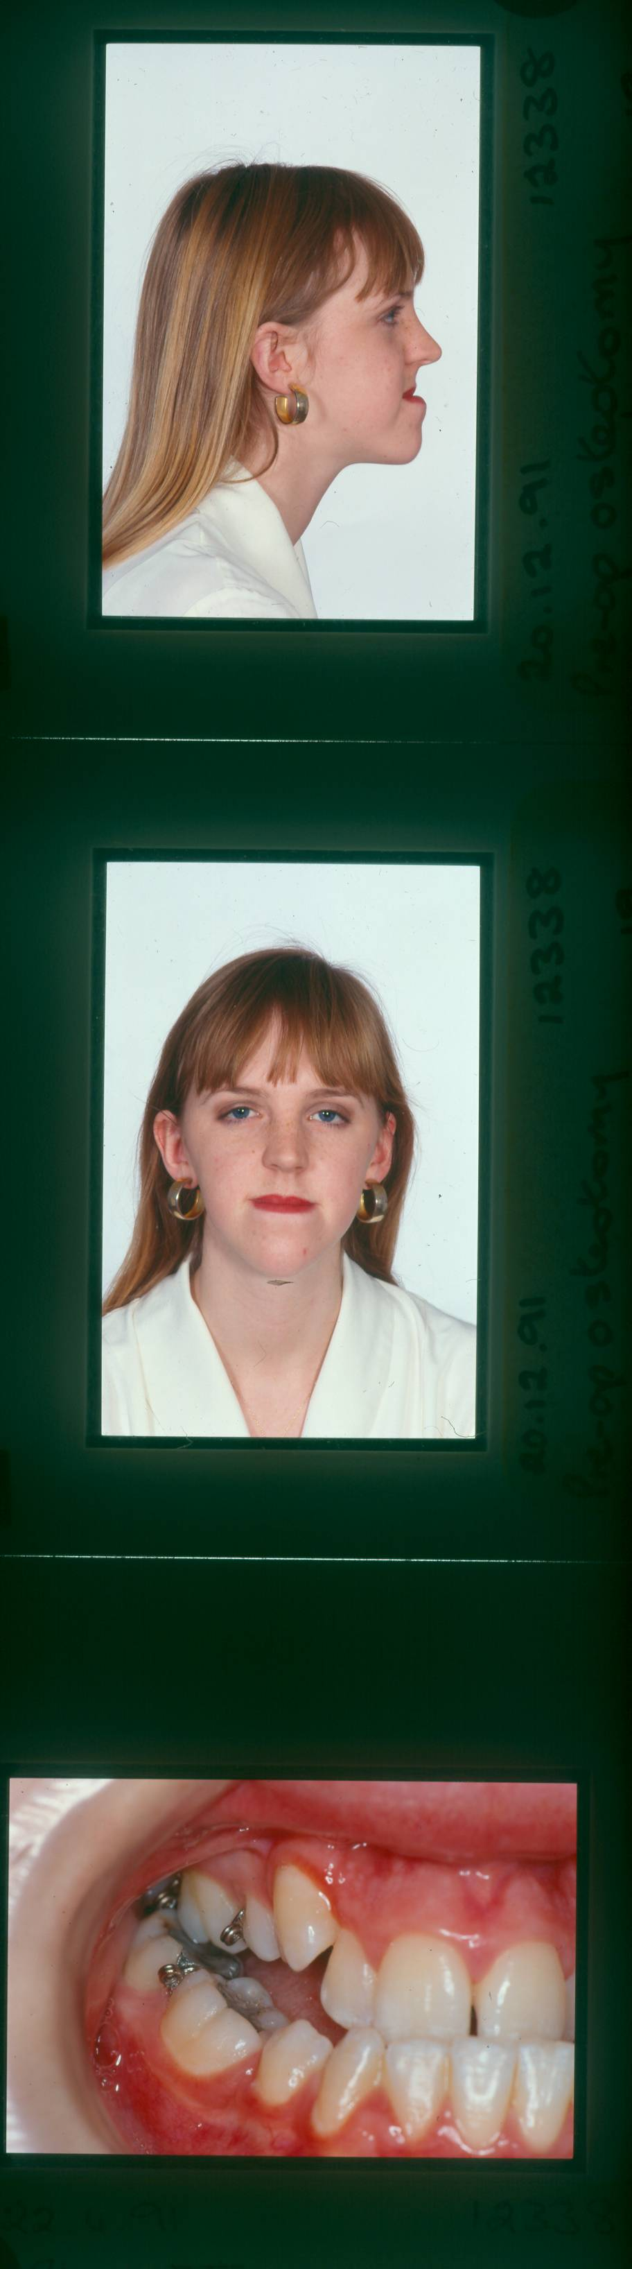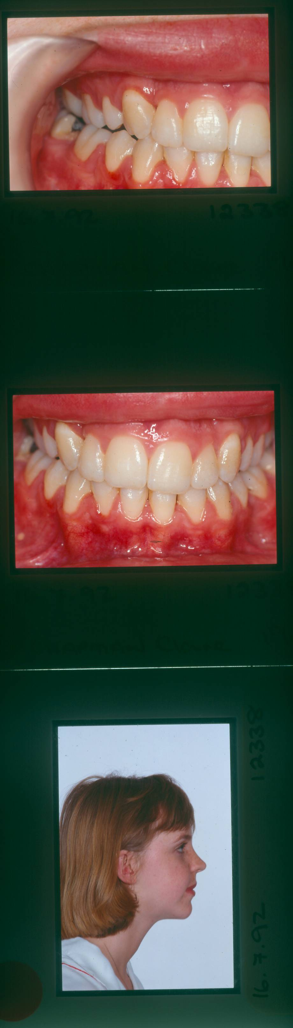

**Mandible back Sagittal split osteotomy**

Of course many patients need both procedures.

6. Do functionals have anything to offer? Very little.

True there is the FR3 but because the labial bow on the lower incisors is active is it a functional?

7. Face mask therapy

Don’t be frightened of using the Delaire facemask or other forms of reverse headgear. They are not difficult to use. The problem is it is difficult to motivate the patient to wear them. The Delaire mask have a pad on the forehead and a cup shaped pad on the chin. The frame has hooks onto which elastics can be attached. In a typical case you would use elastics from the upper 6/6 to the facemask to pull the upper molars forward. You could envisage using it for class III cases to advance the upper dentition and in Hypodontia cases. If only they looked a bit sexy, they would be quite useful but I have never had much success in persuading patients to wear them for some reason they don’t want to look like Hannibal Lecter.

**A chin cap** pulls the lower teeth back a little probably by squeezing the lower lip some people claim that they reduce Mandibular growth but they are probably wrong.

**The sec III appliance** I was impressed with the results achieved by this simple appliance which was shown at the EOS in 2002. The appliance is just an upper and lower splint fitted over the teeth with a flat occlusal cover. There are hooks for elastics in the upper molar and lower canine regions and very light elastics are worn during the day with very heavy elastics at night. Of course, the heavy elastics tend to pull the splints off the teeth so a chin cap is worn at night to hold the teeth in contact.

8. The inclined bite plane.

If you are ever asked to push the incisors over the bite for a child with quite severe learning difficulties. Use a s splint on the lower incisors with an inclined bite plane. They work quite well but reduce the overbite a bit. Remember you need holes over the occlusal surfaces to take a band remover or flat plastic to get the splint off after treatment. I have used plastic ones but they can break on tough patients.

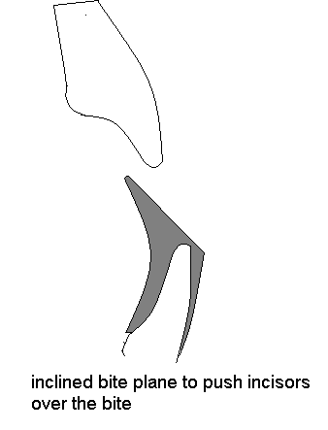

Growth and class III malocclusion

In general, there is a tendency for individuals to become more class III with growth. Although this change is quite slight it is more common in boys than girls and there is often a family history of unfavourable growth. This change may mean that borderline cases may become untreatable without surgery. For this reason, it is often suggested that treatment should be delayed until growth has ceased. Sometimes this is interpreted as meaning all class III treatment should be delayed. But it seems hard to delay treatment for patients who have very mild class III skeletal pattern and would never require surgery.

Some useful rules: -

* Be careful when considering extractions in the upper arch in class III cases. The extraction of upper canines is almost never advisable in non-surgical cases and the second premolar is usually a better choice than the first. If in doubt push the incisors over the bite first and then re-asses the need for extractions.
* It is important to assess the skeletal pattern on a radiograph taken in centric relationship.
* Never extract a lower incisor on a growing patient who might need surgery unless it is of poor prognosis.
* Overbite is an important factor in stability
* It is unwise to procline the upper incisors to more than 125˚. In the lower arch it is suggested that you should not retrocline the lower incisors to less than 85˚ but this depends on the MM angle certainly less than 75˚ is unwise.

(7)

**Class III Malocclusions Areas of Debate**

Introduction

Learning about Orthodontics is a bit different from passing the M.Orth Examination. For the majority of patients there are a range of different treatments with different appliances that would be capable of producing a result that would satisfy the patient. It seems strange therefore that some orthodontists have an almost evangelistic zeal concerning their own favourite treatment, often to the extent of denouncing those who do not use it.

Your goal as a serious student of Orthodontics should be to identify areas of debate and to express the most commonly held view. Only then should you launch yourself into expressing your own opinions. Because of the complex nature of research on populations with natural variability there is often no “correct” answer to the problem.

I have listed the following areas for debate: -

1. Should you push incisors over the bite in the mixed dentition? Should you balance the extraction of deciduous teeth to allow this?
2. Is rapid maxillary expansion and reverse headgear a viable treatment for class III malocclusions?
3. Should treatment of class III malocclusions be delayed until growth has ceased?
4. Should you surgically assist Rapid Maxillary expansion?
5. What is the borderline between surgical and Orthodontic treatment.

Should you push an incisor over the bite in the mixed dentition?

**The most commonly held view** is that it is desirable to push an incisor tooth over the bite in the mixed dentition. You might cite the following reasons: -

* To avoid trauma to the incisor teeth.
* To avoid gingival recession associated with a traumatic bite
* In most cases there is an initial contact and displacement of the mandible on closure. If left untreated this displaced position will become more firmly established as the “centric occlusion” and be more difficult to treat.
* This may be the only treatment needed. To treat in the mixed dentition could be the cheapest least traumatic treatment
* The eruption of the canine may trap the instanding incisor
* The appliance may also serve other functions e.g. keeping the leeway space, open the bite or holding the centreline.
* It will give an improvement in the appearance in the few years between mixed dentition treatment and definitive orthodontic treatment.
* It might be a way to gently acclimatise the patient to having orthodontic treatment
* The treatment could be done by a “non-orthodontist” [muggle]

**You should not**, of course, add that you might get paid for doing it. Or that it might be a nice easy case for a dental student to treat.

**Against this** you might say: -

* The average 9-year-old finds wearing orthodontic appliances and having impressions quite unpleasant and this may put them off having treatment later.
* If the overbite is reduced [perhaps because of less-than-ideal treatment] then there is a risk of relapse.
* Treatment usually involves the extraction of deciduous teeth which can upset the patients.
* The patient may need full fixed appliance treatment anyway and there is no real evidence that this preliminary treatment will shorten the time of the secondary course of treatment
* Most 9 years are not bothered about the appearance of an incisor tooth behind the bite.
* If the canine is erupting it is possible that the roots of the incisor teeth may be moved into a dangerous position.
* Where the treatment is carried out by a non-orthodontist the relapse rate may be very high.
* Treatment may involve cost and time off school which is unacceptable.

***So*** *Mr Examiner*

The commonly held view is that the incisor tooth should be pushed over the bite providing that there is a positive overbite and the canine tooth is not so occlusaly placed that there would be a risk of the roots of the incisors contacting the crown of the canine. The advantage is particularly great where there is evidence of gingival recession or tooth wear because of trauma.

However, all cases should be judged on their merits. Some patients will definitely need a full course or fixed appliance treatment at a later date and for them the advantages seem small. The idea of extractions and appliances at the age of 9 may turn them against orthodontic treatment and be counterproductive*.*

**And**

Should you balance the extraction of deciduous teeth to allow this?

This supplemental part to the question refers to the fact that when pushing a lateral incisor over the bite you usually need to extract the deciduous canine on that side to give sufficient space to allow the tooth to move.

**The most commonly held view** is that it is desirable to balance the extraction of some deciduous teeth by extracting the same tooth on the other side of the mouth. The extraction of a deciduous tooth has three distinct effects: -

1. The eruption of the permanent tooth is speeded up providing at least one third of the root of the deciduous tooth has been resorbed already.
2. The posterior teeth may drift forwards.
3. The centreline may shift towards the side of the extraction.

But the amounts of the changes vary according to the tooth that has been extracted. The extraction of an E gives a maximum of forward movement of the molars but the centreline is not much affected. So, it is not a good idea to balance the extraction of Es. Loss of A’s and B’s cause very little forward movements of molars if the incisors are spaced there is often little change in centreline so again there is no need to balance the extraction. Extraction of a d or c gives a more marked shift of the centreline and orthodontic textbooks suggest that the extraction of these teeth is balanced.

However, this advice dates back to the 1960’s; should our advice be altered?

* Concerns over the centreline were more relevant to removable appliance treatment. With fixed appliances it is relatively easy to correct centreline shifts that are not associated with asymmetry or asymmetrical extractions.
* In the 60’s the extractions would probably have been done under general anaesthetic so it was only slightly more traumatic to balance the extractions.
* In the 60’s most children had a wide experience of dental treatment by the age of 9 this is no longer the case.
* An alternative way of holding the centre line would be to continue with the URA for a while night only. {this might also maintain the leeway space}

**So**

Although in theory one should balance the extraction of deciduous canines yet again it is a matter of judging every case by its merits. For many patients it is best to opt for minimum treatment.

**Is rapid maxilliary expansion and reverse headgear (Maxillary protraction headgear) a viable treatment for class III malocclusions?**

This is quite a new type of treatment and I think it would be difficult to decide what is “**the most commonly held view”,** instead I think it would be best to consider what would we need to know about this treatment before we would recommend it to our patients. This is particularly important because we are talking about quite invasive treatment on young children. One problem with analysis of this type of treatment is that it is recommended for use at a very early age. If you are considering a treatment where the start radiographs are taken at aged 6 years and the finish at 8 years there must be considerable doubt as to the validity of use of the A point as a measure of skeletal pattern as the deciduous teeth are lost and the permanent teeth erupt one would expect a very considerable change in the position of the A point. This means that the use of a control group exactly matched for age would be needed. (An implant study would be even better). Another important feature would be to make sure that the start radiographs are taken in a retruded contact position (Centric relationship) we know that many class III cases have a marked initial contact and forward displacement on closure. Sometimes these individuals can look very gross class III cases and yet they respond to the simplest orthodontic treatment. It is important to understand that we are not looking for tooth movement. Yes, this treatment will move the upper molars forward but so would the extraction of upper E/E and it will procline the upper incisors but so would a URA with a Z spring. Nor would small but significant skeletal change be enough if a patient finally needs only a 6 mm maxillary advancement procedure rather than a 7 mm advancement then they have suffered a painful treatment for no significant advance. And finally, what about the cephalometric measurement. We should always be wary where the author invents a new cephalometric measuring system that proves his or her result. If the changes are worthwhile then they will be obvious with the commonly held systems.

**Before we adopt this procedure, we should expect research to show an increase in SNA to 77° or greater in patients who we would have expected to have needed a maxillary advancement procedure, and we should have expected this change to have occurred in at least 50% of the patients undergoing treatment.**

**So now all we have to do is to search the literature to see if our criteria are met.**

**Beware** you will find papers by Franchi, McNamara, Schultz, Baccetti and Westwood but they all seem to be co-contributors to each other’s papers in many cases the research is on the same patients.

**Baccetti et al AJO 2004 126 p 16-** this paper concerns **selected** successful cases from 102 treatments but the measurements are from a vertical dropped from a new point “T” to a tangent on the anterior cranial fossa. It seems to me either way he loses. If this new method of measurement is highly sensitive to tiny alterations in the maxilla then the changes he shows are likely to be too small to be worth treating. If it is not then why use a new method that nobody else is going to believe in.

**Westwood et al AJO 2003 123 p306-** Again from 34 of these 102 patients but at least we now have SNA and we find that they were not very impressive cases **Average figures at start were= : SNA = 80.7**

**SNB = 80.6**

**OJ = -1.6**

**Upper incisors = 111°**

**Lower incisors = 90.2**

In short, they were the kind of patients you might give a student to push the incisors over the bite. BUT let us continue, the facemask and RME increased the angle SNA by 1.6 ° more than the controls but post treatment the controls increased by 1.1° more than the treatment group.

**So, if you select the best 34 patients from 102 patients undergoing treatment you can increase SNA by an average of 0.5°**

**Baik H S AJO 108 p583-**

Again these are quite mild cases with SNA 78.12 and SNB 78.92 he tried a Delaire face mask with 400 grams per side and found he could increase SNA by 1.5˚ It made no difference whether he used RME or not. At least he showed a couple of cases it was clear that there had been proclination of the upper incisors.

**McDonald AJO 116 p 13-**

Looked at the changes after RME and found that they continued to grow like a class III case i.e., less than a class I case.

**Vaughn AJO 2005 128 p 299-**

Nice paper random allocation of patient to RME and facemask which increased SNA by 2.95˚. Second group facemask only increased SNA by 2.98˚ and the control group SNA increased by 0,32˚. So here we see a significant increase in SNA and we don’t need the RME unfortunately he doesn’t give the start SNA.

**Peter Ngan EJO 1996 18 p 151**

Claims the Maxilla is moved forward by 1.7mm. Again the cases were very mild with an average SNA of 80.9 at the start. [You are asking why does he want to move the Maxilla forward?] He does show a case I note that this has a postured occlusion at the start and that the RME appliance has springs to procline the upper incisors

**Schulz et al AJO 2005 p326**

In this case a chin cap and RME start SNA was 79.1 start SNB was 75.2 the two-phase treatment took 5.7 years and even the authors concluded that the effects of the chin cap were next to nothing.

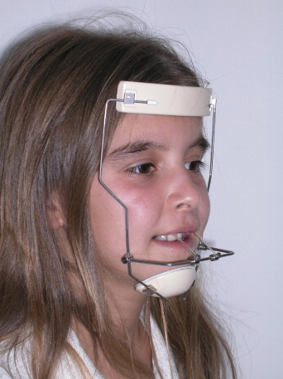

Fig Protraction therapy coupled with RME is quite a lot to inflict upon a young child so we need to be quite sure that there are real benefits to undertaking this treatment.

Let’s look at some of the treated cases that have been published,

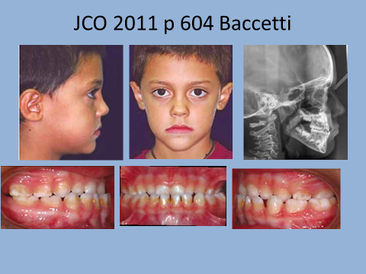

How about this, does this look like a severe class III skeletal base?

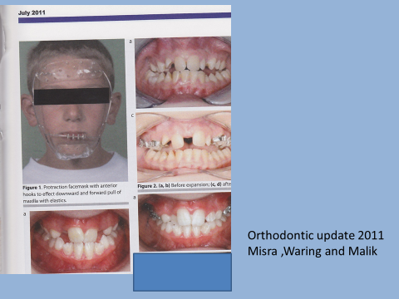

This picture shows two before and afters of RME and face mask theapy are you impressed?

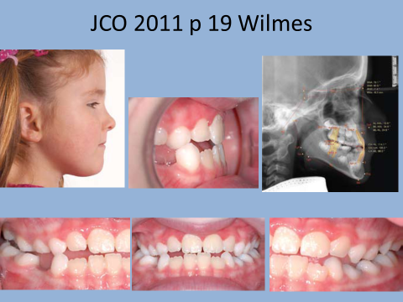

Oh yes this is before

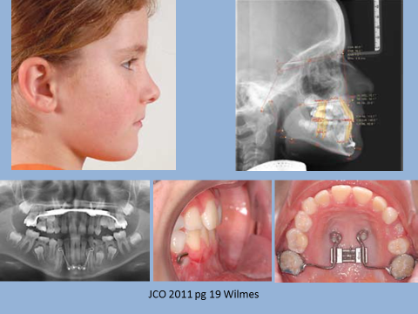

Facemask therapy plus bone anchored RME plus class III elastics to bone plates

Which brings us on to

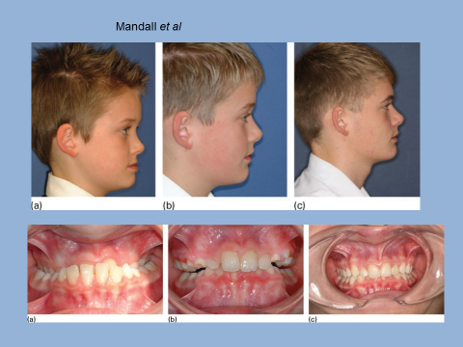

Fig. At last a decent case but the start is in inter-cuspal position this patient could probably bite edge to edge at the start.

**Mandall *et al* JO 2010 37 p149**  a real RCT but start radiographs not in RCP. ANB increased by 2.1 SNA increased by 1.4

I know what you are thinking, this is a bit more like it. It has the EOF prize for the best scientific paper and the Bristol notes say it proves facemask therapy produces orthopaedic change).:

The case for:

1. This is a genuine multi-centre prospective randomised clinical trial
2. Its authors are a group of well-respected British orthodontists.
3. It was published in a well-respected refereed journal.
4. Subsequent papers showed less of the treated group were thought to need surgery than the controls.

The case against:

1. The start radiographs were not taken in retruded contact position but in inter-cuspal position. It is well known that class III cases with positive overbites often have an initial contact edge to edge and then move into a different mandibular position with the posterior teeth in contact This was investigated by Gravely in 1984 BJO vol 11 pages 85-91 he found a difference in ANB of 2.7 degrees between RCP and inter-cuspal position in these cases so an increase of 2.1 does not seem so impressive now does it? (*just a word about Gravely this paper used 50 pairs of radiographs one taken in RCP and one in ICP he concluded that as the mandible closed up into occlusion the chin came forwards as a result of the hinge closure of the mandible and with a reduction in the MM angle but not by a forward movement of the condyle which remained in the glenoid fossa)*
2. The appliance was designed to move the maxilla forwards but the increase in SNA was not significantly different from the controls.
3. RME Moves the palatal cusps of the upper molars to contact the buccal cusps of the lower molars because the crossbite is over corrected. This generates an opening rotation of the mandible and the skeletal pattern moves to less class III or more class II.
4. At any time they could have resolved the problem by taking radiographs of the controls in RCP and compared these radiographs with the treatment group, but they did not do so.
5. More of the controls were thought to need surgery, but is this because they had their assessment done still on radiographs taken in inter-cuspal position and photographs again taken in inter-cuspal position. (They did not examine the actual patients.) Orthodontists have a 100 year history of attributing orthopaedic change that turns out to be an illusion.

Some investigations have also been published on a Bone anchored version known as BAMP again an excellent paper by N Mandall at the 2023 conference. Putting in surgical bollards complicated the treatment with little benefits.

Kevin O’Brien comments on a TAD supported version but I noted the start SNA was over 78°. This seems like a lot of treatment for someone within 1 standard deviation of ideal.

**Well certainly avoid saying anything nasty about this research (that’s alright for me I am very old and nobody has ever taken any notice of what I say.)**

I think you could say: it is a shame that the start radiographs were not taken in RCP and in theory to provide a statistically significant result all the radiographs should be taken in a non-postured position because statistics really gives you the probability that the observed difference could have arisen by chance. Here chance had nothing to do with it.

I think you should also say that because orthodontists have a habit of attributing orthopaedic change which later turns out to be optimism rather that valuable extra growth we should be cautious.

I think you should also point out this is very invasive treatment on very young children and a good standard of truth is required

Further research work is needed. Because the treatment is rather unpleasant there is a need for research on borderline surgical cases to see if the changes are great enough to provide an alternative to Orthognathic surgery.

As I type this, some poor child is being strapped into his/her facemask and their parents are wondering how they will be able to afford the treatment. (In practice the NHS does not fund comprehensive treatment for under 10s) can you see that there is quite a responsibility to get this right.

**Simple class III corrector**

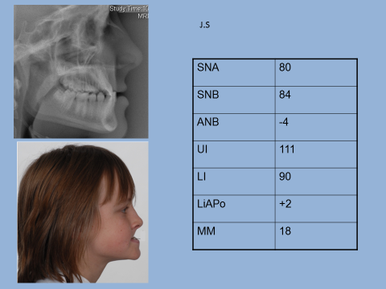

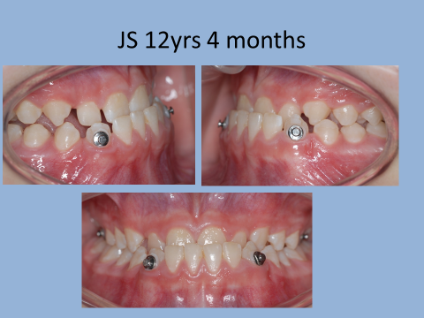

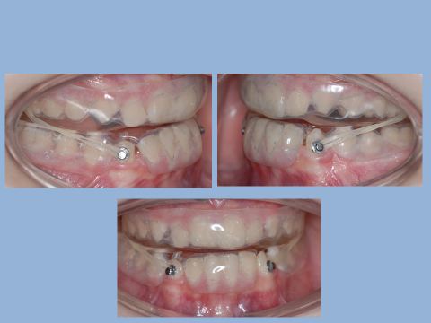

Bonded buttons on upper 6s and lower 3s with strong class III elastics worn together with Esix splints built up with cold cure acrylic.

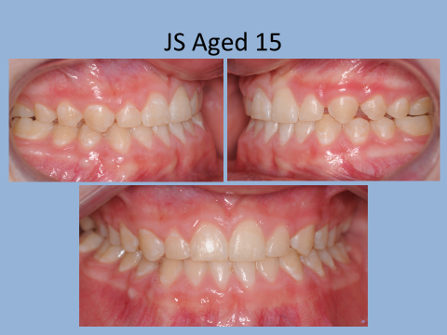

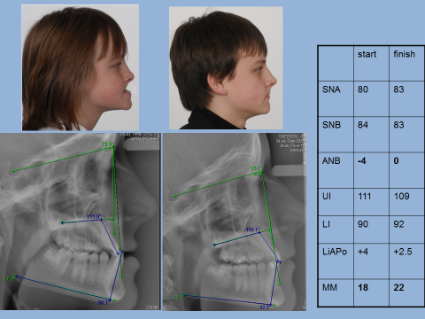

Well I like it anyway and it is very simple

**Should you surgically assist Rapid Maxillary expansion?**

Called SARPE surgically assisted rapid Palatal expansion

We meet surgery and expansion in 4 ways: -

1. You can expand the arch surgically rather than orthodontically.
2. You can surgically split the palate before expansion.
3. You could place a graft into the midline after expansion
4. You could use implants in the palate to be the abutment points for the expansion device.

All these have been tried. I don’t think there is such a thing as a most commonly held view.

Proffit considers that RME works like this: -

The appliance is fitted rigidly onto the teeth and the screw is turned twice per day. Because the teeth are not able to move apart at this speed, forces build up and this causes the sub mucosal separation of the two halves of the maxilla. After a period of 14 days the two parts of the maxilla are separated by almost 7mm. If the patient stops turning the screw the stretched tissues try to pull the two parts of the maxilla back together. Because they are only held apart by the splint which is attached only to the teeth this is possible because the teeth can move through the bone. So, RME does produce some extra bone in the midline of the upper jaw. But the amount is much less than you think. This is why Epkar and Fish suggest that you should not expand the jaws prior to surgery as they feel relapse of the expansion may compromise the surgical result.

**So,** surgical expansion improves stability. **But** it increases morbidity if one of the greater palatine arteries is cut during the surgery there would be a severe complication and part of the maxilla would probably be lost. Clearly surgery to split the mid line to assist RME where it is not part of an osteotomy is a much less risky procedure but I still wonder is the improved stability justifies a general anaesthetic.

Placing grafts in the midline to hold the parts apart just brings in further complications; now you have a graft site, cancellous bone would not resist the forces tending to contract the maxilla. Compact bone and hydroxyl apatite have been tried but I don’t know anyone advocating this treatment today.

**So perhaps the best answer would be to use a RME splint supported by implants**. This is at least logical as you can hold the bony plates apart while the bone forms in the midline. There is still the question as to whether the treatment is justified. Is a crossbite so bad that we would want to subject our children to the placement and removal of four implants?

**Should treatment of class III malocclusions be delayed until growth has ceased?**

**The most commonly held view** is that the fixed appliance treatment of class III malocclusions should be delayed until growth is more or less complete. This is because there is a significant chance that class III malocclusions will worsen with growth. This means that it is quite possible that a borderline case will become sufficiently severe to justify surgical treatment **this is true?** It is also true that it is unwise to carry out the surgery on a patient who is still growing because there may be further growth that will cause relapse.

Further support to the idea of delaying treatment is the suggestion that by attempting to carry out fixed appliance treatment at say 12 years of age if the patient at age 16 decides that they want surgical treatment the outcome will be compromised. **This is not necessarily true.** If, for example, treatment involved extraction of upper 5/5 lower 4/4 and fixed appliances. At the end of treatment the upper incisors would be proclined and the lower incisors retroclined. {Proffit calls this camouflage treatment} If this patient decides at a later date to go for surgery an initial de-compensation would be required but by using class II elastics you can achieve this in a very short time. However if the orthodontics had involved the extraction of a lower incisor then further treatment would indeed have been compromised. For this reason you should be cautious when planning extractions for class III cases.

It is important to remember that the class III skeletal pattern may not be perceived as the major problem as far as the patient is concerned. Class III malocclusions are often associated with severe crowding. For some patients it is justifiable to carry out orthodontic treatment to relieve crowding at the age of 12 while deferring the idea surgery until later.

For other patients they are sure that they will not want surgery even if their skeletal pattern were to worsen significantly. Some patients are precluded from surgery by the health or their religious beliefs for these patients there seems little advantage in delaying their orthodontic treatment.

**So**

The most commonly held view is that orthodontic treatment should be carried out a bit later for class III cases. Certainly, surgical correction should be delayed until all growth has ceased. However, all cases must be judged by their merits. Some cases clearly will never become severe enough to justify surgery while for other patients they are adamant that they would not want surgery even if it might be beneficial. For these groups there is little advantage in delaying treatment. There might also be an argument for attempting treatment for other patients so that unsightly crowding can be corrected early. Suggestions that treatment at a conventional time will complicate later surgery are a little exaggerated but care should be taken with selecting teeth for extraction. **In particular it is unwise to extract a lower incisor before growth has ceased** because if the patient was to grow unfavourably and request surgical correction the loss of a lower incisor would complicate treatment.

Final little test cover the right side and answer these questions.

|  |  |
| --- | --- |
| 1. Why do many class III cases have an inter-cuspal position that is not near retruded contact position | There natural first contact hits the incisors the mandible deviates forwards to avoid damaging contact of these teeth |
| 2 How do you modify your fixed appliance set up in a skeletal III camouflage case if you are using MBT brackets | Swap lower 3 right to left  ? canine brackets on upper 4 and 5 |
| 3. Can you use functional appliances in class III cases | Not really there is a FR3 appliance and a class III Andreson appliance but hey are really active removable appliances and not very good either |
| 4. Why is DJS moving to bonding Hyrax screws directly onto upper 4s | We are running out of premolar bands and bonding agents are now stronger also this design is much easier to fit |
| 5 What is the limit of inclination of incisors in a camouflage case | UI 125° Lower incisors 75° |
| 6. What are the strengths and weaknesses of Mandall et al | Multi-centred RCT, well known respected orthodontists published referred journal but it is a real problem that the cases were measured in Inter-cuspal position at the start |