Chapter 7. Functional appliances it’s complicated

People have tried to put orthodontic treatment planning into a computer but: “it’s complicated.”
As you know we start by looking at the lower incisors which Ballard called the “Foundation stone” of orthodontic treatment planning.
So, the lower incisors are OK if:
Lower teeth are supporting lower lip.
There was no history of digit sucking.
There was no lip trap.
There was no class II div ii malocclusion.
The lower incisors were at APo +1.
The roots were in the middle of the symphysis.
The lower incisors were at 92° to the mandibular plane (adjusted for changes in MM angle).
Treatment does not involve RME.
If our case does not fit this. We can make allowances. For example if there was a history of thumb sucking we could mentally move the lower incisor forward (we might argue by how much).
But already we are simplifying things?
What if a lower incisor is abnormally small? Or Large? Or a funny shape?
What if the gingivae is very thin, would we want to move the incisors back a little?
What if the overbite is reduced wouldn’t we want to retract the lower labial segment a bit?
What if the overjet is reversed with an initial traumatic contact, wouldn’t we want to retract the lower incisors a little?
If it is a deep bite case would a little over proclination of the lower incisors be worthwhile because it helps bite opening?
From this I would like you to understand two things, one it’s complicated and 2 you understand all this stuff and you are used to making this kind of judgement.
So, let’s carry on.
The lower arch is perfectly aligned with no crowding or spacing OR there is room to achieve this without extracting teeth.
Again we could make some adjustments if there is spacing could we angle the brackets to use more space or build up the teeth or use TADs , implants ,bone anchors or Pedro mechanics. If there is crowding we could perhaps use inter-proximal reduction. And what about just saying we could procline the lower incisors a bit and retain with a LBR.
If the crowding is more severe than is possible with IPR we could take out teeth. We know how much space this will give us by measuring the size of the tooth.
Again more complication:
The tooth may be unerupted. But we can still calculate the size from radiographs or estimate from the size of an erupted tooth.
Also some of the space is available for alignment and some may be lost as the posterior teeth drift forward or are pulled forwards by anchorage loss.
This is very complicated because we can control it with our mechanics, for example we could re-inforce anchorage or we could allow free tipping forwards of the molars.
Somehow we have arrived at the new position of our lower first molars and we come to the crunch part of treatment planning.
IF THE MOLARS ARE CLASS 1 we should extract the same number of teeth in the upper as the lower.
Again more complications, what if teeth are missing?
IF THE MOLAR ARE CLASS 2 we need to extract one more tooth each side in the upper than the lower
Again more complications: we can fudge things a little. Let the lower molars come forwards a bit (racebacks?) class II elastics or gable bends BUT straight-wire cannot routinely change class II molars to class I
This is the moment we have been heading to:
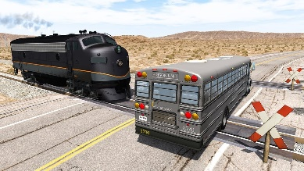
If the molars are class II and you need to extract lower 5s (or the patient wants to avoid extractions) WHAT DO YOU DO?
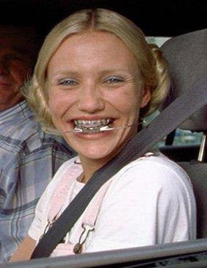
In America they wear headgear
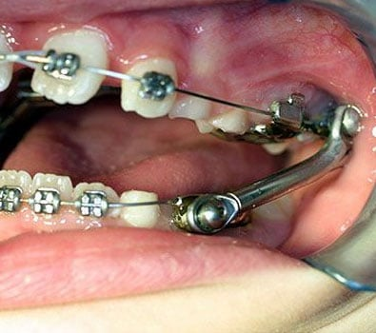
In Europe they like a Herbst appliance
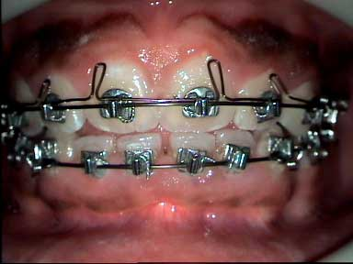
In Australian and the Netherlands they still do some Begg
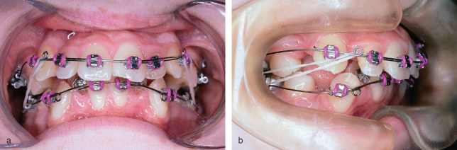
In Leeds they like a Tip-Edge
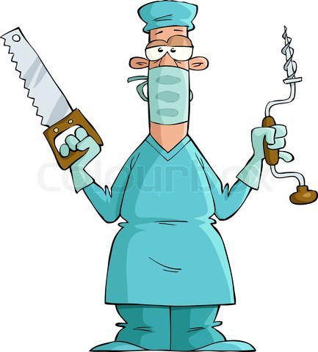
And there is surgery, Non-Compliance appliances and loss of 2 units per quadrant in the upper.
BUT IN THE UK WE USE:
Functional appliances (properly called Myo-Functional appliances)
So Functional appliances are used to convert class II molars to class I so we can treat with Straight wire. Do they do anything else?
- They can be used at an earlier age than fixed appliances so they can reduce OJ earlier.
- Because of this they reduce trauma to the upper incisors (O’Brien).
- They may produce orthopaedic change.
Functional appliances a potted history
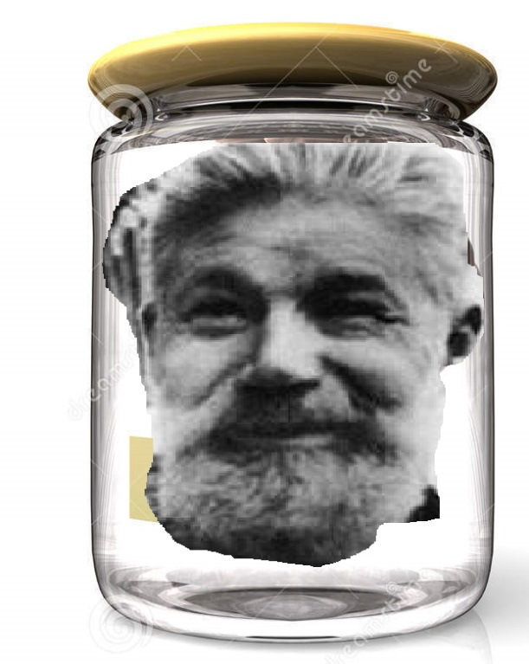
This is Viggo Valdemar Andresen1870-1950 a dentist of Danish extraction.
In 1908 Andresen carried out fixed appliance treatment for his own daughter. The alignment was OK but there was a residual overjet. He removed the fixed and fitted a retention appliance that looked like this:
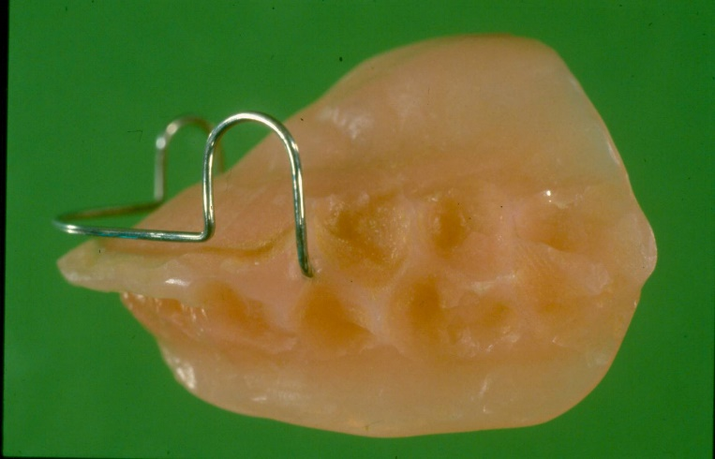
Made of vulcanite with a labial bow. (Adams cribs were not invented until 1950s.) The appliance is quite loose fitted and worn only at night.
Although she had an increased overjet the wax bite was postured to a normal overjet. When she returned from summer camp the overjet had been reduced to normal. Andresen had found a way of reducing the overjet. He called this an “Active Retainer” or “Activator”. But you may see it referred to as a Monobloc, this in deference to Pierre Robin who described an appliance which looks similar although its purpose was not to treat malocclusions but to alter the position of the tongue.
Initially the appliance was not well received in part because Andresen recommended extractions for the treatment of crowding (this was the Angle anti extraction era). But later there seemed advantages in this treatment compared with the fixed appliances of this era. It was simple and cheap. At this time Oppenheim was beginning to report damage caused by the heavy forces used in fixed appliances.
In 1925 Andresen was appointed as director of the University of Oslo in Norway
He advocated his appliance as a simple, cheap, method of a government provided orthodontics. At the university an Austrian born Periodontologist, Karl Häupl became interested in the appliance. Together with Andresen they advocated this as the “Norwegian system” and published a book (Funktions-kieforthopädie) in1936. A certain amount of mystique was involved in trimming channels for the erupting posterior teeth to help overbite reduction. Note there was no suggestion of orthopaedic change at this time.
Claimed advantages of the Andresen appliance
- Could be used in mixed dentition.
- Worn only at night.
- Long gaps between appointments necessary.
- Lighter forces less tissue damage.
- Habit breaking.
- Cheap.
- Less training required.
Disadvantages
- Only works in very compliant patients.
- Cannot align crowded teeth.
- Does not work so well in older patients.

Danish Father Christmas lookalike, Viggo Andresen, discovers a removable appliance made to a postured bite can reduce overjets. Together with relief of crowding by extractions it offers a cheap easy way of treating malocclusions and he is appointed director of orthodontics in Norway. Together with Austrian Periodontologist Karl Häupl they produce a book about this treatment. As well as the Andresen appliance you may also hear this called an activator, a Monobloc or a Norwegian plate. The problem is that this appliance is too bulky to wear during the day and easy to spit out during sleep. So, the success rate is poor. What can you do?
Well you could try:
- Making the appliance too big to spit out
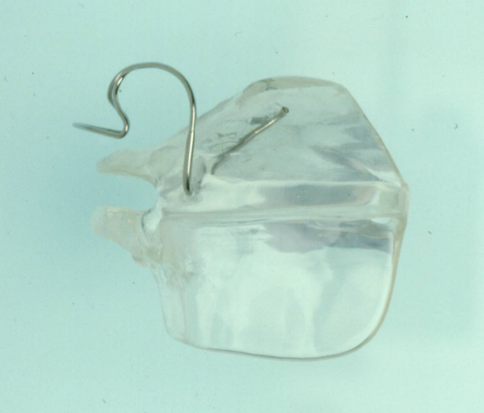
The Harvold appliance. Other advantages might be that it stretches the muscles giving a kind of elastic recoil activity. The acrylic touches the cusps of the upper teeth preventing their eruption but the lower posterior teeth are free to erupt and drift forwards helping to correct the Overbite and the molar relationship. This appliance was supposed to be loose and some people used springs to make it drop down and thus encourage the patient to bite it back up. (Famous British orthodontic story Keith Isaacson fitted one but could not remove it. He spent 3 hours sectioning it so it could be removed.)
- Reduced activators. Make the appliance smaller so it would be possible to wear it during the day
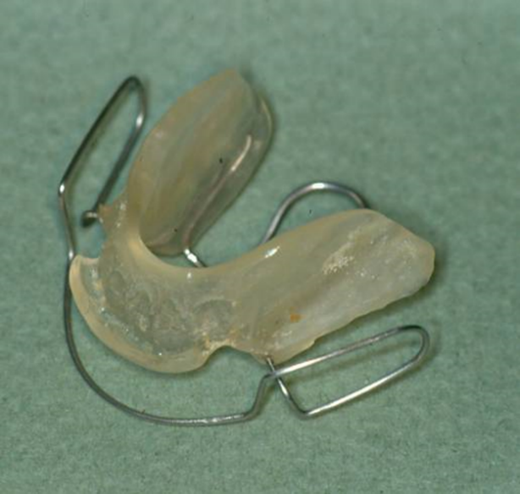
The Bionator designed by Balters is smaller and robust
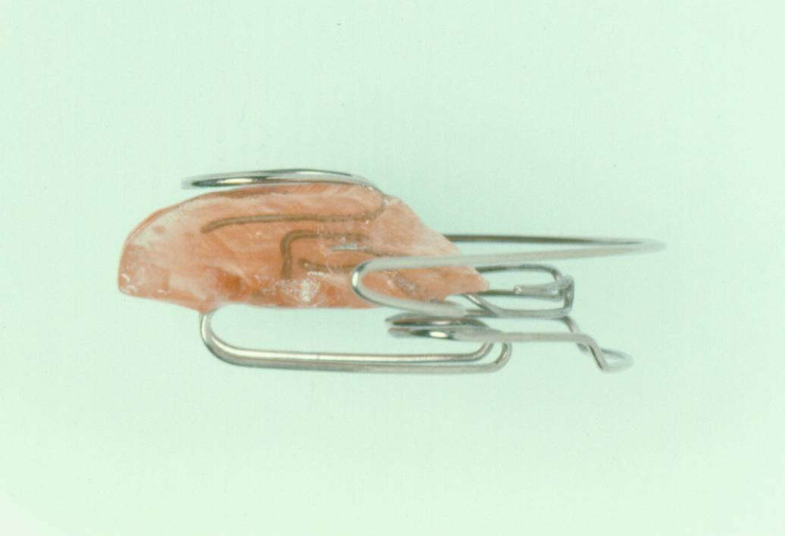
The Bimler is Similar!

- Making the appliance stay in place. Well after 1953 you could add Adams cribs
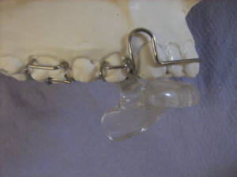
This is the medium opening activator
- Add headgear
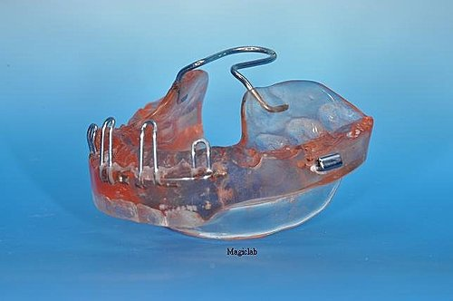
The Teucher or Stockli appliance
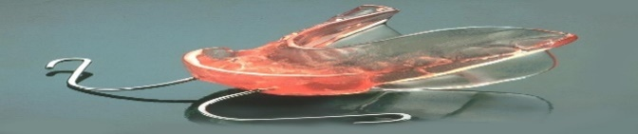
The Van Beek appliance
Both these appliances combine headgear with functional appliances
- Making the appliance easier to wear. The two-part functional appliance
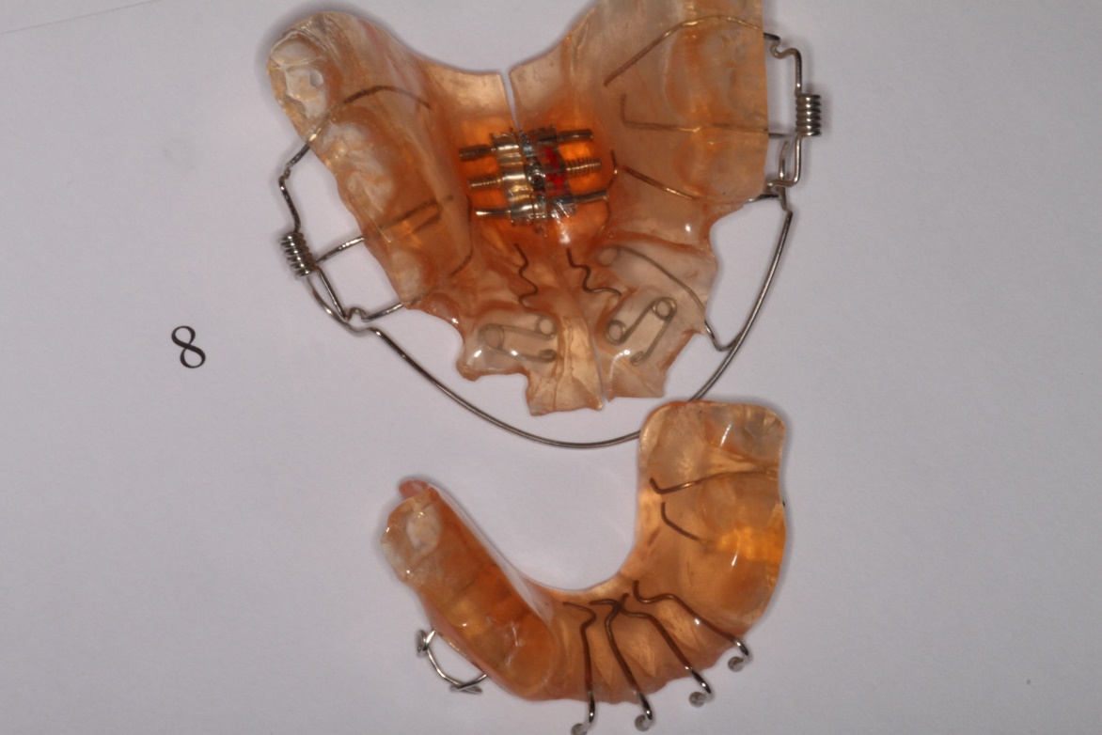
The original Clark twin block had lower blocks than are now used in most institutions it also had headgear and a kind of class II traction from the lower appliance to a spur on the headgear. But the two-part design made it possible to eat and talk with the appliance in place.
A NEW(all) idea
Newall was a contemporary of Andresen and he invented the ORAL SCREEN the appliance is not very important in our story but the idea is.
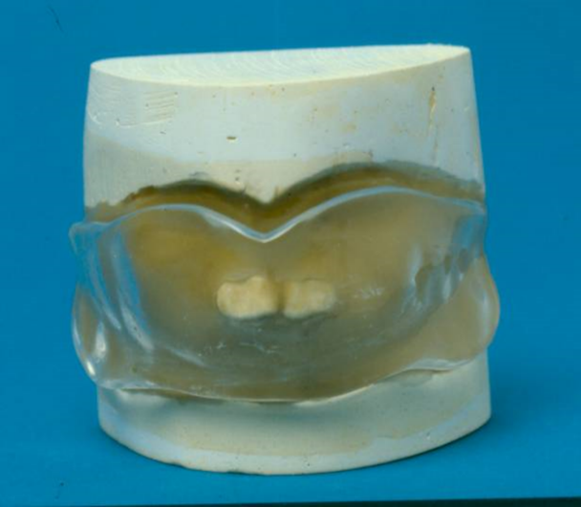
You get the idea it sits in the vestibule and is spaced so that it only touches the upper incisors. Forces from the muscles of the lip and cheeks apply pressure to the upper incisors to move back while the tongue pressure tends to move the lower teeth forwards and the buccal teeth buccally. It reduced the overjet rapidly and was great at stopping digit sucking, but it did not open the bite. This could mean it was liable to cause root resorption if used in a deep bite case. This was not well understood at the time and the appliance is no longer used much, but the idea continues with some functionals.
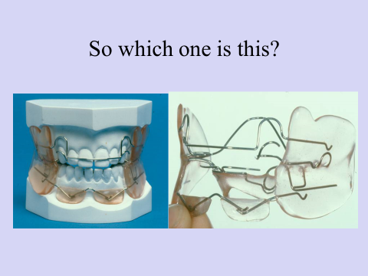
This is a Frankel appliance. Note it has pads to hold the lower lip away from the lower incisors to allow them to come forwards and buccal shields to hold the cheeks away to give some expansion. It is made to a postured bite and has occlusal stops to prevent the eruption of the upper 6s. (This one is a FR1c, but more of this later)
Neville Bass made an appliance along similar lines (Called the Bass appliance, he later designed the Dynamax)
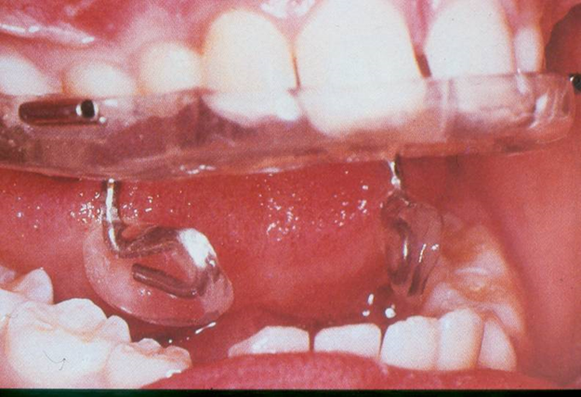
Bass appliance
This started as a URA and bumpers and shields were added plugging in through a series of tubes. It was clever but not robust. (Unfortunately most of my patients are robust but not clever, so they did not get on with the Bass appliance)
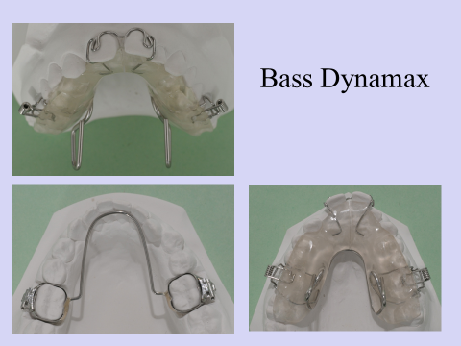
At Burton we modified the Dynamax and even used fixed in ones but in my hands they are not as successful as button and bead appliances

The lip bumper is a myo-functional appliance using the ides of Newall. It holds the lip away from the lower incisors allowing them to procline and transmits the force to the molars moving them distally. Add hooks for class III traction from the upper 6s (supported by EOT) and you get the Denholtz appliance.
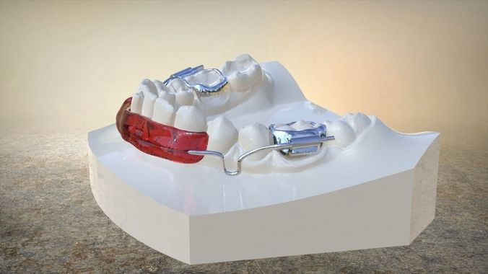
- Fitting the appliance to the teeth
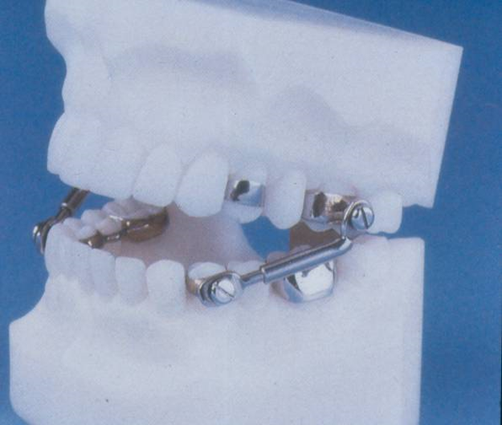
The Herbst appliance
Presented in the International dental congress in Berlin in1905. But you will remember that the Germans were otherwise engaged between 1914-1918 and again between 1939-1945. The Herbst appliance was largely forgotten until it was revived by Panchertz from 1979 on. The original Herbst appliances were made of gold and German silver. In many ways this appliance is absolutely brilliant:
- It’s fixed in so compliance is not a problem
- It opens the bite only in cases where the molars are out of contact in protrusion.
- It is not showy.
- The condyle cannot go back in the fossae so if this causes growth modification then you would expect it to work brilliantly,
However there are two big snags:
- When the rod hits the base of the tube there is a sudden jolting shock which tends to break the brace.
- After some tooth movement it is possible for the patient to get stuck with their mouth wide open.
What you need is a stress breaker:
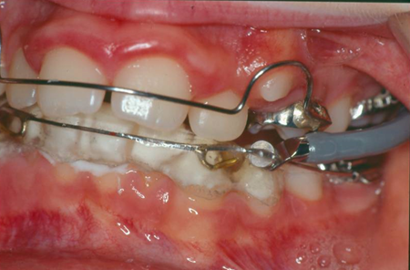
Like a Jasper Jumper
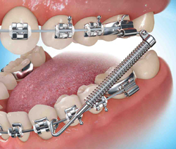
Or a Forsus spring
This is the original version of the Forsus spring, the new version clips into the EOT tube from the front BUT you need to have the correct Unitek molar tubes,
These work OK but tend to break. At least it is the spring that breaks rather than the whole appliance.
There are some more like the Klapper Super-spring and the Gentle Jumper. Which I have never tried.
The Eureka spring is too gentle it does not advance the mandible so I think you should see it as an alternative to class II elastics
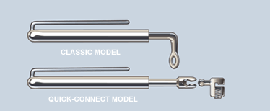
Inside the tube is a NiTi push coil,
At the 2023 BOC Prof Ama Johal gave a paper comparing Twin Block appliance to a new kind of Herbst with a telescopic advancer (so it cannot lock with the mouth open). The Herbst was the better appliance, at least it was preferred by the patients. I note it is a much more complex appliance.
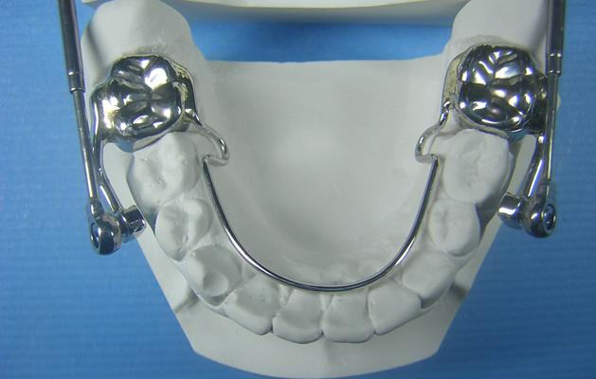

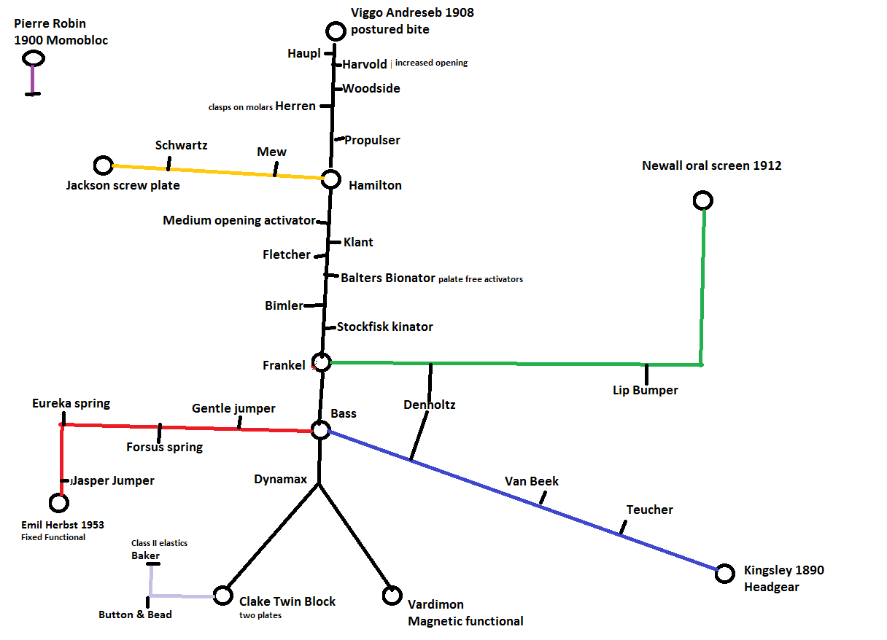

Meet the family
Here are a few of my favourites who we have not met yet:
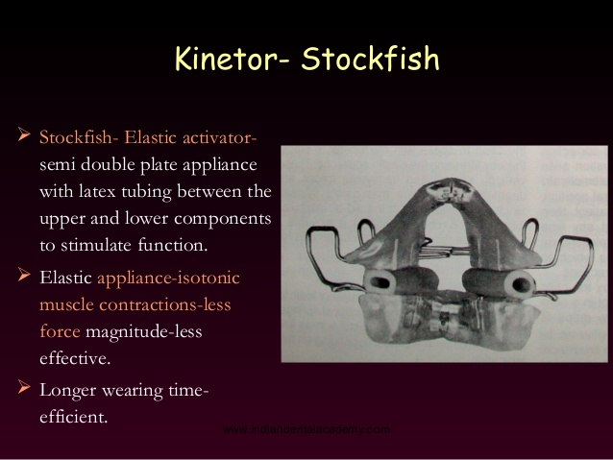
Got to like the Stockfish appliance. It is sort of two separate plates but stuck with two bits of rubber pipe.
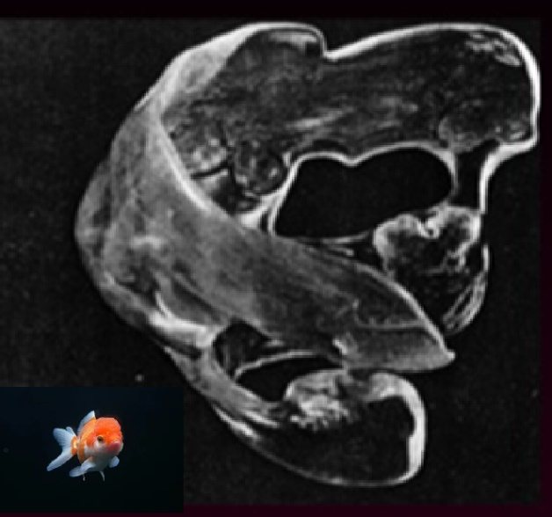

The Propulser is an all plastic functional and looks like a jellyfish. (No It isn’t Nemo it’s just a stock fish)
Special mention should go to the Vardimon magnetic functional. Forward posture of the mandible is achieved by using two plates with posterior bite planes each incorporating high powered magnets.
Drawbacks being the magnets are very toxic and the patient keeps getting stuck to the fridge.
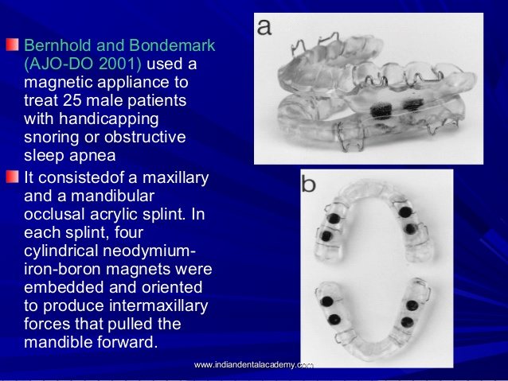
Interesting now it is suggested for sleep apnoea if they swallow the magnets it will certainly stop them snoring.

How does a functional appliance work?
- Postured bite holds condyle out of fossae. So the condyle tries to grow back or the fossa remodels
- Postured bite removes lip trap. So the upper incisors are no longer proclined by the lower lip trying to make a seal and the lip will come forwards over the upper teeth to pull the incisors back
- Postured bite is accompanied by muscular force trying to pull the mandible back. The plate transfers this force to the upper teeth. (so it is rather like class II traction)
- Muscle and soft tissue is stretched (certainly true of increased opening appliances like the Harvold)
- Shields hold muscular forces away from some teeth and direct it onto others
- Stepwise advancement (a theory by Urban Haag and others that advancement brings about a burst of growth at a cellular level which lasts 12 weeks. So keep advancing a few mm at a time every 12 weeks)
- Allow lower teeth to erupt and they will drift mesially correcting a class II relationship
How does a functional appliance open the bite?
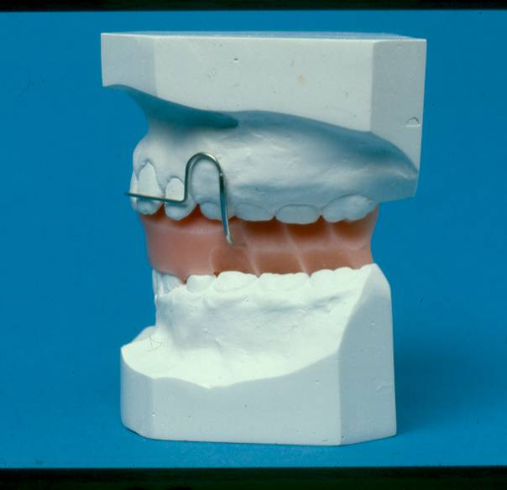
Andresen .cut grooves to allow upper teeth to erupt distally and lower teeth to erupt mesially.
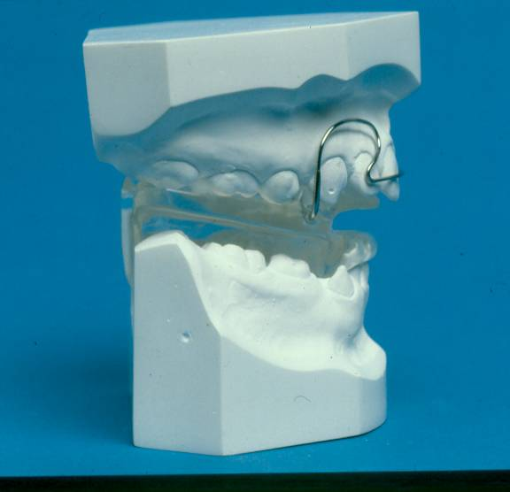
The Harvold appliance stops upper teeth erupting, but allows lower teeth to erupt and drift mesially
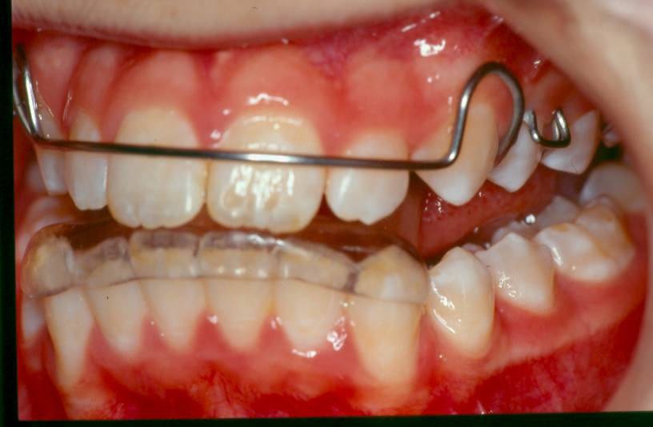
Medium opening activator has nothing over the lower posterior teeth so it always opens the bite
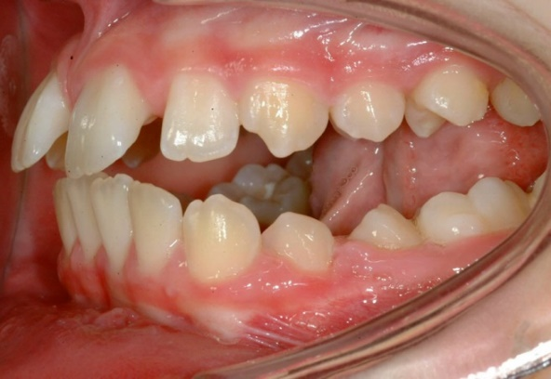
Twin block causes posterior open bites which, if you fit a Hawley, close by eruption of the lower teeth. Many advocate an inclined bite plane (a recognition that some of the change is due to posture because if the bite is really edge to edge the teeth would not bite on the inclined plane)
Managing a Twin block case
Ideal age start just before growth spurt
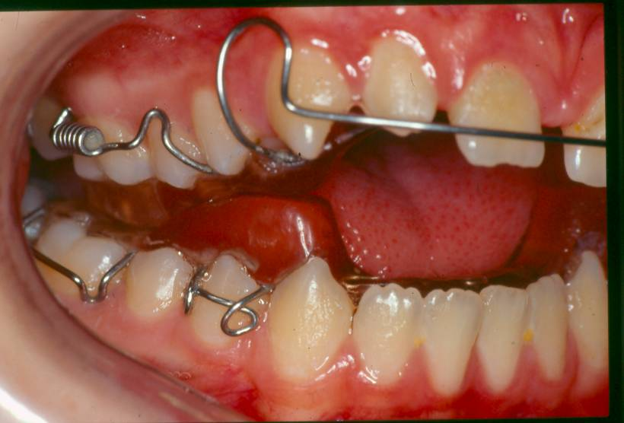
This is the original Clark Twin Block
Most modern cases are modified Clark Twin Blocks. The blocks are bigger about 6mm high and we don’t use a labial bow. Retention in the lower appliance may include
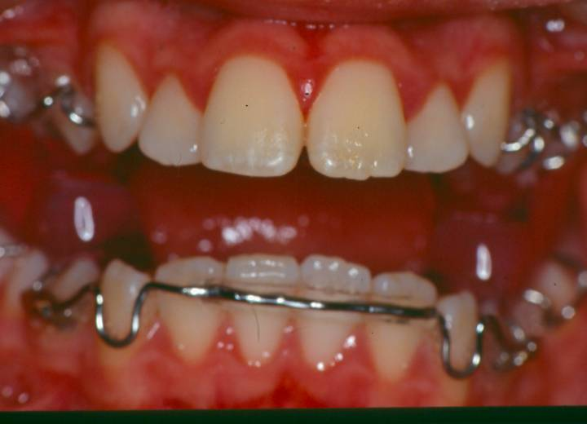
An acrylated labial bow (which I like)
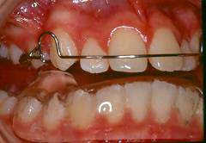
A splint type (Wigglesworth) which I also like
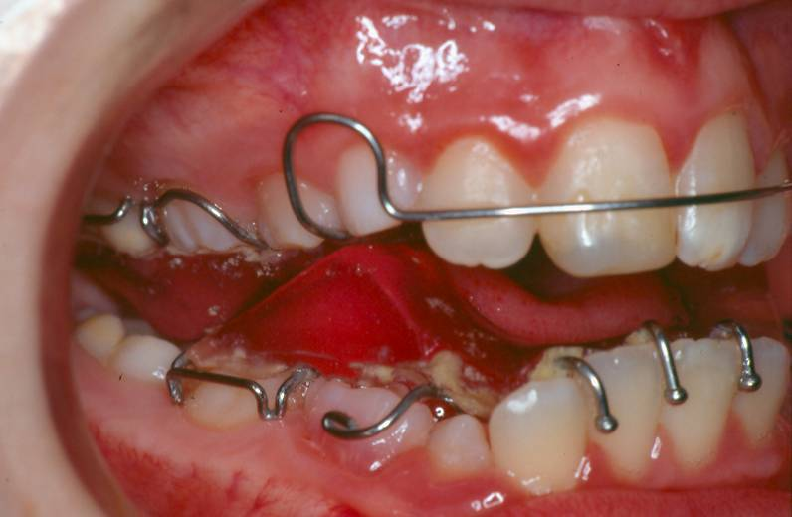
And Ball hooks which I think are ballhooks
The appliances have an upper mid-line screw to expand the upper arch but I think it is a mistake to start turning the screw until you have achieved some overjet reduction.

Seems to me that there is a lot of hocus pocus about functional appliances. And people have very strong views about when to start and when the appliances should be worn. Also on how far you should reduce the overjet and with what appliance you should retain after overjet reduction. There is also a big variation on how long some people hold the change before starting on fixed appliances. (Bob Lee suggests 15 months. Seems a long time to me)
Here is the problem:
- The twin block makes you posture forwards
- The twin block causes posterior open bites to develop
- It is often hard to tell if the overjet reduction is real or is there still an element of posture
- If there is a posture and you extract upper 5/5 lower 5/5 and start fixed appliances you may be sorry

Button and bead appliance
A simple brace for the simple people of Burton on Trent.
First a case
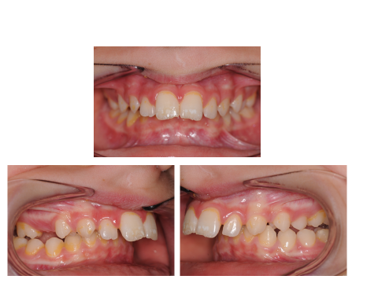
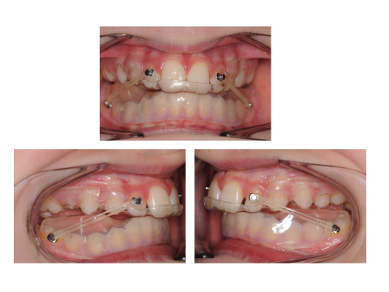
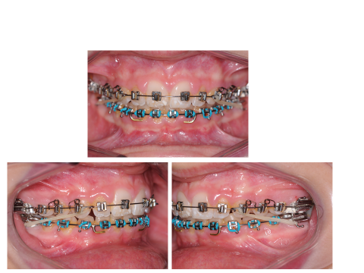
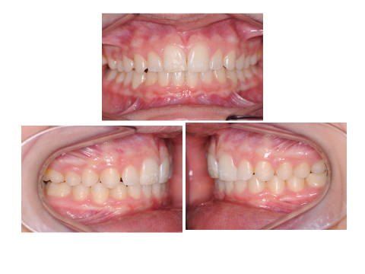
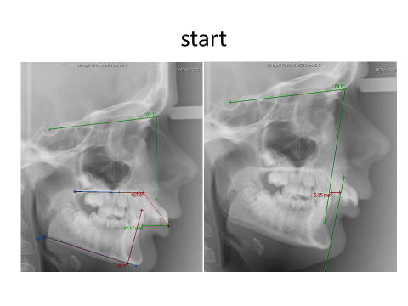
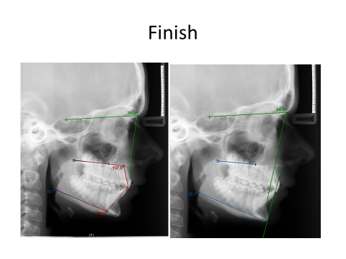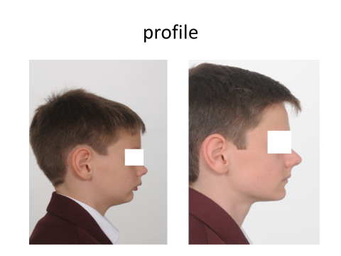
So an 18 mm overjet reduced non-extraction in less than 2 years. Seems OK to me but I have to say that when I submitted cases for publication the referee said “ I see no point in this appliance when we have the Twin Block” The kind of open scientific mind-set that we need in orthodontics.
The theory
When your twin block patient is asleep with his mouth open the appliance is not working. When he is speaking the mandible is not held forward so the appliance is not working. It is not in his mouth for cleaning and sports and although he says he wears it for some foods the truth is he takes it out for anything more difficult than a mint.
This a big problem in Burton because eating, sleeping and talking occupies 99% of the day,
The appliance is a simple upper splint with a 4mm bead made of flowable composite, Tp Orange class II elastics are worn throughout treatment so the appliance is still working in sleep and talking. It is even possible to make soft splint versions for wear during sport (only worthwhile for a very keen sportsman)
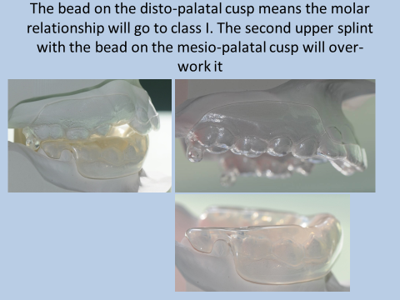
The lower appliance is just an Essix retainer built up with acrylic to form a 4mm thick table. No wax bites are needed to make these appliances. It is important that there are 2 upper splints and that they are made of Centrilux. Don’t think you can get away with an Essix retainer with two beads stuck on use:
1.5 “clear and rigid” from Centrilux™ WHW Plastics LTD Hull UK and block out any undercuts
Read
burtonortho.co.uk
Journal of Orthodontics VOL 42 2015 69-75
David John Spary and Rachel Ann Little
The appliance should be fitted within 3 weeks of the impressions and is worn full time except for cleaning. Sugary food and drink have to be avoided when out of the house. Sugar can be consumed at mealtime at home but the appliance must be removed and the teeth cleaned after eating. This is a hardship for some patients but the treatment is usually complete within 12 weeks.
For Class II div 2 malocclusions a sectional fixed is needed before the button and bead appliance but the brackets can be left for use as the elastic attachment.
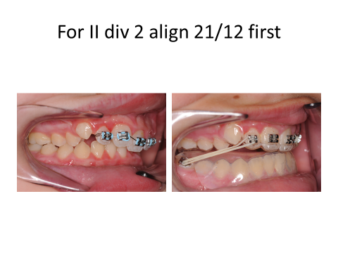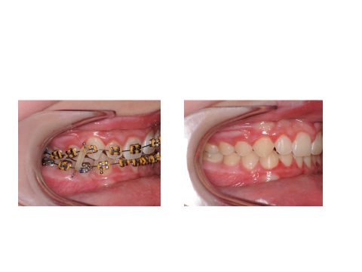
Try it and see if you like it. If you do, thank Pat Watkins the technician at Burton who put in so much work developing this brace.
Help sheet for the Button and Bead appliance
- Check you have the appliance. There should be one lower splint with a 4mm thick table over the lower teeth finishing at the distal edge of the lower 6. The appliance does not extend over the lower 7 even if it is present. The appliance should be fitted within 4 weeks of taking the impressions (a shorter time is necessary if there are loose deciduous teeth) No postured wax bite is needed.
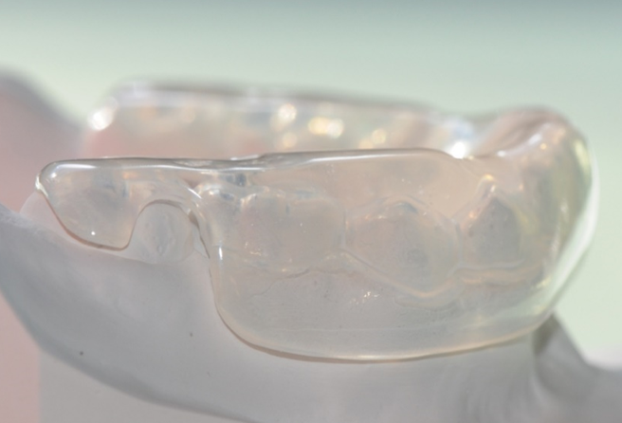
- There should be two upper splints. Splint one has a 4mm bead on the disto palatal cusp of the upper first molar. This appliance is worn for the first 6 weeks. Then the patient moves onto the second upper splint where the bead is on the mesio-palatal cusp of the upper first molar.
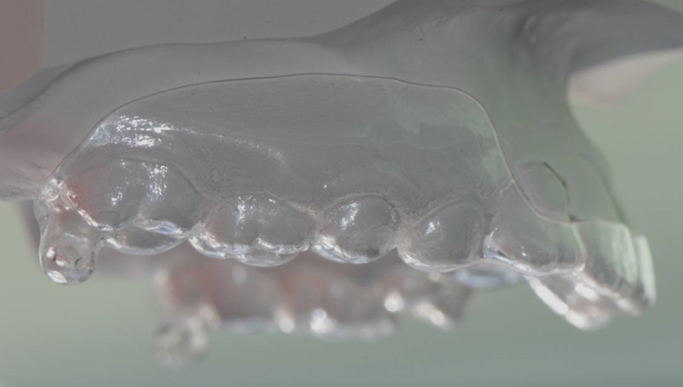
- The appliance needs an attachment on each lower molar and the upper lateral incisors (actually you can use the upper central incisors if the laterals are small or very rotated). On the lower molars bonded tubes work best Bond the tubes very gingivaly and if you use self-etching primer I suggest clean and etch for 10 seconds first. Check that the lower splint is relieved away from the tube enough to allow the patient to place the elastics.
- I think the upper buttons made of composite are best they look good and stay on well
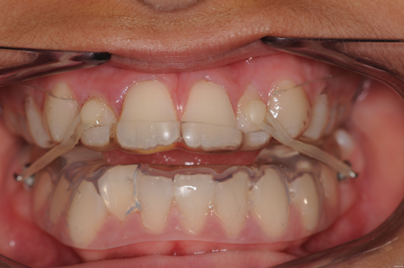
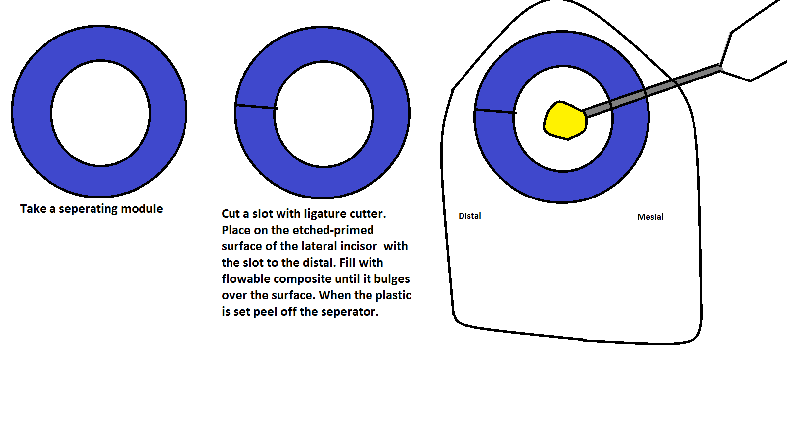
For the most part these are young patients, I always give them the little hook to help placing the elastics
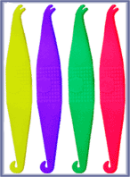
Orthocare 31267-APP
Assuming the buttons are on the laterals you need TP orange elastics changed 3 times per day. If the button is on the central you need TP pink elastics
Advice to patients and parents on the fitting of a simple class II corrector (button and bead appliance)
- This is a simple brace that is used to move the upper teeth back. It is an important part of straightening the teeth but is usually followed by another brace.
- The brace is removed for cleaning the teeth and for contact sports if a sports guard is worn. It should be worn at all other times including for eating.
- Check the fit is comfortable and you can get it in and out easily. Also check you can place and remove the elastics, before you leave the orthodontist.
- For the first few hours it affects speech and feels difficult to swallow, this is normal and will soon pass.
- You have to learn to eat with the brace in. Start with easy to eat food like pasta.
- After a day or two you will be able to eat most things but you still should not eat tough or chewy food or you will break the brace. You should not chew gum.
- When at home you can have sweets of a sweet drink WITH YOUR MEAL but as soon as you finish eating you must remove the brace clean it and clean the teeth and then replace the brace and elastics
- Sorry but at all other times you are not allowed sugary drinks or sweets
- After 6 weeks change to the second upper splint but keep the old one. It can be used as an emergency splint if the second one breaks
- Don’t worry if the bead on the upper plate wears down this is normal.
- Never wear the elastics without the rest of the brace.
- Treatment usually takes 14 weeks but will take longer if you don’t wear the appliance full time or if you break it. It is in your best interest to take care of the brace. Common problems and solutions
- The brace is lost. The solution is to wear it all the time and you can’t lose it
- The brace is trodden on. The solution is to wear all the time and take care of it when brushing the teeth
- The dog eats it. The solution; dogs will always eat braces if they are left lying around. Take care but again full time wear reduces damage
- Someone tries to clean the brace by pouring boiling water over it- this ruins the brace
- A bit of the brace breaks or wears down. The lower splint is very strong it should not break in the mouth. The upper part is thinner and so can break more easily. It does not matter if the bead at the back wears down or even breaks off on one side. However it is important that the brace fits tightly around the upper front teeth or they will move. If the first splint is broken within the first 6 weeks go on to the second splint. If the second splint breaks go back to the first. But in both cases inform the hospital and bring your next appointment forward.
Frankel appliances
Rolf Frankel was a nice man. He worked in East Germany before the fall of the Berlin wall. Edgewise fixed appliances were not possible, so he invented appliances using the materials he had to correct the malocclusions he saw. I had the privilege of talking to him for a while at a BOC. He was very modest about his achievements and felt straight-wire treated class II div ii malocclusions better than he could. His appliances were:
FR1 a…..class I molars and a deep bite
FR1 b…..Class II div I with overjet of less than 5mm
FR1 c…..Class II div I with overjets greater than 7mm
FR 2 ….. Class II div ii (they have a wire behind the upper incisors to prevent them from retroclining and may have little tucking in springs to tuck in the laterals.)
FR 3 ….. for class III malocclusions
FR 4…..For AOB cases and bimaxillary protrusion
FR5….. used with headgear
Class III functionals, are they a step backwards?
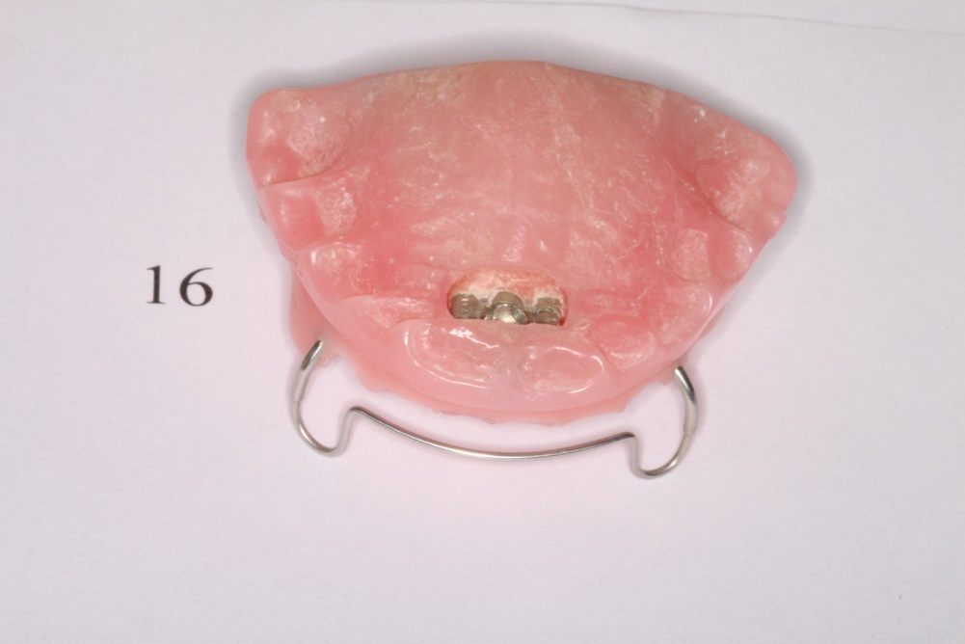
Class III Andreson was not really a functional appliance. The top and bottom halves were joined with a screw which the patient turned once a week moving the upper teeth forward over the bite,
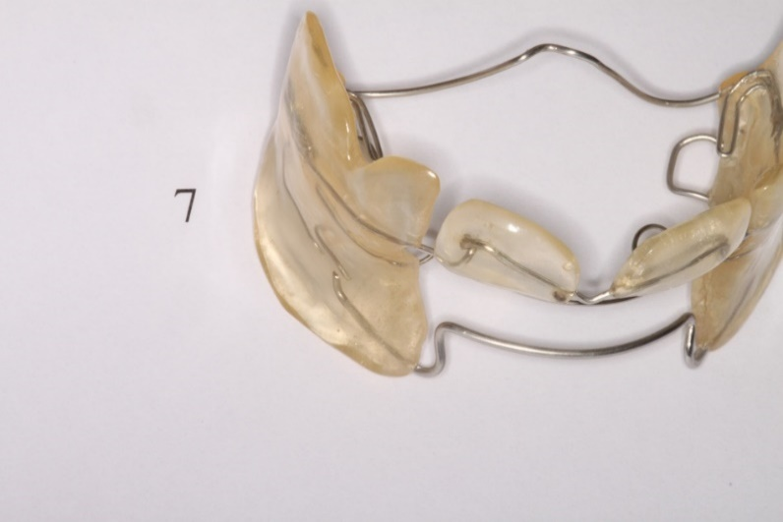
The FR3 is not really a functional either. When the technician makes it they gouge out a groove across the lower incisor teeth on the work model. This means that the lower labial bow is active and will tip the lower incisors back.

FUNCTIONAL APPLIANCES

ARE THEY CAPABLE OF SKELETAL CHANGE?

Read on for a long and tedious explanation or for a short answer go to page 34.
Looking at some patients before and after treatment you will notice a very considerable change in the profile. This has tempted some orthodontists to believe that their appliances are capable of skeletal change.
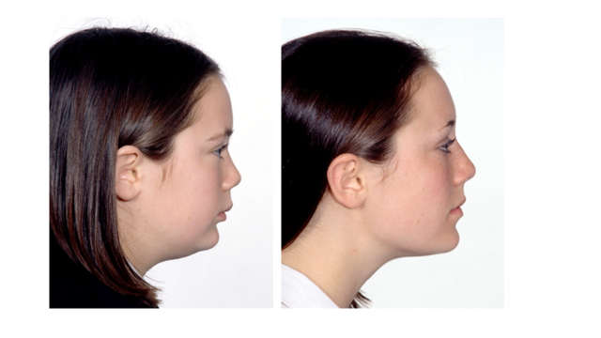
But “it’s complicated”. This patient had Begg therapy a treatment that if anything has a reputation for flattening off the profile. (Wrongly, it is the extractions not the appliance that cause flattening of the profile)
A few points:
- All treatments that remove a lip trap will improve the profile.
- Patients tend to grow less class II.
- Camouflage treatment works. You see the size of the lower jaw by comparing it with the upper.

I think we should be a little unhappy about the history of orthopaedic change. For me it went like this:-
- At first we used to apply high pull headgear for 3 years night only before the start of orthodontic treatment. The idea was that the heavy forces would impede the downwards and forwards growth of the maxilla. But it was later pointed out that the usual problem was that the mandible is too small and not that the maxilla was too big. So this treatment fell out of use.
- Then we went on to RME this was proper orthopaedic change. You could take an occlusal x-ray and see the extra bone and according to Haas there was an improvement in the airway. But Peter Vigg showed that the airway obstruction was much less common than we thought and where it did occur it was in the adenoid region, not affected by RME. So the use of RME became restricted to the treatment of crossbite.
- Then the Rolf Frankel appliance became very popular. Rolf Frankel worked in East Germany where they could not afford buy straight-wire brackets but showed you could move the teeth around with bits of wire and plastic but his claims that stretching the periosteum made the mandible grow were a bit wide of the Deutch-mark.
- The William Clark twin block was a wonderful step forward, at least if you have a low FM angle. It is a quite wearable appliance but does it produce orthopaedic change? Kevin O’Brien says yes but it is clinically insignificant. BUT remember that there is a possibility that there was an element of forward posture in the final measurements. So perhaps we are enlarging a difference that is not just small but in fact is not really there at all
- Let’s try not to repeat this with face mask therapy

FUNCTIONAL APPLIANCES & GROWTH

General Views

The ability of functional appliances to bring about sagittal dental base changes has given rise to controversy in the past. However, current views seem to support the use of these appliances to promote “skeletal” change. The influential textbook “Orthodontics, Current Principles and Techniques (1985)” Graber T M and Swain B R states categorically that successful apical base changes have been achieved. It cites 12 references including Freuthaller FRE (AJO 37)p18. Graber T M GRA (AJO 52)p331. Hausser E Hau(EOST
1973)p427. Moss J P MOS (EOS 1962)p327. Softley J W SOF(DR 73)P458 and Tonge E A TON(AJO 82)p277.
The book differentiates between those authors who claim a retardation of maxillary growth and those who claim enhanced mandibular growth. Maxillary growth inhibition is claimed by Demisch A DEM(EOS 72), Jakobson S O JAK(AJO 53)p446 and Woodside D G WOO(EOS 73)p443.
While more authors claim enhanced mandibular growth including:- Baume Frankel R L J BAU(Oral Surg 14)p61, and BAU(EOS 69)p79, Elgoyhen J ELG(AJO 62)p72, FRA(AJO 84)p54, McDougall P McD(AJO 82)p10 and McNamara J A McN(AJO 64)p578.

K G Isaacson, R T Reed and C D Stephens in their book “Functional Orthodontic Appliances” suggest that the forward posture of the mandible generates forces which can alter the bony development of the maxilla and mandible and that the effect of occlusal separation is also considered to have an influence on skeletal development. Provided that the appliance is used in a period of active growth, it can exert an ‘orthopaedic’ effect by changing mandibular and maxillary growth. They consider that the normal downwards and forwards growth of the maxilla is restrained by the action of the appliance. The mandible may be affected in three ways:-

- Stimulation of total mandibular growth through stimulation of the condylar cartilage. The mandible responds according to Melvin Moss 1968 “Theory of the Functional Matrix” MOS(DP 19)p68.

- Some workers suggest that functional appliances may promote a more favourable rotational type of growth eg Luder H U LUD(EJO 3)p203.

- The glenoid fossa may remodel forwards to allow a forward position of the mandible as suggested by Birkbeback L BIR(EJO 6)p84 and Hinton R J HIN (EJO) p155-.

This book also has a comprehensive summary of published papers, some of which claim growth changes. These include:-

Baumrind S BAU(AJO 84)p83
J Haynes S HAY(AJO 90)p308
Luder H U LUD(EJO 3)p203
Luder H U LUD(AJO 81)p390
Marschner J F MAR(Angle 36)p89
Meach C L MEA(AJO 52)p353
McNamara A McN(AJO 88)p85

Witzig and Spahl’s textbook is entitled “The Clinical Management of Basic Maxillofacial Orthopaedic Appliances” (John W Witzig and Terrance J Spahl). Although this book is mainly concerned with the clinical use of functional appliances rather than the mechanism and viability of skeletal change, it seems to accept that these changes do take place. The actual statement is worthy of quotation: -

“The concept of mandibular advancement at first met with staunch resistance. Many believed that the mandible could not be artificially stimulated to increase in size, or overall diagonal length from condylar head to Pogonion, but recent unbiased computerized serial cephalometric radiographic analysis of patients treated with various functional appliances, has shown that the mandible can, in fact, be stimulated to increase its length by the use of these appliances and the greatest area of growth is in the condylar head and neck*.”

In fact, the references quoted are:- Meikle M C MEI(AJO 64)p50 1976, Enlow D H ENL(AJO 50)p25 1964, CHA(JBDA 46)p845 1925 and Brodie BRO(AJAnat 68)p209 1946. The effect is misleading. The references are not the promised ‘unbiased computerised serial studies’ but old descriptive papers of condylar growth. The authors continue - “Why does such rejection to such plainly observable phenomena occur?” Perhaps they have answered their own question.
There has been so much interest and research into the ability of functional appliances and yet the results fail to conclusively answer the question. This leaves us to ask what would be needed to conclusively prove that functional appliances can produce favourable skeletal change?

David Stirrups D R STI(BJO 20) 1993 p359 gives an account entitled “Guidance on Presentation of Cephalometry Based Research Studies.” Population, Case Mix and Selection are clearly defined and described. This is particularly important when examining data from functional appliance treatment, because there is a tendency to examine data from specially selected cases. The inference is that these patients had worn the appliances whereas the unsuccessful cases had not. This is not a valid assumption. Birte Melson reported one case where spontaneous overjet reduction had occurred in a patient who had a Frankel appliance, but had never worn it.
It might be valid to select cases on the basis of hours of wear but this would be difficult to ascertain. Since it is unlikely that one operator would have treated so many cases that they could be selected at random from a group of started cases, consecutively started cases might seem to be the best option.
Some workers have further biased their results by using the unsuccessful cases as controls, leaving them open to the criticism that they have selected out the best growers in the experimental group and compared them with the worst growers. In this way, a statistically significant difference may appear where none really exists. There is no doubt that the ideal solution is the multi-center prospective Randomised trial.

If the example consists of consecutively started cases, it may unfortunately bring about problems in terms of distribution of age, sex and race. Stirrups gives helpful guidance as to the number of cases required. He chooses as an example DRA(BJO 17)p90, Drage K J and Hunt N P. He suggests that an increase in the angle SNB of 1.5º degrees over and above the 1.1º degree increase, which might be expected to occur as a result of growth between 12 and 16 years. Such a change with 24 patients would be significant at the 5% level or with 45 patients significant at the 1% level.
NB Stirrups suggests that an increase of SNB of 2.6º with n=45+ is a desirable finding.
All excluded cases should be recorded.
Finding suitable controls presents a major difficulty. Patients undergoing treatment with different alternative appliances may be used but: -

- They may differ in age, sex and race.
- They may also show skeletal change.

Ideally, a non-treatment group with similar malocclusion and of the same age and sex distribution as the treatment groups should be used, but Stirrups suggests that historical records could be used as second best.

Great care must be taken with radiographs. A standardised technique must be used and the magnification must either be standardised or corrected for. Landmarks should be clearly defined and identified and standardization of measurement is desirable.

Error analysis is needed. At least 25 cases selected at random and traced twice using a paired T test to assess systematic bias. Random error can be analyzed using the coefficient of reliability or the index of reliability. The root mean square is a combination of random and systematic error. The coefficient of repeatability is derived from the root mean square error. Stirrups favors Confidence Intervals rather than standard error.

In Birte Melson’s excellent textbook “Current Controversies in Orthodontics” a chapter is dedicated to functional appliances by Louis A Norton and Birte Melson. Their approach is a cautious one. However they suggest that functional appliances (as well as some other appliances) can restrain maxillary growth. But the references that they give all include the use of headgear, either alone or as part of a treatment regime except Wieslander L 1979 WIE(AJO 75)p20. The restriction of maxillary growth seems to be followed by a catch-up period, which does not appear to change the dento-alveolar results. Several workers reported that the glenoid fossa moves forward during functional appliance treatment. However, the authors quote only thesis work together with the work of Woodside D G 1987 WOO(AJO 92)p181.

“Contemporary Orthodontics: by William Proffit quotes McNamara 1979 MCN(AJO 76)p593 and Stockli 1971 STO(AJO 60)p142 as a source of the original enthusiasm for the concept of growth changes, but he reports a fading of support for this concept in the light of less impressive clinical results. The ability of functional appliances to restrain maxillary growth is noted e.g. Harvold E 1971 HAR(AJO 60)p478, together with the influence on anterior-posterior dental relationships. This is brought about by control of the amount and direction of eruption of teeth, Frankel R 1969 FRA(AJO 55)p265.

In a “Handbook of Orthodontics” R Moores describes the evidence that animal experiments, causing alterations of the neuromuscular environment, brings about skeletal changes as overwhelming. Unfortunately, despite this, he gives no direct references, although McNamara, Carlson and Petrovic are mentioned. He is more cautious with regard to clinical evidence, which he describes as less compelling, but not in conflict with the laboratory findings. He says that the difficulty in designing clinical studies has given rise to misleading conclusions.

The time it takes to complete and print a textbook means that the most up-to-date references cannot be included. A search of recent literature reveals further articles that claim facial growth. Perhaps the most important of these is Dick Mills 1991 MIL(BJO 18)p267. In this unusual paper, Mills collects together the work of many published researchers to give large experimental and control groups. The large numbers allow very small changes to gain statistical significance (but remember these changes may not be clinically significant) and indeed Mills found activators reduced SNA by 0.38 degrees and Frankel appliances by 0.49 degrees (sig 0.1%). At the same time, SNB increased by 0.67 degrees more than control in activator cases, while the Frankel cases showed a 0.57 degree relative increase (sig 0.1%) Unfortunately, although this approach overcomes the problem of the small numbers in some of the papers, it does not overcome the other problems: -

The use of selected cases. Where an appliance system is not successful in every case, it seems possible that it is more likely to be successful in those cases that already have a favorable growth pattern. Therefore, when viewed from the standpoint of selected successful cases, the resulting growth pattern would appear to be a little more favorable than the mean, even if the appliance had no growth enhancing properties. If an appliance has a very high (or very low) success rate, this effect would be minimal. The maximum effect would occur if the appliance was successful in 50% of cases. Prospective Randomised Trials would be the best solution to this problem, but this would take research beyond the means of all but the largest units. An alternative might be to use consecutively started cases, including records of all unsuccessful cases, as it seems reasonable to assume patients are referred for treatment in an unbiased way.
Selected cases may also include treatments that coincided with the growth spurt.

Postured bites. A postured bite is an intrinsic part of almost all functional appliance therapy. Many patients continue to bite forward, even when the appliance is removed. Some patients become so habituated with this forward bite that it can be difficult to get them to bite back into centric relationship (retruded contact position). In addition some appliances especially the twin block cause posterior open bites. The lack of posterior contacts may also encourage the development of a posture even when the appliance is out of the mouth. If the final radiographs are taken in this postured bite, there will appear to be a favorable forward growth change where none really exists.

Timing of the growth spurt. Because the growth spurt does not occur at the same time for every patient, it is possible that the different amount of growth observed in two patients is because one is undergoing a growth spurt and the other is not. This may be wrongly attributed to the effects of the appliance. In particular, comparing data before and after treatment is unacceptable since the difference may just be the result of growth. For the same reason, a control group derived from the experimental group either before or after treatment is undesirable. Use of the angles SNA and SNB has advantages here, because they remain very constant during normal growth. The problem with SNA is that the A point remodels when the roots of the upper incisors are moved back. It is difficult to know how to evaluate this change. On the one hand it is clearly not the result of bodily movement of the maxilla, on the other hand, if it results in a remodeling of the front of the maxilla without reducing the airway, it is infinitely more acceptable to the patient than an unpleasant surgical procedure that would produce the same visual change and, for this reason, the presence of such a change would be worthy of note.

Increase in mandibular length. Articulare to Pogonion is an easy distance to measure. However, Articulare is not a true anatomical point and this distance increases if the mandible is postured forward, so that some measure of centric relationship should also be used. An alternative is to use Condylion, since this is a true anatomical point. However, it can be very difficult to locate accurately (Lateral views based on cone-beam CT scans have an advantage here but the X-ray dosage is too high). Radiographs with the jaws open or postured forward allows accurate measurement, but it may be considered un-ethical to subject patients to additional radiation for this. Even if an increase in mandibular length can be proven, it does not prove that functional appliances change sagittal dental base relationships, since the growth may be entirely vertical. It is even possible that it might bring about an unfavorable growth rotation, causing a negative effect.

The references given in textbooks, together with a review of recent journals, gives a list of 60 papers, which are said to support the concept of an improvement in sagittal dental base relationship, resulting from the use of functional appliances. Interestingly, 9 of these references do not mention the possibility of sagittal skeletal change. A further 5 gave support for the concept, but do not offer any evidence. 15 give some evidence, but the authors themselves claimed that the changes were not clinically significant. This leaves 31 papers that provide evidence, which is either claimed to be significant, or else the author does not comment on the significance.

The results of clinical trials are usually present in one of three ways:-

- Angular measurements using SNA and SNB.

- The direct forward movement of points, usually from a perpendicular dropped from the Frankfort plane or the SN plane.

- The length of the mandible from Articulare to Pogonion.

It is possible to provide a rough comparison of the magnitude of this data if the following assumptions are made (based on figure from 25 skeletal II cases aged 11).

Nasion to B point = 95 mm
Articulare-Pogonion to Frankfort plane 50 degrees
Increase of SNB in control cases 0.37 degrees (from Mills).

From these assumptions the following table can be constructed. The figures in bold type are the true figures; the others are calculated to give an idea of the magnitude of the change. For the linear distances the figures are the increase in treatment group less the increase in the control group.

Paper see reference list | Change in SNB | Forward growth of chin | Increased Mandibular Length | Selected  Consecutive  Or RCT
ADE(Angle55) p281 | 0.9º | 0.88 mm | 1.37 mm | Selected cases
AHL (BJO 3) p181 | 1.2º | 1.37 mm | 2.15 mm | Selected cases
BAT (EJO11) p243 | 1.03º | 1.09 mm | 1.70 mm | Selected cases
BAU (AJO 80) p17 | 0.65º | 0.45 mm | 0.71 mm | ? consecutive
BAU (AJO 84) p443 | 1.16º | 1.34 mm | 2.1mm | ?
BEN (AJO 121) p376 | 0.8º |  |  | ? consecutive
BIR (EJO 6) p257 | 1.02º | 1.1 mm | 1.72 mm | ? consecutive
CAL (BJO 9) p149 | 0.9º | 0.88 mm | 1.37 mm | ?
COH (BJO 10) p147 | 1.6º | 2.4 mm | 3.17 mm | Selected cases
CRE AJO 83) p89 | 0.6º | 0.58 mm | 0.9 mm | Selected cases
DER (BJO 17) p 33 | 0.77º | 0.66 mm | 1.03 | Selected cases
FOR (EJO 3) p247 | 1.0º | 1.04 mm | 1.62 mm | Selected cases
GHA (AJO 113) p51 | 1.44º | The findings do not equate | 0.46 mm | RCT no control
HAM (AJO 92) p427 | 0.9º | 0.88 mm | 1.37 mm | Consecutive
HAY (AJO 90) p305 | 1.24º | 1.45 mm | 2.26 mm | /
JAK (AJO 53) p446 | 0.75º | 0.64 mm | 1.0 mm | Selected cases
KEL (AJO 113) p40 | 0.6º | 0.58 mm | 0.9 mm | RCT
LIV (AJO 108) p 118 | 1.0º | 1.04 mm | 1.62 mm | Selected cases
LUD ( AJO 81) p390 | 0.4º | 0.09 mm | 0.4 mm | Selected cases
LUD (EJO 3) p205 males | 1.46º | 1.8 mm | 2.8 mm | Selected cases
LUD (EJO 3) p205 female | 0.68º | 0.51 mm | 0.8 mm | Selected cases
LUN (AJO 113) p 104 | 1.5º | 2.2 mm | 2.9 mm | ? Consecutive
MAR (Angle 36) p89 | 1.18 | 1.34 mm | 2.16 mm | ?
McN (AJO 88) p91 | 1.1º | 1.21 mm | 1.88 | Selected cases
MIL (AJO 114) p15 | 1.6º | 2.4 mm | 3.17 mm | Consecutive
NEL(AJO 104) p153 Fr2 | 0.31º | 0 mm | 0.7 mm | Consecutive
NEL(AJO 104) p153 Har | 0.22º | 0 mm | 1.2 mm | Consecutive
PAN (EJO 3) p47 | 1.2º | 1.38 mm | 2.15 mm | Selected cases
PAN( AJO85) p125 | 1.3º | 1.54 mm | 2.4 mm | Selected cases
PAR (BSSO 55)p61 | 1.22º | 1.41 mm | 2.19 mm | Selected cases
REE(AJO 73) p378 | 0.79º | 0.7 mm | 1.1 mm | Selected cases
RIG ( Angle 53 | 1.22º | 1.4 mm | 2.2 mm | Selected cases
ROD(AJO 121) p458 | 0.5º | 0.51 mm | 0.7 mm | Selected cases
STO(Tran eos 73)p435 | 0.66º | 0.5 mm | 0.78 mm | Selected cases
TRA(BDJ 124) p516 | 0.93º | 0.99 mm | 1.54 mm | Selected cases
TRE(AJO 117) p54 | 1.41º | 1.7 mm | 2.7 mm | ? Consecutive
TUL(AJO 113)p61 | 0.48º | 0.1 mm | 0.5 mm | RCT after 2nd stage
VAL(AJO 95) p138 | 1.3º | 1.29 | 2.0 mm | Consecutive
VAR(AJO 85) p138 | 0.4º | 0.9 mm | 0.4 mm | Selected cases
WIE (AJO 75) p20 | 0.49º | 0.2 mm | 0.31 mm | Selected cases
WIE(AJO 104) p319 | 1.27º | 1.5 mm | 2.33 mm | Selected cases
WIE( AJO 112) p19Her | 0.81º | 0.78 mm | 1.2 mm | Selected cases
WIE (AJO 112) p19 JJ | 0.36º | 0.08 mm | 0.4 mm | Selected cases

This table shows the results of 43 papers on functional appliances. Papers that showed only negative findings are not included. The figures in bold type are the actual findings the other findings are calculated mathematically. For forward movement of the chin and increase in mandibular length the figure is the growth exceeding increase in the control group. Where no control is given the control from R Mills is used.
It is doubtful if an average of these figures is of much use because the papers all contain different numbers of subjects and clearly the RCT’s are of much greater power than the studies of selected cases. But for the record the average is SNB increased by 0.89º Note this is considerably below Stirrups suggestion that change of 2.6° would be needed to put a convincing argument that functional appliances produced increased mandibular growth.

Some papers you should know

GHA (AJO113) p51- Philadelphia Study
Ghafari, Shofer FS, Jacobson-Hunt U, Markowitz DL and Laster LL.
Headgear versus Functional Regulator in the early treatment of class II division I malocclusion a randomised clinical trial.
63 children from an initial sample of 84 with class II molars and an ANB greater than 4.5º and with a class II division I malocclusion. They had an age range of 7.2 to 13.4 years. Based on skeletal age judged by wrist X-rays the range was 5.9 to 13.9 years (This big range doesn’t make for a very good sample even if randomly divided) 41 cases were in the headgear group. This consisted of straight pull to the molar tubes with 14 ounces (approx 400 grams). Worn 14 hours per day. 43 cases were in the Frankel group an Fr2 was used activated in increments of 5 mm also worn 14 hours per day. An incentive system was used to increase co-operation even so 25% discontinued and unlike other studies their figures are excluded. The biggest failures were females in the Frankel group while the lowest fall out was females in the headgear group.

Results

SNA
-3.14° in the headgear group + 0.15° In the Functional group.

SNB
-0.55° in the headgear group + 1.44° in the Functional group

ANB
-2.05° in the headgear group -1.30° in the Functional group

Co-Po
4.56mm in the headgear group 5.02 mm in the Functional group
Some efforts were made to exclude the possibility of a dual (postured) bite if Condylion could not be seen a second X-ray was taken with the mouth open. Also the mouth was held open for 5-7 minutes before the lateral skull x-ray was taken.
Of course there were the expected dental changes including a correction of the molar relationship.

Comments
Why was a control not used? It seems that the FR” increased the SNB by 1.4° no control is given but Trenouth found an increase of 0.59º in the control group and Tulloch 0.43º so the change is probably 0.9° . It is interesting that the increase in Co-Po was only 0.46 mm, which was not statistically significant and certainly would be of no significance clinically. It is difficult to equate this with an increase in SNB of 0.9° could there have been an element of posture?
Would this very small change have been less if the 25% of drop out cases were included? (Yes)
Would the changes have been even smaller if measured after the second phase of treatment?

KEL (AJO 113) p40- The Washington / Florida Study.
Keeling S.D, Wheeler TT, King GJ, Garvan CW, Cohen DA, Cabassa S, Mc Gorray SP and Taylor MG.
American Journal Of orthodontics 1998 Vol 113 pages 40-
Antero-posterior skeletal changes after early class II treatment with Bionators and Headgear.
Prospective Randomised Controlled Trial. A trial on 249 children 9.6 years of age (+ or – 0.8) control 81, Bionator 78, EOT and Biteplate 90. Measurements were on lateral skull radiographs before treatment. The end of treatment was taken to be the correction to class I molars or at the end of two years. Another radiograph was taken after a further 6 months. Retention and non retention was randomised.
Clear indications for inclusion were given (Although from a British point of view it is a shame that they were based on the molar relationship rather than the start skeletal pattern.) All subject were followed regardless of co-operation.
Results were analysed using Lyle Johnston’s method. (Pitchfork analysis)

Results
The Maxillary effects appeared to be minimal neither EOT nor Functional appliances seem to restrict Maxillary growth.
Mandibular effects: -
Control 1.7 mm forward
Headgear Biteplate 2.3 mm forward.
Bionator 2.6 mm forward.

It appears that both Headgear / Biteplate and the Bionator appliances bring about a small but significant increase in mandibular growth compared with the control group. This in contrast to Tulloch who found Headgear restricted maxillary growth while the Bionator encouraged Mandibular growth. In the non-retained headgear group the molars relapsed indeed relapse of the dental changes occurred in all groups.

Conclusions
The Biteplate / Headgear and the Bionator did not restrict Maxillary growth.
Both appliances seem to enhance mandibular growth.

Comments
Does 0.9 mm make much difference?
Is it the Biteplate or the Headgear that enhances mandibular growth? If it is the headgear why does a backward force on the upper molars make the lower jaw forwards?
Dr Stephen Keeling died during the preparation of this paper.

TUL (AJO 111) p391- & TUL (AJO 113) p61-

These two papers are considered together. The North Carolina Study.

TUL (AJO 111) p391 is: -
Tulloch JFC, Philips C and Proffit WR.
The effects of early intervention on skeletal pattern in class II malocclusion; A randomised clinical trial.
This sets out to find if early treatment could produce statistically relevant changes in growth, or could the changes be accounted for by dento-alveolar change.
The design of the study was to follow a large group of patients through three phases of treatment:
Phase I was randomised to three groups: _
- Control.
- Functional appliance. (A Bionator)
- Headgear. (Combi Headgear to molar tubes.)
Phase II Was Randomised to 4 orthodontists who carried out Pre-adjusted edgewise mechanics to their own treatment plan.
Phase III was retention.
Clear inclusion criteria were given. (A shame that they were based on overjet rather than skeletal pattern). Standardized Treatment and record were used. He errors of measurement on the cephs were calculated and shown. A restricted number of cephalometric points were used to restrict the chance of false positive findings.

Results
SNA + 0.26 ° Control
+ 0.11° Bionator
- 0.92 ° EOT
SNB
+ 0.43° Control.
+ 0.91° Bionator
+ 0.15° EOT
Max to vertical
+ 0.21mm Control
+ 0.05mm Bionator
- 0.25mm EOT
Man to vertical
+ 0.81mm Control
+ 1.14mm Bionator
+ 0.20mm EOT
ANB change
- 0.17° Control
- 0.93° Bionator
- 1.07° EOT

Conclusions
Shows modest changes in skeletal pattern which although small are in the right direction. In this big sample the changes are statistically significant. All the groups showed great individual variability. Some patients in the headgear group and the functional group got worse rather than improved. On average the EOT produced the greatest effects on the maxilla and the functional appliance produced the greatest effects on the mandible.

Comments
Note the very small change in ANB, which reduced by 0.76°. Functional appliances increased SNB by 0.48°. There was no measure that could eliminate the chance of a posture but presumably that would disappear in the second phase of treatment.

TUL (AJO 113) p62-
Tulloch JFC, Philips C, Proffit WR.
Benefits of early class II treatment: Progress report of a two-phase randomised clinical trial.

This seeks to answer the question “Does growth modification make a difference in the subsequent treatment”
Patients completing the first phase of treatment were randomised for straight wire fixed appliance treatment carried out by 4 orthodontists using their own treatment plans.

Results
Before the start of treatment there was no difference between the ANB of the three groups but after the first phase of treatment there was a significant reduction in the two treatment groups.
But; after phase II a larger reduction had occurred in those patients who had not had any previous treatment in fact the ANB angle was less in these former controls than in the EOT group.

Conclusions
For children with moderate to severe class II malocclusions early treatment followed by conventional treatment offers no real advantage over conventional treatment. The severity of the start malocclusion and the treatment time are not important indicators of the final outcome.

Kevin O’Brien

Thanks to his research and his blog Kevin is a very influential British Orthodontist. It is important that you know his papers.
Here are some abstracts

Effectiveness of early orthodontic treatment with the twin-block appliance: A multicenter, randomized, controlled trial. Part 1: Dental and skeletal effects☆
Kevin O’Brien,
Jean Wright

Frances Conboy

YeWeng Sanjie

Nicky Mandall

Stephen Chadwick

Ivan Connolly

Paul Cook

David Birnie

Mark Hammond

Nigel Harradine

David Lewis

- Cathy McDade

Laura Mitchell

, MDS, BDS, FDSRCPSGlasg, MOrthRCSEng, DOrthRCSEng
Alison Murray

- Julian O’Neill

Mike Read

Stephen Robinson

,
Dai Roberts-Harry

Jonathan Sandler

Ian Shaw

AJODO 2009 vol 135 573- K O’Brien
This study evaluated the effectiveness of early orthodontic treatment with the Twin-block appliance for the developing Class II Division 1 malocclusion. This multicenter trial was carried out in the United Kingdom. A total of 174 children, aged 8 to 10 years old, with Class II Division 1 malocclusion were randomly allocated to receive treatment with a Twin-block appliance or to an untreated, control group. Data were collected at the start of the study and 15 months later. Results showed that early treatment with Twin-block appliances resulted in reduction of overjet, correction of molar relationships, and reduction in severity of malocclusion. Most of this correction was due to dento-alveolar change, but some was due to favorable skeletal change. Early treatment with the Twin-block appliance is effective in reducing overjet and severity of malocclusion. The small change in the skeletal relationship might not be considered clinically significant.
- Introduction: The aim of this study was to evaluate the effectiveness of early orthodontic treatment with the Twin-block appliance for the treatment of Class II Division 1 malocclusion. This was a multi-center, randomized, controlled trial with subjects from 14 orthodontic clinics in the United Kingdom. Methods: The study included 174 children aged 8 to 10 years with Class II Division 1 malocclusion; they were randomly allocated to receive treatment with a Twin-block appliance or to an initially untreated control group. The subjects were then followed until all orthodontic treatment was completed. Final skeletal pattern, number of attendances, duration of orthodontic treatment, extraction rate, cost of treatment, and the child's self-concept were considered. Results: At the end of the 10-year study, 141 patients either completed treatment or accepted their occlusion. Data analysis showed that there was no differences between those who received early Twin-block treatment and those who had 1 course of treatment in adolescence with respect to skeletal pattern, extraction rate, and self-esteem. Those who had early treatment had more attendances, received treatment for longer times, and incurred more costs than the adolescent treatment group. They also had significantly poorer final dental occlusion. Conclusions: Twin-block treatment when a child is 8 to 9 years old has no advantages over treatment started at an average age of 12.4 years. However, the cost of early treatment to the patient in terms of attendances and length of appliance wear is increased. © 2009 American Association of Orthodontists.
AB - Introduction: The aim of this study was to evaluate the effectiveness of early orthodontic treatment with the Twin-block appliance for the treatment of Class II Division 1 malocclusion. This was a multi-center, randomized, controlled trial with subjects from 14 orthodontic clinics in the United Kingdom. Methods: The study included 174 children aged 8 to 10 years with Class II Division 1 malocclusion; they were randomly allocated to receive treatment with a Twin-block appliance or to an initially untreated control group. The subjects were then followed until all orthodontic treatment was completed. Final skeletal pattern, number of attendances, duration of orthodontic treatment, extraction rate, cost of treatment, and the child's self-concept were considered. Results: At the end of the 10-year study, 141 patients either completed treatment or accepted their occlusion. Data analysis showed that there was no differences between those who received early Twin-block treatment and those who had 1 course of treatment in adolescence with respect to skeletal pattern, extraction rate, and self-esteem. Those who had early treatment had more attendances, received treatment for longer times, and incurred more costs than the adolescent treatment group. They also had significantly poorer final dental occlusion. Conclusions: Twin-block treatment when a child is 8 to 9 years old has no advantages over treatment started at an average age of 12.4 years. However, the cost of early treatment to the patient in terms of attendances and length of appliance wear is increased. © 2009 American Association of Orthodontists.
The aim of this study was to evaluate the effectiveness of Herbst and Twin-block appliances for established Class II Division I malocclusion. The study was a multicenter, randomized clinical trial carried out in orthodontic departments in the United Kingdom. A total of 215 patients (aged 11-14 years) were randomized to receive treatment with either the Herbst or the Twin-block appliance. Treatment with the Herbst appliance resulted in a lower failure-to-complete rate for the functional appliance phase of treatment (12.9%) than did treatment with Twin-block (33.6%). There were no differences in treatment time between appliances, but significantly more appointments (3) were needed for repair of the Herbst appliance than for the Twin-block. There were no differences in skeletal and dental changes between the appliances; however, the final occlusal result and skeletal discrepancy were better for girls than for boys. Because of the high cooperation rates of patients using it, the Herbst appliance could be the appliance of choice for treating adolescents with Class II Division 1 malocclusion. The trade-off for use of the Herbst is more appointments for appliance repair.
Badri Thiruvenkatachari AJDO 2010
Compared Twin block and Dynamax and found Twin blocks work better. He also did the Cochrane study that shows early treatment reduces the risk of incisal trauma

Does the effects of functional Appliances diminish after treatment?

Perillo et al PER(AJO 109) p 132 1996 found that the Frankel appliance did not seem to cause a reduction in future growth but this was a very small study. Other authors found a marked drop back in future growth and suggested that the effects of functional appliances might be to deliver the growth earlier rather than bring about additional growth. The matter is discussed in detail by Dermaut and Aelbers DER (AJO 110) p 6671996.
Pancherez has published a whole series of papers following up the effects of Herbst appliances. These indicate that the Herbst appliance has only a temporary effect on skeletal pattern. He concludes that after treatment the maxillary and mandibular growth seems to strive to catch up with the earlier skeletal pattern. PAN (EJO 12) p209-. Melsen reports a similar finding in cases where an orthopaedic effect has been achieved with cervical headgear in a 1978 implant study MEL(AJO 73) p526-. This contradicts an earlier paper by Weislander WEI(AJO 66) p294- which had suggested that the changes due to headgear were basically stable. De Vincenzo DeV (AJO 99) p 241 1991 Showed that after an initially favourable response to functional appliances with a significant increase in mandibular length the treatment group failed to sustain this change. So that, 4 years post treatment there was no long-term effect compared with the control. Weislander and Lagerstrom found a reduction in ANB of 1º still remained 4 years after treatment but such a small change would probably not be of any clinical significance.
Short answer. Are they capable of skeletal change?
No.

Slightly longer answer
It’s complicated.
Usual Questions cover up the right side.
1. What Increase in SNB did David Stirrups feel would indicate proof that functional appliances produced orthopaedic change? | An increase in SNB of 26° or more with an n= 45+
2 Has anyone shown this? | Not yet
3. Who invented the Twin Block? | William Clark
4, How do the appliances in common use today differ from Clark’s original? | The blocks are much higher. We seldom use EOT of class II elastics. (These were normal in Clark’s early treatments.
5. MOAs are not suitable for what type of class II div i? | A poor choice for cases with AOB and high angle cases as they always open the bite.
6. Who invented the first fixed functional appliance | Emil Herbst in 1905
7.What is the idea of the torquing spurs on a Teucher appliance | To stop the upper incisors tipping back
8. Who invented the first functional appliance | Viggo Andresen
9. Possible mechanism for functional appliances | Change in lip position  Inter-maxillary traction  Pulls condyle out of fossae  Allows eruption of lower posterior teeth while inhibiting eruption of uppers
10 what are the other ways of correcting class II molars | EOT  Non-Compliance appliances with or without TADs  Begg or Tip-edge  Surgery

