Chapter 8 Fixed appliances
With thanks to Sara Atia for correcting this text.

Chapter One
In which our hero loses an entire flock of sheep and a wife, but still finds true love and the latest and best orthodontic appliance.

A long and boring history of orthodontics starts with:
Fauchard’s bow was a strip of walrus ivory or whalebone laced, or “braced” to the teeth. Treatment was by expansion. Fauchard is important because he believed in publishing his treatment methods rather than keeping his ideas a secret. Etienne Bourdet was dentist to the king of France he invented a gold lingual version of Fauchard’s appliance and he died in the French revolution. (Certainly he died during the French revolution and as he was the king’s dentist there seems no doubt whose side he was on. However I am unable to confirm that he had his head cut off.)
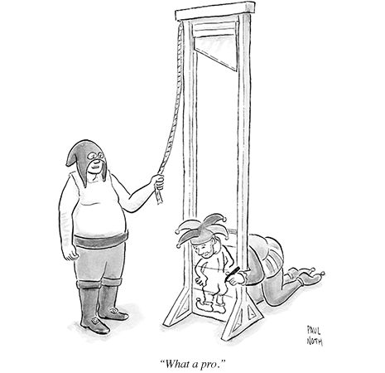
The danger of lingualy bonded gold appliances; a warning from history.

Edward Hartley Angle was born in Herrick Pennsylvania in 1855 and he went to one of the first dental schools graduating in 1878. He went on to publish an important orthodontic text book in 1888.
He classified malocclusion into I, II div i, II div ii and class III. Although remember his classification is not used much in the UK where we prefer incisor classification.

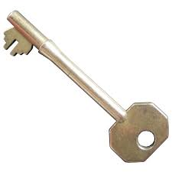
Key moment
Angles first text book in 1888 was only 14 pages but over the years subsequent editions were longer. By 1907 it was called. “Treatment of malocclusion of the teeth: Angle's system / by Edward H. Angle.” You can read it on-line thanks to Google and the University of Chicago. You will see Angle’s classification had various sub-divisions.

In fact Angle’s life had its ups and downs. His first marriage was “rushed” and ended in divorce. At one stage Angle gave up dentistry to become a sheep farmer in Montana. Then, one cold night, every single sheep died. He went back to dentistry (sheepishly) and married his secretary Anna Hopkins (secretly). In a remarkable act of dedication Anna went to dental school to be able to support him better. She helped him set up his school of orthodontia, prepared his papers, soothed the people Edward had upset and after his death became president of the Angle society and looked after his reputation. (She is often referred to as “Mother Angle”).
Angle modified, bands, screws elastics and headgear developed by others. His first appliance was the E-arch.

The E-arch was basically treatment by expansion. A band was clamped to the molar the teeth were tied to the gold arch-wire with ligatures which were tightened regularly. OK for premolars you could use a little grooved block to stop the ligature from sliding off, but for incisors and canines it was more difficult so they needed bands and cleats.

In his next appliance the Pin and Tube. The molar band and tube idea was extended to anterior teeth which had a vertical tube. But this appliance was very difficult to use. The gold vertical pins had to be removed and re-soldered a tiny bit each time.
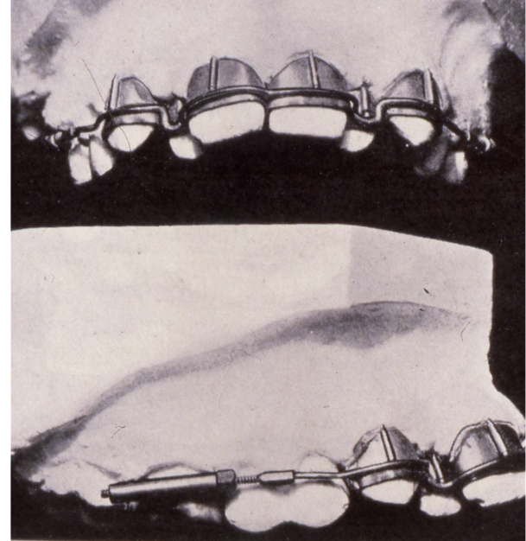
Pin and tube appliance was so difficult to use it is doubtful that anyone ever corrected a malocclusion with it.

The Ribbon arch
Cutting a slot in the tube and using a flattened ribbon arch made the first really usable multi-bracketed system in 1913. Its use continued until the 1960s.
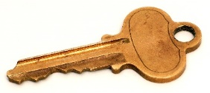
KEY MOMENT
Although you needed uprighting springs this was a fixed appliance system capable of movements in all 3 planes.
Of course this is just a diagram, it really looked like this:
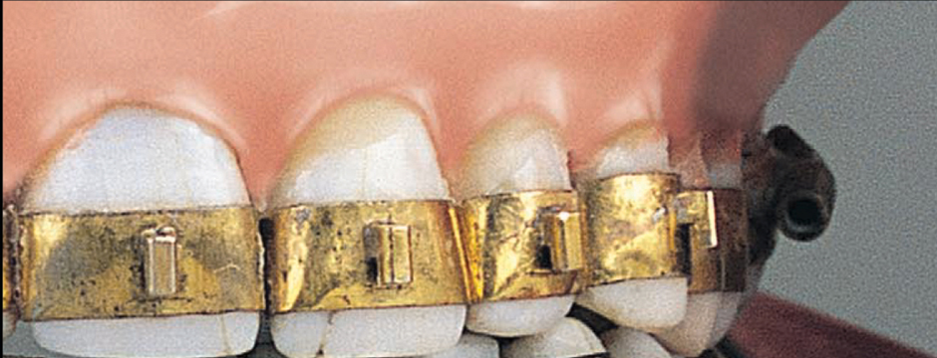
With gold bands and brackets the ribbon arch itself had a screw thread on it just in front of the molar tubes and you could close space by turning a little nut once a week. By the 1960s gold was becoming very expensive and the ribbon arch fell from favour.
But,
In fact you could say it still continues today, because P R Begg modified it to form the Begg appliance.
However Angle went on to produce a machine milled bracket into which a rectangular wire fits edgewise on. This bracket first described in 1927 is now known as the edgewise bracket. He modestly called it; “the latest and best orthodontic appliance.”
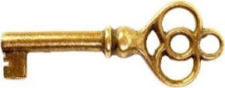
KEY MOMENT
The edgewise appliance can achieve movements in all 3 planes without auxiliary springs
This picture shows some Edgewise brackets, they were milled from German silver (an alloy of Zinc, Copper and Nickel) or gold. You will be able to recognise type B brackets as it is very close to what we use today. For the type “A” bracket the ligature wire when right around the tooth (as in the E-arch)
The narrow bracket proved to be rather poor at controlling rotation and two brackets were often joined together called the Siamese bracket.

This is one of my cases of the 1970’s.
Note bands not bonds. Plain Siamese brackets with no tip or torque. Loops and not sliding mechanics. (We didn’t used to put the tip in until the last archwire. Hence the diastema to allow me to tip the incisors towards each other with the final archwire. These were called artistic finishing bends)
N.B.
The ribbon arch system used gold wires and gold brackets and the expense of this was partly responsible for its gradual demise. Harry Brearley discovered stainless steel in1913 and Hatfield described 18/8 stainless steel in 1924, but the first stainless steel bracket was not made until 1948 (Unitek)
While gold has a very low electrical resistance, that of stainless steel is comparatively high, about 50 times that of copper. This means that two pieces of stainless steel can be spot welded together without the use of solder or flux.
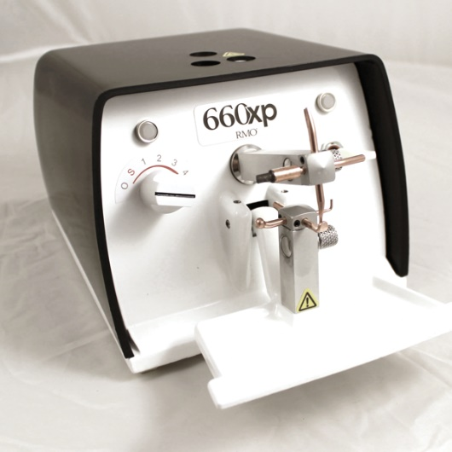
An Orthodontic welder has sprung electrodes that hold the two pieces of steel together with considerable force. Then a pulse of electric current is passed through them. The highest resistance is the spot where the two pieces of steel are toughing. Heat is generated centred at this spot, the heat is sufficient to turn the metals into a plastic state, which then fuse together.
The heat produced is proportional to the square of the current, times the electrical resistance and the time the current is flowing.
Pressure is important not only to hold the two pieces of metal together but also to improve the electrical contacts (you want the minimum resistance between the copper terminals and the steel. So you want a good contact and very clean terminals) and to forge the parts together when the metal is in a plastic state.
The heat generated tends to change some of the chromium and nickel into carbides which precipitate out at the grain boundaries. This may make the steel lose its stainless properties. While if the heat is really excessive it may cause surface pitting. The ideal size for the ends of the copper electrodes is 3mm².
I added this bit in because welding is mentioned in the curriculum. I find myself amazed that something that was once a big part of everyday treatment in orthodontics has now gone completely. Our welder in the department (a Vulcan II) went over to the lab on loan many years ago and we have managed perfectly well without it.

Charles Tweed
A pupil of Edward Angle in the early days of Edgewise. His contribution was:
- He developed a typodont course which represents the high point of plain edgewise and is still running today.
- He went against Angle’s teaching and showed cases treated non-extraction which relapsed. He later retreated them with extractions and they were stable.
- The idea of anchorage preparation using EOT to tip all the lower teeth back and then using class II traction which moved the lowers back to the correct position while reducing the overjet.
- The Tweed triangle.
- The Tweed foundation.

Tweed edgewise used plain edgewise brackets
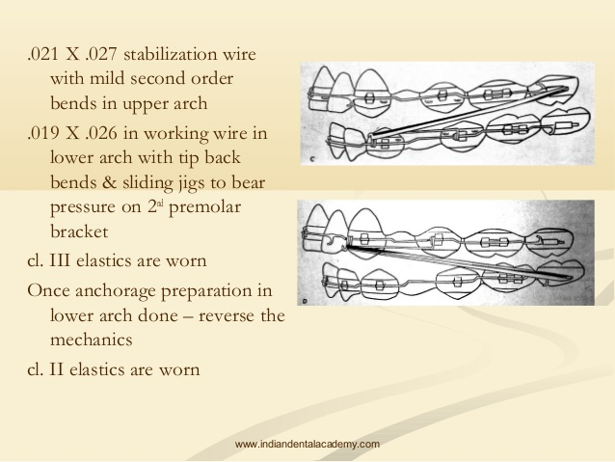
First use EOT and class III traction with tip back bends in the lower arch to tip back the lower 5.6 &7
Then close lower arch space pulling back with class III and headgear to upper 6s
This is called anchorage preparation
Then the mechanics are reversed using the lower arch as an anchor point for class II elastics to pull the upper arch back.
There is a lot of wire bending.
The level anchorage system was developed by Terel L Root in 1981. I would describe it as a sort of straight-wire with built in distal tip of lower teeth so you can use the Tweed method of tipping back the lower teeth first.

Question
Do tipped back teeth provide more anchorage?

Chapter Two
In which we learn what the FA point is.

Andrews and Straight- Wire
Andrews had already described his 6 keys in 1972.If you have mislaid them, I think you left them on page 12.
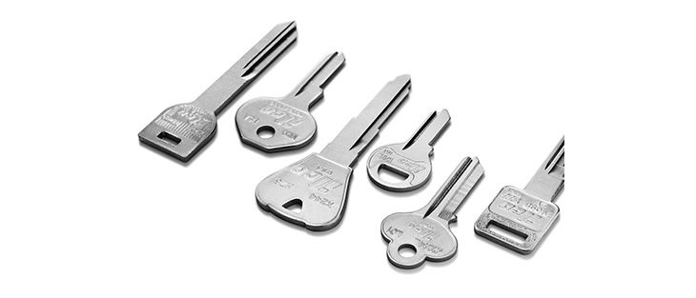
A SIX KEY MOMENT
When in 1976 he introduced the straight-wire appliance. Andrews did not invent pre-torqued pre-angulated edgewise appliances. Holdaway had previously incorporated tip, Ivan Lee torque and Jarabak had used brackets with both tip and torque.

ANDREWS CONTRIBUTION WAS:
- To add a level of science. His torque and tip was based on careful measurement of 120 ideal norms who had not had any orthodontic treatment.
- To add the in-out modifications to the brackets
- To make brackets with a much greater technical sophistication

A major advance was his concept that a central point based on the long axis of the tooth and the half way point between the tip and the amaelo-cemental junction might be a reproducible point. This was his “LA point” now sometimes called the FA point. If we accept that this is a reproducible point it is possible to make brackets that can be fixed to the teeth at this point and will deliver the correct torque, tip and in-out.
However, there was a huge variability within Andrews sample for example the range of torque on the upper central was +15⁰ to -10⁰ with a mean of 7⁰ and a sd of 5⁰. Interesting that in making his brackets Andrews did not exactly follow his own findings but perhaps with a range of 25⁰ it doesn’t matter too much.
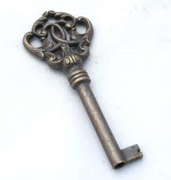
KEY MOMENT
Andrews looked at 120 normal subjects and measured the tangent of the midpoint of the labial surface to a vertical axis. The idea of pre-torqued pre-angulated brackets already existed but Andrews added science and marketed them under the name “Straight-wire”

This was the era of Steiner’s sticks. If you have had the good fortune to miss my tutorial “How to make cephalometrics seem dull” here is what it says on Steiner’s sticks:
Steiner’s analysis goes on to look at the inclination of the upper incisors to the NA plane (mean 22° ) and the inclination of the lowers to NB (mean 25°) Do you think that it is logical to look at the inclinaton of the upper incisors to one plane and the inclination of the lower incisors to another?
The anterior-posterior position of the incisors is judged by the position of the tips of the incisor teeth relative to the NA & NB planes a rather nice touch is the suggestion that Pogonion lies in front of the NB plane by the same amount ( 4mm ) as the incisor tips.
The idea of camouflage type treatment is built in to the Steiner Analysis. In a normal face ANB = 2° upper incisors to NA = 22° Lower incisors to NB = 25° and the incisors are 4mm in front of NA & Pogonion is 4mm in front of NB

This is written 2
22 \ 4
25 / 4

Steiner worked out compromise arrangements for variations in ANB between 6 and -6 these are called Steiner’s sticks.

ANB=6 ANB=4 ANB=2 ANB=0 ANB=-2 ANB=-4 ANB=-6
18 \ 0 20 \ 2 22 \ 4 24 \ 6 26 \ 8 28 \ 10 30 \ 12
29 / 5 27 / 4.5 25 / 4 23 / 3.5 21 / 3 19 / 2.5 17 / 2

So, if you like, this was an acceptance that orthodontic treatment was often camouflage treatment.
So, this is why Andrews developed three sets of incisor brackets

The S or standard set was intended for use in skeletal I cases
The maxillary central had 7⁰ of torque
The maxillary lateral had 3⁰ of torque
The mandibular incisors had -1⁰ or torque

The A or class II set

The maxillary central had 2⁰ of torque
The maxillary lateral had -2⁰ of torque
The mandibular incisors had 4⁰ or torque

The C or class III set
The maxillary central had 12⁰ of torque
The maxillary lateral had 8⁰ of torque

The mandibular incisors had -6⁰ or torque

Andrews showed some non-extraction cases (note the extensive use of EOT in some cases 24 hours a day).
But in extraction cases he envisaged another problem. Because the force was applied at the bracket, not at the centre of resistance of the tooth, he expected teeth adjacent to the extraction space would tip and twist towards the space. Special extraction brackets were made for 3s and 5s to overcome this.

A final problem referred to as the “cartwheel effect” takes account that if the wire is twisted to give positive torque it will reduce the mesial tip (by 2.5⁰ for every 10⁰ of torque)

Ronald Roth
Roth treated straight-wire cases, but found that the upper incisors were under torqued. He found he got better results if he used set C with the extra torque in the upper incisor and the extraction set brackets on the canines with the extra tip. (note I mean in all cases not just class III cases) the Roth prescription is still the most widely used prescription although in the West Midlands hospital units I believe it is limited to Warwick.
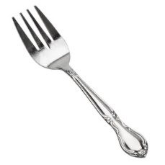
A Forkie, sorry, FOUR KEY MOMENTS. So Andrews was selling pre-torqued, pre-angulated brackets but three other inventions came allong and made this a big deal:
1. Michal Bunocore discovered a method of attaching filling materiall to teeth by acid etching enamel.At first dentists didn’t take up this idea because of the very strong acids he used. Later it was shown that more dilute acids worked even better.
2. Shape memory wire had been known since 1932 (Arne Olander) but this was gold cadmium alloy. In the 1950 William Buehlar invented a Nickel Titanium alloy called Nitanol but it proved difficult to make and so it only appeared in orthodontics in the late 1970s
3 Bis GMA resins became available that were strong enough to bond brackets onto the teeth. Until this invention all the fixed appliances were banded so it was not possible to get the brackets onto the LA point.

Torque in base or slot?
Andrews “Straight wire” brackets had torque in the base.
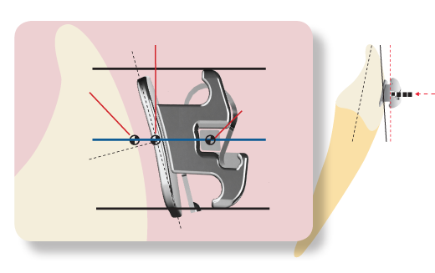

Cheap copies had plain edgewise brackets with the slot milled in at an angle. This added a tiny error much discussed at the time but in fact it was smaller than the errors of bracket positioning. Modern brackets are CAD designed.

Functional Occlusion for the Orthodontist JCO 1981 p32-265
A synopsis of papers by Ronald Roth

Roth has taken some techniques for evaluating functional occlusion originally geared to restorative dentistry and adapted them to suit orthodontics. He feels that functional occlusion is important because:
- Stability of the treatment partly rests on the functional dynamics
- He wanted to refute claims that premolar extraction prevented a good functional occlusion.
- He wanted to show that orthodontic treatment could be of functional benefit.

Roth suggests that treatment objectives in orthodontics should be:
- Good aesthetics
- Class I molar relationship
- A functional occlusion
- A stable result
- Comfort, efficiency and longevity of the teeth, TM joints and supporting structures.
The basic concept for functional occlusion is that, with both condyles in the ideal position in the Glenoid fossae, the mandible should be able to close into maximum intercuspation without deflecting the condyles from their most ideal position.
AND
From this closed position the mandible should be able to move in any direction possible without the teeth getting in the way of the movement pattern as directed by the joints.
If the orthodontist wishes to establish an occlusion with the condyles in their ideal occlusion, he/she must check it at the end of treatment. The height and direction of the cusps and fossae are already set before the treatment starts. The orthodontist must arrange the teeth so that they are in harmony and construct an occlusal plane at a suitable angle to the angle of eminence of the condyle.

Centric Relationship of the Mandible
Centric relationship of the mandible can be defined as “A superior limit position of the condyle in the fossa with the mandible centred at its most closed position” In fact this may not be the most retruded position as the mandible can be moved further posteriorly by abstracting it inferiorly. Roth admits that many patients function asymptomatically with a difference between centric relationship and centric occlusion. But he says:

“In all my experience I have yet to see a patient who has a problem because he/she has a centric related occlusion.”
The fact that the patient has an occlusion that is not centrally related is not, in itself, an indication for treatment. Centric relationship is not a strained position. Stuart defines centric relationship as the rearmost and uppermost position of the condyles in their respective fossa with the mandible at its closed position. Patients with damage to the TM joint can easily be forced into a position where the condyle lies posteriorly and inferiorly (Dyer and Dawson 1963).

Recognising Occlusal Disharmony
Be aware of the following features:
- Occlusal wear
- Excessive mobility of the teeth
- TM joint sounds
- Limited opening
- Myo-facial pain
- Difficult manipulation
- Some types of tongue thrust
Examination
It takes practice to be able to manipulate patients into centric relationship. Place the left thumb and forefinger over the maxillary teeth and the right thumb on the chin applying a downward pressure. At the same time place the first and second fingers of the right hand gently under the Gonial angle pushing it upwards. The patient is instructed to close to the fingers and then finally hinge up into occlusion. If the mandible is easy to manipulate then this is probably centric relationship. If the discrepancy between centric relationship and centric occlusion is large it is best to evaluate it on an anatomical articulator.
When there is resistance to manipulation then the patient may be closing into a bite of accommodation. The correct treatment is splint therapy. Full time wear frees the musculature revealing the true discrepancy.
In addition one should look for tenderness over the TMJ, listen for popping or grating noises and look for signs of wear on the teeth. Patients should be checked for the ability to exhibit right and left lateral excursions. If they cannot it indicated the presence of posterior interferences or incorrect anterior coupling.
Maximum opening is an indication of the state of contraction of the muscles, it should exceed 45mm.
Satisfactory orthodontic treatment planning cannot be made from the starting point of a centric occlusion that differs markedly from centric relationship. It is desirable to use instead correctly articulated study models and to re-draw the lateral skull radiograph with the mandible correctly repositioned into centric relationship.
In addition there may be a lateral or vertical discrepancy. Typically the latter is seen in an anterior open bite with the mandible hinged on the first contact, usually in the first molar region.
Treatment planning must be based on a true centric relationship.

TM Joint tomograms are of value in the diagnosis of TM joint problems, but only in conjunction with anatomical models. It helps to spot this phenomenon of an abnormal inferior position of the condyles but because these radiographs give only a two-dimensional view it does not follow that a normal x-ray picture indicates a normal condylar position.
Repositioning splints
The repositioning splint was first made popular by Eugene Dyer. It should be made in all patients with TM joint symptoms where the mandible is difficult to manipulate. The splint allows the relaxation of the muscles, the resolution of inflammatory changes and possibly the remodelling of the joints. It seems to take some time before a permanently reproducible centric relationship can be found, perhaps because of the reduction in inflammation and perhaps due to remodelling. The splint is made to provide centric closure and gentle anterior guidance which nevertheless slopes sufficiently to disclude the posterior teeth. The anterior teeth must have a 0.0005 inch clearance on centric. Alterations in cold-cure acrylic must be made at each visit if the mandibular position changes because of muscle relaxation or remodelling of the joint. It may take 3-6 months.
Roth splints are made of 0.08 inch pull down acrylic blanks. The anterior guidance ramp is built up in cold-cure acrylic to give a guidance angle of 45◦. The anterior guidance ramp is added afterwards. The occlusal surface is re adapted using cold-cure acrylic. The patient bites until they have made a light imprint and the splint is checked to make sure there is an even contact on every tooth. For the first week the patient is seen every day or alternate days. Second week every 2-3 days then every 4th or 5th day. The splint must be re-adapted each time if necessary. If the patient is in severe pain they may start with a FLAT PLANE SPLINT and this is later re-shaped the splints must be worn full time except for cleaning.

Finishing to Gnathological principles
Maximum intercuspation should be in centric relationship with harmony in all lateral movements.
Objectives
- A stable centric relationship with maximum intercuspation, all centric stops should hit simultaneously with stress going down the long axis of the posterior teeth. There should be no actual contact of the anterior teeth with a clearance in centric of 0.0005 inches.
- A harmonious glide path so that the anterior teeth gently but immediately exclude the posterior teeth as soon as the mandible is moved out of centric. This glide path must be in harmony with all mandibular movements. When there is an immediate side shift the palatal surface of the upper anterior teeth must show a greater concavity. The overjet and overbite must be sufficient but not excessive. Canines should be the main guiding inclines on lateral excursions and the upper teeth 3-3 should contact the lower teeth (lower first standing premolar –lower first standing premolar).
- This gentle lateral and protrusive lift is necessary for post treatment stability. Excessive lateral stress on canines would cause lingual movement and lower anterior crowding. Too steep anterior guidance might cause a relapse in the overjet. Incorrect bracket placement tends to prolong the upper central incisors taking the laterals out of contact; this leads to un-necessary stressing of the central and relapse.
Cusp to Fossa versus Class I occlusion
Restorative dentists advocate a cusp to fossa arrangement with each centric cusp surrounded by three opposing ridges. Unfortunately cusp to fossa will not give the anterior guidance desired for orthodontic stability, but this can be achieved using a class I relationship. Roth suggests that less than 1% of completed cases finish in centric relationship. To find centric first use a repositioning splint reshaping it until a stable position is found. This procedure may not be realistic on an orthodontic case, but what is realistic is to be able to treat close enough to centric that there is no discernible discrepancy. Then equilibration is feasible should it become necessary. Roth considers Andrew’s six keys as a useful guideline to start building up a final occlusion.
Andrew’s Six Keys
- Molar Relationship
- The distal surface of the distal marginal ridge of the upper first molar occludes with the mesial surface of the mesial of the mesial marginal ridge of the lower second molar.
- The mesio-buccal cusp of the first molar occludes in the buccal groove of the lower first molar
- The mesio-lingual cusp of the upper first molar occludes in the central fossa of the lower first molar.

2. Mesio-Distal Tip
- The gingival portion of each crown is distal to the occlusal portion. This inclination depends on the tooth.
3. Crown inclination
- Although the incisal edge of the upper incisors is labial to the gingival margin in all other teeth the incisal edge or occlusal surface lies lingual to the gingival portion
- From the canine backwards in the upper arch there is a progressively increasing lingual inclination
- A similar inclination is found in the lower arch
- There should be no rotations.
- The contacts must be tight
- There is a flat occlusal plane.

In addition Roth suggests the following 11 keys
- That the lower incisors should be at Apo+1
- The incisor edge of the upper incisors lies 2 to 2.5mm below the lip embrasure when the lips are closed without strain.
- That no more than 1mm of attached gingivae shows above the upper incisors in a full smile
- That the overjet is 2.5mm with a tiny clearance (0.0005 inches) of the incisors in centric
- That the curve of Monsen (also called curve of Wilson) is sufficient to allow the seating of the centric cusps but to give clearance on lateral excursions
- That as much divergence is made as is possible between the occlusal plane and the condylar plane (angle of eminence)
- That the roots of the lower incisors lie in the same plane. with a 2⁰ mesial inclination
- That there is a 5⁰ mesial tip of the lower canines and the tip is 1mm higher than the lower lateral incisor
- That the upper incisor must be a proper length to give canine guidance
- That the upper buccal segments have a 14⁰ non-progressive buccal root torque
- That the widest part of the lower arch is the mesio-buccal cusp of the first molars

Treatment Priorities
- Correction of crossbite.
- Correction of crossbite
- Relief of crowding
- Making space for displaced teeth
- Space consolidation in the lower arch
- Level curve of Spee
- Finish the lower arch
- Correct molar relationship
- Consolidation of the upper arch and reducing the overjet and overbite
- Artistic positioning
- Over-correction of the buccal segments
- Final detailing.

The second molar teeth are most commonly involved in occlusal interferences and they must be banded (bonded). If spacing is present in the upper arch it may be decreased by further torquing of the upper incisors or by increased artistic tipping. Mesial rotation of the upper molars causes them to take up too much space. Insufficient buccal root torque of the upper molars cause problems with balancing movements. Excessive mesial inclination of the upper molars allows the disto-buccal cusps of these teeth to interfere with working relationships and centric occlusion.

Lower arch finishing
- There should be mesial tip of the lower incisors
- All incisor roots should lie in the same plane
- The canine teeth should be mesially inclined
- There should be a disto-buccal rotation of the lower canine
- There should be no spacing
- The bicuspids should be upright or overcorrected in extraction cases
- The curve of Spee should be flat
- There should be slight progressive buccal root torque
- The second molars should be tucked in
- The widest part of the arch should be the buccal cusps of the lower first molars

Since the upper arch settles to the lower a high standard of finish of the lower arch is essential.

Control of Vertical Dimension
It is necessary to avoid excessive extrusion of the posterior teeth. This may either form an anterior open bite or posterior interferences with displacement of the condyle into an abnormal position, which may later give rise to TM joint symptoms. Roth calls this a fulcrum effect and he says that it occurs in cases with a short ramus or a reduced posterior face height. He suggests the use of short class II elastics occipital pull headgear and a more radical extraction pattern in these cases. Class II elastics in particular seem to tip the occlusal plane making it more parallel with the articular eminence. This reduces the separation of the posterior teeth in excursions.
The Gnathological Positioner
(At the time of this paper we did not have Essix type retainers. In the UK we largely used Hawley type retainers but in the USA it was common practice to use soft rubber purpose made positioners to improve the finish.)
This can only be used as an adjunct to proper orthodontic treatment. The case must be treated close to centric relationship. The positioner must be made on an anatomical articulator so that the thickness of material separating the teeth is even and does not cause the condyle to move down into an abnormal position. Roth’s positioners were made of Orlastic II
An explanation of the above
The notes above were prepared by me for a tutorial in 1982. Yes in those happy days, before you were born, we did not have computers and I typed it out on a typewriter. So why have I bothered to type it out again and add it to these tutorial notes?
In the 1970s a number of American orthodontists were successfully sued for causing TM joint dysfunction. Groups of disciples of “Gnathology” claimed that orthodontists were causing TMD by asking for premolars to be removed. These people claimed that this caused a collapse of the vertical dimension. In addition other sins included: alteration of incisal guidance and correction to class I molars, rather than cusp to fossa occlusion.
You might think that with little no science behind it these people would stand no chance, but this is not so. A jury of 12 good men and true can be moved by strange things. I suspect:
Nice lady paid a lot for orthodontics.
Then developed TMD.
Orthodontist unsympathetic.
Nice restorative dentist does lots of treatment.
TMD gets better.
Patient wants money back.
Jury think orthodontist a bit of a rogue
Patient has got a great attorney.
Anyway for a while some orthodontists stopped extraction premolars and extracted 7s instead. Then the patient had to wear headgear a LOT.
Gradually the orthodontist fought back showing that there is in fact no evidence that orthodontics causes (or cures) TMD but see this work as part of this period.

Hard to believe it but orthodontics was exciting

1978-1985 was an amazing time in orthodontics. The winner turned out to be straight-wire, but this was not so obvious at the time. We became able to bond brackets directly to the teeth in 1978. This meant that you could do fixed appliance treatment on most patients. A lot of people were persisting with plain Edgewise and getting good results on mild cases. But severe malocclusions were a problem and root resorption was associated with long treatments with heavy rectangular wire. Begg was now developed into a sophisticated technique and was very powerful at reducing big overjets and opening the bite. Finishing was a little poorer than plain edgewise but only slightly. Ricketts developed his bio-progressive technique there were a memorable series of articles in the JCO by Carl Gugino in 1978. Cardiff dental school decided to adopt this system and it did seem to have a lot going for it:
- Forces were light
- Brackets were cheaper than the new straight wire
- You could do several things at once making the treatment quicker
BUT
- There was a lot of wire bending
- Ricketts advocated the use of blue Elgyloy wires that were so soft he appliance broke to easily
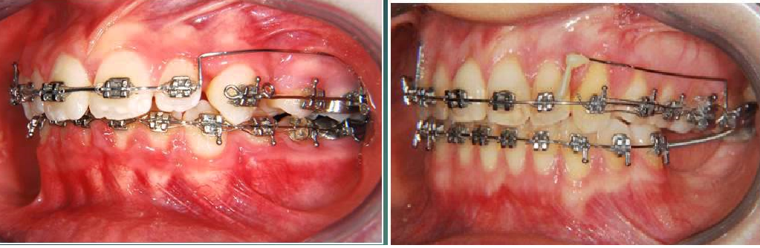
You can still buy Ricketts brackets and they now make them pre-angulated and pre-torqued so wire bending is less. And of course you can use tougher wires if you want to. But too late, time moved on.
Other appliance systems were also in common use “level anchorage” maintained some of the anchorage preparation ideas of Tweed edgewise and Beddiot a kind of combination between edgewise and Begg which was adopted (then dropped) by Glasgow dental school.

Various combinations of edgewise and Begg were tried. The stage 4 appliance and modular Begg were examples. The origins of Tip- Edge may go back to 1968 but it did not appear on the market until much later and it was not until the development of the deep slot that you have the modern appliance Tip-Edge plus. Both Tip-Edge and Begg are the subject of different tutorials.

Chapter Three

In which three famous orthodontists from different parts of the world join together to create an acronym.


KEY MOMENT
MBT is a very practical system born of use of pre-adjusted edgewise by very experienced orthodontists
So you use the brackets but have you read the book?

MBT
A review of “Systemized Orthodontic Treatment Mechanics”
By McLaughlin, Bennett and Trevisi.

Treatment Goals
► Condyles in seated position in centric occlusion, relaxed healthy musculature, Andrews 6 keys, mutually protected occlusion, periodontal health and best possible aesthetics.

Four elements of mechanics
► Bracket selection, Archwire selection, Bracket positioning and force levels.

Andrews values based on examination of non-treated ideal occlusions but with 1 or 2º of extra tip because of the so called “wagon wheel effect” where tip is lost as torque is added. Roth was influential in adopting the broad square arch form. MBT match archform with start occlusion.
Early use of straight wire was associated with problems in bite opening which MBT attribute to the excessive forces used and the extra tip built into the brackets.
► MBT feel that the excessive tip for example on Roth brackets is a disadvantage causing: -A drain on anchorage, increased overbite and the canine roots to be too close to the premolars.
► Because lighter forces are used in MBT there is no need for anti-tip bends. Light forces are considered to be 100-200 grams.
► 0.022 slot seems to work best because the narrow 0.018 slot means using wires that are too light and flexible. (I don’t agree)
► Lacebacks are routinely used to control the canines.
► Bendbacks (bending the wire down behind the tube) are used to prevent mesial movement of the anterior teeth during the alignment of teeth.
► Basically only one size of rectangular wire is used (0.019 x 0.025) HANT (Heat Activated NiTi) & steel. MBT say this works better than they would have expected. They attribute this to the fact that the tip is not quite corrected when the wire is placed and so the slot is a little closed.
► Use posted archwires.
►Bracket design. Rhomboid design reduces bulk and makes the reference lines clearer. Discussions concerning torque in the base and torque in the slot are now not so clear because CAD allows a combination of both to give the optimal position of the slot. Basically the computer describes the best position for the slot and the base and in-fills with a combination of torque in base and in slot.
► An alternative bracket is provided for cases where the upper second premolar is very small.
► Because tip is almost fully expressed it is reduced to 8º on the canines.
► The tip on the molar tubes is 0º but if the tube is placed parallel to the cusps this will give 5º of tip on the upper and 2º of tip on the lowers. There is 2º of mesial tip on the lower premolar brackets.
► Torque is not so efficiently expressed because of the small area of application of the force and the slop in the archwire. So MBT have beefed up the torque levels.
► The upper centrals have 17º of torque and 4º of tip
►the upper laterals have 10º of torque and 8º of tip.
► Upper canines have -7º of torque and 8º of tip BUT this is not suitable in all cases where the basal bone of the Maxilla is narrow the -7º of torque might move the roots too buccaly through the bone so a bracket with 0º torque is available. If the arch is very narrow put the bracket on upside down to give +7º of torque.
► In the lower jaw the buccal root torque is reduced this avoids moving the roots too buccal and cuts down on lingual rolling. So torque is –6º in the canine (reduced from –11º in SWA), -12º in first premolar (reduced from-17º), -17º in second premolar (reduced from –20º), -20º in the first molar (reduced from-30) and –10º in the second molar (reduced from -35º). A special mini second molar tube for bonding is available for use on partly erupted second molars.

► Don’t bond up the whole arch if : - There are blocked out teeth, Deep bite cases with no URA just bond the upper arch first, Enamel reduction cases with triangular shaped upper 1/1 and sliding jig mixed dentition cases. IN ALL OTHER cases bond all the teeth in one visit. For good bonding use the gauges but with an individualised chart. For incisor teeth the gauges are designed to be used at right angles to the labial surface of the teeth but with the other teeth the gauge must be held parallel to the occlusal plane. For good bracket placement you must move your head so that you are looking directly at the mid labial point. The idea is that you examine the study model to see which line of the chart best fits the LA points for that particular patient and use that line of the chart.

7 | 6 | 5 | 4 | 3 | 2 | 1 | UPPER
2.0 | 4.0 | 5.0 | 5.5 | 6.0 | 5.5 | 6.0
2.0 | 3.5 | 4.5 | 5.0 | 5.5 | 5.0 | 5.5
2.0 | 3.0 | 4.0 | 4.5 | 5.0 | 4.5 | 5.0 | MBT
2.0 | 2.5 | 3.5 | 4.0 | 4.5 | 4.0 | 4.5
2.0 | 2.0 | 3.0 | 3.5 | 4.0 | 3.5 | 4.0

7 | 6 | 5 | 4 | 3 | 2 | 1 | LOWER
3.5 | 3.5 | 4.5 | 5.0 | 5.5 | 5.0 | 5.0
3.0 | 3.0 | 4.0 | 4.5 | 5.0 | 4.5 | 4.5
2.5 | 2.5 | 3.5 | 4.0 | 4.5 | 4.0 | 4.0 | MBT
2.0 | 2.0 | 3.0 | 3.5 | 4.0 | 3.5 | 3.5
2.0 | 2.0 | 2.5 | 3.0 | 3.5 | 3.0 | 3.0

BUT
► it is necessary to individualise the chart in some cases –worn down canines, damaged incisors, In AOB cases have the incisor brackets 0.5 mm more gingival and in deep bite cases have the brackets 0.5 mm more incisal.
► If lower 5/5 have been extracted then stick the 6 at the 5 height and the 7 at the 6 height or you will get a step in the arch. (The same true in the upper so if upper 4/4 gone stick 5 at 4 height etc.)
► Take care not to push the molar bands up too far on the distal, the tubes must be parallel to the buccal cusps. If you are using RME use bands half a size too big to allow the splint to fit on the non-parallel teeth.

Archform. ► Reidel 1969 commented on the stability of the inter-canine width and inter-molar width. This was later confirmed by De la Cruz 1995 and Burke 1998. However, a little increase in the lower inter-canine width may be stable in deep overbite cases Shapiro 1974. In RME cases where the expansion is maintained Sandstrom1988 suggests that 1.1 mm of increase in inter-canine width may be stable. Brain et al say that most NiTi wires are expanded by 5.9 mm in the inter-canine region. Felton in the AJO 1987 says that no definite archform predominates and you must customise each case.
► MBT suggest the use of 3 arch forms: - The Square or wide arch form used by Roth is only applicable in 10% of cases. The ovoid arch form (The Euroform type) is applicable in 45% of cases and the Tapered arch form which is narrow in the canine region and wide in the molar region is applicable in 45% of cases.
► MBT suggest the use of clear templates to select the correct archform from the start study models. They suggest that round wires should be stocked in the ovoid form only but rectangular wires should be stocked in all 3 archforms (although you could just buy the ovoid steel wires and modify them yourself).
► The upper archform should superimpose on the lower but 3 mm wider
. ► If you are using RME in the upper arch you should widen the lower just a little so that if the expansion settles just a little the contacts will remain ideal. Remember to hold the expansion with an auxiliary wire in the EOT tube. MBT call this a Jockey arch.

Successful alignment depends on recognising unwanted tooth movements. These can occur as a result of the tip built into the brackets. This needs to be controlled and it is best not to rush into the use of heavy forces e.g. elastic chain to retract canines on a flexible wire. This produces the “roller-coaster effect” with a deep overbite and a lateral open bite.
► The reduction of tip in the MBT bracket helps anchorage control.

MBT advocate the use of Lacebacks they quote Robinson 1989 (Thesis) when used in lower premolar extraction cases the lower incisors moved back 1 mm whereas without them they came forward 1.4 mm during alignment. Lacebacks seemed to produce a little forward movement of the molars (0.23 mm) Comment it is a bit difficult to say if this made any difference by the end of treatment. MBT advocate Bendbacks i.e. they turn the end of the wire down at the back they say this avoids the forward movement of the incisors. For the rectangular heat activated NiTi wire (which they call HANT) they suggest thinning down the wire as well as annealing the end.
► In mild crowding cases they suggest the placement of lingual arches before the E’s are lost to preserve the leeway space. They also advocate the use of headgear and class III elastics for the treatment of mild lower arch crowding. De-rotation of upper molars can give a little space in the upper arch. Once de-rotated the molars must be held in position with a soldered Trans Palatal arch in 1.1 or 1.3 mm steel.
► Where the canines are distally inclined the initial archwire is in danger of increasing the overbite. The solution to this problem is not to bond the incisors until the alignment of the canines is complete.
► If the canines are only partly erupted do not engage them in the wire too soon. Instead thread a module over the archwire and use it to apply gentle traction to the part erupted tooth.

In high angle cases don’t band the 7’s too soon. If you have to bond them place an intrusion bend in the wire. If you extrude the 7’s the AOB will worsen. If you need to expand try to avoid tipping use a fixed expander perhaps combined with high pull headgear to the molars. Don’t use cervical pull headgear in high angle cases. A palatal arch 2 mm away from the mucosa may allow tongue pressure to intrude the molars. Posterior bite blocks may be of some use.

When correcting a lateral crossbite: - Avoid tipping as this extrudes the palatal cusps, If the maxillary bone is wide use a quad helix if the bone is narrow use RME. Minor cross bites can be corrected in the finishing stage.

Wire Sequencing. 0.016 HANT then 0.019 x 0.025 HANT then 0.019 x 0.025 posted steel then 0.014 steel finishing. (But remember their cases are not selected to be IOTN 4 or 5 so that they probably treat milder cases, they do say they have more flexible wires for severe displacement cases.) They also advocate 0.018 steel wires in the lower when lacebacks are being used for canine retraction and in both jaws if you need coil spring to open a space.

Arch levelling and Overbite control.
- Eruption/Extrusion of posterior teeth. In Adults this is not stable because the musculature will impose the original vertical dimension. An exception seems to be in high angle cases where extrusion would be detrimental in any case.
- Proclination of incisors.
- Intrusion of incisors, not required much in children but may be the treatment of choice in adults.
► Details. Non-extraction treatment favours bite opening, the use of bite planes helps bite opening in children and reduces the chance of brackets being bitten off. Bite planes allow the eruption of molars but they may also have an intrusive effect on the incisors. Sticking cement on the occlusal surface of the 6’s and proclining the incisors can open the bite. Banding the 7’s early helps bite opening.
► When the steel wires are first placed they should be flat but after 6 weeks you can place a curve of Spee in the upper (this helps the torque as well so in most cases it is a good thing) and a reverse curve of Spee in the lower. (This has an adverse proclination effect in the lower labial segment so YOU MUST put in reverse torque if you put in a reverse curve of Spee) However these curved wires must be replaced with flat ones for space closure.

► Early treatment of AOB: -
- Habit suppressors.
- Expansion if the arch is narrow.
- Posterior Bite planes. (Minimal Effect)
- High pull to molars and chin caps.
- Palatal bars and lingual arches to restrict eruption of molars.
- AOB favours extraction,
- T’s & A’s removal.
► In treatment management. Don’t band the 7’s unless you have to and if you do put in intrusion bends to avoid extruding them. Especially in the upper where it takes the form of an extra steep curve of Spee at the back use short class II or III elastics but not long elastics which cause molar extrusion. Consider positioners as retainers or remove the acrylic from behind the incisors as a reminder to the tongue.

Treatment planning.
MBT advocate the use of the PIP (planned Incisor Position) the idea is based on Cephalometric work by Dr Arnett. This is based on a Vertical line dropped from Sub-nasale. The vertical is related to the natural head position. It is claimed that this line will be 12 mm in front of the ideal position for the tip of the upper incisors in males and 9 mm in front for females. The tip of the upper incisor should be 4mm below the resting upper lip in male and 5 in females. So now you can position the tip of the upper incisor. Arnett expresses the ideal inclination of the upper central incisors in terms of the angle with the Maxillary occlusal plane the normal angle being 58º in males and 57º in females. You can now draw the ideal upper incisor position on the tracing and assess the likelihood that you could move the teeth to that position with orthodontics if not you could consider compromise or surgery.
Next step is to position the lower incisors they suggest using Fastlight’s triangle JCO 2000 34: 353-360. It is more like two triangles formed by the maxillary plane, the mandibular plane, the long axis of the upper and lower incisors and divided in two by the occlusal plane. Typical figures are given so that you can select the ideal inclination on the lower incisor. Now that you have the lower incisor position you can again judge if it is feasible to get the teeth to this position with or without surgery. Then from the lower molar position at start you can work out the lower arch changes you need for examples extraction and then extend this to the upper molars. There seems to be an assumption that the lower incisor stability will need a permanently bonded lower retainer.

► Incisor intrusion is described using High pull headgear with J hooks as well as incisor extrusion with vertical elastics. ► Forward movement of lower incisors was once considered undesirable because of risk of periodontal recession but now this is considered to be less likely. Quote Artun 1986 J of Perio 57: 341- and Ruf 1998 AJO 114: 100- . However, they suggest a limit to lower incisor proclination at 100º.
► 2.5º of proclination give about 1 mm of forward movement.

► Notes the possibility of idiopathic condylar resorption giving unfavourable mandibular change. Also, unfavourable change when there was an initial contact and displacement at the start of treatment. When the initial contact is removed the mandible drops back to CR.

► A case is shown to illustrate the use of a sliding jig in a neat form with a tube and hook on an 0.020 wire with day time class II elastics, night time EOT and push coil to advance the labial segment. This seems a neat way to open a little space in the upper canine region.
► A case is shown with Twin Blocks although the authors describe the effects of functionals as possibly promoting favourable growth but this is difficult to confirm with research. It is a nice twin block case but is the kind of low angle case which often goes well with functionals.

Class III cases.
MBT express the importance of assessment in centric relationship, correcting occlusal displacements at the age of 9. They suggest that there may be a place for RME and reverse headgear. In borderline cases they suggest delaying the treatment. They also like to delay surgery because of the risk of further unfavourable growth (over 20 in males)
► They describe a possible “Squeezing out” effect where crowding in the upper molar region can cause either an AOB or a class III malocclusion.
► They like the use of class III elastics but in high angle cases the suggest using it with a palatal bar to stop molar extrusion.
►In class III cases the 4 stages in planning are a little different: -
- PIP for upper incisors.
- Ideal lower incisors.
- BUT then sort out the upper arch changes based on the upper molars.
- Finish with the lower arch and lower molars

► Retroclination of the lower incisors should not be to less than 80º to the mandibular plane. MBT have abandoned chin caps because of poor co-operation. Every patient should be informed of the risk of unfavourable growth.

Space Closure.
The closing loops of Tweed mechanics added flexibility and allowed tipping. Heavy forces were used in early straight wire causing unwanted tooth movements and loss of anchorage. Elastic chain gives unwanted rotations.
► MBT like flat posted archwires and lig-a –modules which they claim have a longer than expected effect because of the trampoline effect caused by the occlusal forces pounding the archwire. They quote Samuels 1998 AJO 114: 73-79 who says that a 150 gram NiTi pull coil works better but feel lig-a-mods are just as good in most cases.
► They describe the use of a Hycon a screw device as a powerful method of closing resistant spaces.
Obstacles to space closure: - Damaged brackets, incorrect force level, cuspal interference and soft tissue resistance e.g. from a persistent fraenum.
Finishing.
A miss match of tooth size is a common problem MBT feel that 60% of cases show mandibular tooth excess, 20% maxillary tooth excess and 20% are a perfect match. ► Mandibular excess can manifest in 3 ways: - Upper extraction spaces difficult to close, Spacing in the upper labial segment and Class II buccal segments even when the overjet is fully reduced. The MBT prescription is helpful here the 2º of tip on the lower premolars will bring them slightly forwards. A helpful trick is to place the upper premolar brackets 0.5 mm forwards of the midpoint this rotates the upper premolar buccal cusps back a little. Maxillary tooth excess seems to be associated with very large upper central incisors and in class III cases where the upper incisors are very proclines and the lowers retroclined. In these cases the problem may be closing the lower incisor spaces.
► Despite the extra torque in MBT brackets it is still necessary to add torque to the wire in some cases.
►where there is a horizontal discrepancy it is a good idea to over-treat that is to treat class II cases to edge to edge and then allow the overjet to increase to normal. ► the key to vertical considerations is good bracket placement use flat archwires except in high angle cases where it is necessary to place a curve of Spee in the upper molar region.
► RME should be done a couple of years before the main orthodontics. Expansion cases should be held with a Jockey arch
. ► Functional Occlusion. Check that the diagnosis is in CR and monitor throughout treatment. At completion check for interference during protrusive and lateral movement. The aim is a lateral movement with a slight cuspal rise and disclusion of the posterior teeth on both sides.
► Check the TMJ’s before treatment and inform the patient if there is a problem advice splint therapy if necessary. If symptoms develop during treatment then stop elastics and EOT. Prescribe a soft diet and analgesics. If symptoms persist try splint therapy.

Finishing
Before debond take a lateral skull radiograph to check objectives. In a class I case use ligatures to hold extraction spaces shut and ligate the upper central incisors if there was a diastema. In the lower use a 0.014 or 0.016 HANT but in the upper use 0.014 steel in the upper incisors only. If the upper arch was expanded you will need to place an upper acrylic baseplate. Light triangular elastics are used to settle the buccal segments, full time for 2 weeks then night only for two weeks and then if all OK deband. In overjet cases you will need to leave a full upper arch (0.014 steel) with Bendbacks to stop the overjet increasing.

Retention.
A lingualy bonded retainer in all cases. Positioners are considered good but the major obstacle is poor co-operation. Labialy bonded retainers are a useful short-term solution.
► Most relapse in the upper arch occurs in the first six months but the lower arch is more of a problem the bonded retainer must be left until at least adult +2 then a case by case discussion re removal.

Comments
I have worked through the book trying to include all the significant points. Hence the rather disjointed text. It is a very important book and you should be familiar with all the ideas. It seems to me that the changes to the SWA bracket to produce the MBT are beneficial but it is a bit of a pity that since they admit the problems of the 0.22 slot in producing torque they did not alter the slot for example to 0.019 x 0.032 would be 25% more efficient at producing torque. The bracket placing section is good and I think we should use the gauges at Birmingham. The use of 3 arch forms seems a progressive step. I do have reservations about the Diagnosis section to treat on the assumption that all cases will have permanent retention seems a step too far. Radney suggests that the roots of the teeth are in the middle of the cancellous bone and this seems to make anatomical sense. Ballard and Mills wanted the lower incisors to stay in the start position and this seems logical and was backed up with some research. Williams APo line was supported by clinical observation but Arnett’s incisor position is based on aesthetics rather than stability and natural head position is so difficult to verify for example as I am typing this I am hanging upside-down from a trapeze, could you tell?

Here are some tables of tip and torque the manufactures often sell brackets which are in the spirit of MBT or Roth but vary a little. There is usually some kind of disclaimer to say that they are not actually endorsed by the great man

Maxillary torque
Tooth | 1 | 2 | 3 | 4 | 5 | 6 | 7
MBT | 17 | 10 | 0 or-7 | -7 | -7 | -14 | -14
ROTH | 12 | 8 | 0 | -7 | -7 | -14 | -14
Andrews | 7 | 3 | -7 | -7 | -7 | -9 | -9
Mandibular torque
Tooth | 1 | 2 | 3 | 4 | 5 | 6 | 7
MBT | -6 | -6 | -6 | -12 | -17 | -20 | -10
ROTH | -1 | -1 | -11 | -17 | -22 | -30 | -30
Andrews | -1 | -1 | -11 | -17 | -22 | -30 | -30
Maxillary tip
Tooth | 1 | 2 | 3 | 4 | 5 | 6 | 7
MBT | 4 | 8 | 9 | 0 | 0 | 5 | 5
ROTH | 5 | 9 | 11 | 0 | 0 | 0 | 0
Andrews | 5 | 9 | 11 | 2 | 2 | 5 | 5
Mandibular tip
Tooth | 1 | 2 | 3 | 4 | 5 | 6 | 7
MBT | 0 | 0 | 3 | 2 | 2 | 2 | 2
ROTH | 0 | 0 | 6 | 0 | 0 | -1 | -1
Andrews | 2 | 2 | 5 | 2 | 2 | 2 | 2

- Customised brackets like insignia do exist but we can also consider modification of our existing bracket stock I offer you:
- Swap left and right lower canine brackets in class III cases to prevent the lower incisors being pushed forward
- Place canine brackets on upper 4s and 5s in class III cases to push them forwards
- Invert upper 2 brackets when the lateral incisors are instanding.
- The books tell you to put upper 3 brackets (the type which have -7 degrees of torque) upside down on canines when you want them to be laterals I have tried this a few times and found it doesn’t work as well as putting lateral brackets on and I would offer you this simple rule. Always but he bracket on for the tooth that should be in this position ( so a lateral bracket on a canine if it is in the lateral position a central bracket if it comes down in the central position etc at least you will never get the root coming through the cortical plate.
- Decompensating a class III case. Then put MBT brackets upside down on the lower incisors.
- Some people put lower 7 bands on upper 6s when treating to class II molars

 super-torque
- Special super-torque brackets are available with 22° degrees of torque
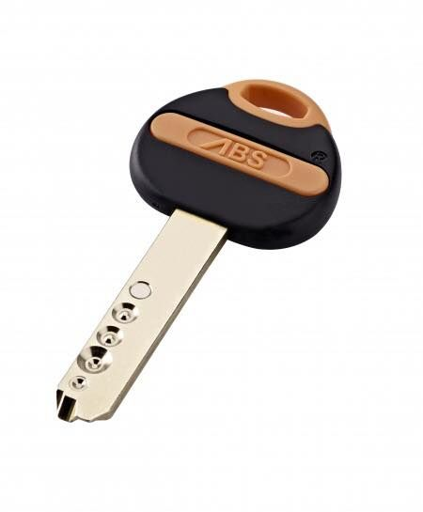
KEY MOMENT
Can you see how the three practical clinicians modified straight wire to make MBT
The cartwheel efffect, great theory but we align with round wire so this causes excessive mesial tip of canines.
Mesial tip in premolars very nice but expensive on anchorage.
Lingual torque on lower buccal segments fine just like Andrews measurements but most cases have class II tration which tends to cause lingual rolling.

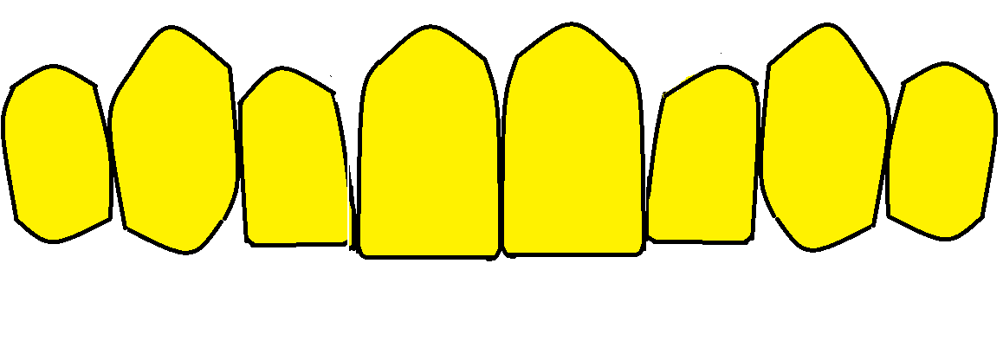

Using the gauge tends to produce this, a gentle curve
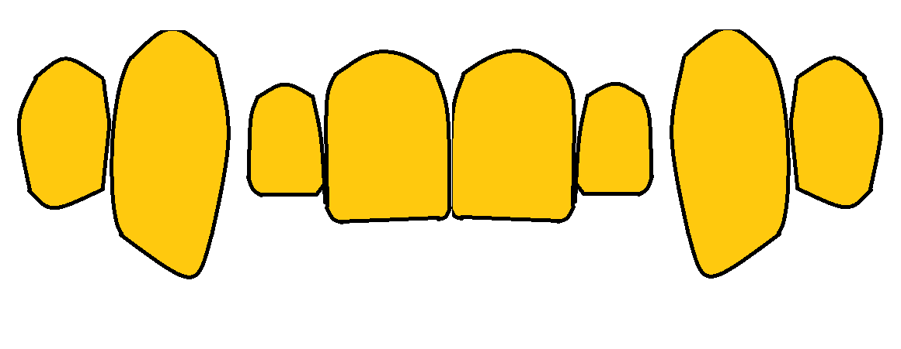
While using the LA point often produces this
Lingual Brackets
Dr. Kinya Fujita introduced the Mushroom arch wire appliance in the year 1979. It was really a kind of ribbon arch bracket. In the lingual bracket, the opening of the slot was set on the occlusal surface of the teeth in order to facilitate the fitting of the wire. The groove for lockpin insertion was set mesio-distally in the slot and an auxiliary groove was set in the occluso-gingival direction.
We are heading into Adult orthodontics here,
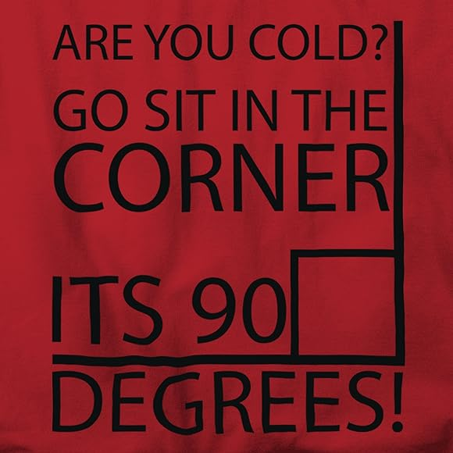

Nerds’ corner

If the wire and bracket sizes were correct
19 x 25 wire in a 22 x 25 bracket would have 6°of slop
18 x 25 would have 12° of slop (022 x 025 bracket)
16 x 25 would have 14° of slop (022 x 025 bracket)
20 x 20 would have 14° of slop (022 x 025 bracket)
16 x 22 would have 21° of slop (022 x 025 bracket)®

If you use 16 x22 in an 018 slot bracket it would have 5° of slop. I have spent years telling people how great 0.018 slot brackets are. Start with 0.014 NiTi then 0.016 x 0.022 NiTi. Then your working wire 0.016 x 0.022 steel Cement on 7s to open the bite. So quick and easy. Surgical cases 0.018 x 0.025 wire is strong enough for surgical wires.
Unfortunately, the brackets you buy may not be exactly 0.022 slot Kusy (1999) found that brackets were 8% oversized. Paul Brown in Angle orthodontist V0l 85 2015 found Unitek Victory brackets had a mean slot width of 0.0229 with a range of 0.0213 to 0.0234. GAC innovation brackets were the most accurate with a mean of 0.0224 and a range 0.0221 of to 0.0224.
Also the wire may not be the correct size. Here it is the rounded edges of the wire that are most to blame. See Lombardo et al Angle Orthodontist 2015. He found in real life the slop/play of 19 x 25 wire in an 022 slot was 10.62°
Wire size | Predicted slop (play) | Actual slop (play)
21 X 25 IN 022 SLOT | 2.5® | 4®
19 x 25 | 6° | 10.5°
18 x 25 | 12° | 20°
16 x 25 | 14° | 23.5°
20 x 20 | 14° | 23.5°
16 x 22 | 21° | 35°
16 X 22 IN 018 SLOT | 5® | 8°
18 X 22 IN 018 SLOT | 0° | 1.5°

In theory a 16 square wire should have 30° of slop but in practice it goes right round
Chapter Four
In which we meet some other fixed appliances that did not quite hit the big time.

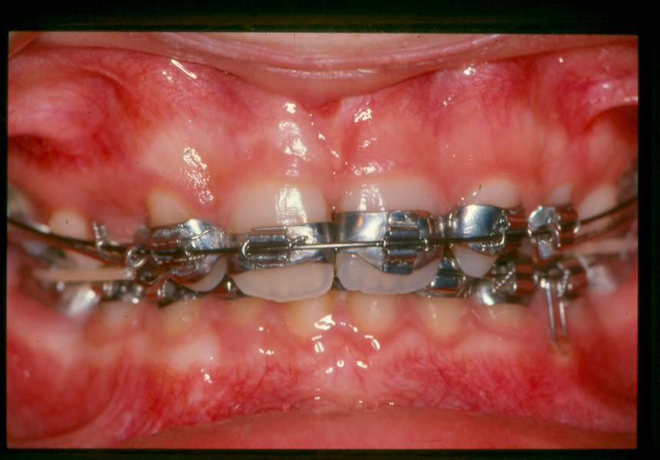
Ripple brackets we pulled them up ourselves out of tape.
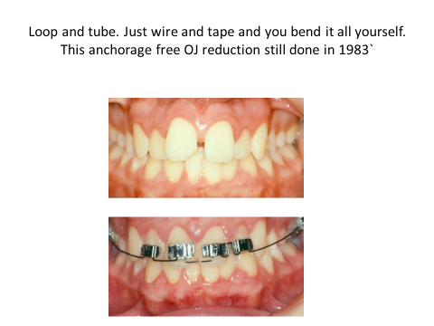
A bit more home made orthodontics Watkin boxes
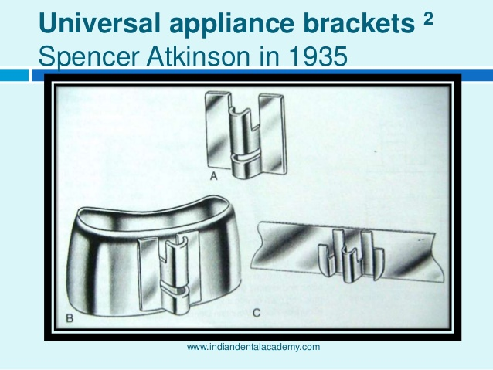
No longer available in this part of the universe. For lovers of wire bending this appliance could take two archwires at once in separate slots.
There are lots more. I can’t find any pictures of the Johnson Twin wire arch a real museum piece.
Many combined edgewise and Begg. I remember igloo brackets which were round and lots of self-ligating brackets.

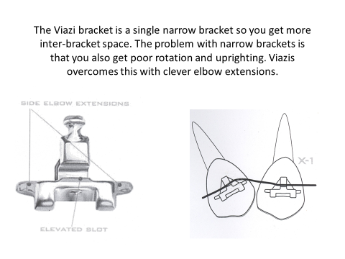
Said to be quicker but not mainstream
Self-ligating brackets
You probably think I have forgotten about self-ligating brackets but they are the subject of 2 separate tutorials (one active and one passive)
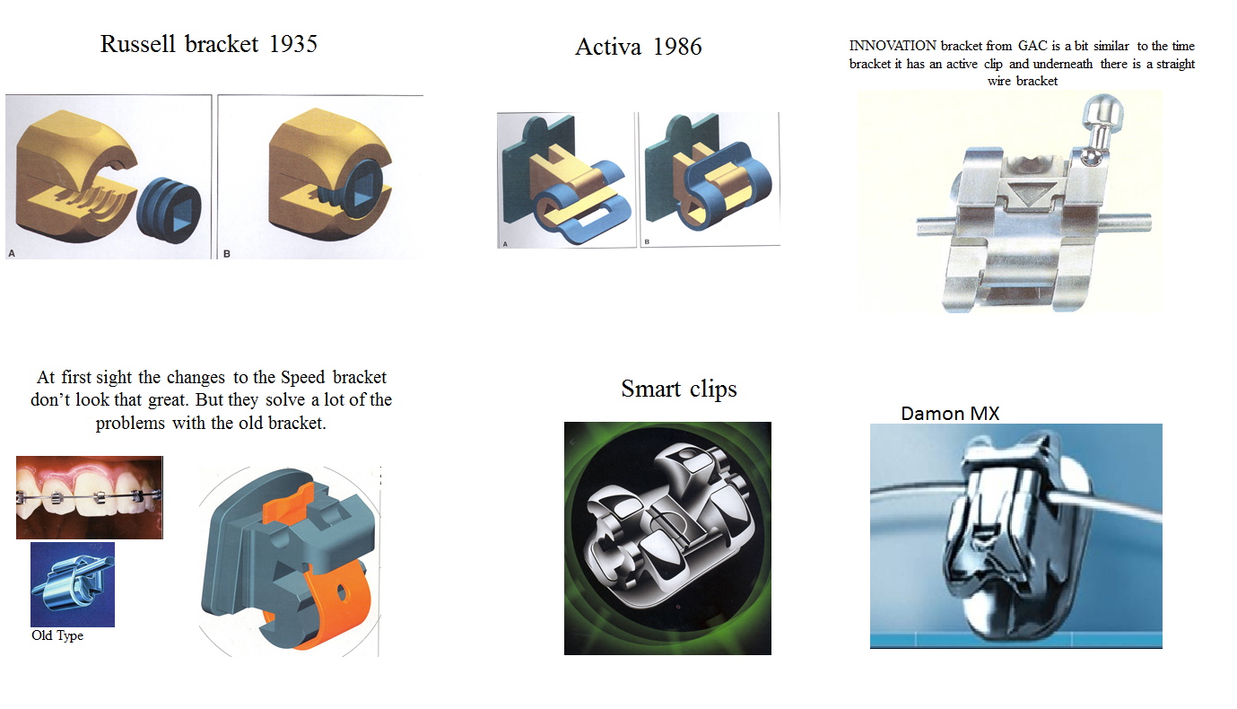


Fixed appliances breaking it down into bits
, Chapter Five
Anchorage

On Christmas day 1642 Galileo died, the English civil war started and Isaac Newton was born. He was useless at school, so they sent him to be a farmer, but he was useless at that too, so they sent him to Cambridge where he was recognised as the greatest mind that ever lived. If this sounds just like your life story you will know that: -
- He revolutionised the picking of apples.
- He invented the cat flap.
- He put all the little grooves on the outside of 10 pence coins.
- His third law of motion states that “Every action has an equal and opposite reaction”
This means that when you use an orthodontic appliance to apply a force to a tooth an equal and opposite reactive force springs up to try and spoil things.

The official definition goes something like this: -

Anchorage is provided by those sites, which resist forces of reaction generated by the active components of the appliance.
(Repeat 3 times per day after meals)
The most common orthodontic procedure is to retract either the upper canines or the labial segment, with anchorage provided by the teeth of the buccal segments. So that if an orthodontist talks of anchorage loss, he/she means forward movement of the buccal segments. You need to understand this common parlance of orthodontics. We also talk of burning up anchorage this means designing the mechanics to deliberately encourage the buccal segments to come forward. Strictly speaking these terms are not always correct, for example if the appliance were designed to procline the upper incisors then anchorage loss would drive back the buccal segments.
Anchorage support means holding back the buccal segments.
Removable appliances and anchorage.
In the 1950’s when America had Tweed Edgewise, probably the most technically complex orthodontic appliance, we had the Upper Removable Appliance (URA). Actually you can do quite a lot with a URA providing that you select the right case. In particular you can extract upper 4/4, retract upper 3/3 and then retract upper 21/12. Let’s consider how to do this properly: -
- Fit the URA before the extraction and only arrange extractions when the patient can demonstrate that they are able to wear the appliance full time including for meals.
- Design the appliances correctly using springs, which generate light forces and have a long range of action. Remember to include an anterior bite platform if you need to open the bite and some form of anterior retention.
- Try to avoid buccal canine springs if you can, they are quite difficult to wear.
- During canine retraction measure the overjet if it increases it is the sign that anchorage is being lost.
- Make sure that you trim back the acrylic to allow the teeth to move and deactivate the spring when the canine touches the premolar or it will rotate.
- Retract the incisors with a Roberts’s retractor. Make sure that the wire that touches the incisors is ideally shaped or you will not achieve alignment. Also you must trim the acrylic behind the upper incisors hollowing it out under the bite platform so that the gingival margin of the palatal surface of the incisors does not touch the acrylic.
If you try this treatment on a number of cases you will find that in some cases anchorage loss is very very small. This is because the forces of action from these appliances are very small and the sites that resist the forces of reaction include the molar teeth and the whole of the surface of the palate. However you will find other cases where you lose a lot of anchorage. I bet this is not because you have over activated the springs. I hope it would not be because you have foolishly decided to use 0.7 rather than 0.5 springs although this would do it. I bet that the cause is poor wear of the appliance. You see if the patient leaves the appliance out for a day the upper 6/6 will drift forwards a little. When the patient puts the appliance back in it will be a little tight behind the incisors and they will be pushed forwards. Repeat recipe 100 times and the overjet will increase. Strictly speaking this is not anchorage loss but forward drifting of the molars into an extraction space but it comes to the same thing in the end.
The Nance Button
This is a way of getting the anchorage of the palatal vault without using a removable appliance that the little darlings can leave out. Try to persuade your technicians to make a proper one. This has a piece of 0.7 wire from each molar band which goes to the palatal vault and bends about a bit. The two wires are joined by a button of acrylic which is added after the wires have been soldered to bands. The button should be the size of a 2 pence piece or larger and occupy the true vault of the palate. Your technicians will hate this idea. They would like to use a single piece of wire going from one molar to the other. They will bend the wire so that it presses so firmly onto the bands that it will stay in place while it is being soldered without them having to go to the trouble of welding it. But as a result of this when you stick it in the mouth it will not be passive and the molars will expand.
There are a few alternative designs, which use a Nance button that passes behind the upper 7/7 and fits into the EOT tubes. One design enters the tube from the back; it has a little hook so that it can be held in place with a module that goes around the hook on the molar. The other bends gingival to the molar tube and enters the tube from the front.
Can a Nance button loose anchorage?
Yes if the molar tubes are not parallel then you need increase force to retract the teeth because of the increased friction. Two solutions: 1.parallel the molars first. 2. Use the EOT tube to cut down on the friction. OJ reduction in upper 4/4 cases the main wire steps out distal to the canine and slides freely through the EOT tube.
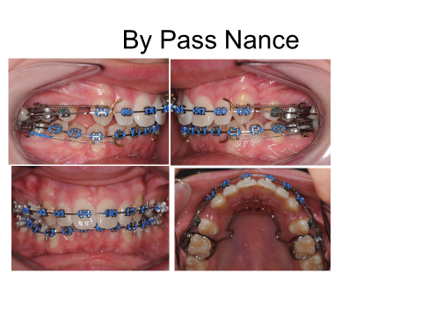
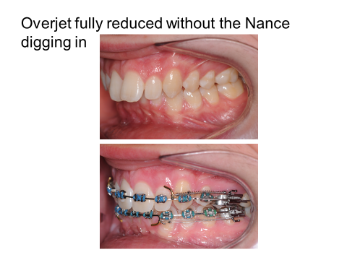
The 0.019 x 0.022 NiTi is sectioned anterior to the 5 and the posted archwire passes straight through the EOT tube. Try it it works really well
The trans-palatal (lingual) arch.
If you stop the molars moving together you make it more difficult for them to move forward and increase anchorage. The idea is that the teeth lie in a narrow channel of cancellous bone and as they move forward the roots will hit the cortical bone unless they can move together.
Ricketts (The Bioprogressive Technique)
The utility arch throws the roots of the molars buccally into the cortical plate the idea is that this will increase their anchorage value. Do you believe it does?
Headgear
This is a big subject consider:-
- Orthopaedic change
- Force Vectors and type of movement.
- Anchorage reinforcement.
- Raegdaeh esrever, sorry I mean reverse headgear.
- Safety Headgear
- Nudgers and screw plate.
- High pull headgear.
- High pull headgear with J hooks
- Ultra-high pull to treat AOB cases

Non-Compliance Appliances
Single arch
1 David Lewis uses URAs
2. I like Gianelley’s appliance (because the name reminds me of ice cream.)
3. The Jones Jig has a nice sense of alliteration but comes in a lot of tidily pieces.
4. Ormco make a neat “distalizer” like a Jones Jig But in one piece.
5. The pendulum appliance adds a palatal baseplate.
6 Distal Jet clever but flimsy
Between the arches
- Instead of class II elastics you can use Sentalloy springs, which are little coil springs in a rubber tube. (Combining a coil and a condom sounds a bit contraceptive to me)
- Jasper Jumpers.
- Forcus springs
- Eureka Spring.
- Herbst appliance
I have done some tutorial notes on non-compliance appliances
The Begg Issue
Two ideas. One is, that if you have a class 1 incisor relationship and spaces in the premolar region in all four quadrants and try to close the space with elastics; if you use a light force you can tip back the incisors whereas if you do the same with a heavy force the molars will come forward. I don’t believe this. (By the way it is called differential anchorage).
The other is that if you tip the labial segment back and then upright the teeth it takes less anchorage than bodily retracting them. Some people don’t believe this they think that by the time the upper incisors are fully torqued back you will use up the same amount of anchorage. They also believe in Santa Claus, a flat earth and the tooth fairy and only one of those is true
Implants
- On the cheap. You can extract the deciduous canine and re-implant it. Then splint it until it ankyloses and then use it to support anchorage. Or you can make use of any naturally submerged teeth. Remember an ankylosed tooth will also support anchorage in the vertical plane e.g. for bite opening. It can also be used together with inter-maxillary traction to move teeth in the opposing arch. Unfortunately ankylosed teeth can work loose and exfoliate.
- End-osseous Implants.
- Mini screws
- Onplants
- Zygomatic wiring
- Bollards (same to you Hugo DeClerk)

Terms you should know
Simple Anchorage
Reinforced Anchorage with headgear.
Reciprocal Anchorage. For example a mid-line expansion screw or closing a diastema.
Stationary Anchorage. Does not really exist, the idea is that if you hold lots of teeth together they will give lots of anchorage.
Differential Anchorage. One of Begg’s ideas. If you extract the 4’s and use light forces to close the space the anterior teeth will move back. But if you use a very heavy force the molars will move forward.
Baker Anchorage. Ye very olde term for class II elastics.
Anchorage Preparation This in an interesting idea that was part of the Tweed system.

Use Less Force.
If anchorage loss is a reaction in the supporting teeth to the force used to move the teeth then it stands to reason that if you use less force you will get less reactive force. But this is not much good if you get less tooth movement. However you could: -
- Waste less overcoming friction by using a low friction bracket such as Damon of Begg.
- Tip the teeth and then upright them as in the Begg and Tip-Edge technique.
- Don’t take the wire through the premolar brackets to cut down friction as in the Begg and Tip-edge techniques.
- Remove cuspal interferences. Use a bite plane or pre-treat with a twin block or put cement on the occlusal surfaces of various teeth.
- Don’t start sliding mechanics until the wire has been in place for a while to allow the teeth to align fully.

Starting with removable appliance
- Said to test cooperation. Indeed I used to say that, but remember, people are very influenced by peer pressure. You will find some children who will not really try URAs because they want a proper brace like their mates. Also it makes treatment more expensive and slower.
- Can open the bite with a flat anterior bite plane. A FABP can open the bite even when the lower 6s are missing.
- Can discourage sucking habits.
- Can support false teeth e.g. when there is a missing central.
- All the above are true but nowadays I don’t often start with URAs. It is slow, expensive and unpopular with the patients. Also as the years go by patients seem to wear them less and break them more.
Starting with functional appliances
- The straight wire appliance cannot change molar relationships very easily. Usually you need straight wire plus something else. That might be EOT or TADS or functional appliances. In some cases this is being done in the hopes of producing some orthopaedic change but in most cases you just want to correct the molar relationship.
- The Twin Block is the most popular functional appliance in the UK
- The button and bead appliance is the most popular with me and my patients and appears to be much more successful than the twin block if made by a good technician
- The twin block seems to be popular in the UK, but less popular in the rest of Europe
Round tripping
- It seems to be taken as true that round tripping is a bad thing, but I don’t believe there is much evidence that that is true. If the lower incisors are proclined during treatment and then moved back to the correct position are they less stable? Perhaps, but I know of no supporting evidence or any reasonable theory to say why it should be so. Cone beam CTs suggests that if the lower incisors are proclined during treatment the labial bone will thin. But if they are then retracted to the original position the bone will fully return to the original level.
- Proclining the lower incisors could in theory lead to gingival recession. But if you are using a round wire the teeth will tip forwards and the roots will if anything move lingualy. We are certainly treating cases a lot further forwards than we were 20 years ago and I don’t see a lot more gingival recession.
- Therapeutic diagnosis. I think this is a good idea. Classic treatment for a class II div ii. Take a lateral skull then align the teeth then take another lateral skull and decide if you need extractions
Sectional arches
- In the 1960s the mainstay of British orthodontics was URA to retract upper 3/3 second URA to retract upper 21/12.
- By 1970 we realised that this was not good enough when the anterior teeth were rotated. We graduated to retract upper 3/3 with a URA and then a primitive fixed appliance called a Johnson’s twin wire arch which was molar bands and bands 21/12 and an archwire that was rigid at the side and flexible at the front to align the incisors.
- By 1976 when the straight wire appliance was being invented British orthodontics had graduated to: (i) a URA to open the bite (ii) a lower plain edgewise in the buccal segments with sectional arches to retract the canines (iii) sectional arches to retract upper canines with a clip over URA with a bite plane (iv) bond the lower incisors and work into a thick archwire (v) throw away the clip over bite plane and bond the upper incisors. THIS WORKED BUT IT WAS SO SLOW. There were no NiTi wires so it was difficult to upright the canine teeth if they were allowed to become retroclined. Official instructions were that at each visit the sectional should be activated by the thickness of a thin dime.
- So it seems a little surprising that some people are going back to sectional arches.
- Perhaps I should say that sectional arches are a part of Ricketts or Bio-progressive appliance therapy (we covered this already, but you were asleep.

Auxiliaries

Edward Angle believe the Edgewise appliance to be his “latest and best appliance because it no longer needed the uprighting springs that were a part of the ribbon arch appliance. However auxiliaries have not gone away. So here are a few.

Torquing auxiliaries e.g. ART

Sliding jig
Ballista springs
Non-Compliance appliances e.g. Jones Jig
E-Arches (jockey arches)
Rotation wedges e.g. Steiner wedges
Rotation wings e.g. Lewis and Alexander brackets
Rotation wedges
Hycon scews
Auxiliary springs using vertical slots
Power arms
Out-riggers
Speed auxiliaries
Rotation springs

Uprighting springs
Uprighting impacted lower 7/7
Power pins
Magnets
Bite turbo’s etc
Fixed bite planes
URA’s Plint clips
Fixed functional (but not in this tutorial)
Lip Bumpers
N.B. I did not consider that surgical ball hooks, crimpable hooks elastic thread [links or chain], lig-a-mods, pull coils, Quads, Nance, Nance +TPA, TPA, implants, mini screws, or push coils were really auxiliaries but the separation is rather arbitrary.

Levelling and aligning

- Archwire sequencing
Some people get quite worked up about this but the problem is that different makes of wire have differing properties for example our cheap OSL British made NiTi wires at Burton are a lot more gutsy than the Unitek NiTi wires used at the dental hospital
Some advice:
- Don’t start with 0.012 NiTi unless the teeth are very displaced or the patient is very sensitive.
- If the module does not pull the wire right into the bracket you have chosen too thick a wire.
- Go right up to 0.019 x 0.025 NiTi before putting in a steel wire.

In Burton we tend only to use the following wires routinely: (note unless stated the wires are lower. We tend not to stock upper NiTi I suppose that if you left a patient with lower NiTi in both arches for long enough they would move into cross bite. But I have never seen that happen.)
0.012 NiTi
0.014 NiTi
0.016 NiTi
0.018 NiTi
0.016 x 0.022 NiTi
0.016 x 0.022 NiTi heat activated
0.019 x 0.025 NiTi
0.019 x 0.025 NiTi heat activated lower
0.016 x 0.022 steel posted Ortho Care upper
0.016 x 0.022 steel posted Ortho Care
0.019 x 0.025 steel posted Ortho Care upper
0.019 x 0.025 steel posted Ortho Care
0.016 x 0.022 counterforce upper
0.016 x 0.022 counterforce
0.019 x 0.025 counterforce upper
0.019 x 0.025 counterforce

So if you count up that is a total of 16 different archwires in the department.
N.B. If you use 0.018 slot brackets you can cut out all the 0.019 wires so you can run an entire practice with only 10 different wires.
N.B. 2. I have not included reels of steel wire. (We now stock Australian special rather than special plus. They altered the wire a little and I find the special plus too brittle. Recent problems with buying Wilcock wires have caused us to move to Tp Original Premium plus) or finishing archwires we do have some beta Timolium which is poor man’s TMA from TP Orthodontics both seem to be the same at a lower price (they are β Titanium).
After the original gold wires of the E-Arch and the ribbon arch came stainless steel but initial alignment was a problem. They did make very fine wire 0.010 but it just distorted then you went up 0.012, 0.014 etc. A big step forwards were the twist-flex arches. Three or more very fine wires twisted around each other. We use them now for palatal bonded retainers but then they were used for initial alignment. (Also called wild cat wire and bob cat wire) Improved properties were claimed for Co-axial twistflex, a central core with the wires wound around it.
The first Nickel titanium archwire was called Nitanol. (Nickel 52%, Titanium 43% Cobalt 3%) Invented by William Buehler of the Naval Ordinance Laboratories. It had shape memory. Except at very low temperatures. The grain structure remained in the Austenitic form. This material was developed for the American space programme. The idea was that aerials and antennae could be packed up into a tiny space and released to form their prober shape when outside the atmosphere.
You may know that studies to compare Nickel Titanium wire and twistflex suggested that there was no real advantage in terms of alignment. So why did we change? Well twistflex just aligned the teeth well enough to get 0.014 steel in place but NiTi wires buy you into a series of pre-shaped wires that get you right up to 019 x 0.025 steel without any wire bending.

From this first Nitanol wire there have been a number of developments these are mainly based on the transition from Austenitic form to the softer Martensitic form. In super –elastic NiTi this change is brought about by stress. Unlike a typical metal spring a super elastic spring will change its structure the more it is deflected. This means that the force it delivers is constant over a longer period. Sound like a great idea but there is often an initial deflection required before this change starts to occur and since archwires are deflected very little this super-elastic property doesn’t seem to make that much difference.
Thermally active wires are in the soft Martensitic form at room temperature but at the critical temperature the Martensite changes to the much springier Austenite. As a user you notice that these wires are softer at all temperatures than the cheaper wires. (I think this is a disadvantage unless you need it) The idea is that you can cool the wire down with some special sprays and engage the soft wire into the bracket and then let it warm up. This is why we have 0.016 x 0.022 Heat Activated Nickel Titanium (HANT) at Burton. This means when you get to this size wire you can reposition brackets and still get the wire in.
If you like Damon then you will want to use Copper NiTi because it is stronger and more flexible and more expensive so it must be the best. My feelings are that I need to put in 0.014 wire one visit and hopefully 0.016 x 0.022 the next as long as it will do that I don’t mind if it is not very posh.

Another Titanium wire is β-titanium (79% Titanium 11% Molybdenum 6% Zinc 4%Tin) high friction and a bit softer than steel it is easy to bend and doesn’t break too easily. It is used as a finishing wire because 0.021 x 0.025 can be placed in the slot without damaging the teeth. One make is called TMA it is very expensive β-Timolium from TP is much cheaper and appears to be the same. There is also a steel rectangular twistflex wire that has been suggested for finishing we don’t have it at Burton but it is OK.

- Lacebacks, bend-backs and racebacks
Prof Fraser McDonald who is probably the external for your MSc is the co-author of a paper which suggests lacebacks have no function. I tend to agree except where 5s have been extracted they do stop the 0.014 NiTi being pulled out of the tube during eating.
Bend backs probably do nothing as well. At least if you anneal a piece of 0.014 NiTi to dead soft and bend the end in it is hard to see that it would offer much resistance to anything. I used to do it routinely, then I stopped and it seems to have made no difference.
Racebacks are my own invention so I am bound to say they are good. Try them and judge for yourself. They are just lig-a mods from lower 6 to lower 3 used in cases where the extraction of lower 5/5 gives more space than needed and you want the lower 6 to come forward. It is interesting to see how much the lower canine will drop back. Remember you can only use them if the lower labial segment is crowded or it will open spaces.
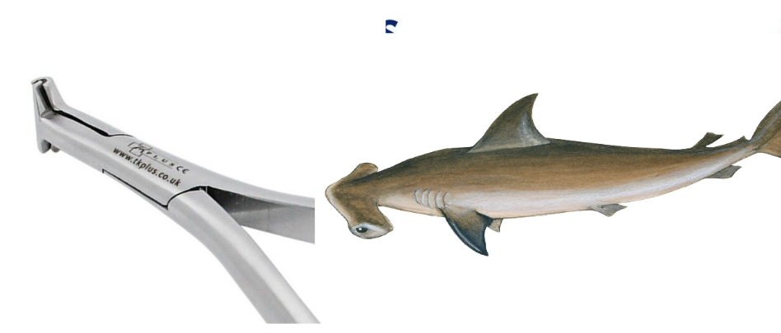

Hammerhead or bend back pliers are available they can bend the end of a NiTi wire these are £131 which is a lot if you plan to add one to each fixed appliance kit.
- Ligatures, modules, rotation wedges, Steiner wedges and Lewis rotation brackets
Edward Angle used ligatures to tie the teeth to his E-Arch. The ligature went right around the tooth. The very first edgewise brackets had the familiar slot but no tie-wings, so again the ligature went around the tooth. Then, with the invention of the tie-wing there were several ways of tying in the wire. The rotation tie pulls the most displaced part of the bracket towards the wire but the part closest to the wire is free to move away.
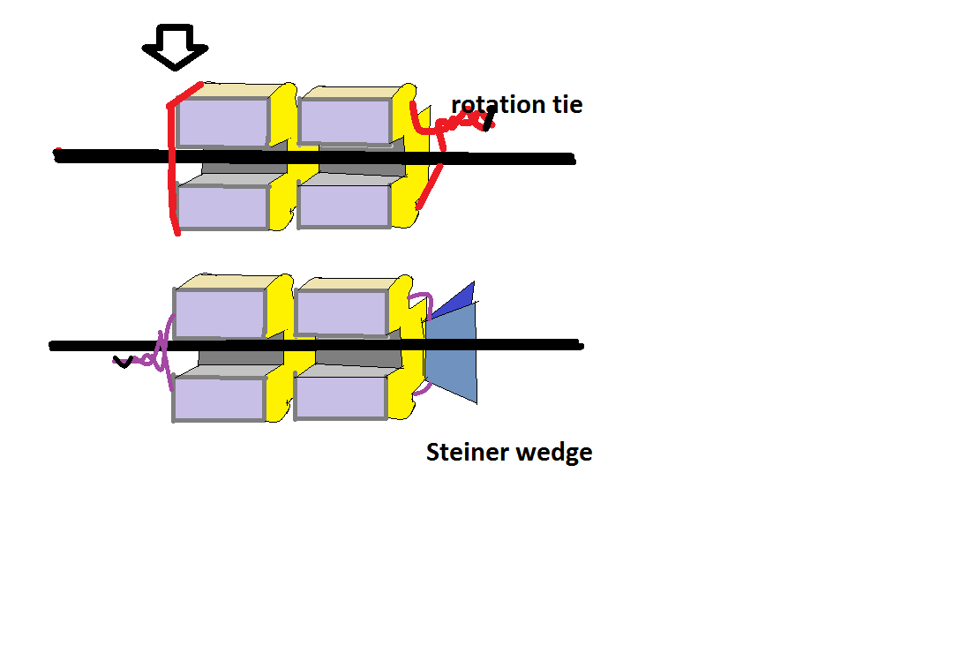
Steiner adds a very springy steel clip that wedges this side (the one closest to the wire) away. Of course Siamese brackets will give better rotation control than the single brackets Wick and Lewis brackets have wings on a single bracket to give rotation control.

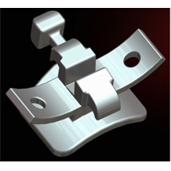
I have used them on transfer cases and found them very easy to use.
In the 1970s ligatures were replaced by modules which were quicker and easier even if they are less hygienic.
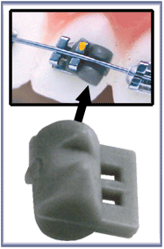
Special rotation modules became available. Some edgewise brackets have vertical slots and allow the use of rotation springs. Also you can use elastic chain to rotate teeth or use buttons or cleats on the palatal surface of the teeth. (For completeness you could add whip springs and something called the Smythe rotator which was considered old fashioned when I started orthodontics in 1970, but I wouldn’t mention that to MOrth examiners I doubt they would have heard of it)

- Cement on 6s
- Can be used to free the occlusion if pushing a tooth over the bite
- Reduces the chance of knocking off a bracket in the first few days
- Removes a displacement for example in unilateral crossbites with displacement
- Allows the lower incisors to align a-traumatically in class II div ii cases
- Will open the bite if the 7s just happen to be erupting at that time (but it is not really a very effective method of bite opening.)

- Gathering the teeth
Please gather the teeth. (Don’t switch your brain off until you are in 0.019 x 0.025 steel wires.) Gather upper 2-2 and lower 3-3 in class I and II cases and upper 3-3 lower 3-3 in class III cases. Leaving spaces until you are in posted wires will mean it takes a long time to close the space on thick wire and the average size posted wires will not fit.

- Bite opening

Methods of reducing Overbite.

The anterior bite platform. (Also called the anterior bite plane)

We all know about the anterior bite platform. If a patient wears a URA with and anterior bite plane the overbite will reduce. If the patient is still growing and they are wearing the appliance full time including for meals the molars will come back into contact in 10 weeks. (Usually much sooner)

We assume that it works by allowing eruption of the molars and that it will increase the FM angle and the lower face height a little. Of course we know that the dento-alveolar structures remodel during growth so that it would be no surprise to discover that by the end of treatment these changes are offset by growth changes and that the facial height and FM angle are not changed.

Bjork found that fitting a bite plane had quite far reaching changes in mandibular growth. Carlson1982 found that if you fitted a bite plane in monkeys the whole maxilla was pushed up and the mandibular incisors were intruded. Mills suggests that the fitting of an anterior bite plane in a developing class II division ii malocclusion will allow further downwards and forwards development of the lower labial segment. There is also evidence that the fitting of a bite plane will encourage increased cartilage formation at the condyle.

Some more advantages: - you can start with a URA before extractions as a test of cooperation. The appliance can space maintain so that the molars are held back, this can be useful if there are still deciduous teeth. You can use the removable appliance to do other things such as expand the upper arch, screw open space or retract the canines. The removable appliance can be worn with headgear either as a nudger type appliance to speed up the distalisation of molars or a screw plate where you want to move one molar back more than the one on the other side.

BUT there is no point in starting with a removable appliance in the upper to open the bite if you let the incisors over erupt again. SO you must continue with the URA until you are in substantial steel wires in the lower. If the overbite is very deep it is worth using a utility arch in the upper as a piggy back arch to prevent the extrusion of the upper incisors. (But you would need double tubes for this).

Functional appliances and overbite.

a) Let’s start with the Herbst appliance, although it is an unusual appliance it does show a principle. The Herbst appliance is a cast splint on the upper teeth joined to a cast splint on the lower teeth by a pair of rod and tube devices. The tubes are attached to the upper splint just buccal to the molars by means of flexible joints. The rods are fitted in a similar way to the lower splint in the canine region. When correctly made the rods hit the ends of the tubes as the mandible closes forcing the lower jaw forwards to an edge-to-edge position. If the overbite was positive the molars will now be out of occlusion and since the appliance prevents the patient from biting in any other position the appliance allows the eruption of the molars while tending to intrude the incisors in this way the overbite will be reduces. If the patient has a reduced overbite at the start of treatment then the postured bite will still have molar contact so that the overbite will not be reduced. This method of bite opening applies to most function appliances but remember most functional appliance treatment is accompanied by an increase in lower face height. This implies that their main activity is allowing the eruption of posterior teeth.

b) The Medium opening activator is no longer a very popular functional appliance but it is worth considering next because its bite opening is easy to understand. The appliance consists of a URA, which is extended down to cap over the lower incisor teeth. The lower premolars and molars are left out of occlusion and they over-erupt and drift forwards. The MOA always opens the bite.

c) The Andreson appliance was the first functional appliance to achieve bite opening it was recommended that the acrylic over the molar teeth was trimmed to form channels for the lower teeth to erupt up and forward and the upper teeth to erupt down and back.

d) Harvold pointed out that the upper teeth did not erupt if they could only erupt by moving back. So you don’t have to spend ages carving out little channels just trim over the lower molars and premolars and these teeth will erupt by themselves.

e) The Twin Block. This is more complicated there are two answers.

First answer. Fit a nice well-made twin block with posterior capping which prevents the eruption of all the teeth in the buccal segments. The appliance will have cribs on the lower 6’s and 4’s. You hope that because the lower appliance has good retention it will be well worn and in 4-6 months the overjet will have reduced. If there was a positive overbite at the start the patient will now have a posterior open bite so you will need to change to a Hawley retainer perhaps with an anterior inclined bite platform to allow the molars to erupt.

Second answer. Either design the lower appliance so that it has no crib on the lower 6/6 and no acrylic over these teeth or start with lower 6/6 cribs and cut them off this allows eruption of the lower molars reducing the size of the lateral open bite. Note that there is no right answer. Some patients develop quite a big lateral open bite and you resolve from then onwards to always cut off the lower molar cribs. Then you find patients saying they can’t wear their lower appliances because they are too loose and you resolve never to cut them off again.

To recap functional appliances can open the bite. The activity is basically by allowing the molars to erupt more.

Fixed appliances

3) Arch levelling. Don’t underestimate this, if the lower incisors are way above the functional occlusal plane the overbite will tend to reduce during alignment. Bonding 7s is heavily promoted by some teachers. I don’t understand why but this doesn’t seem to work for me. Beware of teachers who say things like “proper consultants always band the 7s” try it and record in your notes. Did it work? Or did you have to resort to other methods. Look at their cases have they opened the bite or just proclined the lower incisors.

4) Alignment when the canines are partly erupted. A clever trick if you want to intrude the upper incisors for a patient with a class II division ii malocclusion or with a gummy smile. When the canines are just erupting bond up and align with NiTi this intrudes the incisors.

5) Curve of Spee / Reverse Curve of Spee. You can see that this will help bite opening but it has a problem in an appliance which uses sliding mechanics because it greatly increases friction.

6) Proclination of the lower incisors tends to open the bite. Conversely, early or excessive extractions tend to increase the overbite. Remember that you do not have to take the teeth out at the start of treatment you can open the bite first. Parker and Nanda found that proclination of incisors and extrusion of the molars were the real way that the bite opened, intrusion of the teeth was much more difficult.

7) Extension of appliances to the second Molars. Makes the curve of Spee or reverse curve of Spee work better.

8) Extrusion of molars with EOT.

9) Intrusion of Upper incisors with EOT. Although no longer fashionable at one time the high pull headgear with J hooks was in wide use. It did intrude the upper incisors, retract the upper incisors and in some cases torque the upper incisors. But there were fears that it might risk the vitality of the upper incisors or cause facial trauma. The attitude of most orthodontists is that it probably does not, but why risk it.

10) Class II elastics. Tend to extrude the lower molars and the upper incisors but when the upper arch has a curve of Spee this tends to reduce extrusion of the upper incisors and whereby produces bite opening.

11) Burstone arches. This is a sectional approach the lower labial segment has a sectional arch which is tied to a TMA arch which runs in the buccal sulcus. It certainly opens the bite, Proffit seems to think this method has extra control but this is based on a theoretical evaluation of the forces involved not on clinical trials.

12) CIA arches (I could tell you what they are like but it is a secret). One of the problems of the Burstone arch is that you have to bend it. But don’t worry you can now buy a NiTi version that will do the same.

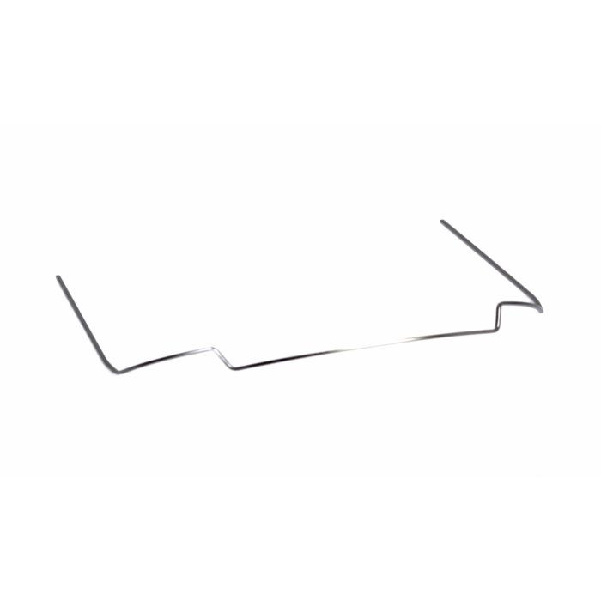

An upper CIA arch you do need double tubes. They are made of NiTi and just fit in under the archwire. Available from Henry Schein.

13) Utility arches. Described by Ricketts and developed into a complete technique which has a sectional approach to treatment. A typical case might start with premolar extraction and sectional arches to retract the canines. At the same time upper and lower utility arches were used to open the bite, align the incisors and if required alter the torque in the labial segments.

The utility arch has a sharp anchor bend just in front of the molar tube and it is this that intrudes the lower incisors. It will also tend to tip back the lower molars but the sectional arch prevents this. This is a clever idea and it works. So why is the Ricketts technique not more widely used? I suggest (a) People tried it when they did not have double molar tubes and found that the lower molars just tipped. (b) There was a lot of wire bending so that new orthodontists found it difficult. (c) Ricketts advocated the use of very soft Blue Elgiloy wire that got damaged very easily.

14) Bite opening with the Begg appliance (also Tip-Edge)

Stage I Begg is a cunning way to open the bite. It is divided into 4 parts. (1) The upper molars are tipped back so that the mesial cusps come down jacking open the bite. (2) Although the class II elastics tend to extrude the upper incisors this is more than offset by the anchor bends, which tend to intrude them. (3) The lower molars are extruded by the class II elastics. (4) There is real intrusion of the lower incisors.

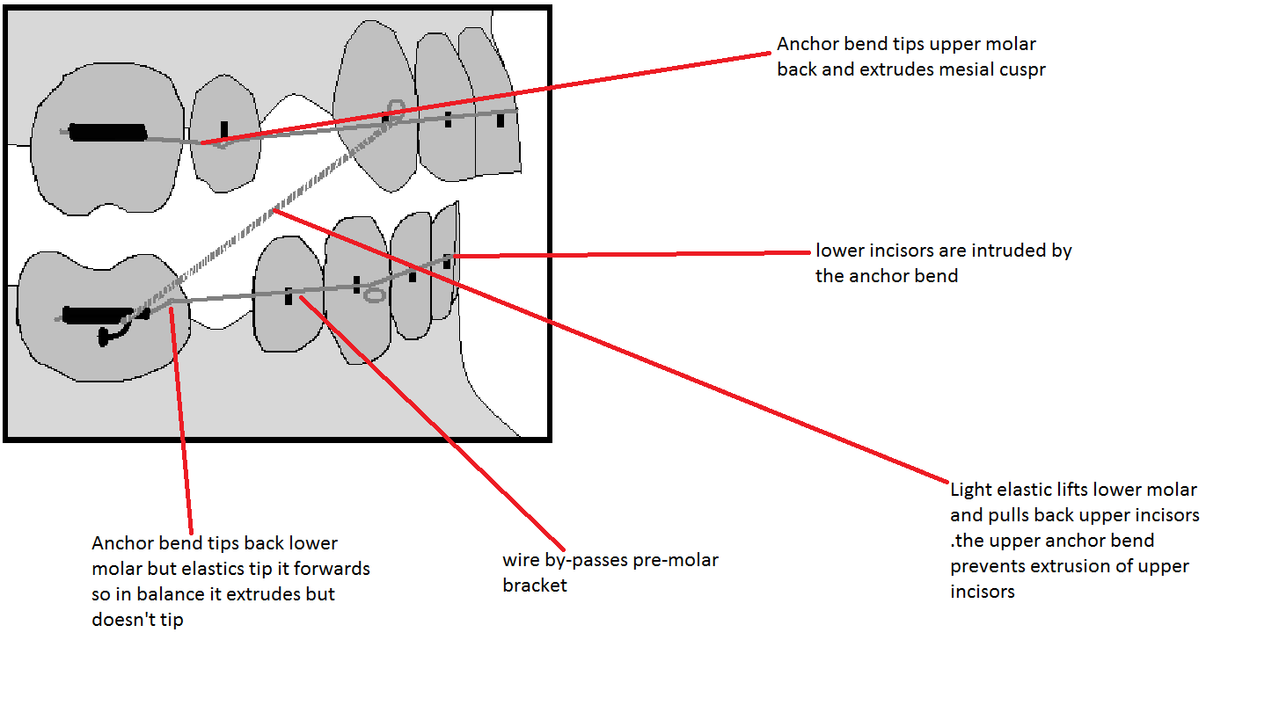

15) Cement on the second molars. Nobody wanted to publish my paper on this. So here it goes.

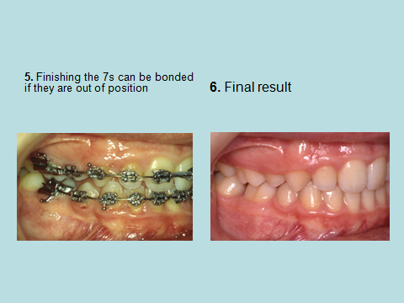

Typical case from my paper BOC 2002

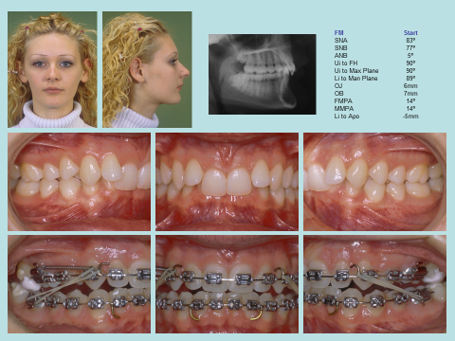

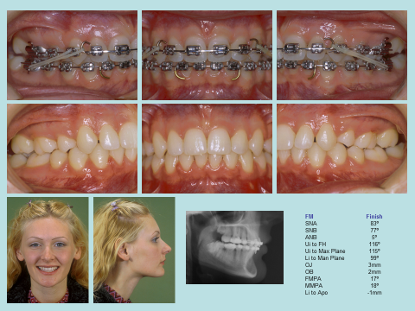



DONKEY MOMENT

When I finaly got to talk at the BOC in 2002. I thought people would try this, after all they had cement in their practices. But they didn’t

16) Some kind of bite plane removable or fixed. Yes you can add a bite plane to a fixed appliance. Really a Nance button with a bite plane they work but are unpopular with patients.

The usual way is to use a removable appliance with Plint clips on the molars. (Note that the Plint clip gets special mention on its own as a method of opening the bite.) This works, but it is quite demanding on cooperation. It also stops any other tooth movement in that arch.

18) Counterforce arches. The story of the invention of counterforce archwires is as follows: Ex vivo experiments on NiTi wires suggested that it was undesirable to use intra traction along a NiTi wire. This is because the wire bows gingivaly as the teeth tip towards each other. The manufactures thought that the answer to this problem was to make the wire with a marked reverse curve of Spee in the lower and an exaggerated curve of Spee in the upper. These new archwires not only counteracted the force of intra traction they had a marked bite opening activity. They work very well but sometimes they cause more problems than they solve. (Dr Margolias of Boston University. They are also called Rocking chair arches and M arches)

(a) They tend to procline the lower incisors. Jim Ferguson wrote a very convincing paper explaining that this is not due to the torque in the wire and I am sure that he is right when he says that although the wire at A seems to be torquing the incisor forward when it is lifted up and put into the slot the torque disappears. However note that the downward force is in front of the centre of resistance of the tooth and so the lower incisor will procline.

(b) The molar will tend to tip back and intrude. If the wire slides round so that it comes out of the molar tube the premolar will intrude very severely. (c) If you use class II elastics with counterforce you will reduce the tip back of the molars and improve the bite opening but the molars will tend to roll lingualy. The lower incisors will procline even more.

Some of these side effects can be very dramatic this is not surprising remember these are NiTi wires so that if for example the class II elastics cause the lower molars to roll inwards they can roll a long way in. It seems good sense to reserve the use of counterforce arches for cases where the bite fails to open with other methods.

19) Stick cement behind the upper incisors. Certainly described in the JCO it is really a fixed bite plane but it would only work if the overjet were relatively normal.

20) Stick Begg brackets behind the upper incisors or special attachments called bite turbos. If you bond a bracket on the palatal surface of an upper incisor you might think that the patient would bite it off but the body has a mechanism to prevent the teeth becoming overloaded so that this tends not to happen so this method does work it has been described in the JCO but you can only use it if the Overjet is normal and there must be some danger that the incisor root may be damaged

. 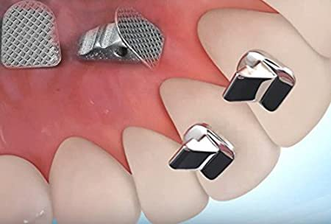

21) Use implants

22) Use ankylosed deciduous teeth. This can be very worthwhile so remember to use the submerged teeth to open the bite and then get them removed.

23) Jasper Jumpers. Eureka spring etc.

Others.

24) Elastic to intrude incisors.

25) Marsh plates. (I think I am the only one who remembers these and the secret is safe with me)

26) Segmental surgery e.g. Kolȅ.

28) Osteotomy.

29) Magnets (but why? They are repulsive) (and poisonous)

30) Grind down the incisal edge of the teeth. Sometimes in periodontal involved teeth this is the right thing to do. But not to be used as a normal method of bite opening.

31) DJS stabilizing arch. A 0.016 arch from the Begg tube shaped like a utility. Although it can open the bite its main use is to allow the use of class II elastics where the main ach is NiTi.

6.5 AOB

Remember if the patient has an obviously long face, plus a FM angle greater than 40° and normal or excessive show of the upper incisors, they need surgery.

Also

If the patient has a history of digit sucking and reduced incisor show they need extrusion of the upper incisors

For AOB in general consider:

You can stick the anterior brackets a little more gingival

If you align non-extraction you tend to reduce the overbite so be a little more radical with your extractions.

My idea of URA to extrude upper incisors

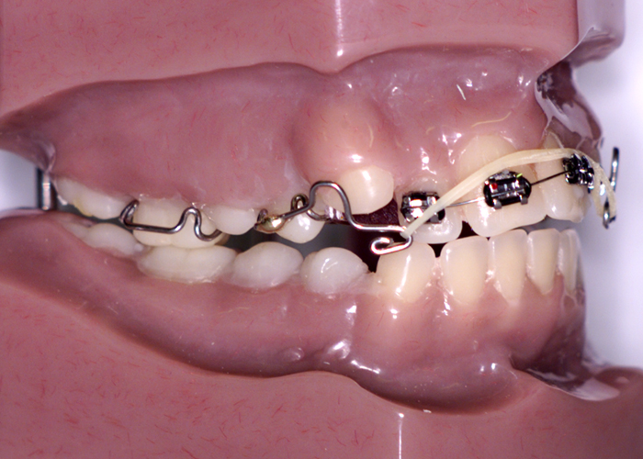

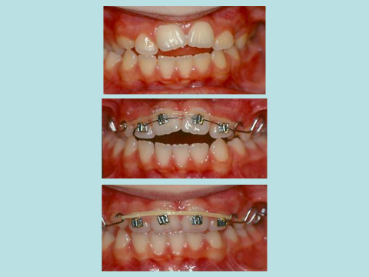
- TADs to intrude molars (I have yet to be fully convinced. show some lateral skull radiographs guys)
- EOT to intrude molars (Orton gave a paper on this and concluded no significant change)
- Jasper jumper between upper and lower first molars
- Kim Mechanics rectangular steel multi-loop arches with massive curve of Spee in the upper and reverse curve in lower. Plus very strong vertical elastics near the front and extraction of 6s or 7s
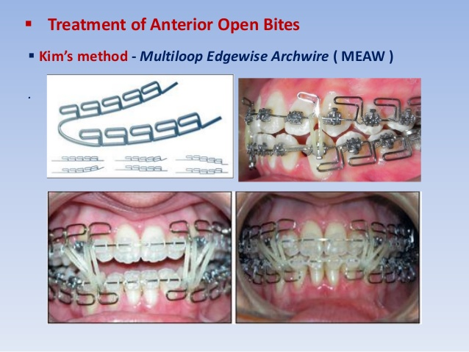
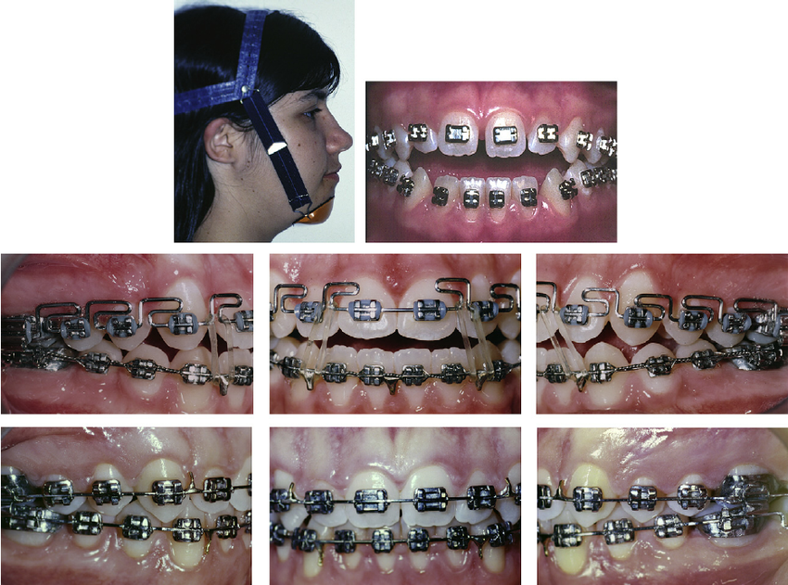
Found this nice case on the internet. Kim mechanics and chin cap (Chim Mechanics?)

- Counterforce the right way up to use as Kim mechanics (Saves you doing the wire bending and much nicer for the patients.)
- Upside down counterforce. My idea for non-skeletal AOB One of my cases:
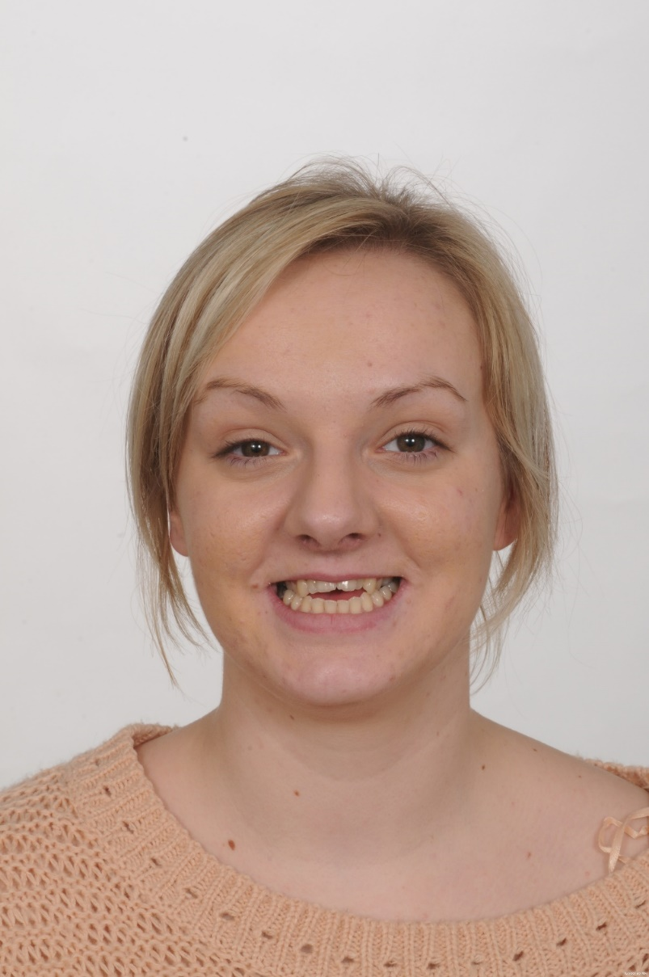
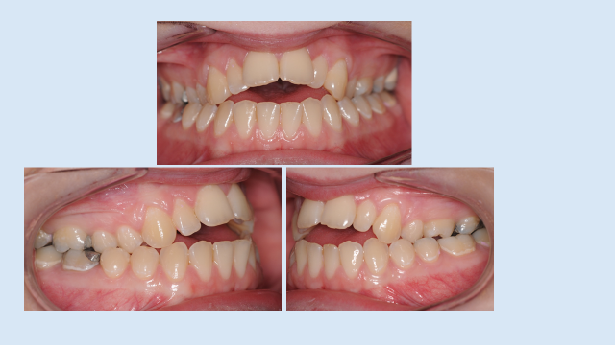
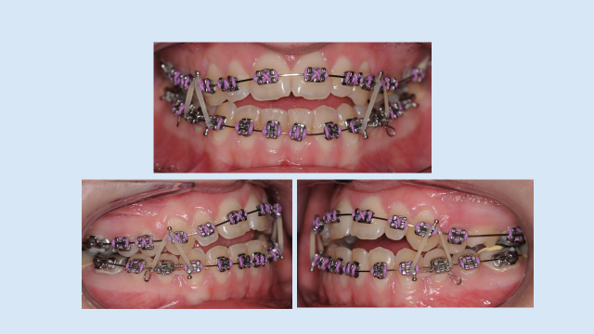
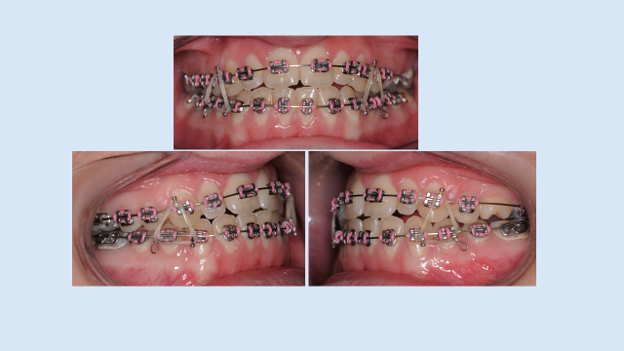
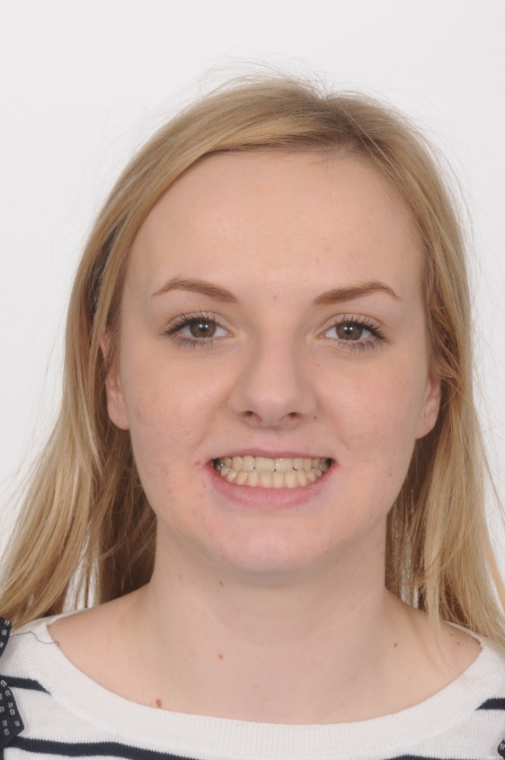
What do you think?

- Overjet reduction

Note you can have an increased overjet and a class I incisor relationship in Bi-maxillary protrusion.

Growth changes and overjet.

Usual tendency for overjet to reduce during growth, in a few cases this can cause a remarkable spontaneous resolution of a malocclusion.

Can orthodontic appliances affect growth?

Two separate issues can the forward and downward growth of the maxilla be impeded? Answer is yes using EOT (Weislander.)

Is it possible to promote extra growth of the mandible? This claim is made so often that you would be forgiven for believing that it is true BUT when the claims are subjected to randomised clinical trials (Tulloch1999, O’Brien 2000) the results are disappointing we may have to face the fact that these appliances do not produce any extra growth. This does not mean that they are not useful appliances. It does mean that you cannot suggest orthopaedics as a true alternative to surgery.

Justification of camouflage treatment.

As orthodontist you are being trained to look at people’s profiles, you are being taught the importance of a normal profile, Small wonder then that if you ask orthodontist which profile they like they are prejudiced. If you ask a normal person they are not so fussy (Cunningham).

Desirability of upper incisor retraction compared with proclination of the lower incisors.

Mills paper was very important, but was the way the data presented misleading? On the other hand there is a huge experience of orthodontic treatment suggesting treatment of overjet by lower incisor proclination is seldom stable.

Stability of overjet reduction.

Nashed gives a depressing picture of overjet relapse, but were the cases properly treated. Ballard suggests that to be stable you must change the situation so that the lips come together in front of the upper teeth during swallowing. Profitt says that forces which move the teeth have to work long term but see a patient who has a tongue to lower lip swallow at the end of treatment and you will see an overjet that is going to relapse.

Removable Appliances. Flexible labial bows, the Roberts retractor, the self-straightening springs, split labial bows, elastics. With a few exceptions removable appliances have no ability to produce apical movement.

Functional appliances. Oral screens, functional appliances with labial bow e.g. MOA, Those with no labial bow e.g. the twin block. Fixed functional appliances (separate tutorial).

Fixed appliances (Historical) Twin wire arch (Johnson) Loop and Tube (Watkins)

. Begg Tip-edge. John Williams said in the 1999 Orthodontic Conference that there were only one or two weirdo’s still doing Begg, but since they have closed down all the funny farms you are probably stuck with me and John Turner. Why do people still bother with Begg or Tip-Edge? It has three clever tricks up its sleeves. (i) Teeth align very rapidly and because the teeth are free to tip the canines drop back into the extraction spaces. (ii) Because Begg brackets have almost no friction and the teeth are free to tip back it is possible to reduce the overjet with a very light force of 50g. If you use 50g of class II elastics the effects on the lower molars will be about 5g of molar extrusion, which probably will not overcome occlusal forces. If you try to reduce the overjet with straight wire mechanics much greater force is needed which tends to extrude the molars and the upper incisors, this tends to rotate the mandible backwards increasing the overjet. (iii) Torquing auxiliaries mat be a pain but they do work. Putting third order bends in a wire is neat engineering but if the wire moves just a tiny amount out of the slot the force is lost.

Classic Tweed edgewise. In Tweed edgewise you start with EOT to the upper molars, then you band (it was in those days) the lower teeth and use class III traction to tip back all the lower teeth. Now all the lower teeth are tipped back and the overjet is worse. Tweed called this “anchorage preparation“but I call it ****. Next you band the upper arch and use class II elastics to pull back the upper teeth as you do this the lower teeth come forward again to finish in their correct position.

Straight Wire. This allows the use of sliding mechanics and no more horrid wire bending. Sliding mechanics is great but now we have to worry about friction. Here are some things that you ought to know about friction. Friction is independent of surface area but it does depend on the force pushing the two surfaces together so if you use figure of eight modules you will increase the friction because the archwire will be pulled harder into the bracket. Ligatures may give less friction than modules but it depends how tight you tie them. Self-ligating brackets are of two types. Type 1 such as the Speed bracket where an active spring holds the wire in place; but does this reduce friction? Type 2 such as the Damon bracket where a little starting gate lifts up to let the wire in and out. They are passive. And type 3 (I lied about the two types) such as the Time/Flair bracket where if the wire is less than 0.016 there is a passive gate and if the wire is bigger there is an active spring. If you simulate natural chewing teeth will move in a test rig with a force that is less than the theoretical static friction. George Simpson found that friction depends on the stiffness of the wire so that if you use wider brackets and have less inter-bracket space you increase the friction. If you place a curve of Spee you will increase the friction. 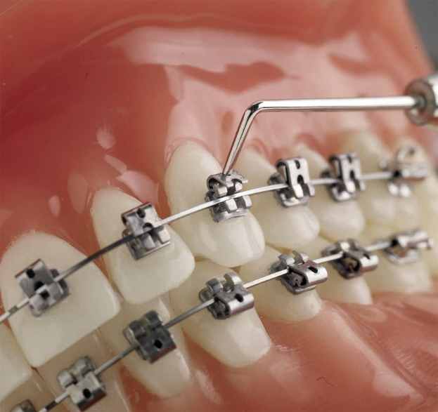 Flair brackets are passive for wires under 0.016 but active for thicker wires

Ricketts? Try vitamin D

EOT. Tooth movement? Orthopaedics? Although Headgear is not used much now it is absolutely wonderful (if the patients wear it) you can forget about anchorage just align the teeth and tell the patients to wear the EOT until the overjet is normal and the buccal segments are perfect and hey presto a perfect result every time. It is a pity that EOT seems to be losing the battle of public acceptability in the UK. Perhaps if all the registrars in orthodontics were to wear headgears all the time it would become de rigueur in smart society. Headgear worn night only is more acceptable but this only supports anchorage you would still need some other active component to reduce the overjet. High forces applied to a large area of the maxilla in an upwards and backwards direction limit the downwards and forwards growth of the maxilla.

Surgery. Maxillary, Mandibular.

Bimaxillary protrusion. Steve Powell favoured radical extractions and pulling everything back I thought it was either brave or foolhardy.

Non-compliance appliances.

Implants and overjet reduction. Mid palatal but difficult to remove. On-plants didn’t really work. TADs ?? a lot of people are using them much less and many of the cases I have seen could have been done without the TADs.

Overjet reduction in high angle cases.

Overjet reduction in patients with gummy smiles & strap like activity of the lower lip during expressive behaviour.

Watkins loop and tube. Closed a diastema and reduced the overjet without loss of anchorage. Now lost in the mists of orthodontic history, but I wouldn’t bother sending out a search party if I were you.

Sandusky arches. Before sliding arches and the Straight wire appliance we had to use closing loops to reduce the overjet. It was not all bad news with the Sandusky loop we had to reduce the overjet, torque and intrude the upper incisors all at once. Try telling that to the young people of today and they just won’t believe you.

Finishing

Finishing with Orthodontics

Once upon a time it was good enough to get the teeth line up with a normal overjet and overbite and then Andrews described his 6 keys. This unlocked the floodgates and now we have more keys than Dartmoor prison. Here are lots.

- Lower incisors should be in the original start position. (Mills)
- Normal overjet.
- Normal overbite.
- Lower incisors occlude with the cingulum plateau of the upper incisors.
- Class I buccal segments. (Andrews)
- Tight contact points. (Andrews)
- No rotations (Andrews)
- Ideal Mesial Inclination. (Andrews)
- Ideal Torque (Andrews)
- Flat occlusal plane(Andrews)
- Centric occlusion coincident with centric relationship. (Roth)
- Shimstock clearance of incisors. (Roth)
- Maximum contact of all posterior teeth in centric occlusion. (Roth)
- Gentle lifting of buccal segments as jaw moves into working or non-working lateral movements (Roth)
- All the anterior teeth touch as the jaw moves into protrusion. (Roth)
- All the posterior teeth gently separated as the jaw moves into protrusion. (Roth)
- The smile line should curve to approximate with the inner surface of the lower lip. (Zachrisson)
- 3.4 mm of the upper incisors should show when the upper lip is at rest in patients under 30. (Zachrisson)
- Perfect upper arch alignment as judged by the incisal edges and palatal surfaces of the upper incisors and the mesio-distal central groove of the premolars and molars. (US board)
- Perfect alignment of the lower arch as judged by incisal edge and labial surface of the incisors and the buccal cusps of the molars and premolars. (US board)
- Marginal ridges at the same height. (US board)
- Ideal root angulation as judged by a panoramic radiograph. (US board).
- Lower incisor tips on or 1mm in front of the APo plane. (Raleigh Williams)
- Lower incisor roots distal to the crown. (Raleigh Williams)
- Apicies of the cuspids should be distal to the crown. (Raleigh Williams)
- Lower incisor apicies must be in the same plane. (Raleigh Williams)
- Lower canine roots must be buccal to the crown. (Raleigh Williams)
- Broad contact points in the lower labial segments. (Raleigh Williams)
- A line from Pogonion through the most anterior point on the lower lip should bisect the lower border of the nose. (Holdaway)
- Lower lip on the Aesthetic plane. (Ricketts)
- Lower incisor positioned on the N-A plane (Creekmore “Radney analysis”)
- Lower intercanine and molar width remains the same
- Lower incisor root in the centre of the cancellous bone. (Ballard)
- Lower incisors at 92º to the mandibular plane if FM angle is 27º.
- Tweed angle is 69º (Tweed)
- Upper incisors at 108º
- Inter-incisal angle 135º.
- Coincident centrelines.
- Upper incisor tip 12 mm behind a vertical dropped from sub-nasale in males 9mm in females Arnetts analysis
- Upper incisor tip 4mm below the resting lip line in males 5mm in females
- Position the lower incisors as MBT suggest using Fastlight’s triangle JCO 2000 34: 353-360. It is more like two triangles formed by the maxillary plane, the mandibular plane, the long axis of the upper and lower incisors and divided in two by the occlusal plane Use a chart to select the correct lower incisor inclination.
- Teeth related to the “Golden proportion”
- Filled buccal corridors.

How do I get a lovely finish on my MOrth cases?
- Stick the brackets on in the correct place & have the correct treatment plan.
- Review when you put the 0.016 x 0.022 NiTi this is the ideal time to replace brackets
- Get the torque right by working into a full thickness wire
- Place a NiTi and reposition brackets
Or
- Revert back to a round steel wire. Now third order bends don’t count so it makes it easier to do finishing bends
Or
- Go for ridged steel wire in the upper and very flexible in the lower (eg braided steel ) and vertical elastics to let it settle
Or
- Debond and fit a positioner
Or
- Upper Hawley or Begg retainer with lower Essix and just let it settle
Or
- Remove the archwire from the buccal segments and use vertical or “Z” elastics
- Or use positioners or pre-finishers Positioners are custom made soft splints constructed to give a perfect occlusion.
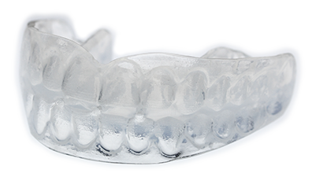
Pre-finishers are made to different widths of teeth and extraction patterns

……………………………………………………………………………………………..

Abstract

Williams R. (1969)
The diagnostic line,
AJO 55, 458 – 476.

Introduction. Williams suggests that our interest in the position of the dentition should be directed at its state of balance with the profile, and that its position after orthodontic treatment should be such that a harmonious soft tissue profile is produced. He felt that many cephalometric treatment norms concentrated on the angulation of the lower incisors relative to a cranial reference plane (the Frankfort plane) as a primary treatment objective rather than the position of the dentition relative to the profile.
Tweed suggested that a correlation between lower incisor angulation and soft tissue balance existed. Unfortunately the norms to which he treated were unrealistic as they were based on dento-cranial relations that were not always attainable, rather than dentofacial relations.
Holdaway, Ricketts and Downs all recognized the importance of lower incisor position on the facial profile but it was apparently impossible for them to ignore the concept of lower incisor angulation.
Downs credited Ricketts with suggesting that the position of the lower incisor to the APog line was important in establishing lower facial balance.
Williams suggested that variation in the final apical base relationship depending on facial type and pattern demanded that the orientation of the lower incisor to the apical base had to be considered. Its orientation did not have to be restricted solely to an inflexible angulation related to a remote cranial plane, the Frankfort plane. He felt that the position of the incisal edge of the lower incisor (LI) relative to APog was the common denominator in individuals who had optimum oral health, function and facial aesthetics but had greatly varying facial types and patterns.

Value of the APog Line.

He felt that there was one cephalometric criterion that was common to all dentitions associated with harmonious and well-balanced lips, and that was the anteroposterior position of LI relative to the APog line.
A and Pog move independently during growth and treatment and Williams felt that to bring LI to the optimal position the orthodontist must be able to anticipate the movement of Pog with growth and the movement of A with treatment.
He states that the angulation of the lower incisor is irrelevant to facial aesthetics or to stability of the dentition. In either treated or non-treated cases with harmonious and well balanced lips, LI will be found to be at or close to the APog line.

Optimum Position of the Lower Incisor. If the lower incisor is positioned too far posteriorly this will create a weak lower lip and a retrusive profile.
If the lower incisor is positioned too far anteriorly this will create a full lower lip and a protrusive profile.

Lower Incisor Angulation. Williams suggests that ‘…the linear anteroposterior position of the lower incisor is what influences upper and lower lip balance, and not the angular attitude. Variations of balanced facial types require a variety of lower incisor angulations’. He demonstrates some cases, relating the angulation of the mandibular incisor to the Frankfort plane (FMIA) and shows that it is irrelevant. Treatment to an FMIA of 68° was once considered a goal of treatment!

Lip Balance and Stability. He suggests that patients with considerable apical base differences can still have lip balance if LI is on or just ahead of the APog line.
He goes on to suggest that this position is a position of stability and that angulation has no effect on stability so angulation of the lower incisor need not be a goal of treatment.
He suggests that a fundamental treatment objective should be what he sees as the ideal position of LI in relation to the APog line.

Diagnosis using the APog Line. Williams goes on to suggest that there are 5 tests that can be used to see if a case can be treated non-extraction to the ‘ideal’ lower incisor position. If the case fails to meet all 5 of the criteria of the tests then he suggests that arch length reduction by extracting will be required.
The 5 tests were:
1. Should the lower arch be crowded, will alignment of the teeth relocate LI too far ahead of APog
2. Will flattening of the Curve of Spee in the lower arch move LI too far ahead of APog? He quotes a calculation by Baldridge.
3. Will correcting the molar relationship consume so much lower molar anchorage that LI is moved too far ahead of APog?
4. In an effort to reduce apical base differences towards a normal range, will the posterior bodily retraction of the upper incisor which induces the posterior movement of A consume so much lower molar anchorage that LI is moved too far beyond APog?
5. Will a precocious mandibular growth carry Pog so far forward as to leave A behind, relatively speaking, and allow LI to be transported too far ahead of APog?
If the case passes all 5 tests Williams suggests that it could be treated non-extraction. Should the diagnosis suggest that extractions are required, the degree by which it fails gives an indication as to which of 3 reliable variations in extraction site is available, first permanent molars, first premolars, or first premolars and first permanent molars.
He then goes on to state that a knowledge of the potential anchorage values of the various teeth is necessary if one is to make the correct decision as to which teeth to extract’. Potential anchorage values being related to root surface area.

- There are many different facial types with harmonious soft tissue profiles and lip balance.
- The common cephalometric denominator for a harmonious soft tissue profile and lip balance is the position of LI relative to the APog line. Positioning too far forward of APog makes a protrusive lower lip and too far back makes a retrusive lower lip. To create well-balanced lips, the optimum position is on or near the APog line.
- The influence of variations in the apical base difference on soft tissue profile and lip balance is well compensated for by placing Li on or near the APog line.
- Whether a case should be treated extraction or non-extraction is determined by a series of 5 questions.
- Differential arch-length adjustment provides the latitude needed in the treatment of various skeletal patterns to position the dentition appropriately to the soft tissue profile and thus create harmonious balance of upper and lower lips.
- The distribution of relative root surface areas of the teeth between the anterior and posterior segments of the dentition will determine the site of extraction that, for treatment purposes, will result in soft tissue profile harmony and balanced lips.
- The influence of the lower incisor position on upper and lower lip balance is significant. The apical base may vary considerably from the normal range and the angulation of the lower incisor may fluctuate, but LI must lie at or near the APog line to create upper and lower lip balance. The angulation of the lower incisor to a cranial landmark is immaterial to either facial aesthetics or stability. The angulation of the lower incisor, therefore, is not a criterion of successful therapy, nor is it of diagnostic interest.

Just a word on golden proportions.

Take a line and divide it into two a larger part and a smaller part so that the ratio of the smaller part to the larger part is the same as the ratio between the larger part and the whole line and you will find the larger section is 0.618 of the whole line and the smaller part is 0.618 of the larger part. Or if you prefer the larger part is 1.618 times the smaller part

Dental Proportions
I found this: “The width of the central incisor is in golden proportion to the width of the lateral incisor (as seen from the front), which in turn is in golden proportion to the part of the canine that is visible from the front.
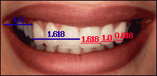 |  | The dark space between the corners of the mouth and the outer surface of the canines during a smile (blue line 1.0) is called negative space. The negative space is in Golden Proportion with one half of the width of the upper anterior segment (blue line 1.618).
Even though the negative space escapes the attention of the public, it cannot be ignored. It creates a balance between cohesive and segregative forces in a smile and provides a harmonious relationship between the smile and other facial features. This example indicates that some fundamental principles are more easily perceived than others.
The presence of a lateral negative space gives depth and mystery to a smile, while its absence displays exuberance and brilliance paired with functional disturbances.”
I would comment but the segregative forces have prevented me.

The Fibonacci Series
No consideration of the golden proportion can be complete without the mention of the Fibonacci Series (after Leonardo de Pisa. Fibonacci means “son of good nature”), which is a complementary view of the golden proportion. In this number series, each term is the sum of the previous two terms as follows:
0 1 1 2 3 5 8 13 21 34 55 89… and so on.

The division of any two adjacent numbers yields the extraordinary golden proportion (also known as the golden section, divine proportion or the phi (φ) value) e.g., 34/55 = 0.618 or inversely 55/34 = 1.618.

Oh well, so that is that. Trouble is that you can find ratios everywhere you look for example I am 72 inches tall; if you multiply this by 0.618 you get 44.3 inches which is exactly the distance from my knees to my shoulder; if you multiply this by 0.618 you get 27.5 the exact distance from my shoulder to my finger tip; if you multiply this by 0.618 you get 17 inches the distance from my elbow to my finger tip; if you multiply this by 0.618 you get 10.5 inches (and I think it is time to stop there don’t you)
The point is it is not difficult to find an approximation to the golden proportion if you just look around, and in something as variable as the body with differing views [after all beauty is in the eye of the beholder]. In particular the size of the teeth seem to [approximately] follow the golden proportion when viewed from the front in a photograph. But so would the bricks in a round tower if viewed from one point. So what you are saying is the front of the arch is curved. [Big deal Leonardo]
Rosemie et al 2006 concluded dental attractiveness was not related to the Golden proportions

Egle Onga, et al in 2005 agreed so the message is

Your smile should be
- Big
- Wide
- White
- Not too much gum
- Curved in the line of the lower lip

Fixed appliance 1-3 True or false questions
Question 1
- Gold cannot be soldered
- Gold cannot be welded using an electric spot welder
- When welding steel with a spot welder you must use fluoride flux
- When welding steel the copper electrodes should be as large as possible to reduce resistance

Question 2
- Charles Tweed advocated non-extraction treatment
- Charles Tweed was trained by Edward Angle
- The Tweed typodont course recommends Roth brackets
- The Tweed typodont course is still held every year
Question 3
- Andrews straight wire was developed in 3 sets developed to deal with different incisor classifications.
- Andrews brackets had different canine brackets and premolar brackets for extraction cases
- Andrews brackets exactly reflect his measurement of 120 untreated cases
- Andrews’s brackets were cast in gold.

Question 4
- Roth suggested that RCP should be the same as Inter-cuspal position
- Roth suggested that every tooth should touch in centric occlusion
- Roth suggested cusp to fossa occlusion
- Roth advocated the use of Pre-finishers

Question 5
- The Ricketts technique is also called light wire
- The Ricketts technique is also called level anchorage
- The Ricketts technique used a deep slot bracket
- The Ricketts technique is now available pre torqued and pre-angulated.

Question 6
- MBT uses reduced tip because they believe the cartwheel effect does not exist
- MBT do not believe in the LA point
- MBT do not believe in archform
- MBT don’t believe in lacebacks

Question 7
- MBT suggest putting in steel wires with a reverse curve of Spee in the lower arch.
- MBT suggest putting in steel wires flat first before putting in a reverse curve of Spee
- MBT suggest putting in steel wires with reverse curve of Spee and reverse torque on the incisors.
- MBT suggest putting in steel wires with a reverse curve of Spee extended back to the 7s

Question 8
- Upper lateral brackets should be swapped left to right when the laterals are instanding
- Lower canine brackets should be swapped left to right in class III camouflage cases
- Roth canine brackets should be placed upside down on canines when they are in the lateral incisor position
- MBT lower second molars may be placed on upper first molars when treating to class II molars

Question 9
- In 1642 Galileo died giving birth to Isaac Newton
- Isaac Newton invented the cat flap
- Isaac Newton wrote backwards
- Isaac Newton was in charge of the royal mint

Question 10
- Increased anchorage can be achieved by pushing the roots into the cortical plate
- Anchorage preparation is part of the Tweed technique
- Baker anchorage is a part of the Begg technique
- Differential anchorage is part of the Begg technique

Question 11
- A lingual arch can be used to correct crossbites
- A lingual arch can be used to correct scissor bites
- A lingual arch can be used to burn up space in the lower arch
- A lingual arch can be used as a space maintainer

Question 12
- Starting with a URA saves money
- Starting with a URA tests cooperation
- Starting with a URA is popular with patients
- Starting with a URA can assist bite opening

Answers (incorrect answers in red)
Question 1
- Gold cannot be soldered
- Gold cannot be welded using an electric spot welder
- When welding steel with a spot welder you must use fluoride flux
- When welding steel the copper electrodes should be as large as possible to reduce resistance

Question 2
- Charles Tweed advocated non-extraction treatment
- Charles Tweed was trained by Edward Angle
- The Tweed typodont course recommends Roth brackets
- The Tweed typodont course is still held every year
Question 3
- Andrews straight wire was developed in 3 sets developed to deal with different incisor classifications.
- Andrews brackets had different canine brackets and premolar brackets for extraction cases
- Andrews brackets exactly reflect his measurement of 120 untreated cases
- Andrews’s brackets were cast in gold.

Question 4
- Roth suggested that RCP should be the same as Inter-cuspal position
- Roth suggested that every tooth should touch in centric occlusion
- Roth suggested cusp to fossa occlusion
- Roth advocated the use of Pre-finishers

Question 5
- The Ricketts technique is also called light wire
- The Ricketts technique is also called level anchorage
- The Ricketts technique used a deep slot bracket
- The Ricketts technique is now available pre torqued and pre-angulated.

Question 6
- MBT uses reduced tip because they believe the cartwheel effect does not exist (because alignment is with round wire)
- MBT do not believe in the LA point
- MBT do not believe in archform
- MBT don’t believe in lacebacks

Question 7
- MBT suggest putting in steel wires with a reverse curve of Spee in the lower arch.
- MBT suggest putting in steel wires flat first before putting in a reverse curve of Spee
- MBT suggest putting in steel wires with reverse curve of Spee and reverse torque on the incisors.
- MBT suggest putting in steel wires with a reverse curve of Spee extended back to the 7s

Question 8
- Upper lateral brackets should be swapped left to right when the laterals are instanding
- Lower canine brackets should be swapped left to right in class III camouflage cases
- Roth canine brackets should be placed upside down on canines when they are in the lateral incisor position
- MBT lower second molars may be placed on upper first molars when treating to class II molars

Question 9
- In 1642 Galileo died giving birth to Isaac Newton
- Isaac Newton invented the cat flap
- Isaac Newton wrote backwards
- Isaac Newton was in charge of the royal mint

Question 10
- Increased anchorage can be achieved by pushing the roots into the cortical plate
- Anchorage preparation is part of the Tweed technique
- Baker anchorage is a part of the Begg technique
- Differential anchorage is part of the Begg technique

Question 11
- A lingual arch can be used to correct crossbites
- A lingual arch can be used to correct scissor bites
- A lingual arch can be used to burn up space in the lower arch
- A lingual arch can be used as a space maintainer

Question 12
- Starting with a URA saves money
- Starting with a URA tests cooperation
- Starting with a URA is popular with patients
8. Starting with a URA can assist bite opening

