Clinical Tips
1 Single tooth torquing auxilliary
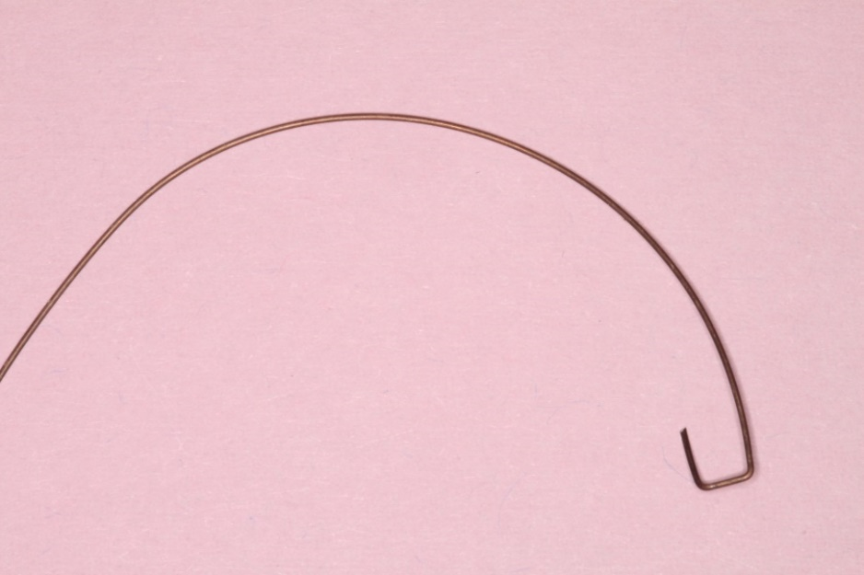
1. Bent in 0.014 resilient wire it will provide torque in either direction.
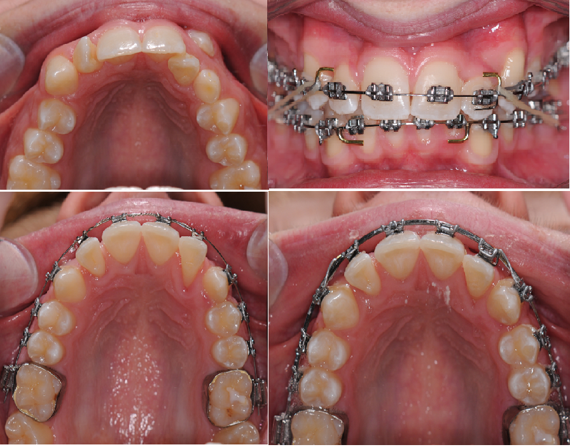
Fig
1 instanding upper left lateral.
2 archwire in place with a single tooth torquing auxiliary set to move the root Labialy.
3 showing excessive lingual crown at the placement of the TA.
4 after 12 weeks
2. Helen Taylor
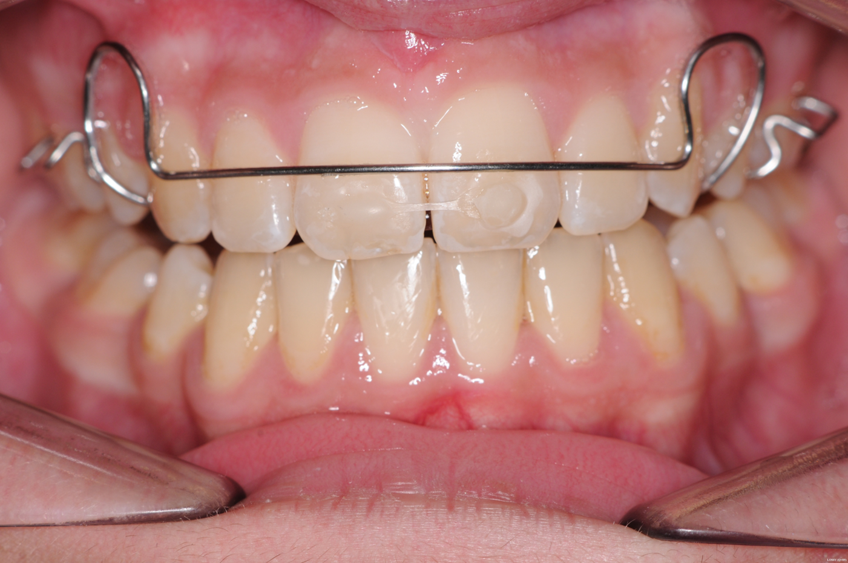
A common problem is a diastema that reopens during retention if this happens
1. Fit a Hawley retainer which must be worn at least 12 hours a day (to stop the incisors rotating)
2. Etch and bond clear chain (under Tension) to the centrals.
3. After a week the diastema will have closed place a PBR if you wish you can change to a pressure formed retainer.
3. Intruding incisors for gummy smile and extruding incisors to treat AOB
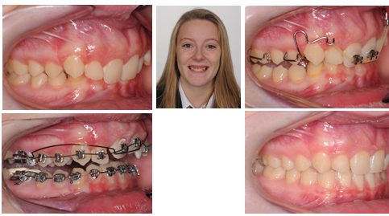
Simple URA and an elastic (You need a very light force.)
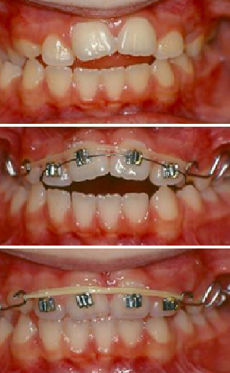
Of course it works just as well up the other way.
4. Correcting a tipped occlusal plane.
A simple URA try night only to start but be prepared to increase the hours a bit
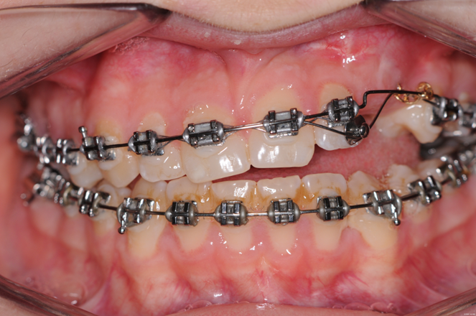
Pulling down the upper left canine tends to lift all the teeth this side.
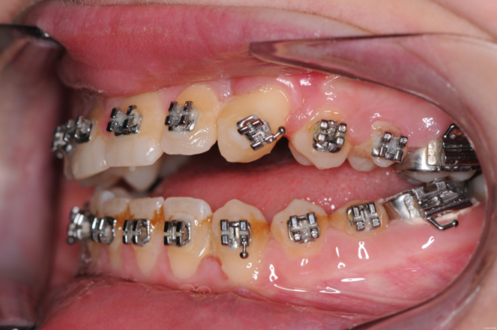
.
The canine is through but the occlusal plane has tipped
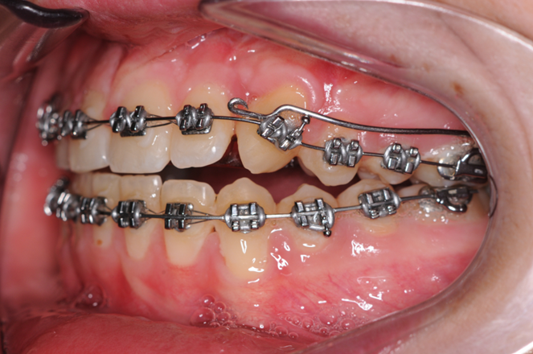
A simple URA with cribs on 7s and a long arm it presses on the canine
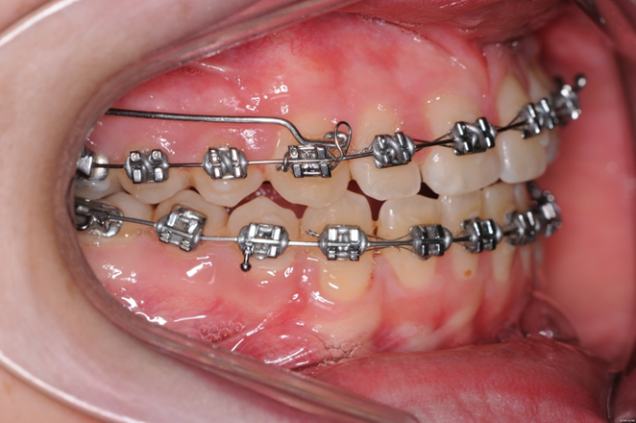
And it pulls the canine to a level occlusal plane.
5. Modified Pedro mechanics (A useful way of closing space.)
Teeth tip easily and NiTi wires are magical at uprighting the tipped teeth.
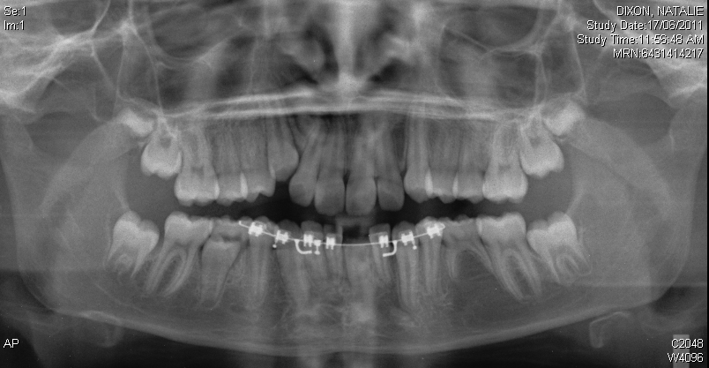
Missing lower left second premolar.
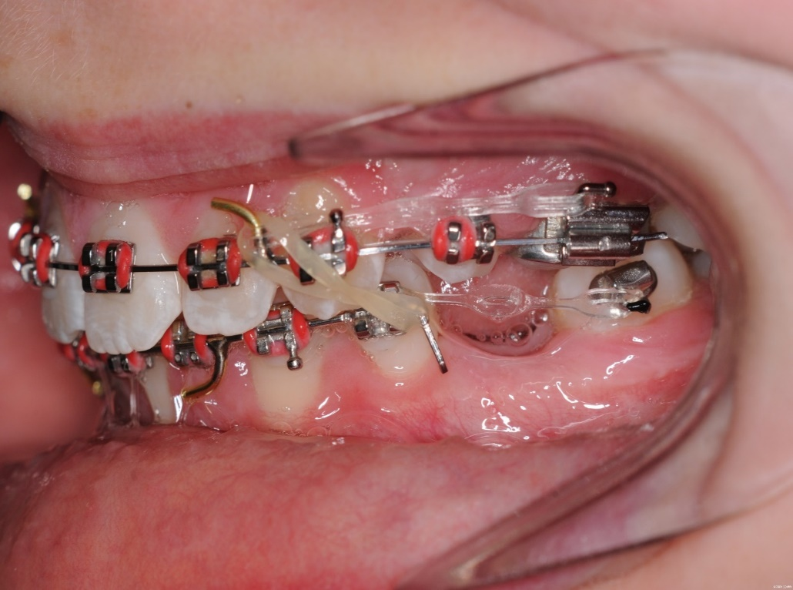
Tip the molar forward with elastic chain on the buccal and lingual
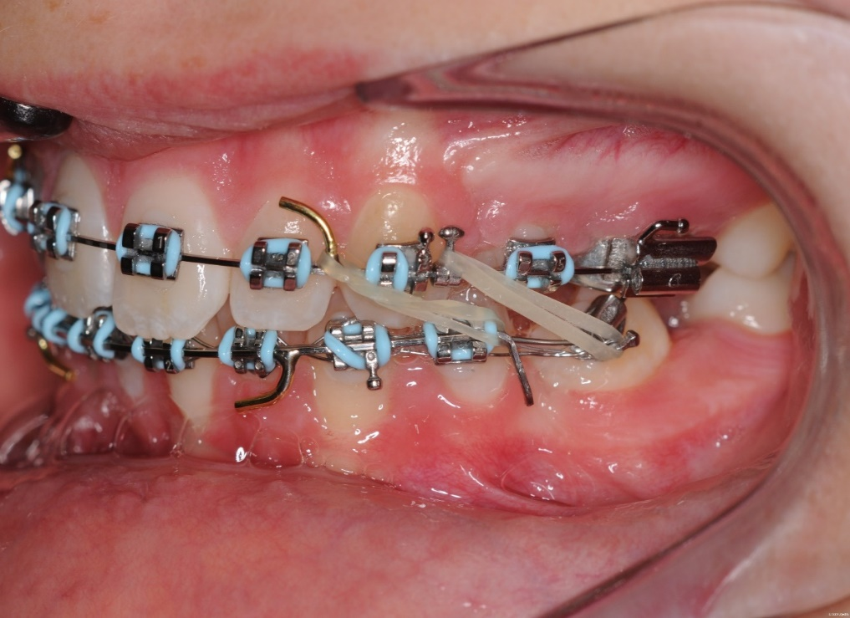
When the molar is tipped forward, tie 6-6 and use NiTi to upright he molar. Note the double short class II elastics preventing drop back of the molar.
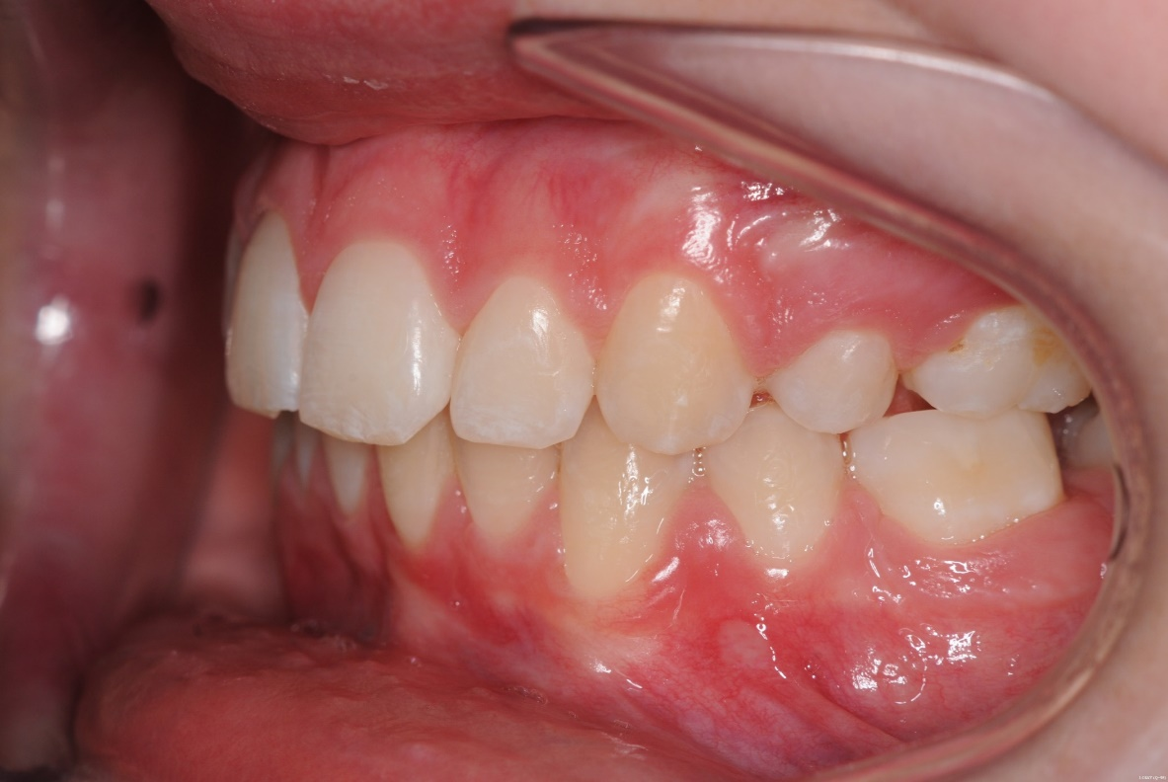
Molar uprighted
6 Racebacks.
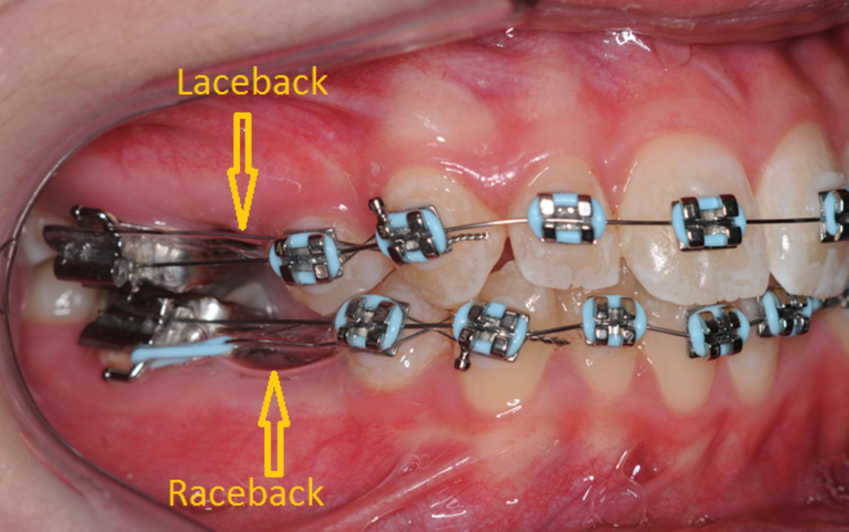
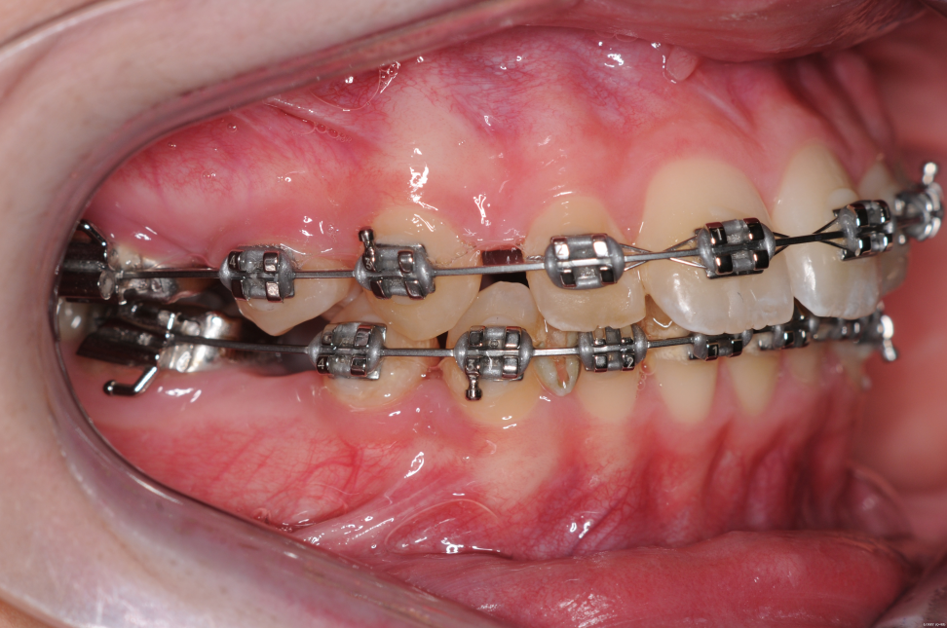
A laceback with a module, Use it where you have excess space in the lower jaw and crowded incisors. Try it this works very well.
7. The split Essix retainer

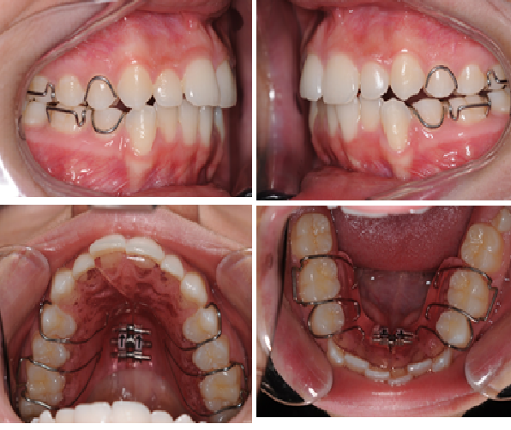
First make space either by stripping or expansion plates
Then cast models cut off the teeth that are out of line and reposition put down two splints for each jaw
And with a scalpel cut one for each jaw from 3-3 along the incisal edge
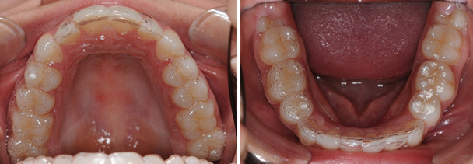
Wear the split ones full time for 2 weeks and the un-split ones for a further 2 weeks.
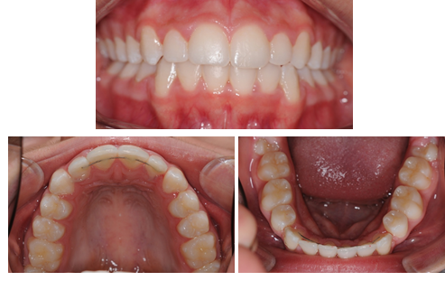
Place a PBR and make new retainers. Decrease wear by one hour a day until you get to 8 hrs.
8 Closing an AOB with upside-down counterforce
Warning do not use in cases with a gummy smile
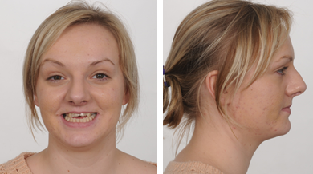
AOB with reduced incisal show
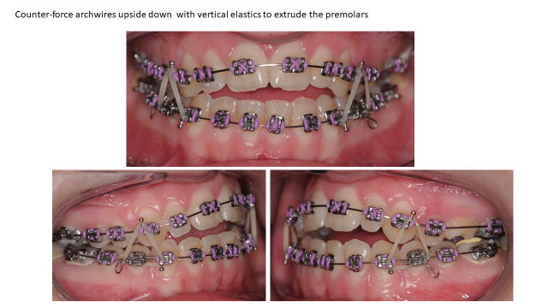
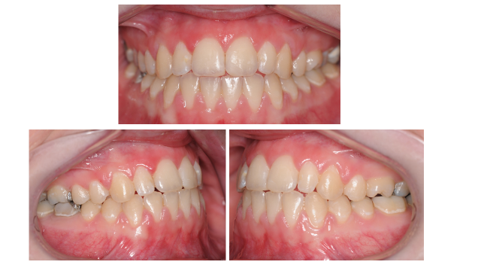
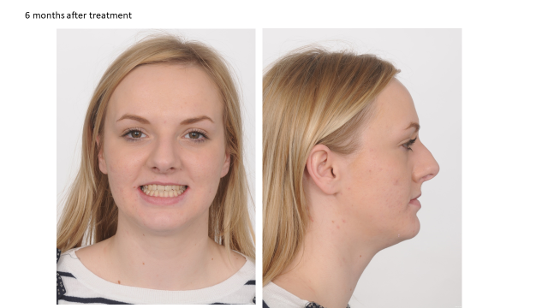
No magic here just patients Will wear elastics in the premolar region but will not wear elastics in the incisor region. Do not confuse this with Kim mechanics where counterforce arches can be used the right way up and strong vertical elastics plus molar extractions.
9. Magic Ballista
See the wire bending chapter 18. It opens the space, brings down the canine and moves it to the middle of the space all in one go. Only use on palatal canines.
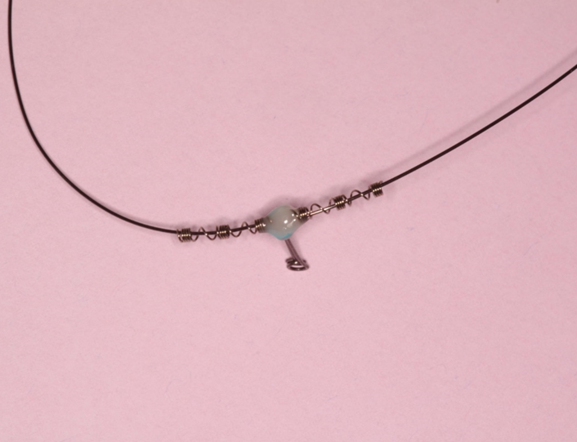
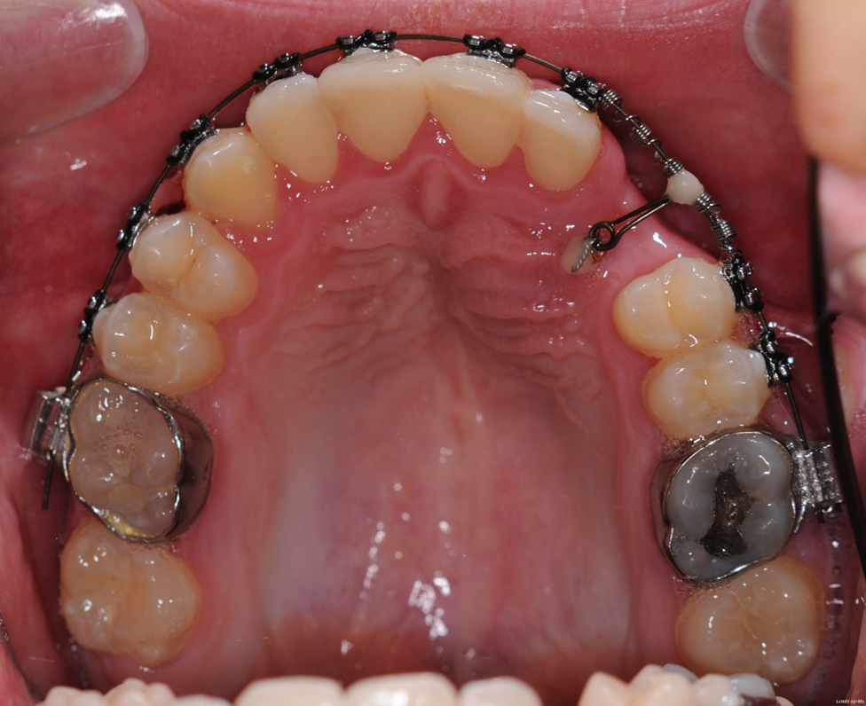
10 Cement on 7s to open the bite
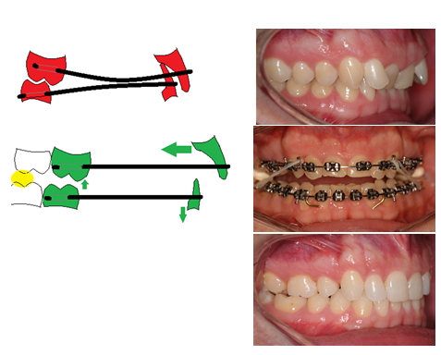
Don’t curve the wires it alters the torque and tip. Don’t be fooled by people telling you that GOOD orthodontists always bond the 7s early. Open the bite by placing a ball of cement on the 7s until the overbite equals zero and then use class II elastics. Cement on the 6s frees the bite but when you remove the cement the overbite returns (unless it is a 13 year old and the 7s are erupting)
11. Use 0.018 slot brackets
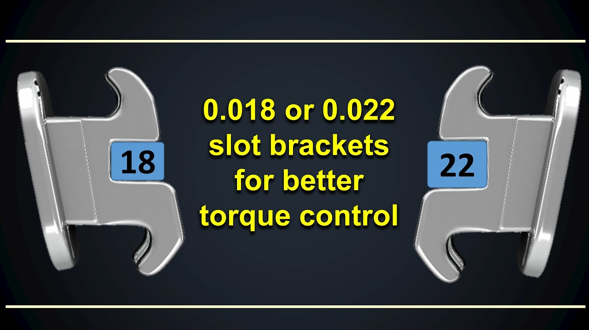If you are choosing your own brackets use 0.018 slot
Start with 014 NiTi
Then 16 x 22 Niti
16 x 22 steel is your working wire
18 x22 can be used if you need full expression of torque
18 x 25 can be used as a surgical wire
You will find all your treatments are quicker

