Chapter 16 The three “R”s Retention Relapse and retreatment
With thanks to Aarti Mehta once an excellent registrar at Birmingham, now an excellent specialist orthodontist; for pointing out that like most teachers I am better at telling people what to do than the reason why they should do it. (Rather too late now, but here is an 810-page explanation)

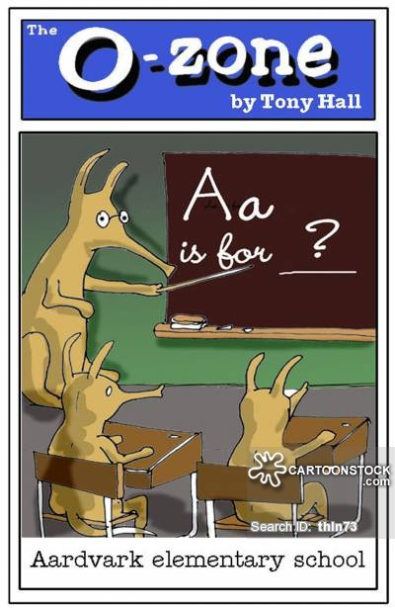
Aarti the aardvark at Aardvark elementary school in Arkansas

Causes of relapse a-z
- Movement out of the zone of stability (inter-canine width, inter-molar width, Gould and Picton, Mills.) Also, Reidel 1969 commented on the stability of the inter-canine width and inter-molar width. This was later confirmed by De la Cruz 1995 and Burke 1998. However, a little increase in the lower inter-canine width may be stable in deep overbite cases Shapiro 1974. In RME cases where the expansion is maintained. Sandstrom 1988 suggests that 1.1 mm of increase in inter-canine width may be stable.
The most constant is the lower inter-canine width if you increase this be prepared for late lower incisor crowding when the patient stops wearing their retainers. This is also the result if the lower incisors are proclined ahead of their start position unless they had previously been retroclined by, for example, a thumb sucking habit or a lip trap. A class II division ii malocclusion with a deep bite may be associated with a holding back of the lower labial segment during forward growth of the mandible from ages 8-16. If this has happened then it is likely that some proclination of the lower labial segment may be stable especially if the upper incisors can be intruded (Selwyn Barnet).

- Rotation and periodontal fibres, (Edwards, Pinson)
The Edwards paper is a real classic. Tattoo some spots onto the gingival rotate the tooth and the spots move round. Hold the tooth and the spots stay where they are carry out a “Pericision” and the spots return to their original position. Couple that with the work of Reitan showing that most fibres in the periodontal ligaments reform in less than a year (245 days) but that the elastic oxytalin fibres are very slow to remodel. So, for some years we did a lot of pericision. Did it stop relapse of rotations? No. Did it reduce the amount of relapse? Perhaps, but this means you are still best to place a bonded retainer and leave it there many years. Would the Oxytalin fibres have reformed by then anyway? Perhaps. But the real clinch is “Informed Consent”
Would you like me to give you an INJECTION into your gums with a NEEDLE and then CUT around the tooth with a SCALPEL and this might reduce the chance of relapse, but I am still going to bond a retainer so the tooth will not relapse even if I don’t do it?

- Occlusal forces (e.g. crowns on upper incisors). We have all done it, cut a crown prep on an upper central and not trimmed enough off the palatal. So, the crown is too thick and the incisal guidance is wrong and it causes tooth movement. Either the upper moves forward or the lowers crowd and move back

Growth (Behrents) yes, the mandible grows forwards and the lower incisor s upright and yet again this causes lower incisor crowding. Class III cases may relapse because of further growth. The good news is that class II cases can get better.

- Overbite instability part1 extrusion of molars (Reidel, Houston, Schudy Angle orthodontics 1968 38 p19, Bjork, Nanda) So here is the story: In growing individuals you can open the bite by extruding the molars or just allowing them to erupt by preventing the patient biting on them (for example, with an anterior bite plane) in non-growing individuals you must not do this but you must intrude the incisors. Please remember to tell this to the examiners in MOrth and say it is in all the textbooks and that they usually cite Bill Houston or Arne Bjork or Schudy. The last paper is interesting because it says no such thing it deals with 11-14 year olds. Houston certainly implies that if you increase vertical dimension in adults the face height will tend to return, but this is not the same as overbite. Consider this; you open the bite in an adult with some extrusion of the molars and you fit Essix type retainers and the patient wears them every night for a couple of years. Will the curve of Spee return to its original so that the retainer fits at the back and on the lower incisors but not in the premolar region? I think common clinical experience would give a large NO to that. Will the overbite relapse if the patient is wearing upper and lower Essix retainers? NO again. Will the face height return to its original? Well very often it does, but that is a good thing isn’t it?

- Overbite part 2, inter-incisal angle. If you don’t want to retain, inter-incisal angle is an important thing when it comes to controlling overbite. The higher the angle the more likely relapse of overbite is to occur. And relapse of overbite is related to an increase in lower incisor crowding. Notice how this can be related to proclination of the lower incisors. 1. You procline the lower incisors this reduces the inter-incisal angle and reduces the overbite. 2. You neglect to hold them in that forward position and 3. They drop back increasing the inter-incisal angle, the overbite and the crowding. Note also that his is just the same as looking at the centroid to lower incisor position. Which is just another way of looking at the inter-incisal angle.

- Mesial drift. Back teeth drift forwards and it causes the anterior teeth to crowd up. You can see this in two ways. One is that individuals with no crowding at say 13 go on to develop mild crowding in the late teens and then this continues to increase. The other relates to the work of Bob Little. This shows that cases with crowding treated with extractions and fixed appliances to a more or less satisfactory standard (some people have suggested that the inter-canine width was increased in some cases) showed very significant relapse. This means that crowded cases are more likely to crowd, so you can see crowding as a property of the periodontal membrane rather than a tooth /tissue ratio.

- Effect of 8s (Kaplan)
Many people still believe that pressure from the erupting lower third molars causes late lower incisor crowding. But Kaplan looked at two groups, those with and those without third molars and found no significant difference between the two groups. What does this prove? Well it is not so easy, you see, nobody suggested that third molars would cause crowding if:
- The occlusion was spaced
- The third molars were distally inclined
- They were horizontal
- They were too deep to erupt
So, we need someone to repeat this comparing partly erupted mesially angulated third molars.

- Fraenal attachments
There is a bit of fibrous tissue running between the central incisors, we used to run a bur between the incisor roots. But like pericision the alternative is the palatal bonded retainer.

- Airway
Block the airway and cause mouth breathing and the jaw drops the lips are held apart and the upper teeth can move forward.
Fit a sleep apnea appliance in a borderline class III case and this might reverse the overjet
- Retainers (damage to bonded retainers. The wire is bent and the tooth moves)
I try to make my patients wear removable retainers as well as PBRs because bonded retainers can get bent or the wire can unravel and this can produce unwanted tooth movement.

- Uprighting of teeth
Imagine you have retracted the lower 3/3 but left them distally inclined. They may tend to upright after treatment this makes them move forward and causes lower incisor crowding.

- Extractions (the effect of further extractions)
Loss of posterior teeth can cause increasing overbite and proclination of the upper incisors.

- Extractions the difference between extraction and non-extraction cases (Tweed and others) Just remember that Tweed was so dissatisfied with the instability of his treated cases done under Edward Angles non-extraction dictum that he was going to give up orthodontics as a waste of time. But then he discovered that extraction treatment was (relatively) stable. You need to add that to Bob Little’s finding that crowded cases treated with extractions tend to crowd again and say yes crowded cases treated non-extraction crowd even more.
- Wear although only found in pre-historic aboriginals and elderly orthodontists in Burton on Trent; severe attrition causes spacing of the teeth (a nice change from lower incisor crowding) and as the vertical dimension reduces and they become more class III

- Cuspation (teeth erupting further by cuspal guidance)
Leave the canines a little class II and the lower canines may erupt forwards causing (guess what) late lower incisor crowding

- Difference between centric occlusion and RCP
Important in functional cases you think that you have reduced the overjet to 4mm but in fact it is 6 and the patient postures. Months or even years later they drop back but partial overjet reduction is seldom stable the upper incisors are out of lip control and the overjet increases

- Lip incompetence
If the upper incisors are not under the control of the lower lip the overjet may increase.

- Condylar resorption
Arthritis and sometimes following mandibular advancement. Also, condylar fracture.

- Periodontal disease Periodontal tissue forms part of the equation of balance as tissue is lost a new balance is found and the upper incisors usually procline and space
- Changes in the muscles.
The textbooks show you pictures of cancrum oris. But we don’t get a lot of that in the West Midlands. Bell’s palsy might be a better example also stroke and muscle wasting conditions.

- Restorations
Veneers crowns and broken anterior teeth. Adding to the labial surface of an incisor can make it drop back. If you advice a patient to have a veneer to mask a slightly instanding incisor. Always fit an Essix retainer or it will drop back more.

- Facial maturation. As you get older the lips thin become more taught. As a result the incisors upright and crowd.
- Habits- You may find reports of joiners holding nails between the teeth or dressmakers holding pins. (I think I am scraping the bottom of the barrel don’t you)

- Why does everything cause lower incisor crowding? Oh by the way Z is poorly made removable retainers.
- Tongue piercing, late lip surgery such as the Abbἑ flap

Have a look through the list above and you will see that many things cause late lower incisor crowding:
- Increase inter-canine width.
- Proclination of lower incisor out of the zone of stability
- Occlusal forces
- Growth
- Facial maturation
- Overbite instability
- Mesial drift
- Third molars
- Uprighting of teeth
- Cuspation

Methods of retention
- Hawley
Allows some settling but allows rotations of the anterior teeth to relapse. Because the wire gets pulled away from the teeth.
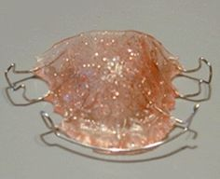
- Hawley but with an acrylated labial bow (nicey but pricey)
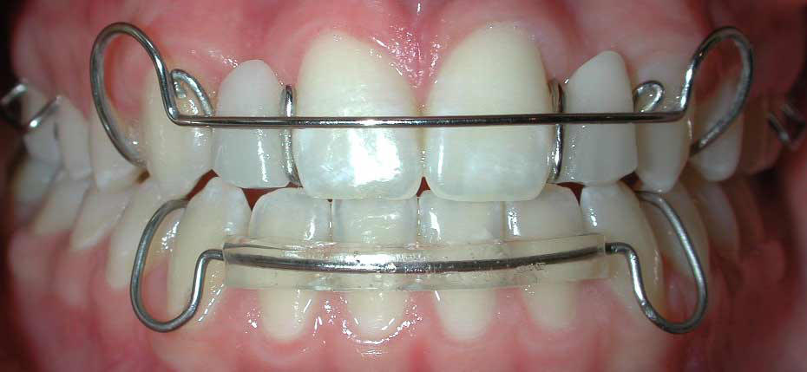
- Essix A C and Ace. Forget all the others the best one is the Ace .030” certainly it is the only one to use if you want to do split trutains
Most popular most comfortable and can be used to whiten the teeth. The only way is Essix.
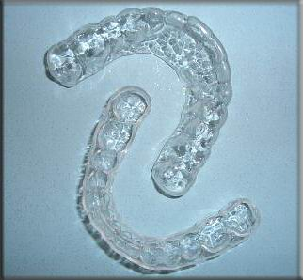
- Pre-finishers
From TP and Orthotain encourage settling but sometimes allows spaces to open
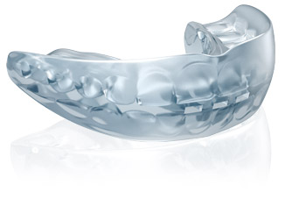
- Positioners
Expensive, not much liked by patients and you need a skilled technician. But when they work the results can be fantastic. I would limit them to 10 weeks and then change to Essix retainers. It’s not fair to ask patients to work so hard with a horrible appliance when the teeth have fully settled.
- Begg retainers
Allow settling and can close space but can be too loose
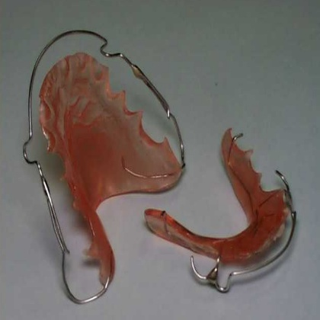
- Begg retainers with c clasp on the 7s
Better than a Begg retainer because the retention is better
- Lower 3-3 retainers
In the olden days when men were men and Bond just meant 007 we had bands on lower 3/3 and a sort of mini lingual arch to try to hold the lower incisors they were not very good and did not hold the overbite so why would you want to use one nowadays? There is a version with pads on the canines and it is bonded.
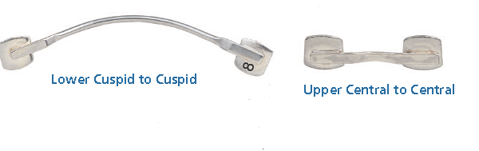
But they are just silly! The lower incisors can still rotate or move labial
There is a version that has a pad on every tooth
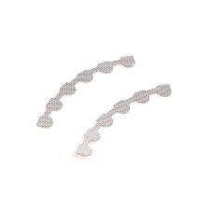
But as it doesn’t flex when individual teeth are loaded they tend to fall off
Also band with wings (Ye olde orthodontics)
- Lingual/palatal bonded retainers
Twistfex shaped for rotations or annealed if you just want to hold a diastema shut. Be aware that they can get bent out of shape or the end can unravel causing unwanted tooth movement so always use an Essix as well.
Special white gold chain. If you use this remember you must extend it at least one tooth past the rotated tooth.
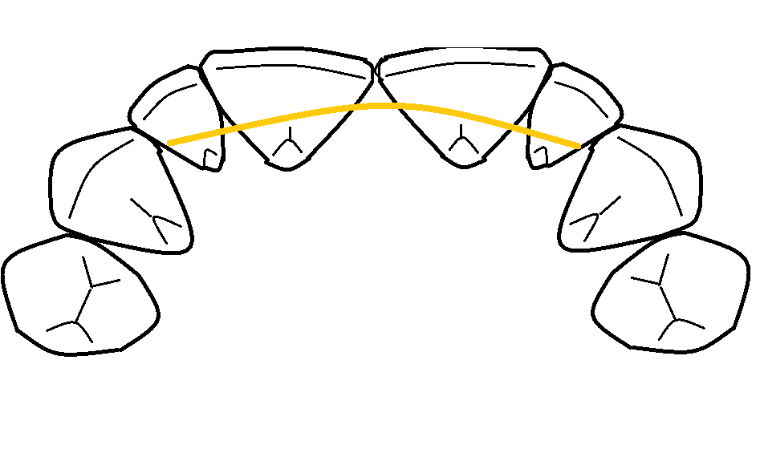

Twist flex type wire
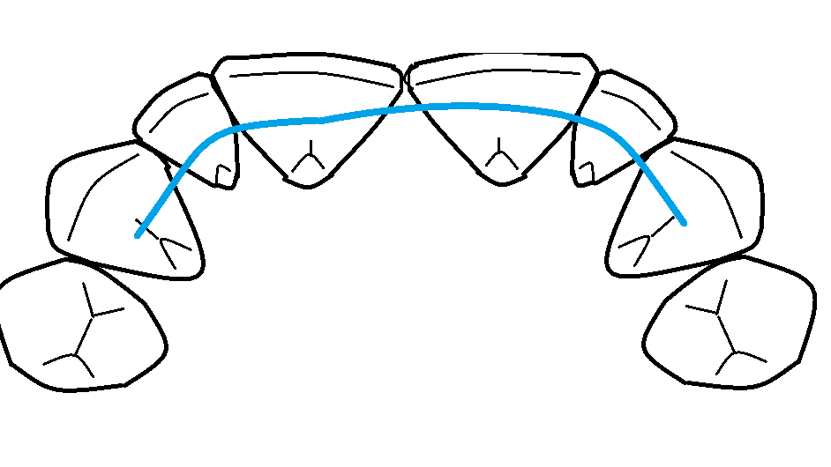
Annealed twist flex (I heat it over a cigarette lighter) to hold rotated laterals must be extended one tooth past the rotated tooth. Clearly as the wire is annealed and dead soft there is no need to bend it accurately. (At the dental hospital you are encouraged to use thick wire I disagree I use thin CO-axial multistrand 0,0155 it costs about £20 for 2 metres of wire which makes a lot of PBRs)
The same is true of the steel braided wire, which is OK but a bit expensive
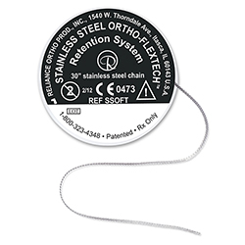

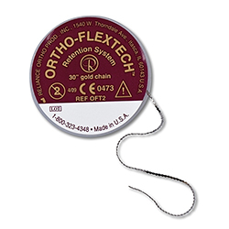
I am not such a big fan of the gold version it stretches and gaps open and it costs a lot
After you have bonded a PBR don’t forget to check with articulating paper
- No retainers (teeth over the bite, pulling down teeth, post thumb sucking, driftodontics)
- Partial Dentures can be used to hold teeth in patients with spaces
- If the patient is wearing a partial denture in the day make an Essix with a tooth in it for night wear.
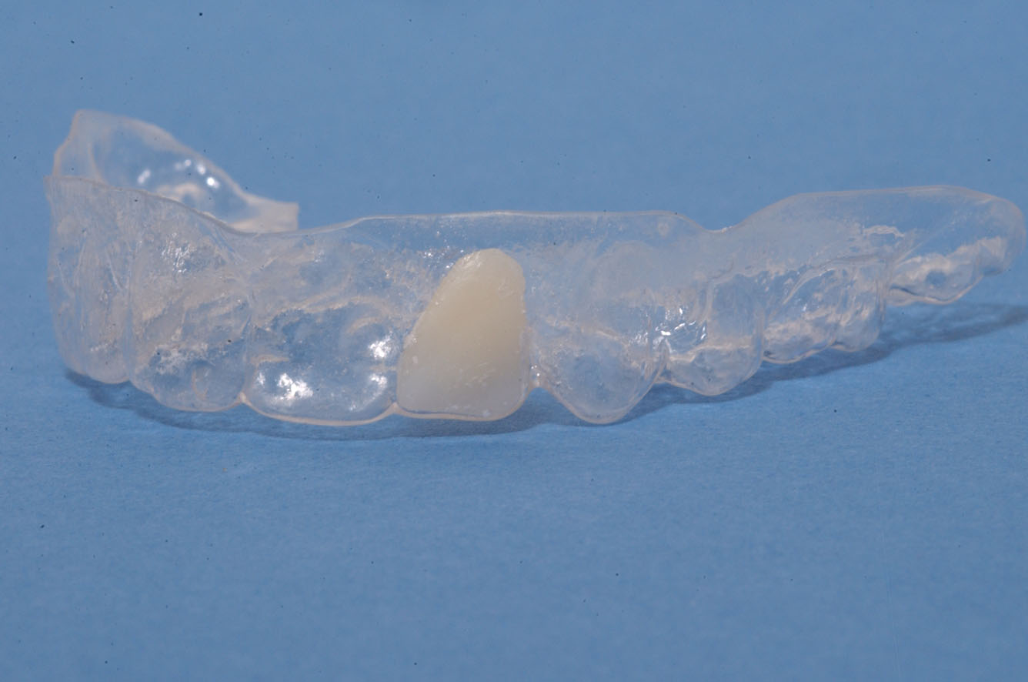
In my opinion this type of retainer is not strong enough for day time wear except for 2 weeks maximum.

How much should the patient wear removable retainers?
You are perhaps looking for Littlewood Cochrane database “insufficient research to base best clinical practice.
Or Shawesh 2010 night only works as well as full time EJO.
My views night only for a year and then every other night for a month and then 1 or 2 night per week for a further 5 years. Plus a possible 1 night per week for ever if they really want to be sure.

A contract of retention
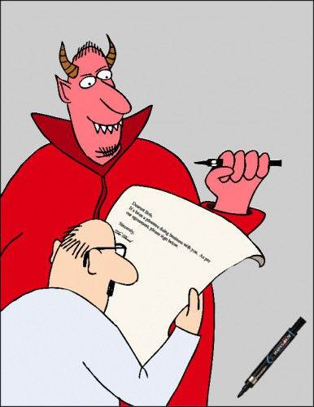
Oh yes we do. In Burton every patient signs a copy of the instructions for retention and we charge for lost retainers
The problem with bonded retainers
1. If they are not passive or annealed they will move the teeth
2. Even if they are bent correctly if the patient eats something hard they may bend and move the teeth.
3. They can fall off are you going to be “on Call” to replace them?
4. If the patient has a removable retainer and does not wear it as prescribed and the teeth move it is the patients fault BUT if the patient has a bonded retainer fitted by you and the teeth move it is your fault
So never rely on bonded retainers only always have an additional vacuum/pressure formed retainer worn one night per week+
5. If calculus builds up on a lingual bonded retainer (it tends always to be the lower) and there is perio-damage it is the orthodontist fault unless he has a letter from the GDP or a Periodontologist accepting the responsibility of looking after the teeth. Just telling the patient to ask their dentist is not enough.
6. John Bennet says he makes more from the hygienist servicing the PBR/LBRs than from doing the orthodontics BUT if you plan to do this it is ethical to tell the patient first that post treatment they have to come every few months for a scale and polish and they will be charged
For a paper on tooth movement with bonded retainers Laursen JCO 2016 p261 & Katsaros AJODO 2007 look at their references there are lots of case reports

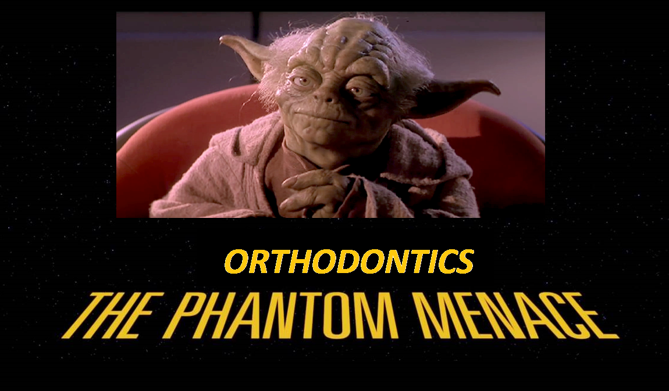

Spary tutorials, rubbish they are. A prequel, needed it is.

Yoda is right!
We are talking about retention but we haven’t talked about debond yet so here is a prequel:
- For molar bands use band removers but if the band does not come off easily use a high speed drill and cut through the band on the lingual/palatal side you will find it quite easy to cut through to the cement without touching the enamel. This is especially important if the tooth has a large restoration.
- Metal brackets except Dentauram Discovery

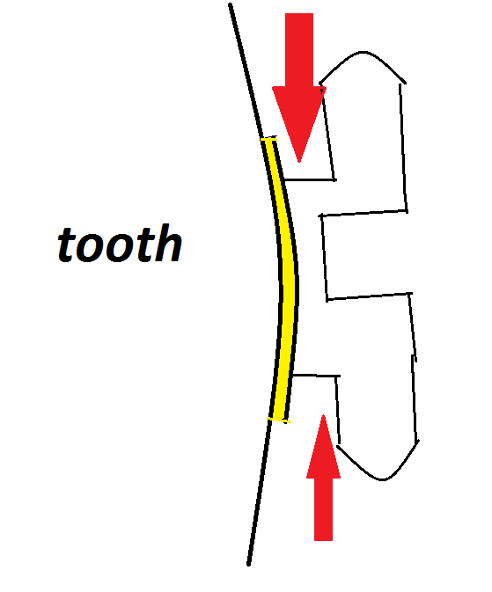
The metal of the bracket is soft and will bend the surface of the tooth will not so squeeze the bracket with bracket removing pliers and twist a little at the same time and the bracket just falls off.
- Discovery brackets
These stick on so well that you are in danger of damaging the tooth if you use a conventional method but they have a vertical groove within them so you need to remove the archwire and squeeze the bracket from side to side and the bracket falls off easily.

- Ceramic Clarity brackets. Like discovery these have a vertical weakness so you remove them by squeezing them from side to side. There are special pliers that help you to do this. You must hold the pliers at 90° to the surface of the tooth or the bracket will only come half off and you will need to go to section 6.

5. “In view” ceramic brackets are a TP product that has a plastic base it is easy to take off but falls off too easily. You must use their adhesive.

6. Other ceramic brackets can be a swine to remove. Starfire a beautiful clear bracket was so difficult to remove that a lot of teeth got broken and the product was removed from sale. If the manufacturer advocates a special pair of pliers you must use it. Otherwise:
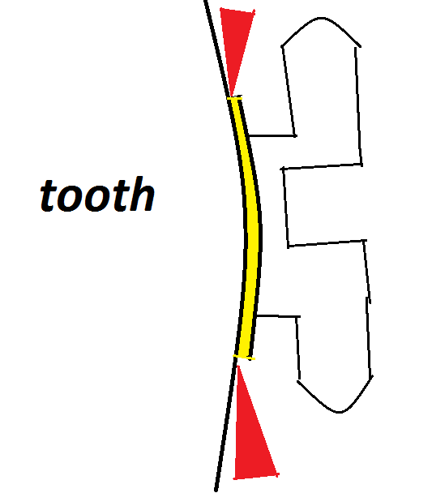
Squeezing the bracket won’t work. You need to get the bracket removers right on the edge. Wear glasses if the bracket shatters it can fly into your face.
If it does shatter use a high speed drill and a diamond bur and a water spray and thin it down to a 1mm layer then use a sonic scaler and spray run over it the ceramic will go black remove this with the diamond bur and repeat until the ceramic is all gone. If a lot of brackets fracture it can take a long time (buy clarity)
7. Plastic brackets, no problem they will already have fallen off.

Getting rid of the glue
YOU DON’T NEED TO GET RID OF IT ALL AT THE DEBOND VISIT. I suggest:
- Use a fine fluted bur in a high speed handpiece with no water spray and remove the big lumps of adhesive.
- A fine fluted bur in a slow handpiece but at quite high speed and very light pressure
- Polish the teeth with prophy paste
- Tell the patient there will be some adhesive left on the teeth but if they brush well some will come off the rest you will remove after 12 weeks
- At the 12 week appointment the teeth will be less tender use a fine fluted bur with a little more pressure.

What to do if there are marks on the teeth
- Tell the patient and the parents
- Tell them some of the marks may be residual glue and even the decalcification may reduce by 60%
- Be careful to use light pressure or you will abrade the teeth
- Advise good brushing but not topical fluoride
- Restore frank cavities or find a colleague who will
- After 3 months provide some tooth mousse (Calcium Caseinate)
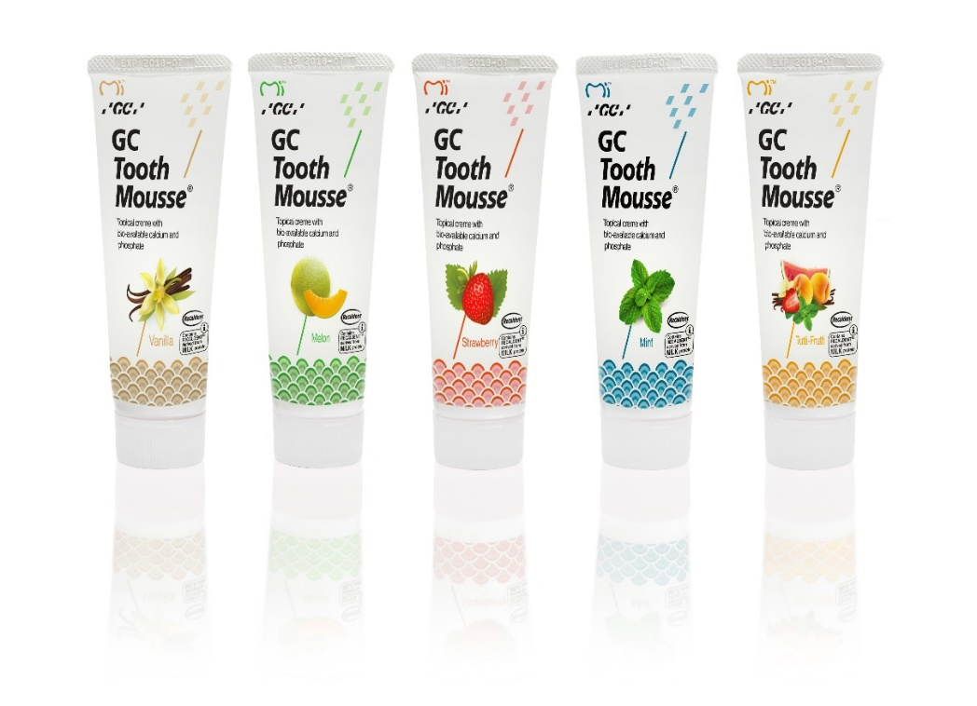
Rub it on the teeth with a finger before placing the retainers
- Consider whitening the teeth this doesn’t remove the white patches but does make them less obvious
DON’T
Tell the patient it is all their fault they should have listened to the advice given. If you do you will be sued.

Dealing with post treatment change
- Split trutains
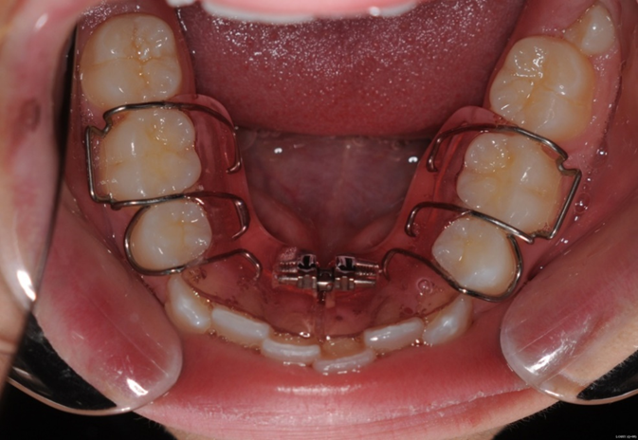
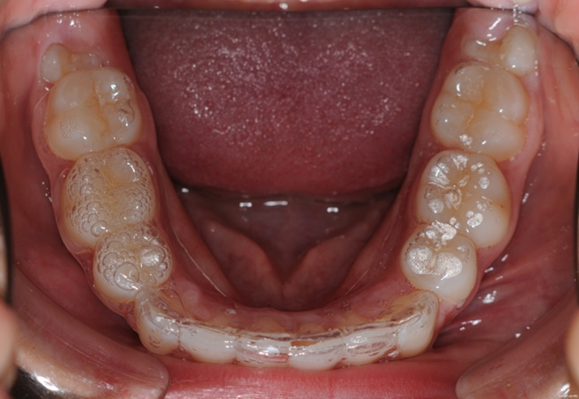
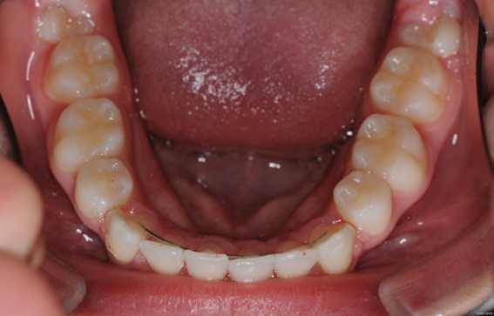
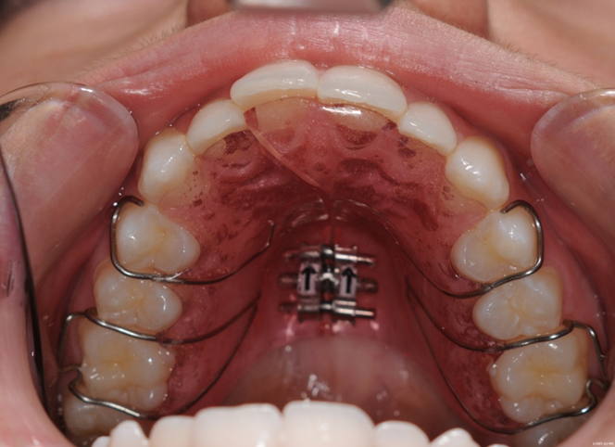
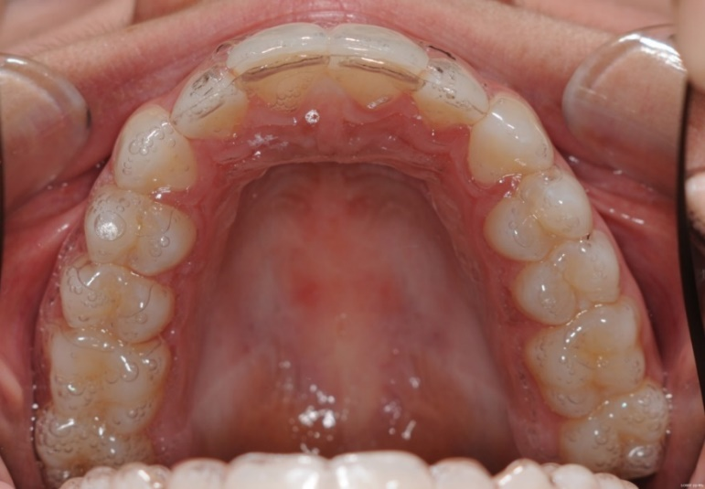
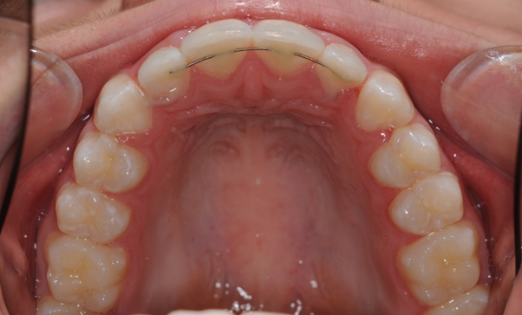
From burtonortho.co.uk
Help sheet SPLIT RETAINERS
Indication
Minor irregularities of the anterior teeth in the upper or lower arch or both at once. Control of rotations is not bad except for canine teeth which tend to respond less well. Less good than simple URAs for instanding upper premolars.

Case preparation
Split retainers neither make nor close space. If the crowding is minimal then you can strip the teeth but remember it can damage the teeth and the periodontium. So, for more significant crowding, expand the arches first with a simple removable appliance.
It might be a surprise to you that these appliances seem to be quite well tolerated by adults. Of course, you need to warn them it will affect speech for a few hours. I put C clasps on the premolars at first; if retention is poor, add a spot of composite on the labial surface and this gives a good undercut. If the retention is good once the patient is used to the appliance they can pop back for you to cut off the c clasps. Measure the crowding in mm and you need so ask the patient to turn the screw 4 times per mm plus 2 for luck. If there is a little spacing take a length of clear plastic thread etch upper 3-3 and then bond it to the upper left 3 once it is bonded to the canine stretch it a little and bond it to the 2 and so on round the mouth leave it for 4 to 6 weeks.
By this method you should have prepared the case so there is no crowding or spacing you are ready for split retainers remember to tell the patient to keep wearing the appliance until the split retainers are fitted.

Method
- Good alginate impression.
- Cast impression and cut off teeth to be moved with a fine saw.
- Reposition teeth with hard wax or plaster in position. The special hard wax with a high melting point is called: Ausblockwachs transp (blocking out wax transparent)melting point 86degrees C ref-725-080 from EM NATT ltd 45-47 Frien Barnet road London N11 3EG
- Pull down two retainers You must use Essix ACE 0.030” material.(available from Orthocare)
- On one retainer use a sharp scalpel and cut along the incisor edge of the teeth that have been moved and extend to one tooth each side.
- You now have a split and un-split retainer. The split one will fit in the patient’s mouth and just feel a little tight the un-split one will either not fit down or will be very tender.
- Make sure the patient knows that if the retainers stick in the gum they can trim them back with a sharp pair of scissors.
- The split retainer must be worn absolutely full time (except for brushing) for two or three weeks.
- Then try the un-split one if it is still too painful go back to the split one for another week
- Wear the un-split retainer full time except for meals for at least 2 weeks
- Review if finished you can consider lingual bonded retainers (AFTER THE BONDED RETAINERS ARE FITTED I WOULD STILL ADVISE A NEW Essix retainer on top for night wear) or a very gradual reduction in the wear of the Essix retainers.
- 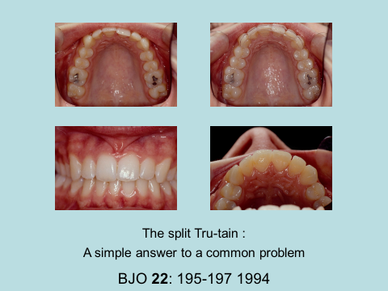

- Diastemas. Deserve a special section because they relapse so easily
You must place a PBR before debond. Either one piece of annealed twistflex or two pieces on non-annealed twistflex. (This is because it can tend to unravel and this would make one central incisor more proclined) or one piece of Orthoflextech stainless steel I would advise against the gold version I believe it stretches and the diastema reopens.
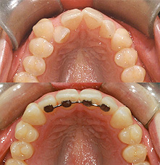
I would also advise against these although they are neat and very easy to place. The problem is they do not flex in between teeth so that if the patient bites loading one tooth the resin cracks. With all PBRs use articulating paper to make sure that they are free of the bite.
As soon as possible after debond fit an Essix type retainer spaced to fit over the PBR. It should be worn night only but if the PBR becomes loose or falls off it must be worn full time except for brushing and the patient needs to contact you immediately for a replacement PBR
What to do if a diastema relapses
- Fit a Hawley and tighten the labial bow trimming the acrylic behind 1/1
- Bond clear elastic chain directly to the labial surface of 1/ then apply tension to the chain and bond to /1 this will close the diastema in 3 days but it does tend to rotate the centrals disto-labially if left too long even with the Hawley in place so if you cannot see the patient in 3 days bond some on the palatal as well
- After 3 days place a PBR you can continue with the Hawley or take another impression for a new Essix.
- Barrer appliance
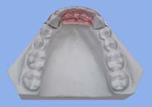
Cut the teeth off the model and reposition bend Australian 0.020 wire clips as you see they go over the canines and there are two clips one from each side. Then build up the acrylic.
Pray the patient doesn’t swallow it!
Harry Barrer was a Begg practitioner in the USA who gave courses in the UK in the 1970s and 198
- ESLA or ELSA
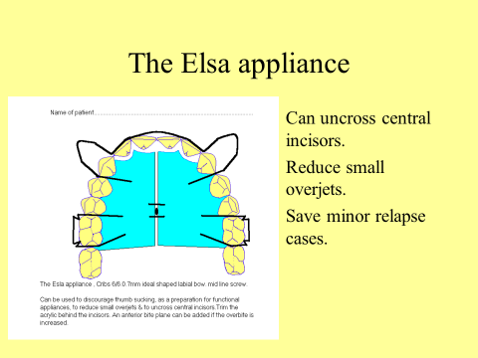

- Inman aligner
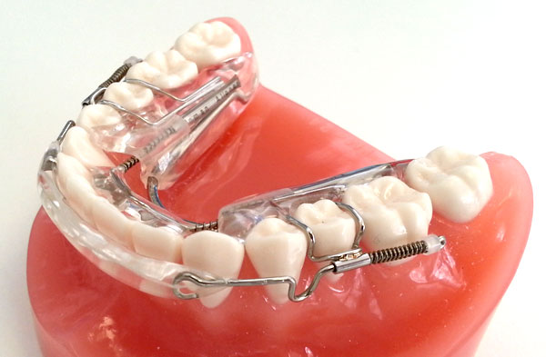
If you are familiar with removable appliances you will say “what’s the point” you could do the same with an ESLA appliance with a Z spring behind the incisors. But you would need to be able to adjust the appliance. The Inman aligner does this for you. The acrylated labial bow is retracted using NiTi push coil as is the acrylated lingual /Palatal section. You get the idea the teeth are cut off the model and repositioned first.

- Retreat non-extraction. Great if you have class I molars and the patient does not look too bimax. Consider Damon archwires they are very very wide.

So the alignment is by expansion lateral as well as anteriorly.
Don’t bother with the brackets just the archwires and of course the permanent retention.
- 6/6 extraction If you have class II molars then the answer may be the extraction of upper 6s you need 8s and plenty of time

Logical retention programmes
- Full or part time
- Patient motivation
- Contract
- Perio-damage
- TMD can occur with positioners and Essix type retainers solution may be to go for Begg retainers which have no occlusal covering for a while.
- Other benefits of retention (decay is reduced if the teeth are brushed with a fluoride toothpaste immediately before placing the retainers. Attrition due to night grinding is reduced but the retainer wear instead and tooth whitening patients can use Essix retainers without any kind of modification to whiten the teeth using Carbamine peroxide 10% many patients like this and if it encourages them to wear their retainers I like it too)

Stability
- Mills Dick Mills and Prof Ballard promoted the idea that the lower incisors should not be moved forward or they would move back and cause crowding. They later modified their ideas to allow for a little proclination in thumb sucking patients. (Mills believed 2 div cases should have a bite plane fitted for many years and that the lower incisors would come forwards by themselves
- Rayliegh Williams said that he had noted that if the lower incisors are moved towards the Apo line they tended to be stable but if they were moved away from it they tended to relapse and crowd
- Extraction of 7s
Cryer in the 1960s advocated this and Margaret Richardson reported on a huge number of cases (I think 2000) extraction of 7s reduces late crowding and usually allows the 8s to come through. But you have to persuade the child to have 7s out

