Chapter Three
Class I malocclusions
Important Note.
This chapter also describes problems that can occur in any malocclusions:
- Crowding and Spacing
- Un-erupted teeth including un-erupted canines.
- Missing teeth
- Teeth of poor prognosis
- Asymmetry
- Anterior open bite
- Lateral open bite
Definition of Class I malocclusion
A Malocclusion where the lower incisors occlude (or would occlude if the overbite is incomplete) with the middle one third of the palatal surface of the upper incisors.
Description
For the most part the skeletal pattern will be normal or near normal, the overjet will be normal except in cases of severe bi-maxillary prognathism where it will be a little increased. Features may include all those listed in chapter 2 as local causes of malocclusion as well as those listed above.
----------------------------------------------------------------------------------------------------------
Crowding
Crowding and the treatment of crowding is described in chapter 2
---------------------------------------------------------------------------------------------------------
Spacing
Spacing can occur even if no teeth are missing. There is no doubt that some patients can be very concerned about the appearance. However there are issues:
- Closing the spaces will tend to pull the dentition back in the face (dishing in) and so good treatment of these cases may be complex.
- A well aligned spaced occlusion is compatible with good dental health and the treatment may not be justifiable.
- Stability of the treated case will be very poor and three will be a need for palatally / lingualy bonded retainers.
- In extreme cases it may be necessary to localise spaces and put in prosthetic teeth to restore the space. This adds to the cost of treatment.
------------------------------------------------------------------------------------------------------

Canines



Before reading these notes answer the following questions

How common are impacted canines?

Are they more commonly impacted palatally or buccally?

BOS guidelines you should inspect the canines at what age?

Why is it sometimes unwise to extract the deciduous canines?

What are the dangers of leaving an un-erupted canine in situ?

What instructions should you give to surgeons when requesting the bonding of gold chain to un-erupted canines?

Name some mechanics used to pull down canines?

Ericson and Kurol found extraction of c’s allowed 78% of unerupted canines to erupt in uncrowded mouths. What is the weakness of this research?

What were the findings of Leonardi in 2004?

What were the findings of Baccetti in 2008?

Why do canines sometimes erupt in the central incisor region?

What are the problems of transplanting canines?

Why should you never use intermaxillary elastics to pull down canine that you believe may be ankylosed?

Do not write on the patients notes that the canines are “missing” when you mean they are un-erupted or just not present in the mouth. This can lead to misunderstanding. In fact canines can be congenitally missing, but it is very rare 0.08%
Impaction of canines is much more common 2% and treating them makes about 10% of the cases I treat at Burton. Silvaros and Mandall say 60% palatal and 5% buccal with the rest in the line of the arch.
Canine impaction may be more common in cases where the 2s are missing and in Class II div 2 malocclusions. They may also be more common in people with late developing occlusions.
The inclination of the lateral incisor is often a helpful clue to the position of the unerupted teeth.
An OPG radiograph is also very helpful. But remember it will exaggerate the inclination of the tooth. (Ferguson 1990, also says it under-estimates the proximity to the midline).
Add a little common sense to interpretation of the OPG. If the canine appears right over the root of the lateral if it were buccal then you would be able to palpate it, if you cannot, it must be palatal. If you can see the root of the lateral and the crown of the canine then it is unlikely that there is severe root resorption. If you can see the crown of the canine but not shadow of the lateral root then you must take intra oral views. Parallax views are helpful; horizontal ones are easier to interpret than vertical. No doubt the use of cone beam CT will show more cases of root resorption but remember that these teeth will often serve a lifetime without symptoms.

Diagnosis

Remember the patients should be told ALL the treatment options including doing nothing. They also have a right to know how long the treatment is likely to take and what is involved. I have particular concerns over rushing patients into joint surgical clinics. The problem is that surgeons recommend surgery. You need to go through all the options first. Here are some factors to consider: -
Is keeping the deciduous canine an option. If it is not (it is worn down has no root or is discoloured) it makes the decision to extract it easier. It is worth saying here that I have seen patients in their 70s with deciduous teeth. Can you promise an implant would last that long?
Are other teeth of poor prognosis? (Look at the lateral incisor)
Check the mobility of the other teeth.
Can the canine be brought down and how long would it take?
If the un-erupted canine were to be extracted would it be possible to close the space? If so how long would it take? Are there 8s that otherwise would be non-functional.
Remember spacing of the anterior teeth in the late mixed dentition can be a sign of crowding with the pressure of the canine teeth pushing the roots together. This used to be called the “ugly duckling stage” but it is not now considered politically correct to compare our patients with ducklings (and it is very unfair to the ducklings.)
Referral and Diagnosis
There are guidelines that suggest if a practitioner cannot palpate a buccal bulge in the canine region at the age of 10 then they should refer for orthodontic advice. I find these referrals a bit difficult. I don’t myself believe that the extraction of the c alone does anything more than reduce the likely cooperation with future treatment. If the 3 is so close to the root of the c that extraction helps it would probably come through anyway. I agree with Olive 2002 what is needed is space opening but I don’t have the time to do that for every 10 year old and could you justify it when you consider that 50% or more would probably erupt without treatment.
My guidelines are to wait until aged 14 unless there are signs of root resorption. But perhaps you shouldn’t say that in your MOrth exam.

Extraction of deciduous canines.
The extraction of deciduous canines is often suggested as a way of encouraging the eruption of the permanent teeth but remember: -
This means you lose the option of retaining the deciduous teeth long term, so check that the patient is prepared to have surgery to bring down the canine etc.
The condition of the deciduous tooth is a good clue, if it has lost most of the root and is a bit mobile then it would be a poor candidate to last a lifetime and so you could extract it. If it looks good and has a long root then it might well last 40 years.
Extraction is not enough, you must also open the space to 9.5 mm to improve the chances of the canine erupting. Sometimes this means increasing the overjet as a temporary measure.
It is only those cases where the crypt of the canine touches the root of the c where you can expect a beneficial effect from extraction of the deciduous teeth.
Leaving un-erupted teeth in situ.
What is the danger of leaving the un-erupted teeth where they are? Do they resorb the roots of the other permanent teeth? Do cysts develop? How often should you take radiographs? I can only give you my views: -
I have never seen a case where there was no root resorption before the age of 14 and it subsequently developed. It seems to be the phase of active eruption that is associated with resorption.
I have only seen two cases where cysts formed associated with canines and they seem to be very slow growing.
I have seen cases where teeth were damaged during the surgical removal of canines.
There is no “no risk” solution.
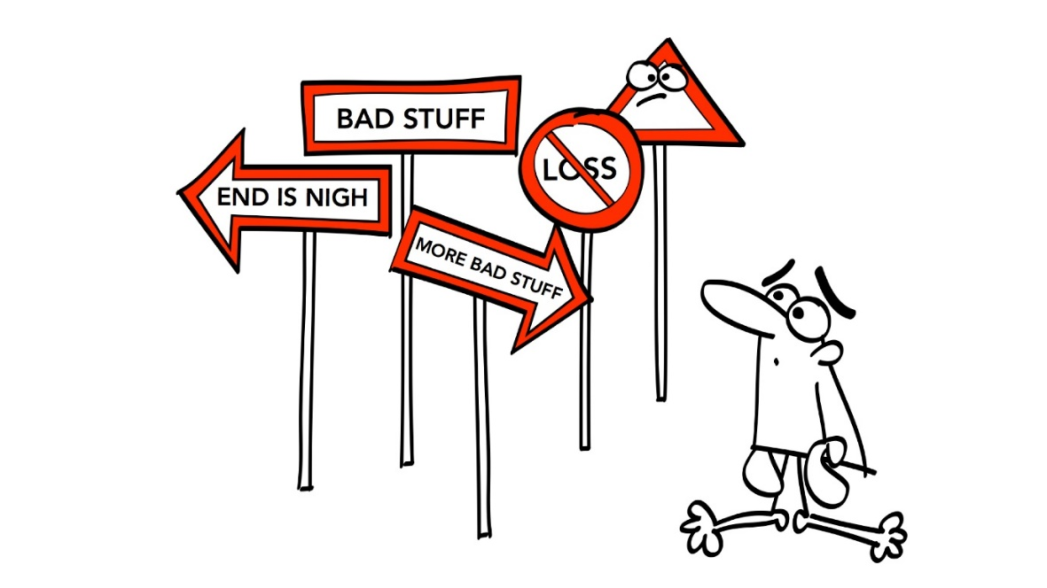
Fig there is no “no risk” solution

I conclude after the age of 16 a radiograph every 5 years is more than sufficient.
The exciting possibility of cone beam CT pictures of un-erupted teeth should clarify the situation considerably and might show root resorption in cases which with our present radiographs seem to be resorption free. It certainly is a great help to the surgeon who has to expose or remove the tooth.
Space opening. If you insist on removable appliances I like to use a two screw URA. EOT can be added if needed but if the patient refuses I am happy to let the overjet increase. I do not like to extract premolars until the canines are through into the mouth. Extract the deciduous canines when the patient is making reasonable progress.
Which is better; open expose or bond chain?
It is impossible to say. Some units are good at bonding chain they never come off. The surgeon knows to stick the chain on the right place (as near the tip as possible) and threads the chain through a hole in the flap to give a direct line of pull. In this unit I would always go for bonding chain. In another unit the chains fall off they are stuck near the gingival margin of the canines and instead of going through a hole in the flap they go in a loop right under the flap. In this unit you will be better to go for open exposure providing they can expose the tip of the canine and leave it in a shallow bowl shaped depression rather than down the bottom of a deep hole.
Exposing canines. For exposure and packing it is important that the tip is exposed. Generally gold chain is best for palatal teeth unless they are very superficial. For buccal canines I use an apically repositioned flap. It is said to be important that you preserve the attached gingiva BUT I have seen cases where the exposure just went through the non-attached mucous membrane and in both cases a normal gingival margin developed [perhaps I was just lucky]
Remember it is important the surgeon does not move the canine or it will cause ankylosis
Pulling down canines: -
- Just tie the gold chain to NiTi base wire
It is better if you use NiTi wire piggybacked to a rigid base wire, but not just a little section of Niti it must go right round 6-6 if you only have single tubes have the base wire 5-5
- Ballista and modified ballista
- Sectional arch from molars. Favoured by Harradine.
To move the tooth across the arch I favour cement on upper 6/6 a button on the palatal surface of the canine and a base arch with offsets distal to the lateral and mesial to the first premolar.
- Then elastomeric chain can be used to catapult the canine across the arch.

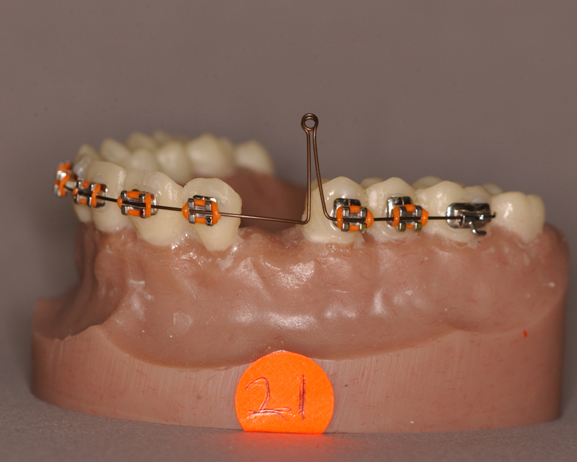
Fig Ballista
With the arrival of “flowable” composites I have modified my ballista with two pieces of NiTi push coil. Now I can open the space, pull down the canine and centre the ballista all at the same time
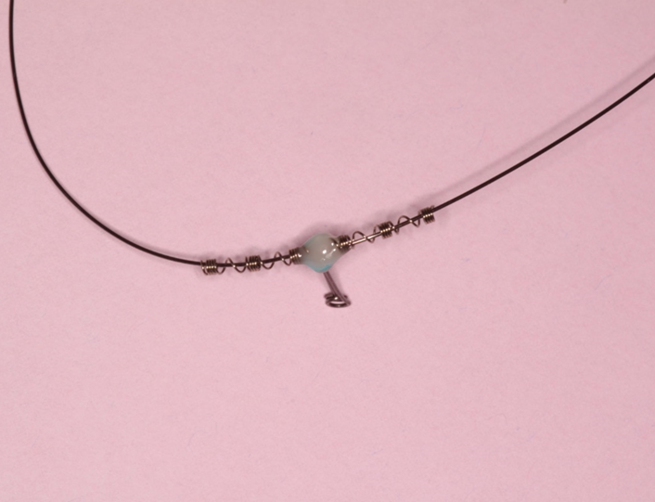
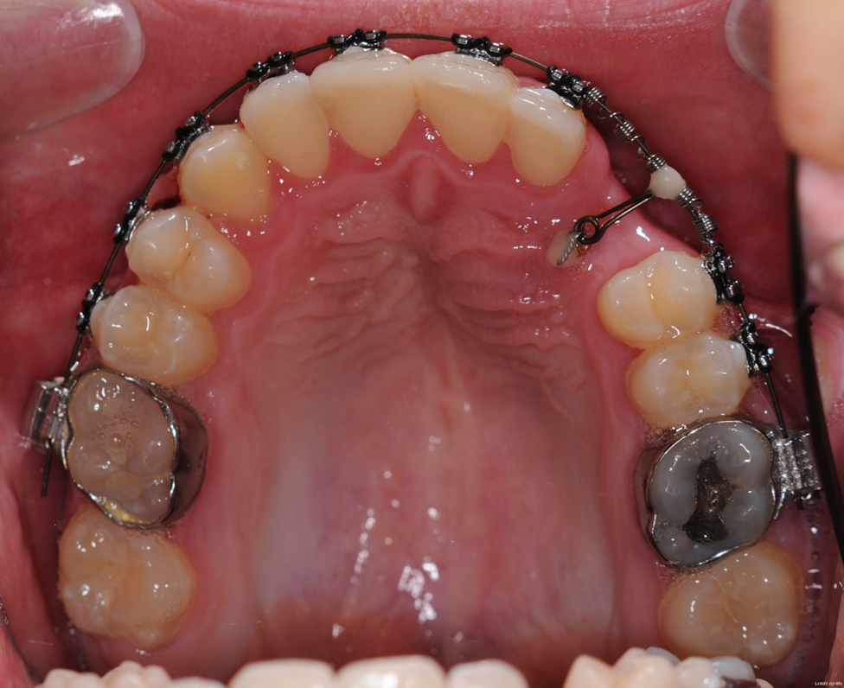

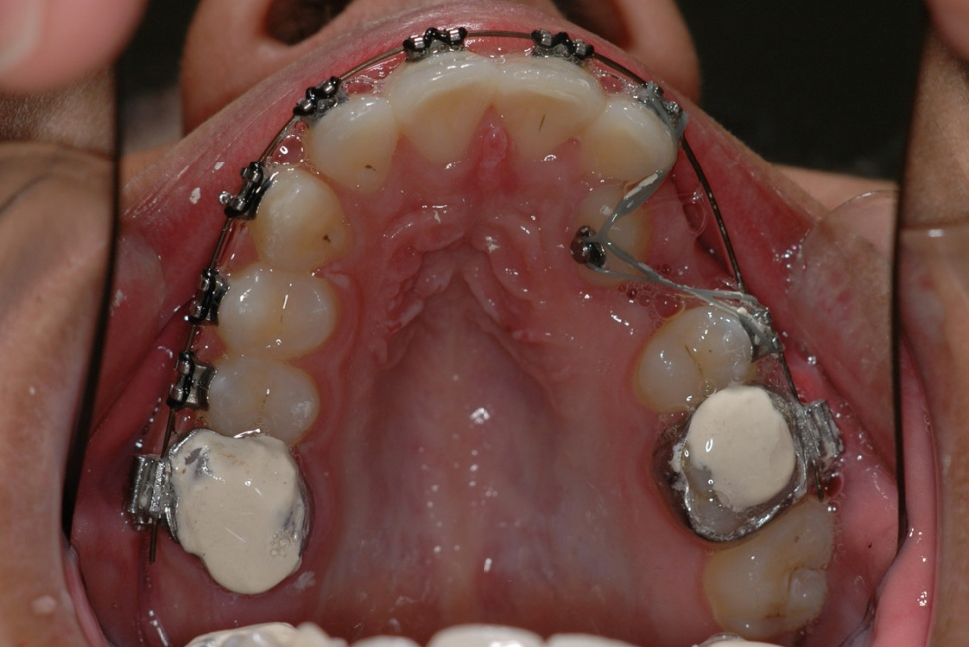
Fig Canine catapult cement on molars to free the bite

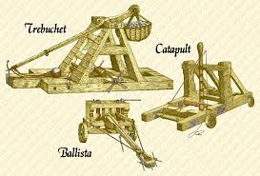
Fig siege engines. Prizes will be offered if you develop the canine trebuchet.
Root resorption
I have seen canines resorb the roots of laterals and then go on to damage both centrals so sometimes you need to take action, but it can be difficult. Do you extract the canine or the lateral? It takes a lot of guts to write the patient up for the extraction of a lateral incisor. When I have done this I have always asked for photographs of the lateral just to show how short the root is. It is worth remembering that teeth with quite short roots often survive a long time.
Buccal root torque.
After you have pulled down the canine check the need for buccal root torque.
Extraction of canines and space closing
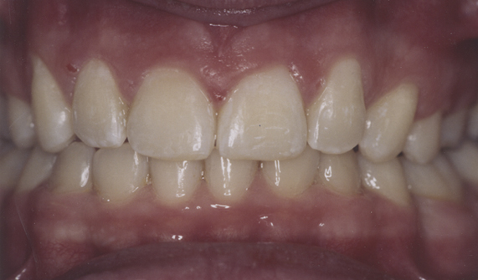
More predictable but remember that space closure can be slow; typically I say 3 years to bring down a difficult palatal canine and two years if you take the canine out and space close. However it would take less time if there was significant crowding. Remember to put a canine bracket on the first premolar and place it distally to rotate the tooth. This makes the 7mm wide tooth take up 9 mm of space. The 7 degrees of mesial tip you will achieve by having a canine bracket makes it much easier to close the space. If there is not excessive gingival show stick the bracket more gingival to elongate the tooth and make it look more like a canine. But if there is a gummy smile you could consider intruding the premolar and building it up to make it look like a canine. NICE IDEA BUT WHO IS GOING TO DO THE BUILD UP.
A letter to the BDJ was published

Canines Crowding and Consent.

Although I agree with Dr Hassan and Dr Nute that hospital advice is needed for patients with impacted canines, I am concerned that practitioners reading the introduction to their paper might decide to extract the deciduous canines without asking for such advice. I feel some of the papers need explanation. The authors quote Eriksson and Kuroll who showed that 78% of permanent canines erupted following the extraction of deciduous canines. It is important to understand that there was no control group in this investigation so that it is possible that the same number of teeth would have erupted without the extractions. Indeed in a randomised controlled trial published in a refereed journal in 2004 by Leonardi et al there was no significant difference between the extraction group and the non-extraction control group. However there was a difference between these two groups and a third group where the deciduous canines were extracted and headgear was used. The significantly improved success rate in this group throws into doubt the suggestion by Hassan and Nute that crowding is not a factor. For this the authors quote a paper by Power et al, again this paper has no control group so that it compares extractions of deciduous canines in cases with and without crowding and finds no difference between the groups. Of course if the findings of Leonardi et al are true and there is no benefit from the extraction of deciduous canines then there would be no difference between the two groups.
A problem here may be the definition of crowding. From the erupting canines point of view this would be a space between the lateral incisor and the first premolar that is too small for the canine. In a typical 11 year old this could occur in a patient with no overall crowding because the deciduous second molar is much bigger than the second premolar tooth.
Practitioners should remember that even if some patients do benefit from the extraction of deciduous canine teeth, some are worse off, because the option of retaining the deciduous tooth into adult life is lost. It is important that when a deciduous canine with a good crown and no root resorption is extracted a proper consent is obtained explaining to the patient that they will require complex orthodontics if the permanent canine fails to erupt.

I wrote this letter in 2004 but in 2008 Baccetti published in EJO his paper found extraction of c’s did work better than doing nothing but not as well as extraction of canines plus space opening.
Unfortunately nobody has done a paper on opening space without extraction of c’s.

Look out there are other papers by Kuroll advising extraction of Cs but still with the same lack of a control.
Transplanting canine
The idea goes back years. Moss described 100 cases in 1975. But it isn’t a great idea. If the canine is so far away from the right place then it will be difficult to remove and so it is unlikely that it will be quickly removed without the surgeon touching the root cementum. As you know the ideal time would be when 2/3 of the root is formed which for a canine would be age 10 to 11 but these patients seldom present at this time. A further problem is that the space is seldom big enough for the tooth so that some orthodontics is required. I have seen cases where the canine was removed and parked in the sulcus while the space was opened. And then a further surgical procedure was needed. You have to be fairly desperate for a publication to do that, after all if the space was small you could have removed the canine and space closed.
I can see that transplantation of a canine might be useful in a hypodontia case where the canine was miles away from the right place. If you do this then remember you should move the transplanted tooth within 3 months to reduce the risk of ankyloses
Why do canines erupt in the central incisor space?

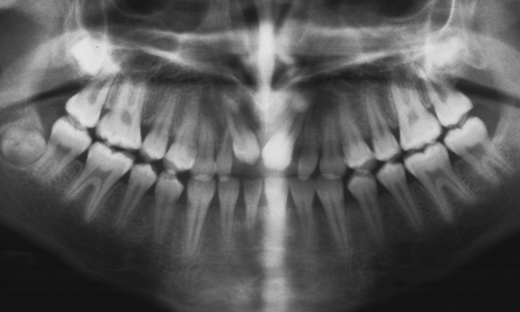
Fig canines erupting in the central space.
Usually the surgeons have been around, in this case a supernumerary tooth had been removed when the patient was 10. Bone had been removed close to the crypts of the canines and this persuaded the canines to erupt resorbing the roots of the centrals as they did so. No orthodontic correction is possible but you can build up the canines to look like centrals. Remember to use central brackets if you use -7°Canine brackets you will move the root out of the bone.
Cystic change
I have said root resorption gets to be less of a problem after 14 but what about the risk of cystic change if you decide to leave an un-erupted canine in situ?
The books all say you should monitor for cystic change but it is very rare; is the radiation more damaging than risk? Perhaps one radiograph after 5 years and the every 10.
Ankylosis
Causes
- The surgeon moved the tooth when exposing and bonding chain
- Age related
- No known cause
It happens to us all you pull the canine down and all the other teeth go up in the air and create a huge AOB. Of course you expect some bite opening after all every action has an equal and opposite reaction. So your first step is to check your mechanics. Have you opened enough space? Are you sure you are not pulling the canine into the root of another tooth?
Next step allow the teeth to re-erupt by removing the traction to the canine. Don’t use inter-maxillary traction.
Next try a different mechanism to apply the traction I would go for a TPA and long arm from the molar tube but you could use a URA.
If this fails I would go for surgical removal of the canine (thank goodness you didn’t ask for the premolar to be removed) and space closure alternatives a localised osteotomy, localised distraction, if the tooth is partly erupted you could just build it up with composite or remove the canine and put in an implant.
Kevin O Brien’s blog
Julia Naoumova, Juri Kurol and Heidrun Kjellberg
European Journal of Orthodontics: E-pub in advance of print
Discusses this paper or at least part one where in non-crowded cases extraction of deciduous teeth seems to improve the chances of eruption of the permanent tooth. I suspect there is no trans- bony telephone line from the un-erupted tooth to the deciduous tooth so the question still remains if the crypt of the canine is separated by a wall of solid bone from the root of the deciduous tooth how does it know the tooth has been extracted? Is it possible that we have two different problems here one a failure of the deciduous tooth to exfoliate and one a failure of the path of eruption of the deciduous tooth?
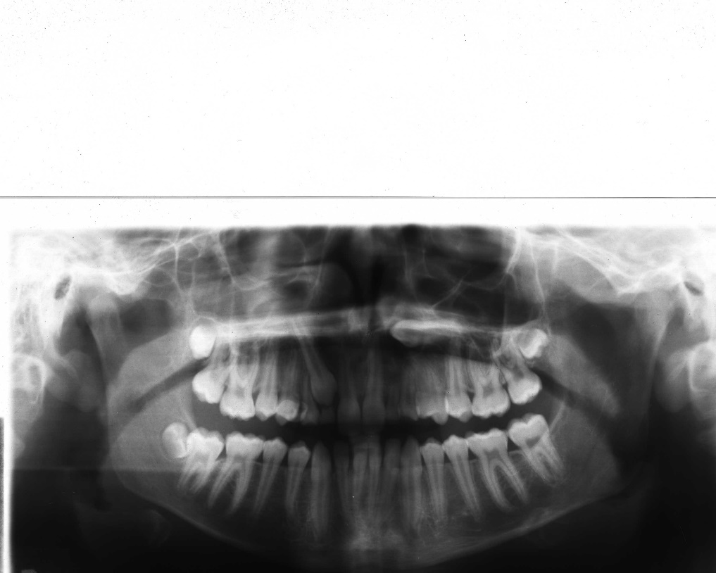
In this case I can see extraction of upper cb/ might encourage the eruption of the upper 3/. But do you believe that extraction of upper /bc would encourage the eruption of upper /3?
Just in case you think such teeth are beyond hope see the next few pictures
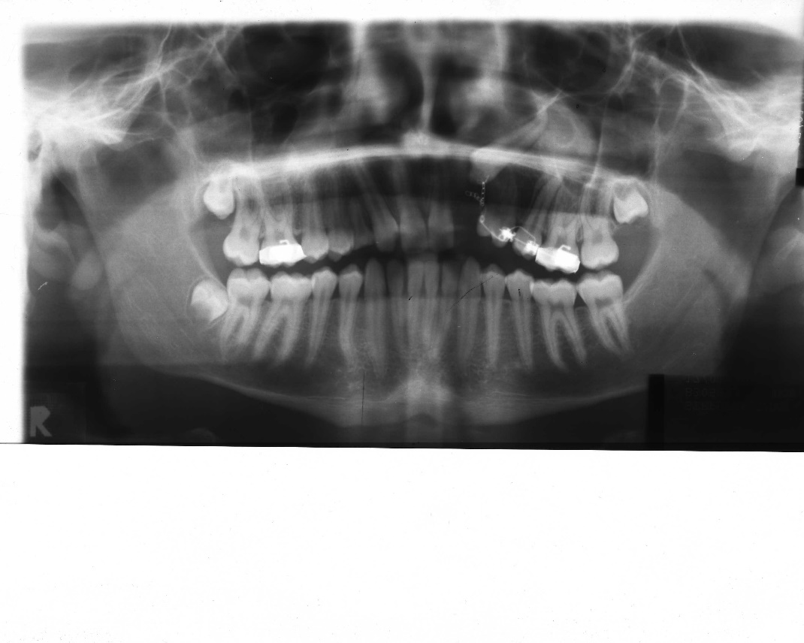
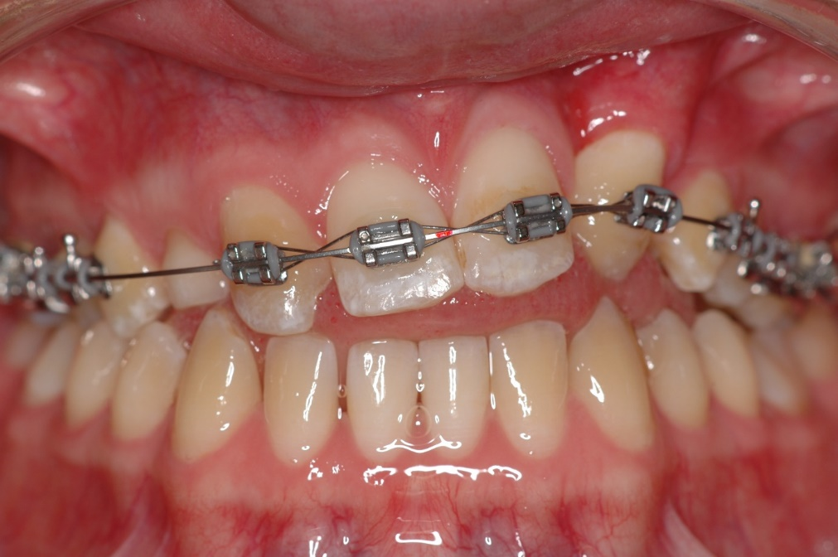
Note the upper c/ was not extracted until this stage of treatment.
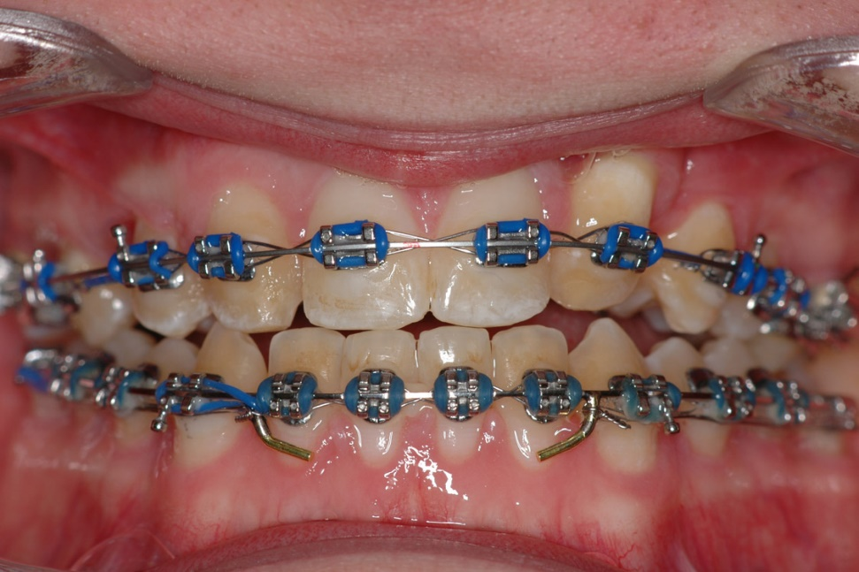
Now my guess is that this kind of case was not included in Naoumova’s study.
Can you see what this would mean?
Excluding some rare syndromes and drugs not normally given to children there are three causes of failure of eruption of canines they are:
- Impaction due to crowding.
- Abnormal path of eruption.
- Failure of exfoliation of the deciduous teeth.

My fear is that Naoumova et al may have excluded some or all of group 2 and they admit they have excluded all of group 1. So is it a big surprise that group 3 seems to predominate?

What you must never do
A sad story
An orthodontist tried to pull down an upper /3. But the tooth was ankylosed so the upper /1245 6 went up in the air. So to improve the traction he bonded the lower teeth and used strong vertical elastics from the lower /123456.
These teeth then went up so the occlusal plane was canted up on the left side.
The patient had to have an osteotomy to correct the occlusal plane.
And she sued the orthodontist.
What should you do?
Mention the possibility of ankylosis in the consent
If the tooth is ankylosed make sure the ankylosed tooth is not attached to the archwire if you are using any kind of vertical elastics. If the occlusal plane does tip I have found TADs can help and a simple URA with cribs on 7s and a baseplate arms from the 7 cribs press down on the 4s

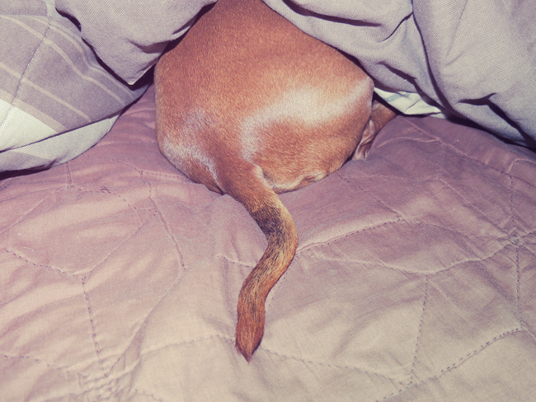
Fig canines the end
Other un-erupted teeth
Remember that maxillary canines erupt after mandibular canines so that by the age of 14 the prognosis of pulling the canine up into occlusion starts to be poor. On the other hand 5s and 7s are usually easier although it depends on the actual position of the teeth.
Having struggles with various bits of wire bending to pull up impacted lower 7s
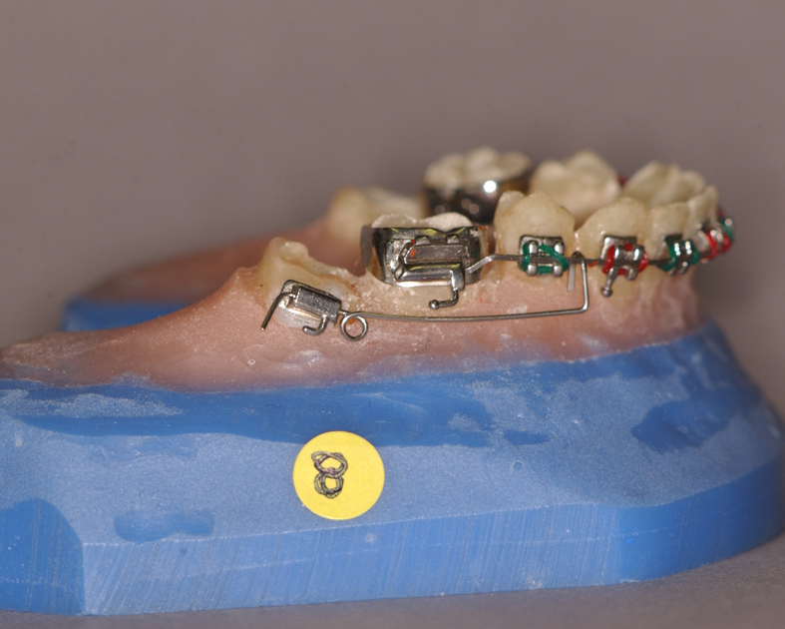
I see that it is so much easier to use either a converted tube or a bracket on the 6 and then just put NiTi wire from 7 to 7. You can even put push coil between 7 and 6.
-----------------------------------------------------------------------------------------------------------------
Missing teeth
Dr Vahid Rakhshan has clearly put a huge amount of work into this essay. I have not included the reference list as it is enormous. I have included it because it shows the huge problem of discussing a condition where the aetiology is multifactorial. I have highlighted the important bits but you can read the whole thing or go online and read all the references.
Author information Article notes Copyright and License information Disclaimer
1Iranian Tissue Bank and Research Center, Tehran University of Medical Sciences, Department of Dental Anatomy and Morphology, Dental Branch, Islamic Azad University, Tehran, Iran
Address for correspondence: Dr. Vahid Rakhshan, #22 Behruzi Alley, Karegar St., P.O. Box 14188-36783, Tehran, Iran. E-mail: ri.ca.uailatned@nahshkar_v
Received 2013 Oct; Accepted 2014 Feb.
Copyright : © Dental Research Journal
This is an open-access article distributed under the terms of the Creative Commons Attribution-Noncommercial-Share Alike 3.0 Unported, which permits unrestricted use, distribution, and reproduction in any medium, provided the original work is properly cited.
This article has been cited by other articles in PMC.
Abstract
Congenitally missing teeth (CMT), or as usually called hypodontia, is a highly prevalent and costly dental anomaly. Besides an unfavourable appearance, patients with missing teeth may suffer from malocclusion, periodontal damage, insufficient alveolar bone growth, reduced chewing ability, inarticulate pronunciation and other problems. Treatment might be usually expensive and multidisciplinary. This highly frequent and yet expensive anomaly is of interest to numerous clinical, basic science and public health fields such as orthodontics, paediatric dentistry, prosthodontics, periodontics, maxillofacial surgery, anatomy, anthropology and even the insurance industry. This essay reviews the findings on the aetiology, prevalence, risk factors, occurrence patterns, skeletal changes and treatments of congenitally missing teeth. It seems that CMT usually appears in females and in the permanent dentition. It is not conclusive whether it tends to occur more in the maxilla or mandible and also in the anterior versus posterior segments. It can accompany various complications and should be attended by expert teams as soon as possible.
INTRODUCTION
Oral health plays a crucial role in public health. Dental treatments are rather expensive health services and the combination of different modalities such as orthodontic, prosthodontic and surgical treatments can put a heavy burden on the average family's health budget. Some frequent dental anomalies need quite expensive treatments. One of them is congenitally missing teeth (CMT), congenital absence of teeth, congenital dental aplasia, or dental agenesis. It is one of the most common dental anomalies It might negatively affect both the aesthetics and function. Aesthetics itself is an important factor and its problems might affect patients’ self-esteem, communication behaviour, professional performance and quality of life. Patients with missing permanent teeth may suffer from complications such as malocclusion (which itself can lead to mastication problems), periodontal damage, lack of alveolar bone growth, reduced chewing ability, inarticulate pronunciation, changes in skeletal relationships and an unfavourable appearance, most of which need rather costly and challenging multidisciplinary treatments.
AETIOLOGY OF DENTAL AGENESIS
CMT is a result of disturbances during the early stages of development and is suggested as a mild dysplastic expression of the ectoderm. When a primary tooth is congenitally absent, its permanent counterpart might also be missing. Genetics plays a crucial role in congenital dental aplasia, as confirmed by studies on monozygotic twins. Interestingly, the pattern of CMT can differ between monozygotic twins, possibly pointing to additional underlying mechanisms, such as epigenetic factors which might be implied by simultaneous occurrence of two anomalies. This multifactorial aetiology can include environmental factors as well, since a combination of environmental and genetic factors might contribute to the occurrence of dental agenesis. These include infection, trauma and drugs, as well as genes associated with about 120 syndromes, such as cleft lip, cleft palate or both, ectodermal dysplasia and Down, Rieger and Book syndromes. A possible general explanation is that except in hereditary cases, CMT has greater occurrence likelihood when the dental germ is developing after the surrounding tissues have closed the space needed for the tooth development. Other investigations demonstrated that delays in tooth development and reductions in tooth size correlate with advanced CMT. Both of these might accord with the terminal reduction theory. Furthermore, it is suggested that anterior agenesis may depend more on genes while posterior missing might be sporadic.
The most supported aetiological theory suggests a polygenic mode of inheritance, with epistatic genes and environmental factors exerting some influence on the phenotypic expression of the genes involved, which this can disturb the tooth germ during the initial stages of formation, i.e., the initiation and proliferation. The exact genetic mechanism is not known. Separate mechanisms might as well account for missing of each tooth.
CMT can form in isolation as well. Isolated cases are more common than syndromic type and might be familiar or sporadic. The isolated condition can follow autosomal dominant, autosomal recessive or X-linked patterns of inheritance, with remarkable variation in both penetrance and expressivity Different sub-phenotypes of dental agenesis might be probably caused by various genes. Mutations in genes such as MSX, PAX9 or TGFA might cause CMT in different racial groups.[9 Among the homeobox genes, MSX1 and MSX2 play an important role in mediating direct epithelial-mesenchymal interactions during craniofacial bone and tooth development. The autosomal-dominant CMT might be correlated with a mutation in the MSX1 and PAX9 genes. MSX1 mutations affect predominantly the second premolars and third molars, sometimes in combination with other types of teeth like the first molars. On the other hand, in more common cases of incisor-premolar type of dental agenesis, MSX1 is less likely to play a role as the causative locus for this type of CMT. In addition, PAX9 and TGFA are associated with congenital missing by interacting between MSX1 and PAX9. A recent study showed a novel mutation in MSX1 gene responsible for CMT of the second premolars and third molars only.
DIAGNOSIS AND CLASSIFICATION OF CONGENITALLY MISSING TEETH
Dental aplasia is classified based on the number of missing teeth. Mild and moderate cases have usually less than three and less than six teeth missing, respectively. The definitions of hypodontia, oligodontia and anodontia differ in the number of missing teeth, on which there is no clear agreement. This can account for some of the variation observed. An ideal CMT diagnosis requires radiographic, clinical and dental cast examinations, but in any case, radiographic examination is a must. Since radiographic evidence of tooth germs needs certain level of calcification to appear, inclusion of too young individuals might enter insufficiently calcified tooth buds into the sample, which can be mistakenly diagnosed as missing teeth on the radiograph. It can be of a greater concern for the mandibular premolars and boys, both with more delayed eruption odds. Therefore scientists should take into consideration the late development of the lower second premolars in boys; and should not include subjects without the canines and premolars neither erupting nor fully erupted, or at least under 6. Some authors have recommended the exclusion of children younger than 9 or 10 or even 12 years old The third molar bud calcification begins at the age of about 7.5 only in very few people; however, the average age for the initiation of its calcification is about the age 9.5 Therefore, by including patients younger than 9, or even 11 (as the 85th percentile for initiation of calcification), researchers might considerably overestimate the third molar missing rate. This might explain the very high prevalence reported by some studies (34.8%). It should be noted that even the initiation of calcification does not guarantee well detection in radiographs; and older ages might be needed for some cases, in order to make sure calcification has reached a detectable minimum.
THE PREVALENCE OF DENTAL AGENESIS
In the primary dentition, the CMT is not frequent, being between 0.1% and 2.4%. However, primary dental aplasia is usually followed by permanent tooth missing. The prevalence of CMT in the permanent dentition excluding the third molars ranges between 0.15% and 16.2% [Table 1] in studies varying in size from about 200 subjects to about +100,000 ones. Japanese people showed the highest rates both in deciduous and permanent dentitions. The CMT prevalence was found to differ between continents and races, but unlikely over time. The CMT prevalence in third molars has been reported over a rather broad range, between 5% and 37%. For example, Ghaznawi et al. reported 5.5% of wisdom tooth missing in Saudi Arabia, while Varela et al observed that 11.5% of a population from Spain had missing of third molars. Other rates might be much greater. For instance, Afify and Zawawi[ and Silva Meza reported 24% third molar absence rates in Saudi Arabia and Mexicans, respectively. Sheikhi et al. have reported 34.8% missing prevalence of Iranians’ third molars. Australian aborigines and perhaps African Blacks might have a low chance of dental agenesis. Indians have shown very small prevalence rates, as two out of three studies in India had rates less than 1% and the other one had about 4% prevalence. The different rates reported could be explained by different measurement approaches or other methodologies and ethnic backgrounds. In contrast, X-ray is a carcinogen factor and cannot be prescribed without any treatment needs Thus, researchers need to use previously taken radiographic images. In very rare cases, such images have been taken from randomly selected subjects (epidemiological samples such as patients attending mandatory public health protocols that oblige periodic dental radiographs be taken from healthy people). However, in almost all recent assessments, dental radiographs have been taken from dental patients. It is possible, however, that dental patients include more cases of dental anomalies which might bias the result.
Table 1
The minimum and maximum prevalence of congenitally missing teeth/hypodontia in different continents
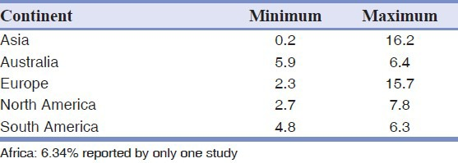
The CMT prevalence may be increasing, perhaps due to evolutionary changes or because of increases in the diagnosis, not necessarily the evolution. Nevertheless, some authors suggest that it might be evolutionary to adapt with the gradually shrinking size of the jaws. Some researchers state that evolution needs much more time to happen; whereas some account for the rapid environmental changes as the causes of CMT. However meta-analyses have not confirmed such an increase in the previous decades.
THE ASSOCIATION OF CMT WITH OTHER DENTAL ANOMALIES
CMT can accompany other conditions such as delayed eruption of other teeth, reductions in coronal or radical dimensions, retained primary teeth, ectopic canine eruption and abnormal dental morphologies such as taurodontism and peg-shaped maxillary lateral incisors. While some researchers have reported that the size of teeth and the width of the dental arch are not related to dental agenesis, some others reported conflicting results indicating that CMT is associated with dental anomalies such as microdontia and decreases in the size of the incisors and canines as well as conical or tapered teeth such as peg lateral. However, some investigators did not find a link between tooth agenesis and microdontia but with peg laterals. They concluded that CMT was not associated with changes in the overall tooth size, while changes in tooth morphology especially in the maxillary lateral incisors might still be possible. This might be in line with other studies finding correlations between severe CMT and taurodontism especially in boys, or between CMT and taurodontism; it might also be in agreement with studies that could not associate CMT with microdontia of contralateral teeth. Some authors found links between CMT with size anomalies and taurodontism. Therefore, the literature is not conclusive. Both CMT and taurodontism seem to be a part of syndromes characterized by decreased mitotic cellular activity which might also affect dental germ development.[ On the other hand, some other studies found clear associations between both mild and severe CMT and reduced tooth size, especially in the upper laterals (in the mesiodistal dimension) and the lower canines (the labiolingual dimension).[165] The latter agrees with the synergism and allelism of major genes possibly affecting CMT.

ASSOCIATIONS WITH SKELETAL CHANGES IN THE HORIZONTAL PLANE
The results pertaining to skeletal changes are controversial. Some authors did not find a significant correlation between malocclusions and CMT prevalence, although suggested a link between CMT and Class II division 2. While according to others, there could be significant links. CMT might accompany reduced intercanine and intermolar widths. Anterior missing can accompany retrognathic maxillae, prognathic mandibles and smaller lengths of posterior cranial base. It also might be more common in the skeletal Class III malocclusion due to smaller or retrognathic maxillae In some studies, Class III was associated merely with severe CMT. CMT might be also significantly less frequent in Class II cases, although a study reported non-significant results for this decrease (possibly due to small sample of Class II cases).[ On the contrary, Cua-Benward et al. found the greatest prevalence of CMT in Class II patients and observed a significant number of missing maxillary teeth in Class III patients. However, it might depend on the most common missing teeth, as it appears that the missing tooth affects its own jaw. A study by Hirukawa et al concluded that Class III might be the most common malocclusion observed among the subjects who had missing teeth only in the maxilla, while when teeth were missing only in the mandible, it was frequently associated with Class II malocclusion. Perhaps the tendency towards a Class III relationship is caused by decreased maxillary and mandibular angular prognathism and the effect might be greater on the maxilla than on the mandible.

ASSOCIATIONS WITH VERTICAL SKELETAL CHANGES
According to some studies, dental aplasia is not correlated with the vertical relationship of the jaws. However some investigators have found significant associations between the CMT occurrence with reduced anterior lower facial height and increased overbite, which intensifies by increasing the severity of CMT, or less severe deep bite in CMT patients and decreased maxillary-to-mandibular-planes angle, which was clinically relevant only in severe CMT. Furthermore anterior CMT might have a significant effect on the vertical skeletal relationships with increasing severity of CMT. It also might contribute to a more acute mandibular angle and flatter chin.
SEX DIMORPHISM
Gender might act as a dental agenesis risk factor. Women are usually more affected and the male-to-female ratio is about 2:3. Some authors studied the teeth individually and found significant gender dimorphism only for certain teeth, such as the upper incisors and upper first premolars, all on the right side only. Of these teeth, only the missing of the upper right central incisor was more prevalent in males and the other ones were more prevalent in females. Silva Meza[ reported significant intersex differences only for the lateral incisors and third molars (without indicating the predominant gender). Eidelman et al. reported significant differences only for the lateral incisor missing cases, being more common in females. Some studies found a non-significant predominance of CMT in males. A very large study on six districts of Turkey showed that in five regions, females had a significantly higher CMT prevalence, while in one of them males had a significantly greater prevalence. Male-to-female ratios were previously summarized as 1:1.37 and 1:1.4 in literature reviews. The higher rates observed in females might be associated with biological differences such as smaller jaws which might trigger environmental factors. This might be confirmed by the suggestion that teeth might be absent also when the development of dental germs is delayed and thus the needed space has been compromised by the surrounding tissues. As well, another factor can contribute to the higher rates of CMT in females: The existence of a probable higher orthodontic treatment need in females with the tooth missing due to their higher concern regarding the appearance and the higher value that society gives to aesthetics in females.[29] Nevertheless, the latter might not be the case, since most of studies on schoolchildren as well showed a higher rate in females. Moreover, some other studies did not find such a difference in orthodontic patients, or even reported higher prevalence rates in male orthodontic patients and male patients of the public health services.[148] Furthermore, since males tend to have lower rates of CMT, studies enrolling more males, might show lower total CMT prevalence rates.
A possible reason for the controversies is that different teeth might vary in terms of sex dimorphism. Küchler et al. showed that the M:F ratio of incisor agenesis was 1.4:1, while in the case of the upper lateral incisors, this ratio was 2:1 and for the lower incisors, the M:F ratio was 1:1. On the other hand, the M:F ratio of premolar missing was 0.5:1 (0.3:1 for the upper second premolar ratio and 0.5:1 for the lower second premolar ratio). Thus a combination of various M:F ratios for different teeth can disallow to easily identify significant differences in the whole dentition. Based on the differences in sex ratios depending on the specific tooth types affected, Küchler et al. suggested a continuous variable, “liability,” with a threshold value, beyond which individuals might be affected. This system is called multifactorial because both genetics and environmental factors determine liability. Based on this concept, they concluded two possibilities: Either the same genetic model might have different thresholds for males and females, or each gender is influenced by an independent genetic model, each having its own threshold. Another factor contributing to the controversy might be the ethnicity.
There is no consistent finding as to which sex is predominant in regard to having more missing teeth per child. In one research, each male had an average of missing teeth per person higher than that of each female (2.32 compared to 1.40). However, in another one, the average numbers of missing per person dentition were almost similar for both genders with a slight increase in boys (2.5 for boys, 2.4 for girls) and in some others, girls had a higher chance for having more missing teeth per person. From information reported in a study on Swedish schoolchildren, these ratios were calculated and showed 1.46 missing teeth in each boy in comparison to 1.74/girl. Evaluation of six regions of Turkey showed that in five of them, females had a significantly greater chance of having more missing teeth per individual and in one of them, males had a greater chance of having more missing teeth in each person. Some other studies as well showed that females might have oligodontia much more likely than males might do. However, another study found the opposite and another one found similarity between the two.
THE MOST FREQUENTLY MISSING TEETH
Clinicians could be assisted by knowing the CMT risk factors and its pattern of occurrence. As a general rule, if only a few teeth are missing, the absent tooth would be the most distal tooth of any given type. This applies to the maxillary laterals and the mandibular second premolars. On the other hand, it is suggested that the permanent maxillary first premolars, canines and first molars, which are likely to be more stable, have a relatively greater rate of CMT in children with five or more teeth
UNILATERAL VERSUS BILATERAL DENTAL AGENESIS
Most authors observed predominance of bilateral CMT to extents such as about as twice as unilateral missing or even as trice as unilateral missing. Even Endo et al.[5] have reported that in 89% of patients, the teeth were bilaterally missing. However, a few studies failed to find a significant difference, or reported non-significant or significant predominance of unilateral missing. In studies on Koreans and Iranians, these were almost similar. Nevertheless, a careful examination of presented information by Kim implied that that article has compared “patients” with bilateral or unilateral missing teeth, not the number of missing teeth. This author further evaluated the values and it was implied that many patients had more than only a pair of bilaterally missing teeth and that if the number of teeth was to be compared, bilateral missing would be as double as unilateral missing in their study. In another Korean study, 70.9% of sample had unilateral missing. On this subject, a review shows that overall, unilateral missing is more common, but bilateral missing is seen mostly in the maxillary lateral incisors. Furthermore, it is suggested that unilateral agenesis might be more common in the case of the upper and lower second premolars, whereas, bilateral missing might be more common in the maxillary laterals. Except for the first molars in both jaws and the maxillary centrals, bilateral agenesis was significantly more common than unilateral aplasia.
WHICH TEETH ARE MOSTLY SYMMETRICALLY MISSING?
This question is not assessed thoroughly. Medina stated that while symmetrical dental missing affects the maxilla, the mandible shows mostly unilateral agenesis. According to some other reports, the most common symmetric missing tooth could be the mandibular second premolar agenesis, followed by the absence of the maxillary second premolar or maxillary lateral incisor According to a meta-analysis, the maxillary lateral incisor might be the most common bilateral missing tooth. Endo et al. found a similar pattern in children other than those with two missing teeth. However, in children with two missing teeth, the mandibular lateral incisor agenesis had a higher prevalence rate.
THE RIGHT VERSUS THE LEFT SIDES
No studies so far have found a significant difference between missing teeth located in the left and right sides. For example, Sisman et al. did not find any significant right-left differences for the whole CMT prevalence and for any of teeth assessed individually. Even a study on more than 100,000 dental patients showed that the number of missing teeth on the left and right sides was almost identical (1574 vs. 1573). According to Fekonja, the missing teeth were more commonly absent on the right side (26 teeth, 54.2%) than on the left side (22, 45.8%). However, their comparison was not statistically substantiated. Statistical comparison was carried out by this author using the Chi-square goodness-of-fit test, which did not detect a significant difference (P = 0.564).
THE OCCURRENCE OF CMT ACROSS THE ANTERIOR/POSTERIOR REGIONS
Few studies have evaluated the difference between CMT rates in the anterior and posterior segments and this should be considered in future studies. Most studies showed higher prevalence in the anterior segmen[ and the few remaining researches found no significant differences. Some investigators suggest that in mild cases of CMT, the anterior segment might be more involved while the posterior segment might be predominant in severe cases. Many studies did not calculate or report the anterior versus posterior missing and many of them did not present raw data. Their raw data were recovered from their tables, graphs and/or texts. The anterior/posterior occurrence was calculated and statistically analysed using the Chi-square goodness-of-fit test, after making sure that the third molars were excluded. Some of these differences analysed by this author were statistically significant (P < 0.01, P < 0.01, P < 0.01, P < 0.01, P < 0.01, P < 0.01, P = 0.000, P = 0.003, P = 0.000[4]) and some were non-significant (P > 0.05). Galluccio and Pilotto investigated the family trees of CMT patients. They identified two groups: Nine families exhibited dental missing seemingly as a function of autosomal dominant genetic transmission. In these families, CMT mainly involved the maxillary lateral incisors. Since other dental anomalies were present, CMT seemed one of the manifestations of an anomaly of the dental lamina. Six families had CMT as a sporadic condition. In this group, CMT was seen only in orthodontic patients and it most often involved the second molars and second premolar.
THE OCCURRENCE OF CMT ACROSS THE ARCHES
The results as which arch is predominant are not conclusive. Some investigators found that congenital tooth agenesis was more common in the maxilla, and some others reported a higher rate of missing teeth in the mandible. The following studies did not analyse/report maxillary/mandibular missing. However, their data were recovered and analysed by this author. Some studies showed significant differences (P = 0.09, P = 0.063, P = 0.054, which were only marginally significant, P = 0.000, P = 0.000, P = 0.003, P = 0.000, P = 0.000) and some did not demonstrate significant or marginally significant differences (P > 0.1).

TREATMENT OF CONGENITALLY MISSING TEETH
CMT has direct clinical implications. The treatment is comprehensive and expensive, costing in some countries from about $3000 to $15,000/patient for minor prosthodontic interventions like a fixed partial denture in mild cases with only one or two missing permanent teeth, to $60,000 for comprehensive interdisciplinary treatments. The treatment would be usually difficult. It might represent an interdisciplinary challenge for specialists in oral and maxillofacial surgery, operative dentistry, paediatric dentistry, orthodontics and prosthodontics. General or paediatric dentists can facilitate multidisciplinary treatments by diagnosing congenital absence of primary teeth and then through early referrals of patients; as the absence of primary teeth highly associates with missing of permanent successors. They might also ensure the retention of reduced number of teeth, in cases such as palatal canines.
Ectodermal dysplasia impaction of the maxillary canines caused by the missing laterals, in which early extraction of deciduous canines might guide the eruption of the permanent ones into the correct position. This necessitates the early evaluation of the number of missing teeth and the consideration of the CMT risk factors, as well as the size and number of teeth remaining in both arches in planning and managing treatment. The type of malocclusion, severity of crowding and facial profile are of major concern in determining the final treatment plan. Bone volume is related to facial aesthetics such as smile, and should be considered in treatment planning as well. During treatment planning, possible changes in the craniofacial morphology associated with CMT should be as well borne in mind.
Another therapeutic challenge is the need to carry out treatment in the growing young patient. While treatment should be initiated during adolescence, interim treatment should begin at around 7-9 years of age before the affected children realise they are different from other children.
The edentulous space can be either left open for prosthetic restoration, or closed by orthodontic means. Other treatment modalities might include auto-transplantation or protraction of the third molars, which are otherwise extracted, in order to substitute for the edentulous region or to increase the number of occluding teeth In prosthodontic treatments, transplantation is a better choice than implanting, since osteo-integrated implants are contraindicated in the growing alveolar bone Successful auto-transplantation of teeth ensures the stability of alveolar bone volume due to physiological stimulation of the periodontal ligament. Implant treatment is postponed until the jaws have stopped growing in adolescence. It is also possible to close the lateral space in crowded maxillae and recontour the canine into the lateral's shape. In an aligned maxillary arch, the distributed excess space can be localised and then restored using prosthetic approaches. Absent lower incisors need esthetic and functional camouflage regarding the relationship between the maxillary and mandibular anterior teeth in crowded jaws, the missing premolar spaces can be used as one of the extraction spaces for arch alignment. In uncrowded jaws with missing permanent premolars, the primary second molar might be left in situ. However, since, there is the risk of infra-occlusion or progressive root resorption, it might be eventually extracted and replaced with an implant or and auto-transplanted tooth. The treatment of severe cases is complex and should be performed in centres such as “Hypodontia Clinics” with access to paediatric dentistry, orthodontics, prosthodontics and oral and maxillofacial surgery. It should be noted that orthodontic/prosthodontic treatments might compromise aesthetics and periodontal
CONCLUSION
CMT is a prevalent multifactorial dental anomaly, usually appearing in females and in the permanent dentition. It is not conclusive whether it tends to occur more in the maxilla or mandible and also in the anterior versus posterior segments. It can accompany various dento-skeletal deformities, anomalies, or simply complications. Thus it should be attended by expert teams at the earliest possibility.
Although the CMT prevalence has been investigated thoroughly, no or few quasi-experimental (case-control or cohort) studies have assessed CMT risk factors. Besides, the number of studies assessing the severity of CMT is very small as well. It is recommended to evaluate within quasi-experimental designs the effect of gender on the prevalence of CMT and also its effect on the severity of CMT. Another problem which should be avoided in future research is the lack of proper report of every finding in many studies. Future studies are recommended to report not only the prevalence of CMT, but also the prevalence of cases with different numbers of missing teeth (for example how many subjects had two, three, or more missing teeth? etc.). This is valuable, since definitions of hypodontia might differ from study to study. This approach would allow the standardization of the results. Another suggestion might be a global consensus on the definitions. Furthermore, it would be helpful if each study clearly defines hypodontia. Many studies have used the term hypodontia to refer to congenitally absent teeth in general. Perhaps it would be better to distinguish CMT and hypodontia in each report, by clearly defining the hypodontia (for example congenital missing of six teeth or more) or oligodontia terminologies (for example congenital missing of 10 teeth or more) in each study. Another limitation of most previous studies is that they have not reported the number of the affected patients with bilateral CMT, unilateral CMT and both simultaneously.
Future studies are warranted to state the severity of CMT in both genders, both arches, both sides (left/right) and across other possible variable levels. The data can be simply summarized within a couple of tables and/or figures. Therefore, it is highly recommended to state all the numbers of all the missing teeth according to tooth types, jaws and sides, etc., in each study.
Ectodermal dysplasia
Just occasionally this condition is picked up by orthodontists. In fact it is a group of 180+ syndromes which makes it impossible to give a meaningful description. This is from the UK Ectodermal Dysplasia society.
The Ectodermal Dysplasias are genetic disorders affecting the development or function of the teeth, hair, nails and sweat glands. More than 180 different types of Ectodermal Dysplasia have been identified. Depending on the particular type (syndrome), an Ectodermal Dysplasia can also affect the skin, the eyes or ears, the lining of the airways, the development of fingers and toes, the nerves and other parts of the body.
Each type usually involves a different combination of symptoms, which can range from mild to severe, such as:
- Absence or abnormality of hair growth.
- Absence or malformation of some or all teeth.
- Impairment in the development of many glands, especially sweat glands, but also salivary glands (make saliva), lacrimal glands (make tears), mucous glands and the breasts.
- Lack of the ability to sweat causes overheating.
- Too little production of tears and other protective secretions of the eyes. This can make them sensitive and even painful.
- Reduced production of mucus in the airways, that leads to chest infections and – in those exposed too often to smoke or dust – to chronic lung damage (emphysema).
- Impairment or loss of hearing.
- Nasal blockage due to a build-up of secretions.
- Frequent infections due to immune system deficiencies and, in some cases, the inability to keep bacteria from entering the body through cracked or eroded skin.
- Less effective barrier properties of the skin, airways and gut leading to infections and to allergies (e.g. asthma, eczema and hay-fever).
- Respiratory problems: not only asthma and chest infections but also, in those who smoke or are exposed to dust, a severe form of chronic chest disease (may be diagnosed as emphysema or as pneumoconiosis).
- Absence or malformation of some fingers or toes.
- Cleft lip and/or palate.
- Irregular skin pigmentation.
In addition to the above individuals affected by Ectodermal Dysplasia may have:
- Sensitivity to light.
- A lack of breast development.
- Psychological challenges due to changes in physical appearance.
Individuals affected by Ectodermal Dysplasia may face a lifetime of special needs.
These can include:
- Dentures at a young age with frequent adjustments and replacements.
- Osseo-integrated dental implants.
- Special diets to meet dental/nutritional needs.
- Air-conditioned environments.
- Wigs to conceal the lack of hair and scalp conditions.
- Creams or devices to protect from direct sunlight.
- Respiratory therapies for asthma and infections.
Ectodermal dysplasia usually occurs because of a change in an individual’s DNA. The individual with ectodermal dysplasia may be the first person in the family to have the genetic change or the change, may have been inherited from a family member. Not all ectodermal dysplasias are passed on in families in the same way.
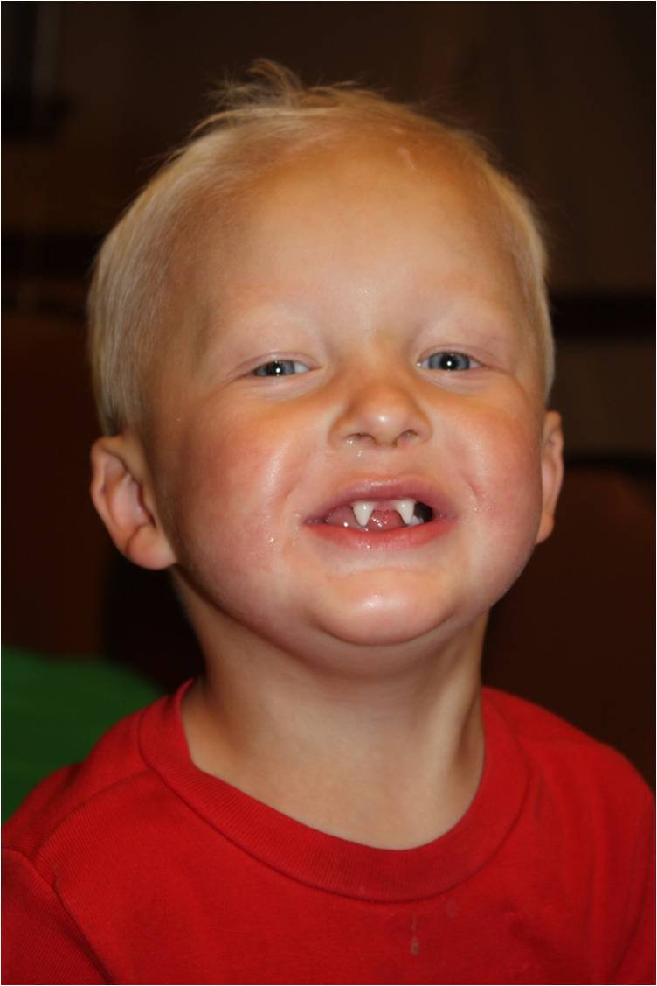
In these days of exotic holidays Anhidrotic types (those who cannot sweat) are at severe risk of heat stroke. So your diagnosis may save a life. A typical picture is of sparse very thin blond or white hair. Blue eyes and very pale skin with a blue grey hue around the eyes. As well as the many missing teeth there is a dished in profile.
Hypodontia a personal history
In 1980 I was asked to help set up a hypodontia clinic in Birmingham Dental Hospital. With Dr Linda Shaw (senior lecturer in paediatric dentistry) and her husband Jeremy Shaw (Restorative Consultant)
PART A
TREATMENT IN 1980
- I used upper appliances to move the two upper centrals together and in the correct position to support the upper lip
- The teeth that were present were restored and brought down as needed. Deciduous teeth were retained, restored if necessary and only removed if they were going completely subgingival
- Very occasionally auto-transplants were used
- Having moved the upper centrals to the correct position an upper partial denture was made with a full height flat anterior bite plane.
- A lower appliance was fitted to move the lower incisors forward to a normal overjet. Often this meant opening space for 5 or even 6 lower incisors. At this stage we had a well-supported upper lip and a normal overjet and overbite.
- Finally the space was adjusted for the maxillary lateral incisors
- At this stage well-fitting cobalt-chrome dentures were made as well as replacing the missing teeth they over-laid infra-occluded deciduous teeth
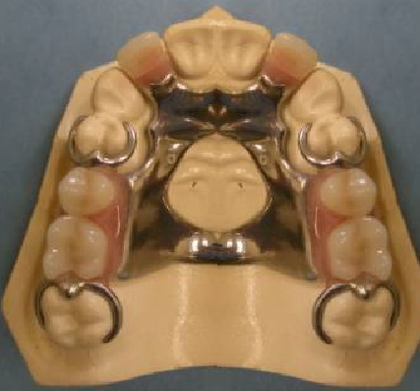
I know what you are thinking.
Gosh that was primitive treatment
BUT
- Most patients were finished by the age of 14
- A lot of patients got treated
- The appearance was good
- Patients had a spare acrylic partial at home for emergency
- Some patients did go on to have bridgework etc. later
- They had relatively few appointments and usually finished well before GCSE examinations
I KNOW PEOPLE DON’T LIKE WEARING DENTURES. WE USED TO CALL THEM TEMPORARY BRIDGES AND THE PATIENTS SEEMED QUITE HAPPY WITH THAT.
TREATMENT IN 2020
Is so much more sophisticated. We set exact criteria for mm of space in each quadrant. BUT in severe hypodontia the orthodontist has so little anchorage. This makes it very hard to achieve the requirements of the restorative dentist. Often the upper incisors are too far back in the face and the overjet and overbite are not normal. Treatment is often very long and with turnover of staff it means they are transferred to different operators. The restorative treatment is not now started until all growth has finished and this can leave a long delay between completion of orthodontics and the start on restorative work. Often retainers break and treatment relapses. New improved restorative techniques bone grafts implants and composite build-up of teeth should give an improved result but their very complexity means long waiting lists, delays and very many appointments. Many patients are judged to have poor mouths and are referred back to GDPs and never complete treatment others decide they cannot afford the time for the large number of appointments needed.
I feel the result is a very few patients achieve great results but many more get poorer treatment than in 1980.
And

The cost must be frightful
THE FUTURE
Why not:
Go back to 1980s treatment and aim to get all our hypodontia patients with a normal overjet and overbite and some nice cobalt-chrome partials by the age of 14. I think we could do this without much input from our restorative colleagues.
Then I think we will have three groups:
- Some will be happy with what they have got and not want the time consuming second stage.
- Some will have poor cooperation and not be suitable for a second stage.
- This group are suitable for stage two which would be wait until growth has stopped then implants in the most anterior space in each quadrant. Followed by orthodontics using these implants as absolute anchorage to get the desired spaces for future restoration.
Please be aware this is only my suggestion I don’t expect anyone else would agree.
Teeth of poor prognosis
Extraction of 6s has been dealt with in General causes of malocclusion/crowding. IN general a good orthodontist will always remove teeth of poor prognosis if this is compatible with a good result.
I would like to mention one scenario the avulsed central incisor. I do see cases where an avulsed tooth has been out of the mouth for a considerable time and kept under poor conditions. It is then re-implanted in a patient with an increased overjet. This is followed by many appointments to follow up and root fill the tooth. Often a painful experience for the child. After years of this at an orthodontic assessment they are told the tooth will need to be removed. Everyone is upset. The solution orthodontic advice early.
In another scenario a 7 year old has a central knocked out. A partial denture is fitted. It is frequently broken and the space reduces. At 14 they present for orthodontic treatment. Refuse to leave out the denture so that you have to try to do the treatment with a false tooth in place. The parents remind you at every visit that the treatment has been going on for 7 years. The solution in my opinion is that if the patient is under 10 they don’t need a denture. Yes the space may close up BUY HEY I’M AN ORTHODONTIST I CAN OPEN IT UP AGAIN.
Last scenario. An upper central incisor is of poor prognosis in a patient with a crowded lower arch. A lower 5 could have been transplanted into the upper central incisor space. BUT NOBODY REFERED THEM TO HAVE THIS DONE UNTIL IT WAS TOO LATE.

Asymmetry

I am grateful to Pertti Pirttiniemi AJO 1994 p191-200 for “Associations of mandibular and facial asymmetries” This review article says: -

- Asymmetry is common in the human cranio-facial skeleton. The larger and smaller structures are consistently on the same side. This phenomenon is referred to as a directional asymmetry. The left side of the face is usually the larger particularly in the vertical direction and the left side of the mandible is commonly longer than the right. Melnick AJO 1992 Vol 101 p355-366 showed that mandibular asymmetry is a common feature and that the direction of this asymmetry is age and sex dependent.
- Asymmetries of the size of the teeth and the form of the dental arches do not seem to have any systematic bias.
- Asymmetrical variation in the TMJ is also common but it may be a secondary response to asymmetries of force applied to the joints.
- Mandibulo-Facial Asymmetries arising in the pre-natal period. About 1% of all new-born babies have multiple birth defects 40% of which can be identified as a known ”syndrome” Asymmetry may be a direct part of the syndrome or a result of the upset in genetic control. That is the inability of the genetic information to control development efficiently. Hemifacial Microsomia is relatively common. There is mandibular asymmetry which affects the occlusion. Growth is distorted due to inadequate vertical growth with a failure of growth in the mid-face. There is evidence of a defect in the proliferation and migration of early embryonic neural crest cells. The TM joint varies from normal to completely missing. A similar condition has been induced experimentally by causing haemorrhage near the neural crest at a critical period in development and by giving the mother vitamen A derivatives. Congenital Hemifacial Hypertrophy is a rare cause of marked asymmetry involving hard and soft tissues. It is probably a result of an asymmetry in the primary distribution of the neural crest cells. It almost always affects the right side of the face
- Mandibulo-Facial Asymmetries arising in the Foetal period. It is suggested that the foetus is prone to deformation as a result of pressures in the uterus because of its great plasticity. Congenital Muscular Torticollis typically shows a shortening of the Stero-mastoid muscle either due to inter-uterine postural influences or birth trauma. In Unilateral premature cranial stenosis of the coronal suture. (plagiocephaly) the mid face goes towards the affected side but the un-affected mandible grows to the opposite side as a result of compensatory mechanisms especially in the ramus and the condyle. It has been shown experimentally that cranio-stenosis can be induced by intra-uterine constraint. The defect seems to start at the cranial base and progress to the coronal sutures. Birth trauma can affect the TM joint the most severe outcome leads to ankylosis and growth arrest. This damage is associated with breech and forceps deliveries.
- Mandibulo-Facial Asymmetries with predominantly post Natal Expression.
- Uni-lateral overgrowth of the Mandible. Results in a class III malocclusion with a cross-bite and a shift of the centre-line. Increased metabolic activity in the affected condyle can be demonstrated scintigraphically. The condition is usually idiopathic but also familial, associated with unilateral differences in vasculaity, associated with earlier trauma, inter-uterine pressure or endocrine disorders. The appearance of the condyle on an OPG radiograph is characteristic with a very elongated appearance. There is an interesting comparison with uni-lateral condylar hyperplasia as a cause of asymmetry and the work of Koski and others who suggest that the condlye is not a true growth centre.
- Masseter hypertophy can be unilateral it causes overgrowth of the gonial region and the ramus.(now treated with Botox)
- Progressive hemifacial atrophy (Romberg syndrome) A slowly progressing atrophy primarily involving subcutaneous tissues fat and bone usually affects the left side of the face it is more common in females than males. It does not affect the TM joint. The cause is unknown.
- Infection. In the past middle ear infections spreading to the TMJ were a significant cause of mandibular asymmetry.
- Rheumatoid arthritis in childhood can affect the TMJ usually causes a class II malocclusion with a high angle but the effects can be more severe on one side leading to asymmetry.
- Arthritis associated with psoriasis
- TRAUMA Proffit suggests that the incidence of un-diagnosed condylar fracture in childhood may be high. If it leads to ankylosis the asymmetry will be severe, but any damage may lead to some impairment of growth. Sometimes the maxilla is also affected with some shift of the centreline towards the affected side. There have been cases reported where damage to the condyle was followed by compensatory growth which actually shifted the centreline to the opposite side. Complete removal of the condyle will produce less deformity than ankylosis and a new TMJ may form by a combination of a re-growth of the condylar neck and a modification of the glenoid fossa.
- Initial Contact and Mandibular displacement.
- Caused by: -
  - Sucking habits
  - Crowding e.g. Lateral incisor behind the bite.
  - Mouth breathing
  - Skeletal discrepancies of arch width leading to cusp to cusp contact in retruded contact position.
  - Retrained deciduous teeth or supernumerary teeth causing cuspal interference.

If left untreated a uni-lateral crossbite with a displacement may cause minor changes to the condyle Masseter muscle and the ramus.

With great respect to Mr Pertti Pirttiniemi my attitude is simpler.

- How to tell if an asymmetry is the result of an initial contact and a displacement.
- Look to see if there is anything that might cause a displacement such as an upper lateral in crossbite or an upper 7 in scissorbite.
- Try to get the patient to bite back into retruded contact position.
- Mark the mid-line of the lower jaw. As the patient opens the mouth the mark should move towards the centreline. Whereas with true asymmetry the mark will move further towards the affected side.
- The condyle should look normal on both sides.
- If in doubt you could fit a URA with a bite plane to see if the displacement (and the asymmetry) disappeared.
- You could fit a Gothic arch tracing device (if you can remember what one is.)
- You could take a history which might help you if there had been trauma to the joint.

- What do you do if you do find a skeletal asymmetry?
- Find out if it is getting worse.
- Exclude syndromes.
- Remember a cone beam CT can measure and compare the volume of one side of the face to the other.

- If it is not getting worse you need to find out if the patient perceives this as a significant problem and would wish to investigate a surgical solution. If no then you can formulate a camouflage treatment with asymmetrical extractions to compensate for the asymmetry.
- Surgical treatments.
- Condylectomy for ankylosis.(plus modified functional)
- Condylar shave for progressive condylar hypertrophy.
- Osteogenic distraction for hemifacial microsomia
- Osteotomies maxillary movements may also be required.

Orthodontic treatment
Just in case you thick this paper on asymmetry has been a bit biased to one side. I should mention orthodontic treatment.
- Where you see a lateral incisor behind the bite causing a displacement push it over the bite.
- Unilateral crossbites with displacements are worth correcting in the mixed dentition. Especially if you can get the GDP to do it for you.
- Appliances with flanges do sometimes help.
- See a scissorbite and think of functionals but actually a lower contraction bite works well.
- The E-Arch can be modified to give uni-lateral expansion.
- A suitable functional for a patient after condylectomy would be a MOA (some people favour a Frankel)
- Note crossbites associated with thumb sucking or a lateral incisor behind the bite may not indicate skeletal deficiency so RME would be inappropriate.
- Starting with a bite plane or cement to free the occlusion might be worthwhile.
Centrelines
Don’t Worry about centrelines in the early part of orthodontic treatment unless: -
- It is a surgical case
- There is a true asymmetry
- The extractions are asymmetrical.
In most other cases it is best to ignore centrelines and concentrate on getting the molars and canines correct then as you reduce the overjet the centreline will correct itself.
Anterior Open Bite
The problem is that the aetiology Anterior open bite is multifactorial so you get these obvious types:
- Skeletal
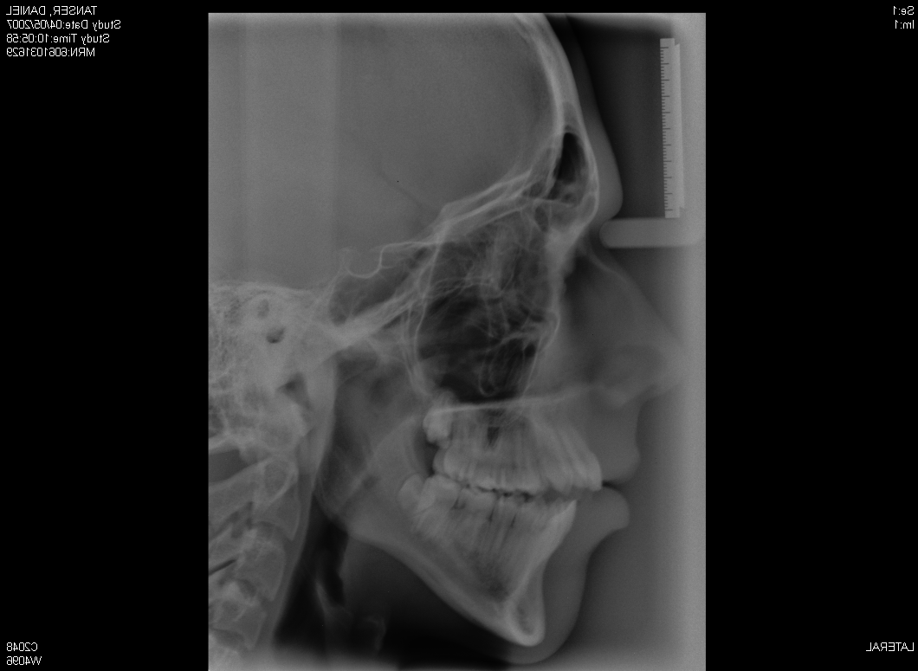
Classic features
- FM angle greater than 35°
- Long Face
- Open bite extends back to canines and premolars
- Normal or even excessive show of upper incisors and gingivae when smiling
- Lots of bone below the roots of the lower incisors. The symphysis looks thin, even hour-glass shape.
- The upper and lower occlusal lines are flat.
These patients require surgery.
- Digit or Dummy sucking
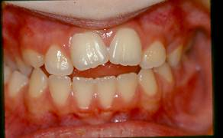
Classic features:
- Reduced show of upper incisors in speech and smiling
- AOB confined to incisors (and sometimes canines but not premolars)
- History of habit
- Lower incisors can be retroclined and there may be a cross bite
These patients need extrusion of the upper incisors until the tips are 3-4mm below the upper lip at rest. In most cases no surgery is required but be aware patients with a long face can suck their thumbs.
- Endogenous Tongue thrust.
Does this condition even exist? Note it is quite different from the adaptive tongue behaviour during swallowing that you see in the other cases where the tongue is just preventing saliva from squirting forwards
- Lisp
- Obvious massive muscular activity of the lips and tongue during swallowing
- History of relapsed treatment.
- Very proclined incisors
Treatment has a poor prognosis you could go for tongue reduction but I bet the surgeons would say no.
- Trauma and ankylosis of the incisors.
- History of trauma follower by increasing AOB
Honestly the best treatment is probably removal of the ankylosed teeth after growth has ceased follower by implants. However you can build up the crowns to make the teeth longer and also you can attempt to surgically sub lux the teeth and then pull them down,
- Iatrogenic.
- History of a normal overbite before treatment.
Yes a problem of arch development treatment the upper incisors were at 110° and crowded. Someone thinks I can align these non-extraction. Now they are 125° but this reduces the overbite. Solution extract and re-treat
- Retainers.
Classic error retainers do not cover the most posterior teeth. If wear is very good an anterior open bite will follow
- Soft splints
I understand that provision of soft splints is the most lucrative thing a GDP can do under the NHS. Again if they don’t cover all the teeth it can cause an AOB/
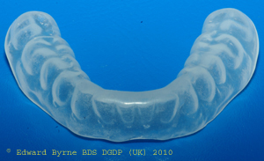
Fig Does my cynicism look big in this?

- Trauma
Fracture of TMJ and dislocation of the TMJ can cause AOB. Treatment is surgical but orthodontics may be needed to adjust the occlusion.
- No very clear aetiology
Here is the problem sometimes the FM angle is a little bit high and there is a vague history of dummy or digit sucking. But nothing is very obvious.
Treatment
Skeletal AOB requires surgery.
Closing AOB with reduced incisal show
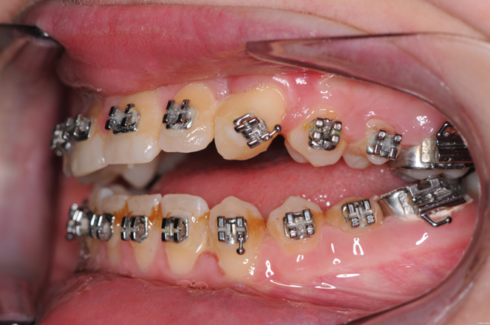
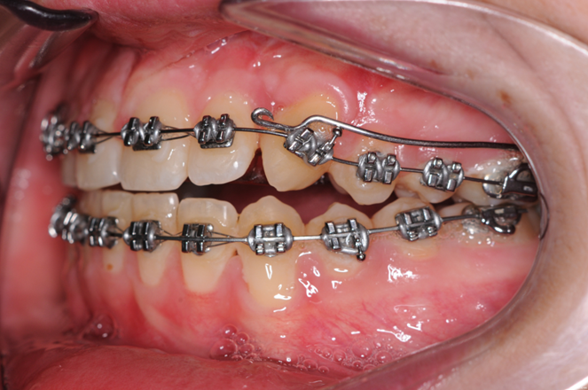
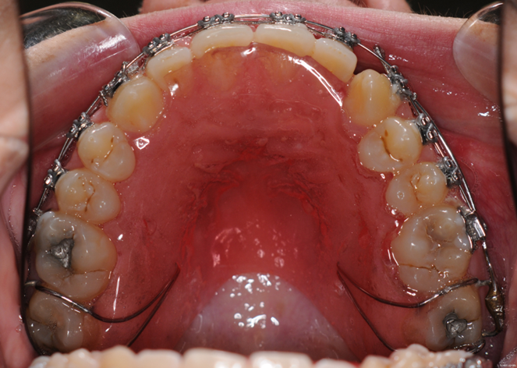
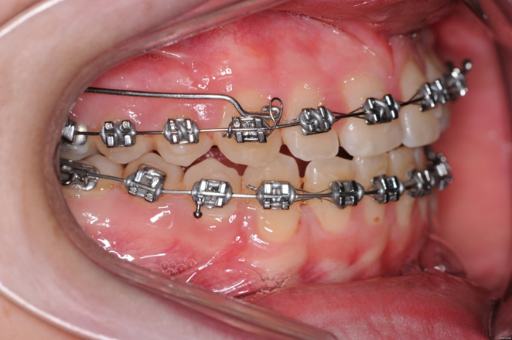
Simple URA worn night only to control AOB
Upside-down counterforce and Kim Mechanics are described in “Fixed Appliances”
Lateral Open Bite.
In normal circumstances swallowing is a very simple procedure. The tongue lifts up and fills the mouth. The food cannot go into the buccal sulcus or through the lips because these exits are closed by having the teeth in occlusion and the lips together. This pushes the food back into the pharynx. Can you see an anterior or lateral open bite is an emergency situation? The body’s solution is to use the tongue to block the space. So when you see an open bite Anterior or lateral you will always see an adaptive tongue behaviour to fill the space. (Note the difference between this and an endogenous tongue thrust) This means that the commonest cause of a lateral open bite is:
- Impaction of the first molars. In a crowded case the first molar gets impacted at 6 years of age. When the D and E are lost it creates a Lateral open bite. (Age 11) and the tongue MUST fill this area to allow swallowing. The molar is now5 years past its normal eruption time and will probably not erupt. The 4 &5 will not erupt because the tongue will stop them. The important message is if you see impacted 6s DO SOMETHING.

If you have to extract the E you can always move the 6 back (you’re an orthodontist remember)
Other causes of lateral open bite.
- Localised failure of alveolar bone. Does this exist? I suspect most cases are cause by the tongue but it is hard to say
- Extraction of deciduous teeth due to caries leaving a space which the tongue must fill
- Class III cases. A bilateral Lateral open bite can occur post-surgery. There are two reasons for this one is that further growth has occurred bringing the mandible forwards giving an edge to edge bite. The other is that the tongue is cramped by the backwards movement on the mandible and spreads between the teeth.

Cover the right side and try these questions
Questions on chapter 3
Cover the left side and try these questions.
1. Why may patients be refused NHS treatment to close spacing | Because the NHS uses IOTN and index of NEED for dental health and spaced teeth are not un-healthy.
2.How common are impacted canines | 2%
3. What features increase the risk of impaction of canines | 2 div2, missing lateral incisors, late development of the teeth.
4. What structures are affected by ectodermal dysplasia | Skin, sweat glands, teeth, hair, lacrimal gland it can also affect hearing, mucous glands breasts skin pigmentation
5 How many types of ectodermal dysplasia are there? | At least 120
6. How common are missing teeth in the primary dentition | 0.1-2.4%
7. how common are missing teeth in the permanent dentition (excluding 8s) | 0.15-16.2%
8. Which side of the face is usually larger | Left
9. What are the features of a thumb sucking malocclusion | AOB/X-Bite/Lisp/Reduced show of upper incisors
10. What are the features of a malocclusion with an endogenous tongue thrust? | Lisp/AOB/procline incisors/muscular activity during swallowing

