Help Sheet SPEEDING UP ORTHODONTICS
Indications
You can use these ideas on any straight wire case
Method
- At bond up place a little cement on the occlusal surface of the 6s. You need to place enough to completely exclude any occlusal contacts. This will allow the teeth to align quicker, reduce the chance of bracket loss, reduce pain and help eliminate root resorption.
- If the maxillary canines are mesialy tipped and crowded out of place use Begg

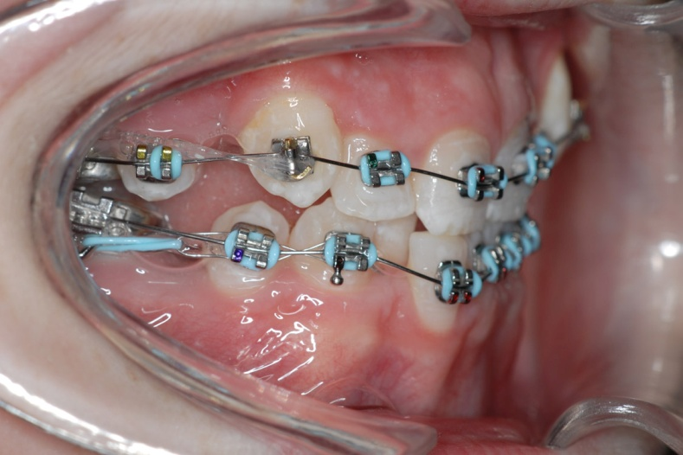
brackets (you will need curved base TP 256-500 brackets and stage I pins) TP 217-440) use elastics to pull the canine back . You can either use separate elastics hooked onto the bent over end of the Begg pin. Or use elastic chain. If you prefer you can use Tip-Edge brackets (also from TP)
- Use RACEBACKS. In fact this is nothing more than a laceback made active by adding an elastomeric module. The module is hooked onto the 6 (mesial hook) and then ties forward to the canine. Expect to get about 2mm of distal movement of the canine (so you can only use them if there is some crowding) and about 4 mm of mesial movement of the 6. This mesial movement is accompanied by a little mesial tipping and the molar may drop back a little later as it uprights. The use of a raceback is confined to cases where the extraction of lower 5/5 gives too much space and you want some forward movement of the lower molars. YOU SHOULD NOT USE THEM IN THE UPPER ARCH UNLESS YOU WANT TO BRING THE UPPER MOLARS FORWARDS. (For example A CLASS III CASE WITH CROWDED CANINES AND CLASS III MOLARS.)
- Modified Parkhouse arch. Where you have very crowded lower incisors they align more quickly if you just tie in 3 of the lower incisors and allow them to align at the expense of the forth. Then use a steel wire with two circle hooks just mesial to the 4s and stretch the elastomeric modules from both canines to the circle hook behind them. This will force open some space but it might not be in the right place so I add a little piece of push coil. The advantage of the modified Parkhouse arch is its reliability with practice you can make it so it always opens just the right amount of space, not too little and not too much.
- 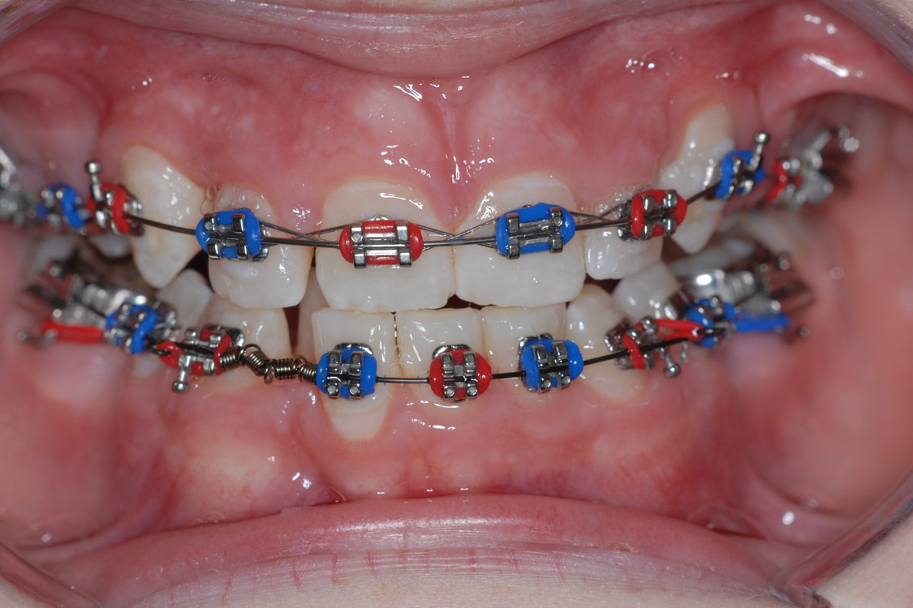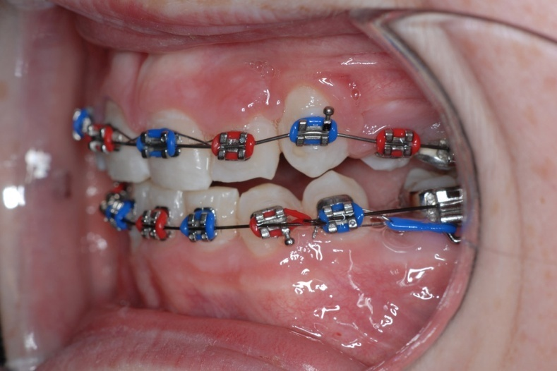

- Stabilizing arch. This wire is bent in 0.016 or 0.018 steel and sits underneath the main archwire. If you only have single tubes on the molars (go on change them ideally to Tip Edge molar tubes) then you can still use an 0.016 stabilizing arch with 0.014 NiTi as they will both fit together through a 0.022 x 0.025 molar tube. The advantage of a stabilizing arch is that it makes the NiTi wire behave like a steel wire; it will allow the use of class II elastics without tipping the molar. The wire is as shown below but it needs a 20 degree anchor bend just in front of the molars
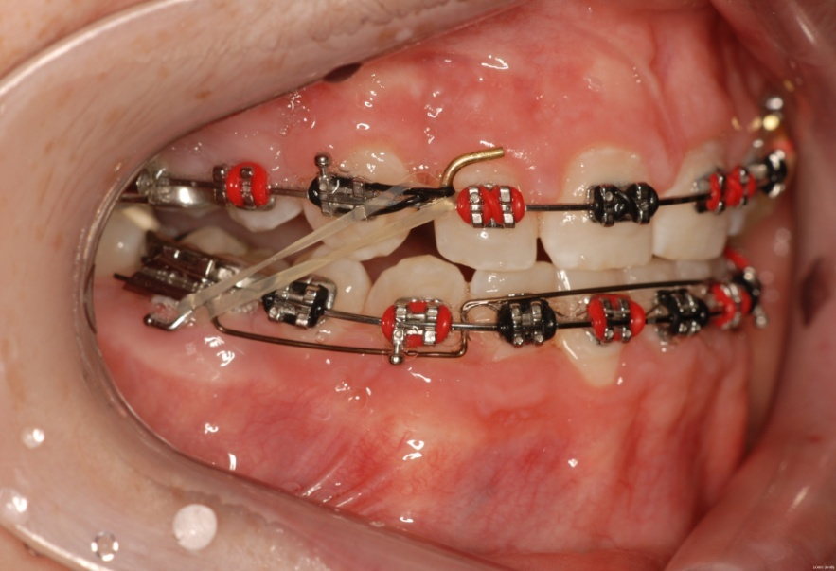

- Cement on 7s. Yes it is a way of opening the bite but it also speeds up overjet reduction. Remember the lower arch must be rigid either steel or NiTi with a stabilizer. The upper wire must be flat and rigid and you need class II elastics (100Grams e.g. TP Orange)
- Final space closure. If you took my advice earlier and put in Tip-Edge tubes on the lower 6s you can now speed up the forward movement of the lower molars. Step the archwire down distal to the lower 4s and go through the wider Begg tube. Yes the 6 will tip but no problem it will upright with NiTi and short class II (or tie lower 6-6
