Help sheet UPPER BEGG LOWER STRAIGHT-WIRE NON EXTRACTION
WHAT IS IT
Begg therapy is an interesting technique which deserves your study; but this is not it. In fact one of the proper principles of Begg is that teeth naturally move forwards so I am not sure that PR Begg would approve of my technique which uses Begg brackets to distalizes the upper arch.
INDICATIONS
Any case where the lower arch is good or can be aligned and still not too far forwards. It is worth noting that Begg can be problematic in asymmetry or asymmetrical extraction cases. Probably not a good idea for your first case then
SORRY BUT YOU NEED SOME STUFF
- Begg brackets with curved bases for upper 3,4 & 5 TP 256-650
- Begg brackets with flat bases for the incisors TP 256-550
- Begg pins you need 3 types :
- Stage 1 pins (actually called 1-pt safety pins) TP 217-440
- Stage 3 pins (actually called Hook pins TP 207-341
- High hat pins(they really are called high hat pins) TP 202-152
You can get all the above from TP Ortho just to make it more difficult they don’t even admit to selling Begg stuff anymore so you can’t see it in the catalogue. They assure me they have no plans to stop making it. You will find they make a whole host of very similar Begg pins loner and shorter and also with steel rather than brass it doesn’t make a lot of difference.
- Some 0.016 special A J Wilcock wire 231-320 (sorry you can’t get it from TP as they have fallen out with Wilcock you have to order it from Torque orthodontics www.torqueorthodontics.com or direct from Wilcock www.ajwilcock.com actually Orthocare and Hawley Russell also supply it but not (I think)the uprighting springs although if enough people ask they might. Note I suggest using the special rather than the special plus which tends to break too easily.
- Uprighting springs. They must be in really resilient wire the TP ones are not really good enough get proper special plus ones FROM Wilcock (direct or via Torque orthodontics)I am told the mini springs are the best you need left and right they are 223-171 and 223-170 BUT THEY ARE SO TINY I FIND THEN HARD TO USE so I prefer the universal springs 222-160 and 222-161 ( note uprighting springs come in left and right, you do need both)
YOU NEED TO KNOW
- Which way up do you stick a Begg bracket?
- How do you get the pin in?
- How do you get the pin out
- What do the different pins do
- How do you get an uprighting spring in
- Which way round do the pins go

Answers
1

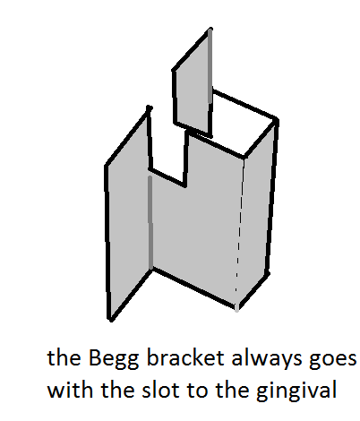
2.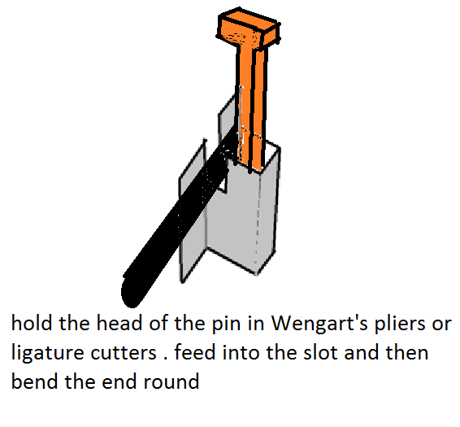

3. To get the pin out just cut the bent over end with a sharp pair of ligature cutters

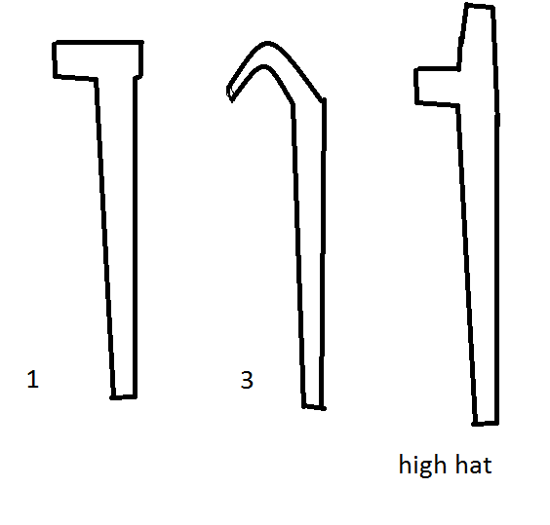
4.The unipoint saftey pin used in stage 1 is TP 217-440 the idea is that the back of the head of the pin prevents it being pulled in too tight and squeezing the wire.
The hook pin in stage three allows two wires to be held tightly in place
TP 207-341
While the high hat pin is intended to give you a hook for the attachment of elastics. Yes if you want to you can use high hat pins and loop a coloured elastic module over the bracket. It does no good and in theory adds to the friction but it doesn’t stop the teeth moving and if it makes the patient happy then OK
5 Easy to do with a little practice the end of the uprighting spring pushes in from the gingival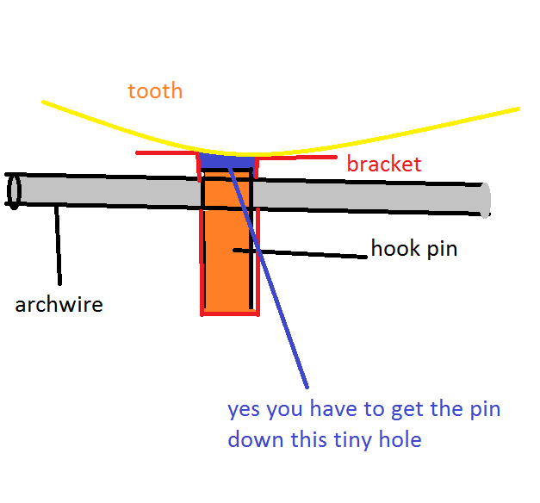
Between the stage three pin and the tooth. NOTE IT WILL NOT GO IN IF YOU HAVE USED A STAGE 1 PIN.
6.
HAVING GOT THE PIN IN YOU NEED TO KNOW THAT THERE ARE TWO TYPES NOW CALLED LEFT AND RIGHT BUT PREVIOUSLY CALLED CLOCKWISE AND ANTI CLOCKWISE.
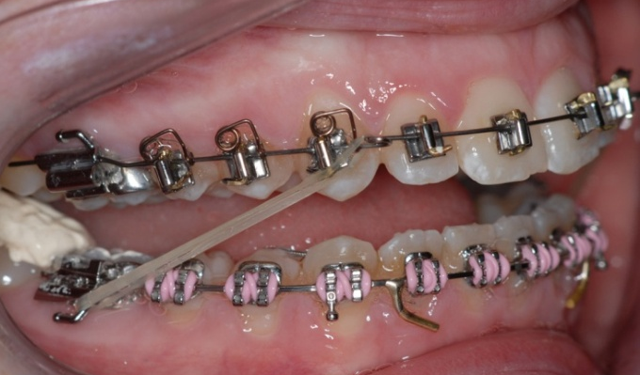
In non extraction Upper Begg lower straight-wire the pin hooks over BEFORE the bracket in phase B

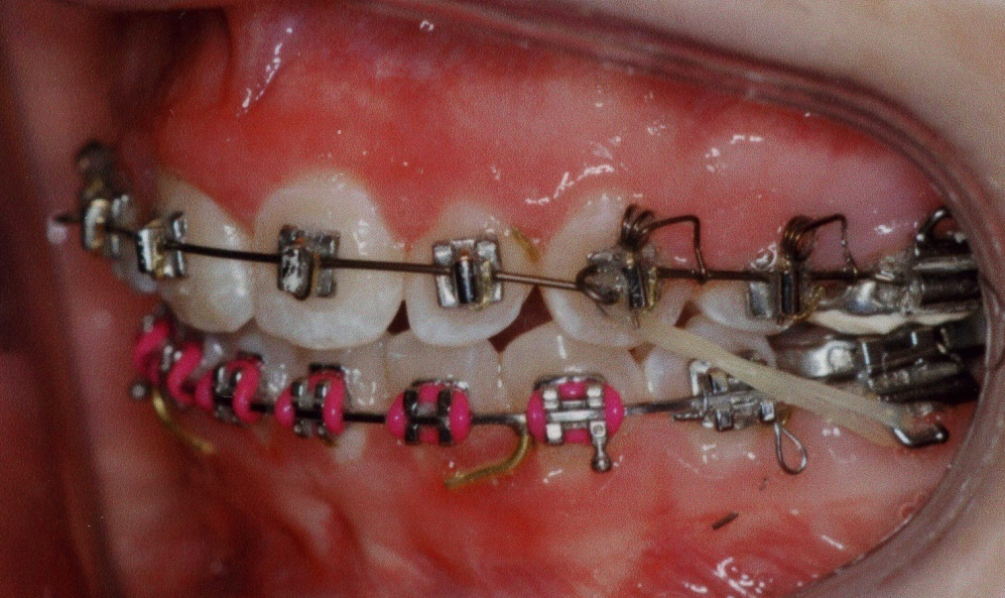
And DISTAL to the bracket in phase D

NOW YOU KNOW THE BASICS HERE IS THE METHOD

- Bond up but with bands on the 6s. YOU MUST NOTE DOWN THE SIZE OF THE BANDS ON THE UPPER 6S.
- Stick the Begg brackets on with the slot to the gingival in about the same place you would stick straight wire brackets
- In the upper pin in a suitable NiTi wire you can use elastics from half bent round pins if you want to do some tooth movement closing space. Use stage 1 TP 217-440 pins
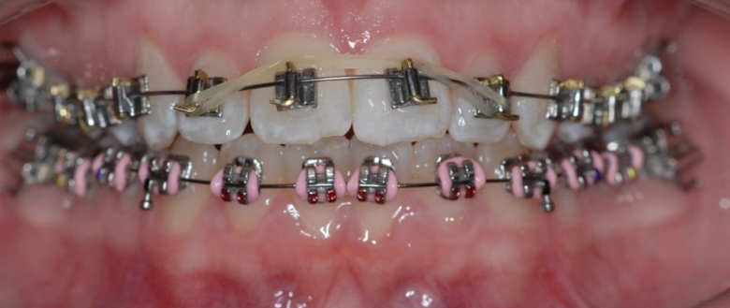

Or if you want to open space you can use push coil. I am assuming that you will have no difficulty in aligning the lower. You do need to work right up to 0.019 x 0.025 steel wire. So in fact in this phase, PHASE A ALIGNMENT there is not much to do in the upper just let it sit there with the NiTi wire.

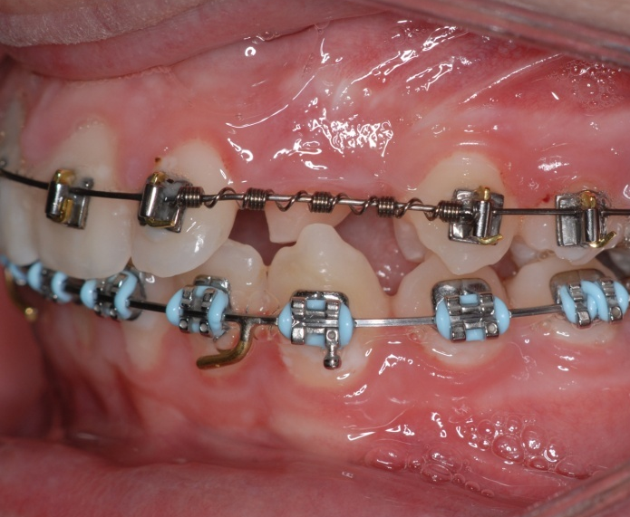

3. At the end of phase A place in the lower 0.019 x 0.025 steel posted wire together with a lingual bonded retainer 4-4 and tie in very tight with either ligature wire or figure of 8 modules.

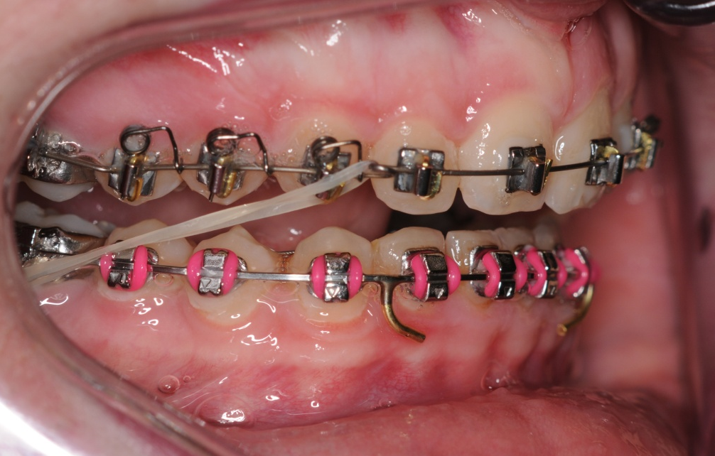
4. Now Phase B BITE CORRECTION. First mix some very thick Poly-F cement (use glass Ionomer if you want, but it will be difficult to remove) place it on the lower 7s if the overbite is positive and on lower 4&5 if there is a reduced overbite its job is to free the occlusion it must set rock hard before you let the patient bite together
- Now the upper arch. It is in 0.016 special. More or less a straight wire arch form but with circle hooks just distal to the lateral incisors and small molar offsets with quite a sharp anchor bend (20 degrees). The wire goes through the straight-wire tube (you do not need to buy special Begg or Tip-Edge tubes) leave the ends of the wire a little long and do not bend them up. YOU MUST PIN IN WITH STAGE 3 HOOK PINS TP 207-341. To correct the buccal segments the patients must wear quite strong class II elastics ALL THE TIME INCLUDING EATING 100-140 grams use TP Orange). Until the buccal segments are class I. What do you do if it doesn’t correct to class I? If there is no evidence that the patient is wearing the class II elastics i.e. not wearing them at the appointment, lower molars not mobile and patient cannot put them on without a mirror then extract upper 4/4 and close space with a NiTi pull coil. If some progress but not quite there try for 18 weeks and then try EOT night only as well as the class II this usually just pulls it back the last little bit.

6 Phase C Cuspation is easy

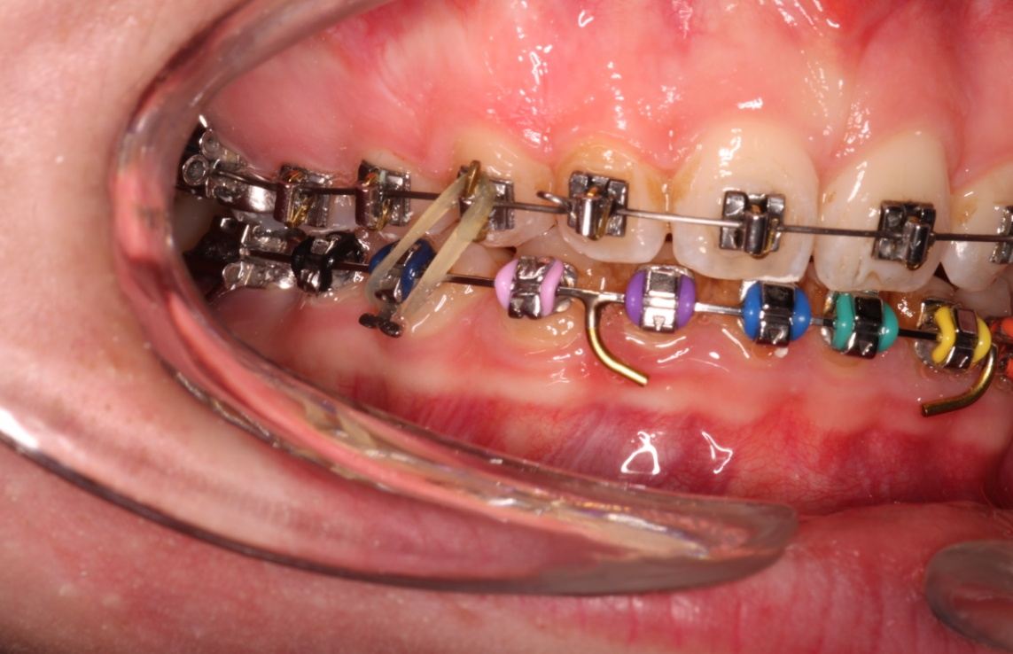
Remove the cement from the 7s.
Remove the anchor bend from the upper
Take an upper impression and place upper molar bands one size larger than the size you have noted down in the impression for the Nance button.
Use vertical elastics from high hat pins on the upper canines TP 202-152 the idea is to slot in the canines now that they are class 1.

- Phase D Detailing. Remove the molar bands and archwire and place the Nance. Replace the archwire and turn the ends up hard (if you cut it short you will have to bend a new one.)before you pin in decide what detailing you want to do if you want to torque the incisor teeth you will need to bend a two spur torquing auxiliary
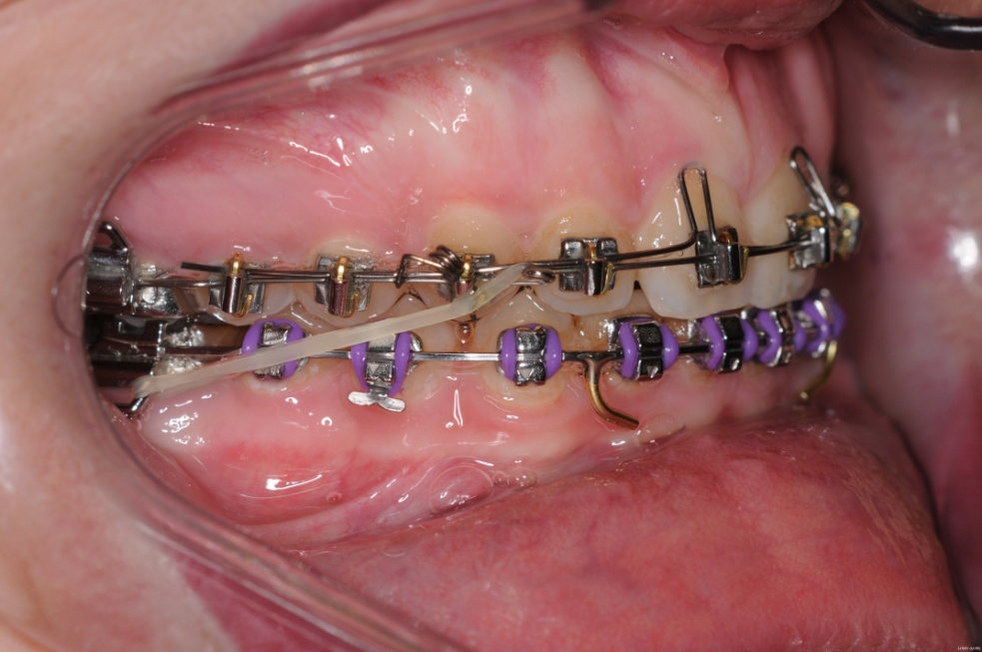
You can buy them pre-bent or bend one in 0.014 special or special plus wire

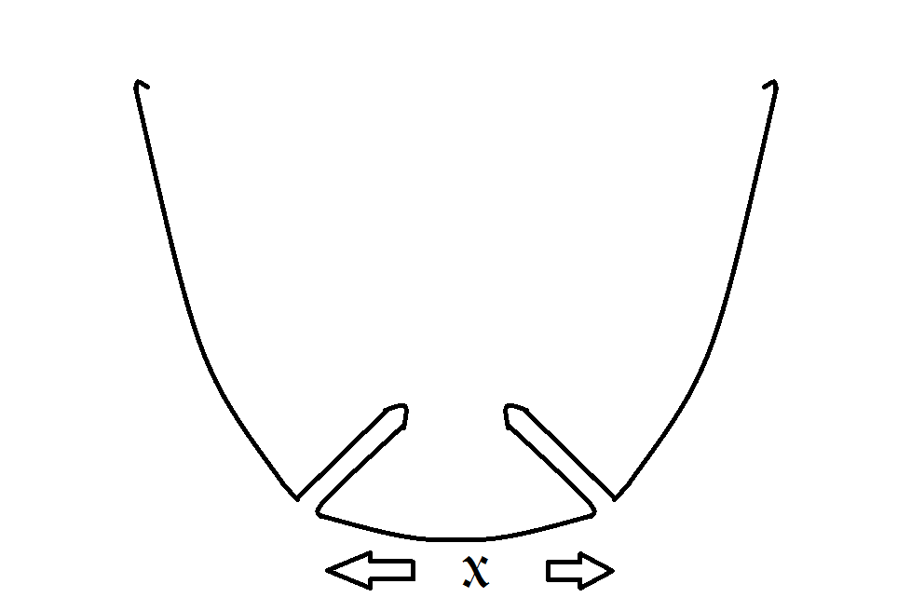
They look like this and should be the width of a 50p coin and lie flat. The distance X must be exactly the width of the brackets on the centrals which is usually 12 mm. if you want to buy them ready bent you need a range of sizes TP 246 100 is for centrals 10 mm across from bracket to bracket
TP 246 110 for 11mm
TP 246 120 for 12 mm
TP 246 130 for 13 mm
They do half mm sizes as well but I think you could manage without them
If needed place the torquing auxiliary above the base arch and pin in with stage three pins. Support with class II elastics.
Until you get a feel for this I would do the torquing first and then upright the teeth otherwise you may find the overjet increasing.
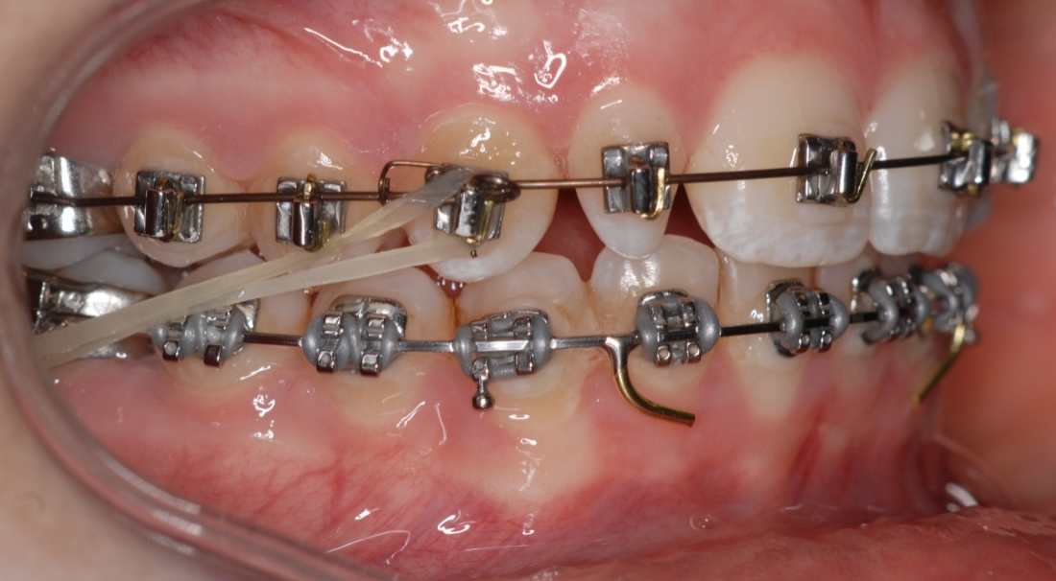
Then remove the torquing auxiliary and place uprighting springs . In Phase D the springs go Distal to the teeth. That’s it.
What do you do if:
- You are not happy with the finishing. Complete phase D then rebond with straight wire.
- You think the lower incisors are too proclined. In other words you have produced a Class I case with Bi-maxillary protrusion. Re-bond upper 4-4 with straight wire. Then extract all four second premolars and close the space. This may sound like hard work but in fact you should be able to put in a thermally active 0.019 x 0.025 on the visit when you rebond the teeth (after all the teeth are aligned) and after the extractions place posted steel wires in both arches and space close with NiTi pull coils and light class II elastics.

