**Help sheet for a simple class II corrector (bracket and Bead appliance)**

**Clinician**

Suitability

The patient should be 10-14 years of age with a class II malocclusion with class II molars. If there are loose deciduous teeth it is best to delay the start impressions until they have exfoliated.

You need to take good impressions and note the overjet. The impressions will do for start study models and the class II corrector. There is no need to take a functional bite.

**Technician**

* Cast the models and a duplicate set for the study models.
* On the working models block out excessive undercuts as you would do when constructing a vacuum formed retainer use heat resistant wax*. Pay attention to unerupted teeth and the lower anterior teeth. Insufficient blocking out will make the lower very difficult to remove; while excessive blocking out of the upper will make it unretentive.
* It is helpful to place on a plasterless articulator to give a class I molar relationship.
* Position 4mm diameter plastic beads onto the Disto-palatal cusp attaching it with heat resistant wax* or super glue. Don’t use too much wax or the bead will not be incorporated into the appliance.

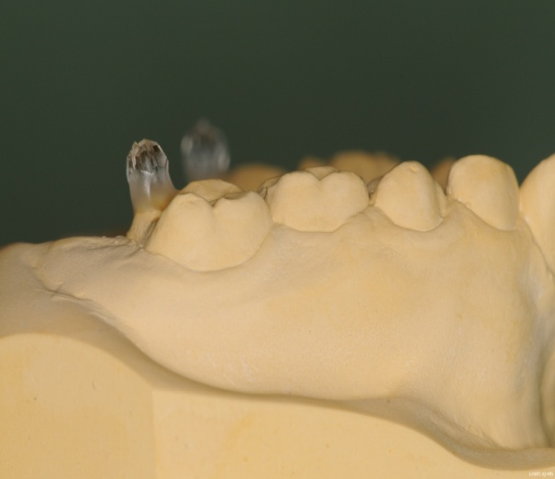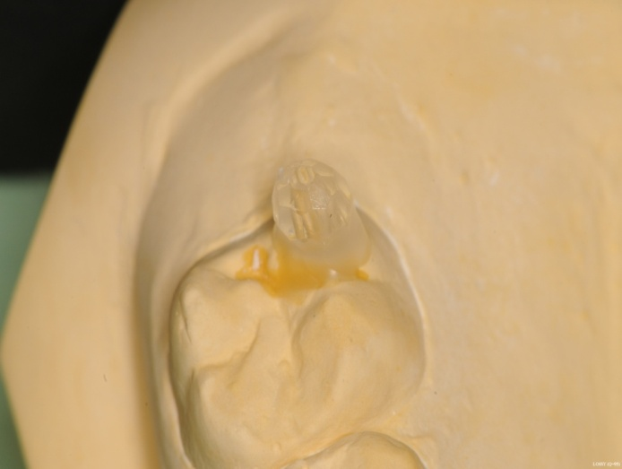

* Remove the upper model from the articulator, coat with separating medium and allow to dry. Pull down a vacuum form blank using Essix 0.75mm ACE material or Erkodur 0.8mm.
* Remove from model, clean away the wax. The bead should be securely retained.
* Trim the upper appliance to a retainer shape with upper 21/12 only half covered on the labial surface to allow the clinician to place brackets on upper 2/2 (or buttons).

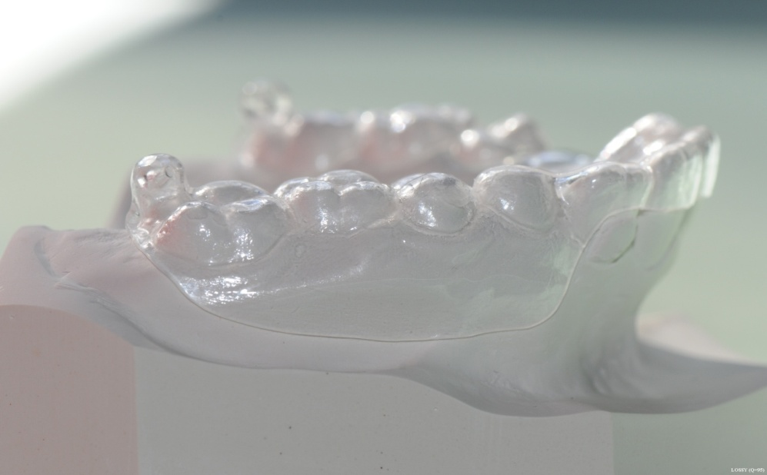

* THIS APPLIANCE IS QUITE DELICATE AND WE ROUTINELY MAKE TWO.
* Construct a vacuum formed retainer from 0.030 inch/ 0.75mm Essix ACE material. Finish to size and return to the model.
* Rearticulate both models the beads on the upper should engage distal to the lower 6/6 and the bite will have opened as a result. Use clear acrylic to build up a thin even posterior bite plane.
* If there are lower second molars and you wish to extend the appliance over them, before curing close the articulator for the bead to indent the acrylic. Reopen and cure the lower appliance only. The lower appliance is very strong and there is no need to make two.
* When cured trim away excess acrylic, produce flat bite planes with the addition of a slight posterior tilt. Remove enough acrylic to allow the bead to centre the occlusion in a class I relationship.
* Remove a window to the buccal of lower 6/6 to allow the placement of tubes or buttons on lower 6/6.
* Polish.

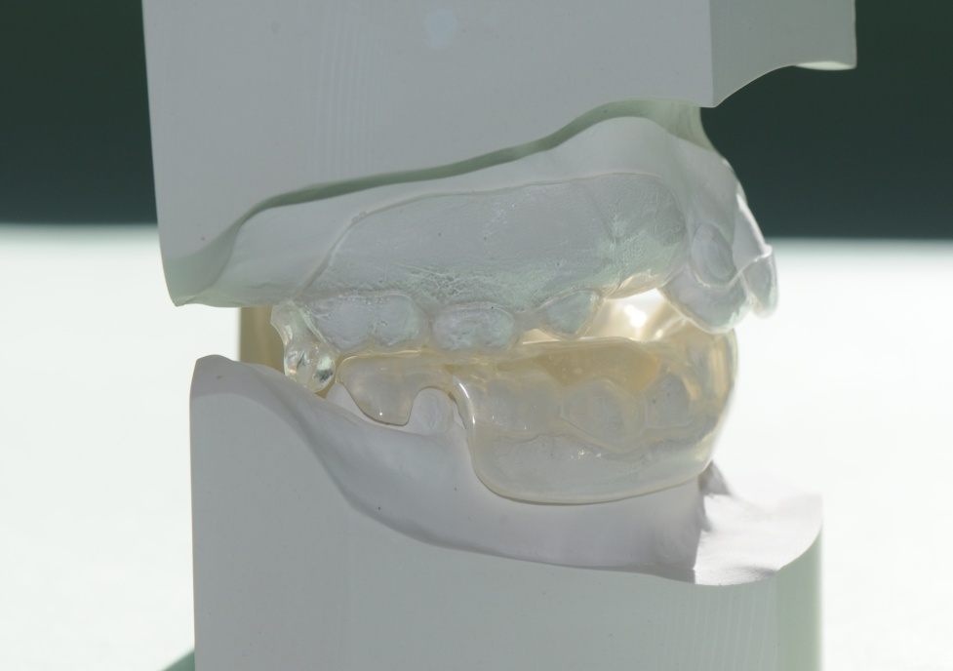

**Clinician**

* Fit splints.
* Bond tubes lower 6/6.
* Bond brackets upper 2/2 or if you wish you can use buttons instead of the tubes and brackets, but, because this appliance works so quickly, it is easier to put the brackets on. You will probably be ready to bond up in 12 weeks
* Use elastics lower 6/6 to upper 2/2 TP ¼” orange 4.5oz
* IMPORTANT RULES

1. NEVER WEAR THE ELASTICS WITHOUT THE SPLINTS
2. IF THE UPPER SPLINT IS DAMAGED AROUND THE UPPER LATERAL INCISOR DO NOT WEAR THE ELASTIC
3. LOW SUGAR DIET AND GOOD BRUSHING IS INPORTANT

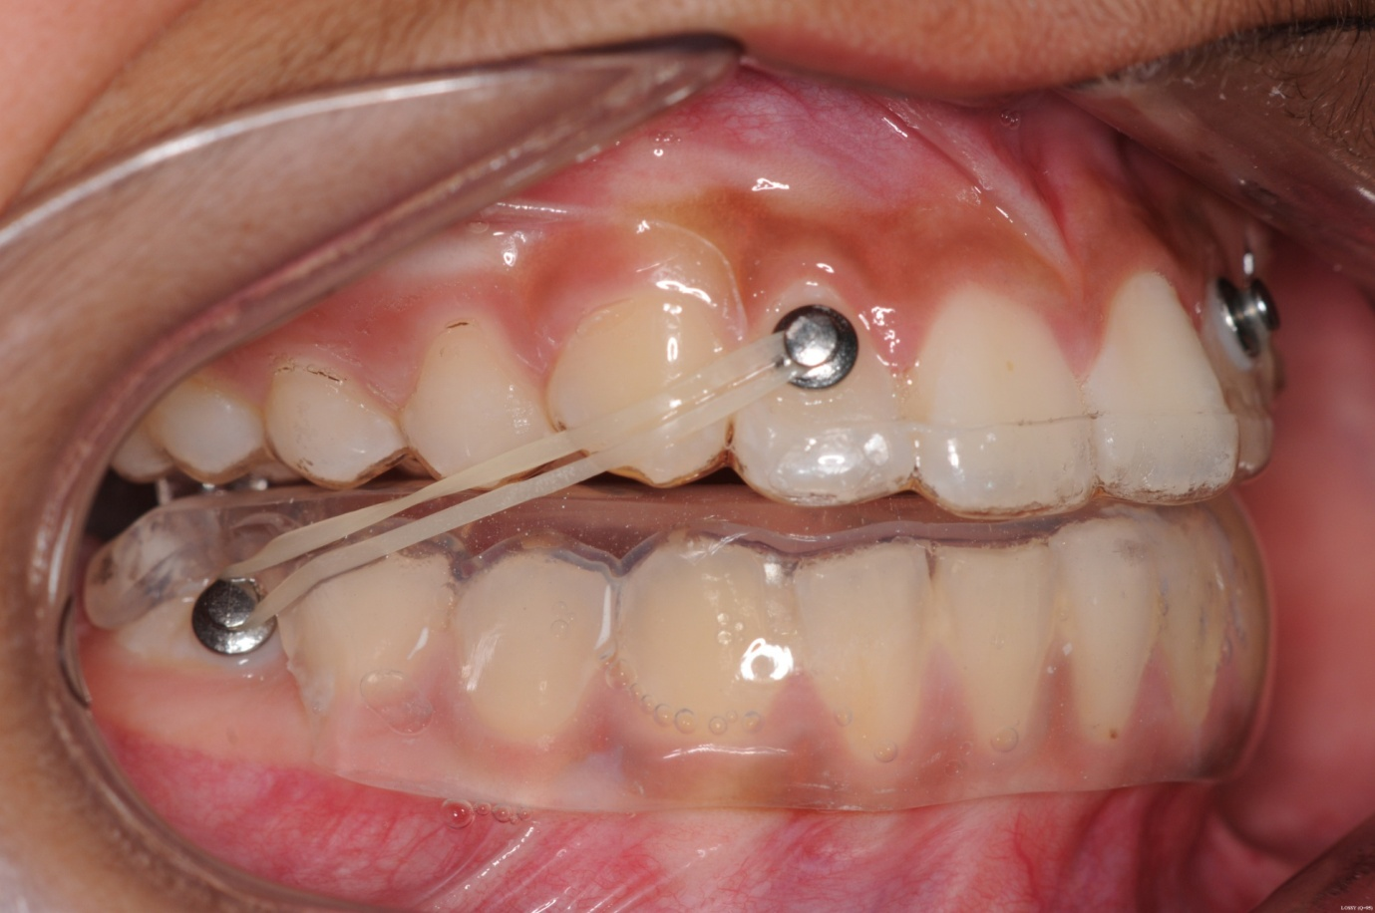

*Transparent Heat resistant blocking out wax from Erkodent supplied by Natt Ltd

Plastic beads PB 101. 4mm from the Spellbound bead company £1 per 100.

[www.**spellboundbead**.**co**.uk/](http://www.spellboundbead.co.uk/)

Advice Pat Watkins Queens Hospital Burton on Trent Tel 01283 56633 dental lab