Help sheet opening the bite with cement on 7s
Indications
All cases where you want to open the bite except where you wish to intrude the upper incisors.
Method
- Bond up pace a tiny little bit of cement on the occlusal surface of the 6s this helps reduce bracket loss, speeds up tooth movement and reduces trauma to the teeth (trauma to the teeth is a significant cause of pain and root resorption) use Poly-F a carboxylate cement the first time you use it you will think it very messy but you need to mix it very very thick so the surface is dry, in fact you can even get the nurse to dust it with a little dry powder so it doesn’t stick to you gloves. (At first your nurse will hate Poly-F it sticks to steel instruments and is hard to remove but keep adding more powder and it becomes a dry ball that you can pick up easily.)
- You don’t need to remove the cement from the 6s it will wear down as you align the teeth. Just work through the archwires until you can get up to 0.019 x 0.025 steel wires at this visit 1. Clean off any remaining cement from the 6s and place a ball of cement on the 7s. You must do this at the start of the visit or the patient will bite on it before it has set. Put a ruler or flat plastic on the incisors and get the patient to close. This should mean that the overbite is reduced to zero. Try to clear off any cement that has spread over the 6s
- Use class II elastics in upper 4s lower5s extraction cases if you have extracted in the upper arch only and you think class II elastics might reduce the overjet too well then use elastic lower 6 to upper 6 and then forward to the traction hook
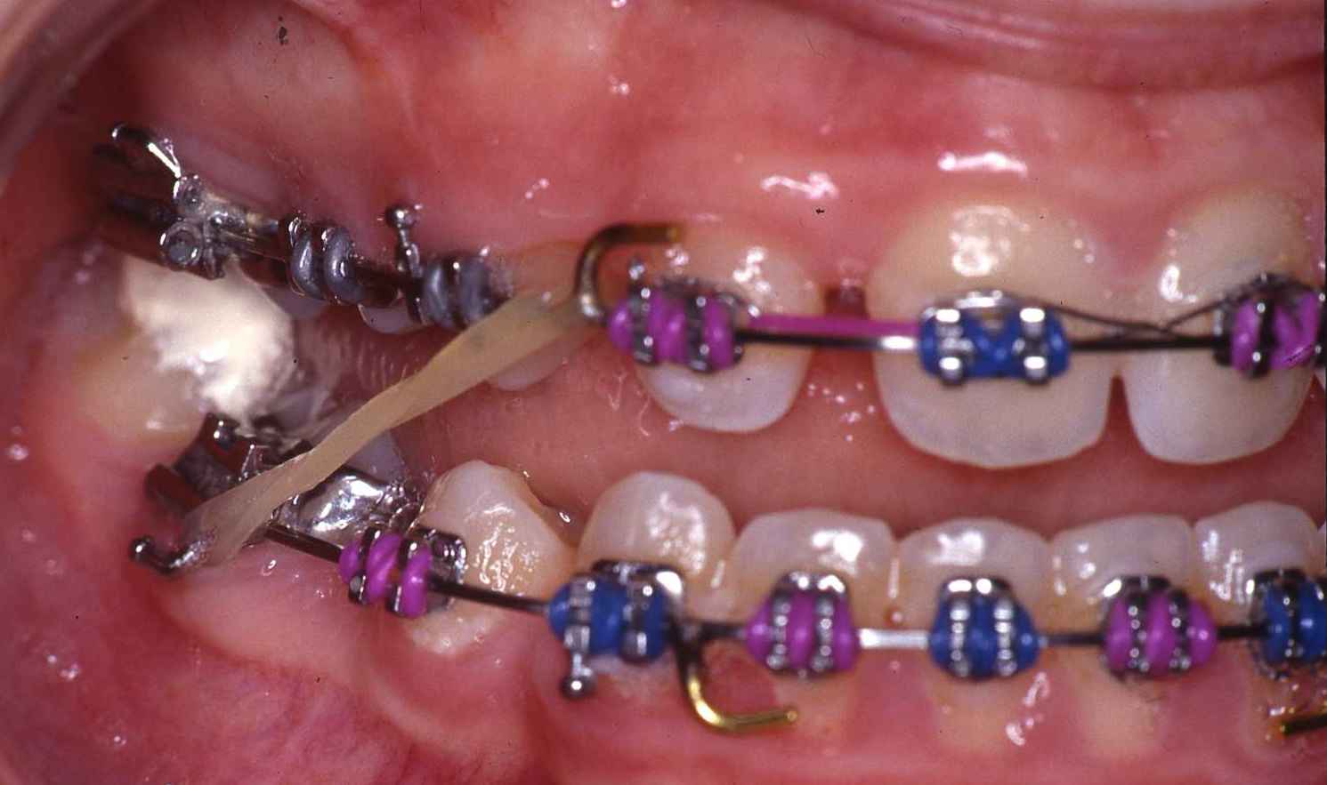
I use TP Orange class II elastics or the green for the L shaped elastics in upper 4s cases.
- The speed of overjet reduction is surprising (providing the patient wears the elastics)
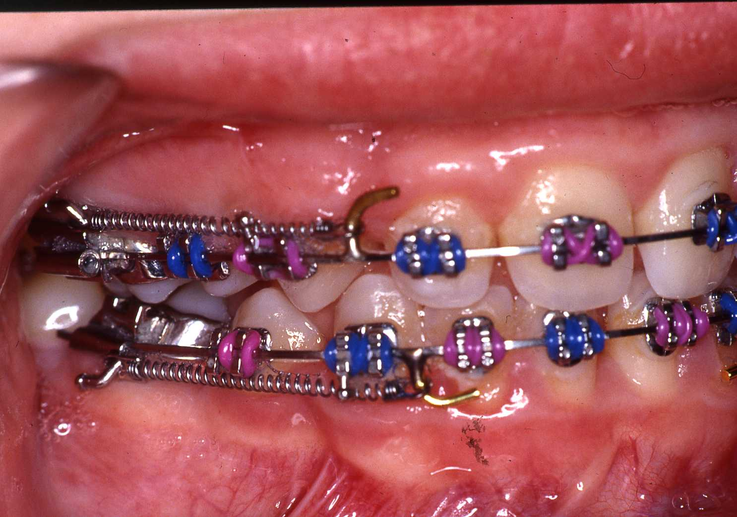
- If you have extracted teeth in the lower arch don’t use intra elastics until the overjet is fully reduced (it will make your molars go class II if you put intra in the upper arch).
- When the overjet and overbite is normal close any remaining space with intra. Remembering that if you have lower space to close you must continue with the class II elastics. You must remove the cement from the 7s now. If you did not take my advice and have used glass Ionomer cement you will now regret it. To remove Poly F cement take a tungsten bur in an air turbine with the water on. Cut a groove down the middle of the cement. Then place a flat plastic in the groove and twist
- Problems. 1. Cement falls off, solution, add more and don’t let the patient leave the chair until it has set hard. This is not such a problem, in very deep bite cases expect to have to add several times.
2. Patient says they cannot eat. Considering I have added to cement to 7s thousands of times you might be surprised that this has only happened a couple of times. Unless the patient was seriously underweight I would advocate a wait and see policy for 6 weeks.
3. 7s intrude. This will only happen in very difficult cases or if you left the cement on too long. If they are going a long way down you might have to remove the cement for a while

