**Long term changes related to orthodontics**

Tutorial 28/3/14 D.J Spary

**Stability and related factors**

Some orthodontic tooth movements are completely stable .For example; let us consider an un-erupted canine impacted between the lateral incisor and the first premolar. Open up the space expose the canine and pull it down into occlusion. After the appliance is removed will it go back up again? No, it is completely stable.

*(I feel obliged to explain a problem with un-erupted canines which does cause some relapse. In most cases the tooth germ of the developing canine is in the correct place, so that the tip of the root apex of an un-erupted canine is in a normal position. However consider a canine that has been deflected into the palate. Now you carry out orthodontic treatment tipping the tooth buccaly. As you do this, the tip of the root apex will tip into the palate. This is because in free tipping a tooth tips about a point one third of the way down the root from the apex. By the time you have the crown in the correct position the tip of the root may be quite palatal. i.e. the tooth is over-torqued. This can cause post treatment palatal movement of the crown. The answer is to torque the roots buccaly. MBT allows for this with an alternative canine bracket with -7⁰ of torque or you can put torque into the wire or there is a very simple reciprocal torquing auxiliary.)*

Other tooth movements are very very unstable. Closing a diastema is the most obvious example. But even this is not quite so simple because the aetiology of a diastema is multi-factorial:

1. Natural spacing
2. The ugly duckling stage (I don’t think we are supposed to call it this anymore but I cannot remember what we are supposed to call it. ( perhaps physiological spacing)

3. Supernumerary tooth between the incisors

4 A persistent labial fraenum

Can you see that the ugly duckling stage is quite different from the other three? It is really caused by crowding pushing the roots of the anterior teeth together and splaying the crowns apart. So supposing I decide to do a little research programme, let us say I have invented a new laser/surgical treatment to remove the incisive fraenum called the “Spary Slice” if I select a cohort of patients in the ugly duckling stage and give them a “Spary slice” hey presto, no relapse after treatment. While the control group all of whom had persistent fraenae all relapsed after orthodontics.

So let’s look in a bit more detail at the problem. A thick fibrous labial fraenum associated with a diastema should be noted in the original assessment and its significance pointed out to the patient and parents. You can try pulling the lip and see if the incisive papilla blanches. This is said to be a sign that the fraenum is particularly thick and fibrous and therefore most likely to cause relapse. (Remember this is not evidence based). You should also look at the occlusion. A crowded case where the two centrals are distally inclined is suggestive of a persistent fraenum causing a diastema while a spaced occlusion may just mean that the fraenum has persisted because the teeth erupted spaced.

**Question1. Does a fraenectomy reduce relapse when you have closed a diastema orthodontically?**

**Answer: Yes but only if the diastema is caused by a thick fleshy persistent fraenum. It will be of no benefit if it not.**

**Question 2. if you do a fraenectomy does it guarantee that a diastema will not relapse?**

**Answer :NO so I would place a PBR (palatal bonded retainer)**

**Question 3. If you place a PBR will the diastema stay closed even if you don’t do a fraenecomy?**

**Answer Yes**

**Question 4. So why do a fraenectomy?**

**Answer: Funny you should say that. I don’t do one very often. I do offer it and of course, the PBR can fall off. But patients usually refuse. The exception is where the fraenum itself is unsightly.**

**Question 5 How do you do a fraenectomy**

**Answer; I do it after I have closed the diastema but while the fixed appliance is still in situ. I incise either side of the fraenum from the gingival margins don to the sulcus depth. Then I remove the tag of tissue from the lip. You need to stitch the lip up but the area under the fraenum is scraped out with a Mitchell’s trimmer to remove all the fibres of the fraenum. (We used to bur them out but I don’t do that anymore) then I cover with Coe-Pak. They can bleed and I have known quite a thick artery in the fraenum which needed bipolar to stop it. Leave it to heal then place a PBR and debond**

**Question 6 how do I do I PBR?**

**Answer: Our next topic has to be rotations and PBRs to deal with rotations are different. For a diastema you can use:**

* **A piece of annealed twistflex wire between 1/ and /1**
* **A little section of gold chain intended for lingual bonding**
* **Two pieces of twistflex**
* **Any of the retainers intended to stop rotations**

**Question 7 I have never done a PBR before can you teach me to do one that will not drop off?**

**Answer: yes but will you listen?**

Here goes

For A diastema take a bit of thin twistflex ideally 0.015 about 8mm long and heat over a cigarette lighter flame until dull red. This anneals the wire so it is dead soft. Then clean behind the upper incisors using a composite removing bur. Don’t use a brush or rubber cup or you will make the papilla bleed. Use cotton wool rolls to isolate the area. Etch with phosphoric acid for 30 seconds. Rinse and dry using a triple syringe and a hair dryer (yes really and you might look stupid if you use it, but you will be stupid if you don’t) and then place resin on the dry surface. Place the piece of twist flex on the tooth if you are right handed hold it onto the left central so that you can bond it to the right. Then add flowable composite over the twistflex. Because the wire is dead soft you can now bend the twistflex to the correct position on the leftt central using a tucker. Now cover the wire with more flowable composite. Now you need some articulating paper the PBR must be placed out of occlusion. Note, you do not need to bend the end of the twistflex into a funny hook at the end. The composite sticks to the twistflex. Some people advocate the use of two pieces of twistflex parallel to each other. Do you see the idea behind this? The idea is that if you have a single piece that might un-wind causing altered torque on the two incisors. Actually this s not going to happen if you anneal the wire. But if you use two pieces then certainly it can not happen. *Learn more about PBRs after rotations.*

**Question 8 Do I need an Essix retainer as well**

**Answer: Yes always. It must be spaced behind upper 1/1 and get the patient to sign a contract saying that they understand that they must wear the Essix every night for a year and then 1 night per week. And if the PBR is lost they will wear the Essix full-time until they see you.**

**After diastemas the next type of malocclusion most prone to relapse is rotation.**

Let’s go back to the British orthodontics of the 1960s. People were not so fussy in those days, they wanted a normal overjet and 6 straight upper front teeth. Treatment: Extract if necessary usually upper 4//4. Retract canines with URA1 then retract 21/12 with URA2. BUT if there were rotated teeth at the end put metal bands with brackets on upper 21/12 and use twin wire arches or later twistflex to align the teeth. **BIG PROBLEM AFTER TREATMENT THE ROTATED TEETH RELAPSED.**

Reitan claimed to know why this was Angle orthodontist 1959 showed that while almost all the fibres of the periodontal membrane had reorganised after 20 weeks the superficial ones had not.this was in dogs. At this point you may be wondering how you retained these rotations. **There were no bonded retainers in use until about 1978** . You had a Hawley retainer and you could make a metal band with wings on a single rotated tooth (but patients did not like these)

Begg came along after 1971 and it was different. The first arch had multi-loop arches with over-rotation bends so that each rotated tooth was rotated by an equal and opposite amount. This was held throughout the whole treatment so perhaps this is why Begg cases relapsed less



This table comes from Reitan. note the fibres in the Marginal region were only partly reorganised after 8 months (I assume after this they had run out of dogs)

Edwards AJO 1970 57pages 35-46

Is the dream piece of research. He took individuals where 4s were going to be extracted and tattooed 4 little marks vertically of tattoo marks on the gingivae. Then he put on fixed appliances and rotated the teeth. This distorted the line of tattoo marks. He held it for a while and the tattoo marks stayed twisted. Then he cut the superficial gingival fibres and within a few days the line had returned to their original vertical position.

Can you see how satisfying this is?

Reitan provided the basic research. Edwards uses this understanding of the biologic principles and devises a treatment that is clearly going to relieve the un-stabilising effects of the superficial free gingival fibres. Nobody really understands how these work. They do not seem to be different from the rest of the fibres of the periodontal membrane and are not elastic in the way that the walls of arteries are. They do contain some oxytalin fibres which stain like elastic fibres but may not actually be elastic.

Edward’s new treatment was called Pericision or circumcision (yes really) or fiberotomy. It was the TAD of its day everyone loved it.

**NOW READ TANER *et al* AJODO 2000 118 pages 617-623**

10 minutes

Answer these question A

* **The treatment time for one group (the treatment group) was significantly longer than the control group. Could that be significant?**
* **Crowding increased betweenT2 and T3 when retainers were worn full time .Can you explain this?**
* **Does this retention regime replicate the one in your unit?**
* **Does the Little irregularity score equate with rotations of the teeth?**
* **Are the conclusions of this paper justified?**

Edwards himself gives us a long term evaluation of circumferential super-crestal fibrotomy

**NOW READ AJODO 1988 VOL 93 pages 380-387**

10 minutes

Now answer these questions B

1. **Were the examiners who measured Little’s irregularity score blinded as to the type of treatment?**
2. **What are the chances of 320 consecutively treated patients returning for review after 15 years?**
3. **What was the retention regime and is it typical of the regime in your unit?**
4. **How much of the irregularity was rotation?**
5. **Did fibrotomy stop relapse, reduce it or make no difference?**

I think a fair conclusion to the fibrotomy saga is:<***Fibrotomy reduces the risk of relapse of rotations in a case where no retainers are being worn***>”1970 and Edward’s original paper is quite a long time ago now. Of course the basic biology has not changed but orthodontics has. The first I heard about palatal bonded retainer was in the JCO 1978 Bjorn Zachrisson this is a significant year for British orthodontics. In January 1978 I and most British orthodontists were banding all our cases i.e. even the incisors were separated and a metal band was placed around each tooth with a plain edgewise bracket. Only a few quick cases had bonded clear acrylic brackets which were stuck using an acid etch technique. The bracket base was dipped into liquid monomer and then touched into powdered acrylic and then dipped into monomer again and placed onto the tooth surface. It seemed like a miracle; but the brackets were not really strong enough to do any more than a basic alignment. During the year we were introduced to metal brackets with mesh bases that could be bonded to the teeth and much stronger Bis-GMA resins such as concise a two mix adhesive system. By December I had said goodbye to bands on everything except molars and this was true of almost every orthodontist. (Although some kept premolar bands for a few years). Up to 1978 lower retainers meant keeping bands on lower 3/3 with a piece of wire soldered between them like a little lingual arch

**Bis-GMA resins and twistflex wire made a bonded retainer a possibility**

If you fit a bonded retainer rotated teeth will not relapse at least until the retainer falls off. Now Reitan’s research seems inadequate. If a PBR is on for 3 years will the fibres have remodelled?

This brings us to the next change. In 1970 we were not too fussed with consent, but now you can’t just do a fiberotomy. So how does this sound:

“**I am going to give you a lot of injections, including the very painful palatal injections and cut round your teeth with a scalpel. This would reduce the chances of rotated teeth relapsing. Although they will not relapse in any case because I will be placing a palatal bonded retainer and giving you an Essix retainer.” It probably won’t damage your gums although there has not been a long term follow up and you will not bleed much”**

Magic yourself back to being 13 again what do you think have the pericision or just rely on the PBR?

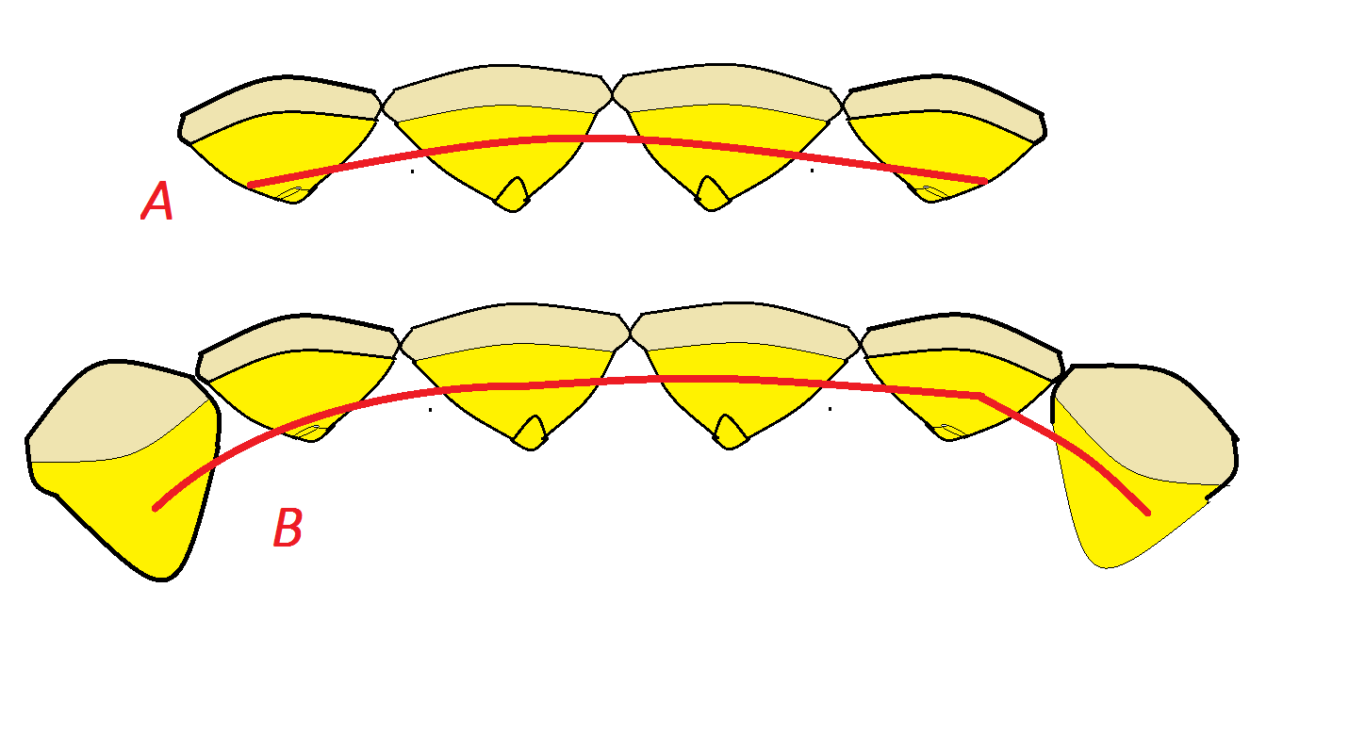

There are two ways of making a satisfactory PBR to control rotated lateral incisors.

**A** Take a piece of multi-strand wire (e.g. twistflex or wild cat wire) and bend it into a curve a little tighter than you need then flatten out the curve until it lies in the correct place. DO NOT ANNEAL THE WIRE. Clean the tooth by running a composite removal bur over the palatal surface. You do need to get rid of any staining. Don’t make the gums bleed. Etch for 30 seconds, rinse and dry. (Go on use a hair dryer) paint with resin trying not to get the resin between the teeth. Place the bit of multi-strand wire and hold in place on just one tooth. Shine the light. The wire should now stay in place it should be passive and touching every tooth. Add flowable composite over each tooth/wire contact spot and allow it to flow smooth. Check the occlusion with articulating paper. Take an alginate impression over the PBR with instructions to the technician. Essix retainer spaced behind upper 21/12. The patient should wear the Essix retainer every night for 1 year then every other night for one month then one night per week for at least 5 years. If the PBR comes off or breaks they should wear the PBR full time except for brushing and eating and return ASAP for a replacement PBR.

**B if** you want to use the gold chain type of PBR or annealed twistflex you have to extend past the lateral incisors onto the canines. The laterals cannot rotate because the material will not allow a space to open between the lateral and the adjacent tooth. Bonding instructions remain the same.

[](http://www.google.co.uk/url?sa=i&rct=j&q=&esrc=s&source=images&cd=&cad=rja&uact=8&docid=8SI6K6sq6U6IbM&tbnid=xnflTE8uKspH3M:&ved=0CAYQjRw&url=http://www.bbc.co.uk/news/business-13455691&ei=g2QjU92RC6ie0QWFkYCwBQ&bvm=bv.62922401,d.d2k&psig=AFQjCNF2FjuoNKH3xMtUWkN2tvYUFV7kFQ&ust=1394914795860989)

So far we have considered Diastemas and rotation but now we must get to the big issue:

Crowding

Crowding a potted history

* Edward Angle did not believe in extraction of teeth and denounced colleagues who advocated extractions as guilty of malpractice.
* Begg attributed crowding to a lack of attrition and advocated extraction.
* Tweed treated cases according to Angles maxims but found only 20% were stable.
* Retreatment of these cases with extraction gave improved stability.
* Little looked at cases treated (by others) at the university of Washington

**NOW read chapter 6 of retention and stability in orthodontics by Nanda and Burstone**

**“stability and relapse of dental arch alignment” by Robert M Little**

**Now answer questions C**

* **Did the crowding effects continue after the age of 30?**
* **Which group showed the greatest increase in crowding?**
* **Was the decision made to extract teeth made at random?**
* **What happened to the spacing group**
* **What archform does Little suggest?**

So Little suggests that extraction cases have a 70% risk of relapse and treatment by arch expansion has a 90% risk of relapse but even patients with normal occlusions showed shortening and constriction of the arch (worse in females) with resultant crowding and even people with spaced occlusions could finish up crowded.

[](https://www.google.co.uk/url?sa=i&rct=j&q=&esrc=s&source=images&cd=&cad=rja&uact=8&docid=u6e7zbsgmK0i5M&tbnid=Dxz391tqi0kpyM:&ved=0CAYQjRw&url=https://www.cashflownavigator.com/blog&ei=D7AkU-ieKcTB0gXT5oHwAw&bvm=bv.62922401,d.d2k&psig=AFQjCNHfBf2i6zodmT8P1Bnz-3qUWukIsg&ust=1394999668341227)

-a minute. Before we go further should you consult, your beloved parents, your partner, your admirer, your parole officer, your cell mate (tick applicable). Is this their experience of life? Are their teeth on a downhill slide or is this “much ado about Little”.

Cyril Sadowsky looked at long term results in Chicago 20 years after orthodontic treatment 33% had worse lower incisor crowding 20 years after treatment than they did at the start extraction and non extraction made no difference (but I guess the extraction cases were more severe at the start otherwise why the extractions). The results were very variable but on average Overjet and crowding were reduced from the original value despite some relapse. Overall his results are more favourable than Bob Little’s but not much.

Suggested useful tips (J Gorman) are: don’t increase the inter-canine width. Strip the lower incisors to give broad contact points. Try to finish with the lower incisors upright at 90⁰.Create a flat occlusal plane. Retain until all growth has ceased. Carry out a fibrotomy on rotated teeth and fit retainers on the day of debond. But let’s be honest if you want to be sure the teeth will not relapse keep on wearing those retainers

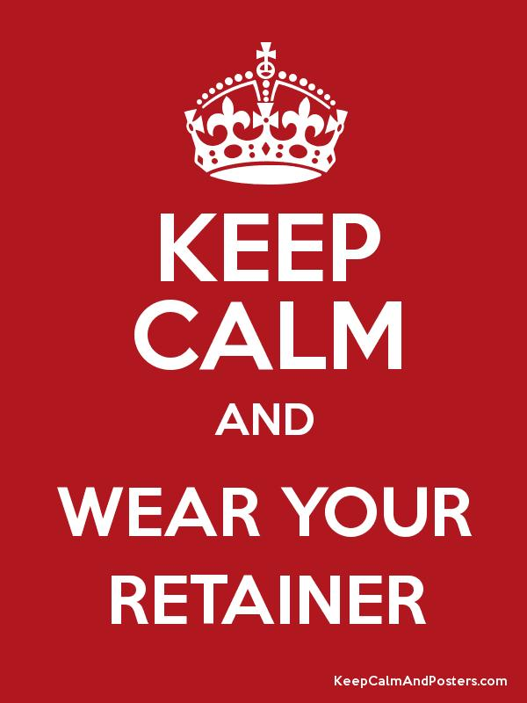

So far we have struggled with diastemas, rotation and crowding we still have open bite deep bite, increased overjet and reverse overjet to go. Honestly I’d make a run for it.

[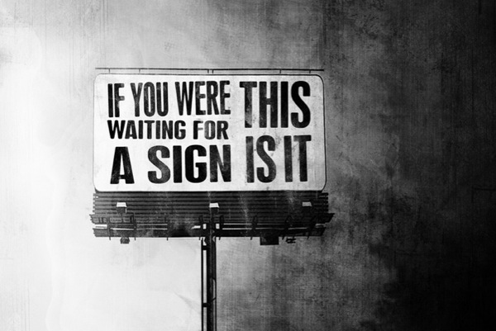](http://www.google.co.uk/url?sa=i&rct=j&q=&esrc=s&source=images&cd=&cad=rja&uact=8&docid=3QH50c_FBEzuWM&tbnid=yNlBq_Ky9UCPgM:&ved=0CAYQjRw&url=http://www.eatlearndiscover.com/2012/01/26/dont-just-exist-live/&ei=G7wkU-TODaWV0QWAroCwBg&psig=AFQjCNEy5jbvSMjze6MKlv7rS9NwBjbtGQ&ust=1395002521452759)

Lopez- Gavito *et al* AJO 87 p175-135

Abstract on AOB

Long-term response of the anterior open-bite malocclusion was evaluated in forty-one white subjects who had undergone orthodontic treatment and were out of retention a minimum of 9 years 6 months. The purpose of the study was threefold: (1) To make cephalometric comparisons between a sample of open-bite patients and a sample with normal cephalometric standards,

(2) To evaluate treatment and post-treatment changes that occurred in treated open-bite patients, and

(3) To search for predictors and associations of value. Changes occurring across time in the open-bite patients were analyzed by computer means using pre-treatment, post-treatment, and long-term cephalometric radiographs and dental casts. An analysis of subgroups was reviewed to compare dento-alveolar and skeletal relationships of both stable and relapse groups.

**More than 35% of the treated open-bite patients demonstrated a post-retention open bite of 3 mm or more,** with the relapse subgroup demonstrating across-time, less mandibular anterior dental height, less upper anterior facial height, greater lower anterior facial height, and less posterior facial height.

**Neither the magnitude of pre-treatment open bite, mandibular plane angle, nor any other single parameter of dento-facial form proved to be a reliable predictor of post-treatment stability.**

So once again we are swimming in a sea of uncertainty. I would like you to note:

* **You can close AOBs without TADs or surgery**
* Even **with just orthodontics 65% remained stable**
* Nothing on the start Ceph was a reliable predictor of stability

The problem is AOB is multi-factorial. **If the patient’s complaint is a long face they need surgery**

If they have a thumb sucking habit and a lack of incisal show they need something to stop the habit and appliances to extrude the teeth

If you want to get a publication to add to your c.v. put in a few TADs and get the patient to wear elastics upper 1/1 lower 1/1 to close the AOB (sorry I am being cynical)

Otherwise you’re on your own

**Deep bite**



**Here are some general views that you can put forward in MOrth exams**

* If you fit a growing child with an anterior Bite plane there will of course be an instant increase in the lower face height. At the same time there will be eruption of the molars and perhaps in some cases a little intrusion of the lower incisors. With time natural growth occurs and a general remodelling takes place so that there is no difference in the lower face height.
* The official story is that you should not open the bite in adults by extruding the molars as this will increase the lower face height and gradually after treatment remodelling of the mandible would take place. (actually it starts straight away so it if often complete by debond) This would mean the bite opening would not be stable unless the patient was wearing a retainer, which if you have just read diastemas, rotation and crowding you might think would be a bright idea anyway.(It would have to be an Essix type retainer, a bonded lower 3-3 retainer would not retain overbite as the curve of Spee could still re-establish itself)

The extraordinary thing is the lack of research in this field; certainly Nanda and Burzin have shown that you can open the bite by intruding the incisors. They imply that extrusion of the molars is a bad thing as it will rotate the mandible back, but they do not offer any evidence that this is a problem and remember as a rule deep bites occur in low angle cases so you might think a little backwards rotation would be a spiffingly good idea. You have got to like F F Schudy, AO 1968 page 19-37, often cited as saying that the ability to open the bite is related to the increase in lower face height. He also says bite opening by molar extrusion is stable, but that by intrusion of the lower incisors is not. That functional appliances do not open the bite and my favourite bit (Fig 15 if you want to look it up). I quote “four premolars were removed not to relieve crowding but to reduce dental height, however anterior dental height increased by 7mm despite our efforts, **one shudders to think what would have happened if the wrong procedures had been used**” they just aren’t writing papers like this anymore, well done FF.

* One of the factors which stops overbite increasing after orthodontics is the inter-incisal angle, remember the normal is 135⁰. Bill Houston found a way to describe the same thing in a different way relating the midpoint of the root of the upper central incisor (centroid) to the tip of the lower incisor. If you drop a point from centroid perpendicular to the occlusal plane if it lies behind the tip of the lower incisor then the overbite is more likely to be stable.
* The degree of proclination of the lower incisors can be an issue here. If the lower incisors have been proclined as a result of orthodontic treatment and then drop back. This will remove incisor contact and the incisor teeth can erupt increasing the overbite. Looks like retainers then.

[](http://www.google.co.uk/url?sa=t&rct=j&q=&esrc=s&source=images&cd=&cad=rja&uact=8&ved=0CAQQjRw&url=http://www.beano.com/characters/bash-street-kids/cast/bash-street-kids-plug&ei=eGEnU8StOYiJ0AWl6oGYAw&usg=AFQjCNFG8PTEH-04FpEYHmKdQnyMCY6EYQ&bvm=bv.62922401,d.d2k)

Overjet

**Now read Nashed and Reynolds BJO vol 16 1989 p31-37 (10 minutes)**

**answer the following questions D**

* Could you repeat this research in the UK today?
* From the fig how many of the 50 cases finished with an overjet of 0-2mm?
* How many of the cases were treated with functional appliances?
* How does the fixed appliance treatment carried out in the majority of cases differ from modern fixed appliance treatment?
* The group where it was not possible to reduce the overjet had a different overbite to the successful overjet reduction group. What was the difference and was it statistically significant?
* Can you suggest some reason why the Begg Appliance seemed more successful?

I remember being quite shocked when I read this paper in 1989 and feeling that this did not represent my experience of orthodontic treatment. In those days retention was 1 year full time then 1 year night only then stop and review after a year.

The authors quote Calvert also from the Eastman looking at functionals 1 year out of retention and finding the overjet went from 8.7mm before treatment to 4.1 mm one year out of retention. Sadowsky shows OJ reduction from 4.5 to 2 increasing to 2.5 out of retention but the start overjet is only very slightly increased and the post treatment change may be rather more due to a return of crowding than relapse of overjet.

1.

Times have changed a bit and we probably would not treat these cases the same way. More would have surgery. Functional appliances would be different and I doubt if they would go for Begg and if they did it would be a different extraction pattern

2. The usual problem, that is, that relapse is multi-factorial. So possible causes might include:

* They could be a thumb sucker who still sucks their thumb
* Upper incisors out of control of lower lip (vertical, that is to say the active lip line is below the tip of the upper incisor)
* The overjet was not fully reduced so that the lip could get behind the upper incisors
* The bite was not correct i.e. not in RCP
* The lower incisors had been over proclined and had dropped back
* Tongue thrust
* Condylar resorption
* Did not wear retainers for a sufficient time.
* I suppose we should take a moment to consider why Begg cases seemed to be more stable. This may be because proper extraction Begg. (Not the non extraction upper Begg lower straight wire which is not real proper Begg as described by P R Begg) reduces the overjet and overbite at the beginning of stage 1 and it is held at normal or even reduced for the whole of the rest of the treatment. In effect it has been in retention for a year before debond.

I suppose I should have included growth, but growth is more relevant to our next topic, which would be the relapse of class III malocclusions.



Apart from pathology, skeletal pattern is the principal aetiological factor in class III malocclusions. So that further growth is of great importance in post treatment change in class iii malocclusions. Although we should start by saying that class I and even class II cases treated to a normal overjet and overbite can develop into class III malocclusions if the forward growth of the mandible greatly exceeds that of the maxilla.

The concern over the effects of growth in class III cases was so great that there is a school of thought that you should not start orthodontic treatment in class III cases until the patient is 15 years of age. The fear was that the patient would grow more skeletal III and would require surgical treatment and that this surgical treatment would have been compromised by the treatment carried out.

A degree of common sense is called for. If the skeletal base is not very severe and the treatment requires a non extraction alignment of the upper incisors in a girl with no family history of a severe skeletal III base it seems unkind to delay treatment. However the reckless extraction of a lower incisor in a boy with a family history of severe class III malocclusions should be condemned

Although I do not approve of the work of Mandall *et al* in their papers of treatment of class III malocclusions with RME and protrusion headgear, this is because the start radiographs are not taken in RCP and therefore statistical evaluation (which tells you the probability that a difference did not occur by chance) is not relevant when you know the radiographs are taken with the mandible held in a different position. (Imagine if I tried to publish a paper on the treatment of asymmetry if I used start radiographs with patients holding their mandibles to one side). There has been a renewed interest in the early treatment of class III cases and I feel this is a good thing.

Post treatment growth is a problem in class III cases. They can go edge to edge or even relapse into class III cases

You may read CLASS III OVERBITE + STABILITY. This is true when pushing incisors over the bite in class I or mild class III cases. But if you are doing orthodontic camouflage in a case that should really have had surgery. You need to go for reduced overbite or even edge to edge.

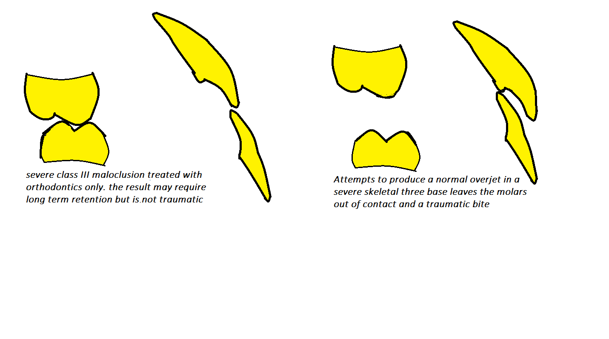

**Growth changes**

**Now read Lewis and Roche 1988 A O 58 127-135 late growth changes 15 minutes**

Now answer these questions E

* In class III cases we are interested in the length of the jaw Lewis and Roche use Articulare to Gnathion what do you think of this measure and at what age does it reach its maximum?
* What is the increase in Ar-Gn from 18 to maximum give mean and range?
* How much anterior movement of the chin does this represent?
* How much does the Nasion move forwards relative to S and how much anterior movement does that represent?
* Does the maxilla move forwards?

There are a few more aspects of growth that you might like to consider. Bjork in his consideration of growth rotation offer some advice in patients with a closing type of growth rotation you could fit an appliance with an anterior bite plane as this might alter the centre of rotation of the growth rotation. While in high angle cases some types of treatment would be undesirable. Nanda looks at the timing of the growth spurt in various types of malocclusion and find deep bite cases reach their growth spurt later. The suggestion is that retention should be prolonged, but now we believe in retention forever I doubt this matters.

**Long term benefits from orthodontics**

I do not know how much to write on this.

The increased demand for orthodontic treatment suggests that people value straight teeth. There is of course the research about teasing and bullying; but Bill Shaw says if I tell you about that he will beat me up. In fact everyone knows how important it is. Just imagine your upper central incisor fell out leaving just a space of 9mm, would you be embarrassed to go out? You bet!

And you don’t know who will be the next president of the USA or British Prime minister but I bet they will have straight teeth.

**Iatrogenic damage related to orthodontics**

Please read the consent doc with references on **burtonortho.co.uk**

You will note it does not give the uses and risks associated with TADs

Perhaps we should add them I would suggest

uses

* Certainly they can reduce the need for patients to wear elastics.
* They may also reduce the need for headgear.
* They can intrude single over erupted upper posterior teeth.

People say, but I do not consider it proven that they can

* Change class II molars to class I
* Close AOBs by intruding the molars
* Close more than a single unit of space in the lower jaw

*Would you like to add some more?*

Risks

* They can fall out
* They can hurt when placed
* The local anaesthetic can hurt or you can have a reaction to it
* When placed they can damage the roots of teeth
* They can move under load and hit the roots of the teeth
* You could hit an artery or nerve during placement
* The TAD could break leaving a part stuck in the bone

**Some more abstracts for you to read**

De la Cruz *et al* AJODO 1995 vol 107 518-530

* The purpose of this study was to evaluate the long-term stability of orthodontically induced changes in maxillary and mandibular arch form. Dental casts were evaluated before treatment, after treatment, and a minimum of 10 years after retention for 45 patients with Class I and 42 Class II, Division 1 malocclusions who received four first premolar extraction treatment. Computer generated arch forms were used to assess changes in arch shape over time. Buccal cusp tips of first molars, premolars, and canines plus mesial, distal, and central incisal aspects of incisors were marked, photocopied, and digitized in a standardized manner. An algorithm was used to fit conic sections to the digitized points. The shape of the fitted conics at each time period was described by calculating the parameter eccentricity; a small value represented a more rounded shape and a larger value represented a more tapered shape. Findings demonstrated a rounding of arch form during treatment followed by a change to more tapered. Arch form tended to return toward the pre-treatment shape after retention. The greater the treatment change, the greater the tendency for post-retention change. However, individual variation was considerable. **The patient's pre-treatment arch form appeared to be the best guide to future arch form stability, but minimizing treatment change was no guarantee of post-retention stability.** (AM J ORTHOD DENTOFAC ORTHOP 1995;107:518-30.)

Ades  *et al*  AJO 97 323-335 on third molars

The purpose of this study is to determine the relationship of third molars to changes in the mandibular dental arch. The sample for this study consisted of four groups and subgroups. The groups consisted of premolar extraction treated, non-extraction treated with initial generalized spacing, non-extraction treated, and serial extraction untreated subjects. The subgroups were divided into persons who had mandibular third molars that were either impacted, erupted into function, congenitally absent, or extracted at least 10 years before post-retention records. The mean post-retention time interval was 13 years, with a range of 10 to 28 years. The mean post-retention age was 28 years 6 months, with a range of 18 years 6 months to 39 years 4 months. Two-way analysis of variance with repeated measures was used to compare the changes over time (before treatment, at end of active treatment, and after retention) of groups and third molar subgroups. With time, mandibular incisor irregularity increased while arch length and inter-canine width decreased. The eruption patterns of mandibular incisors and first molars were similarly dispersed in all groups studied. The findings between the subgroups in which mandibular third molars were impacted, erupted into function, congenitally absent, or extracted 10 years before post-retention records revealed no significant differences between any of the subgroups for the parameters studied. No significant differences in mandibular growth were found between the third molar subgroups; this suggests **that persons with third molars erupted into satisfactory function do not have a significantly different mandibular growth pattern than those whose third molars are impacted or congenitally missing.** In the majority of cases some degree of mandibular incisor crowding took place after retention, but **this change was not significantly different between third molar subgroups. This finding suggests that the recommendation for mandibular third molar removal with the objective of alleviating or preventing mandibular incisor irregularity may not be justified.**



And now we find that minds immeasurably superior to ours had already written this stuff.

**Now read Blake and Bibby 1998 AJODO114 299-306**

And answer questions F

* Incisor irregularity increases in teenage years is it worse in males or females?
* Haas claims that if you expand the upper arch using RME some lower arch expansion is stable. How much and did Moussa confirm this?
* What did De La Cruz suggest is the best archform?
* What did Peck and Peck advocate as a treatment to reduce lower arch crowding? Did Gilmore and Little find this to be true?
* Does the presence of lower third molars increase lower arch crowding?

Finally consider

**Special considerations associated with surgical change**

Yes it is true surgical cases relapse as well. Underlying all the problems of orthodontic relapse and the need to wear retainers there is the concern of surgical relapse:

* In class III cases try to avoid large backwards movement of the mandible with no forward movement of the maxilla. Where is the tongue going to go? I am convinced that the cases where the mandible moves back say 6-10mm and the Maxilla moves forward 4-6 gives the best stability.
* Epker and Fish do not like orthodontic expansion in their surgical cases as they say it is responsible for relapse ( I am not sure I agree but I give you their views.
* Of course the best solution is to have a really good surgeon and I should say I have been blessed. They have all been very careful, no distorted nasal septum and no widening of the nostrils (It’s not the operation it is the surgeon)
* I think the agreed best op for long faces is setting the maxilla up and this seems to work. I am aware that there has been renewed interest in mandibular procedures but I am happy to wait until these have been fully evaluated
* Surgical relapse of class III cases can be due to inadequate decompensation or continued growth. To procline the lower incisors



* Should plates be removed? No unless there is infection or sometimes they can cause irritation e.g. by rubbing on glasses
* Long term nerve damage very rare in lingual nerve but parasthesia of the lower lip can be a real problem probably worse than true anaesthesia
* Condylar resorption Hoppenreijs *et al* 7.7% unilateral condylar resorption and 7.7% bilateral condylar resorption. condylar contours, as assessed on orthopantomographic radiographs, were classified as five different types. Condyles with pre-existing radiological signs of osteo-arthrosis or having a posterior inclination were at high risk for progressive resorption. **Female patients with severe anterior open bite, high mandibular plane angle and a low posterior-to-anterior facial height ratio, who underwent a bimaxillary osteotomy, were prone to condylar resorption.** Bone loss was predominantly found at the anterior site of the condyle. The incidence of condylar resorption was significantly higher after bimaxillary osteotomies (23%) than after only Le Fort I intrusion osteotomies (9%). Avoidance of intermaxillary fixation by using rigid internal fixation tended to reduce condylar changes, in particular in patients who underwent only a Le Fort I osteotomy. Rigid internal fixation in bimaxillary osteotomies resulted in condylar remodelling in 30% and progressive condylar resorption in 19% of the patients
* Relapse especially relapse of AOB .Yes AOB cases relapse after surgery

**Long term wear of retainers benefits and costs**

Answer these question A (Taner)

* **The treatment time for one group ( the treatment group) was significantly longer than the control group. Could that be significant? Possible but unlikely**
* **Crowding increased betweenT2 and T3 when retainers were worn full time .can you explain this. Retainers poor fit or not worn all the time**
* **Does this retention regime replicate the one in your unit no**
* **Does the Little irregularity score equate with rotations of the teeth no**
* **Are the conclusions of this paper justified I think they are fair but the retention procedures have changed since**

Edwards himself gives us a long term evaluation of circumferential supre-crestal fibrotomy

NOW READ AJODO 1988 VOL 93 pages 380-387

10 minutes

Now answer these questions B (Edwards)

1. **Were the examiners who measured Little’s irregularity score blinded as to the type of treatment? It does not say they were this may be a concern because Edwards devised the procedure**
2. **What are the chances of 320 consecutively treated patients returning for review after 15 years Zero we need the drop out figures.**
3. **What was the retention regime and is it typical of the regime in your unit no**
4. **How much of the irregularity was rotation we have no way of telling**
5. **Did fibrotomy stop relapse, reduce it or make no difference**

**Now answer questions C (Little)**

* **Did the crowding effects continue after the age of 30? Yes but slower**
* **Which group showed the greatest increase in crowding arch developement**
* **Was the decision made to extract teeth made at random? No the decision was made based on the crowding**
* **What happened to the spacing group it had the best arch alignment at the end but again unpredictable and prone to crowding**
* **What ARCHFORM DOES Little suggest? One based on the pre-treatment models**

**Questions D (Nashed)**

* Could you repeat this research in the UK today? A No it would not get ethical approval because it means stopping retention after a year
* From fig how many of the 50 cases finished with an overjet of 0-2mm A only 3
* How many of the cases were treated with functional appliances A none and yet today most orthodontists would fit functional appliances to these cases
* How does the fixed appliance treatment carried out in the majority of cases differ from modern fixed appliance treatment A plain edgewise cases with very little use of rectangular wire some Begg cases and some removable appliances
* The group where it was not possible to reduce the overjet had a different overbite to the successful overjet reduction group. What was the difference and was it statistically significant. A overbite reduction was much greater in the successful group and this was the only difference significant at the p = 0.001 level
* Can you suggest some reason why the Begg Appliance seemed more successful? A it is better at opening the bite, it reduces the overjet within the first 6 months and holds the reduced overjet for 1 year before debond

Now answer these questions E (lewis)

* In class III cases we are interested in the length of the jaw Lewis and Roche use Articulare to Gnathion what do you think of this measure and at what age does it reach its maximum? A Articulare is not a real point and is unreliable if the jaw is postures as it may be in a class III malocclusion. Maximum growth at 32
* What is the increase in Ar-Gn from 18 to maximum give mean and range? A mean 5.5mm range 1.9-8.8
* How much anterior movement of the chin does this represent? A well the line is at approx 45⁰ to the horizontal so the mean would be 2.75 with a range of 0.95-4.4
* How much does the Nasion move forwards relative to S and how much anterior movement does that represent? A 2.7 with a range 1.7 -3.3 since S-N is almost parallel to the Frankfort plane you can call this true sag change.
* Does the maxilla move forwards? A they don’t say but as SNA tend to be constant I think you can assume that ANS moves forward by about as much as S.

answers questions F( Bibby)

* Incisor irregularity increases in teenage years is it worse in males or females? A. females
* Haas claims that if you expand the upper arch using RME some lower arch expansion is stable. How much and did Moussa confirm this? A no despite Haas and Sandstrom (bassed on only 10 Cases) Moussa based on 55 cases found no stable expansion
* What did De La Cruz suggest is the best archform? A the original archform
* What did Peck and Peck advocate as a treatment to reduce lower arch crowding? Did Gilmore and Little find this to be true? A Interdental stripping to a size formula. But gillmore and Little found that this only explained 6% of relapse
* Does the presence of lower third molars increase lower arch crowding? A multiple trials say no